ATIC Accessibility
To support the accessible community in making informed travel decisions for their individual needs

This report prepared for:
Business name: | Amberesque B&B
Address: | 80 Main St
Town: | Rutherglen
Contact for enquiries: | Amber Welsh
Contact Number: | 02 60327000
Contact Email: | info@amberesque.com.au
Website: | https://amberesque.com.au/
Date: | 2026-09-30 09:27

ATIC Accessibility
The following pages provides travellers with information on the businesses facilities and amenities which aims to support the traveller to make an informed decision on whether the business is suitable for their individual needs.
OVERVIEW 4
Business Overview 4
Bookings 4
Emergency Management 4
Communications 5
Other Information 5
Guide Dog and Service Animals 5
GENERAL 6
Pre-arrival, arrival and reception 6
Cognitive Impairment Support 6
Car Park and Access amenities 6
Internal Spaces 7
External Paths 7
Steps 7
ACCOMMODATION 8
Room Amenities 8
Bathrooms 8
COMMON AREAS 10
FOOD AND DRINK 11
Dining Spaces 11
Report Disclaimer 14

OVERVIEW

Business Overview

The business has the following products/services available
- Accommodation
- Food and Drink

Our business caters for the following disability types:
- Blind or low vision
- Deaf or low hearing
- Food allergies or intolerances
- Cognitive or people on the Autism Spectrum

Bookings

The business offers the following methods for bookings and enquiries:
- Phone
- Email
- Webportal
- Our website supports Screen Readers
- Our forms have high contract boxes and submit boxes
- Staff have undergone disability awareness and training

Emergency Management
- Emergency and evacuation procedures are explained on arrival
- There are visual device/s to alert occupants to evacuate.
- Exit signs are clear and easy to see
- Exit access is free and clear at all times
We ensure exit access is free and clear at all times by:
Clear corridor and pathway that is never obstructed.
- Exits and access to exists are greater than 900mm
- Exit doors are able to be opened by all occupants
- The evacuation point is clearly marked by a sign
- In addition, the following further information can assist guests:
Each guest is personally checked in by owner and any special requirements are discussed on arrival.
- In addition, the following further information can assist guests:
On a case by case basis - owner is contactable at all times should a guest need assistance.

Communications
- An accessibility guide is available on the website

https://amberesque.com.au/accommodation/
- Our website meets WCAG 2.0 accessibility standards
- Our business offers the following alternative communication methods
- Plain English
- Magnifiers

Due to the highly personal nature of the B&B; the owner lives on premises, contactable by mobile 24/7 and is able to directly assist as best as possible.
- There is easy to read signage and information (e.g. menus and emergency information)
- There is a Pictorial menu

Other Information
- The business accepts the companion card

Guide Dog and Service Animals
- The business provides a secure area with shade and water for service animals
- The business provides a toilet area for service animals
- Bowls, bedding, etc. are provided for service animals
The business provides the following services for services animals:
Decidated area for service animals with appropriate facilities and supplies.

GENERAL

Pre-arrival, arrival and reception
The business has the following in place to support guests during pre-arrival, arrival and reception
- Booking information and websites are compatible with screen readers
- There is a reception/public entryway.
- Seating available at reception

Check-in: When a guest arrives at the B&B, the owner greets the guests at their vechile, shown around the property and escorted to their rooms. Hence, there is no requirement to check in at reception.
- Information and maps are available in written form
- A familiarisation tour
- Keys are available for each guest
- Luggage assistance
- In addition, the following further information can assist guests:
Chairs are available in every room of the property.
- In addition, the following further information can assist guests:
The B&amp;B has only two guest rooms and is owned by a highly personable host who can tailor check-in as per guests' requirements.

Cognitive Impairment Support
- Documents are available in plain English for people with cognitive impairment (This may include instructions, guides, menus and general information)
- Quiet periods or early opening times for people on the Autism Spectrum
- A space for parents and children on the Autism Spectrum

Car Park and Access amenities
The business has the following Car Park and Access amenities
- A drop off zone
- Designated disabled parking bays
- Level or ramped access from the car park to the entrance
- The accessible entrance is clearly signed from the parking bay
- In addition, the following further information can assist guests:
The owner meets the guests at the car park, and an intercom is available at the main entry; should the guests use the Main St entry.

Internal Spaces
- Menus are available in large print or Braille
- Tableware/glassware contrast with the table surface or table cloth

External Paths
External paths of travel
- Surfaces are concrete, asphalt, smooth paving or hard packed fine gravel (max aggregate size 13mm)
- Paths or slopes longer than 15 metres have resting places or seats
- Pathways are wider than 900mm
- There 3 successive steps or less on any path or at any doorway

There are no steps on the external paths around the property.

Steps
Steps
- There are steps.
- All steps or staircases have enclosed risers
- The underside of all staircases are enclosed or protected to a height of at least 2 metres
- Handrails fitted to all open sets of steps

ACCOMMODATION

Room Amenities
- Lower hanging rails are in wardrobes
- Visual alarm is fitted to the room
- Televisions are equipped with closed captioning capability
- There is contrast between the walls, skirtings, floor and furniture
- There is a clear path through the room
- The edges of all furniture and fixtures are rounded
- Housekeeping procedures instruct staff not to reposition furniture that has been moved
- Doors open fully against the adjoining wall
- There is a clear opening at least 850mm wide
- There luggage racks for at least two suitcases
- There at least one chair with rigid arms
- Wardrobe and drawer handles are easy to grip
- The bedside lamp switch is easy to reach from the bed
- There is at least 850mm clear space beside the bed
- The bed height is no higher than 680mm from the floor
- Blocks are available to put under the bed legs
- The business offers a range of non-allergenic bedding
- Non-allergenic cleaning products are used

Bathrooms
The bathrooms have the following facilities/amenities in place
- All heating appliances and hot water pipes are protected or insulated
- All shower, bath and basin taps are clearly differentiated between hot and cold
- Fixtures and fittings have rounded edges
- The door is at least 850mm wide
- The width beside the toilet is Unclear what the question is actually asking - the toilet has walls on either side, less than 700mm space..
- There is a minimum of 1400mm of clear space in front of the toilet
- The actual height of the toilet seat is 420mm.
- A range of non-allergenic toiletries are available
  - Bathroom Image(s)
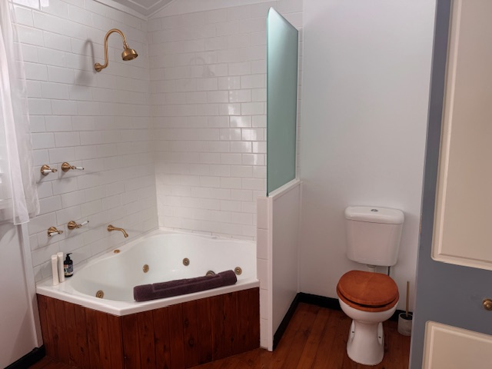
Amberesque - bathroom

COMMON AREAS

FOOD AND DRINK

Dining Spaces
The dining spaces have the following facilities/amenities in place
- The entrance has level access
- The doorway is at least 850mm wide
- There is level access through the dining area
- Chairs are moveable to allow for wheelchairs to be seated at the tables
- There are areas of full lighting
- There are large print menus
- There are Plain English menus

Our business caters for the following dietary requirements
- Sugar free (diabetic)
- Gluten free (celiac)
- Lactose free (dairy free)
- Low fat and fibre with no gastric content
- Low potassium
- Low sodium
- Nut free
- Additive free
- Organic
- Vegetarian
- Vegan
- Kosher
- Halal
- In addition, the following further information can assist guests:
Procedures for protecting food from contamination at Amberesque B&amp;B:
• Store raw food – especially meat, fish and poultry – below and away from ready-to-eat food in a
cool room or fridge.
• Store chemicals and equipment well away from food items, food packaging and food handling
areas.
• Maintain the premises, including all fixtures, fittings and equipment, in a clean and undamaged
condition.
• Regularly clean and sanitise food contact surfaces and utensils, such as chopping boards, knives.
• Use separate equipment and utensils for raw and ready-to-eat foods, or thoroughly wash and
sanitise equipment and utensils between handling raw and ready-to-eat foods.
• Avoid unnecessary contact with food, for example use utensils rather than bare hands.
• Thoroughly wash and dry hands before starting work, changing tasks or returning from a break, for
example between serving customers and preparing food, and after handling raw foods and
garbage, or using the toilet.
• Cover cuts and wounds with an appropriate dressing.
• Do not handle food if feeling unwell or suffering from a contagious illness.

Report Disclaimer
Please note that this business report, provided as a result of the use of the diagnostic assessment, is for information purposes only.
Australian Tourism Industry Council (ATIC) cannot guarantee the accuracy of respondent’s answers, or that they are fully representative of your business. Therefore, ATIC does not warrant or guarantee any particular outcome in respect of your businesses self-assessment.
This report is intended as guidance only for your business and should not be relied on for future marketing considerations. ATIC recommends that you seek your own independent advice as well as the results from the diagnostic.
Links to external web sites are inserted for convenience and do not constitute endorsement of material at those sites, or any associated organisation, product or service.
ATIC does not:
- Assume any legal liability for the accuracy, completeness, or usefulness of any information from this report or any links provided; or
- Accept responsibility for any loss associated directly or indirectly from the use of this report.

