ATIC Accessibility
To support the accessible community in making informed travel decisions for their individual needs

This report prepared for:
Business name: | Kimberley Safari Tours
Address: | PO Box 41
Town: | Dardanup
Contact for enquiries: | Glenn Ursino
Contact Number: | 0437142904
Contact Email: | info@kimberleysafaris.com.au
Website: | www.gibbriverroadtours.com.au
Date: | 2026-09-15 20:04

ATIC Accessibility
The following pages provides travellers with information on the businesses facilities and amenities which aims to support the traveller to make an informed decision on whether the business is suitable for their individual needs.
OVERVIEW 4
Business Overview 4
Bookings 4
Emergency Management 5
Communications 5
Guide Dog and Service Animals 5
GENERAL 6
Pre-arrival, arrival and reception 6
Displays, exhibits, commentary and live performances 6
External Paths 6
Steps 6
TOUR OPERATORS 8
Tour/Transport Services 8
Route Planning 8
Guides 8
ACCOMMODATION 9
Bedrooms 9
Room Amenities 9
Bathrooms 9
COMMON AREAS 10
FOOD AND DRINK 11
Dining Spaces 11
Report Disclaimer 14

OVERVIEW

Business Overview

The business has the following products/services available
- Tour/Transport
- Accommodation
- Food and Drink

Our business caters for the following disability types:
- Blind or low vision
- Deaf or low hearing
- Limited mobility
- Food allergies or intolerances
- Cognitive or people on the Autism Spectrum


Bookings

The business offers the following methods for bookings and enquiries:
- Phone
- Email
- Webportal
- Our website supports Screen Readers
- Our forms have high contract boxes and submit boxes

Emergency Management
- Emergency and evacuation procedures are explained on arrival
- Guests with disabilities are noted in the guest log book for emergency and evacuation purposes

Communications
- Our business offers the following alternative communication methods
- Plain English

Not specified
- There is easy to read signage and information (e.g. menus and emergency information)

Guide Dog and Service Animals
- The business provides a toilet area for service animals
The business provides the following services for services animals:
upon request

GENERAL

Pre-arrival, arrival and reception
The business has the following in place to support guests during pre-arrival, arrival and reception
- Booking information and websites are compatible with screen readers
- Information and maps are available in written form
- Luggage assistance
- In addition, the following further information can assist guests:
Our tours are long duration (Min 12 Day) tours and may not be suitable for guests with fatigue related issues. We discuss all requirements and medical conditions with guest at the time of booking.

Displays, exhibits, commentary and live performances
For displays, exhibits, commentary and live performances the following amenities are in place
- Seating
- Wheelchair accessible spaces/seating

External Paths
External paths of travel
The width of the smallest pathway is:
natural terrain walks
- There 3 successive steps or less on any path or at any doorway
- Any paths having steps are clearly identified as non-wheelchair accessible
- In addition, the following further information can assist guests:
This is a remote outback tour that may not be suitable for limited mobility guests.

Steps
Steps
- There are steps.
- All steps or staircases have enclosed risers
- The underside of all staircases are enclosed or protected to a height of at least 2 metres
- Handrails fitted to all open sets of steps
- Where steps are present are there three steps or less
- In addition, the following further information can assist guests:
The steps are entry into the tour vehicle

TOUR OPERATORS

Tour/Transport Services
The tour/transport services have the following facilities/amenities in place
- Buses/Coaches
- 0 vehicles have wheelchair lifts or ramps
- 0 vehicles have low floors with ramped entry
The maximum wheelchair capacity available in the fleet is:
0

Route Planning
- Route Planning
- The tour route includes stops with accessible toilet facilities
- Lunch stop venues are accessible
- Overnight Stops
- For overnight stays, wheelchair accessible rooms are available
The total number of wheelchair passengers that can be catered for at overnight stops are:
0
- Walking Tours
- Multi-paced to account for slower walkers
- Hearing aid compatible

Guides

Guides have been trained in the following
- Use of clear/simple English
- There is a audio description of surroundings
- In addition, the following further information can assist guests:
Everywhere in Western Australia is an option. Primarily on the coastal rout between Perth and Broome including inland locations such as Karijini and surrounding areas and then the bulk of the Kimberley Region.

ACCOMMODATION

Bedrooms
The bedrooms have the following facilities/amenities in place
- There are All tents could be accessed with a wheelchair. rooms available to guests who use a wheelchair
- Bedroom furniture can be re-arranged on request

Room Amenities

Its a Tent
- There is a clear path through the room
- The edges of all furniture and fixtures are rounded
- Housekeeping procedures instruct staff not to reposition furniture that has been moved
- Doors open fully against the adjoining wall
- There is a clear opening at least 850mm wide
- The bed height is no higher than 680mm from the floor
- The business offers a range of non-allergenic bedding
- Non-allergenic cleaning products are used
- In addition, the following further information can assist guests:
The accommodation is a 4 person tent with up to 2 guests with 1 mattress provided per person.

Bathrooms
The bathrooms have the following facilities/amenities in place
- The width of the door is Don't know. We rely on other facilities. Some locations only have a portable camping shower tent.
- The width beside the toilet is Unsure. Provided by others.
- There is Unsure. Provided by others mm of clear space in front of the toilet
- The actual height of the toilet seat is Unsure. Provided by others.
- A door is fitted to the shower
- In addition, the following further information can assist guests:
We rely on facilities provided by others.

COMMON AREAS

FOOD AND DRINK

Dining Spaces
The dining spaces have the following facilities/amenities in place
- The entrance has level access
- The doorway is at least 850mm wide
- There is level access through the dining area
- Chairs are moveable to allow for wheelchairs to be seated at the tables
- All glass doors and full height windows have contrast markings
- There are areas of full lighting

Our business caters for the following dietary requirements
- Sugar free (diabetic)
- Gluten free (celiac)
- Lactose free (dairy free)
- Low fat and fibre with no gastric content
- Low potassium
- Low sodium
- Nut free
- Vegetarian
- Vegan
- In addition, the following further information can assist guests:
Guests are required to provide dietary requirements prior to the tour. For most meals guests will serve themselves at self serve stations. Guests with specific dietary requirements are managed on a case by case basis. Although we do cater for a range of requirements there are some times when we can not ensure that we can fully cater and guests are made aware of this.
  - Food and Beverage Image(s)
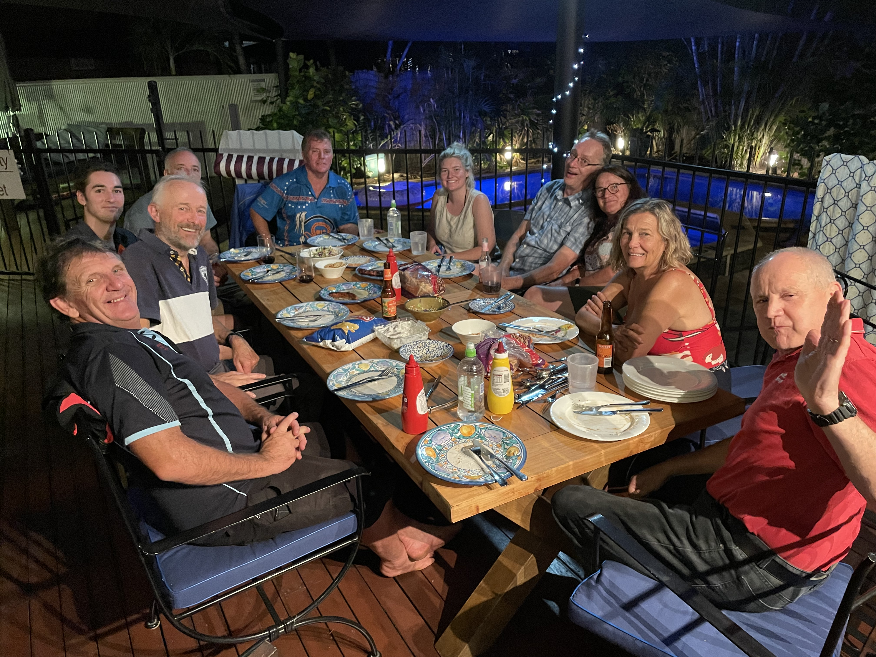
IMG_2292
- In addition, the following further information can assist guests:
Our tours are camping tours and equipment and layout are to suit camping

Report Disclaimer
Please note that this business report, provided as a result of the use of the diagnostic assessment, is for information purposes only.
Australian Tourism Industry Council (ATIC) cannot guarantee the accuracy of respondent’s answers, or that they are fully representative of your business. Therefore, ATIC does not warrant or guarantee any particular outcome in respect of your businesses self-assessment.
This report is intended as guidance only for your business and should not be relied on for future marketing considerations. ATIC recommends that you seek your own independent advice as well as the results from the diagnostic.
Links to external web sites are inserted for convenience and do not constitute endorsement of material at those sites, or any associated organisation, product or service.
ATIC does not:
- Assume any legal liability for the accuracy, completeness, or usefulness of any information from this report or any links provided; or
- Accept responsibility for any loss associated directly or indirectly from the use of this report.

