ATIC Accessibility
To support the accessible community in making informed travel decisions for their individual needs

This report prepared for:
Business name: | Charter North 4WD Safaris
Address: | Unit 4 30C Duke Street
Town: | Stuart Park
Contact for enquiries: | Alina Baldrich
Contact Number: | 0481677048
Contact Email: | enquiries@charternorth.com.au
Website: | https://www.charternorth.com.au
Date: | 2026-10-23 01:13

ATIC Accessibility
The following pages provides travellers with information on the businesses facilities and amenities which aims to support the traveller to make an informed decision on whether the business is suitable for their individual needs.
OVERVIEW 4
Business Overview 4
Bookings 4
GENERAL 5
Internal Spaces 5
Displays, exhibits, commentary and live performances 5
TOUR OPERATORS 6
Route Planning 6
Guides 6
ACCOMMODATION 8
ATTRACTIONS 9
COMMON AREAS 10
FOOD AND DRINK 11
Dining Spaces 11
ADVENTURE ACTIVITIES 12
Report Disclaimer 14

OVERVIEW

Business Overview

The business has the following products/services available
- Tour/Transport
- Accommodation
- Attraction
- Food and Drink
- Adventure

Our business caters for the following disability types:
- Food allergies or intolerances
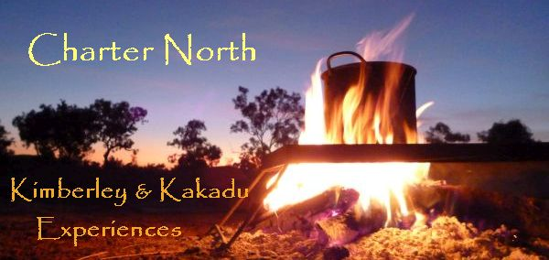

Bookings

The business offers the following methods for bookings and enquiries:
- Phone
- Email

We are an outdoor product that dont require such procedures
The business provides the following services for services animals:
We are unable to offer services for service animals

GENERAL
- In addition, the following further information can assist guests:
This is completely N/A for our type of product
- In addition, the following further information can assist guests:
We are a remote mobile 4WD hiking adventure product that is not safe for most types of disability
- In addition, the following further information can assist guests:
We are not responsible for infrastructure in National parks and other outdoor areas we operate in

Internal Spaces
- Menus are available in large print or Braille

Displays, exhibits, commentary and live performances
For displays, exhibits, commentary and live performances the following amenities are in place
- Seating
- In addition, the following further information can assist guests:
All commentary is provided by tour guides
The width of the smallest pathway is:
We mostly dont walk on pathways

We use a variety of hiking trails, not pathways as such
- In addition, the following further information can assist guests:
All hiking trails we use are designed and maintained by external sources

TOUR OPERATORS

Route Planning
- Route Planning
- Overnight Stops
The total number of wheelchair passengers that can be catered for at overnight stops are:
0
- Walking Tours
- Multi-paced to account for slower walkers
- Hearing aid compatible

Guides

Guides have been trained in the following
- Use of clear/simple English
- Correct pronunciation for lip readers
- There is a audio description of surroundings
- Marine
  - Image(s)
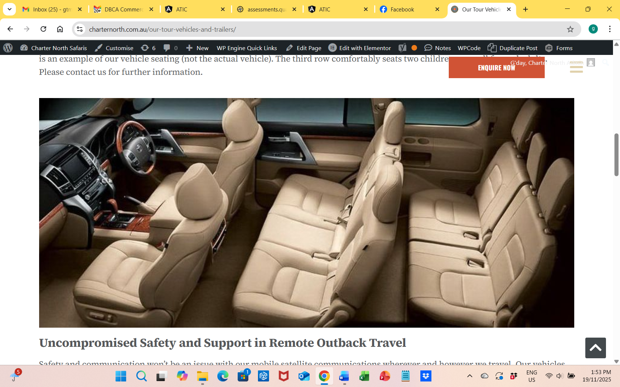
Screenshot 2025-11-19 13.53.24
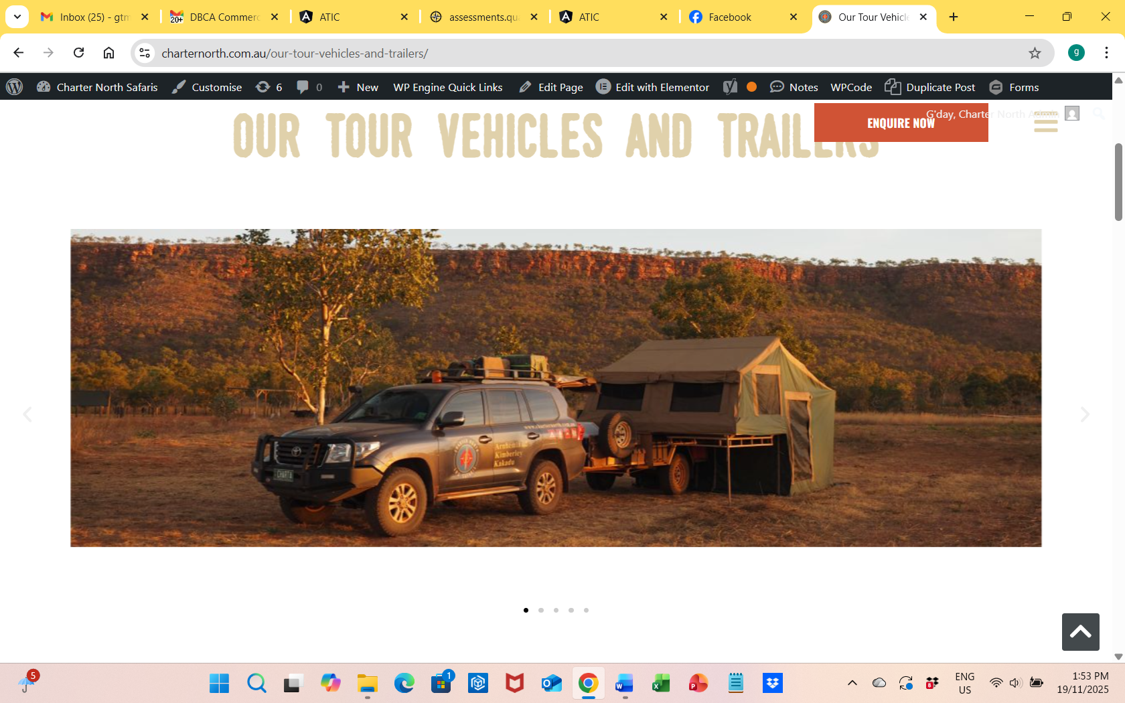
Screenshot 2025-11-19 13.53.59
- In addition, the following further information can assist guests:
Cooinda Lodge
https://kakadutourism.com/stay/cooinda-lodge?
Anbinik Resort Kakadu
https://www.anbinik.com.au/
Nitmiluk tours
https://www.nitmiluktours.com.au/accommodation/nitmiluk-cabins/
Bell Gorge Wilderness Lodge
https://www.aptouring.com/en-au/our-fleet/bell-gorge-lodge

ACCOMMODATION

These are not our premises, they are a range of third party providers. As such we are not privey to this type of information
- Openings are a minimum of Have no idea of various provider specs wide
- The width of the door is Of which door?.
- The width beside the toilet is No idea.
- There is Have no idea mm of clear space in front of the toilet
- The actual height of the toilet seat is Have no idea.

ATTRACTIONS

COMMON AREAS

FOOD AND DRINK

Dining Spaces
The dining spaces have the following facilities/amenities in place
- The smallest doorway is 600mm wide
- There are areas of full lighting
- There are large print menus
- There are Plain English menus

Our business caters for the following dietary requirements
- Gluten free (celiac)
- Lactose free (dairy free)
- Nut free
- Vegetarian
- Vegan
- In addition, the following further information can assist guests:
As we operate in a remote area with mixed groups, we can not guarentee against cross contamination
- There is a sample menu available online
Sample menu is available here -
https://www.charternorth.com.au/charter-north-tour-catering/

ADVENTURE ACTIVITIES

Report Disclaimer
Please note that this business report, provided as a result of the use of the diagnostic assessment, is for information purposes only.
Australian Tourism Industry Council (ATIC) cannot guarantee the accuracy of respondent’s answers, or that they are fully representative of your business. Therefore, ATIC does not warrant or guarantee any particular outcome in respect of your businesses self-assessment.
This report is intended as guidance only for your business and should not be relied on for future marketing considerations. ATIC recommends that you seek your own independent advice as well as the results from the diagnostic.
Links to external web sites are inserted for convenience and do not constitute endorsement of material at those sites, or any associated organisation, product or service.
ATIC does not:
- Assume any legal liability for the accuracy, completeness, or usefulness of any information from this report or any links provided; or
- Accept responsibility for any loss associated directly or indirectly from the use of this report.

