ATIC Accessibility
To support the accessible community in making informed travel decisions for their individual needs

This report prepared for:
Business name: | Top Didj Art Gallery
Address: | 363 Gorge Rd
Town: | Lansdowne
Contact for enquiries: | Laura Metcalf
Contact Number: | 0422495230
Contact Email: | sales@topdidj.com
Website: | topdidj.com
Date: | 2026-10-22 14:23

ATIC Accessibility
The following pages provides travellers with information on the businesses facilities and amenities which aims to support the traveller to make an informed decision on whether the business is suitable for their individual needs.
OVERVIEW 4
Business Overview 4
Bookings 4
Emergency Management 4
Communications 5
Guide Dog and Service Animals 5
GENERAL 6
Pre-arrival, arrival and reception 6
Cognitive Impairment Support 6
Car Park and Access amenities 6
Entry 6
Internal Spaces 7
Public areas 7
External Paths 7
Steps 8
Public Toilets/Adult change facilities 8
ATTRACTIONS 9
COMMON AREAS 10
Report Disclaimer 12

OVERVIEW

Business Overview

The business has the following products/services available
- Attraction

Our business caters for the following disability types:
- Deaf or low hearing
- Limited mobility
- Wheelchairs or mobility scooters
- Food allergies or intolerances
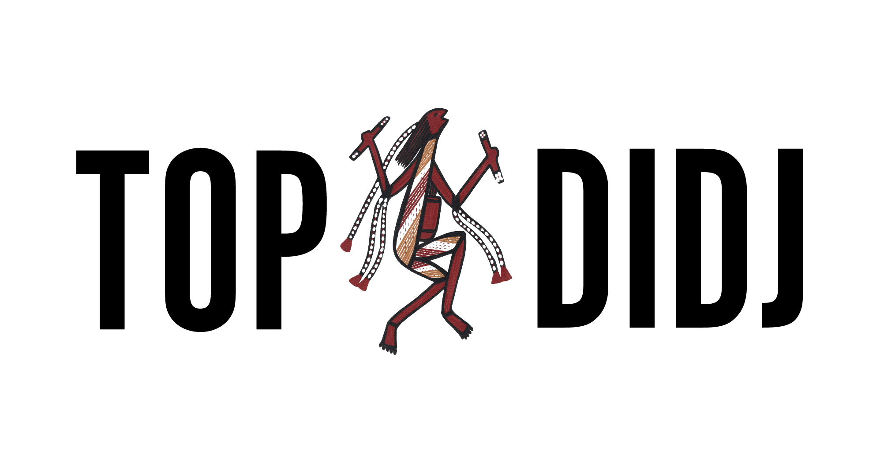

Bookings

The business offers the following methods for bookings and enquiries:
- Phone
- Email
- Staff have undergone disability awareness and training

Emergency Management
- Emergency and evacuation procedures are explained on arrival
- Exit signs are clear and easy to see
- Exit access is free and clear at all times
We ensure exit access is free and clear at all times by:
Exit doors are always kept clear
- Exits and access to exists are greater than 900mm
- Exit doors are able to be opened by all occupants
- Exits to the emergency evacuation point does not include stairways
- The evacuation point is clearly marked by a sign
- In addition, the following further information can assist guests:
We have an small open plan gallery and all visitors will be guided to the exits by staff in the case of an emergency
- In addition, the following further information can assist guests:
Customers with disabilities will be given priority assistance in the event of an emergency.

Communications
- An accessibility guide is available on the website

https://accreditation.qualitytourismaustralia.com/report/AccessReportPublicHtml2/bc5f8baa-101b-44e2-956c-7e9183f7688f

Guide Dog and Service Animals
- The business provides a secure area with shade and water for service animals
- The business provides a toilet area for service animals
- Bowls, bedding, etc. are provided for service animals
The business provides the following services for services animals:
Service animals are allowed into our gallery and water is offerede

GENERAL

Pre-arrival, arrival and reception
The business has the following in place to support guests during pre-arrival, arrival and reception
- There is a reception/public entryway.
- Seating available at reception
- Lighting in the reception area is even and glare free

we do not offer any ticketed events or tours
- In addition, the following further information can assist guests:
We do not offer tours or events. Our entryway is large and wheelchair accessable and we have seting in the gallery close to the entryway. This allows visitors to view the gallery from a seated position, or to wait for others still wandering the gallery

Cognitive Impairment Support
- Quiet periods or early opening times for people on the Autism Spectrum

Car Park and Access amenities
The business has the following Car Park and Access amenities
- A drop off zone
- Designated disabled parking bays
- Level or ramped access from the car park to the entrance
- The accessible entrance is clearly signed from the parking bay

Entry
The business has the following amenities/systems in place for entry
- A drop off point close to the entrance
- A path of access to the building is slip resistance and even
- A path of access to the building is clear of obstruction
- Self opening entry doors or fitted with a self closer
- Glass doors are fitted with a visual sighting strip
- Door jams/doors are of a contrasting colour to surrounding walls
- Door handles are of a contrasting colour to the door
- Signage is written in a contrasting colour
- The entry door is a minimum of 850mm wide
- The entry door has self opening or a light opening pressure (for manual operations)
- The entrance sill is less than 13mm
- There a clear space of at least 1500mm x 1500mm in front of all doors.
- The entrance door mats have a thickness less than 13mm and a width of 7500mm or greater
- In addition, the following further information can assist guests:
We have an upper level of the gallery that has stair access only

Internal Spaces
- Clear and unobstructed routes through and between buildings
- Interior walls are matte or low sheen
- Floors, walls, counters and furniture are of contrasting colours
- Floor surfaces are hard or short pile carpet
- Seating is available for guests unable to stand for long periods
- Accessible facilities are clearly signed and visible from all areas
- All corridors greater than 900mm

Public areas
The public areas have the following amenities in place
- Even lighting
- Seating

External Paths
External paths of travel
- Surfaces are concrete, asphalt, smooth paving or hard packed fine gravel (max aggregate size 13mm)
- Paths or slopes longer than 15 metres have resting places or seats
- Pathways are wider than 900mm
- There 3 successive steps or less on any path or at any doorway

all paths are wheelchair accessible.

Steps
Steps
- There are steps.
- Top and bottom steps are easily distinguished through colour contrast or the use of TGSIs (Tactile Ground Surface Indicators)
- The underside of all staircases are enclosed or protected to a height of at least 2 metres
- Handrails fitted to all open sets of steps
- Handrails extend 300mm beyond the top and bottom step
- Where steps are present are there three steps or less
- In addition, the following further information can assist guests:
The gallery has no accessible lift to the upper level of the gallery that has stair access only

Public Toilets/Adult change facilities
Public Toilets/Adult change facilities have the following amenities are in place
- There is an accessible toilet for public use
- The door is at least 850mm wide
- There is a minimum of 850mm beside the toilet
- Handrails are fitted
- The toilet seat is 460mm above the floor
- The toilet seat of a contrasting colour to the floor
- The toilet seat is460mm above the floor

ATTRACTIONS

COMMON AREAS

Report Disclaimer
Please note that this business report, provided as a result of the use of the diagnostic assessment, is for information purposes only.
Australian Tourism Industry Council (ATIC) cannot guarantee the accuracy of respondent’s answers, or that they are fully representative of your business. Therefore, ATIC does not warrant or guarantee any particular outcome in respect of your businesses self-assessment.
This report is intended as guidance only for your business and should not be relied on for future marketing considerations. ATIC recommends that you seek your own independent advice as well as the results from the diagnostic.
Links to external web sites are inserted for convenience and do not constitute endorsement of material at those sites, or any associated organisation, product or service.
ATIC does not:
- Assume any legal liability for the accuracy, completeness, or usefulness of any information from this report or any links provided; or
- Accept responsibility for any loss associated directly or indirectly from the use of this report.

