ATIC Accessibility
To support the accessible community in making informed travel decisions for their individual needs

This report prepared for:
Business name: | Motor Museum of Western Australia Pty Ltd
Address: | 233a Drumpellier Drive
Town: | Whiteman
Contact for enquiries: | Danny Ganon
Contact Number: | 0455322282
Contact Email: | reception@motormuseumwa.com.au
Website: | www.motormuseumwa.com.au
Date: | 2026-10-30 13:08

ATIC Accessibility
The following pages provides travellers with information on the businesses facilities and amenities which aims to support the traveller to make an informed decision on whether the business is suitable for their individual needs.
OVERVIEW 4
Business Overview 4
Bookings 4
Emergency Management 5
Communications 5
Other Information 6
Guide Dog and Service Animals 6
GENERAL 7
Pre-arrival, arrival and reception 7
Cognitive Impairment Support 7
Car Park and Access amenities 7
Entry 8
Internal Spaces 8
Public areas 8
Displays, exhibits, commentary and live performances 9
External Paths 9
Steps 9
Ramps 9
ATTRACTIONS 11
COMMON AREAS 12
Report Disclaimer 14

OVERVIEW

Business Overview

The business has the following products/services available
- Attraction

Our business caters for the following disability types:
- Blind or low vision
- Deaf or low hearing
- Limited mobility
- Wheelchairs or mobility scooters
- Cognitive or people on the Autism Spectrum
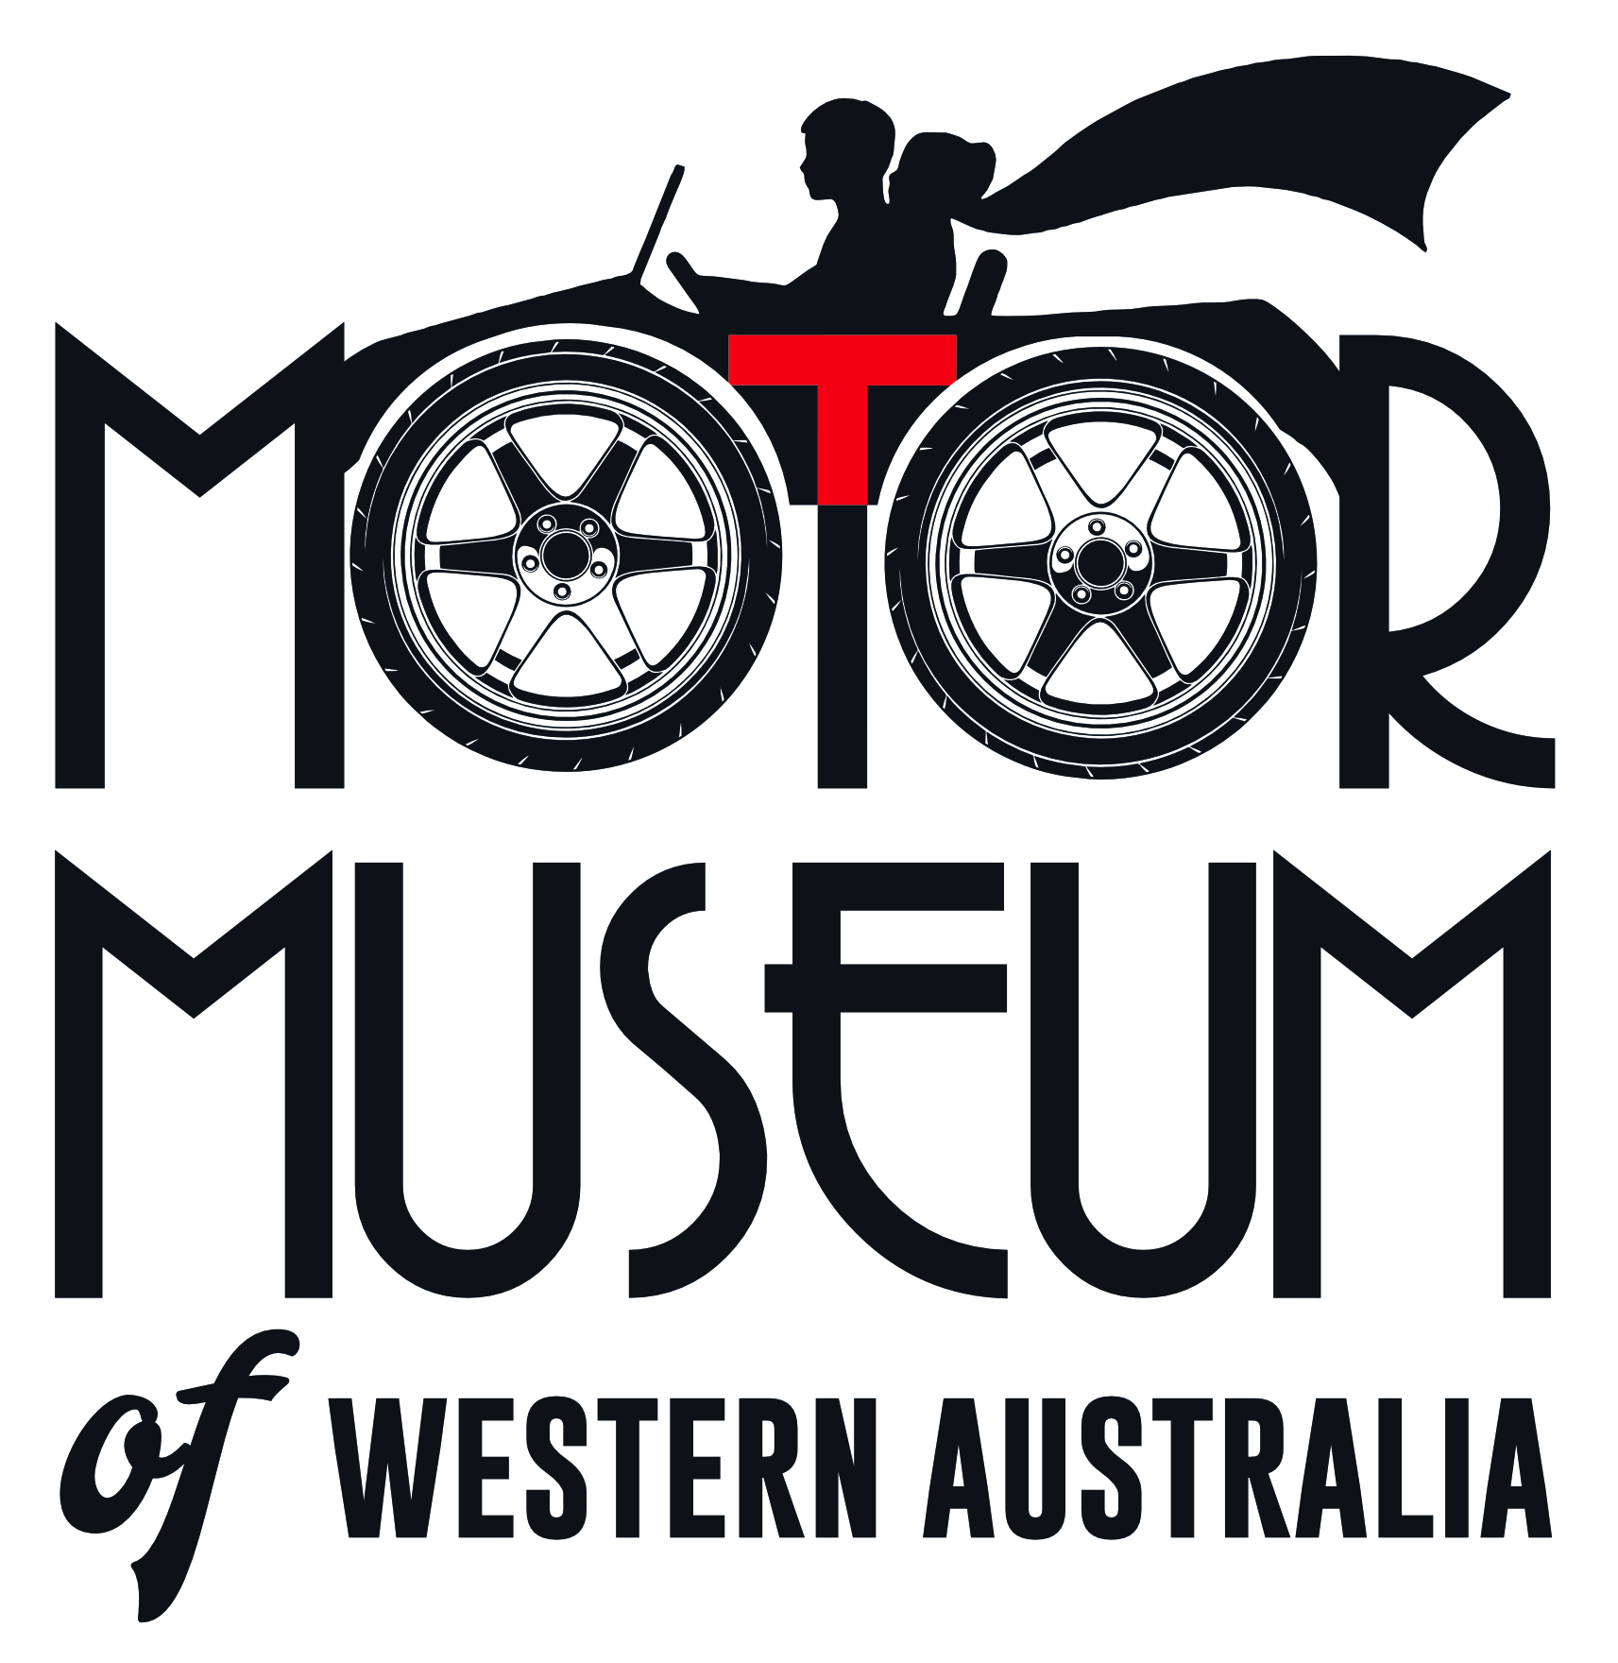

Bookings

The business offers the following methods for bookings and enquiries:
- Phone
- Email
- Webportal
- Our website supports Screen Readers
- Our forms have high contract boxes and submit boxes
- Staff have undergone disability awareness and training

Emergency Management
- Exit signs are clear and easy to see
- Exit access is free and clear at all times
We ensure exit access is free and clear at all times by:
We have volunteers on the museum floor at all times looking after customers and looking for issues like if a door has been blocked for any reason.
- Exits and access to exists are greater than 900mm
- Exit doors are able to be opened by all occupants
- Exits to the emergency evacuation point does not include stairways
- The evacuation point is clearly marked by a sign
- In addition, the following further information can assist guests:
Staff and volunteers are aware that they are to identify who is in the building and in addition, provide assistance if required.
- In addition, the following further information can assist guests:
TBC

Communications
- An accessibility guide is available on the website

https://www.motormuseumwa.com.au/policies/accessibility-and-inclusion-policy/
- Our website meets WCAG 2.0 accessibility standards
- Our business offers the following alternative communication methods
- Plain English

Not specified
- There is easy to read signage and information (e.g. menus and emergency information)

Other Information
- For bookings made onsite, the ticket booth/counter/box office is accessible for people using a wheelchair
- The business accepts the companion card

Guide Dog and Service Animals
- The business provides a secure area with shade and water for service animals
- The business provides a toilet area for service animals
- Bowls, bedding, etc. are provided for service animals
The business provides the following services for services animals:
We have an area at our front door where a bowl of water can be used, if someone asks to enter the premises with a dog, we ensure that they are a service animal and let the person know if they need assistance to let a volunteer know.

GENERAL

Pre-arrival, arrival and reception
The business has the following in place to support guests during pre-arrival, arrival and reception
- Booking information and websites are compatible with screen readers
- There is a reception/public entryway.
- A tablet with text to voice or pen and paper at reception to aid in communication
- Lighting in the reception area is even and glare free
- Large print information sheets and registration forms

There is no seating directly at reception, however there is seating close by (both inside and outside the building). Generally people will buy their ticket (cash or EFT) and then move into the museum. There are no picture boards at the front counter for our ticket purchases.
- Information and maps are available in written form
- A step free map/guide
- A familiarisation tour
- In addition, the following further information can assist guests:
We rarely have long wait times at our front counter, and on days where we expect longer wait times (eg Father's Day), we have multiple people on the front counter to assist as required.

Cognitive Impairment Support
- Documents are available in plain English for people with cognitive impairment (This may include instructions, guides, menus and general information)

Car Park and Access amenities
The business has the following Car Park and Access amenities
- A drop off zone
- Designated disabled parking bays
- Level or ramped access from the car park to the entrance
- The accessible entrance is clearly signed from the parking bay
- The public transport services available are:

Yes, on our website. We note that the distance from Train Station to our museum is 2.5km.
- Kerb ramps are in place where a pavement or walkway needs to be crossed

Entry
The business has the following amenities/systems in place for entry
- A drop off point close to the entrance
- A path of access to the building is slip resistance and even
- A path of access to the building is clear of obstruction
- Self opening entry doors or fitted with a self closer
- Glass doors are fitted with a visual sighting strip
- Signage is written in a contrasting colour
- Signage is written in a Sans Serif font and use upper and lower case letters
- The entry door is a minimum of 850mm wide
- The entry door has self opening or a light opening pressure (for manual operations)
- The entrance sill is less than 13mm
- There a clear space of at least 1500mm x 1500mm in front of all doors.

Internal Spaces
- Clear and unobstructed routes through and between buildings
- Interior walls are matte or low sheen
- Floors, walls, counters and furniture are of contrasting colours
- Any protruding or overhanging obstructions are at least 2meters above the floor or are protected
- Floor surfaces are hard or short pile carpet
- Seating is available for guests unable to stand for long periods
- Accessible facilities are clearly signed and visible from all areas
- All corridors greater than 900mm

Public areas
The public areas have the following amenities in place
- Display units, Televisions, Video displays etc. are open captioned
- Even lighting
- Seating

Displays, exhibits, commentary and live performances
For displays, exhibits, commentary and live performances the following amenities are in place
- Seating
- Wheelchair accessible spaces/seating

External Paths
External paths of travel
- Surfaces are concrete, asphalt, smooth paving or hard packed fine gravel (max aggregate size 13mm)
- Pathways are wider than 900mm
- There 3 successive steps or less on any path or at any doorway

There are steps at the front of the building, however direct access from the car park and cafe are via a slight sloping ramp and can be easily seen as the space is open.
- Step free routes clearly signed

Steps
Steps
- There are steps.
- Top and bottom steps are easily distinguished through colour contrast or the use of TGSIs (Tactile Ground Surface Indicators)
- All steps or staircases have enclosed risers
- The underside of all staircases are enclosed or protected to a height of at least 2 metres
- Handrails fitted to all open sets of steps
- Handrails extend 300mm beyond the top and bottom step
- In addition, the following further information can assist guests:
We have an alternative ramp that guests can use rather than the stairs and visitors are advised when they arrive of the two options to reach out second level. There are 6 stairs that guests would need to climb if stairs are chosen.

Ramps
Ramps have the following amenities are in place
- There are ramps.
- All fixed ramps are 1:14 or less
- Hand rails are fitted
- Long ramps (more than 10m) are 1:20 or less
- Ramps have a raised edge of at least 100mm

ATTRACTIONS

COMMON AREAS

Report Disclaimer
Please note that this business report, provided as a result of the use of the diagnostic assessment, is for information purposes only.
Australian Tourism Industry Council (ATIC) cannot guarantee the accuracy of respondent’s answers, or that they are fully representative of your business. Therefore, ATIC does not warrant or guarantee any particular outcome in respect of your businesses self-assessment.
This report is intended as guidance only for your business and should not be relied on for future marketing considerations. ATIC recommends that you seek your own independent advice as well as the results from the diagnostic.
Links to external web sites are inserted for convenience and do not constitute endorsement of material at those sites, or any associated organisation, product or service.
ATIC does not:
- Assume any legal liability for the accuracy, completeness, or usefulness of any information from this report or any links provided; or
- Accept responsibility for any loss associated directly or indirectly from the use of this report.

