ATIC Accessibility
To support the accessible community in making informed travel decisions for their individual needs

This report prepared for:
Business name: | Whitsunday Coast Airport
Address: | Lascelles Avenue
Town: | Gunyarra
Contact for enquiries: | Marianne Goldman
Contact Number: | 07 4945 0480
Contact Email: | airport@whitsundayrc.qld.gov.au
Website: | www.whitsundaycoastairport.com.au
Date: | 2026-10-06 12:33

ATIC Accessibility
The following pages provides travellers with information on the businesses facilities and amenities which aims to support the traveller to make an informed decision on whether the business is suitable for their individual needs.
OVERVIEW 4
Business Overview 4
Bookings 4
Emergency Management 4
Communications 5
Guide Dog and Service Animals 6
GENERAL 7
Pre-arrival, arrival and reception 7
Cognitive Impairment Support 7
Car Park and Access amenities 8
Entry 8
Internal Spaces 9
Public areas 9
External Paths 9
Public Toilets/Adult change facilities 10
COMMON AREAS 11
Report Disclaimer 13

OVERVIEW

Business Overview

The business has the following products/services available

Our business caters for the following disability types:
- Blind or low vision
- Deaf or low hearing
- Limited mobility
- Wheelchairs or mobility scooters
- Food allergies or intolerances
- Cognitive or people on the Autism Spectrum


Bookings

The business offers the following methods for bookings and enquiries:
- Phone
- Email
- Staff have undergone disability awareness and training

Emergency Management
- There are Audible device/s to alert occupants to evacuate with instructions on how to evacuate.
- There are visual device/s to alert occupants to evacuate.
- Exit signs are clear and easy to see
- Exit signs have raised lettering or braille
- Exit access is free and clear at all times
We ensure exit access is free and clear at all times by:
Exit access is monitored continually by staff to ensure it is always free and maintained
- Exits and access to exists are greater than 900mm
- Exit doors are able to be opened by all occupants
- Exits to the emergency evacuation point does not include stairways
- The evacuation point is clearly marked by a sign
- In addition, the following further information can assist guests:
The airline identifies passengers requiring additional assistance through notes recorded on the flight manifest, including those with reduced mobility or other specific needs. In the event of an emergency, the airport will liaise directly with the airline to access this information and ensure appropriate support is provided to those passengers.
- In addition, the following further information can assist guests:
he procedure for assisting guests who require assisted rescue is guided by the Airport Emergency Plan and carried out in coordination with airline staff. Passengers identified as requiring additional assistance are prioritised, with information obtained from the airline manifest. Trained airport personnel and responding emergency services will be deployed to assist these guests, using appropriate equipment where required (e.g. wheelchairs or evacuation aids). Assistance will be provided to move passengers to a place of safety as quickly and safely as possible, with ongoing communication maintained between the airport, airlines and emergency responders throughout the incident.
- Guests with disabilities are noted in the guest log book for emergency and evacuation purposes

Communications
- An accessibility guide is available on the website

https://www.whitsundaycoastairport.com.au/Passenger-Services/Accessibility
- Our website meets WCAG 2.0 accessibility standards
- Our business offers the following alternative communication methods
- Plain English
- Braille Displays

Not specified
- There is easy to read signage and information (e.g. menus and emergency information)
- There is a Pictorial menu
  - Pictorial Menu Image(s)
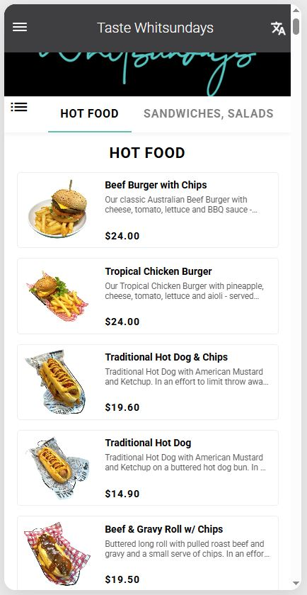
Pictorial Menu.JPG

Guide Dog and Service Animals
- The business provides a secure area with shade and water for service animals
- The business provides a toilet area for service animals
The business provides the following services for services animals:
The airport supports guests travelling with service animals in accordance with all relevant legislation and regulations. Designated outdoor areas are available, including grassed spaces located just outside the boarding gate, where service animals can relieve themselves. Airport staff are available to provide assistance on request, including facilitating access to appropriate areas and coordinating with airline staff where required. The airport ensures that service animals can remain with their handlers at all times throughout the terminal and boarding process, in line with regulatory requirements.

GENERAL

Pre-arrival, arrival and reception
The business has the following in place to support guests during pre-arrival, arrival and reception
- Booking information and websites are compatible with screen readers
- There is a reception/public entryway.
- Seating available at reception
- A tablet with text to voice or pen and paper at reception to aid in communication
- Picture Board at reception to aid in communication
- Hearing loop fitted to the reception area
- Lighting in the reception area is even and glare free

As an airport, check-in and ticketing services are managed directly by the airlines. While clipboards are not standard, airline check-in counters are designed to accommodate passengers who need to remain seated where possible. Assistance can be provided by airline or airport staff to complete the check-in process, including the use of accessible counters or alternative arrangements as required. Passengers requiring additional support are encouraged to advise their airline in advance or speak with staff on arrival to ensure appropriate assistance is provided.
- In addition, the following further information can assist guests:
The airport works in collaboration with airline partners to support passengers who may experience fatigue related to their disability. Where possible, priority processing can be facilitated at check-in and boarding through airline coordination. Seating is available throughout the terminal to allow passengers to rest, and assistance can be provided by airport or airline staff on request. Passengers are encouraged to notify their airline in advance or speak with staff upon arrival so that appropriate arrangements can be made to minimise wait times and reduce fatigue.

Cognitive Impairment Support
- A "social script" guide to your premises or attraction describing the sights, sounds and smells to aid parents/carers prepare visitors in advance

Car Park and Access amenities
The business has the following Car Park and Access amenities
- A drop off zone
- Designated disabled parking bays
- Level or ramped access from the car park to the entrance
- The accessible entrance is clearly signed from the parking bay
- Kerb ramps are in place where a pavement or walkway needs to be crossed
- In addition, the following further information can assist guests:
Whitsunday Coast Airport offers convenient on-site parking with accessible bays located close to the terminal. Step-free pathways, kerbside drop-off zones, and clear signage support easy access. Assistance is available on request, ensuring a smooth and comfortable journey from car park to check-in for all passengers.

Entry
The business has the following amenities/systems in place for entry
- A drop off point close to the entrance
- A path of access to the building is slip resistance and even
- A path of access to the building is clear of obstruction
- Self opening entry doors or fitted with a self closer
- Glass doors are fitted with a visual sighting strip
- Door jams/doors are of a contrasting colour to surrounding walls
- Door handles are of a contrasting colour to the door
- Signage is written in a contrasting colour
- Signage is written in a Sans Serif font and use upper and lower case letters
- The entry door is a minimum of 850mm wide
- The entry door has self opening or a light opening pressure (for manual operations)
- The entrance sill is less than 13mm
- There a clear space of at least 1500mm x 1500mm in front of all doors.
- The entrance door mats have a thickness less than 13mm and a width of 7500mm or greater
- In addition, the following further information can assist guests:
Whitsunday Coast Airport features automatic entry doors to provide seamless, hands-free access into the terminal. For boarding, airline staff are available to manually open airside gates as required, ensuring passengers needing assistance can move safely and comfortably through all access points within the airport.
- In addition, the following further information can assist guests:
N/A

Internal Spaces
- Clear and unobstructed routes through and between buildings
- Interior walls are matte or low sheen
- Floors, walls, counters and furniture are of contrasting colours
- Any protruding or overhanging obstructions are at least 2meters above the floor or are protected
- Floor surfaces are hard or short pile carpet
- Seating is available for guests unable to stand for long periods
- Accessible facilities are clearly signed and visible from all areas
- All corridors greater than 900mm
- In addition, the following further information can assist guests:
Whitsunday Coast Airport offers ample seating throughout the terminal, including spaces designed for comfort and accessibility. The interior layout provides clear pathways and open areas to support easy movement for all passengers, including those using mobility aids, ensuring a safe and comfortable experience while waiting for flights.

Public areas
The public areas have the following amenities in place
- Hearing loops
- Hearing loop symbols are displayed
- Even lighting
- Seating
- In addition, the following further information can assist guests:
Whitsunday Coast Airport is equipped with hearing loop technology in key areas of the terminal to assist passengers with hearing impairments. These systems enhance audio clarity for announcements and staff interactions, supporting improved communication and a more accessible and inclusive airport experience for all travellers.

External Paths
External paths of travel
- Surfaces are concrete, asphalt, smooth paving or hard packed fine gravel (max aggregate size 13mm)
- Pathways are wider than 900mm
- There 3 successive steps or less on any path or at any doorway
- Step free routes clearly signed
- In addition, the following further information can assist guests:
Passengers requiring assistance are encouraged to contact airline or airport staff on arrival. Support is available for navigation, mobility assistance, and access to appropriate facilities to ensure a safe and comfortable journey.
- In addition, the following further information can assist guests:
N/A

Public Toilets/Adult change facilities
Public Toilets/Adult change facilities have the following amenities are in place
- There is an accessible toilet for public use
- The door is at least 850mm wide
- There is a minimum of 850mm beside the toilet
- Handrails are fitted
- The toilet seat is 460mm above the floor
- The toilet seat of a contrasting colour to the floor
- The toilet seat is460mm above the floor

COMMON AREAS

Report Disclaimer
Please note that this business report, provided as a result of the use of the diagnostic assessment, is for information purposes only.
Australian Tourism Industry Council (ATIC) cannot guarantee the accuracy of respondent’s answers, or that they are fully representative of your business. Therefore, ATIC does not warrant or guarantee any particular outcome in respect of your businesses self-assessment.
This report is intended as guidance only for your business and should not be relied on for future marketing considerations. ATIC recommends that you seek your own independent advice as well as the results from the diagnostic.
Links to external web sites are inserted for convenience and do not constitute endorsement of material at those sites, or any associated organisation, product or service.
ATIC does not:
- Assume any legal liability for the accuracy, completeness, or usefulness of any information from this report or any links provided; or
- Accept responsibility for any loss associated directly or indirectly from the use of this report.

