ATIC Accessibility
To support the accessible community in making informed travel decisions for their individual needs

This report prepared for:
Business name: | Budj Bim Cultural Landscape Tourism
Address: | 4/48 Edgar Street
Town: | Heywood
Contact for enquiries: | Harriet Keatley
Contact Number: | 0355271427
Contact Email: | marketing@budjbim.com.au
Website: | www.budjbim.com.au
Date: | 2026-09-28 11:02

ATIC Accessibility
The following pages provides travellers with information on the businesses facilities and amenities which aims to support the traveller to make an informed decision on whether the business is suitable for their individual needs.
OVERVIEW 4
Business Overview 4
Bookings 4
Emergency Management 5
Communications 5
Other Information 5
Guide Dog and Service Animals 5
GENERAL 6
Pre-arrival, arrival and reception 6
Car Park and Access amenities 6
Entry 6
Internal Spaces 7
Public areas 7
Displays, exhibits, commentary and live performances 7
External Paths 8
Steps 8
Ramps 8
Public Toilets/Adult change facilities 9
TOUR OPERATORS 10
Tour/Transport Services 10
Route Planning 10
Guides 10
ATTRACTIONS 13
Attractions Basics 13
COMMON AREAS 14
Parks and gardens 14
FOOD AND DRINK 18
Dining Spaces 18
ADVENTURE ACTIVITIES 20
Adventure activities 20
Report Disclaimer 23

OVERVIEW

Business Overview

The business has the following products/services available
- Tour/Transport
- Attraction
- Food and Drink
- Adventure

Our business caters for the following disability types:
- Deaf or low hearing
- Limited mobility
- Wheelchairs or mobility scooters
- Food allergies or intolerances
- Cognitive or people on the Autism Spectrum
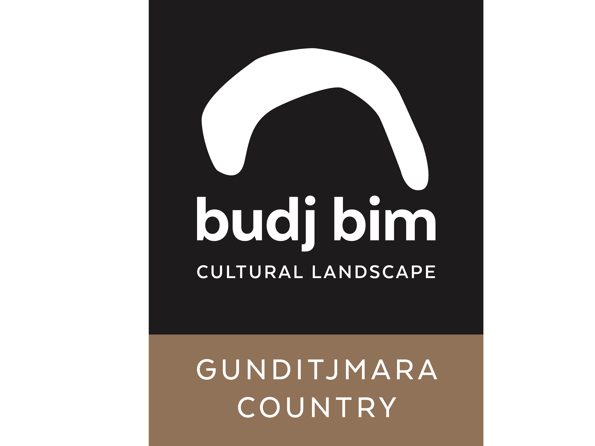

Bookings

The business offers the following methods for bookings and enquiries:
- Phone
- Email
- Webportal

Emergency Management
- The business has an emergency management and evacuation plan for guests with a disability

Because we are outside and if there were fires in the area no one would be allowed on site
- Guests with disabilities are noted in the guest log book for emergency and evacuation purposes

Communications
- An accessibility guide is available on the website

https://www.budjbim.com.au/visit/questions/

Other Information
- For bookings made onsite, the ticket booth/counter/box office is accessible for people using a wheelchair
- The business accepts the companion card

Guide Dog and Service Animals
The business provides the following services for services animals:
They are allowed on site and where ever there owner goes

GENERAL

Pre-arrival, arrival and reception
The business has the following in place to support guests during pre-arrival, arrival and reception
- Booking information and websites are compatible with screen readers
- There is a reception/public entryway.
- Seating available at reception
- A clipboard to allow check-in/ticket purchase whilst seated
- A tablet with text to voice or pen and paper at reception to aid in communication
- Lighting in the reception area is even and glare free
- A familiarisation tour
- In addition, the following further information can assist guests:
We do not have long wait times, but we do have ample seating in every area of the business including out on tour.
- In addition, the following further information can assist guests:
Not applicable

Car Park and Access amenities
The business has the following Car Park and Access amenities
- A drop off zone
- Designated disabled parking bays
- Level or ramped access from the car park to the entrance
- The accessible entrance is clearly signed from the parking bay

Entry
The business has the following amenities/systems in place for entry
- A drop off point close to the entrance
- A path of access to the building is clear of obstruction
- Self opening entry doors or fitted with a self closer
- Glass doors are fitted with a visual sighting strip
- Door jams/doors are of a contrasting colour to surrounding walls
- Door handles are of a contrasting colour to the door
- Signage is written in a contrasting colour
- Signage is written in a Sans Serif font and use upper and lower case letters
- The entry door is a minimum of 850mm wide
- The entry door has self opening or a light opening pressure (for manual operations)
- The entrance sill is less than 13mm
- There a clear space of at least 1500mm x 1500mm in front of all doors.
- The entrance door mats have a thickness less than 13mm and a width of 7500mm or greater
- In addition, the following further information can assist guests:
Its no0t necessary as we have ramps

Internal Spaces
- Clear and unobstructed routes through and between buildings
- Interior walls are matte or low sheen
- Floors, walls, counters and furniture are of contrasting colours
- Any protruding or overhanging obstructions are at least 2meters above the floor or are protected
- Tableware/glassware contrast with the table surface or table cloth
- Seating is available for guests unable to stand for long periods
- Accessible facilities are clearly signed and visible from all areas
- All corridors greater than 900mm
- There is a quiet space for parents and children on the Autism Spectrum
- In addition, the following further information can assist guests:
No but they can sit in an area away from other guests if they need to

Public areas
The public areas have the following amenities in place
- Seating

Displays, exhibits, commentary and live performances
For displays, exhibits, commentary and live performances the following amenities are in place
- Seating
- Wheelchair accessible spaces/seating
- In addition, the following further information can assist guests:
We have hearing aids for those that are hearing impaired.

External Paths
External paths of travel
- Surfaces are concrete, asphalt, smooth paving or hard packed fine gravel (max aggregate size 13mm)
- Paths or slopes longer than 15 metres have resting places or seats
- Pathways are wider than 900mm
- There 3 successive steps or less on any path or at any doorway
- Any paths having steps are clearly identified as non-wheelchair accessible
- Step free routes clearly signed
- In addition, the following further information can assist guests:
We have steps into the aquaculture centre but we also have ramps

Steps
Steps
- There are steps.
- Top and bottom steps are easily distinguished through colour contrast or the use of TGSIs (Tactile Ground Surface Indicators)
- All steps or staircases have enclosed risers
- Handrails fitted to all open sets of steps
- Handrails extend 300mm beyond the top and bottom step
- In addition, the following further information can assist guests:
But there are ramps to use instead of steps

Ramps
Ramps have the following amenities are in place
- There are ramps.
- All fixed ramps are 1:14 or less
- Hand rails are fitted
- Long ramps (more than 10m) are 1:20 or less
- Ramps have a raised edge of at least 100mm
- In addition, the following further information can assist guests:
Ramps are made of steel and have been built to the correct standards so that anyone can safely use them

Public Toilets/Adult change facilities
Public Toilets/Adult change facilities have the following amenities are in place
- There is an accessible toilet for public use
- The door is at least 850mm wide
- There is a minimum of 850mm beside the toilet
- Handrails are fitted
- The toilet seat is 460mm above the floor
- There is 1400mm mm of clear space in front of the toilet
- The toilet seat of a contrasting colour to the floor
- The toilet seat is460mm above the floor
- There is a registered changing places facility
- There is a 'Changing Place' within 4m x 4m of our business
- In addition, the following further information can assist guests:
If you need a changing place please let staff know in advance

TOUR OPERATORS

Tour/Transport Services
The tour/transport services have the following facilities/amenities in place
- Buses/Coaches
- 0 vehicles have wheelchair lifts or ramps
- 0 vehicles have low floors with ramped entry
The maximum wheelchair capacity available in the fleet is:
0

Route Planning
- Route Planning
- The tour route includes stops with accessible toilet facilities
- In addition, the following further information can assist guests:
Guests with disabilities are able to use their own vehicles to get out on country with enough notice.
- Lunch stop venues are accessible
- Sightseeing and photo opportunity stops are step free
- Walking Tours
- Operated on a step free route
- Multi-paced to account for slower walkers

Guides

Guides have been trained in the following
- Use of clear/simple English
  - Image(s)
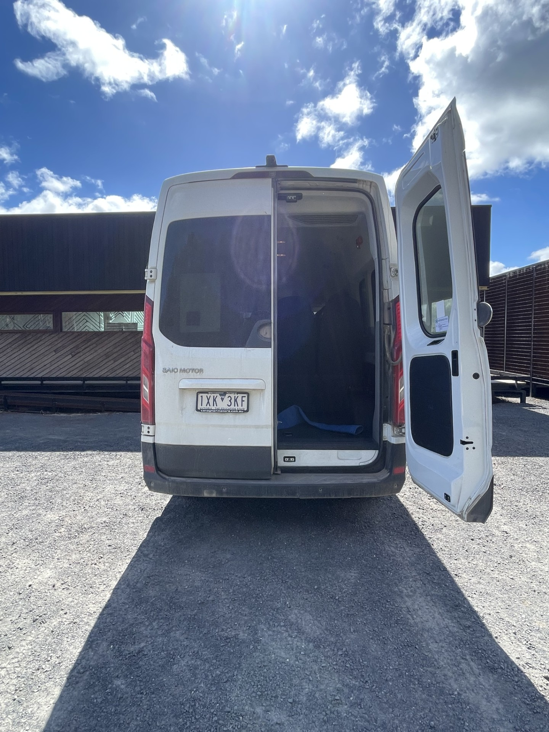
GetAttachmentThumbnail
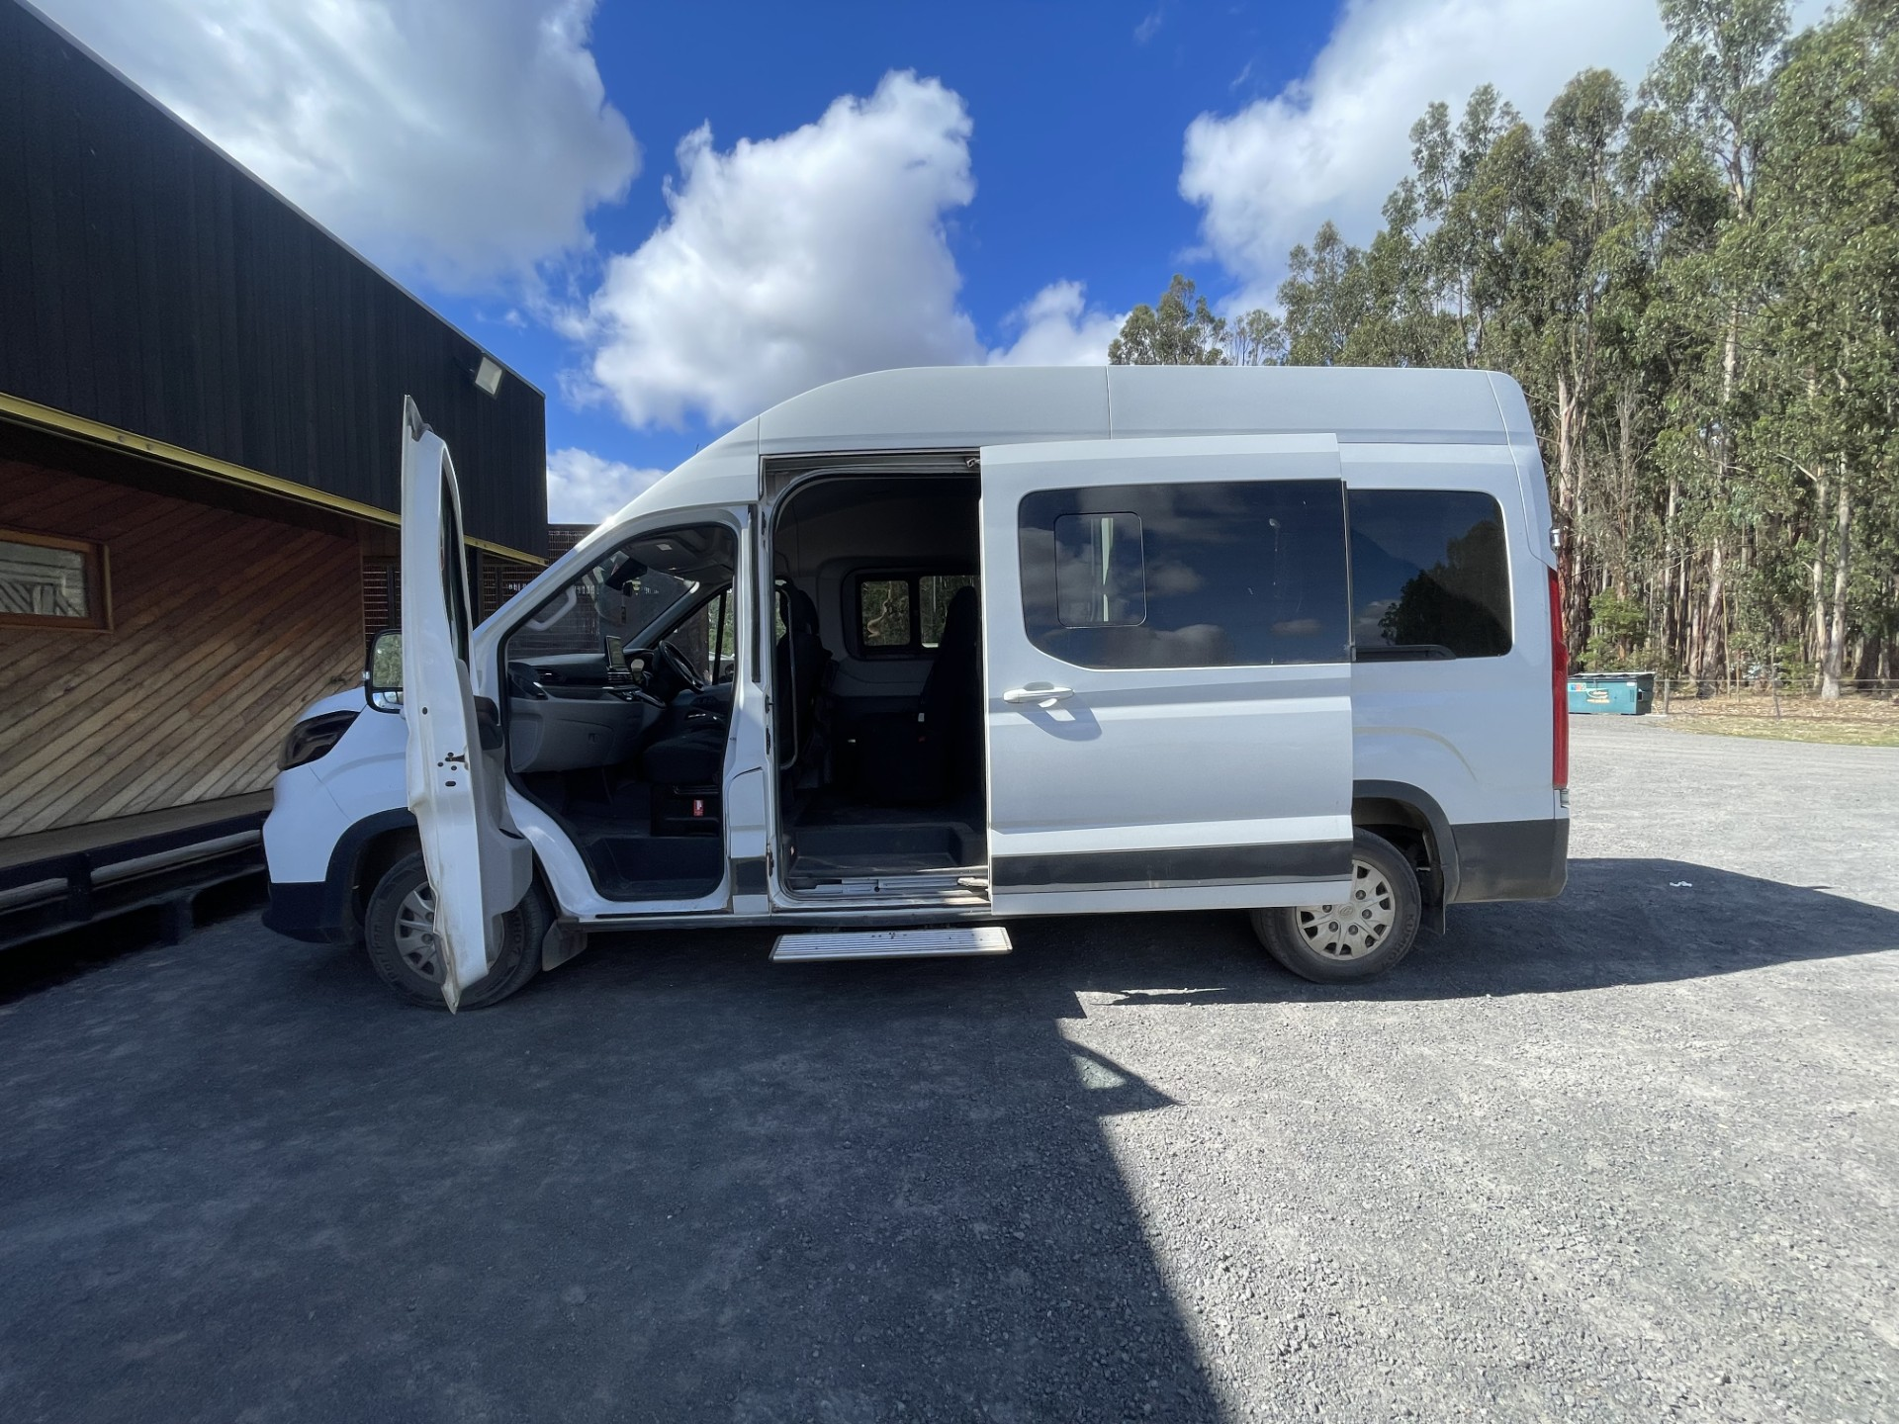
GetAttachmentThumbnail
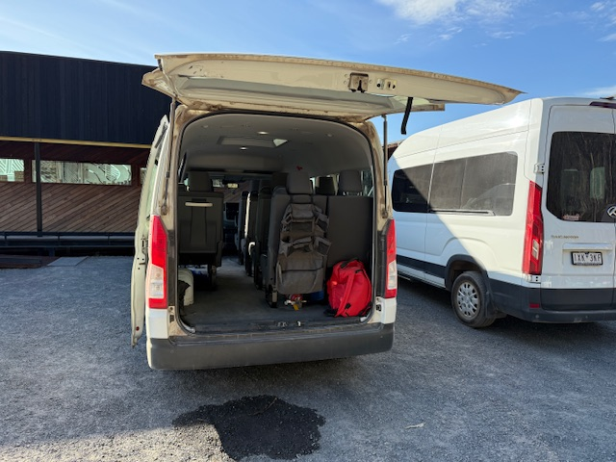
Bus1.JPG
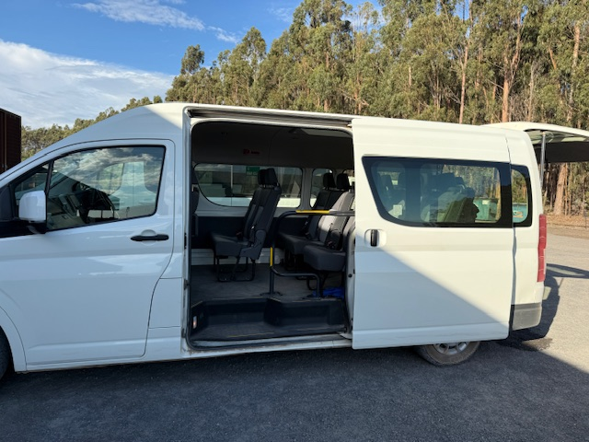
Bus2.JPG

ATTRACTIONS

Attractions Basics
- A park map is available here:

https://www.budjbim.com.au/visit/cultural-landscape-map/

COMMON AREAS

Parks and gardens
- The following parks and gardens amenities are available
- Seats are provided at regular intervals
- Accessible picnic tables
- The park contains an observation deck or tower
- The observation deck or tower has level or ramped access
- The observation deck provides a clear view through the safety railing
- Edge protection is provided
- Edge protection is a contrasting colour to the deck
  - Parks and Gardens Access/Entry Image(s)
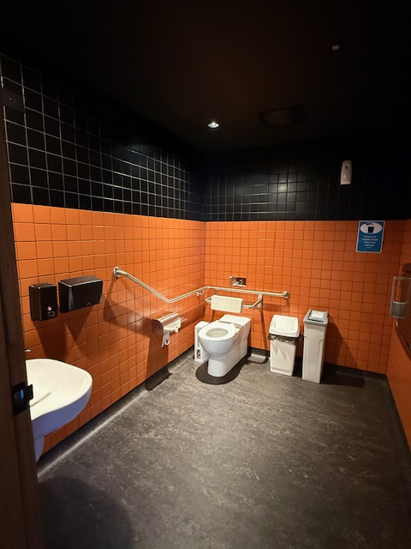
Toilet1 photo.JPG
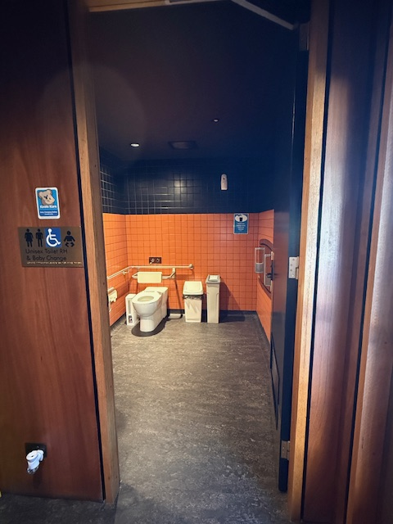
Toilet2.JPG
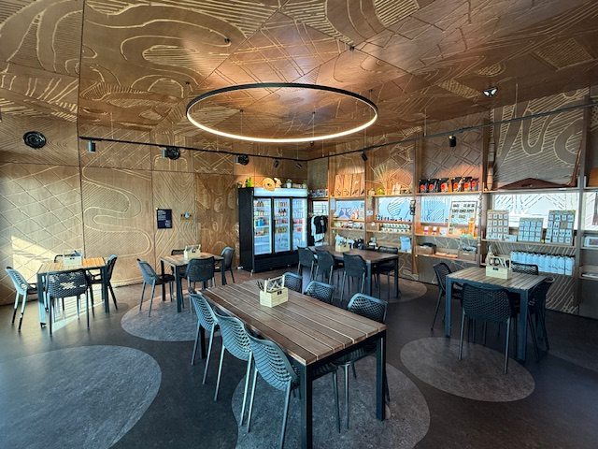
TableLayout1.JPG
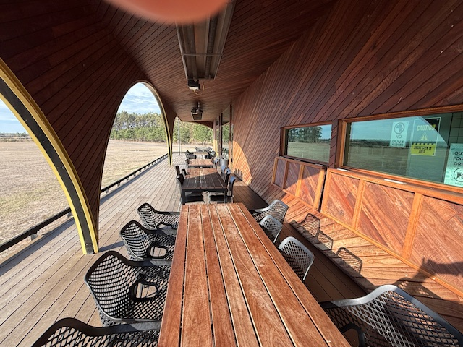
TableLayout2.JPG
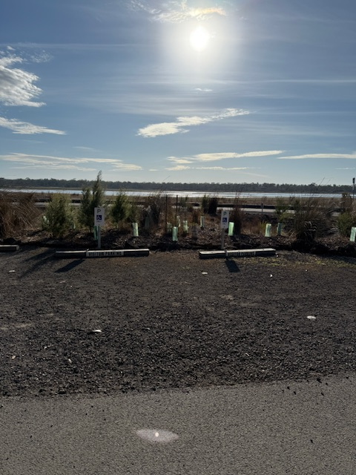
Parking.JPG
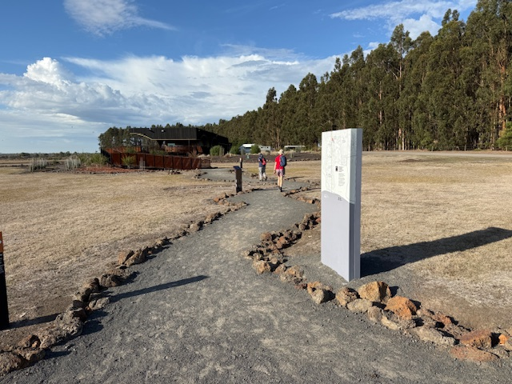
Paths.JPG
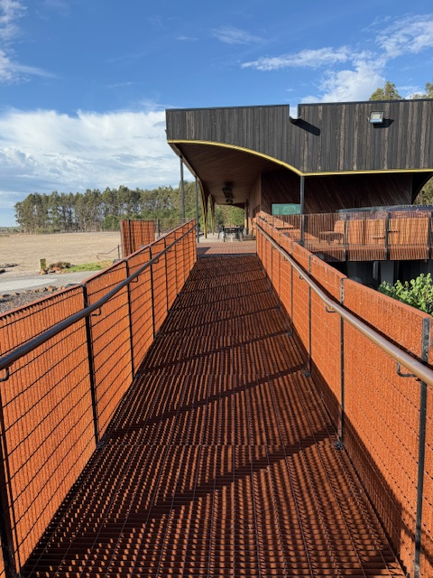
Ramp Handrails.JPG
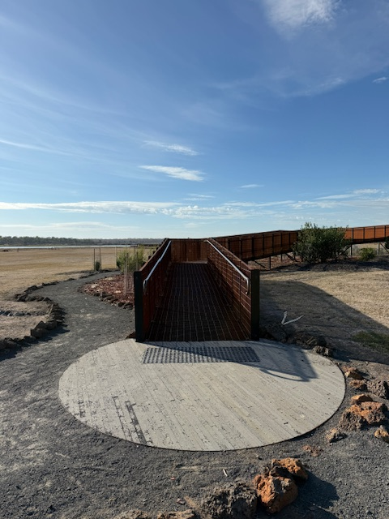
Ramp Entry.JPG
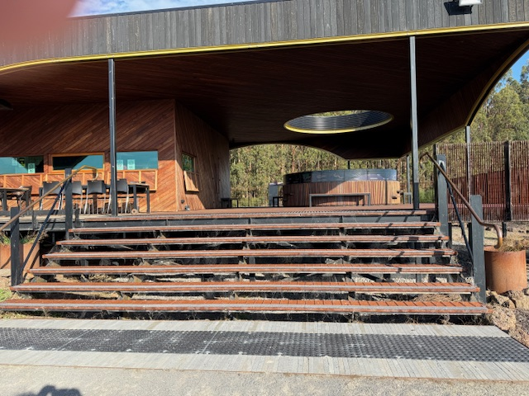
Stairs and Rails.JPG
- Handrails and stairs are built as per state/territory building code.
- Slip resistance surfaces are used.
- A handrail is available and at 865-965mm in height.
- The handrail is continuously graspable along entire length at least one side.
  - Parks and Gardens Stair entry and exit Image(s)
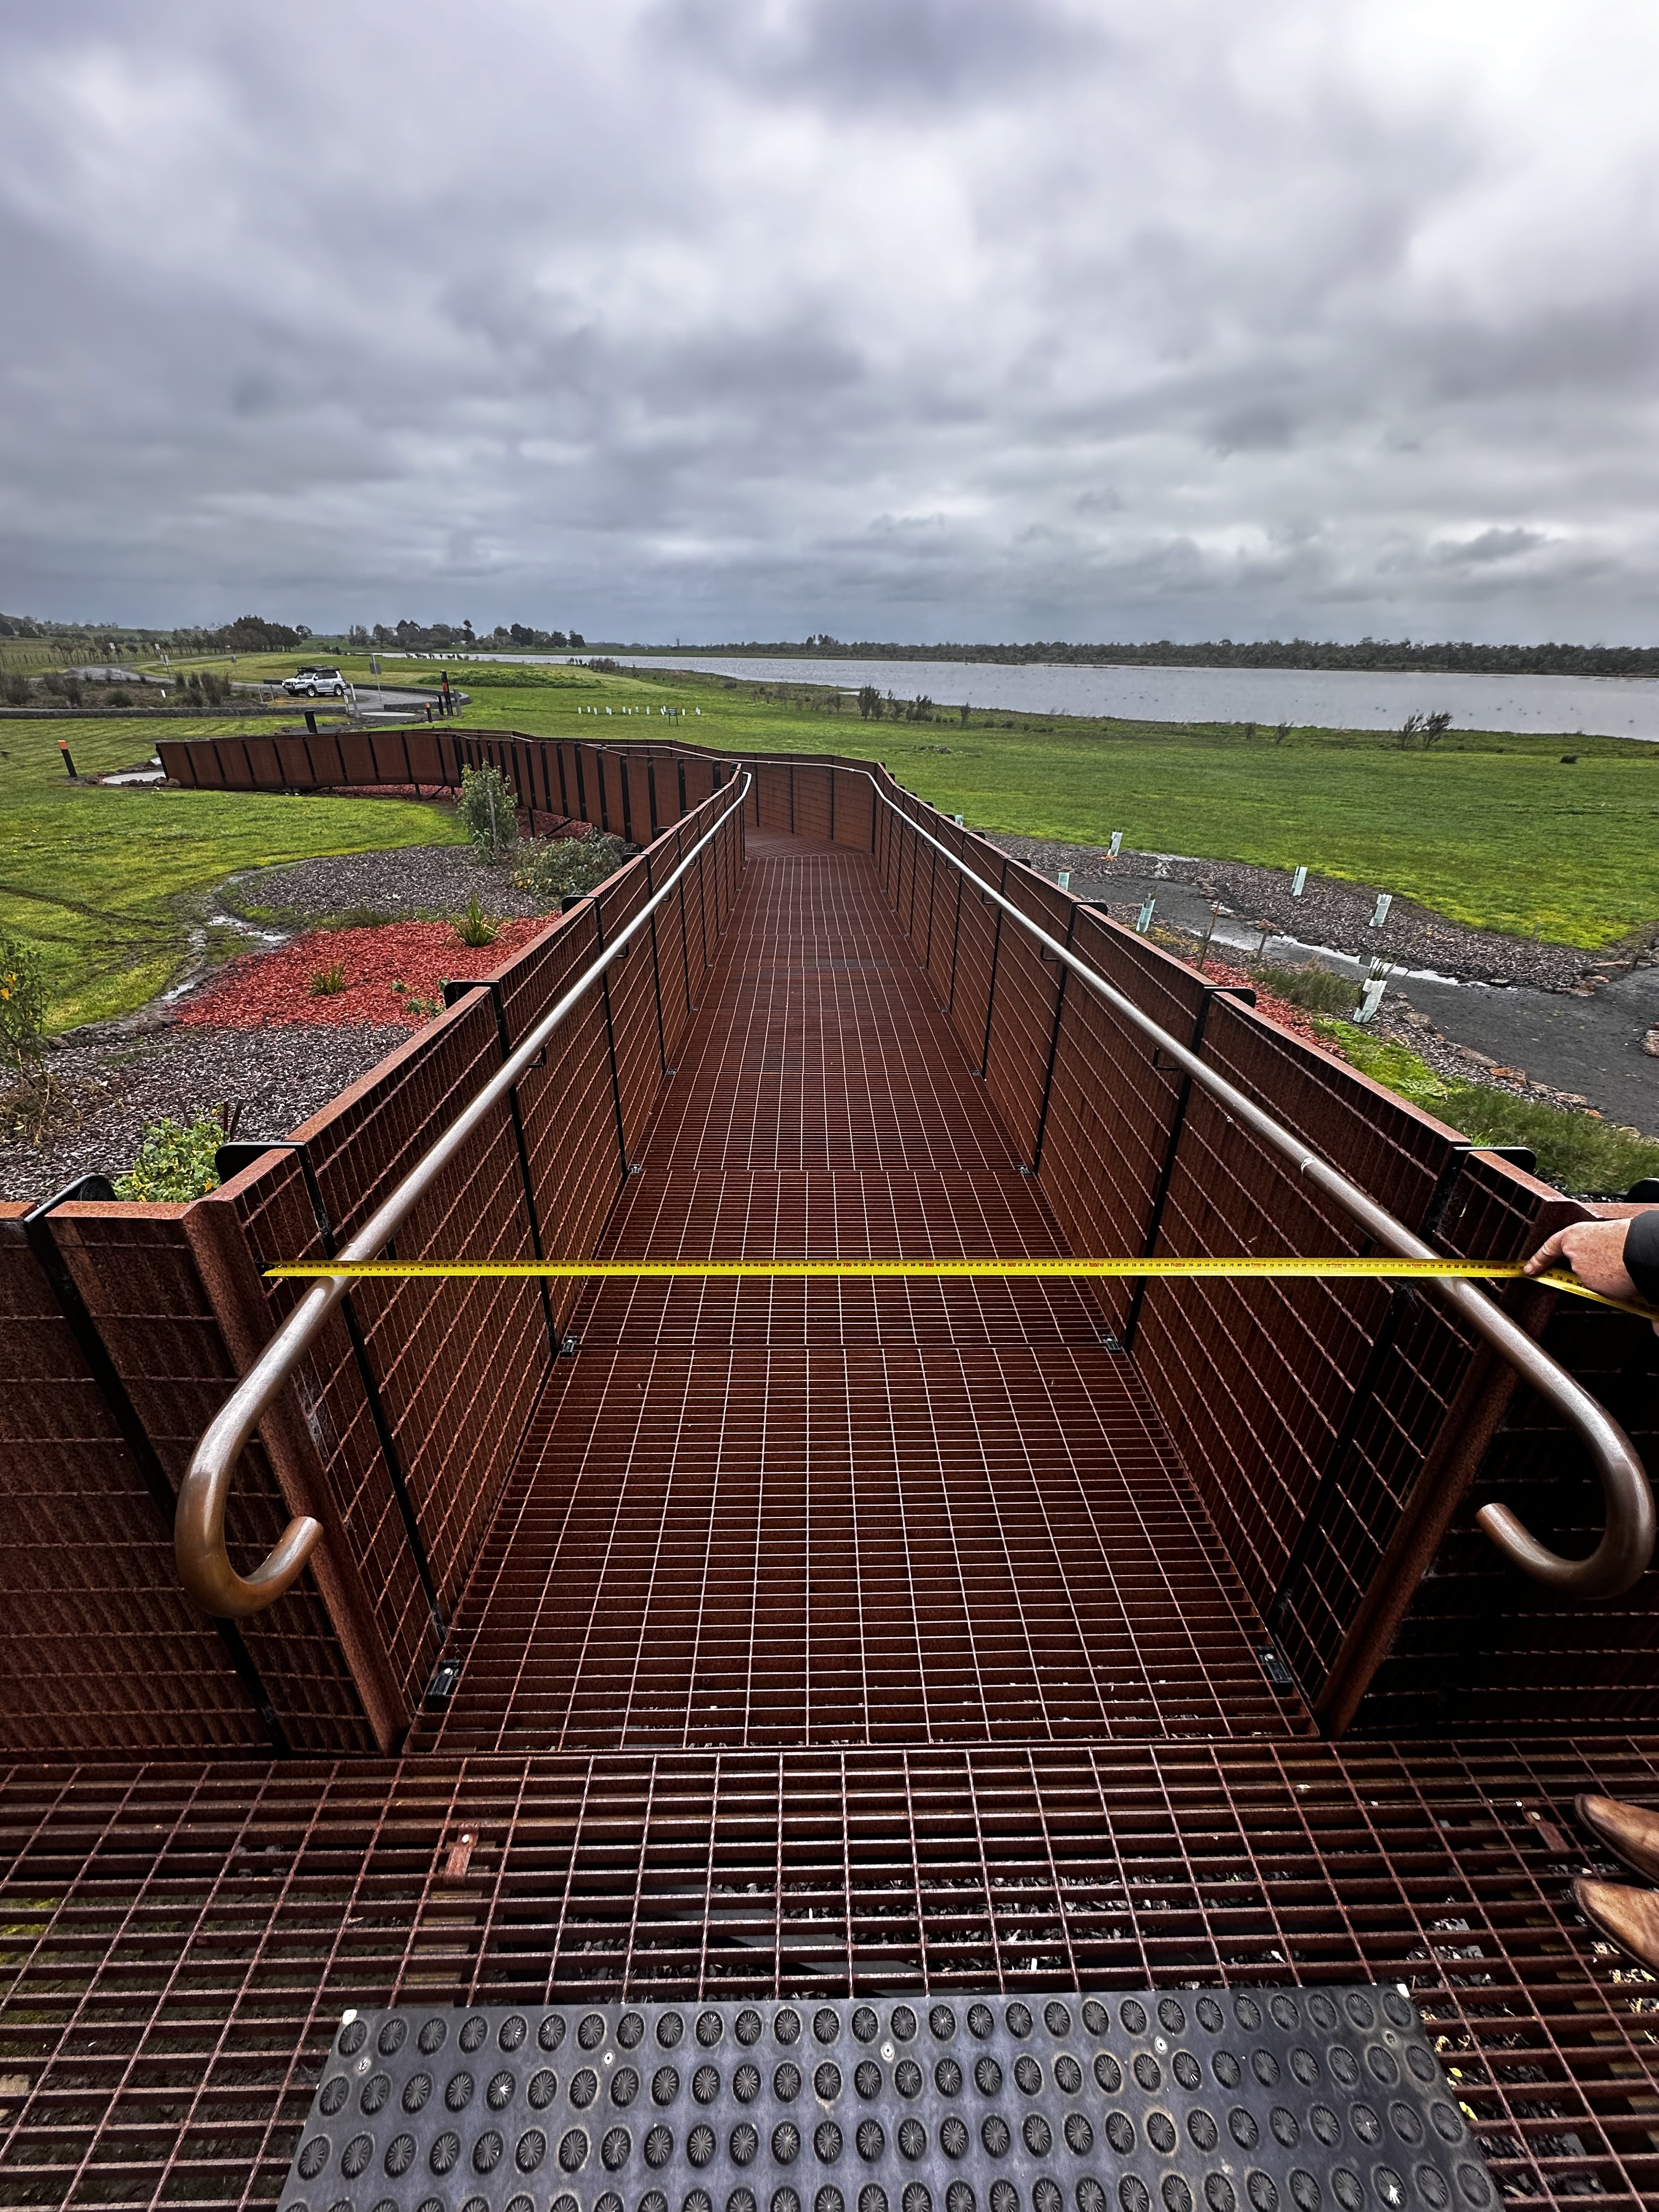
Ramp
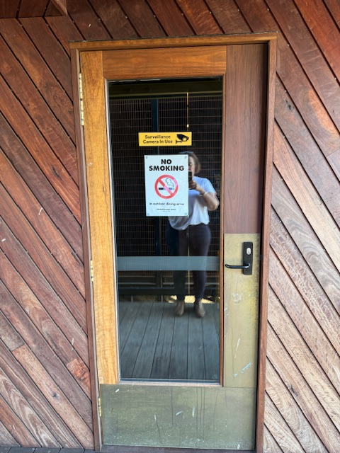
Door4.JPG
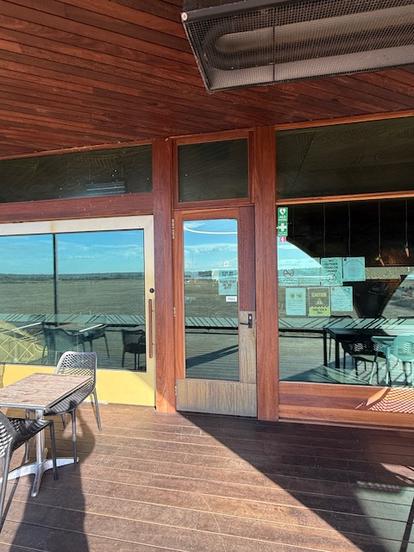
Door1.JPG
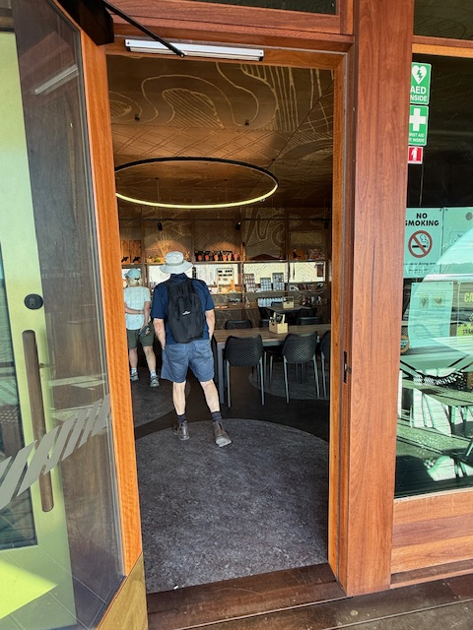
Door2.JPG

FOOD AND DRINK

Dining Spaces
The dining spaces have the following facilities/amenities in place
- The entrance has level access
- The doorway is at least 850mm wide
- There is level access through the dining area
- Chairs are moveable to allow for wheelchairs to be seated at the tables
- All glass doors and full height windows have contrast markings
- There are areas of full lighting
- There are Plain English menus
- There is an accessible toilet

Our business caters for the following dietary requirements
- Sugar free (diabetic)
- Gluten free (celiac)
- Lactose free (dairy free)
- Low fat and fibre with no gastric content
- Low potassium
- Low sodium
- Nut free
- Additive free
- Organic
- Vegetarian
- Vegan
- Kosher
- Halal
- In addition, the following further information can assist guests:
Food is prepared using color coded chopping boards. Where there are allergies, food is prepared in a completely separate area to stop cross contamination. Dietary restrictions are added to all bookings and must be given in advance
  - Food and Beverage Image(s)
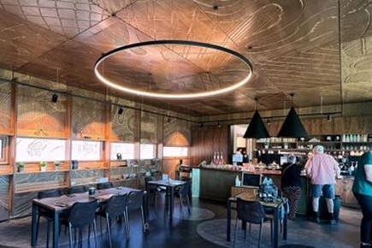
InsideTaeRakCafe

ADVENTURE ACTIVITIES

Adventure activities
The adventure activities have the following facilities/amenities in place
- Our adventure activities cater for people with a disability
- In addition, the following further information can assist guests:
People with a disability can do a tour either two hours, half day or full day. They can have lunch in the cafe and enjoy the views of Lake Condah. They will need to provide their own transport if in a wheelchair.
- In addition, the following further information can assist guests:
We have ramps, wide paths and disabled toilets
- In addition, the following further information can assist guests:
There would be limitations visiting the National Park as the terrain is hilly and can be unstable but everything else is doable.
  - Adventure Activity Image(s)
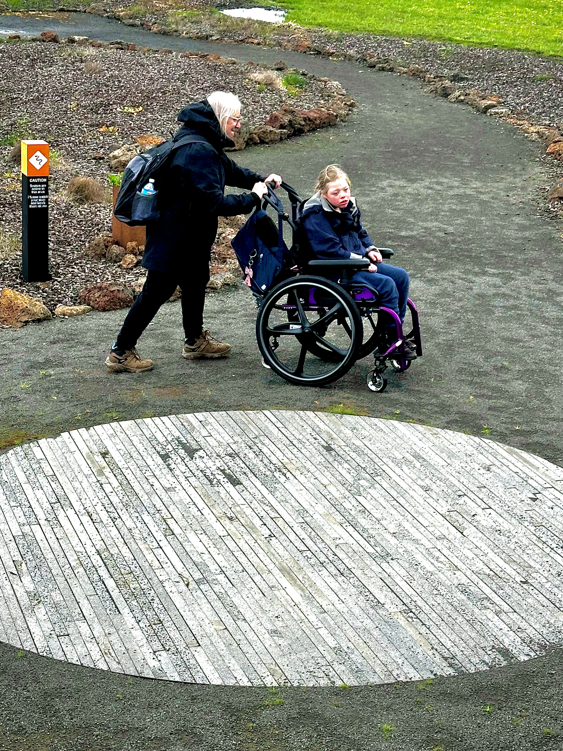
Adia2
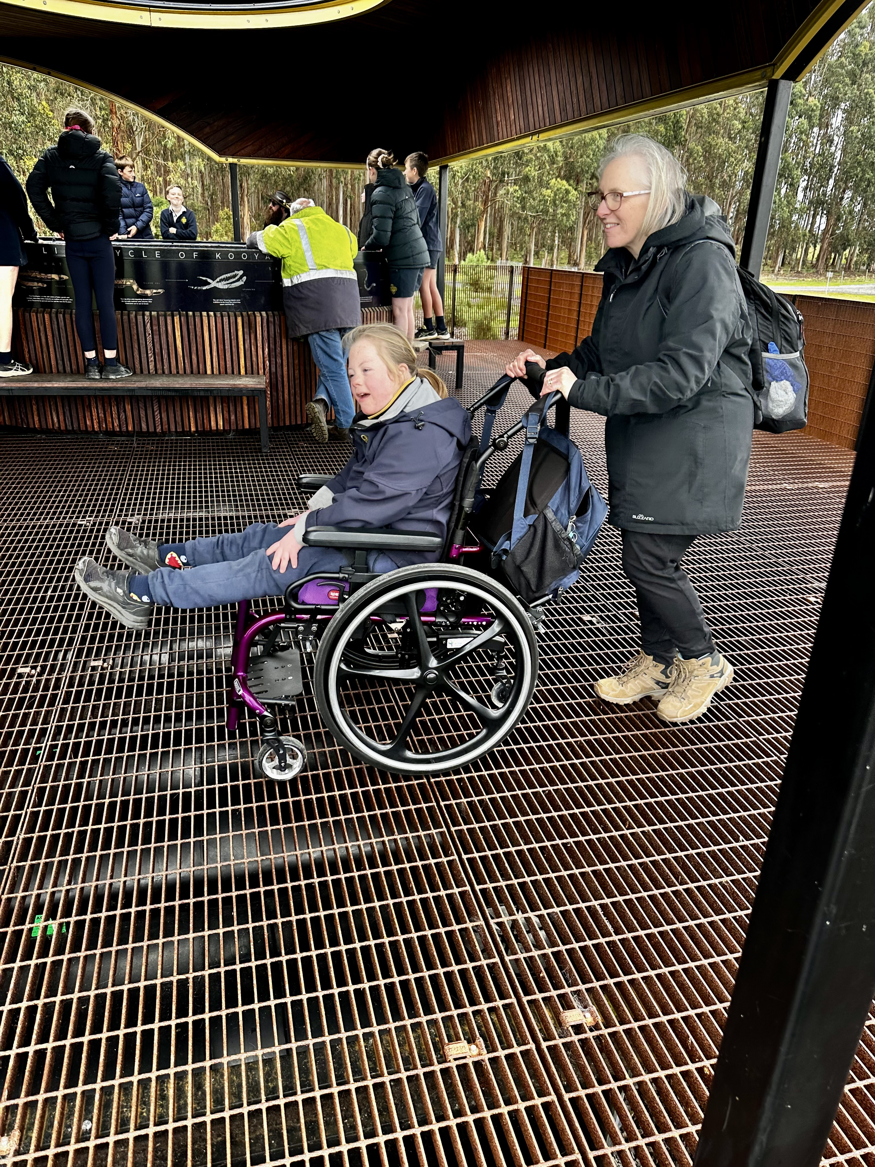
Adia1Accessibility

Report Disclaimer
Please note that this business report, provided as a result of the use of the diagnostic assessment, is for information purposes only.
Australian Tourism Industry Council (ATIC) cannot guarantee the accuracy of respondent’s answers, or that they are fully representative of your business. Therefore, ATIC does not warrant or guarantee any particular outcome in respect of your businesses self-assessment.
This report is intended as guidance only for your business and should not be relied on for future marketing considerations. ATIC recommends that you seek your own independent advice as well as the results from the diagnostic.
Links to external web sites are inserted for convenience and do not constitute endorsement of material at those sites, or any associated organisation, product or service.
ATIC does not:
- Assume any legal liability for the accuracy, completeness, or usefulness of any information from this report or any links provided; or
- Accept responsibility for any loss associated directly or indirectly from the use of this report.

