ATIC Accessibility
To support the accessible community in making informed travel decisions for their individual needs

This report prepared for:
Business name: | All About Margaret River
Address: | 12 Mann Street
Town: | Margaret River
Contact for enquiries: | Ezequiel Fernandez Aguirre
Contact Number: | 0455608008
Contact Email: | ezequiel@allaboutmargaretriver.com.au
Website: | https://www.allaboutmargaretriver.com.au/
Date: | 2026-11-02 22:24

ATIC Accessibility
The following pages provides travellers with information on the businesses facilities and amenities which aims to support the traveller to make an informed decision on whether the business is suitable for their individual needs.
OVERVIEW 4
Business Overview 4
Bookings 4
Emergency Management 5
Communications 5
Guide Dog and Service Animals 5
GENERAL 6
Pre-arrival, arrival and reception 6
Cognitive Impairment Support 7
Car Park and Access amenities 7
Displays, exhibits, commentary and live performances 8
External Paths 8
Steps 9
Public Toilets/Adult change facilities 9
TOUR OPERATORS 11
Tour/Transport Services 11
Route Planning 11
Guides 11
Report Disclaimer 16

OVERVIEW

Business Overview

The business has the following products/services available
- Tour/Transport

Our business caters for the following disability types:
- Blind or low vision
- Deaf or low hearing
- Limited mobility
- Wheelchairs or mobility scooters
- Food allergies or intolerances
- Cognitive or people on the Autism Spectrum
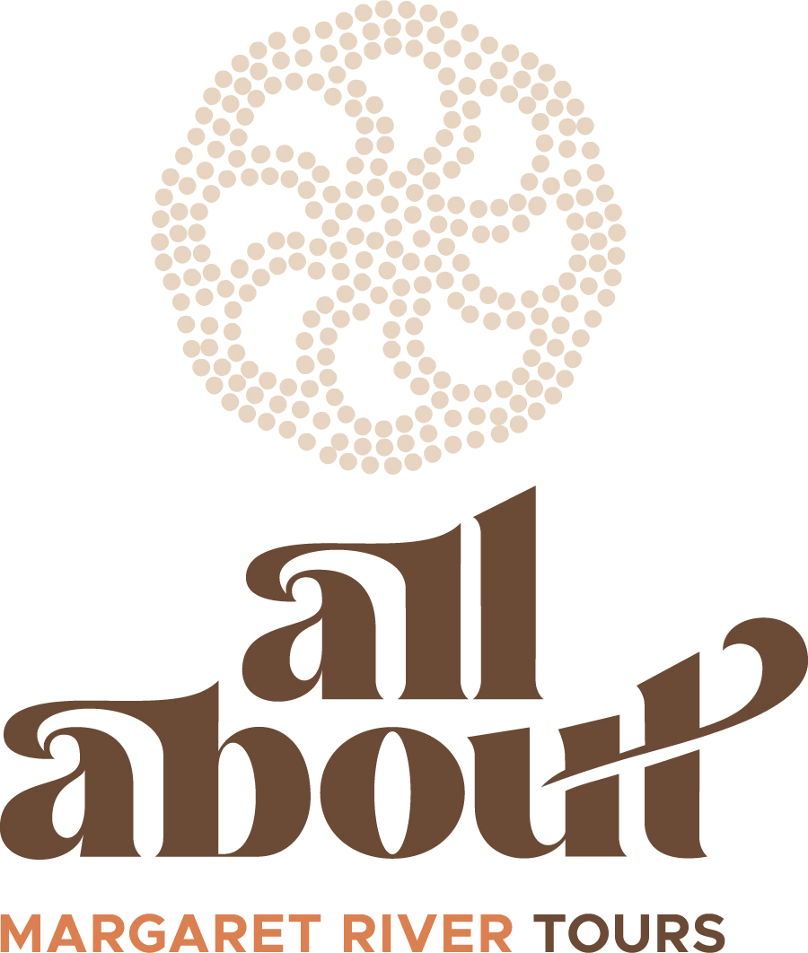

Bookings

The business offers the following methods for bookings and enquiries:
- Phone
- Email
- Webportal
- Our website supports Screen Readers
- Our forms have high contract boxes and submit boxes
- Staff have undergone disability awareness and training

Emergency Management
- The business has an emergency management and evacuation plan for guests with a disability
- Emergency and evacuation procedures are explained on arrival
- Guests with disabilities are noted in the guest log book for emergency and evacuation purposes

Communications
- An accessibility guide is available on the website

https://accreditation.qualitytourismaustralia.com/report/AccessReportPublicHtml2/b11f7187-3093-4338-aef4-ce21bff1aafb
- Our website meets WCAG 2.0 accessibility standards

Guide Dog and Service Animals
- The business provides a secure area with shade and water for service animals
- Bowls, bedding, etc. are provided for service animals
The business provides the following services for services animals:
We specially ensure to have space in the vehicles for services animals with mat. At the venues we visit there's always a dog water bowl and shade (the shade is exactly where any patron can stand and spend their time). Given we pick up and drop-off our customers at the same place, no food other than snacks is needed for service animals during our tours, however we accept food or snacks to be brought if our customers consider it better for the service animal.

GENERAL

Pre-arrival, arrival and reception
The business has the following in place to support guests during pre-arrival, arrival and reception
- Booking information and websites are compatible with screen readers
- Information and maps are available in written form
- A familiarisation tour
- In addition, the following further information can assist guests:
We don't have long wait times. Our tours are limited to 11 people, which is reduced to 9 if someone has a wheelchair or anything bulky to assist them. We all move together, so there's no need to think of wait times.
When visiting restaurants, wineries, or any venue, these are all booked in advance and we specifically request whatever is needed for people with special needs or limitations. Examples:
- low chair with a back rest, instead of stools
- table accessible with no need of steps
- dietary, such as Gluten Free, Dairy Free, Vegan, etc.
- proximity to:
toilets
fireplace or heater (especially when having aged people in cold and wet winter days)
airconditioning (same case in hot summer days)
Also, because everything is booked in advance, we make sure that a table and seat is available on arrival for all our customers. There's no need to stand around waiting for a spot to rest.
- In addition, the following further information can assist guests:
We are a small company, where communication prior and during the tour is at the top of our points of difference in customer service excellence.
Finding out about our customer's needs in advance is essential for our team to ensure to make all the arrangements mentioned above. It's important to mention, we are on top of anything that arises during the tour to help out our customers if required, or to simply ensure they have a smooth and seemless experience (as if nothing happens, though behind the scenes we're super active). Though it might sound casual we do it in an extremely professional way.

Cognitive Impairment Support
- Documents are available in plain English for people with cognitive impairment (This may include instructions, guides, menus and general information)
- Quiet periods or early opening times for people on the Autism Spectrum
- A space for parents and children on the Autism Spectrum

Car Park and Access amenities
The business has the following Car Park and Access amenities
- A drop off zone
- Designated disabled parking bays
- Level or ramped access from the car park to the entrance
- The accessible entrance is clearly signed from the parking bay
- Kerb ramps are in place where a pavement or walkway needs to be crossed
- In addition, the following further information can assist guests:
Given our communication it purely oral, any support in communication is made by means of "one-on-one" conversations, in slow and easy to understand language.
Also, within our team of managers and tour guides, we can speak 3 languages with native-like proficiency (English, Spanish, Portugues), plus French at a basic level.

For vision impaired people, we focus a lot in highlighting other sensorial experiences. Wine tasting being at the top of these, but also for example when walking in the bush we make sure to include sensorial experiences such as:
- break leaves of a tree to smell the intense aromas
- differentiate the texture of the bark of different trees, and other elements such as resin in the barks, dirt and soil, etc.
- stop moving and be quiet to listen to different birds and point out all the different birds singing

For customers in the Autism Spectrum, while all our tours have an easy paced timing, we always consider the option of having a quiet space and time at each stop or venue throughout the day. Examples are:
- Extra time before, during or after a winery experience
- Extra time before and after lunch
- Special considerations for bush and coastal walks

Displays, exhibits, commentary and live performances
For displays, exhibits, commentary and live performances the following amenities are in place
- Seating
- Wheelchair accessible spaces/seating
- In addition, the following further information can assist guests:
We do not have special language skills for hearing impaired people. We trust on companions to assist our tour guides. For the purpose of ensuring the best experience for hearing impaired customers, we take the time and anything needed to communicate with them and their companions.
Repeating what was mentioned above, given we are so warm and friendly when dealing with our customers, we make sure we treat everyone as a friend. Where this might sound shallow or lacking content, it is highly professional. We train our team of tour guides to show the friendliest appearance, though behind the scenes we are at all times "reading" the needs of our customers.

External Paths
External paths of travel
- Surfaces are concrete, asphalt, smooth paving or hard packed fine gravel (max aggregate size 13mm)
- Pathways are wider than 900mm

We sometimes need to cross small roads. For example, Memorial Dr at the intersection with Bussell Hwy, in Cowaramup, WA 6284. Knowing our routes and itineraries with precision, we can anticipate exactly what places our groups will move during each tour, and can ensure they are all suitable for patrons with any kind of dissability. In addition, our tour guides always walk together with our customers.

All the venues we visit are wheelchair accesible, and when walking on public side-walks, we know each corner so precisely that we make sure to avoid any non-wheelchair accessible site.
- In addition, the following further information can assist guests:
We recognise our only limitation for people with mobility limitations to be getting in and out of our vehicles.
For assistance, on all our vehicles we carry a safe low step to make it easier to access and exit the vehicle. These are between 14 and 17cm high, providing a step in between the ground and the vehicle's step.

Steps
Steps
- There are steps.
- Top and bottom steps are easily distinguished through colour contrast or the use of TGSIs (Tactile Ground Surface Indicators)
- All steps or staircases have enclosed risers
- The underside of all staircases are enclosed or protected to a height of at least 2 metres
- Handrails fitted to all open sets of steps
- Handrails extend 300mm beyond the top and bottom step
- Where steps are present are there three steps or less
- In addition, the following further information can assist guests:
In line with the text above, we always have a step to assist people to get on and off the vehicles. Also, all our vehicles have large handles on both sides of the sliding door for extra asssitance.

Public Toilets/Adult change facilities
Public Toilets/Adult change facilities have the following amenities are in place
- There is an accessible toilet for public use
- The door is at least 850mm wide
- There is a minimum of 850mm beside the toilet
- Handrails are fitted
- The toilet seat is 460mm above the floor
- The toilet seat of a contrasting colour to the floor
- The height of the toilet seat is: Same as above..
- There is a registered changing places facility
- In addition, the following further information can assist guests:
Being a tour operator, we trust our partner venues which we visit to comply with all these specifications.
What I, as the company's manager and director, can guarantee is that we have checked at all these venues that an accessible toilet is available, and that they all have wheel-chair access.
It is also an important part of our assesment when considering a new venue, that it can cover all the needs mentioned so far for disabled people.

TOUR OPERATORS

Tour/Transport Services
The tour/transport services have the following facilities/amenities in place
- Buses/Coaches
- 0 vehicles have wheelchair lifts or ramps
- 0 vehicles have low floors with ramped entry
The maximum wheelchair capacity available in the fleet is:
We have two minibuses for up to 11 passengers: these have capacity for 1 wheelchair. We have a 7-seater people mover: this vehicle has capacity for 2 wheelchairs.
- Commentary is available in written format

Route Planning
- Route Planning
- The tour route includes stops with accessible toilet facilities
- In addition, the following further information can assist guests:
As mentioned in the "General" section, we make sure that all the places we visit on our tours have an accessible toilet, and step-free access.
We don't provide displays or screenings on our tours, therefore there's no need to consider subtitles. All our communicaion with our customers is oral.
- Lunch stop venues are accessible
- Sightseeing and photo opportunity stops are step free
- Walking Tours
- Operated on a step free route
- Multi-paced to account for slower walkers
- Hearing aid compatible

Guides

Guides have been trained in the following
- Use of clear/simple English
- Correct pronunciation for lip readers
- There is a audio description of surroundings
  - Image(s)
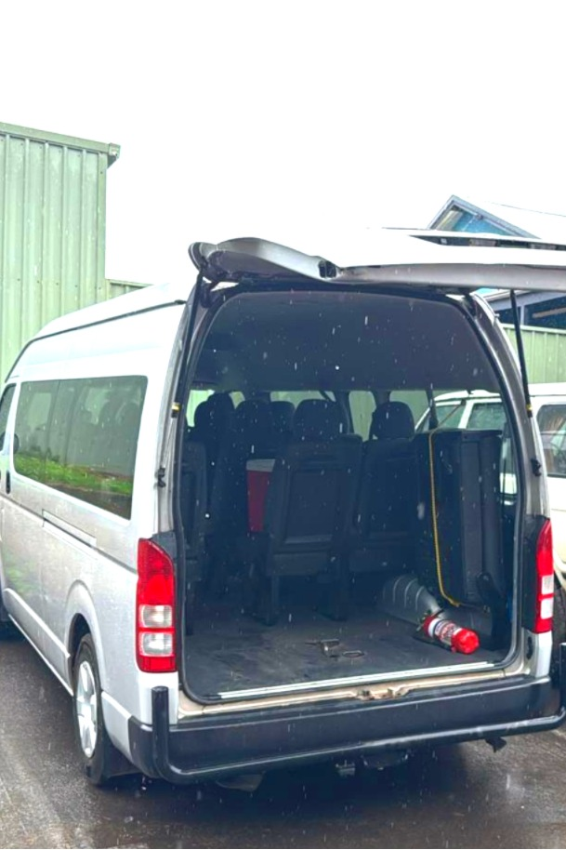
Accessible - Extra space in minibus 2.JPG
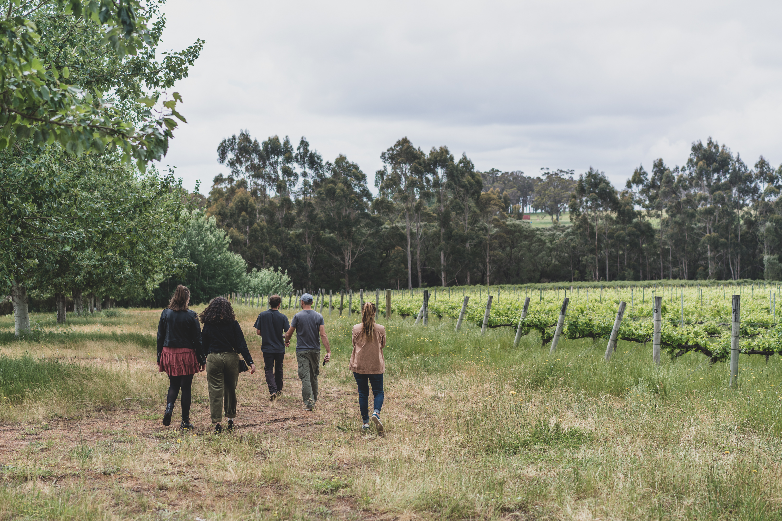
Vineyard - 2
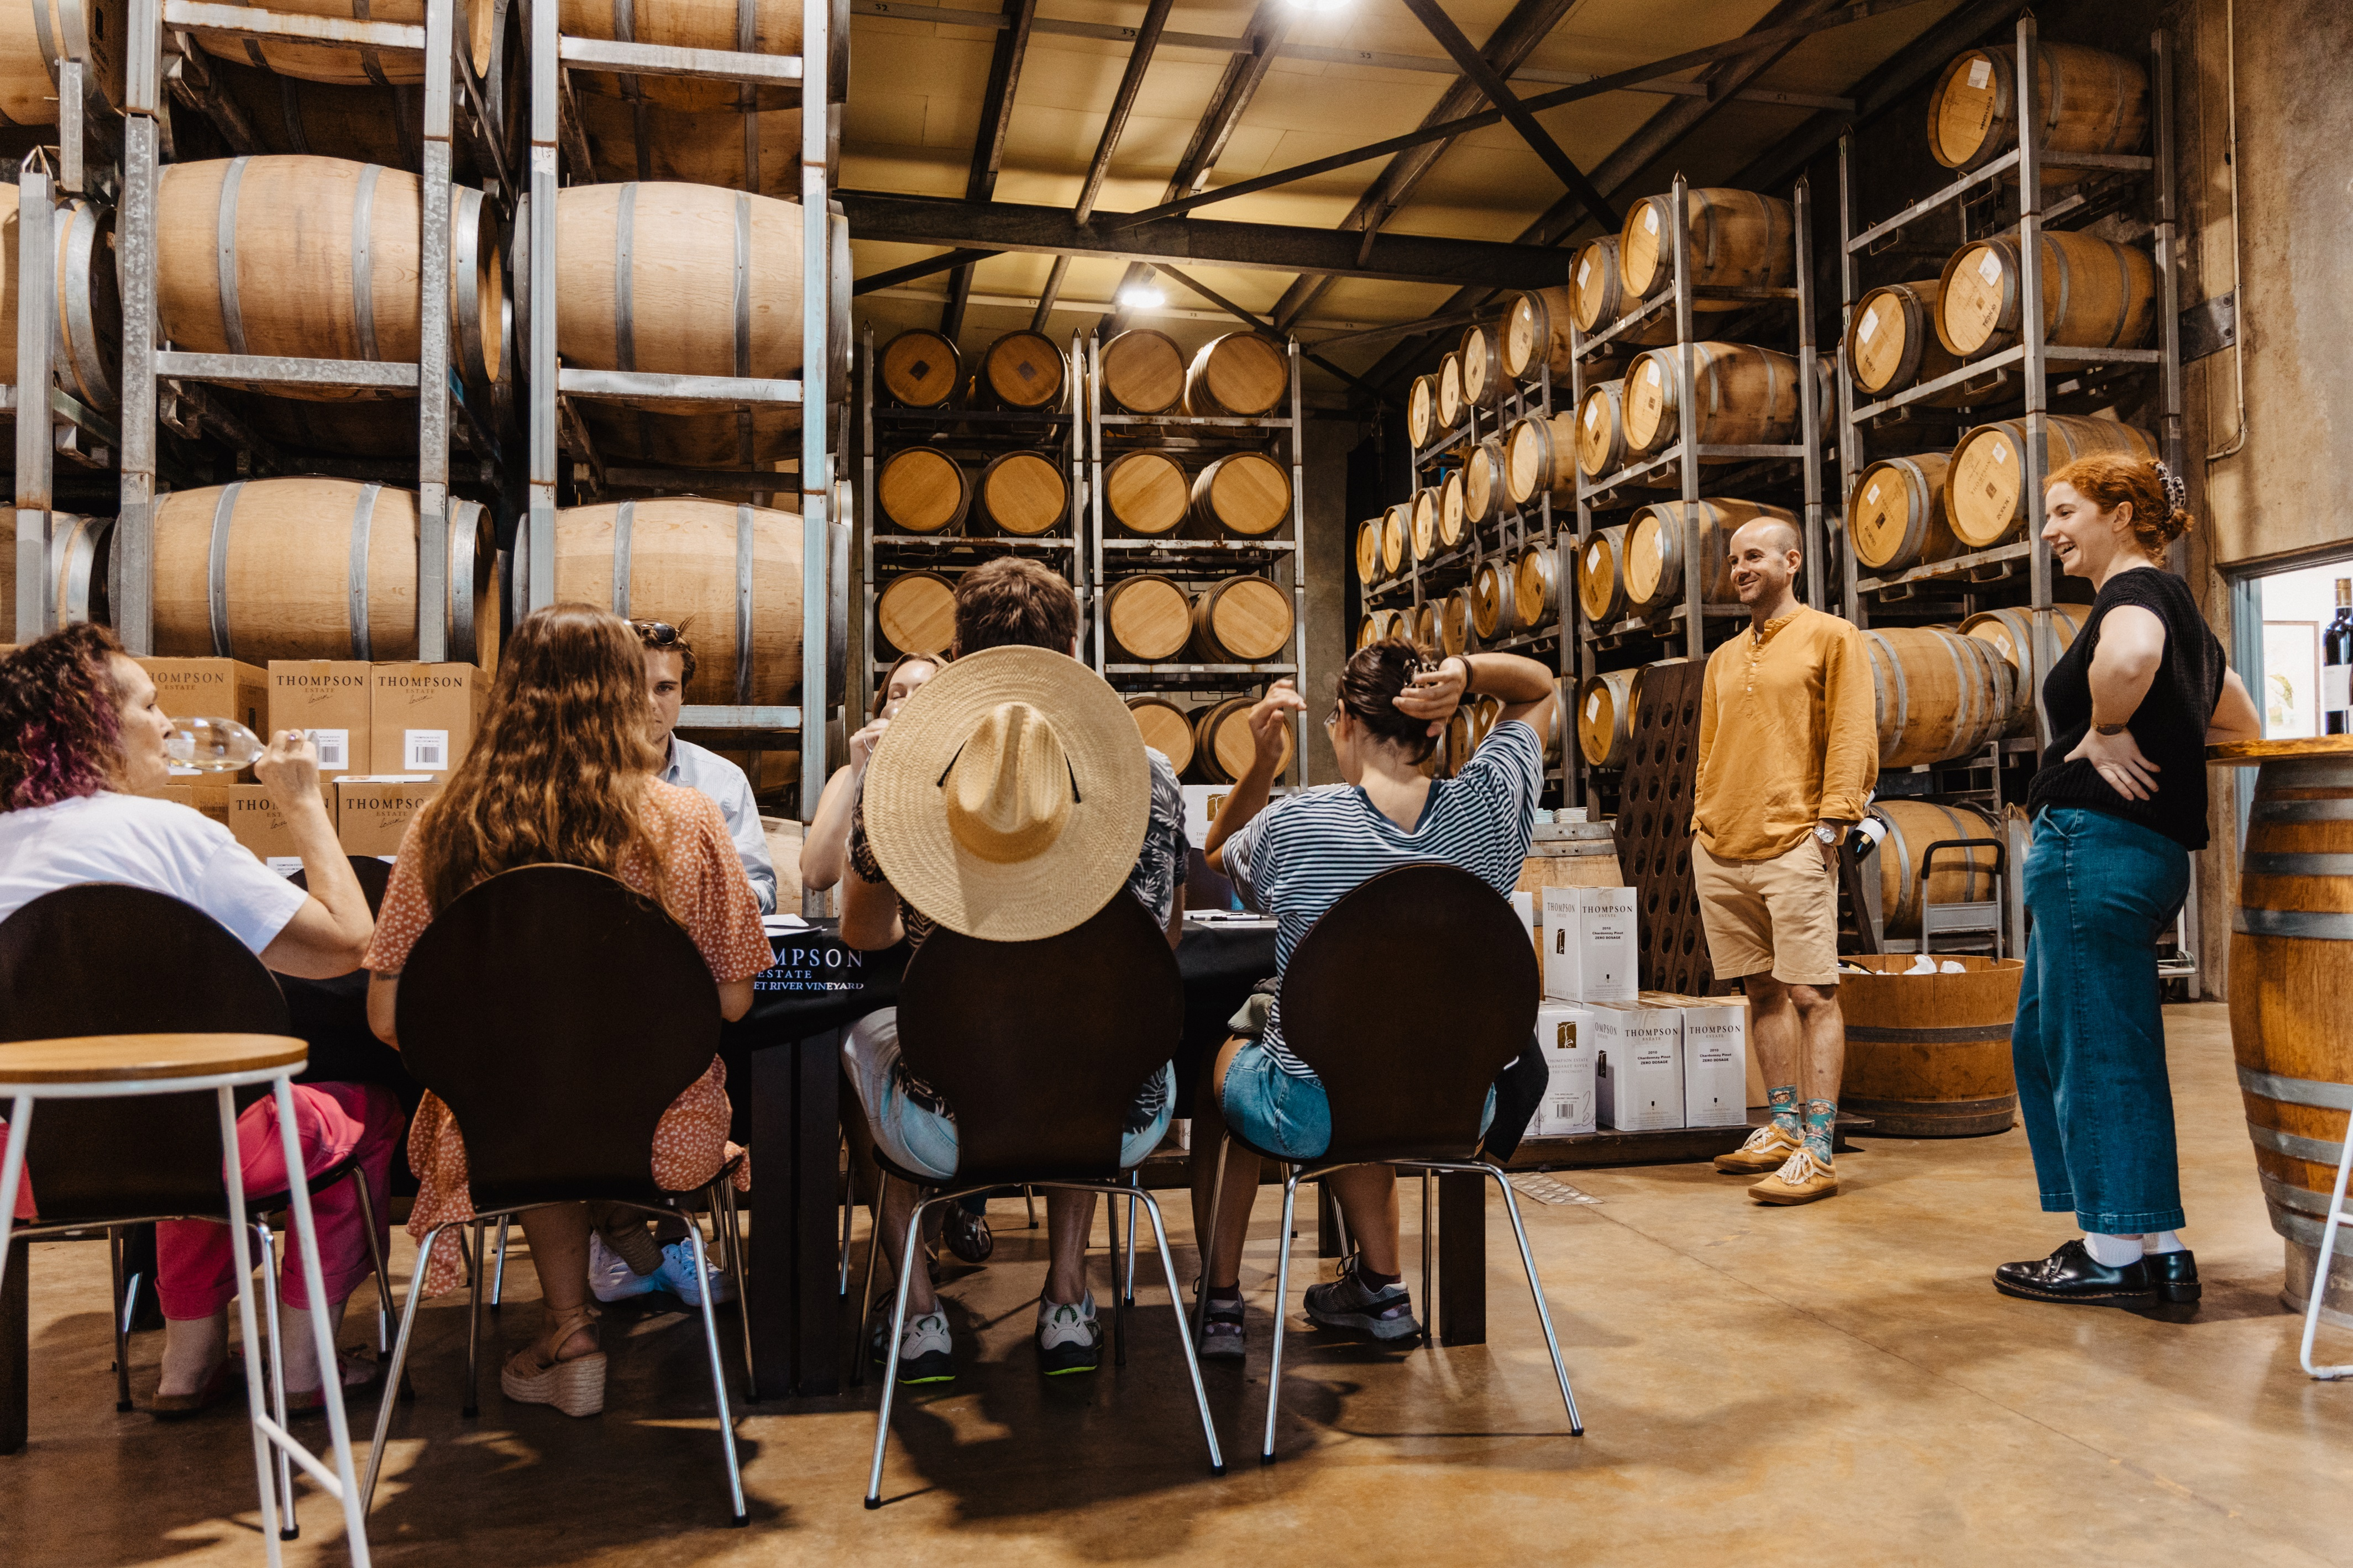
SMALL AllAboutMR_Chloe-124
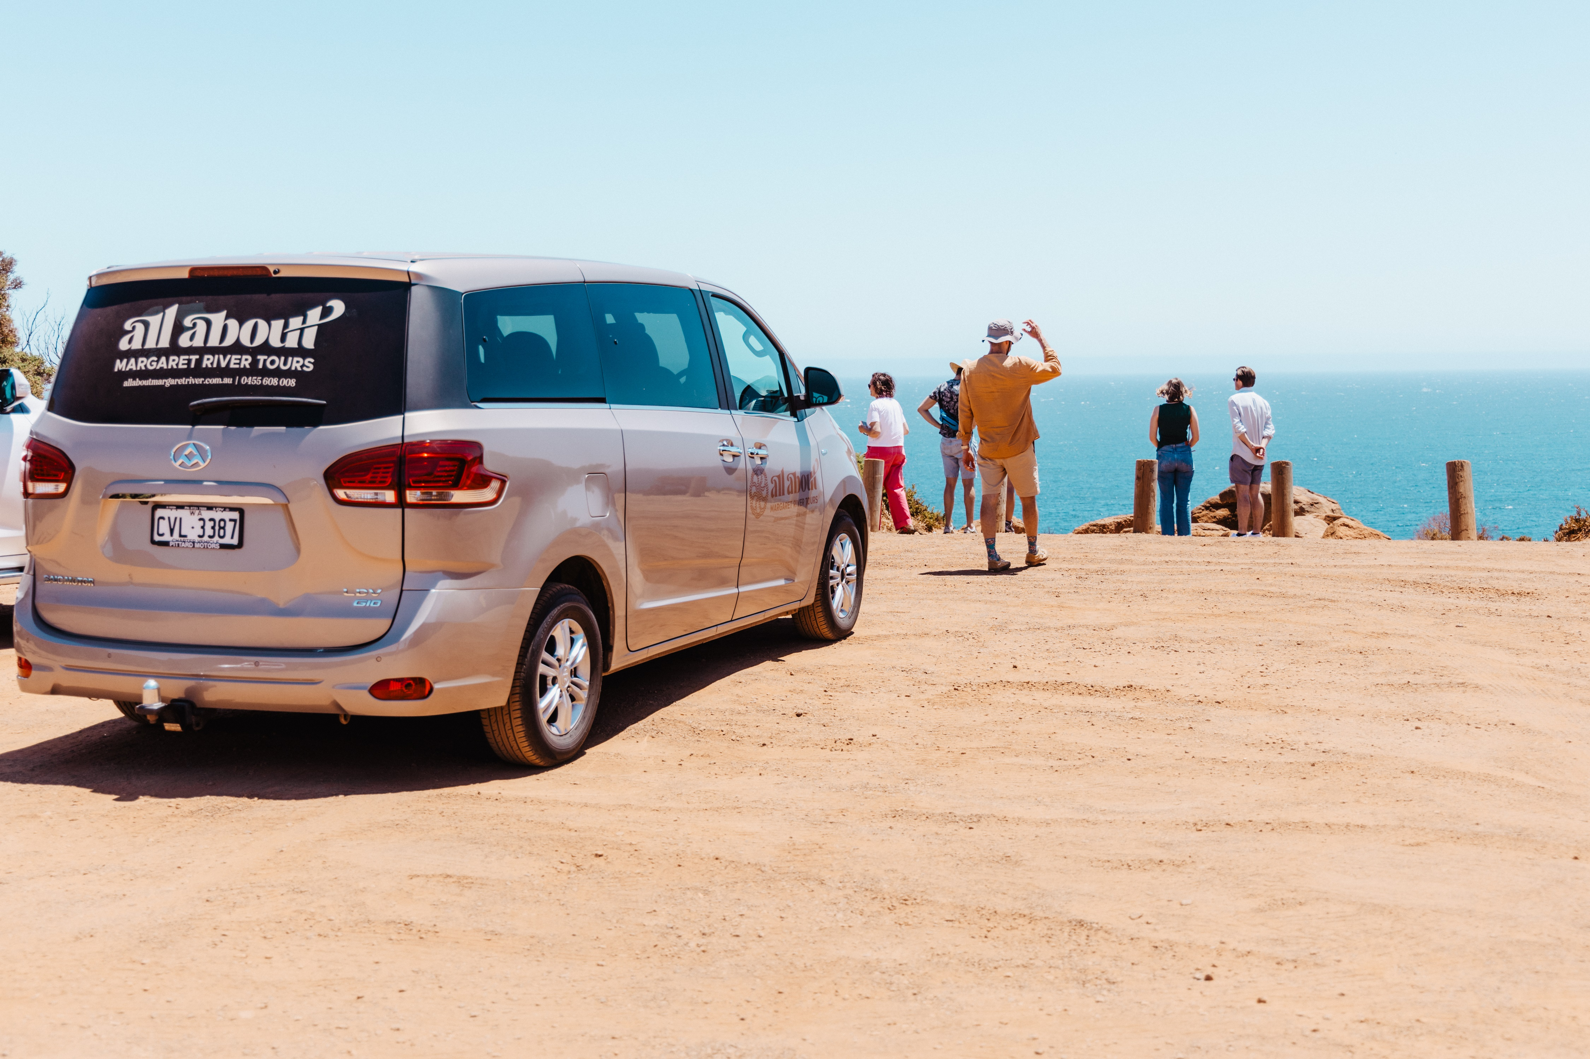
SMALLAllAboutMR_Chloe-087
- In addition, the following further information can assist guests:
Ashbrook Estate - https://ashbrookwines.com.au/
Thompson Estate - https://thompsonestate.com/
Juniper Estate - https://www.juniperestate.com.au/
Woody Nook Wines - https://woodynook.com.au/
Brown Hill Estate - https://www.brownhillestate.com.au/
Redgate Wines - https://redgatewines.com.au/
Olio Bello - https://oliobello.com/
Berry Farm - https://theberryfarm.com.au/
Temper Temper Fine Chocolate - https://www.tempertemper.com.au/
Yahava Koffee Works - https://yahava.com.au/

On our Private Bespoke Tours, we tailor the itineraries and selection of venues visited to our customers wishes and needs. Direct communication with our customers or their travel agents is essential in the planning of these tours, therefore we specifically attend to any need or request, and check these matters with the venues if required.
- In addition, the following further information can assist guests:
As mentioned in the "General" section, our communication it all oral. All support in communication is made by means of "one-on-one" conversations, in slow and easy to understand language.
Within our team of managers and tour guides, we can speak 3 languages with native-like proficiency (English, Spanish, Portugues), plus French at a basic level. In particular in English, we ensure to speak loud, slow, clear and with correct language.

In particular, when we do any walking as part of a tour, the group moves together, with the tour guide being part of it. Such experiences are planned in such way that the group doesn't split in "sub-groups" while walking.

For vision impaired people, as also mentioend previously, we focus a lot in highlighting sensorial experiences. Some examples, but not limited to these, are:
- break leaves of a tree to smell the intense aromas
- differentiate the texture of the bark of different trees, and other elements such as resin in the barks, dirt and soil, etc.
- stop moving and be quiet to listen to different birds and point out all the different birds singing

Report Disclaimer
Please note that this business report, provided as a result of the use of the diagnostic assessment, is for information purposes only.
Australian Tourism Industry Council (ATIC) cannot guarantee the accuracy of respondent’s answers, or that they are fully representative of your business. Therefore, ATIC does not warrant or guarantee any particular outcome in respect of your businesses self-assessment.
This report is intended as guidance only for your business and should not be relied on for future marketing considerations. ATIC recommends that you seek your own independent advice as well as the results from the diagnostic.
Links to external web sites are inserted for convenience and do not constitute endorsement of material at those sites, or any associated organisation, product or service.
ATIC does not:
- Assume any legal liability for the accuracy, completeness, or usefulness of any information from this report or any links provided; or
- Accept responsibility for any loss associated directly or indirectly from the use of this report.

