ATIC Accessibility
To support the accessible community in making informed travel decisions for their individual needs

This report prepared for:
Business name: | Peppers Silo Hotel
Address: | 89-91 Lindsay Street
Town: | Invermay
Contact for enquiries: | Paul Seaman
Contact Number: | 0423 728 029
Contact Email: | silo.gm@peppers.com.ai
Website: | https://www.peppers.com.au/silo
Date: | 2026-06-17 19:48

ATIC Accessibility
The following pages provides travellers with information on the businesses facilities and amenities which aims to support the traveller to make an informed decision on whether the business is suitable for their individual needs.
OVERVIEW 4
Business Overview 4
Bookings 4
Emergency Management 5
Communications 5
Other Information 5
Guide Dog and Service Animals 5
GENERAL 6
Pre-arrival, arrival and reception 6
Cognitive Impairment Support 6
Car Park and Access amenities 6
Entry 7
Lifts 7
Internal Spaces 7
Public areas 8
External Paths 8
Steps 8
Ramps 9
Public Toilets/Adult change facilities 9
ACCOMMODATION 10
Bedrooms 10
Room Amenities 10
Bathrooms 11
COMMON AREAS 13
FOOD AND DRINK 14
Dining Spaces 14
EVENTS 16
Events 16
Report Disclaimer 18

OVERVIEW

Business Overview

The business has the following products/services available
- Accommodation
- Food and Drink
- Event

Our business caters for the following disability types:
- Blind or low vision
- Deaf or low hearing
- Limited mobility
- Wheelchairs or mobility scooters
- Food allergies or intolerances
- Cognitive or people on the Autism Spectrum
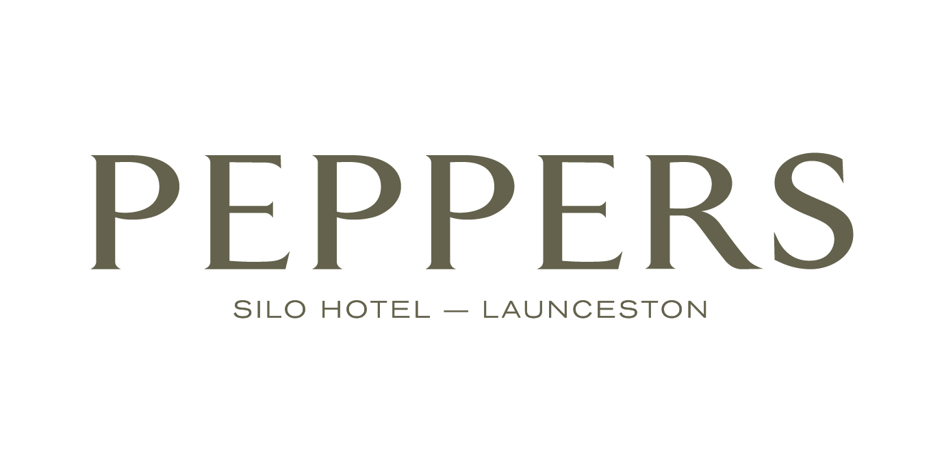

Bookings

The business offers the following methods for bookings and enquiries:
- Phone
- Email
- Webportal
- Our forms have high contract boxes and submit boxes
- Staff have undergone disability awareness and training

Emergency Management
- The business has an emergency management and evacuation plan for guests with a disability
- Emergency and evacuation procedures are explained on arrival
- Guests with disabilities are noted in the guest log book for emergency and evacuation purposes

Communications
- An accessibility guide is available on the website

https://accreditation.qualitytourismaustralia.com/report/AccessReportPublicHtml2/aff0cb6e-a105-42d1-be36-953531f664f9
- Our website meets WCAG 2.0 accessibility standards
- Our business offers the following alternative communication methods
- Plain English

https://all.accor.com/web-accessibility/index.en.shtml
- There is easy to read signage and information (e.g. menus and emergency information)

vacayit program available for hotel and restaurant

Other Information
- For bookings made onsite, the ticket booth/counter/box office is accessible for people using a wheelchair

Guide Dog and Service Animals
- The business provides a secure area with shade and water for service animals
- The business provides a toilet area for service animals
- Bowls, bedding, etc. are provided for service animals
The business provides the following services for services animals:
Accommodated in Guest Rooms as needed, water bowls, areas for toileting

GENERAL

Pre-arrival, arrival and reception
The business has the following in place to support guests during pre-arrival, arrival and reception
- Booking information and websites are compatible with screen readers
- There is a reception/public entryway.
- Seating available at reception
- A lower counter at reception/ticket office
- A clipboard to allow check-in/ticket purchase whilst seated
- A tablet with text to voice or pen and paper at reception to aid in communication
- Picture Board at reception to aid in communication
- Lighting in the reception area is even and glare free
- Large print information sheets and registration forms
- Information and maps are available in written form
- A familiarisation tour
- Keys are available for each guest
- Luggage assistance
- In addition, the following further information can assist guests:
Staff on hand to assist, ample seating areas and access to water and refreshments
- In addition, the following further information can assist guests:
Staff on hand to assist, ample seating areas and access to water and refreshments

Cognitive Impairment Support
- Documents are available in plain English for people with cognitive impairment (This may include instructions, guides, menus and general information)
- A "social script" guide to your premises or attraction describing the sights, sounds and smells to aid parents/carers prepare visitors in advance
- The 'social script' is available in word and other editable formats
- Quiet periods or early opening times for people on the Autism Spectrum
- A space for parents and children on the Autism Spectrum

Car Park and Access amenities
The business has the following Car Park and Access amenities
- A drop off zone
- Designated disabled parking bays
- Level or ramped access from the car park to the entrance
- The accessible entrance is clearly signed from the parking bay
- Kerb ramps are in place where a pavement or walkway needs to be crossed
- In addition, the following further information can assist guests:
Easy access through all doors

Entry
The business has the following amenities/systems in place for entry
- A drop off point close to the entrance
- A path of access to the building is slip resistance and even
- A path of access to the building is clear of obstruction
- Self opening entry doors or fitted with a self closer
- Glass doors are fitted with a visual sighting strip
- Door jams/doors are of a contrasting colour to surrounding walls
- Door handles are of a contrasting colour to the door
- Signage is written in a contrasting colour
- Signage is written in a Sans Serif font and use upper and lower case letters
- The entry door is a minimum of 850mm wide
- The entry door has self opening or a light opening pressure (for manual operations)
- The entrance sill is less than 13mm
- There a clear space of at least 1500mm x 1500mm in front of all doors.
- The entrance door mats have a thickness less than 13mm and a width of 7500mm or greater
- In addition, the following further information can assist guests:
All areas flat

Lifts
- Premises has lifts
- Lift location: Middle of each floor. Available to all public; Has visual floor indicator; Has breakdown procedure for guest who are hearing impaired

Internal Spaces
- Clear and unobstructed routes through and between buildings
- Interior walls are matte or low sheen
- Floors, walls, counters and furniture are of contrasting colours
- Any protruding or overhanging obstructions are at least 2meters above the floor or are protected
- Menus are available in large print or Braille
- Tableware/glassware contrast with the table surface or table cloth
- Floor surfaces are hard or short pile carpet
- Seating is available for guests unable to stand for long periods
- Accessible facilities are clearly signed and visible from all areas
- All corridors greater than 900mm
- There is a quiet space for parents and children on the Autism Spectrum

Public areas
The public areas have the following amenities in place
- Even lighting
- Seating

External Paths
External paths of travel
- Surfaces are concrete, asphalt, smooth paving or hard packed fine gravel (max aggregate size 13mm)
- Pathways are wider than 900mm

No paths with steps

Steps
Steps
- There are steps.
- Top and bottom steps are easily distinguished through colour contrast or the use of TGSIs (Tactile Ground Surface Indicators)
- All steps or staircases have enclosed risers
- The underside of all staircases are enclosed or protected to a height of at least 2 metres
- Handrails fitted to all open sets of steps
- Handrails extend 300mm beyond the top and bottom step
- Where steps are present are there three steps or less
- In addition, the following further information can assist guests:
No steps required for normal entry

Ramps
Ramps have the following amenities are in place
- There are ramps.
- All fixed ramps are 1:14 or less
- Hand rails are fitted
- Long ramps (more than 10m) are 1:20 or less
- Ramps have a raised edge of at least 100mm
- In addition, the following further information can assist guests:
external ramp only at alternate entrance. not required for normal entry

Public Toilets/Adult change facilities
Public Toilets/Adult change facilities have the following amenities are in place
- There is an accessible toilet for public use
- The door is at least 850mm wide
- There is a minimum of 850mm beside the toilet
- Handrails are fitted
- The toilet seat is 460mm above the floor
- There is 1400 mm of clear space in front of the toilet
- The toilet seat of a contrasting colour to the floor
- The toilet seat is460mm above the floor

ACCOMMODATION

Bedrooms
The bedrooms have the following facilities/amenities in place
- There are 7 rooms available to guests who use a wheelchair
- Bedroom furniture can be re-arranged on request
  - Layout of room Image(s)
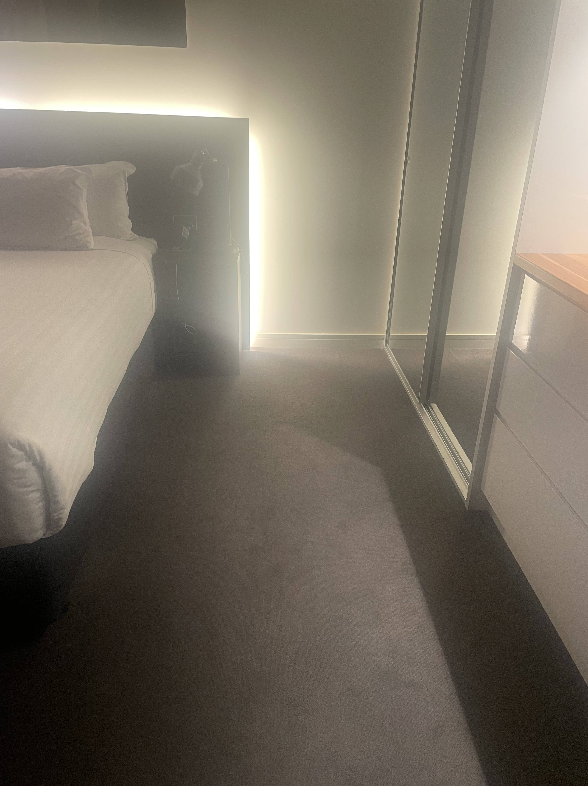
IMG_5415
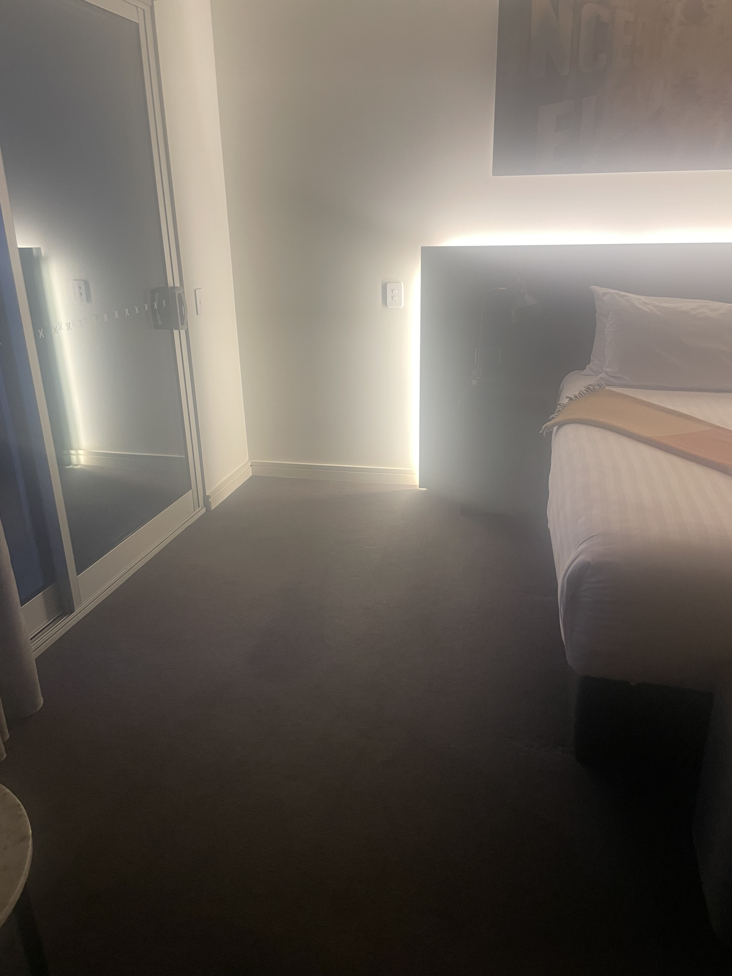
IMG_5416

Room Amenities
- In addition, the following further information can assist guests:
Any guests with a disability are added to a "PEEP" form with custom details to be undertaken for that guest in the event of an evacuation
- Televisions are equipped with closed captioning capability
- Vibrating alarm clocks
- Room phones are hearing loop compatible
- Room phones have volume control
- Room phones have a visual ringing indicator
- There is contrast between the walls, skirtings, floor and furniture
- There is a clear path through the room
- The edges of all furniture and fixtures are rounded
- Wardrobe handles are a contrasting colour to the doors and draws
- Housekeeping procedures instruct staff not to reposition furniture that has been moved
- Doors open fully against the adjoining wall
- There is a clear opening at least 850mm wide
- There luggage racks for at least two suitcases
- There at least one chair with rigid arms
- Wardrobe and drawer handles are easy to grip
- The bedside lamp switch is easy to reach from the bed
- There is at least 850mm clear space beside the bed
- The bed height is no higher than 680mm from the floor
- There is at least 130mm clearance under the bed
- The business offers a range of non-allergenic bedding
- Non-allergenic cleaning products are used

Bathrooms
The bathrooms have the following facilities/amenities in place
- All heating appliances and hot water pipes are protected or insulated
- All shower, bath and basin taps are clearly differentiated between hot and cold
- Fixtures and fittings have rounded edges
- The hot water is thermostatically controlled to 41 degrees
- The door is at least 850mm wide
- There is a minimum of 850mm beside the toilet
- Handrails are fitted
- There is a minimum of 1400mm of clear space in front of the toilet
- The toilet seat is a contrasting colour to the floor
- The toilet seat is 460mm above the floor
- A range of non-allergenic toiletries are available
- There is a roll-in shower with fold down fixed seat or a shower chair
- There is a portable shower head on flexible hose
  - Bathroom Image(s)
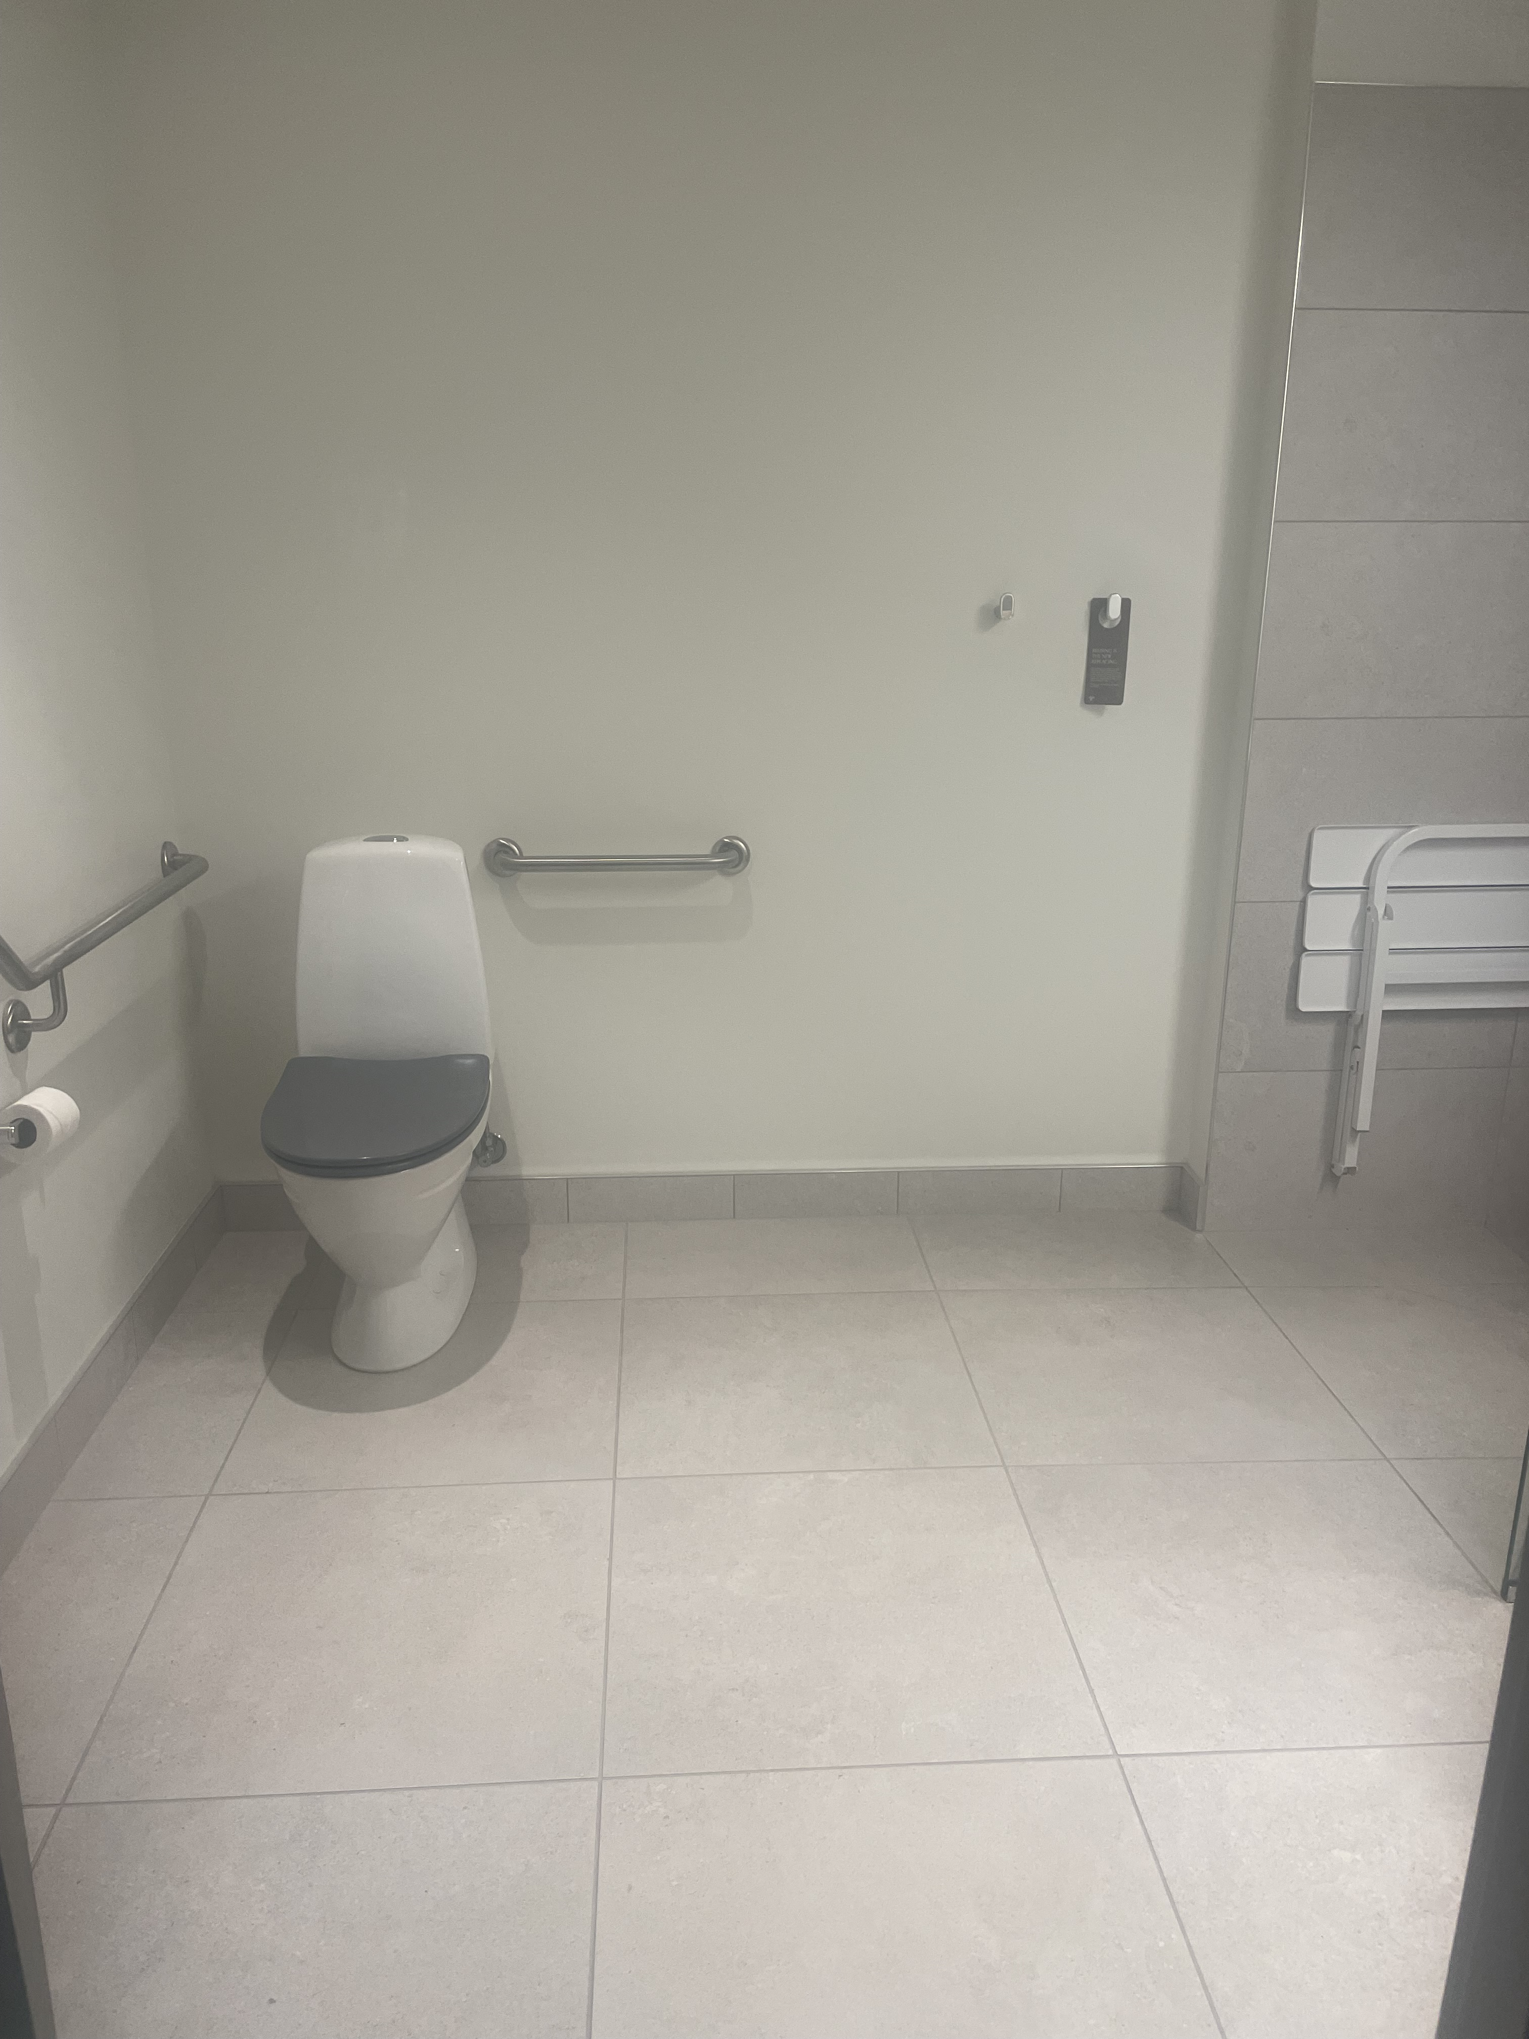
IMG_5417
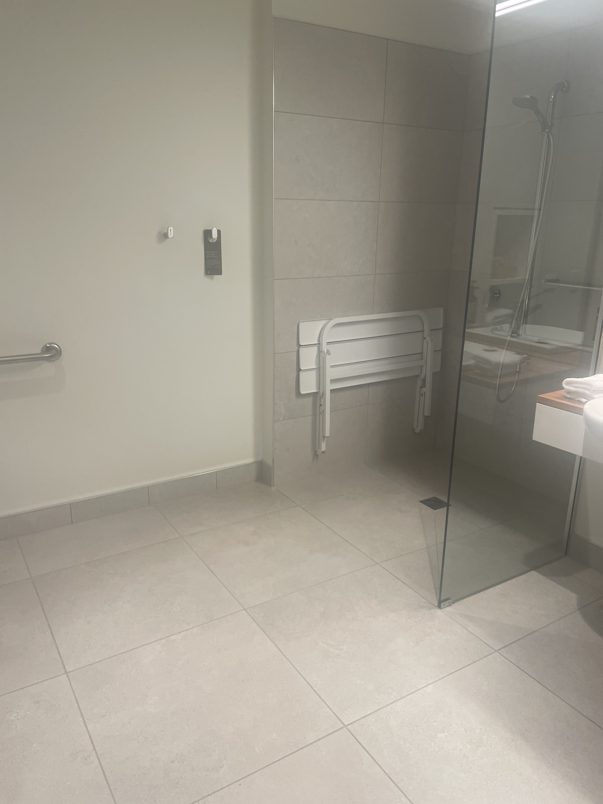
IMG_5418

COMMON AREAS

FOOD AND DRINK

Dining Spaces
The dining spaces have the following facilities/amenities in place
- The entrance has level access
- The doorway is at least 850mm wide
- There is level access through the dining area
- Chairs are moveable to allow for wheelchairs to be seated at the tables
- All glass doors and full height windows have contrast markings
- There are areas of full lighting
- There are large print menus
- There are Plain English menus
- There is an accessible toilet

Our business caters for the following dietary requirements
- Sugar free (diabetic)
- Gluten free (celiac)
- Lactose free (dairy free)
- Low fat and fibre with no gastric content
- Low potassium
- Low sodium
- Nut free
- Additive free
- Organic
- Vegetarian
- Vegan
- Kosher
- Halal
- In addition, the following further information can assist guests:
Tt the time of taking a guest order ask guests to confirm any dietaries and or allergens. This service point is trained and inserted in to all sequence of service&nbsp;Should a guest enquire as to an allergen or dietary free option the wait person is to identify these options for the guest but must reference that these items are “intended” to be free from said dietary or allergen and we are unable to 100% guarantee due to the shared production environment.Our menu and kitchen contains multiple allergens and foods which may cause an intolerance. Our team will make efforts to accommodate dietary requirements. However due to the shared production and serving environment, we cannot guarantee the complete omission of such allergens or foods which may cause an intolerance.
- There is a sample menu available online
Sample menu is available here -
https://grainofthesilos.com.au/menu

EVENTS

Events
Events have the following facilities/amenities in place
- There is step free access throughout the venue
- Reception, registration desks or ticket offices have a lower counter section
- All ancillary areas are step free e.g. breakout rooms, dining areas, outside areas and exhibition spaces
- All stage areas including speaker platforms are accessible
- A low height lectern is available
- Accessible toilets are available at the venue
- There is clear signage throughout the venue including accessible routes and accessible facilities
- Wheelchair designated seating is provided
- We cater for a range of seating and viewing options
- We cater for varying group sizes
- Our event can be booked from the main web site
- Audio description is available
- There is good circulation space with the number of people expected to allow people with a disability to move around freely
- Food and water is available for guide and service animals
- Accessible car parking is available
- There are designated drop-off points
- There is accessible public transport to the venue
- Accessible public transport is detailed in the event information
- There is an event map available
- The event map shows accessible facilities
- The event map shows accessible public transport points
- A step free route is shown
- Quiet rooms, marquees or spaces are available

Report Disclaimer
Please note that this business report, provided as a result of the use of the diagnostic assessment, is for information purposes only.
Australian Tourism Industry Council (ATIC) cannot guarantee the accuracy of respondent’s answers, or that they are fully representative of your business. Therefore, ATIC does not warrant or guarantee any particular outcome in respect of your businesses self-assessment.
This report is intended as guidance only for your business and should not be relied on for future marketing considerations. ATIC recommends that you seek your own independent advice as well as the results from the diagnostic.
Links to external web sites are inserted for convenience and do not constitute endorsement of material at those sites, or any associated organisation, product or service.
ATIC does not:
- Assume any legal liability for the accuracy, completeness, or usefulness of any information from this report or any links provided; or
- Accept responsibility for any loss associated directly or indirectly from the use of this report.

