ATIC Accessibility
To support the accessible community in making informed travel decisions for their individual needs

This report prepared for:
Business name: | Jackalope
Address: | 166 Balnarring Road
Town: | Melbourne
Contact for enquiries: | Nicola Kirk
Contact Number: | 0359312500
Contact Email: | hello@jackalopehotels.com
Website: | https://jackalopehotels.com/
Date: | 2026-10-21 12:54

ATIC Accessibility
The following pages provides travellers with information on the businesses facilities and amenities which aims to support the traveller to make an informed decision on whether the business is suitable for their individual needs.
OVERVIEW 4
Business Overview 4
Bookings 4
Emergency Management 4
Other Information 5
Guide Dog and Service Animals 5
GENERAL 6
Pre-arrival, arrival and reception 6
Cognitive Impairment Support 6
Car Park and Access amenities 6
Entry 7
Lifts 7
Internal Spaces 8
Public areas 8
External Paths 8
Steps 9
Ramps 9
Public Toilets/Adult change facilities 9
ACCOMMODATION 11
Bedrooms 11
Room Amenities 12
Bathrooms 13
COMMON AREAS 16
Swimming pools, spas and waterparks 16
FOOD AND DRINK 21
Dining Spaces 21
Report Disclaimer 25

OVERVIEW

Business Overview

The business has the following products/services available
- Accommodation
- Food and Drink

Our business caters for the following disability types:
- Blind or low vision
- Limited mobility
- Wheelchairs or mobility scooters
- Food allergies or intolerances
- Cognitive or people on the Autism Spectrum

Bookings

The business offers the following methods for bookings and enquiries:
- Phone
- Email
- Webportal
- Our forms have high contract boxes and submit boxes

Emergency Management
- There are Audible device/s to alert occupants to evacuate with instructions on how to evacuate.
- Exit signs are clear and easy to see
- Exit access is free and clear at all times
We ensure exit access is free and clear at all times by:
As part of the Duty Manager's checklist, inspections are conducted during the morning, afternoon, and overnight shifts to ensure safety standards are consistently maintained. Please note that the exit doors have a width of 890mm.
- Exit doors are able to be opened by all occupants
- Exits including stairwells, have bright edges used on the steps.
- The evacuation point is clearly marked by a sign
- In addition, the following further information can assist guests:
At time of check in, we would discuss with the guest and put a profile note in our system. We would also communicate this internally via our hotel chat system and the 'what's on tomorrow' internal email to department heads
- In addition, the following further information can assist guests:
We allocate a specific team member to check with the DM at the time of the rescue, and it is their sole responsibility to provide assistance to their best ability based on the assistance required
- Guests with disabilities are noted in the guest log book for emergency and evacuation purposes

Other Information
- For bookings made onsite, the ticket booth/counter/box office is accessible for people using a wheelchair

Guide Dog and Service Animals
- The business provides a secure area with shade and water for service animals
- The business provides a toilet area for service animals
- Bowls, bedding, etc. are provided for service animals
The business provides the following services for services animals:
When guests stay with their service animals, we allocate our Accessible room due to extra size of the room, location to outdoors and hotel facilities.

GENERAL

Pre-arrival, arrival and reception
The business has the following in place to support guests during pre-arrival, arrival and reception
- There is a reception/public entryway.
- Seating available at reception
- A tablet with text to voice or pen and paper at reception to aid in communication
- Lighting in the reception area is even and glare free

Guests are not required to complete any forms during check-in. Our team personally escorts each guest to their room, offering a thorough introduction to the hotel’s facilities and detailing the available in-room amenities.
- Information and maps are available in written form
- A step free map/guide
- A familiarisation tour
- Keys are available for each guest
- Luggage assistance
- In addition, the following further information can assist guests:
The Flaggerdoot Bar, situated opposite reception, offers a quiet space for guests to relax during the day, although it typically opens from 5pm onwards. Alternatively, guests are welcome to unwind in our private event space, which can be converted into a lounge area for added comfort.
- In addition, the following further information can assist guests:
We strive to provide a seamless arrival experience for all guests. The reception desk is conveniently located near the main entrance, allowing our team to offer immediate assistance as needed.

Cognitive Impairment Support
- A space for parents and children on the Autism Spectrum

Car Park and Access amenities
The business has the following Car Park and Access amenities
- A drop off zone
- Designated disabled parking bays
- Level or ramped access from the car park to the entrance
- The accessible entrance is clearly signed from the parking bay
- In addition, the following further information can assist guests:
Upon arrival, we recommend guests park in the piazza arrival area, as close as possible to the reception entrance for convenient check-in. While accessible parking is available, these spaces are generally located nearer to the accommodation rooms rather than the main entrance. Guests are welcome to relocate their vehicle after check-in if preferred. For those requiring transportation assistance, we offer a complimentary local transfer service (within a 10km radius) via our hybrid Lexus, available by advance reservation.

Entry
The business has the following amenities/systems in place for entry
- A drop off point close to the entrance
- A path of access to the building is slip resistance and even
- A path of access to the building is clear of obstruction
- Self opening entry doors or fitted with a self closer
- Glass doors are fitted with a visual sighting strip
- Door jams/doors are of a contrasting colour to surrounding walls
- Door handles are of a contrasting colour to the door
- Signage is written in a contrasting colour
- The entry door is a minimum of 850mm wide
- The entry door has self opening or a light opening pressure (for manual operations)
- There a clear space of at least 1500mm x 1500mm in front of all doors.
- In addition, the following further information can assist guests:
The entrance mat is recessed into the floor, ensuring a flush surface with no raised edges. The entry features automatic glass doors, and our staff are readily available to offer additional assistance upon arrival, with reception monitored 24 hours a day.

Lifts
- Premises has lifts
- In addition, the following further information can assist guests:
All hotel signage and font are presented in uppercase. The hotel comprises only two levels - Ground and Level One. The accessible room is located on the Ground Floor, eliminating the need for guests with accessibility requirements to use the lift.

Internal Spaces
- Clear and unobstructed routes through and between buildings
- Interior walls are matte or low sheen
- Floors, walls, counters and furniture are of contrasting colours
- Any protruding or overhanging obstructions are at least 2meters above the floor or are protected
- Tableware/glassware contrast with the table surface or table cloth
- Floor surfaces are hard or short pile carpet
- Seating is available for guests unable to stand for long periods
- All corridors greater than 900mm
- There is a quiet space for parents and children on the Autism Spectrum
- In addition, the following further information can assist guests:
Should a guest require a large-print menu, we will be pleased to accommodate this request with prior notice before arrival.

Public areas
The public areas have the following amenities in place
- Even lighting
- Seating
- In addition, the following further information can assist guests:
Please note that the hallways and public areas leading to the accommodation feature a darker, moodier aesthetic as part of the hotel's design. For ease of access, the accessible accommodation room is conveniently located near the entrance to this area.

External Paths
External paths of travel
- Surfaces are concrete, asphalt, smooth paving or hard packed fine gravel (max aggregate size 13mm)
- Pathways are wider than 900mm
- In addition, the following further information can assist guests:
The hotel's paths and ramps are relatively short, each measuring less than 15 metres in length; therefore, rest areas or seating have not been incorporated. For guests who prefer or require an alternative means of access, a nearby stairway with up to six steps and a handrail is available, primarily intended for able-bodied individuals.

Steps
Steps
- There are steps.
- Top and bottom steps are easily distinguished through colour contrast or the use of TGSIs (Tactile Ground Surface Indicators)
- All steps or staircases have enclosed risers
- The underside of all staircases are enclosed or protected to a height of at least 2 metres
- Handrails fitted to all open sets of steps
- Handrails extend 300mm beyond the top and bottom step
- In addition, the following further information can assist guests:
Note that we have paths/ramps as an alternative to outside steps leading into the hotel.

Ramps
Ramps have the following amenities are in place
- There are ramps.
- All fixed ramps are 1:14 or less
- Long ramps (more than 10m) are 1:20 or less
- Ramps have a raised edge of at least 100mm
- In addition, the following further information can assist guests:
While the ramps lack handrails, the hotel ensures accessibility through other means. The ramps are designed with gentle gradients to accommodate guests with mobility challenges. Additionally, the hotel provides alternative access points (via reception) for those who require them, ensuring that all guests can enjoy the facilities comfortably and safely.

Public Toilets/Adult change facilities
Public Toilets/Adult change facilities have the following amenities are in place
- There is an accessible toilet for public use
- The door is at least 850mm wide
- There is a minimum of 850mm beside the toilet
- Handrails are fitted
- The toilet seat is 460mm above the floor
- The toilet seat of a contrasting colour to the floor
- The toilet seat is460mm above the floor
- In addition, the following further information can assist guests:
As a five-star hotel, guests have the convenience of using their accommodation rooms to meet any changing or related needs.

ACCOMMODATION

Bedrooms
The bedrooms have the following facilities/amenities in place
- There are 1 rooms available to guests who use a wheelchair
- Bedroom furniture can be re-arranged on request
  - Layout of room Image(s)
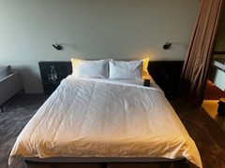
Bedroom
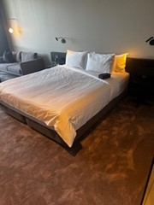
Bedroom 2
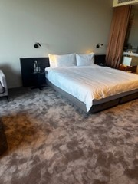
Bedroom 3

Room Amenities
- Lower hanging rails are in wardrobes
- Televisions are equipped with closed captioning capability
- Room phones are hearing loop compatible
- Room phones have volume control
- Room phones have a visual ringing indicator
- There is contrast between the walls, skirtings, floor and furniture
- There is a clear path through the room
- The edges of all furniture and fixtures are rounded
- Housekeeping procedures instruct staff not to reposition furniture that has been moved
- Doors open fully against the adjoining wall
- There is a clear opening at least 850mm wide
- There luggage racks for at least two suitcases
- There at least one chair with rigid arms
- Wardrobe and drawer handles are easy to grip
- The bedside lamp switch is easy to reach from the bed
- There is at least 850mm clear space beside the bed
- The bed height is no higher than 680mm from the floor
- Blocks are available to put under the bed legs
- The business offers a range of non-allergenic bedding
- In addition, the following further information can assist guests:
While we do not offer a full range of non-allergenic bedding, please note that we do provide non-allergenic pillows upon request. The wardrobe handles are black, matching the cupboard doors, but are positioned lower than those in the standard rooms to enhance accessibility.

Bathrooms
The bathrooms have the following facilities/amenities in place
- All heating appliances and hot water pipes are protected or insulated
- All shower, bath and basin taps are clearly differentiated between hot and cold
- The hot water is thermostatically controlled to 41 degrees
- The width of the door is 710mm.
- The width beside the toilet is The width is 710mm.
- Handrails are fitted
- There is a minimum of 1400mm of clear space in front of the toilet
- The toilet seat is a contrasting colour to the floor
- The actual height of the toilet seat is 450mm.
- There is a portable shower head on flexible hose
- A door is fitted to the shower
- A door is fitted to the showers with an outward swing at minimum width of 900 mm
  - Bathroom Image(s)
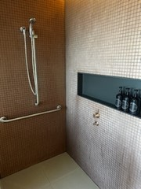
Bathroom 1
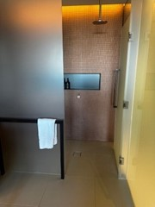
Bathroom 2
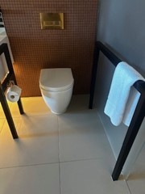
Bathroom 3
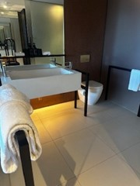
Bathroom 4
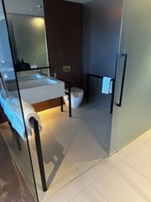
Bathroom 5
- In addition, the following further information can assist guests:
Jackalope's accessible room is designed to combine functionality with the hotel’s signature contemporary aesthetic, featuring lower wardrobe handles and accessible fittings while maintaining a stylish environment.

COMMON AREAS

Swimming pools, spas and waterparks
- The following swimming pools, spas and waterparks amenities are available
- Unisex change facilities with an accessible toilet
- The park map includes a step free route
  - Pool Access Image(s)
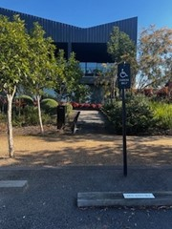
Parking 1
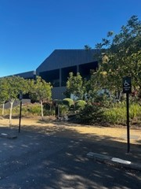
Parking 2
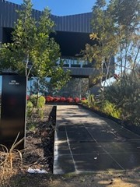
Ramp to Accm
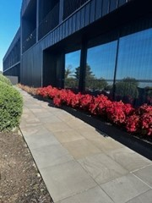
Ramp to Accm 2
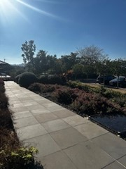
Ramp_Path to Accm
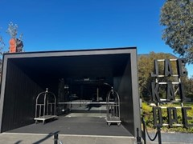
Entrance
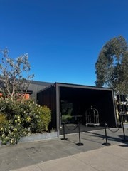
Entrance with close parking access
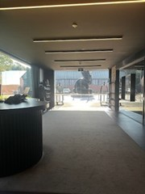
Inside reception noting location of reception desk
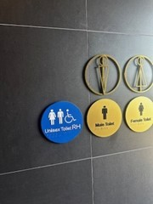
Accessible Toilet Entrance
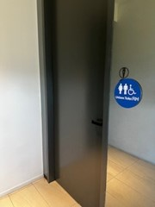
Accessible Toilet Entrance 2
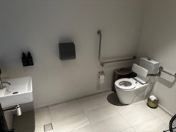
Accessible Toilet_Bathroom
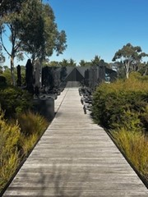
Ramp_Path to Pool
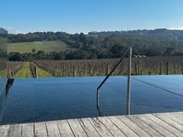
Pool_Spa access
- In addition, the following further information can assist guests:
A pool hoist is available to accommodate guest needs; advance notice prior to arrival is kindly requested to ensure it is prepared for use.

FOOD AND DRINK

Dining Spaces
The dining spaces have the following facilities/amenities in place
- The entrance has level access
- The doorway is at least 850mm wide
- There is level access through the dining area
- Chairs are moveable to allow for wheelchairs to be seated at the tables
- All glass doors and full height windows have contrast markings
- There are areas of full lighting
- There are Plain English menus
- There is an accessible toilet

Our business caters for the following dietary requirements
- Sugar free (diabetic)
- Gluten free (celiac)
- Lactose free (dairy free)
- Low sodium
- Nut free
- Organic
- Vegetarian
- Vegan
- Halal
- In addition, the following further information can assist guests:
1. Personal Hygiene
Wash hands frequently, especially after handling raw foods, touching face/hair, using the restroom, or switching tasks.Wear clean uniforms, aprons, and hair restraints (hats, hairnets).Use gloves when handling ready-to-eat foods, and change them frequently.Stay home when ill, especially with symptoms like vomiting, diarrhoea, or fever.2. Proper Food Storage
Store raw meats separately from ready-to-eat foods, ideally on lower shelves to prevent dripping.Label and date all food items correctly and follow FIFO (First In, First Out).Use color-coded containers or wrap to distinguish between raw and cooked items.3. Equipment and Utensil Usage
Use separate cutting boards and knives for raw meat, poultry, seafood, and vegetables (color-coded if possible).Sanitize utensils and surfaces between tasks with food-safe sanitiser.Never reuse marinades or sauces that have contacted raw meats unless boiled.4. Cooking and Holding Temperatures
Cook foods to internal temperatures (e.g., chicken to 74°C).Keep hot foods hot (above 57°C) and cold foods cold (below 5°C).Use calibrated food thermometers to verify temperatures.5. Allergen Awareness
Avoid allergen cross-contact by cleaning and sanitizing surfaces and equipment.Use separate utensils and prep areas when possible for allergen-free meals.Train staff to understand major allergens and how to respond to allergen-related requests.6. Cleaning and Sanitizing
Follow a strict cleaning schedule for all equipment, surfaces, and tools.Use approved cleaning agents and ensure proper contact time.Air-dry equipment rather than towel-drying to avoid contamination.7. Employee Training and SOPs
Regularly train staff on food safety protocols and updates.Post standard operating procedures (SOPs) in food prep and storage areas.Conduct regular internal audits and inspections.
- There is a sample menu available online
Sample menu is available here -
https://dootdootdoot.com.au/
  - Food and Beverage Image(s)
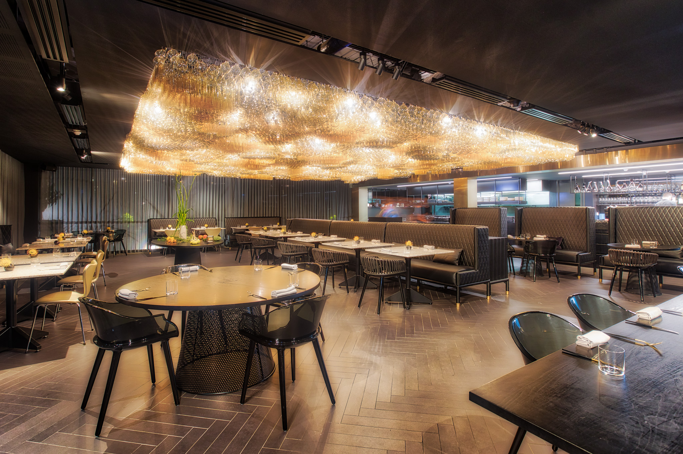
Doot Doot Doot Layout LowRes-0270
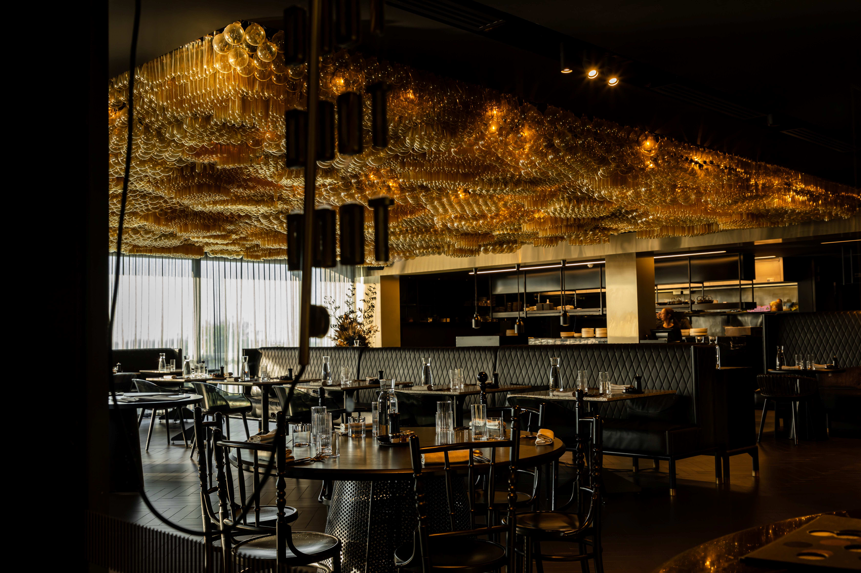
Doot Doot Doot Entrance
- In addition, the following further information can assist guests:
For guests who are partially blind, our team provides a detailed verbal walkthrough of the entire menu. This mirrors the experience offered to all guests, as our staff take time to explain menu items and additional options to enhance the dining experience.

Any dietary requirements or allergies are noted in advance of arrival and reconfirmed upon seating. Our staff then personally consult with the guest to clarify specific allergies, enabling them to confidently recommend suitable dishes.

For guests using wheelchairs, we allocate accessible tables with ample space for comfort and ease of movement, and our team also points out the location of nearby accessible restrooms.

As a hatted restaurant within a five-star hotel, we offer full table service, eliminating the need for guests to order or pay at a counter.

Report Disclaimer
Please note that this business report, provided as a result of the use of the diagnostic assessment, is for information purposes only.
Australian Tourism Industry Council (ATIC) cannot guarantee the accuracy of respondent’s answers, or that they are fully representative of your business. Therefore, ATIC does not warrant or guarantee any particular outcome in respect of your businesses self-assessment.
This report is intended as guidance only for your business and should not be relied on for future marketing considerations. ATIC recommends that you seek your own independent advice as well as the results from the diagnostic.
Links to external web sites are inserted for convenience and do not constitute endorsement of material at those sites, or any associated organisation, product or service.
ATIC does not:
- Assume any legal liability for the accuracy, completeness, or usefulness of any information from this report or any links provided; or
- Accept responsibility for any loss associated directly or indirectly from the use of this report.

