ATIC Accessibility
To support the accessible community in making informed travel decisions for their individual needs

This report prepared for:
Business name: | The Timothee Resort
Address: | 70 Causeway Rd
Town: | Busselton
Contact for enquiries: | Jamie Brady
Contact Number: | (08) 9752 3000
Contact Email: | stay@thetimothee.com.au
Website: | https://www.thetimothee.com.au/
Date: | 2026-11-03 00:13

ATIC Accessibility
The following pages provides travellers with information on the businesses facilities and amenities which aims to support the traveller to make an informed decision on whether the business is suitable for their individual needs.
OVERVIEW 4
Business Overview 4
Bookings 4
Emergency Management 4
Communications 5
Other Information 5
Guide Dog and Service Animals 5
GENERAL 6
Pre-arrival, arrival and reception 6
Cognitive Impairment Support 6
Car Park and Access amenities 6
Entry 6
Internal Spaces 7
Public areas 7
External Paths 7
Steps 7
ACCOMMODATION 9
Room Amenities 9
Bathrooms 9
COMMON AREAS 10
Swimming pools, spas and waterparks 10
Parks and gardens 10
Report Disclaimer 12

OVERVIEW

Business Overview

The business has the following products/services available
- Accommodation

Our business caters for the following disability types:
- Blind or low vision
- Deaf or low hearing
- Limited mobility
- Cognitive or people on the Autism Spectrum
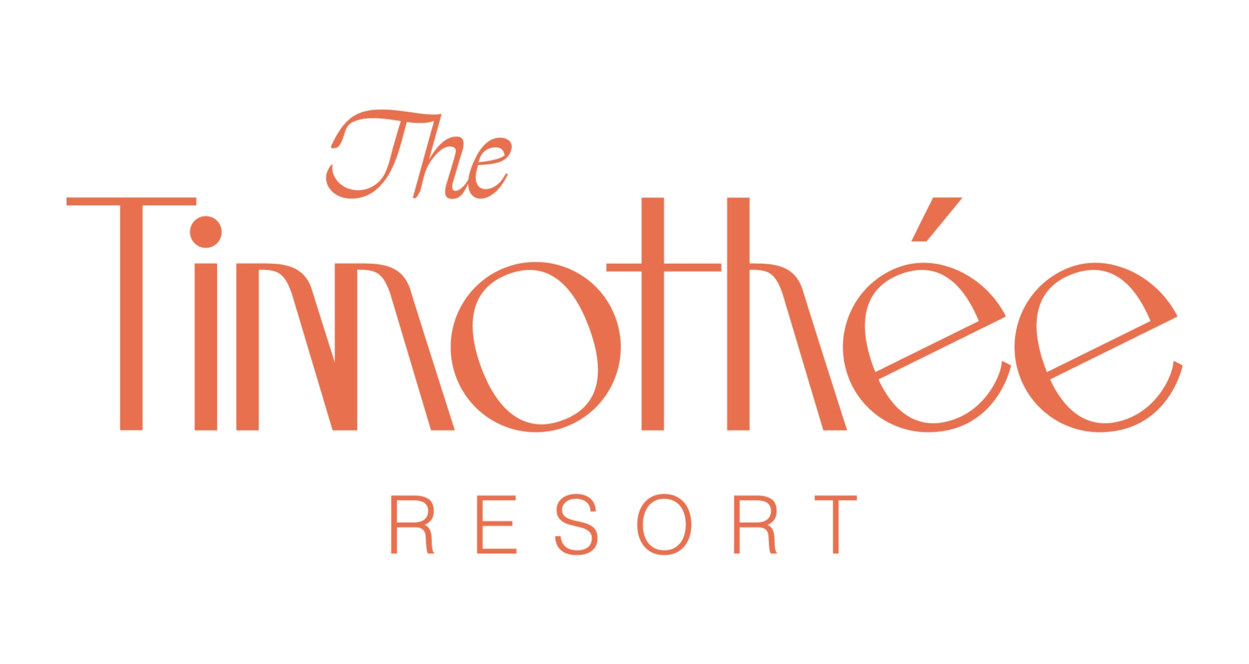

Bookings

The business offers the following methods for bookings and enquiries:
- Phone
- Email
- Webportal
- Our forms have high contract boxes and submit boxes

Emergency Management
- The business has an emergency management and evacuation plan for guests with a disability
- Emergency and evacuation procedures are explained on arrival
- Guests with disabilities are noted in the guest log book for emergency and evacuation purposes

Communications
- Our business offers the following alternative communication methods
- Plain English

Not specified
- There is easy to read signage and information (e.g. menus and emergency information)

Other Information
- For bookings made onsite, the ticket booth/counter/box office is accessible for people using a wheelchair

Guide Dog and Service Animals
The business provides the following services for services animals:
Not specified

GENERAL

Pre-arrival, arrival and reception
The business has the following in place to support guests during pre-arrival, arrival and reception
- Booking information and websites are compatible with screen readers
- There is a reception/public entryway.
- Seating available at reception
- A clipboard to allow check-in/ticket purchase whilst seated
- A tablet with text to voice or pen and paper at reception to aid in communication
- Lighting in the reception area is even and glare free
- Information and maps are available in written form
- A familiarisation tour
- Keys are available for each guest
- Luggage assistance
- In addition, the following further information can assist guests:
Our check-in time is very short with no more than a 2 minute wait for checkin.

Cognitive Impairment Support
- Documents are available in plain English for people with cognitive impairment (This may include instructions, guides, menus and general information)
- A space for parents and children on the Autism Spectrum

Car Park and Access amenities
The business has the following Car Park and Access amenities
- A drop off zone
- Designated disabled parking bays
- Level or ramped access from the car park to the entrance
- The accessible entrance is clearly signed from the parking bay

Entry
The business has the following amenities/systems in place for entry
- A drop off point close to the entrance
- A path of access to the building is slip resistance and even
- A path of access to the building is clear of obstruction
- Glass doors are fitted with a visual sighting strip
- Door handles are of a contrasting colour to the door
- Signage is written in a contrasting colour
- The entry door is a minimum of 850mm wide
- The entrance door mats have a thickness less than 13mm and a width of 7500mm or greater

Internal Spaces
- Clear and unobstructed routes through and between buildings
- Interior walls are matte or low sheen
- Tableware/glassware contrast with the table surface or table cloth
- Floor surfaces are hard or short pile carpet
- Seating is available for guests unable to stand for long periods
- All corridors greater than 900mm
- There is a quiet space for parents and children on the Autism Spectrum

Public areas
The public areas have the following amenities in place
- Even lighting
- Seating

External Paths
External paths of travel
- Surfaces are concrete, asphalt, smooth paving or hard packed fine gravel (max aggregate size 13mm)
- Paths or slopes longer than 15 metres have resting places or seats
- Pathways are wider than 900mm

Steps
Steps
- There are steps.
- Top and bottom steps are easily distinguished through colour contrast or the use of TGSIs (Tactile Ground Surface Indicators)
- All steps or staircases have enclosed risers
- The underside of all staircases are enclosed or protected to a height of at least 2 metres
- Handrails fitted to all open sets of steps

ACCOMMODATION

Room Amenities
- In addition, the following further information can assist guests:
During an emergency evacuation, staff will open doors of any guest unaccounted for after phoning and then knocking on room doors.
- Televisions are equipped with closed captioning capability
- There is a clear path through the room
- The edges of all furniture and fixtures are rounded
- Wardrobe handles are a contrasting colour to the doors and draws
- Housekeeping procedures instruct staff not to reposition furniture that has been moved
- Doors open fully against the adjoining wall
- Openings are a minimum of 820 wide
- There at least one chair with rigid arms
- Wardrobe and drawer handles are easy to grip
- The bedside lamp switch is easy to reach from the bed
- There is at least 850mm clear space beside the bed
- The bed height is no higher than 680mm from the floor
- There is at least 130mm clearance under the bed

Bathrooms
The bathrooms have the following facilities/amenities in place
- All heating appliances and hot water pipes are protected or insulated
- All shower, bath and basin taps are clearly differentiated between hot and cold
- Fixtures and fittings have rounded edges
- The hot water is thermostatically controlled to 41 degrees
- The width of the door is 600mm.
- The width beside the toilet is 300mm.
- There is a minimum of 1400mm of clear space in front of the toilet
- The actual height of the toilet seat is 420.
- There is a portable shower head on flexible hose
- A door is fitted to the shower

COMMON AREAS

Swimming pools, spas and waterparks
- The following swimming pools, spas and waterparks amenities are available

Parks and gardens
- The following parks and gardens amenities are available
- Accessible BBQs
- Handrails and stairs are built as per state/territory building code.
- Slip resistance surfaces are used.
- A handrail is available and at 865-965mm in height.
- The handrail is continuously graspable along entire length at least one side.
  - Parks and Gardens Stair entry and exit Image(s)
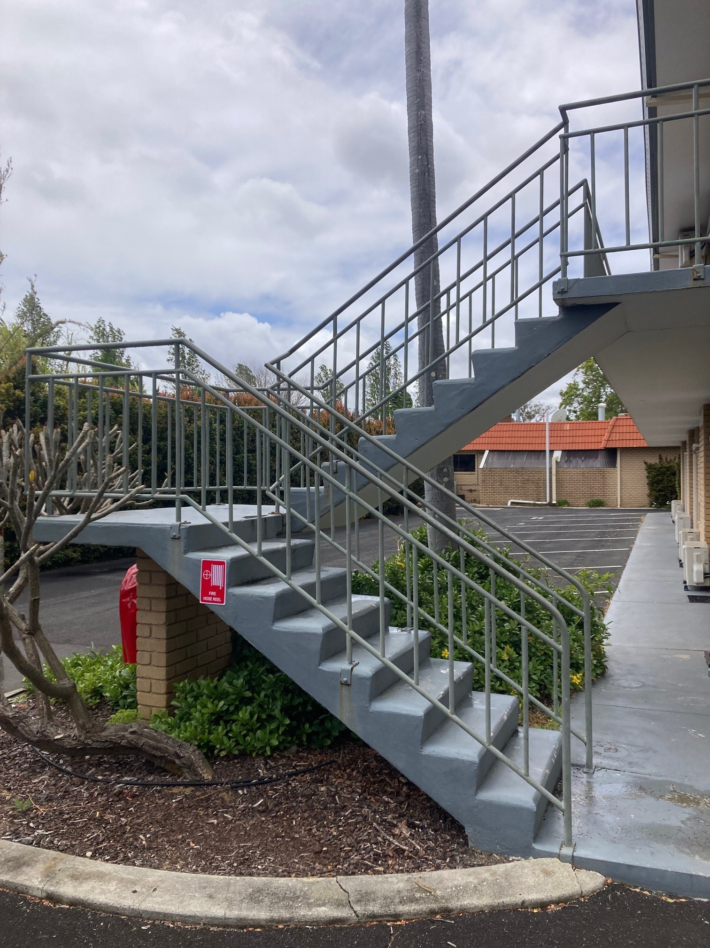
Second story stairs

Report Disclaimer
Please note that this business report, provided as a result of the use of the diagnostic assessment, is for information purposes only.
Australian Tourism Industry Council (ATIC) cannot guarantee the accuracy of respondent’s answers, or that they are fully representative of your business. Therefore, ATIC does not warrant or guarantee any particular outcome in respect of your businesses self-assessment.
This report is intended as guidance only for your business and should not be relied on for future marketing considerations. ATIC recommends that you seek your own independent advice as well as the results from the diagnostic.
Links to external web sites are inserted for convenience and do not constitute endorsement of material at those sites, or any associated organisation, product or service.
ATIC does not:
- Assume any legal liability for the accuracy, completeness, or usefulness of any information from this report or any links provided; or
- Accept responsibility for any loss associated directly or indirectly from the use of this report.

