ATIC Accessibility
To support the accessible community in making informed travel decisions for their individual needs

This report prepared for:
Business name: | Filefish Sea
Address: | Prevelly, Margaret River
Town: | Margaret River
Contact for enquiries: | Rebecca Sheedy-Ryan
Contact Number: | 0415562569
Contact Email: | bec@filefish.com.au
Website: | filefish.com.au
Date: | 2026-11-04 09:50

ATIC Accessibility
The following pages provides travellers with information on the businesses facilities and amenities which aims to support the traveller to make an informed decision on whether the business is suitable for their individual needs.
OVERVIEW 4
Business Overview 4
Bookings 4
Emergency Management 5
Communications 5
Guide Dog and Service Animals 5
GENERAL 6
Pre-arrival, arrival and reception 6
Cognitive Impairment Support 6
Car Park and Access amenities 6
ATTRACTIONS 8
Zoos and Wildlife Parks 8
COMMON AREAS 9
Play Spaces 9
Swimming pools, spas and waterparks 9
Parks and gardens 9
ADVENTURE ACTIVITIES 10
Report Disclaimer 12

OVERVIEW

Business Overview

The business has the following products/services available
- Attraction
- Adventure

Our business caters for the following disability types:
- Deaf or low hearing
- Limited mobility
- Cognitive or people on the Autism Spectrum
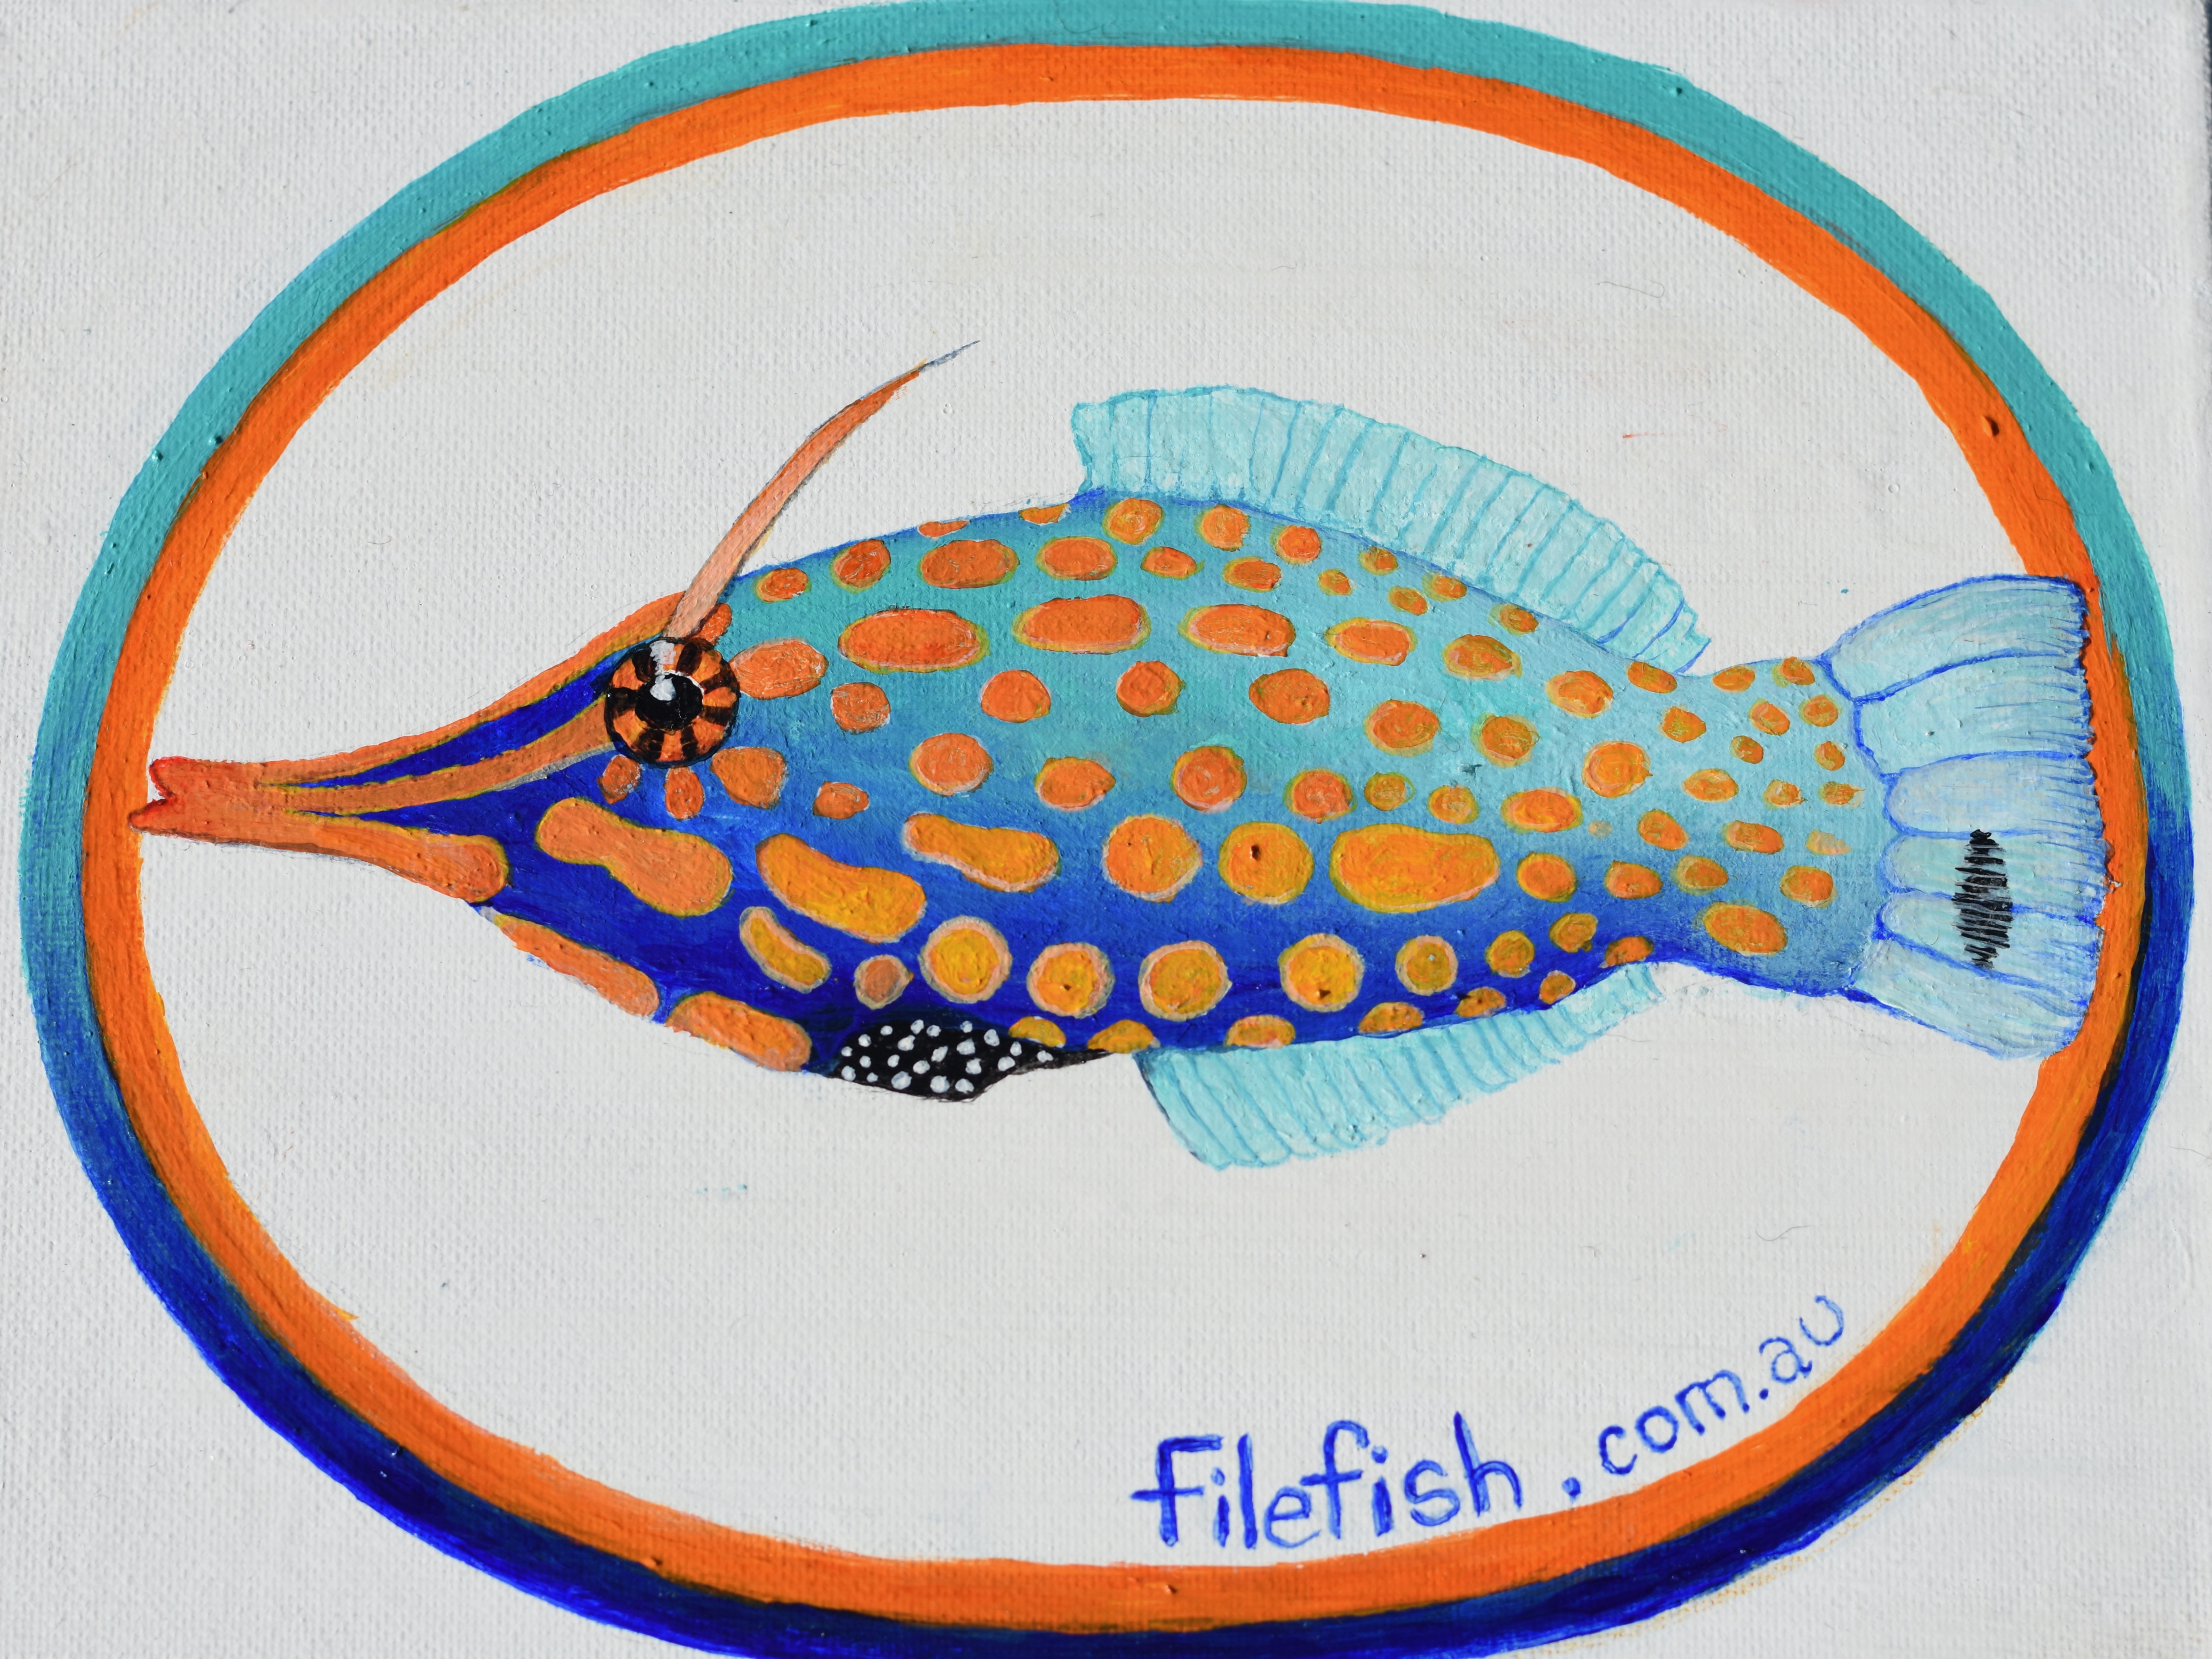

Bookings

The business offers the following methods for bookings and enquiries:
- Phone
- Email
- Webportal
- Our website supports Screen Readers
- Our forms have high contract boxes and submit boxes

Emergency Management
- Emergency and evacuation procedures are explained on arrival
- There are Audible device/s to alert occupants to evacuate with instructions on how to evacuate.
- There are visual device/s to alert occupants to evacuate.
- Exit signs are clear and easy to see
- Exit doors are able to be opened by all occupants
- Exits to the emergency evacuation point does not include stairways
- The evacuation point is clearly marked by a sign
- In addition, the following further information can assist guests:
Yes this would be made clear and individual plans made clear. ID vest or wrist bands can be used
- In addition, the following further information can assist guests:
DRSABCD - Use Flotation - Head instructor takes over the process
- Guests with disabilities are noted in the guest log book for emergency and evacuation purposes

Communications
- Our business offers the following alternative communication methods
- Plain English

Not specified
- There is easy to read signage and information (e.g. menus and emergency information)
- There are Picture boards

Guide Dog and Service Animals
The business provides the following services for services animals:
Shade, bowls & bedding ect can be supplied if needed

GENERAL

Pre-arrival, arrival and reception
The business has the following in place to support guests during pre-arrival, arrival and reception
- Booking information and websites are compatible with screen readers
- A familiarisation tour
- In addition, the following further information can assist guests:
The service does not involve queues
- In addition, the following further information can assist guests:
Additional services and maps can be provided for specific locations

Cognitive Impairment Support
- Quiet periods or early opening times for people on the Autism Spectrum
- A space for parents and children on the Autism Spectrum

Car Park and Access amenities
The business has the following Car Park and Access amenities
- A drop off zone
- Designated disabled parking bays
- In addition, the following further information can assist guests:
Pool programs have all the essential requirements in place for accessibility. All other locations are beach locations with various carparks and terrain.
The width of the smallest pathway is:
Beach access path can be 50cm - Pool programs are accessibile

Pool no steps - Beach is variable

Pool - has clear signage and pathways - beach does not
- In addition, the following further information can assist guests:
Pool programs offer much better accessibility, beaches variable with both signage and accessibility
- In addition, the following further information can assist guests:
Steps for pool entry in pool programs are available - ocean programs have no steps
- In addition, the following further information can assist guests:
Pool locations - have accessible toilets and change areas.
Beach locations are variable

ATTRACTIONS

Zoos and Wildlife Parks
- Guide and service dogs are welcome
- In addition, the following further information can assist guests:
Certified guide dogs are permitted in Ngari Cpaes Marine Park, Margaret River Recreation Center and Geographe Leisure Center
- A secure area with shade and water for service dogs is available
- Signage is in a font larger than 18 point
- In addition, the following further information can assist guests:
Guide dog shade at beach can be arranged for each guest when required.

COMMON AREAS

Play Spaces
- The space contain colour contrasting elements
- Seating is provided in or around the play space
- In addition, the following further information can assist guests:
Geographe Leisure Center Programs have the most accessibility options

Swimming pools, spas and waterparks
- The following swimming pools, spas and waterparks amenities are available
- Unisex change facilities with an accessible toilet
- The park map includes a step free route

Parks and gardens
- The following parks and gardens amenities are available
- The park or garden contains sensory experiences
- Accessible picnic tables
- In addition, the following further information can assist guests:
Margaret River and Geographe Leisure Center both have many of the accessibility features listed

ADVENTURE ACTIVITIES
- In addition, the following further information can assist guests:
Some disabilities can be catered for depending on the program and the location.

Report Disclaimer
Please note that this business report, provided as a result of the use of the diagnostic assessment, is for information purposes only.
Australian Tourism Industry Council (ATIC) cannot guarantee the accuracy of respondent’s answers, or that they are fully representative of your business. Therefore, ATIC does not warrant or guarantee any particular outcome in respect of your businesses self-assessment.
This report is intended as guidance only for your business and should not be relied on for future marketing considerations. ATIC recommends that you seek your own independent advice as well as the results from the diagnostic.
Links to external web sites are inserted for convenience and do not constitute endorsement of material at those sites, or any associated organisation, product or service.
ATIC does not:
- Assume any legal liability for the accuracy, completeness, or usefulness of any information from this report or any links provided; or
- Accept responsibility for any loss associated directly or indirectly from the use of this report.

