ATIC Accessibility
To support the accessible community in making informed travel decisions for their individual needs

This report prepared for:
Business name: | TRIBE Perth
Address: | 4 Walker Avenue
Town: | West Perth
Contact for enquiries: | Diane Haynes
Contact Number: | 0862473333
Contact Email: | diane.haynes@tribehotels.com.au
Website: | https://tribehotels.com/en/
Date: | 2026-10-20 02:20

ATIC Accessibility
The following pages provides travellers with information on the businesses facilities and amenities which aims to support the traveller to make an informed decision on whether the business is suitable for their individual needs.
OVERVIEW 4
Business Overview 4
Bookings 4
Emergency Management 4
Communications 4
Other Information 5
Guide Dog and Service Animals 5
GENERAL 6
Pre-arrival, arrival and reception 6
Car Park and Access amenities 6
External Paths 6
Ramps 7
Public Toilets/Adult change facilities 7
ACCOMMODATION 8
Bedrooms 8
Room Amenities 8
Bathrooms 9
COMMON AREAS 12
FOOD AND DRINK 13
Dining Spaces 13
Report Disclaimer 18

OVERVIEW

Business Overview

The business has the following products/services available
- Accommodation
- Food and Drink

Our business caters for the following disability types:
- Blind or low vision
- Limited mobility
- Wheelchairs or mobility scooters
- Food allergies or intolerances

Bookings

The business offers the following methods for bookings and enquiries:
- Phone
- Email
- Webportal
- Our website supports Screen Readers
- Our forms have high contract boxes and submit boxes

Emergency Management
- The business has an emergency management and evacuation plan for guests with a disability
- Guests with disabilities are noted in the guest log book for emergency and evacuation purposes

Communications
- An accessibility guide is available on the website

https://tribehotels.com/en/terms-and-policies/accessibility/
- Our website meets WCAG 2.0 accessibility standards
- Our business offers the following alternative communication methods
- Plain English
- Braille Displays

Not specified
- There is easy to read signage and information (e.g. menus and emergency information)

Other Information
- The business accepts the companion card

Guide Dog and Service Animals
- The business provides a secure area with shade and water for service animals
The business provides the following services for services animals:
NA

GENERAL

Pre-arrival, arrival and reception
The business has the following in place to support guests during pre-arrival, arrival and reception
- Booking information and websites are compatible with screen readers
- There is a reception/public entryway.
- A clipboard to allow check-in/ticket purchase whilst seated
- Lighting in the reception area is even and glare free

-
- Information and maps are available in written form
- A familiarisation tour
- Keys are available for each guest
- In addition, the following further information can assist guests:
Guests can be seated in the Lobby if waiting longer than usual.
- In addition, the following further information can assist guests:
N/A

Car Park and Access amenities
The business has the following Car Park and Access amenities
- A drop off zone
- Designated disabled parking bays
- Level or ramped access from the car park to the entrance
- The accessible entrance is clearly signed from the parking bay
- An intercom system is available at the entrance of car park
- In addition, the following further information can assist guests:
NA

External Paths
External paths of travel
- Surfaces are concrete, asphalt, smooth paving or hard packed fine gravel (max aggregate size 13mm)
- Paths or slopes longer than 15 metres have resting places or seats
- Pathways are wider than 900mm
- In addition, the following further information can assist guests:
NA
- In addition, the following further information can assist guests:
-

Ramps
Ramps have the following amenities are in place
- There are ramps.
- All fixed ramps are 1:14 or less
- Hand rails are fitted
- In addition, the following further information can assist guests:
-

Public Toilets/Adult change facilities
Public Toilets/Adult change facilities have the following amenities are in place
- There is an accessible toilet for public use
- The door is at least 850mm wide
- There is a minimum of 850mm beside the toilet
- Handrails are fitted
- The toilet seat is 460mm above the floor
- The toilet seat of a contrasting colour to the floor
- The toilet seat is460mm above the floor

ACCOMMODATION

Bedrooms
The bedrooms have the following facilities/amenities in place
- There are 8 rooms rooms available to guests who use a wheelchair
  - Layout of room Image(s)
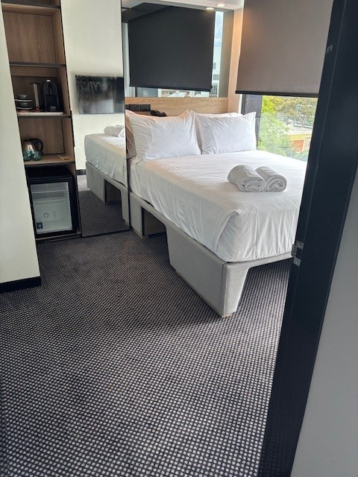
Accessible Tribe Guestroom space

Room Amenities
- Room phones have volume control
- Room phones have a visual ringing indicator
- There is contrast between the walls, skirtings, floor and furniture
- There is a clear path through the room
- The edges of all furniture and fixtures are rounded
- There is a clear opening at least 850mm wide
- There at least one chair with rigid arms
- Wardrobe and drawer handles are easy to grip
- The bedside lamp switch is easy to reach from the bed
- There is at least 850mm clear space beside the bed
- There is at least 130mm clearance under the bed
- Non-allergenic cleaning products are used
- In addition, the following further information can assist guests:
-

Bathrooms
The bathrooms have the following facilities/amenities in place
- All heating appliances and hot water pipes are protected or insulated
- The hot water is thermostatically controlled to 41 degrees
- The door is at least 850mm wide
- There is a minimum of 850mm beside the toilet
- Handrails are fitted
- There is a minimum of 1400mm of clear space in front of the toilet
- The toilet seat is a contrasting colour to the floor
- The toilet seat is 460mm above the floor
- There is a portable shower head on flexible hose
  - Bathroom Image(s)
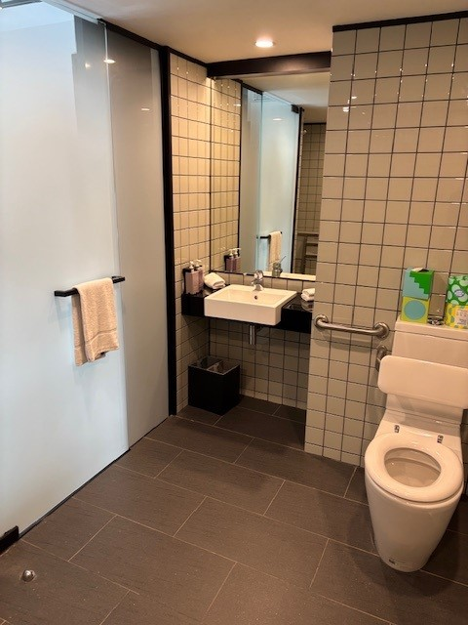
Accessible Bathroom space
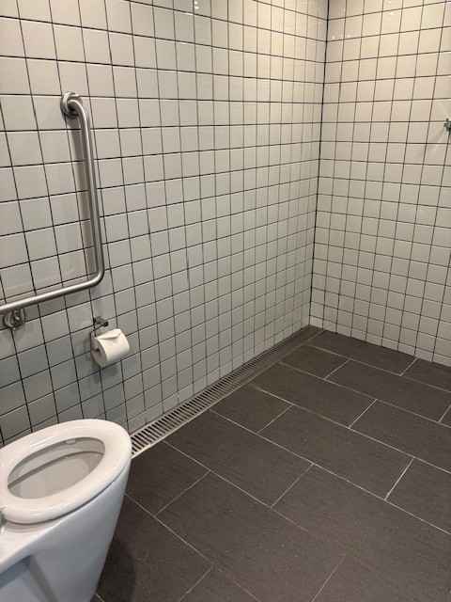
Accessible Shower_3
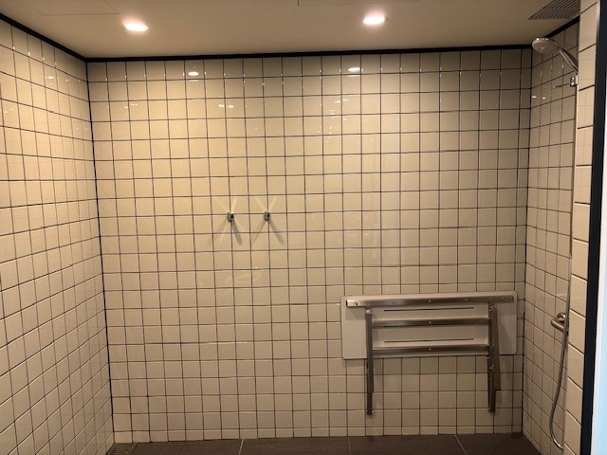
Accessible Shower_2
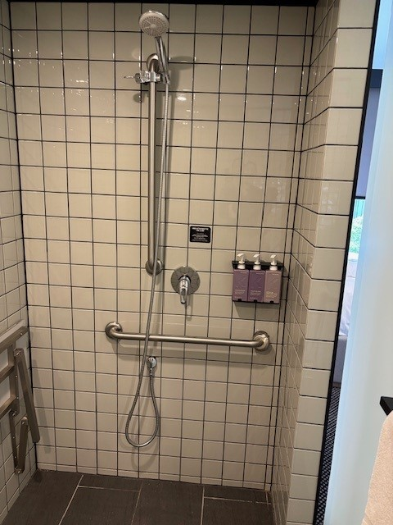
Accessible Shower_1
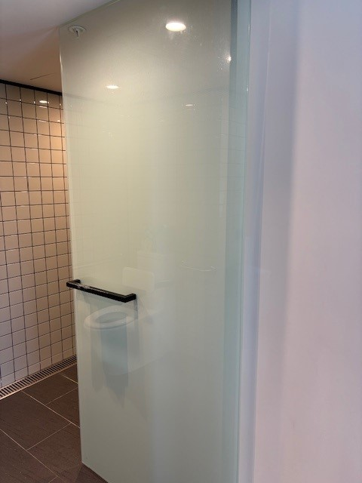
Accessible Door to Bathroom
- In addition, the following further information can assist guests:
-

COMMON AREAS

FOOD AND DRINK

Dining Spaces
The dining spaces have the following facilities/amenities in place
- The entrance has level access
- The doorway is at least 850mm wide
- There is level access through the dining area
- Chairs are moveable to allow for wheelchairs to be seated at the tables
- There are areas of full lighting
- There are Plain English menus
- There is an accessible toilet

Our business caters for the following dietary requirements
- Sugar free (diabetic)
- Gluten free (celiac)
- Lactose free (dairy free)
- Organic
- Vegetarian
- Vegan
- In addition, the following further information can assist guests:
Staff to ensure high risk food items served or prepared reach an internal core temperature of 75 degrees; maintain visibility over catering and function food served or re-heated, ensure meal preparation method are corrected upon failed results.
Kitchen staff are to ensure all surfaces, knives, and other tools after each use, particularly after contact with any raw food are sanitised throughly.
- There is a sample menu available online
Sample menu is available here -
https://tribehotels.com/en/australia/perth/tribe-table/
  - Food and Beverage Image(s)
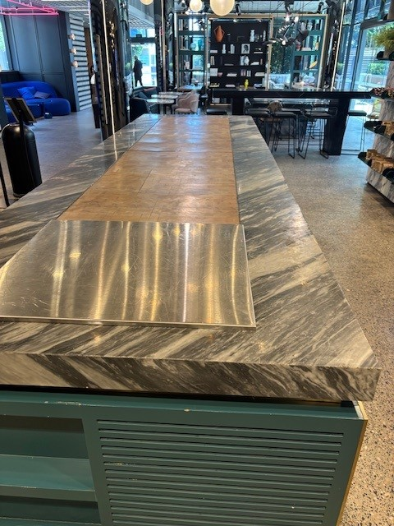
Tribe Buffet Table
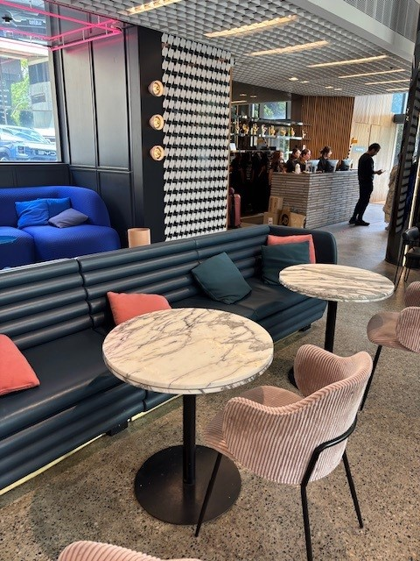
Tribe Table Layout_3
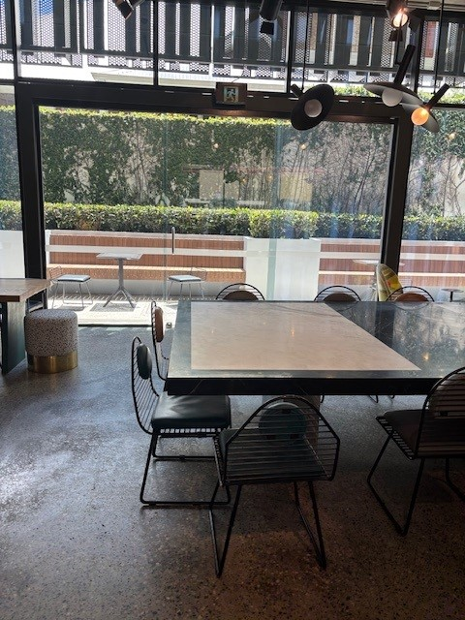
Tribe Table Layout_2
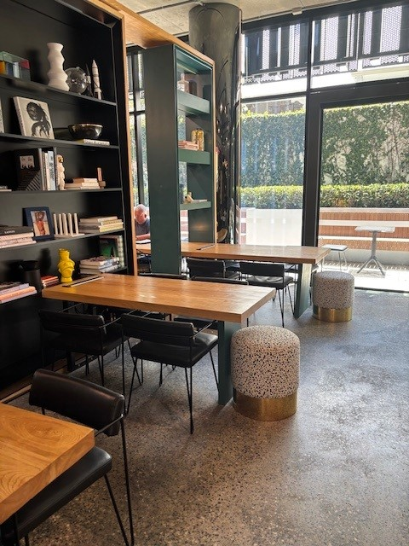
Tribe Table Layout
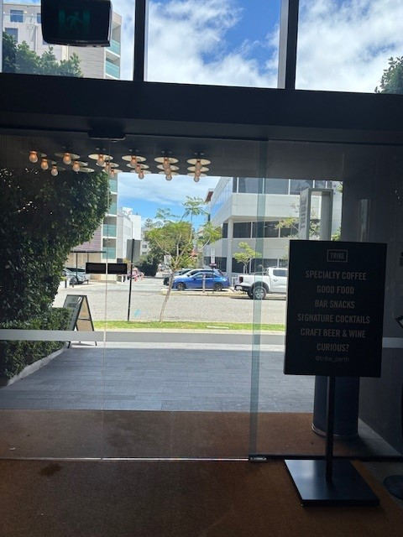
Entry to Reception
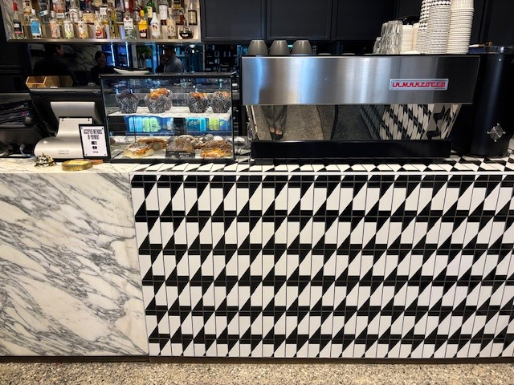
Tribe Counter_Bar area
- In addition, the following further information can assist guests:
-

Report Disclaimer
Please note that this business report, provided as a result of the use of the diagnostic assessment, is for information purposes only.
Australian Tourism Industry Council (ATIC) cannot guarantee the accuracy of respondent’s answers, or that they are fully representative of your business. Therefore, ATIC does not warrant or guarantee any particular outcome in respect of your businesses self-assessment.
This report is intended as guidance only for your business and should not be relied on for future marketing considerations. ATIC recommends that you seek your own independent advice as well as the results from the diagnostic.
Links to external web sites are inserted for convenience and do not constitute endorsement of material at those sites, or any associated organisation, product or service.
ATIC does not:
- Assume any legal liability for the accuracy, completeness, or usefulness of any information from this report or any links provided; or
- Accept responsibility for any loss associated directly or indirectly from the use of this report.

