ATIC Accessibility
To support the accessible community in making informed travel decisions for their individual needs

This report prepared for:
Business name: | Loose Riders
Address: | 5 Ferndown Retreat
Town: | Meadowsprings
Contact for enquiries: | Tony Holland
Contact Number: | 0400917781
Contact Email: | looseridersperth@gmail.com
Website: | www.looseriders.com.au
Date: | 2026-09-22 08:52

ATIC Accessibility
The following pages provides travellers with information on the businesses facilities and amenities which aims to support the traveller to make an informed decision on whether the business is suitable for their individual needs.
OVERVIEW 4
Business Overview 4
Bookings 4
Emergency Management 4
Communications 5
Other Information 9
Guide Dog and Service Animals 9
GENERAL 10
Pre-arrival, arrival and reception 10
Car Park and Access amenities 10
Public Toilets/Adult change facilities 10
TOUR OPERATORS 11
Tour/Transport Services 11
ATTRACTIONS 13
Attractions Basics 13
COMMON AREAS 14
ADVENTURE ACTIVITIES 15
EVENTS 16
Events 16
Report Disclaimer 18

OVERVIEW

Business Overview

The business has the following products/services available
- Tour/Transport
- Attraction
- Adventure
- Event

Our business caters for the following disability types:
- Deaf or low hearing


Bookings

The business offers the following methods for bookings and enquiries:
- Phone
- Email
- Webportal

Emergency Management
- The business has an emergency management and evacuation plan for guests with a disability
- Emergency and evacuation procedures are explained on arrival

Communications
- Our business offers the following alternative communication methods
- Plain English

Not specified
- There is easy to read signage and information (e.g. menus and emergency information)
- There are Picture boards
  - Picture Boards Image(s)
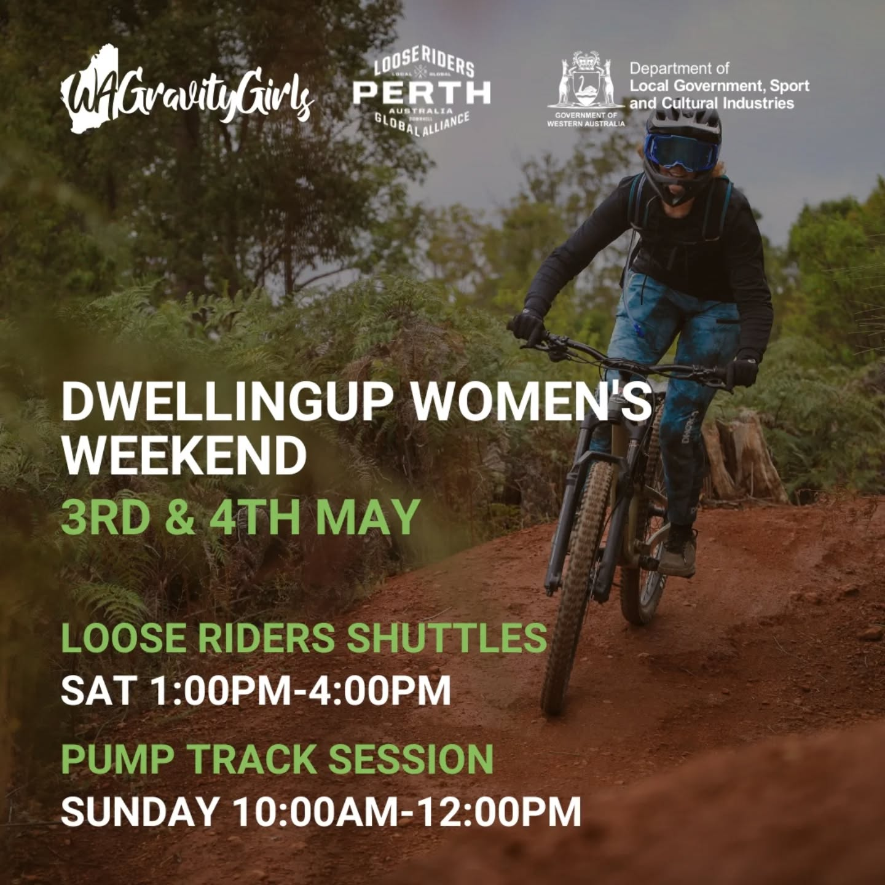
491493541_18060530492037999_5804892184521719118_n
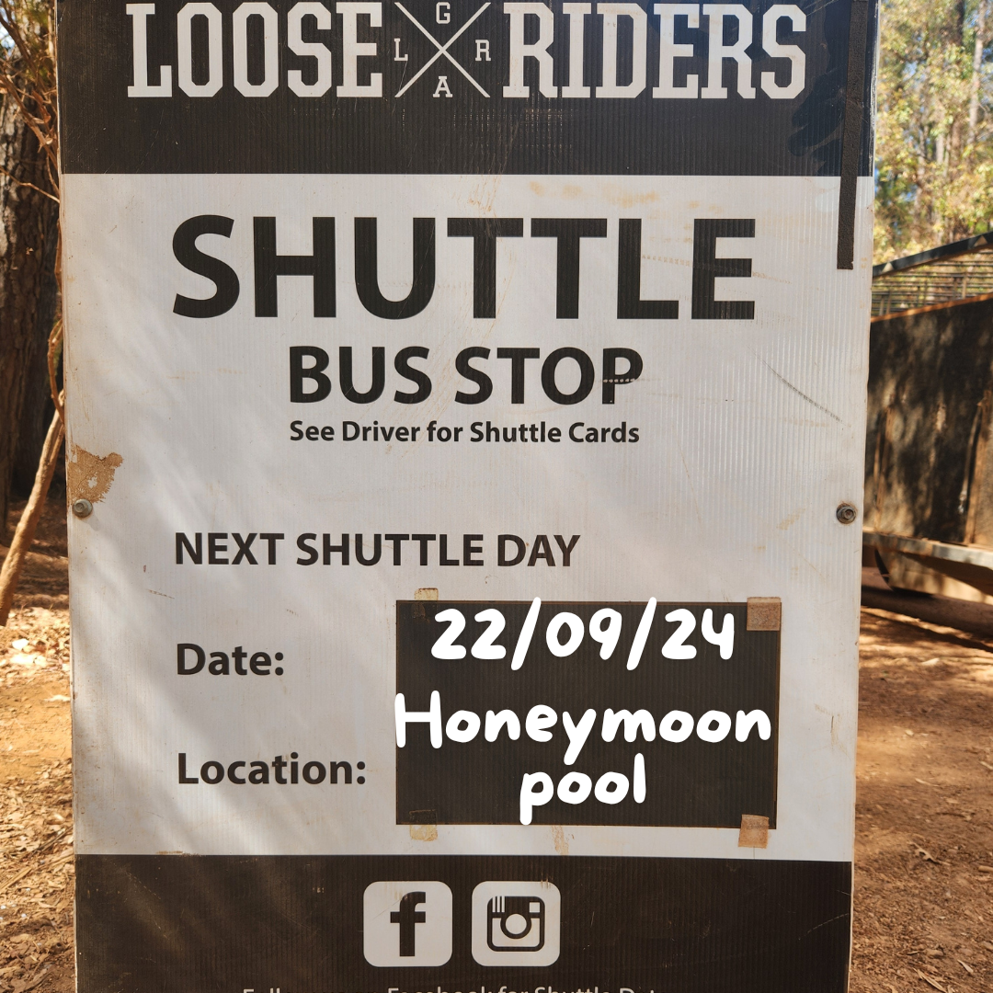
220924
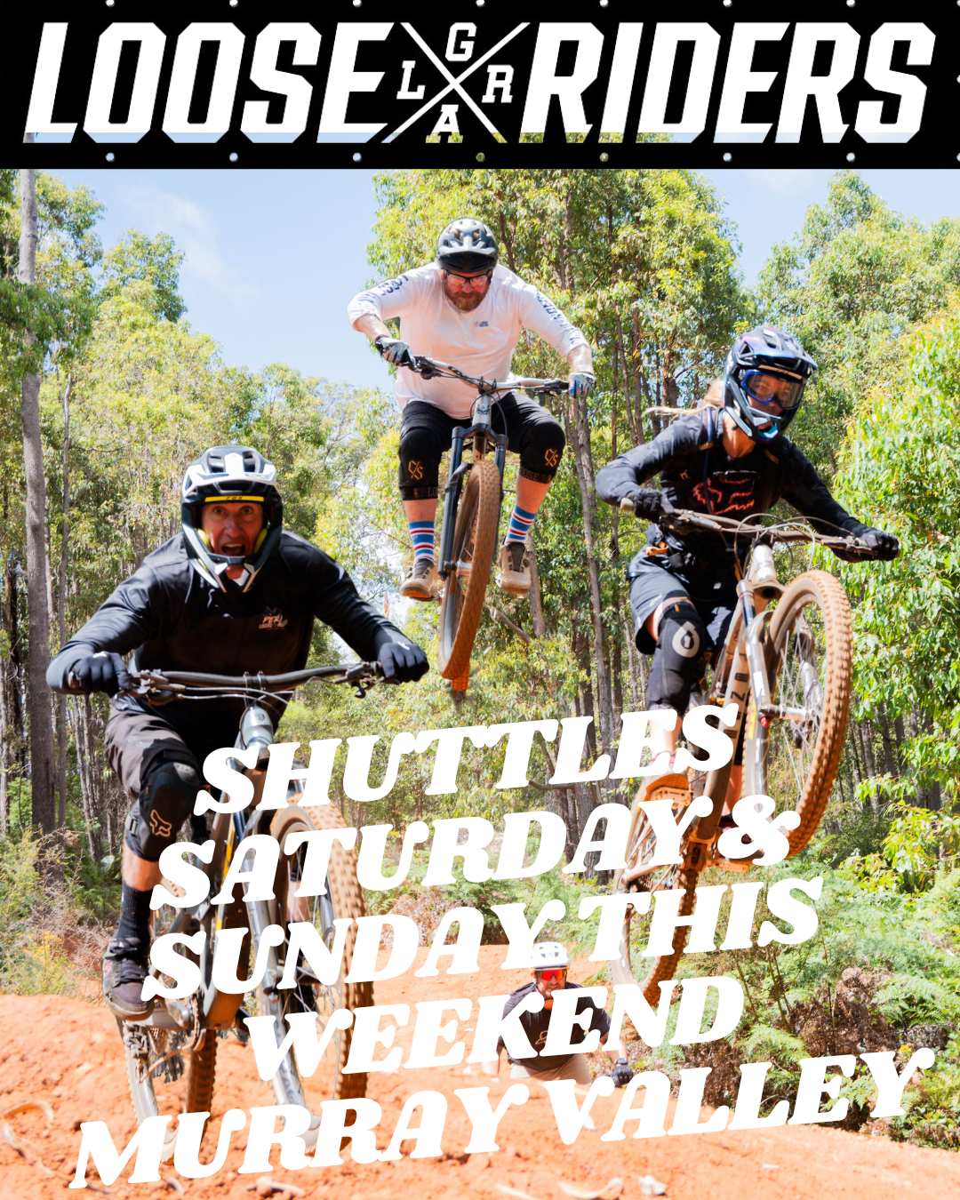
Murrray Valley Sunday 8.00am-12.00pm

Other Information
- The business accepts the companion card

Guide Dog and Service Animals
The business provides the following services for services animals:
We don't cater for service animals.

GENERAL

Pre-arrival, arrival and reception
The business has the following in place to support guests during pre-arrival, arrival and reception
- A familiarisation tour
- In addition, the following further information can assist guests:
We operate mainly in the bush &amp; wait times are no longer than 15 minutes.

Car Park and Access amenities
The business has the following Car Park and Access amenities
- A drop off zone
The width of the smallest corridor is:
No corridors
The width of the smallest pathway is:
500mm

Mountain bike trails are steep & technical with loose rock & tree roots on most trails.

Trails are all mountain bike trails not suitable for wheelchairs.

Public Toilets/Adult change facilities
Public Toilets/Adult change facilities have the following amenities are in place
- There is an accessible toilet for public use
- The door is at least 850mm wide
- There is a minimum of 850mm beside the toilet
- The toilet seat is 460mm above the floor
- The toilet seat is460mm above the floor
- In addition, the following further information can assist guests:
Depending where we are there are toilet facilities available but are limited.

TOUR OPERATORS

Tour/Transport Services
The tour/transport services have the following facilities/amenities in place
- Buses/Coaches
- 0 vehicles have wheelchair lifts or ramps
- 0 vehicles have low floors with ramped entry
The maximum wheelchair capacity available in the fleet is:
0
- In addition, the following further information can assist guests:
We only operate a 11 seat mountain bike shuttle bus
  - Image(s)
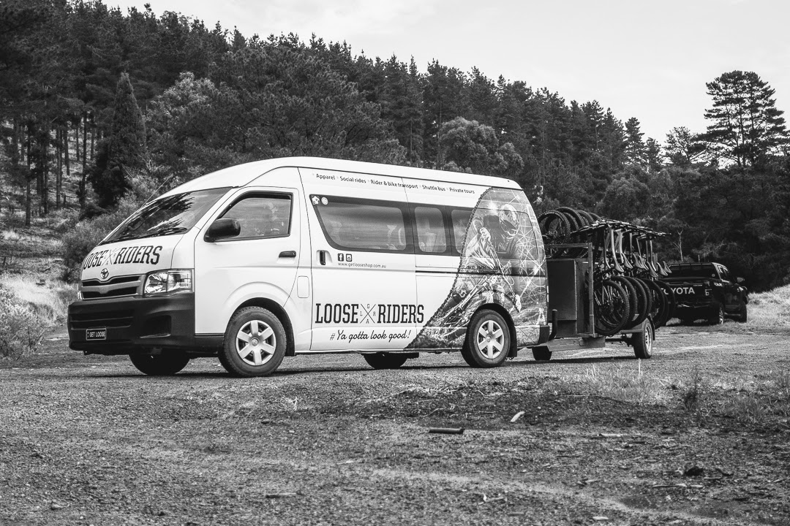
210313_Wellington_Mills-17
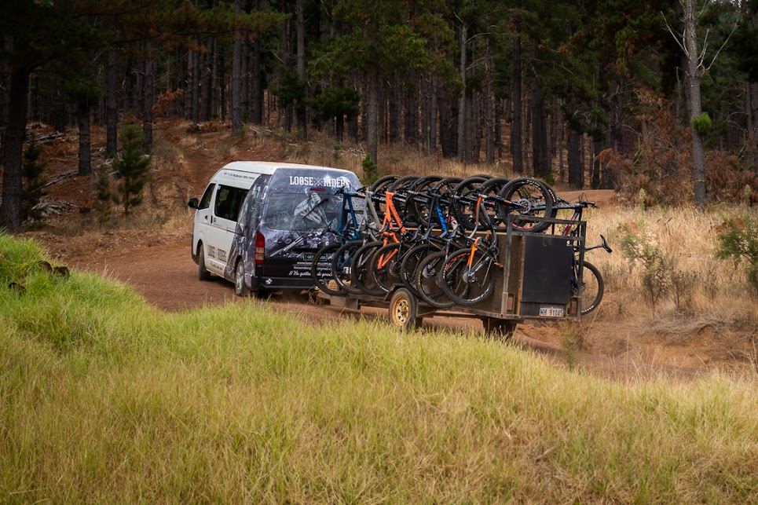
210313_Wellington_Mills-18
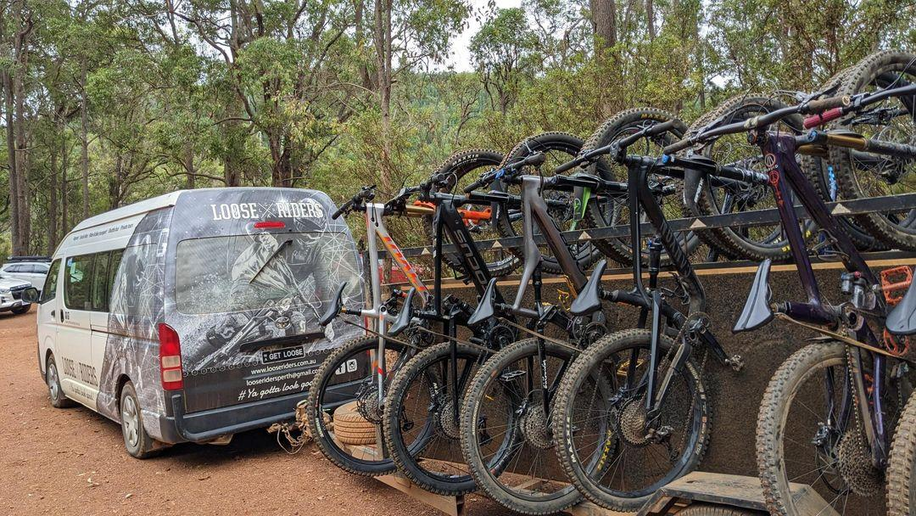
IMG_20230404_071841_455 - Copy

ATTRACTIONS

Attractions Basics
- A park map is available here:

https://getlooseshop.com.au/

COMMON AREAS

ADVENTURE ACTIVITIES

EVENTS

Events
Events have the following facilities/amenities in place
- Accessible toilets are available at the venue
- Food and water is available for guide and service animals
- The event is outdoors
- Accessible car parking is available
- There is an event map available

Report Disclaimer
Please note that this business report, provided as a result of the use of the diagnostic assessment, is for information purposes only.
Australian Tourism Industry Council (ATIC) cannot guarantee the accuracy of respondent’s answers, or that they are fully representative of your business. Therefore, ATIC does not warrant or guarantee any particular outcome in respect of your businesses self-assessment.
This report is intended as guidance only for your business and should not be relied on for future marketing considerations. ATIC recommends that you seek your own independent advice as well as the results from the diagnostic.
Links to external web sites are inserted for convenience and do not constitute endorsement of material at those sites, or any associated organisation, product or service.
ATIC does not:
- Assume any legal liability for the accuracy, completeness, or usefulness of any information from this report or any links provided; or
- Accept responsibility for any loss associated directly or indirectly from the use of this report.

