ATIC Accessibility
To support the accessible community in making informed travel decisions for their individual needs

This report prepared for:
Business name: | Epic Marine Charters
Address: | Shop 11 1050 Manly Road
Town: | Tingalpa
Contact for enquiries: | NICOLE MILES
Contact Number: | 0434853742
Contact Email: | info@eipicmarinecharters.com.au
Website: | www.epicmarinecharters.com.au
Date: | 2026-10-25 03:22

ATIC Accessibility
The following pages provides travellers with information on the businesses facilities and amenities which aims to support the traveller to make an informed decision on whether the business is suitable for their individual needs.
OVERVIEW 4
Business Overview 4
Bookings 6
Emergency Management 6
Communications 6
GENERAL 8
Pre-arrival, arrival and reception 8
Cognitive Impairment Support 8
Car Park and Access amenities 8
External Paths 8
Steps 9
Public Toilets/Adult change facilities 9
TOUR OPERATORS 10
Route Planning 10
FOOD AND DRINK 11
Dining Spaces 11
ADVENTURE ACTIVITIES 12
Report Disclaimer 14

OVERVIEW

Business Overview

Our business caters for the following disability types:
- Deaf or low hearing
- Cognitive or people on the Autism Spectrum
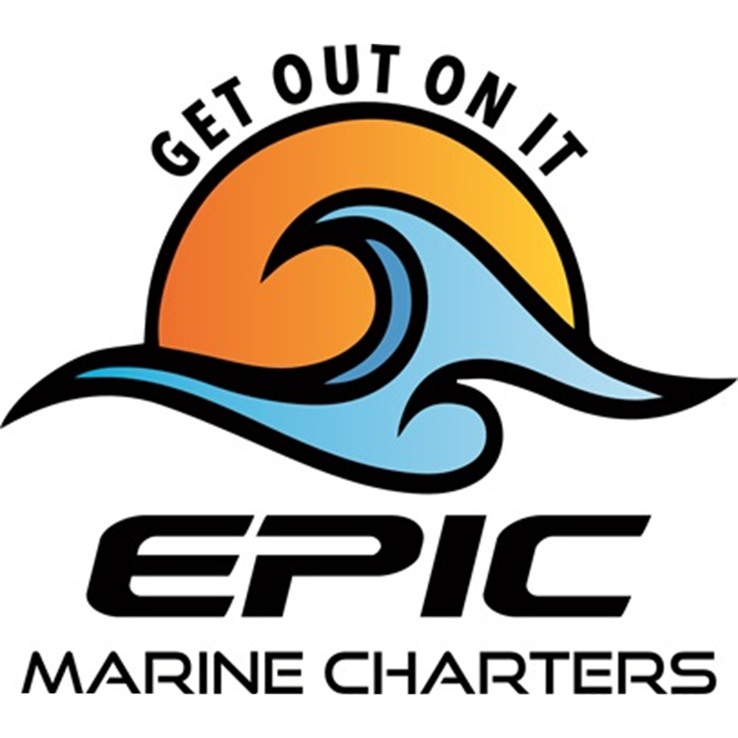

Bookings

The business offers the following methods for bookings and enquiries:
- Phone
- Email
- Webportal
- Our forms have high contract boxes and submit boxes

Emergency Management
- Emergency and evacuation procedures are explained on arrival
- There are visual device/s to alert occupants to evacuate.
- Exit signs are clear and easy to see
- Exit access is free and clear at all times
We ensure exit access is free and clear at all times by:
Door on transom is accessible
- Exits to the emergency evacuation point does not include stairways
- The evacuation point is clearly marked by a sign
- In addition, the following further information can assist guests:
They are usually accompanied by a carer
- In addition, the following further information can assist guests:
Crew will assist the passenger in putting on the life jacket and evacuating the vessel
- Guests with disabilities are noted in the guest log book for emergency and evacuation purposes

Communications
- Our business offers the following alternative communication methods
- Plain English
- Magnifiers

Not specified
- There is easy to read signage and information (e.g. menus and emergency information)
The business provides the following services for services animals:
Not specified

GENERAL

Pre-arrival, arrival and reception
The business has the following in place to support guests during pre-arrival, arrival and reception
- Booking information and websites are compatible with screen readers
- Information and maps are available in written form
- In addition, the following further information can assist guests:
N/A
- In addition, the following further information can assist guests:
N/A

Cognitive Impairment Support
- Documents are available in plain English for people with cognitive impairment (This may include instructions, guides, menus and general information)

Car Park and Access amenities
The business has the following Car Park and Access amenities
- A drop off zone
- Designated disabled parking bays
- Level or ramped access from the car park to the entrance
- In addition, the following further information can assist guests:
N/A

External Paths
External paths of travel
- Surfaces are concrete, asphalt, smooth paving or hard packed fine gravel (max aggregate size 13mm)
- Paths or slopes longer than 15 metres have resting places or seats
- Pathways are wider than 900mm
- There 3 successive steps or less on any path or at any doorway
- Any paths having steps are clearly identified as non-wheelchair accessible
- Step free routes clearly signed
- In addition, the following further information can assist guests:
N/A

Steps
Steps
- There are steps.
- Top and bottom steps are easily distinguished through colour contrast or the use of TGSIs (Tactile Ground Surface Indicators)
- The underside of all staircases are enclosed or protected to a height of at least 2 metres
- Handrails fitted to all open sets of steps
- Where steps are present are there three steps or less
- In addition, the following further information can assist guests:
N/A

Public Toilets/Adult change facilities
Public Toilets/Adult change facilities have the following amenities are in place
- There is an accessible toilet for public use
- The door is 650mm wide
- There is 650mm mm beside the toilet
- The toilet seat of a contrasting colour to the floor
- The toilet seat is460mm above the floor
- In addition, the following further information can assist guests:
N/A

TOUR OPERATORS
- 0 vehicles have wheelchair lifts or ramps
- 0 vehicles have low floors with ramped entry
The maximum wheelchair capacity available in the fleet is:
0

Route Planning
- The door is at least 850mm wide
- There is 250mm mm beside the toilet
- The toilet seat of a contrasting colour to the floor
- The height of the toilet seat is 450mm.
  - Accessible Toilet Image(s)
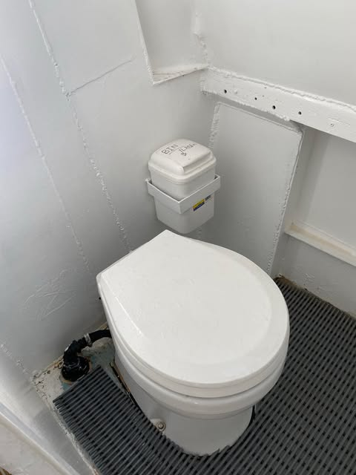
TOILET ONBOARD

FOOD AND DRINK

Dining Spaces
The dining spaces have the following facilities/amenities in place
- There is an accessible toilet close by that is open during our business hours

ADVENTURE ACTIVITIES
- In addition, the following further information can assist guests:
Sightseeing on the vessel
- In addition, the following further information can assist guests:
Passengers need to have the ability to step on board and off the boat
- In addition, the following further information can assist guests:
We do not have wheelchair accessible toilet

Report Disclaimer
Please note that this business report, provided as a result of the use of the diagnostic assessment, is for information purposes only.
Australian Tourism Industry Council (ATIC) cannot guarantee the accuracy of respondent’s answers, or that they are fully representative of your business. Therefore, ATIC does not warrant or guarantee any particular outcome in respect of your businesses self-assessment.
This report is intended as guidance only for your business and should not be relied on for future marketing considerations. ATIC recommends that you seek your own independent advice as well as the results from the diagnostic.
Links to external web sites are inserted for convenience and do not constitute endorsement of material at those sites, or any associated organisation, product or service.
ATIC does not:
- Assume any legal liability for the accuracy, completeness, or usefulness of any information from this report or any links provided; or
- Accept responsibility for any loss associated directly or indirectly from the use of this report.

