ATIC Accessibility
To support the accessible community in making informed travel decisions for their individual needs

This report prepared for:
Business name: | Hobart City Apartments
Address: | 147 Macquarie st Hobart Tas 7000 Australia
Town: | Hobart
Contact for enquiries: | Lawrence Heasman
Contact Number: | 03 6240 5585
Contact Email: | lawrence@hobartcityapartmenthotel.com
Website: | hobartcityapartmenthotel.com
Date: | 2026-05-11 23:52

ATIC Accessibility
The following pages provides travellers with information on the businesses facilities and amenities which aims to support the traveller to make an informed decision on whether the business is suitable for their individual needs.
OVERVIEW 4
Business Overview 4
Bookings 6
Emergency Management 6
Communications 6
Other Information 7
Guide Dog and Service Animals 7
GENERAL 8
Pre-arrival, arrival and reception 8
Car Park and Access amenities 8
External Paths 8
Steps 9
Ramps 9
Public Toilets/Adult change facilities 9
ACCOMMODATION 10
Bedrooms 10
Room Amenities 10
Bathrooms 11
COMMON AREAS 12
Report Disclaimer 14

OVERVIEW

Business Overview

The business has the following products/services available
- Accommodation

Our business caters for the following disability types:
- Blind or low vision
- Limited mobility
- Wheelchairs or mobility scooters
- Cognitive or people on the Autism Spectrum
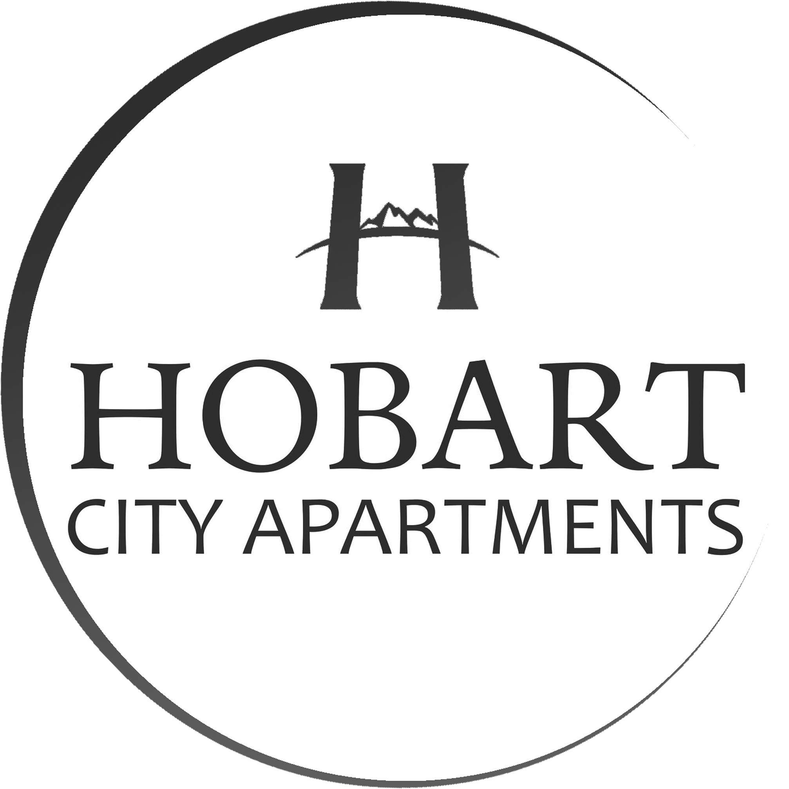

Bookings

The business offers the following methods for bookings and enquiries:
- Phone
- Email
- Webportal
- Our website supports Screen Readers
- Our forms have high contract boxes and submit boxes

Emergency Management
- There are Audible device/s to alert occupants to evacuate with instructions on how to evacuate.
- Exit signs are clear and easy to see
- Exit access is free and clear at all times
We ensure exit access is free and clear at all times by:
By monitoring it.
- Exits and access to exists are greater than 900mm
- Exit doors are able to be opened by all occupants
- Exits to the emergency evacuation point does not include stairways
- The evacuation point is clearly marked by a sign
The business identifies guests who need additional assistance should an emergency occur by:
by room type
The procedure for assisting guests who need assisted rescue is:
Go to room and show them where to wait until the emergency services arrive.
- Guests with disabilities are noted in the guest log book for emergency and evacuation purposes

Communications
- Our website meets WCAG 2.0 accessibility standards

Other Information
- The business accepts the companion card

Guide Dog and Service Animals
- The business provides a secure area with shade and water for service animals
The business provides the following services for services animals:
Not specified

GENERAL

Pre-arrival, arrival and reception
The business has the following in place to support guests during pre-arrival, arrival and reception
- Booking information and websites are compatible with screen readers
- There is a reception/public entryway.
- Seating available at reception
- A lower counter at reception/ticket office
- A clipboard to allow check-in/ticket purchase whilst seated
- A tablet with text to voice or pen and paper at reception to aid in communication
- Picture Board at reception to aid in communication
- Lighting in the reception area is even and glare free
- Large print information sheets and registration forms
- Information and maps are available in written form
- A familiarisation tour
- Keys are available for each guest
- Luggage assistance
- In addition, the following further information can assist guests:
Most people are dealt with immediately upon entering the hotel reception. At most there would be a 5 minute wait if there is a guest already being served.

Car Park and Access amenities
The business has the following Car Park and Access amenities
- A drop off zone
- Designated disabled parking bays
- Level or ramped access from the car park to the entrance
- The accessible entrance is clearly signed from the parking bay
- An intercom system is available at the entrance of car park

External Paths
External paths of travel
- Surfaces are concrete, asphalt, smooth paving or hard packed fine gravel (max aggregate size 13mm)
- Pathways are wider than 900mm

We have no paths.
- Step free routes clearly signed

Steps
Steps
- There are steps.
- Top and bottom steps are easily distinguished through colour contrast or the use of TGSIs (Tactile Ground Surface Indicators)
- All steps or staircases have enclosed risers
- The underside of all staircases are enclosed or protected to a height of at least 2 metres
- Handrails fitted to all open sets of steps
- Handrails extend 300mm beyond the top and bottom step
- Where steps are present are there three steps or less
- In addition, the following further information can assist guests:
There are lifts to all levels

Ramps
Ramps have the following amenities are in place
- There are ramps.
- All fixed ramps are 1:14 or less
- Hand rails are fitted
- Long ramps (more than 10m) are 1:20 or less

Public Toilets/Adult change facilities
Public Toilets/Adult change facilities have the following amenities are in place
- There is an accessible toilet for public use
- The door is at least 850mm wide
- There is a minimum of 850mm beside the toilet
- Handrails are fitted
- The toilet seat is 460mm above the floor
- The toilet seat of a contrasting colour to the floor
- The toilet seat is460mm above the floor

ACCOMMODATION

Bedrooms
The bedrooms have the following facilities/amenities in place
- There are 5 rooms available to guests who use a wheelchair
- Bedroom furniture can be re-arranged on request
  - Layout of room Image(s)
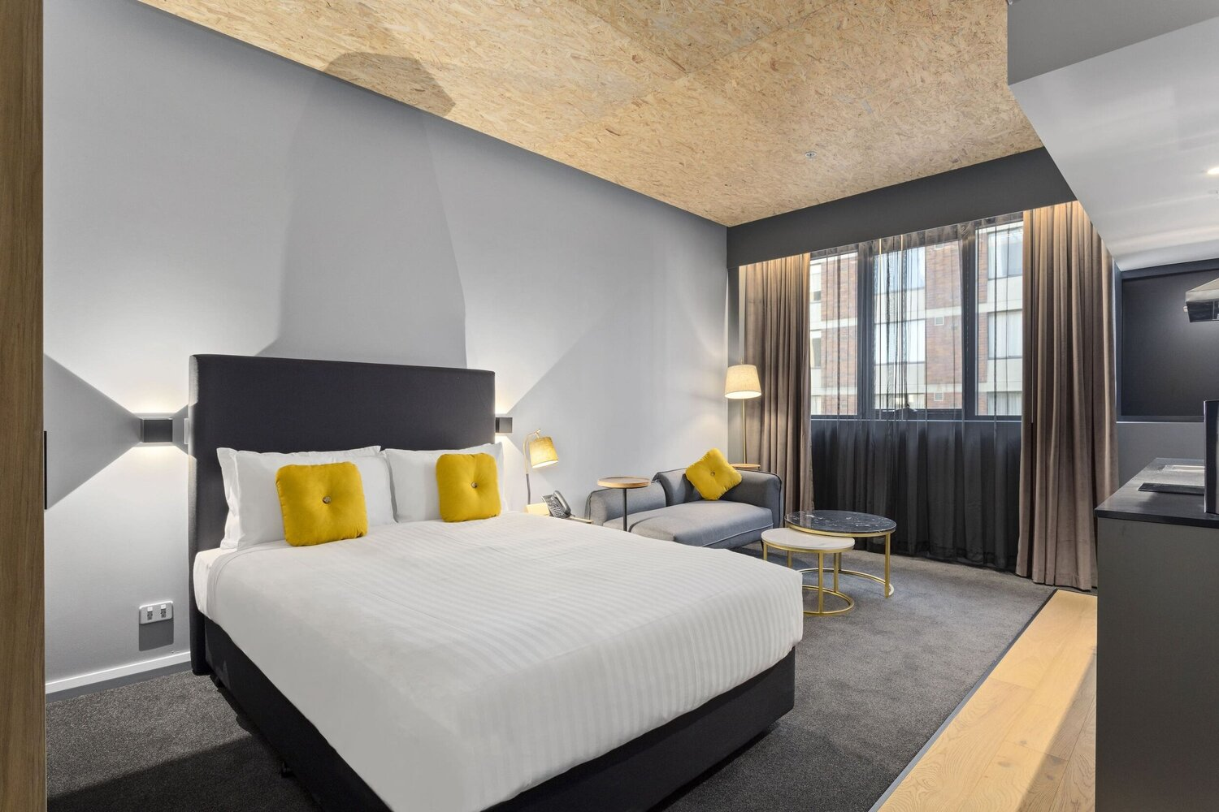
accessible Queen

Room Amenities
- Televisions are equipped with closed captioning capability
- Room phones have volume control
- Room phones have a visual ringing indicator
- There is contrast between the walls, skirtings, floor and furniture
- There is a clear path through the room
- The edges of all furniture and fixtures are rounded
- Wardrobe handles are a contrasting colour to the doors and draws
- Housekeeping procedures instruct staff not to reposition furniture that has been moved
- Doors open fully against the adjoining wall
- There is a clear opening at least 850mm wide
- There luggage racks for at least two suitcases
- Wardrobe and drawer handles are easy to grip
- The bedside lamp switch is easy to reach from the bed
- There is at least 850mm clear space beside the bed
- The bed height is no higher than 680mm from the floor
- There is at least 130mm clearance under the bed

Bathrooms
The bathrooms have the following facilities/amenities in place
- All heating appliances and hot water pipes are protected or insulated
- All shower, bath and basin taps are clearly differentiated between hot and cold
- Fixtures and fittings have rounded edges
- The door is at least 850mm wide
- There is a minimum of 850mm beside the toilet
- Handrails are fitted
- There is a minimum of 1400mm of clear space in front of the toilet
- The toilet seat is a contrasting colour to the floor
- The toilet seat is 460mm above the floor
- There is a roll-in shower with fold down fixed seat or a shower chair
- There is a portable shower head on flexible hose
  - Bathroom Image(s)
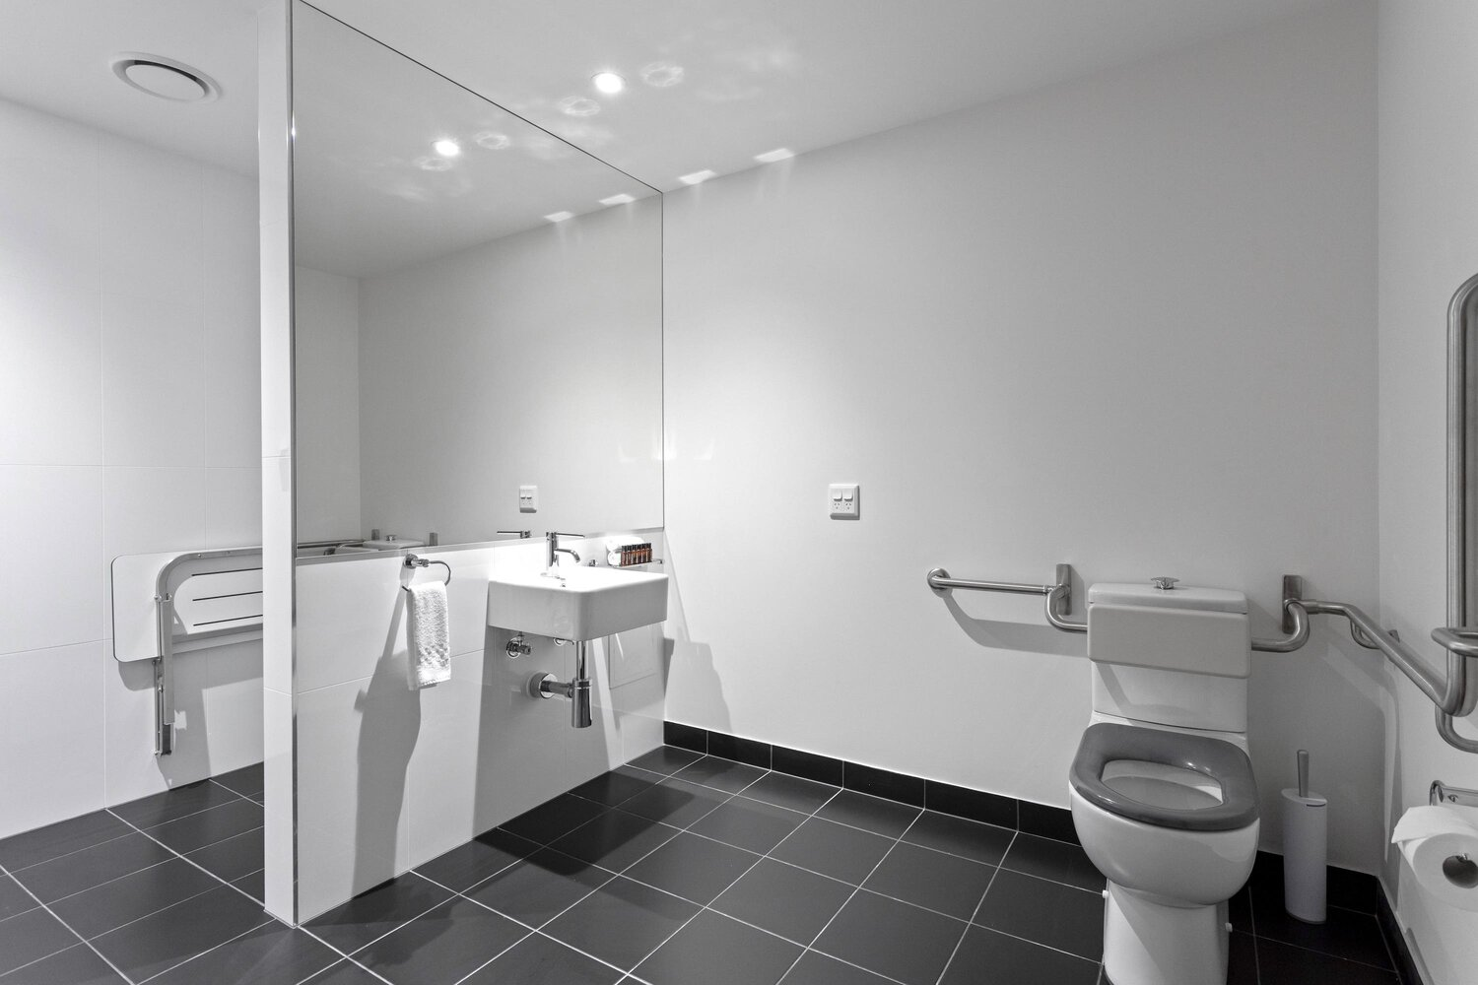
accessible bathroom
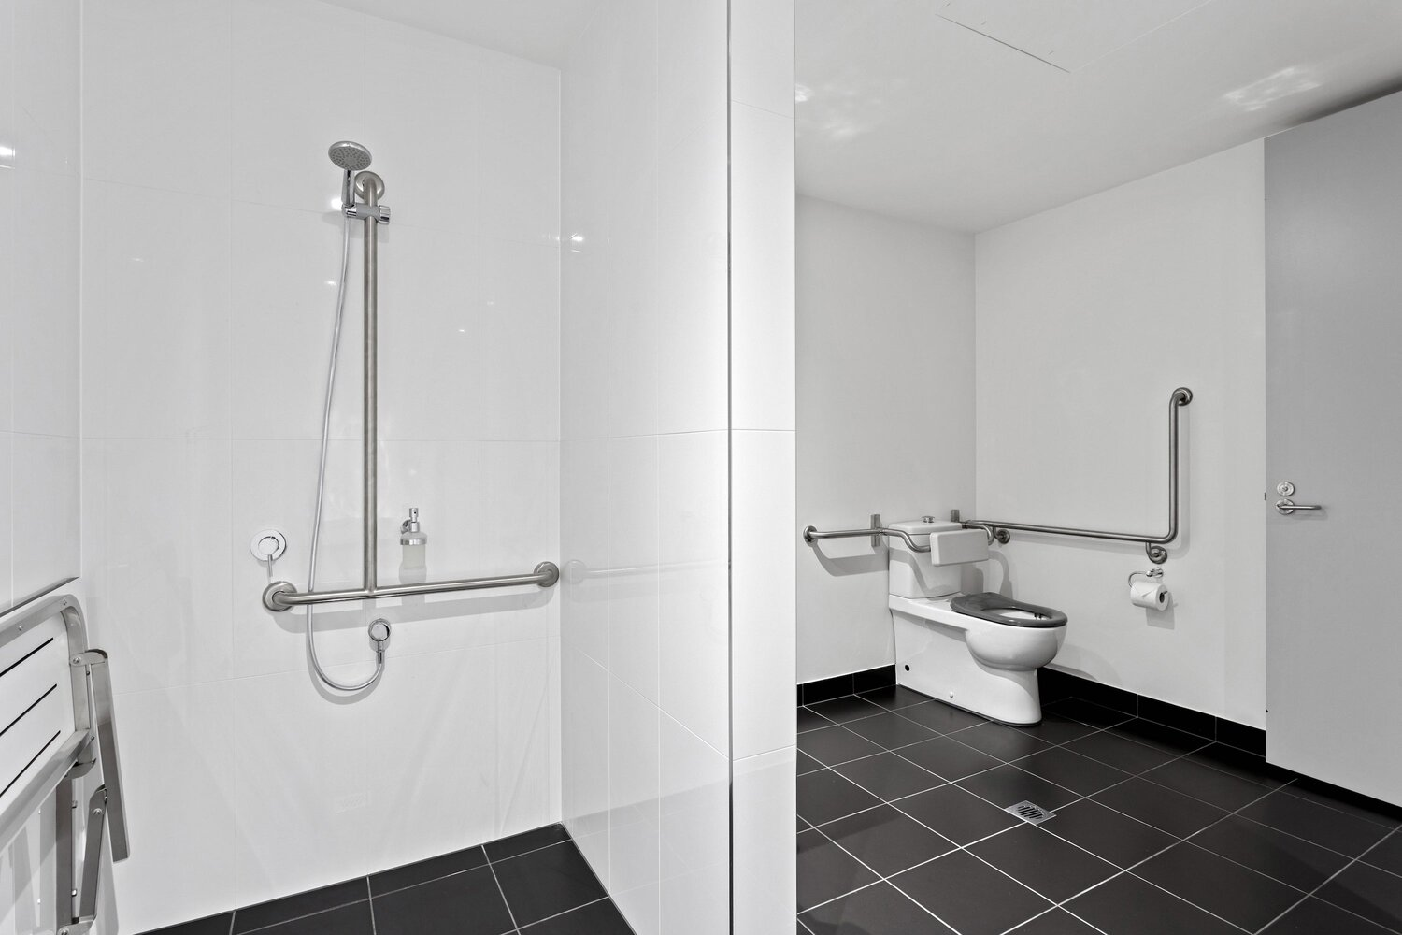
Accessible showe

COMMON AREAS

Report Disclaimer
Please note that this business report, provided as a result of the use of the diagnostic assessment, is for information purposes only.
Australian Tourism Industry Council (ATIC) cannot guarantee the accuracy of respondent’s answers, or that they are fully representative of your business. Therefore, ATIC does not warrant or guarantee any particular outcome in respect of your businesses self-assessment.
This report is intended as guidance only for your business and should not be relied on for future marketing considerations. ATIC recommends that you seek your own independent advice as well as the results from the diagnostic.
Links to external web sites are inserted for convenience and do not constitute endorsement of material at those sites, or any associated organisation, product or service.
ATIC does not:
- Assume any legal liability for the accuracy, completeness, or usefulness of any information from this report or any links provided; or
- Accept responsibility for any loss associated directly or indirectly from the use of this report.

