ATIC Accessibility
To support the accessible community in making informed travel decisions for their individual needs

This report prepared for:
Business name: | Turquoise Safaris
Address: | 10 Grigson Street
Town: | Jurien Bay
Contact for enquiries: | Kane Krollig
Contact Number: | 1300 723 274
Contact Email: | info@turquoisesafaris.com.au
Website: | www.turquoisesafaris.com.au
Date: | 2026-10-19 15:48

ATIC Accessibility
The following pages provides travellers with information on the businesses facilities and amenities which aims to support the traveller to make an informed decision on whether the business is suitable for their individual needs.
OVERVIEW 4
Business Overview 4
Bookings 4
Emergency Management 5
Communications 5
Other Information 5
Guide Dog and Service Animals 5
GENERAL 6
Pre-arrival, arrival and reception 6
Car Park and Access amenities 6
External Paths 6
Ramps 6
Public Toilets/Adult change facilities 6
TOUR OPERATORS 8
Tour/Transport Services 8
Guides 8
ADVENTURE ACTIVITIES 10
Adventure activities 10
Report Disclaimer 12

OVERVIEW

Business Overview

The business has the following products/services available
- Tour/Transport
- Adventure

Our business caters for the following disability types:
- Blind or low vision
- Deaf or low hearing
- Limited mobility
- Wheelchairs or mobility scooters
- Food allergies or intolerances
- Cognitive or people on the Autism Spectrum


Bookings

The business offers the following methods for bookings and enquiries:
- Phone
- Email
- Webportal
- Our website supports Screen Readers
- Our forms have high contract boxes and submit boxes

Emergency Management
- Emergency and evacuation procedures are explained on arrival
- Exit access is free and clear at all times
We ensure exit access is free and clear at all times by:
Crew keep exit door clear, passenger items are stored under seats, able to exit over sides if required.
- Exit doors are able to be opened by all occupants
- Exits to the emergency evacuation point does not include stairways
- In addition, the following further information can assist guests:
Logged on daily manifest, crew are informed
- In addition, the following further information can assist guests:
Staff are allocated to guest and are with guests who need assistance throughout the tour and will assist.
- Guests with disabilities are noted in the guest log book for emergency and evacuation purposes

Communications
- Our business offers the following alternative communication methods
- Plain English

Not specified

Other Information
- The business accepts the companion card

Guide Dog and Service Animals
The business provides the following services for services animals:
N/A

GENERAL

Pre-arrival, arrival and reception
The business has the following in place to support guests during pre-arrival, arrival and reception
- Booking information and websites are compatible with screen readers
- Information and maps are available in written form
- In addition, the following further information can assist guests:
Priority Boarding

Car Park and Access amenities
The business has the following Car Park and Access amenities
- A drop off zone
- Designated disabled parking bays
- Level or ramped access from the car park to the entrance
- The accessible entrance is clearly signed from the parking bay

External Paths
External paths of travel
- Surfaces are concrete, asphalt, smooth paving or hard packed fine gravel (max aggregate size 13mm)
- Pathways are wider than 900mm

Ramps
Ramps have the following amenities are in place
- Temporary ramps are in place for the duration of the guests stay

Public Toilets/Adult change facilities
Public Toilets/Adult change facilities have the following amenities are in place
- There is an accessible toilet for public use
- The door is at least 850mm wide
- There is a minimum of 850mm beside the toilet
- Handrails are fitted
- The toilet seat of a contrasting colour to the floor
- The toilet seat is460mm above the floor

TOUR OPERATORS

Tour/Transport Services
The tour/transport services have the following facilities/amenities in place
- Buses/Coaches
- 0 vehicles have wheelchair lifts or ramps
- 1 Low floor, no ramp required. vehicles have low floors with ramped entry
The maximum wheelchair capacity available in the fleet is:
1
- Commentary is available in written format
- The door is N/A wide
- There is N/A mm beside the toilet

Guides
- Use of clear/simple English
- Correct pronunciation for lip readers
- Marine
- Marine craft are wheelchair accessible
- Length (cm) 80cm.
- Width (cm) 60cm.
- Height (cm) 90cm.
- Weight (kg) 30kg.
  - Image(s)
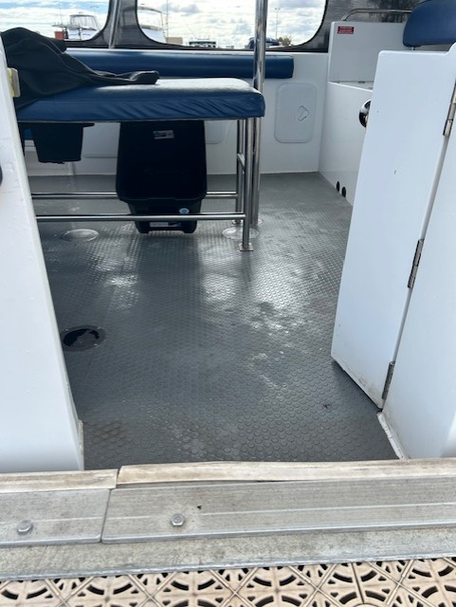
Access Door 2
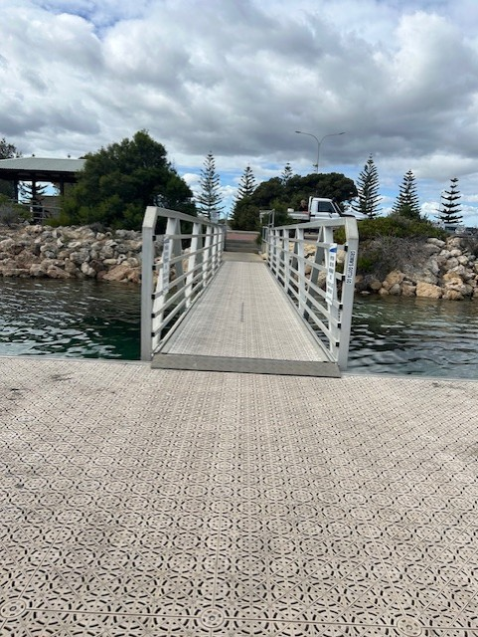
Access Ramp
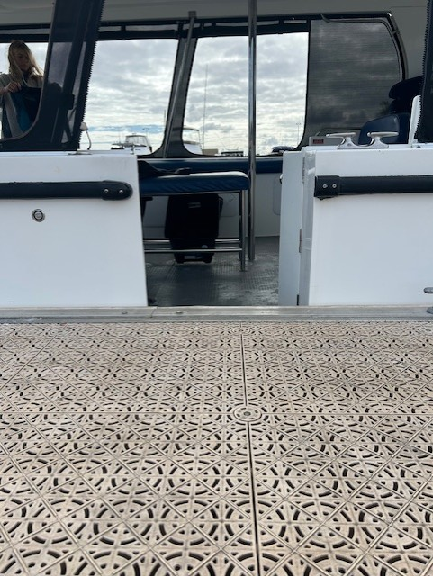
Doorwar Vessel

ADVENTURE ACTIVITIES

Adventure activities
The adventure activities have the following facilities/amenities in place
- Our adventure activities cater for people with a disability
- In addition, the following further information can assist guests:
Observing or Snorkeling with Australian Sea Lions
- In addition, the following further information can assist guests:
Buoyancy vests, life rings and extra crew members
- In addition, the following further information can assist guests:
Participants must have a basic swimming ability to participate as a snorkeler.
  - Adventure Activity Image(s)
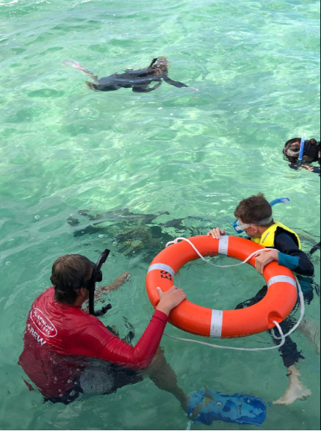
Crew with life ring

Report Disclaimer
Please note that this business report, provided as a result of the use of the diagnostic assessment, is for information purposes only.
Australian Tourism Industry Council (ATIC) cannot guarantee the accuracy of respondent’s answers, or that they are fully representative of your business. Therefore, ATIC does not warrant or guarantee any particular outcome in respect of your businesses self-assessment.
This report is intended as guidance only for your business and should not be relied on for future marketing considerations. ATIC recommends that you seek your own independent advice as well as the results from the diagnostic.
Links to external web sites are inserted for convenience and do not constitute endorsement of material at those sites, or any associated organisation, product or service.
ATIC does not:
- Assume any legal liability for the accuracy, completeness, or usefulness of any information from this report or any links provided; or
- Accept responsibility for any loss associated directly or indirectly from the use of this report.

