ATIC Accessibility
To support the accessible community in making informed travel decisions for their individual needs

This report prepared for:
Business name: | Wongai Beach Hotel
Address: | 2 Wees Street
Town: | HORN ISLAND
Contact for enquiries: | Kylie Ghee
Contact Number: | 0740831100
Contact Email: | manager@wongaibeachhotel.com.au
Website: | www.wongaibeachhotel.com.au
Date: | 2026-10-28 21:04

ATIC Accessibility
The following pages provides travellers with information on the businesses facilities and amenities which aims to support the traveller to make an informed decision on whether the business is suitable for their individual needs.
OVERVIEW 4
Business Overview 4
Bookings 4
Emergency Management 5
Communications 5
Guide Dog and Service Animals 6
GENERAL 7
Pre-arrival, arrival and reception 7
Cognitive Impairment Support 7
Car Park and Access amenities 7
Internal Spaces 8
External Paths 8
Steps 8
ACCOMMODATION 9
Room Amenities 9
Bathrooms 9
COMMON AREAS 12
Swimming pools, spas and waterparks 12
FOOD AND DRINK 13
Dining Spaces 13
Report Disclaimer 19

OVERVIEW

Business Overview

The business has the following products/services available
- Accommodation
- Food and Drink

Our business caters for the following disability types:
- Blind or low vision
- Deaf or low hearing
- Limited mobility
- Food allergies or intolerances
- Cognitive or people on the Autism Spectrum
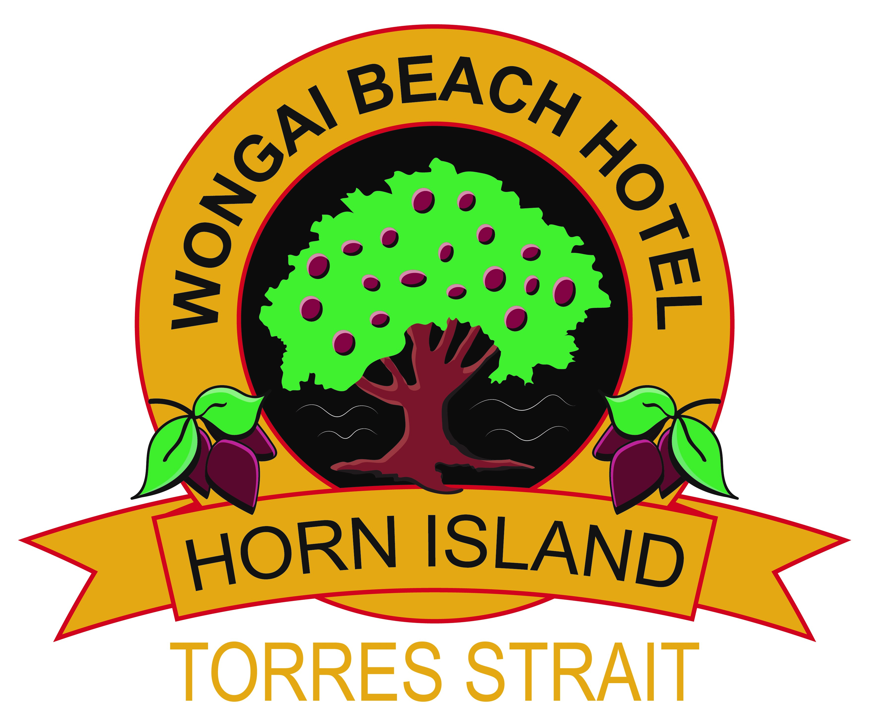

Bookings

The business offers the following methods for bookings and enquiries:
- Phone
- Email
- Webportal
- Our website supports Screen Readers
- Our forms have high contract boxes and submit boxes
- Staff have undergone disability awareness and training

Emergency Management
- Emergency and evacuation procedures are explained on arrival
- Exit signs are clear and easy to see
- Exit access is free and clear at all times
We ensure exit access is free and clear at all times by:
Staff are trained to ensure exit access is free and clear at all times.
- Exits and access to exists are greater than 900mm
- Exit doors are able to be opened by all occupants
- Exits to the emergency evacuation point does not include stairways
- The evacuation point is clearly marked by a sign
- In addition, the following further information can assist guests:
Staff note guest needs for additional assistance in the guest notes.
- In addition, the following further information can assist guests:
We will nominate a staff member to personally assist this person.
- Guests with disabilities are noted in the guest log book for emergency and evacuation purposes

Communications
- An accessibility guide is available on the website

https://www.wongaibeachhotel.com.au/accessible-tourism/
- Our website meets WCAG 2.0 accessibility standards
- Our business offers the following alternative communication methods
- Plain English
- Magnifiers

Not specified
- There is easy to read signage and information (e.g. menus and emergency information)

Guide Dog and Service Animals
- The business provides a secure area with shade and water for service animals
- The business provides a toilet area for service animals
- Bowls, bedding, etc. are provided for service animals
The business provides the following services for services animals:
We have a shaded area outside reception with water bowl provided. We can also access a small gated courtyard for a longer or quieter stay.

GENERAL

Pre-arrival, arrival and reception
The business has the following in place to support guests during pre-arrival, arrival and reception
- Booking information and websites are compatible with screen readers
- There is a reception/public entryway.
- Seating available at reception
- A clipboard to allow check-in/ticket purchase whilst seated
- Lighting in the reception area is even and glare free
- Large print information sheets and registration forms
- Information and maps are available in written form
- A familiarisation tour
- Keys are available for each guest
- Luggage assistance
- In addition, the following further information can assist guests:
We offer seating at reception.
- In addition, the following further information can assist guests:
Social script downloadable from the website.

Cognitive Impairment Support
- Documents are available in plain English for people with cognitive impairment (This may include instructions, guides, menus and general information)
- A "social script" guide to your premises or attraction describing the sights, sounds and smells to aid parents/carers prepare visitors in advance
- The 'social script' is available in word and other editable formats
- A space for parents and children on the Autism Spectrum

Car Park and Access amenities
The business has the following Car Park and Access amenities
- A drop off zone
- Level or ramped access from the car park to the entrance

Internal Spaces
- Menus are available in large print or Braille
- Tableware/glassware contrast with the table surface or table cloth

External Paths
External paths of travel
- Surfaces are concrete, asphalt, smooth paving or hard packed fine gravel (max aggregate size 13mm)
- Pathways are wider than 900mm
- There 3 successive steps or less on any path or at any doorway

Steps
Steps
- There are steps.
- Where steps are present are there three steps or less
- In addition, the following further information can assist guests:
Room 101-104 has deep, concrete steps without a handrail. Room 105-121 have 2 or 3 wooden steps with a handrail.

ACCOMMODATION

Room Amenities
- In addition, the following further information can assist guests:
Notes on guest file and staff member allocated to assist evacuation.
- Televisions are equipped with closed captioning capability
- There is a clear path through the room
- Wardrobe handles are a contrasting colour to the doors and draws
- Housekeeping procedures instruct staff not to reposition furniture that has been moved
- Doors open fully against the adjoining wall
- There is a clear opening at least 850mm wide
- Wardrobe and drawer handles are easy to grip
- The bedside lamp switch is easy to reach from the bed
- There is at least 850mm clear space beside the bed
- The bed height is no higher than 680mm from the floor
- There is at least 130mm clearance under the bed

Bathrooms
The bathrooms have the following facilities/amenities in place
- All heating appliances and hot water pipes are protected or insulated
- All shower, bath and basin taps are clearly differentiated between hot and cold
- The door is at least 850mm wide
- The width beside the toilet is 250.
- There is 900 mm of clear space in front of the toilet
- The toilet seat is a contrasting colour to the floor
- The toilet seat is 460mm above the floor
  - Bathroom Image(s)
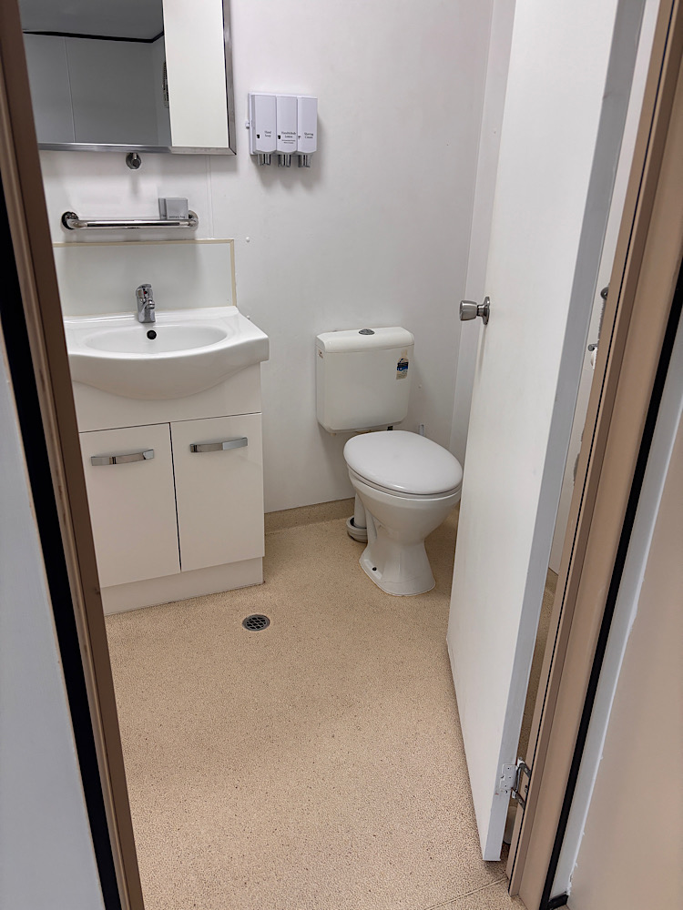
IMG_1876.JPG
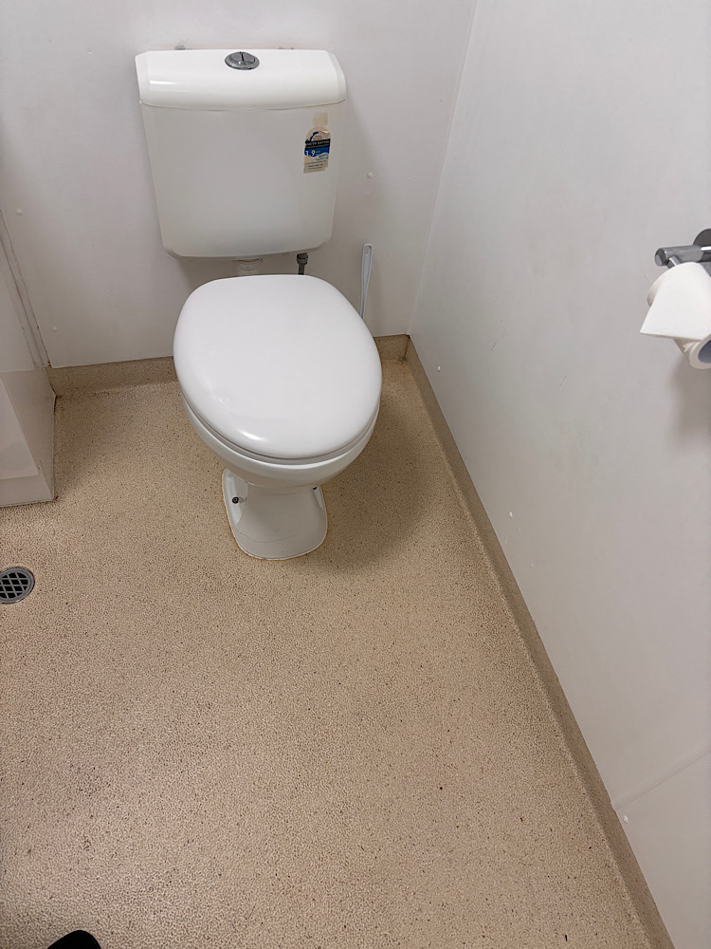
IMG_1877.JPG
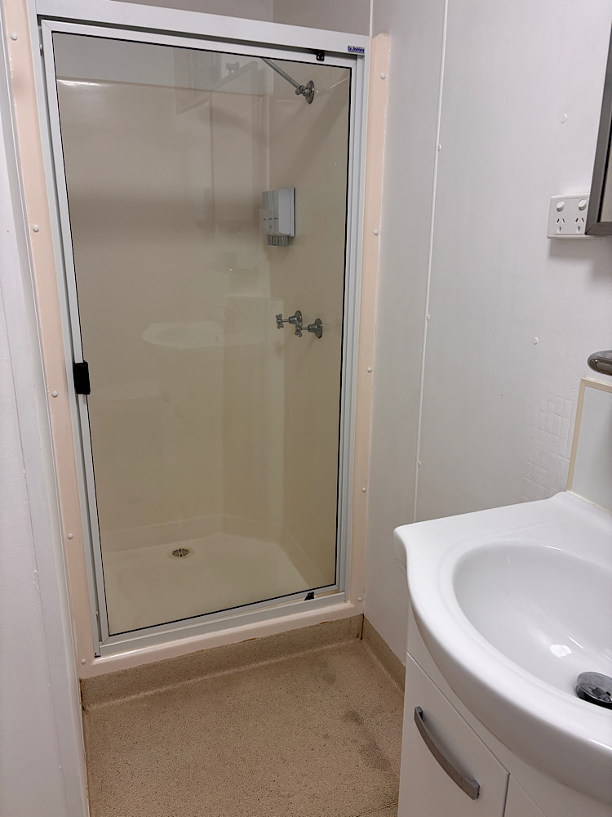
IMG_1878.JPG
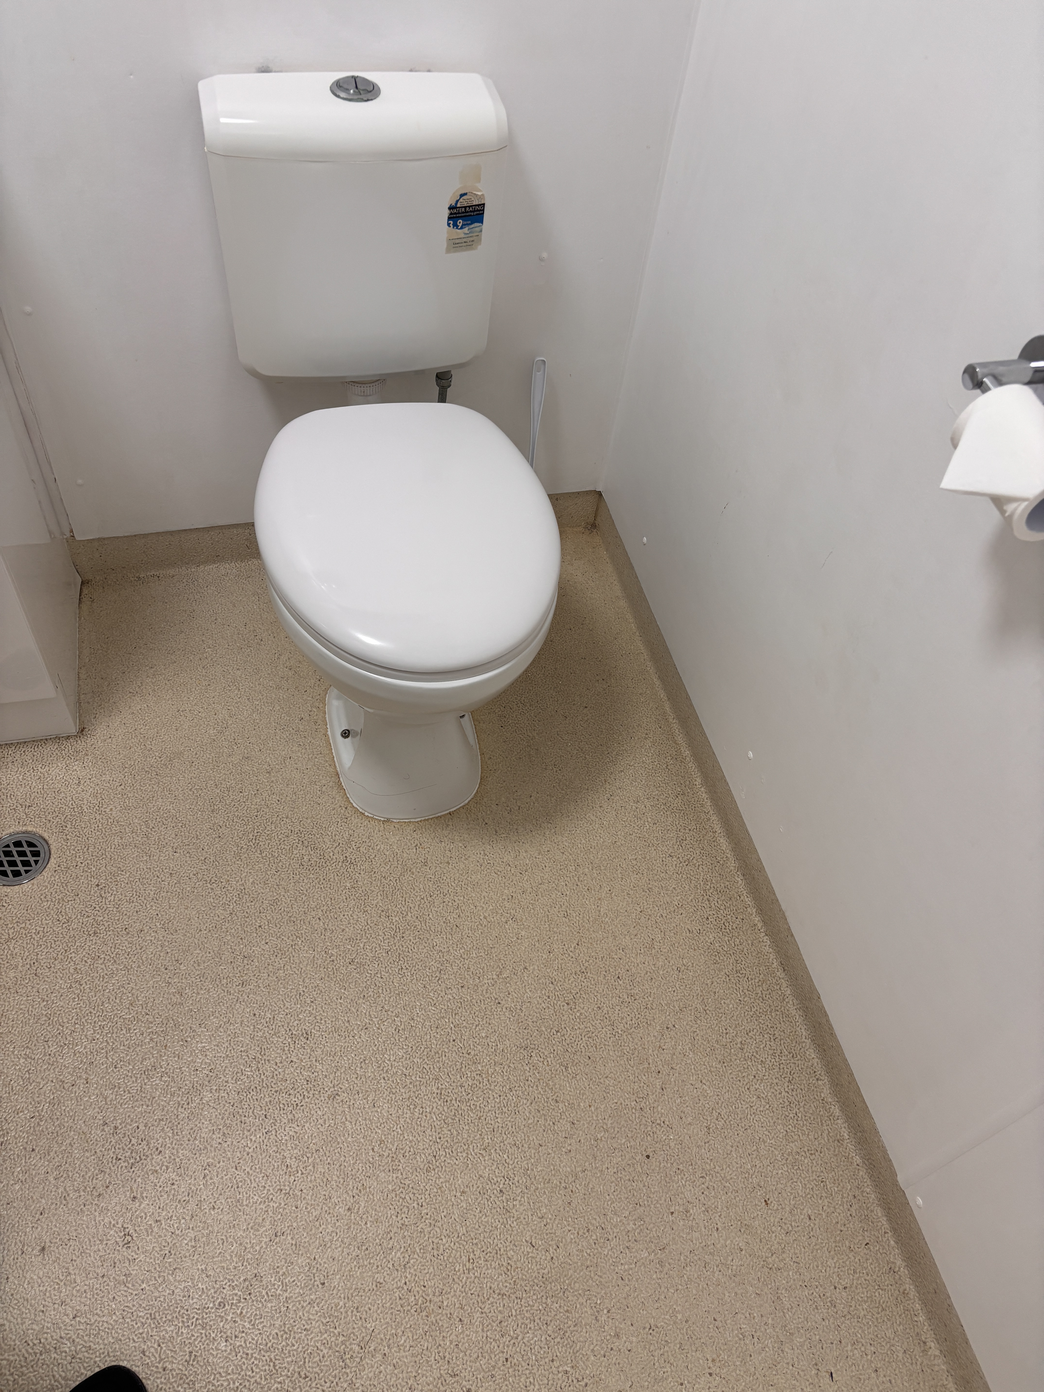
IMG_1865.JPG

COMMON AREAS

Swimming pools, spas and waterparks
- The following swimming pools, spas and waterparks amenities are available

FOOD AND DRINK

Dining Spaces
The dining spaces have the following facilities/amenities in place
- The entrance has level access
- The doorway is at least 850mm wide
- There is level access through the dining area
- Chairs are moveable to allow for wheelchairs to be seated at the tables
- All glass doors and full height windows have contrast markings
- There are areas of full lighting
- There are large print menus
- There are Plain English menus

Our business caters for the following dietary requirements
- Sugar free (diabetic)
- Gluten free (celiac)
- Lactose free (dairy free)
- Nut free
- Vegetarian
- Vegan
- In addition, the following further information can assist guests:
Seperate fryer and equipment used for gluten intolerance. Seperate equipment and prep area used for vegetarian and vegan.
  - Food and Beverage Image(s)
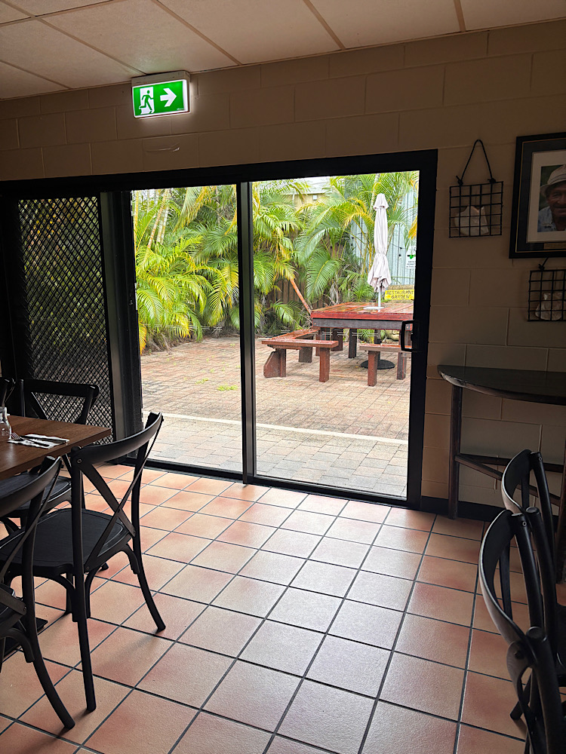
IMG_1879.JPG
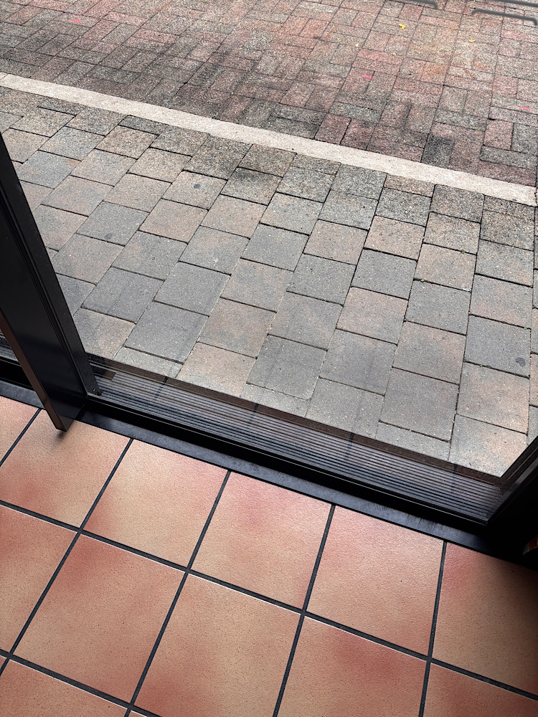
IMG_1880.JPG
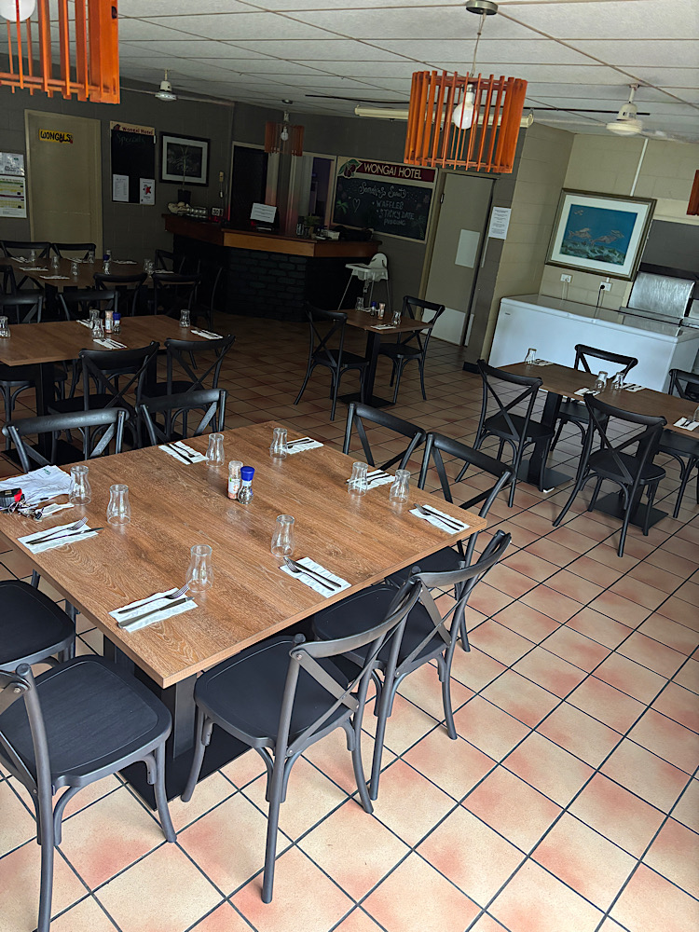
IMG_1881.JPG
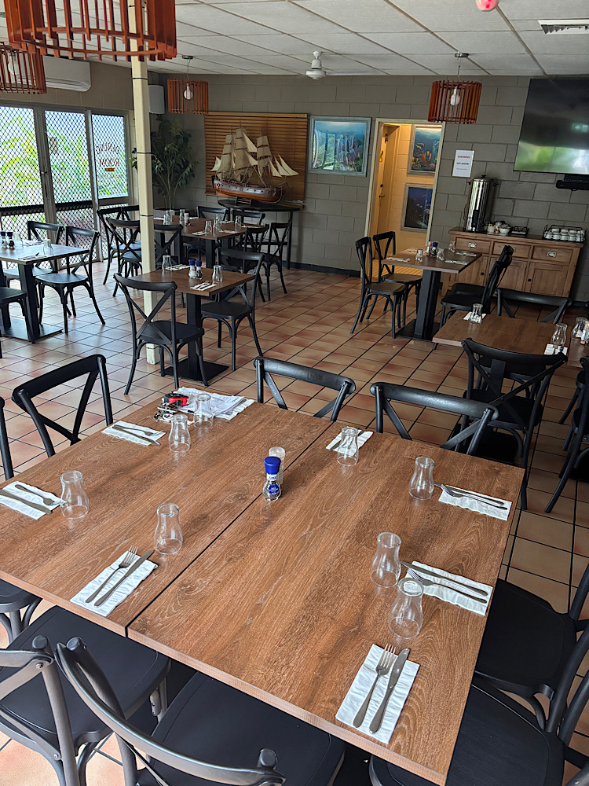
IMG_1882.JPG
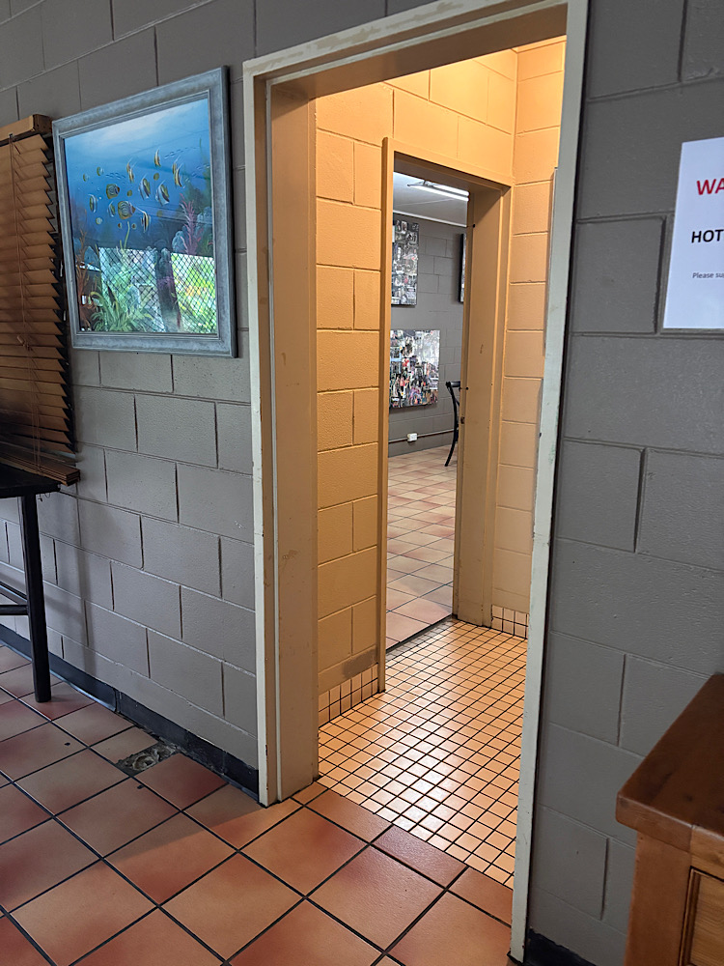
IMG_1883.JPG
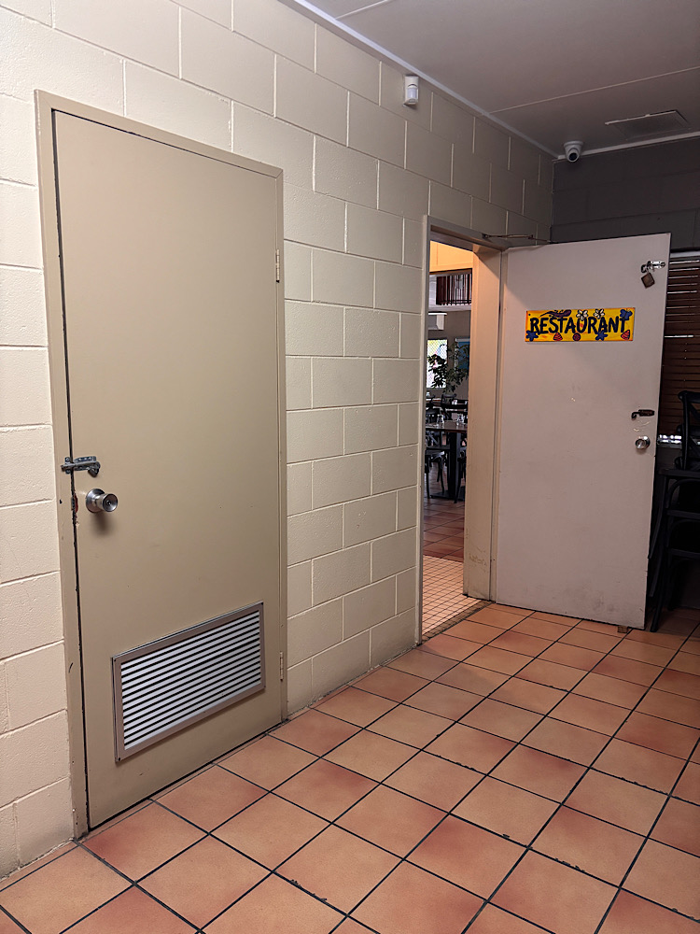
IMG_1884.JPG
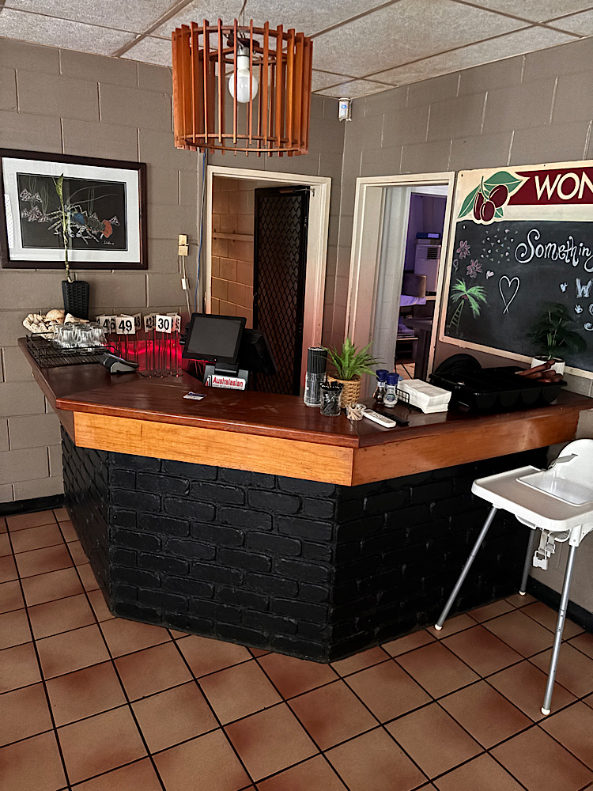
IMG_1885.JPG
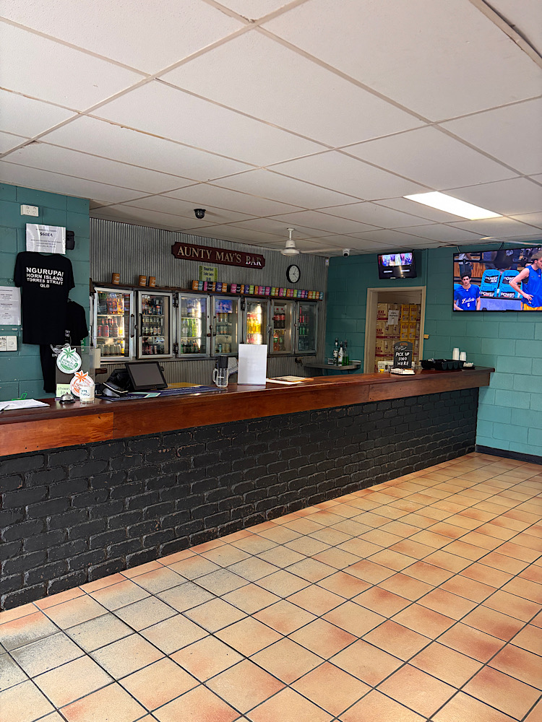
IMG_1886.JPG
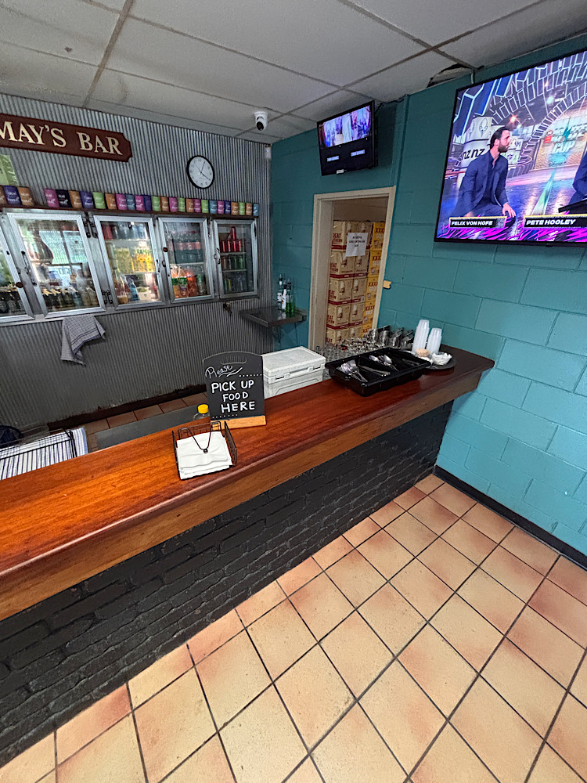
IMG_1887.JPG

Report Disclaimer
Please note that this business report, provided as a result of the use of the diagnostic assessment, is for information purposes only.
Australian Tourism Industry Council (ATIC) cannot guarantee the accuracy of respondent’s answers, or that they are fully representative of your business. Therefore, ATIC does not warrant or guarantee any particular outcome in respect of your businesses self-assessment.
This report is intended as guidance only for your business and should not be relied on for future marketing considerations. ATIC recommends that you seek your own independent advice as well as the results from the diagnostic.
Links to external web sites are inserted for convenience and do not constitute endorsement of material at those sites, or any associated organisation, product or service.
ATIC does not:
- Assume any legal liability for the accuracy, completeness, or usefulness of any information from this report or any links provided; or
- Accept responsibility for any loss associated directly or indirectly from the use of this report.

