ATIC Accessibility
To support the accessible community in making informed travel decisions for their individual needs

This report prepared for:
Business name: | ibis Mackay
Address: | Christensen Circuit
Town: | East Mackay
Contact for enquiries: | Adriette Meyer
Contact Number: | 07 4898 0000
Contact Email: | adriette.meyer@accor.com
Website: | https://www.ibismackay.com.au/
Date: | 2026-11-04 18:43

ATIC Accessibility
The following pages provides travellers with information on the businesses facilities and amenities which aims to support the traveller to make an informed decision on whether the business is suitable for their individual needs.
OVERVIEW 4
Business Overview 4
Bookings 4
Emergency Management 5
Communications 5
Other Information 5
Guide Dog and Service Animals 5
GENERAL 6
Pre-arrival, arrival and reception 6
Cognitive Impairment Support 6
Car Park and Access amenities 6
Entry 7
Lifts 7
Internal Spaces 7
Public areas 8
External Paths 8
Public Toilets/Adult change facilities 8
ACCOMMODATION 10
Bedrooms 10
Room Amenities 11
Bathrooms 11
COMMON AREAS 13
Swimming pools, spas and waterparks 13
FOOD AND DRINK 15
Dining Spaces 15
Report Disclaimer 18

OVERVIEW

Business Overview

The business has the following products/services available
- Accommodation
- Food and Drink

Our business caters for the following disability types:
- Blind or low vision
- Limited mobility
- Wheelchairs or mobility scooters
- Food allergies or intolerances
- Cognitive or people on the Autism Spectrum
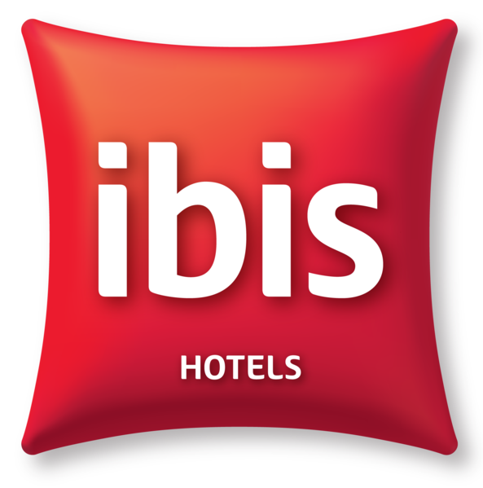

Bookings

The business offers the following methods for bookings and enquiries:
- Phone
- Email
- Webportal
- Staff have undergone disability awareness and training

Emergency Management
- The business has an emergency management and evacuation plan for guests with a disability
- Guests with disabilities are noted in the guest log book for emergency and evacuation purposes

Communications
- An accessibility guide is available on the website

https://www.ibismackay.com.au/rooms/accessible-room/

Other Information
- For bookings made onsite, the ticket booth/counter/box office is accessible for people using a wheelchair

Guide Dog and Service Animals
- The business provides a secure area with shade and water for service animals
- Bowls, bedding, etc. are provided for service animals
The business provides the following services for services animals:
We will provide services for service animals on request

GENERAL

Pre-arrival, arrival and reception
The business has the following in place to support guests during pre-arrival, arrival and reception
- There is a reception/public entryway.
- Seating available at reception
- A lower counter at reception/ticket office
- A tablet with text to voice or pen and paper at reception to aid in communication
- Lighting in the reception area is even and glare free
- Large print information sheets and registration forms

We do not allow self check-in. Check in is always assisted by one of our team
- Information and maps are available in written form
- A facility map and information is available in Braille
- A familiarisation tour
- Keys are available for each guest
- Luggage assistance
- In addition, the following further information can assist guests:
Always have enough team members to assist, and the team is also trained to notice if guests with disabilities need more urgent assistance, and will give them preference.

Cognitive Impairment Support
- Documents are available in plain English for people with cognitive impairment (This may include instructions, guides, menus and general information)
- Quiet periods or early opening times for people on the Autism Spectrum

Car Park and Access amenities
The business has the following Car Park and Access amenities
- A drop off zone
- Designated disabled parking bays
- Level or ramped access from the car park to the entrance
- The accessible entrance is clearly signed from the parking bay
- The public transport services available are:

Closest bus stop is at the airport, easily accessible by wheelchair
- Kerb ramps are in place where a pavement or walkway needs to be crossed
- An intercom system is available at the entrance of car park
- The following modifications have been put in place to ensure that a person with a hearing impairment or reduced limb movement is not disadvantaged in using the system
- In addition, the following further information can assist guests:
Can use their room key to enter the car park boomgate, or press the button to take a ticket.
- Instructions on how to use the system are in Plan English and accompanied by Universal design standard pictures

Entry
The business has the following amenities/systems in place for entry
- A drop off point close to the entrance
- A path of access to the building is slip resistance and even
- A path of access to the building is clear of obstruction
- Self opening entry doors or fitted with a self closer
- Glass doors are fitted with a visual sighting strip
- Door jams/doors are of a contrasting colour to surrounding walls
- Door handles are of a contrasting colour to the door
- Signage is written in a contrasting colour
- Signage is written in a Sans Serif font and use upper and lower case letters
- The entry door is a minimum of 850mm wide
- The entry door has self opening or a light opening pressure (for manual operations)
- The entrance sill is less than 13mm
- There a clear space of at least 1500mm x 1500mm in front of all doors.
- The entrance door mats have a thickness less than 13mm and a width of 7500mm or greater

Lifts
- Premises has lifts

Internal Spaces
- Clear and unobstructed routes through and between buildings
- Interior walls are matte or low sheen
- Floors, walls, counters and furniture are of contrasting colours
- Any protruding or overhanging obstructions are at least 2meters above the floor or are protected
- Tableware/glassware contrast with the table surface or table cloth
- Floor surfaces are hard or short pile carpet
- Seating is available for guests unable to stand for long periods
- Accessible facilities are clearly signed and visible from all areas
- All corridors greater than 900mm
- There is a quiet space for parents and children on the Autism Spectrum
- In addition, the following further information can assist guests:
We can provide a quiet space on request.

Public areas
The public areas have the following amenities in place
- Display units, Televisions, Video displays etc. are open captioned
- Even lighting
- Seating

External Paths
External paths of travel
- Surfaces are concrete, asphalt, smooth paving or hard packed fine gravel (max aggregate size 13mm)
- Pathways are wider than 900mm

No steps

No steps
- Step free routes clearly signed
- In addition, the following further information can assist guests:
No steps in the building

Public Toilets/Adult change facilities
Public Toilets/Adult change facilities have the following amenities are in place
- There is an accessible toilet for public use
- The door is at least 850mm wide
- There is a minimum of 850mm beside the toilet
- Handrails are fitted
- The toilet seat is 460mm above the floor
- There is 1900mm mm of clear space in front of the toilet
- The toilet seat of a contrasting colour to the floor
- The toilet seat is460mm above the floor
- In addition, the following further information can assist guests:
N/A

ACCOMMODATION

Bedrooms
The bedrooms have the following facilities/amenities in place
- There are 8 rooms available to guests who use a wheelchair
- Bedroom furniture can be re-arranged on request
  - Layout of room Image(s)
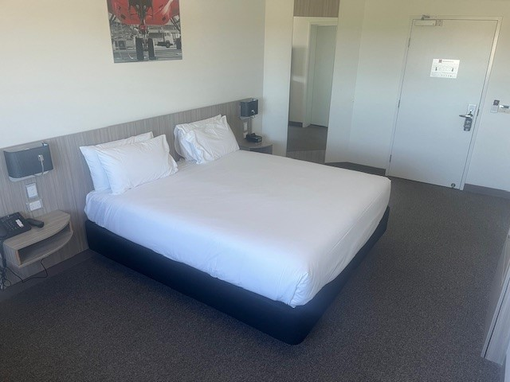
Accessible accommodation room
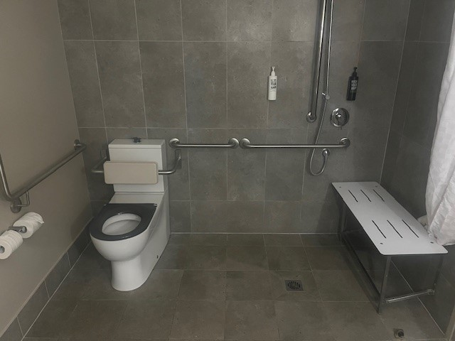
Accessible room shower and toilet
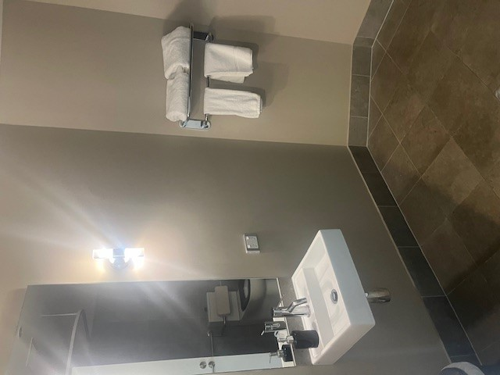
Accessible room bathroom

Room Amenities
- Lower hanging rails are in wardrobes
- Visual alarm is fitted to the room
- Televisions are equipped with closed captioning capability
- Vibrating alarm clocks
- Room phones have volume control
- Room phones have a visual ringing indicator
- There is contrast between the walls, skirtings, floor and furniture
- There is a clear path through the room
- The edges of all furniture and fixtures are rounded
- Wardrobe handles are a contrasting colour to the doors and draws
- Housekeeping procedures instruct staff not to reposition furniture that has been moved
- Doors open fully against the adjoining wall
- There is a clear opening at least 850mm wide
- There luggage racks for at least two suitcases
- There at least one chair with rigid arms
- Wardrobe and drawer handles are easy to grip
- The bedside lamp switch is easy to reach from the bed
- There is at least 850mm clear space beside the bed
- The bed height is no higher than 680mm from the floor
- There is at least 130mm clearance under the bed
- The business offers a range of non-allergenic bedding
- Non-allergenic cleaning products are used

Bathrooms
The bathrooms have the following facilities/amenities in place
- All heating appliances and hot water pipes are protected or insulated
- All shower, bath and basin taps are clearly differentiated between hot and cold
- Fixtures and fittings have rounded edges
- The hot water is thermostatically controlled to 41 degrees
- The door is at least 850mm wide
- There is a minimum of 850mm beside the toilet
- Handrails are fitted
- There is a minimum of 1400mm of clear space in front of the toilet
- The toilet seat is a contrasting colour to the floor
- The toilet seat is 460mm above the floor
- A range of non-allergenic toiletries are available
- There is a roll-in shower with fold down fixed seat or a shower chair
- There is a portable shower head on flexible hose
  - Bathroom Image(s)
Accessible room shower and toilet
Accessible room bathroom

COMMON AREAS

Swimming pools, spas and waterparks
- The following swimming pools, spas and waterparks amenities are available
- Unisex change facilities with an accessible toilet
- The park map includes a step free route
  - Pool Access Image(s)
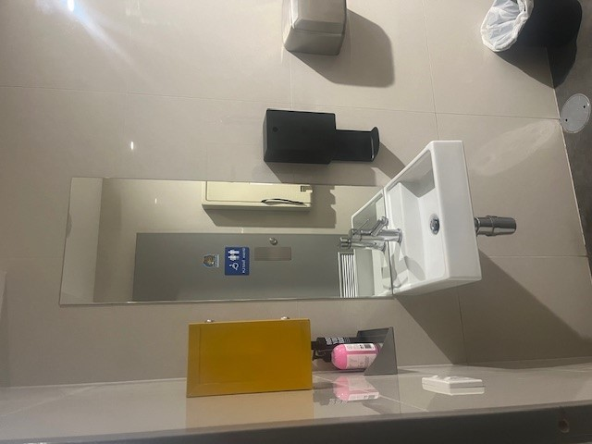
Public area accessible toilet
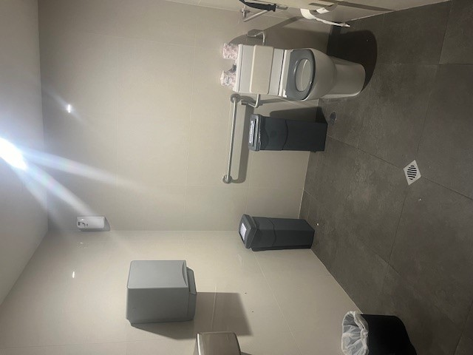
Public area accessible toilet2
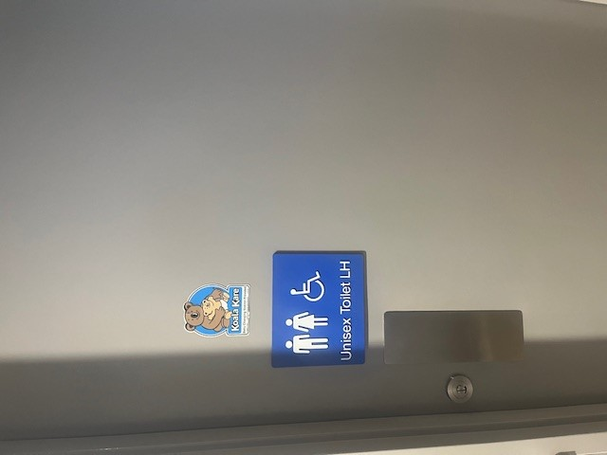
Accessible toilet entrance - public areas

FOOD AND DRINK

Dining Spaces
The dining spaces have the following facilities/amenities in place
- The entrance has level access
- The doorway is at least 850mm wide
- There is level access through the dining area
- Chairs are moveable to allow for wheelchairs to be seated at the tables
- All glass doors and full height windows have contrast markings
- There are areas of full lighting
- There are large print menus
- There are Plain English menus
- There is an accessible toilet

Our business caters for the following dietary requirements
- Sugar free (diabetic)
- Gluten free (celiac)
- Lactose free (dairy free)
- Low fat and fibre with no gastric content
- Low potassium
- Low sodium
- Nut free
- Additive free
- Organic
- Vegetarian
- Vegan
- In addition, the following further information can assist guests:
Store food products separate, use separate kitchen equipment, such as chopping boards, oven trays, knives, etc. to avoid cross contamination.
- There is a sample menu available online
Sample menu is available here -
https://www.ibismackay.com.au/turbarlencetavern/turbarlence/
  - Food and Beverage Image(s)
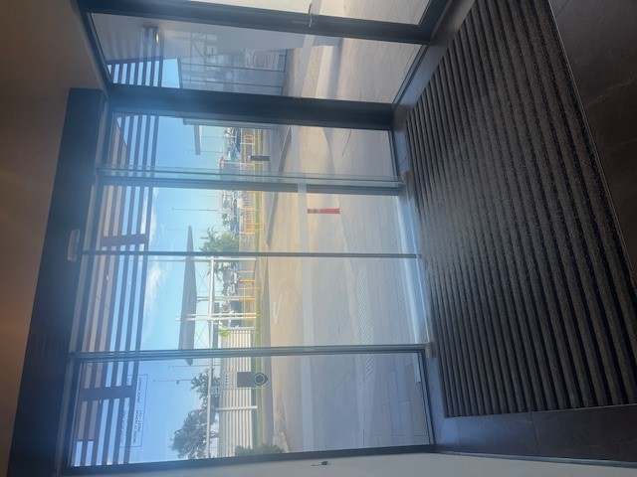
Hotel entrance
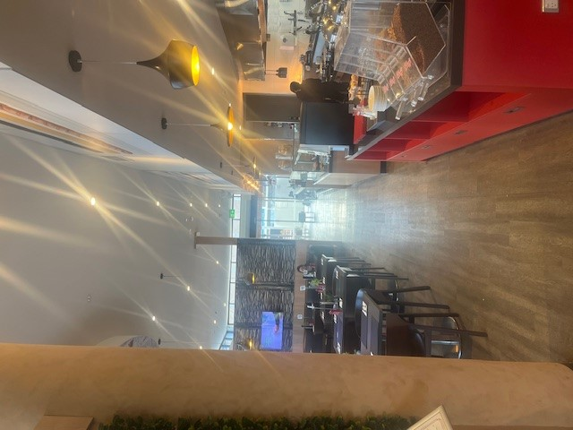
Walkway between restaurant and bar
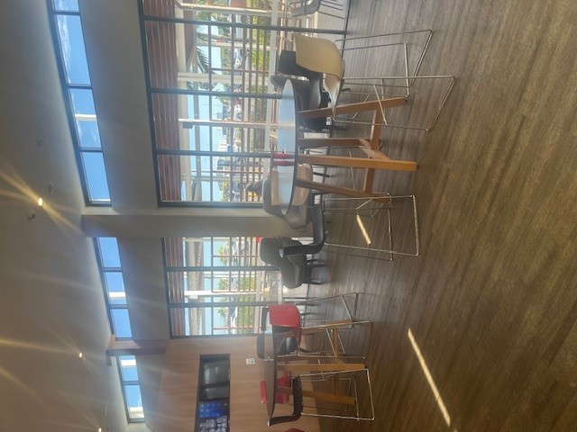
Bar showing space around tables

Report Disclaimer
Please note that this business report, provided as a result of the use of the diagnostic assessment, is for information purposes only.
Australian Tourism Industry Council (ATIC) cannot guarantee the accuracy of respondent’s answers, or that they are fully representative of your business. Therefore, ATIC does not warrant or guarantee any particular outcome in respect of your businesses self-assessment.
This report is intended as guidance only for your business and should not be relied on for future marketing considerations. ATIC recommends that you seek your own independent advice as well as the results from the diagnostic.
Links to external web sites are inserted for convenience and do not constitute endorsement of material at those sites, or any associated organisation, product or service.
ATIC does not:
- Assume any legal liability for the accuracy, completeness, or usefulness of any information from this report or any links provided; or
- Accept responsibility for any loss associated directly or indirectly from the use of this report.

