ATIC Accessibility
To support the accessible community in making informed travel decisions for their individual needs

This report prepared for:
Business name: | The Margaret River Discovery Company
Address: | 11 Shady Glen
Town: | MARGARET RIVER
Contact for enquiries: | Sean Blocksidge
Contact Number: | (61) 4399 1006
Contact Email: | sean@margaretriverdiscovery.com.au
Website: | http://www.margaretriverdiscovery.com.au/
Date: | 2026-10-23 15:16

ATIC Accessibility
The following pages provides travellers with information on the businesses facilities and amenities which aims to support the traveller to make an informed decision on whether the business is suitable for their individual needs.
OVERVIEW 4
Business Overview 4
Bookings 4
Communications 5
Guide Dog and Service Animals 5
GENERAL 6
Pre-arrival, arrival and reception 6
Cognitive Impairment Support 7
Car Park and Access amenities 7
Internal Spaces 7
Displays, exhibits, commentary and live performances 7
External Paths 7
TOUR OPERATORS 8
Tour/Transport Services 8
Route Planning 8
Guides 8
FOOD AND DRINK 10
Dining Spaces 10
ADVENTURE ACTIVITIES 12
Adventure activities 12
Report Disclaimer 15

OVERVIEW

Business Overview

The business has the following products/services available
- Tour/Transport
- Food and Drink
- Adventure

Our business caters for the following disability types:
- Blind or low vision
- Deaf or low hearing
- Limited mobility
- Food allergies or intolerances
- Cognitive or people on the Autism Spectrum
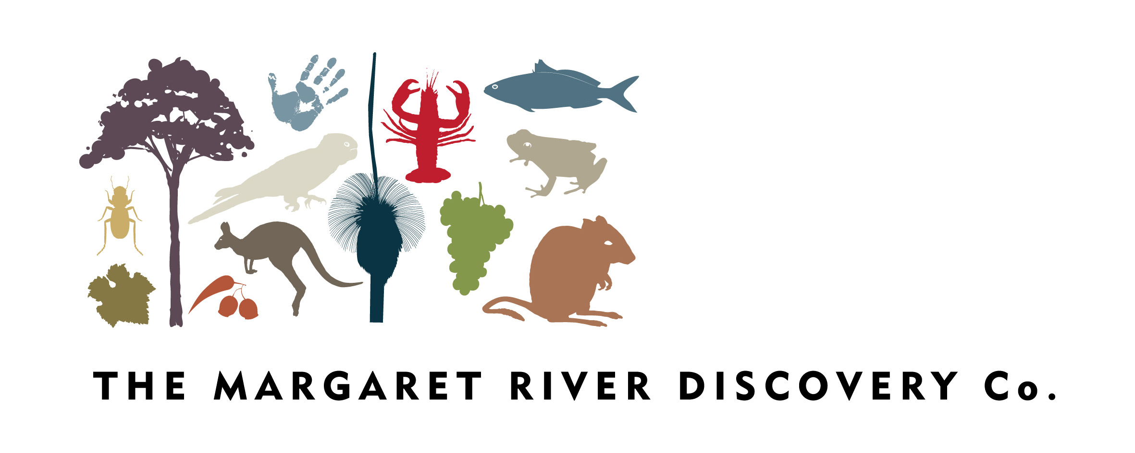

Bookings

The business offers the following methods for bookings and enquiries:
- Phone
- Email
- Webportal
- Our forms have high contract boxes and submit boxes

We are operating a tour. No evacuation is required.

Communications
- An accessibility guide is available on the website

https://margaretriverdiscovery.com.au/faqs
- Our website meets WCAG 2.0 accessibility standards
- Our business offers the following alternative communication methods
- Plain English

Not specified
- There is easy to read signage and information (e.g. menus and emergency information)

Guide Dog and Service Animals
- The business provides a secure area with shade and water for service animals
- The business provides a toilet area for service animals
The business provides the following services for services animals:
Guests can book a service animal as Private Discovery Tour.

GENERAL

Pre-arrival, arrival and reception
The business has the following in place to support guests during pre-arrival, arrival and reception
- Information and maps are available in written form
- In addition, the following further information can assist guests:

Flexible Scheduling: We offer flexible tour start times where possible, and provide early access to essential information so guests can plan their day to reduce physical and cognitive fatigue.

Priority Support: If a guest notifies us of a fatigue-related condition, we prioritise their needs and adjust the pace of the experience.

Small Group Sizes: With a maximum of six guests, our tours inherently allow for more personalised attention and flexibility on the day.

Clear Communication: We maintain regular communication leading up to the tour, offering proactive updates and the option to adjust participation as needed to accommodate changing energy levels.

These adjustments ensure a more inclusive, comfortable, and respectful experience for all guests, particularly those managing fatigue-related conditions.

Cognitive Impairment Support
- Documents are available in plain English for people with cognitive impairment (This may include instructions, guides, menus and general information)

Car Park and Access amenities
The business has the following Car Park and Access amenities
- A drop off zone
- Designated disabled parking bays
- Level or ramped access from the car park to the entrance
- The accessible entrance is clearly signed from the parking bay

Internal Spaces
- Tableware/glassware contrast with the table surface or table cloth

Displays, exhibits, commentary and live performances
For displays, exhibits, commentary and live performances the following amenities are in place

External Paths
External paths of travel
The width of the smallest pathway is:
500mm
- There 3 successive steps or less on any path or at any doorway

TOUR OPERATORS

Tour/Transport Services
The tour/transport services have the following facilities/amenities in place
- Buses/Coaches
- None vehicles have wheelchair lifts or ramps
- None vehicles have low floors with ramped entry
The maximum wheelchair capacity available in the fleet is:
No

Route Planning
- Route Planning
- The tour route includes stops with accessible toilet facilities
- Lunch stop venues are accessible
- Walking Tours
- Multi-paced to account for slower walkers

Guides

Guides have been trained in the following
- Use of clear/simple English
- Correct pronunciation for lip readers
- Marine
  - Image(s)
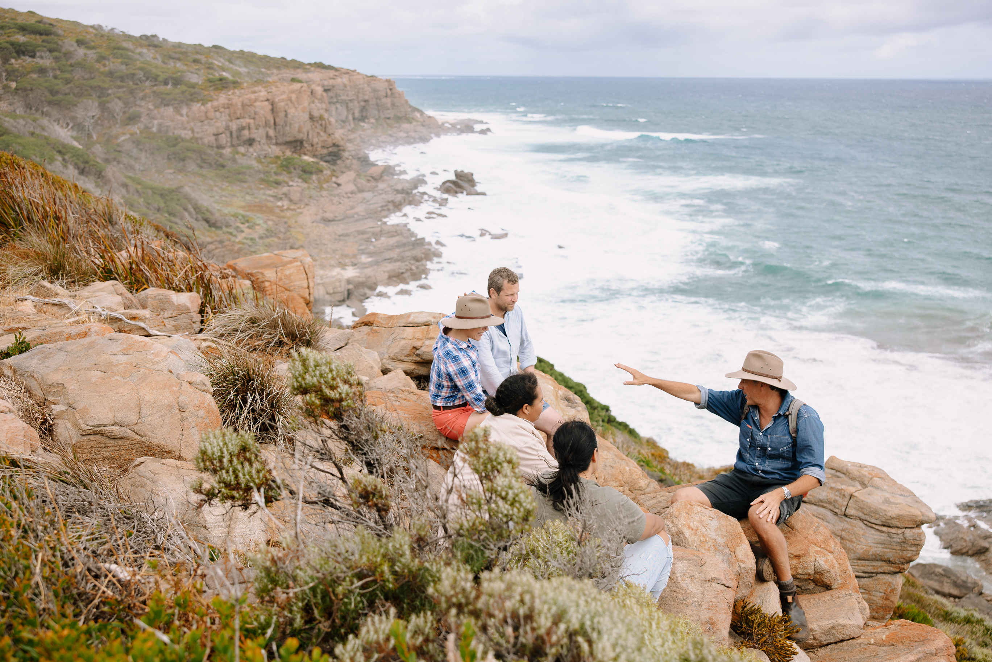
TA_NECI_WA_MRDiscoveryCo_Feb2022 SENG0522
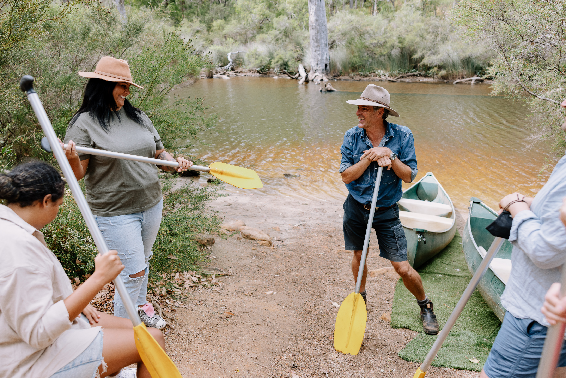
TA_NECI_WA_MRDiscoveryCo_Feb2022 SENG9899
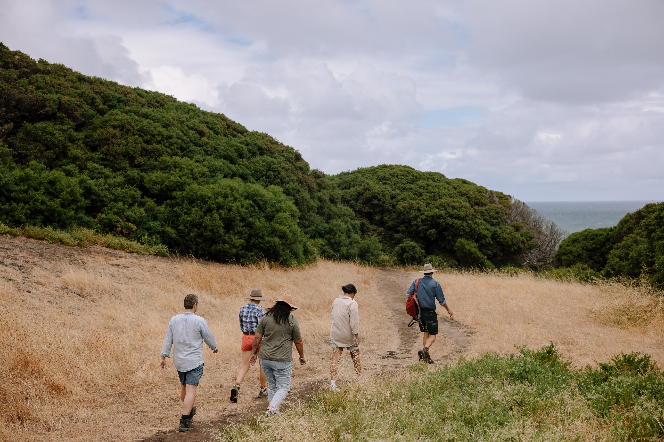
TA_NECI_WA_MRDiscoveryCo_Feb2022 SENG0261
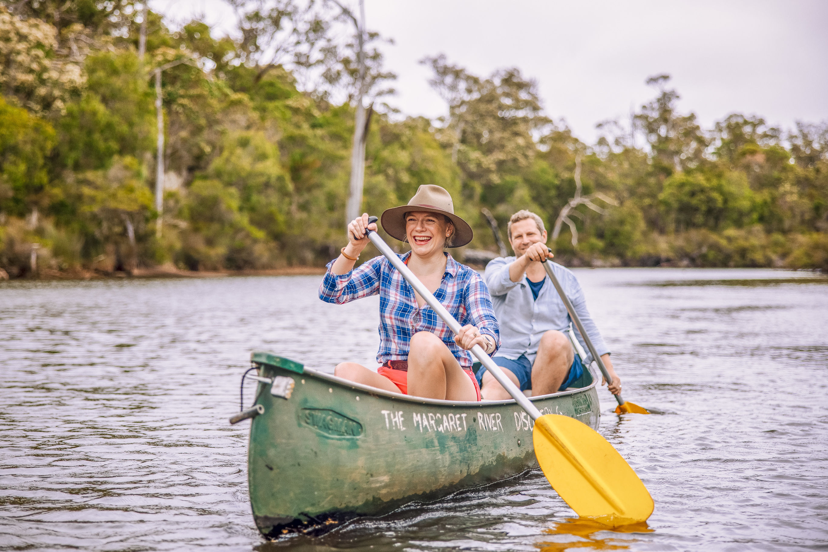
TA_NECI_WA_MRDiscoveryCo_Feb2022 SENG0196
- In addition, the following further information can assist guests:
White Elephant Beach Cafe and Fraser Gallop Estate

FOOD AND DRINK

Dining Spaces
The dining spaces have the following facilities/amenities in place
- The entrance has level access
- The doorway is at least 850mm wide
- There is level access through the dining area
- All glass doors and full height windows have contrast markings
- There are areas of full lighting
- There are large print menus
- There are Plain English menus
- There is an accessible toilet

Our business caters for the following dietary requirements
- Sugar free (diabetic)
- Gluten free (celiac)
- Lactose free (dairy free)
- Low fat and fibre with no gastric content
- Low potassium
- Low sodium
- Nut free
- Vegetarian
- Vegan
- In addition, the following further information can assist guests:
To ensure the safety of all guests, especially those with allergies or dietary restrictions, we follow strict procedures to avoid cross-contamination of food products:

Supplier Standards: We work exclusively with reputable local suppliers who adhere to high food safety and allergen handling standards. Products are sourced with clear labelling of ingredients and allergens.

Separate Storage: All food items are stored in sealed, clearly labelled containers. Allergen-free products are stored separately to avoid accidental exposure.

Dedicated Preparation Areas: When preparing food (e.g., picnic platters or tastings), we use clean, sanitised surfaces and utensils, with separate cutting boards and serving tools for allergen-sensitive items.

Hygiene Protocols: Hands are thoroughly washed and sanitised before and after food handling. Disposable gloves are used during food prep and changed between handling different items.

Advance Guest Communication: We ask guests to inform us of any dietary needs or allergies in advance. This allows us to plan accordingly and prepare safe, separate alternatives if required.

Serving Protocols: All shared platters are served in a way that avoids utensil-sharing between guests, reducing the risk of transfer. Allergen-safe options are plated and served individually to those who need them.

By maintaining a cautious and methodical approach, we reduce the risk of cross-contamination and ensure a safe, enjoyable experience for all guests.

ADVENTURE ACTIVITIES

Adventure activities
The adventure activities have the following facilities/amenities in place
- Our adventure activities cater for people with a disability
- In addition, the following further information can assist guests:
Yes. Margaret River Discovery Co is committed to providing a welcoming and inclusive experience for all guests, including those with disabilities. While the nature-based and small group structure of the tour presents some physical limitations, we take every possible step to accommodate guests’ individual needs and create a meaningful, accessible experience wherever feasible.
We work closely with guests prior to their booking to understand individual access needs and tailor the day accordingly. Available activities for guests with limited mobility or other disabilities may include:

Scenic 4WD tour: A comfortable and immersive experience in our air-conditioned Land Rover Discovery, providing access to remote wilderness areas with minimal walking required.

Wine tasting experience: A hosted seated experience at a premium local winery, with easy access, comfortable seating, and the option for personalised tastings.

Short walks: For guests with some mobility, short, flat walks to key lookouts and cultural sites can be incorporated, with frequent rest stops and support as needed.

Nature interpretation: Guests who are unable to leave the vehicle or prefer a seated experience can still enjoy rich storytelling, environmental education, and cultural interpretation delivered in accessible language and formats.

- In addition, the following further information can assist guests:
While our tours are conducted in a rugged natural environment, we make practical adjustments where possible to improve accessibility:

Modified tour vehicle: The Land Rover Discovery features wide doors, step assistance, and supportive seating.

Communication tools: Visual guides and photo prompts are used during interpretation to assist guests with sensory processing needs.

Flexible itinerary: We can adjust pacing, timing, and activity types in real time to accommodate energy levels, sensory sensitivity, or fatigue-related conditions.

- In addition, the following further information can assist guests:
Due to the physical terrain and small group format, some activities may not be suitable for all guests:

Canoeing: This activity requires a moderate level of mobility and stability and may not be suitable for guests with significant mobility impairments or balance issues.

Hiking component: Some sections include uneven surfaces, inclines, and loose gravel, which can pose challenges for those using walking aids, or with limited lower limb strength.

Vehicle transfers: While our vehicle accommodates most guests, it is not a wheelchair-accessible van. Guests must be able to transfer into a seat with or without assistance.

We are transparent about these limitations during the booking process and work with guests to either adapt the experience or recommend alternative operators with full accessibility infrastructure if needed.

Report Disclaimer
Please note that this business report, provided as a result of the use of the diagnostic assessment, is for information purposes only.
Australian Tourism Industry Council (ATIC) cannot guarantee the accuracy of respondent’s answers, or that they are fully representative of your business. Therefore, ATIC does not warrant or guarantee any particular outcome in respect of your businesses self-assessment.
This report is intended as guidance only for your business and should not be relied on for future marketing considerations. ATIC recommends that you seek your own independent advice as well as the results from the diagnostic.
Links to external web sites are inserted for convenience and do not constitute endorsement of material at those sites, or any associated organisation, product or service.
ATIC does not:
- Assume any legal liability for the accuracy, completeness, or usefulness of any information from this report or any links provided; or
- Accept responsibility for any loss associated directly or indirectly from the use of this report.

