ATIC Accessibility
To support the accessible community in making informed travel decisions for their individual needs

This report prepared for:
Business name: | Devonport Visitor Centre
Address: | 145 Rooke Street
Town: | DEVONPORT
Contact for enquiries: | Susan Foster
Contact Number: | 03 64202900
Contact Email: | tourism@devonport.tas.gov.au
Website: | www.visitdevonport.com.au
Date: | 2026-10-26 06:52

ATIC Accessibility
The following pages provides travellers with information on the businesses facilities and amenities which aims to support the traveller to make an informed decision on whether the business is suitable for their individual needs.
OVERVIEW 4
Business Overview 4
Bookings 4
Emergency Management 4
Communications 5
Other Information 5
Guide Dog and Service Animals 5
GENERAL 6
Pre-arrival, arrival and reception 6
Cognitive Impairment Support 6
Car Park and Access amenities 6
Entry 7
Lifts 7
Internal Spaces 7
Public areas 8
Displays, exhibits, commentary and live performances 8
External Paths 8
Steps 8
Ramps 9
Public Toilets/Adult change facilities 9
ATTRACTIONS 10
Attractions Basics 10
COMMON AREAS 12
Report Disclaimer 14

OVERVIEW

Business Overview

The business has the following products/services available
- Attraction

Our business caters for the following disability types:
- Blind or low vision
- Deaf or low hearing
- Limited mobility
- Wheelchairs or mobility scooters
- Food allergies or intolerances
- Cognitive or people on the Autism Spectrum


Bookings

The business offers the following methods for bookings and enquiries:
- Phone
- Email
- Webportal
- Staff have undergone disability awareness and training

Emergency Management
- The business has an emergency management and evacuation plan for guests with a disability

Interactions happen quickly at The Visitor Centre and not explained on a one-on-one basis.

Communications
- An accessibility guide is available on the website

https://www.visitdevonport.com.au/visitor-information/

Other Information
- For bookings made onsite, the ticket booth/counter/box office is accessible for people using a wheelchair
- The business accepts the companion card

Guide Dog and Service Animals
- The business provides a secure area with shade and water for service animals
The business provides the following services for services animals:
Not specified

GENERAL

Pre-arrival, arrival and reception
The business has the following in place to support guests during pre-arrival, arrival and reception
- Booking information and websites are compatible with screen readers
- There is a reception/public entryway.
- Seating available at reception
- A lower counter at reception/ticket office
- A clipboard to allow check-in/ticket purchase whilst seated
- A tablet with text to voice or pen and paper at reception to aid in communication
- Lighting in the reception area is even and glare free
- Large print information sheets and registration forms
- Information and maps are available in written form
- A step free map/guide
- A familiarisation tour
- In addition, the following further information can assist guests:
Seating available, quiet area with couches, training to staff to recognise signs of fatigue and offer proactive assistance.
- In addition, the following further information can assist guests:
Information is readily provided for those who need assistance bringing someone to the building and particularly access to our theatre. We can show them where they will be seated.

Cognitive Impairment Support
- Documents are available in plain English for people with cognitive impairment (This may include instructions, guides, menus and general information)
- Quiet periods or early opening times for people on the Autism Spectrum
- A space for parents and children on the Autism Spectrum

Car Park and Access amenities
The business has the following Car Park and Access amenities
- A drop off zone
- Designated disabled parking bays
- Level or ramped access from the car park to the entrance
- The accessible entrance is clearly signed from the parking bay
- The public transport services available are:

Timetable information is available from Customer Service.
- Kerb ramps are in place where a pavement or walkway needs to be crossed
- In addition, the following further information can assist guests:
Should you need assistance from the car park, please contact 64202900

Entry
The business has the following amenities/systems in place for entry
- A drop off point close to the entrance
- A path of access to the building is slip resistance and even
- A path of access to the building is clear of obstruction
- Self opening entry doors or fitted with a self closer
- Glass doors are fitted with a visual sighting strip
- Door jams/doors are of a contrasting colour to surrounding walls
- Door handles are of a contrasting colour to the door
- Signage is written in a contrasting colour
- Signage is written in a Sans Serif font and use upper and lower case letters
- The entry door is a minimum of 850mm wide
- The entry door has self opening or a light opening pressure (for manual operations)
- The entrance sill is less than 13mm
- There a clear space of at least 1500mm x 1500mm in front of all doors.
- The entrance door mats have a thickness less than 13mm and a width of 7500mm or greater

Lifts
- Premises has lifts

Internal Spaces
- Clear and unobstructed routes through and between buildings
- Interior walls are matte or low sheen
- Floors, walls, counters and furniture are of contrasting colours
- Any protruding or overhanging obstructions are at least 2meters above the floor or are protected
- Floor surfaces are hard or short pile carpet
- Seating is available for guests unable to stand for long periods
- Accessible facilities are clearly signed and visible from all areas
- All corridors greater than 900mm
- There is a quiet space for parents and children on the Autism Spectrum

Public areas
The public areas have the following amenities in place
- Seating

Displays, exhibits, commentary and live performances
For displays, exhibits, commentary and live performances the following amenities are in place
- Seating
- Wheelchair accessible spaces/seating
- Hearting loops for live shows and presentations

External Paths
External paths of travel
- Surfaces are concrete, asphalt, smooth paving or hard packed fine gravel (max aggregate size 13mm)
- Pathways are wider than 900mm
- There 3 successive steps or less on any path or at any doorway
- Any paths having steps are clearly identified as non-wheelchair accessible
- Step free routes clearly signed

Steps
Steps
- There are steps.
- Top and bottom steps are easily distinguished through colour contrast or the use of TGSIs (Tactile Ground Surface Indicators)
- All steps or staircases have enclosed risers
- The underside of all staircases are enclosed or protected to a height of at least 2 metres
- Handrails fitted to all open sets of steps
- Handrails extend 300mm beyond the top and bottom step
- Where steps are present are there three steps or less

Ramps
Ramps have the following amenities are in place
- There are ramps.
- All fixed ramps are 1:14 or less
- Hand rails are fitted
- Long ramps (more than 10m) are 1:20 or less
- Temporary ramps are available
- Temporary ramps are in place for the duration of the guests stay
- Ramps have a raised edge of at least 100mm

Public Toilets/Adult change facilities
Public Toilets/Adult change facilities have the following amenities are in place
- There is an accessible toilet for public use
- The door is at least 850mm wide
- There is a minimum of 850mm beside the toilet
- Handrails are fitted
- The toilet seat is 460mm above the floor
- There is 2 metres mm of clear space in front of the toilet
- The toilet seat of a contrasting colour to the floor
- The toilet seat is460mm above the floor

ATTRACTIONS

Attractions Basics
- A park map is available here:

https://www.visitdevonport.com.au/wp-content/uploads/2024/09/Devonport-City-Council-Devonport-Tourism-Map-2024.pdf
  - Image(s)
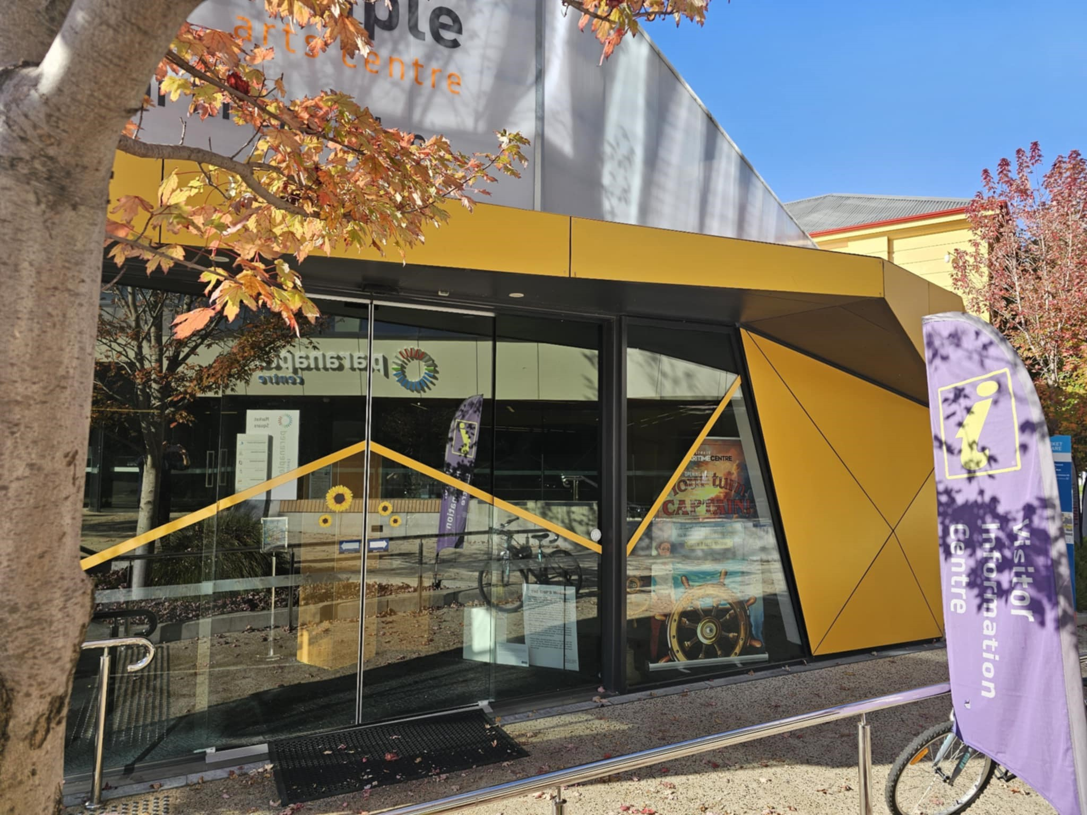
Main Entrance
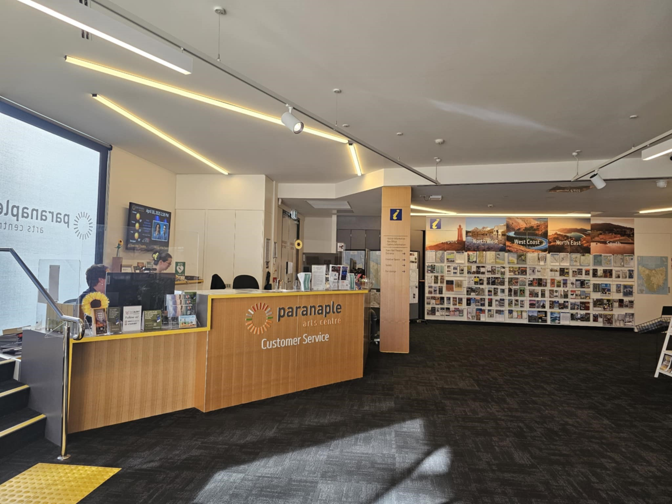
Customer Service Ticket Counter
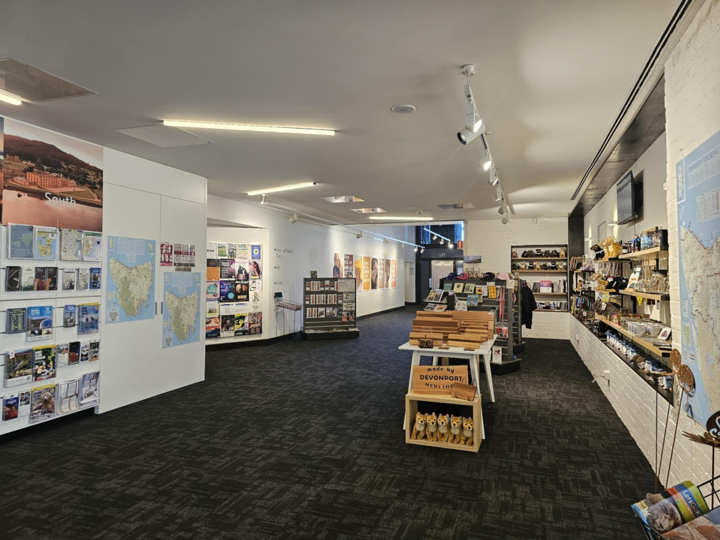
Retail Gift Shop
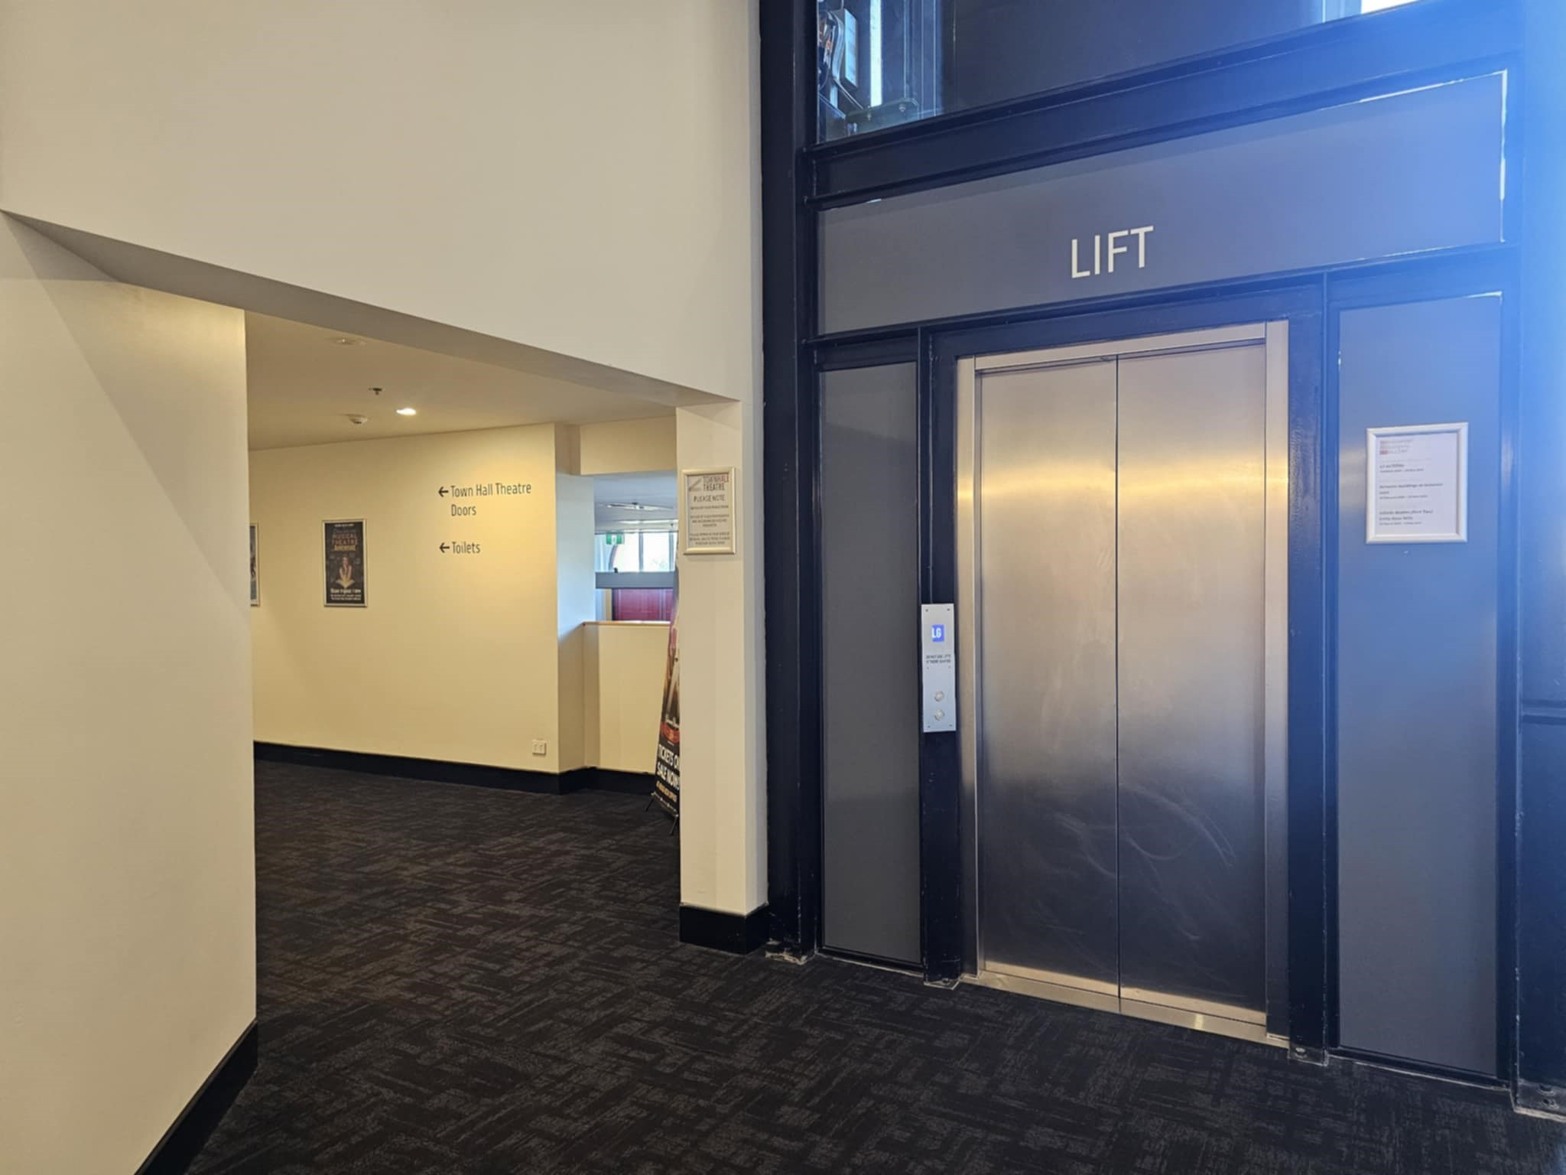
Lift
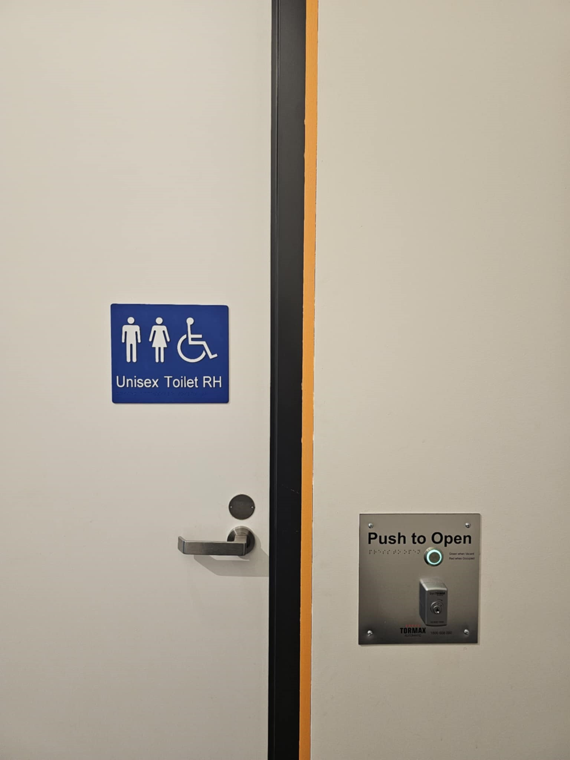
Accessible Toilet

COMMON AREAS

Report Disclaimer
Please note that this business report, provided as a result of the use of the diagnostic assessment, is for information purposes only.
Australian Tourism Industry Council (ATIC) cannot guarantee the accuracy of respondent’s answers, or that they are fully representative of your business. Therefore, ATIC does not warrant or guarantee any particular outcome in respect of your businesses self-assessment.
This report is intended as guidance only for your business and should not be relied on for future marketing considerations. ATIC recommends that you seek your own independent advice as well as the results from the diagnostic.
Links to external web sites are inserted for convenience and do not constitute endorsement of material at those sites, or any associated organisation, product or service.
ATIC does not:
- Assume any legal liability for the accuracy, completeness, or usefulness of any information from this report or any links provided; or
- Accept responsibility for any loss associated directly or indirectly from the use of this report.

