ATIC Accessibility
To support the accessible community in making informed travel decisions for their individual needs

This report prepared for:
Business name: | Great Ocean Road Resort
Address: | 105 Great Ocean Road
Town: | Anglesea
Contact for enquiries: | Damien Cerantonio
Contact Number: | 0352633363
Contact Email: | enquiries@greatoceanroadresort.com.au
Website: | www.greatoceanroadresort.com.au
Date: | 2026-10-26 05:13

ATIC Accessibility
The following pages provides travellers with information on the businesses facilities and amenities which aims to support the traveller to make an informed decision on whether the business is suitable for their individual needs.
OVERVIEW 4
Business Overview 4
Bookings 4
Emergency Management 4
Communications 5
Other Information 5
Guide Dog and Service Animals 5
GENERAL 6
Pre-arrival, arrival and reception 6
Cognitive Impairment Support 6
Car Park and Access amenities 6
Entry 6
Internal Spaces 7
Public areas 7
External Paths 7
Steps 8
Ramps 8
Public Toilets/Adult change facilities 8
ACCOMMODATION 9
Bedrooms 9
Room Amenities 9
Bathrooms 10
COMMON AREAS 11
Swimming pools, spas and waterparks 11
FOOD AND DRINK 12
Dining Spaces 12
Report Disclaimer 15

OVERVIEW

Business Overview

The business has the following products/services available
- Accommodation
- Food and Drink

Our business caters for the following disability types:
- Blind or low vision
- Deaf or low hearing
- Limited mobility
- Wheelchairs or mobility scooters
- Food allergies or intolerances
- Cognitive or people on the Autism Spectrum


Bookings

The business offers the following methods for bookings and enquiries:
- Phone
- Email

Emergency Management
- Exit signs are clear and easy to see
- Exit access is free and clear at all times
We ensure exit access is free and clear at all times by:
we ensure no items of furniture are placed in these areas and exit signs are visible.
- Exits and access to exists are greater than 900mm
- Exit doors are able to be opened by all occupants
- Exits to the emergency evacuation point does not include stairways
- The evacuation point is clearly marked by a sign
- In addition, the following further information can assist guests:
we currently don't have a procedure
- In addition, the following further information can assist guests:
we currently don't have a procedure

Communications
- Our business offers the following alternative communication methods
- Plain English

Not specified
- There is easy to read signage and information (e.g. menus and emergency information)

Other Information
- For bookings made onsite, the ticket booth/counter/box office is accessible for people using a wheelchair

Guide Dog and Service Animals
- The business provides a secure area with shade and water for service animals
The business provides the following services for services animals:
Service animals are welcomed at our property and we will customise our offering depending on the owner/guide dogs requirements.

GENERAL

Pre-arrival, arrival and reception
The business has the following in place to support guests during pre-arrival, arrival and reception
- There is a reception/public entryway.
- Seating available at reception
- A clipboard to allow check-in/ticket purchase whilst seated
- A tablet with text to voice or pen and paper at reception to aid in communication
- Large print information sheets and registration forms
- Information and maps are available in written form
- A familiarisation tour
- Keys are available for each guest
- Luggage assistance
- In addition, the following further information can assist guests:
We are boutique accommodation provider with only 40 rooms and we always have 2 people on reception to ensure we do not have long wait times. We also gather as much information as possible prior to arrival to reduce this time at check in. We have seating areas in reception on the odd occasion guests do need to wait.

Cognitive Impairment Support
- Documents are available in plain English for people with cognitive impairment (This may include instructions, guides, menus and general information)
- A space for parents and children on the Autism Spectrum

Car Park and Access amenities
The business has the following Car Park and Access amenities
- A drop off zone
- Level or ramped access from the car park to the entrance

Entry
The business has the following amenities/systems in place for entry
- A drop off point close to the entrance
- A path of access to the building is slip resistance and even
- A path of access to the building is clear of obstruction
- Self opening entry doors or fitted with a self closer
- Glass doors are fitted with a visual sighting strip
- Door jams/doors are of a contrasting colour to surrounding walls
- Door handles are of a contrasting colour to the door
- Signage is written in a contrasting colour
- The entry door is a minimum of 850mm wide
- There a clear space of at least 1500mm x 1500mm in front of all doors.
- The entrance door mats have a thickness less than 13mm and a width of 7500mm or greater

Internal Spaces
- Clear and unobstructed routes through and between buildings
- Interior walls are matte or low sheen
- Floors, walls, counters and furniture are of contrasting colours
- Any protruding or overhanging obstructions are at least 2meters above the floor or are protected
- Menus are available in large print or Braille
- Tableware/glassware contrast with the table surface or table cloth
- Floor surfaces are hard or short pile carpet
- Seating is available for guests unable to stand for long periods
- All corridors greater than 900mm
- There is a quiet space for parents and children on the Autism Spectrum

Public areas
The public areas have the following amenities in place
- Display units, Televisions, Video displays etc. are open captioned
- Even lighting
- Seating

External Paths
External paths of travel
- Surfaces are concrete, asphalt, smooth paving or hard packed fine gravel (max aggregate size 13mm)
- Pathways are wider than 900mm
- There 3 successive steps or less on any path or at any doorway

Steps
Steps
- There are steps.
- All steps or staircases have enclosed risers
- The underside of all staircases are enclosed or protected to a height of at least 2 metres
- Where steps are present are there three steps or less

Ramps
Ramps have the following amenities are in place
- There are ramps.
- All fixed ramps are 1:14 or less
- Hand rails are fitted
- Long ramps (more than 10m) are 1:20 or less
- Ramps have a raised edge of at least 100mm

Public Toilets/Adult change facilities
Public Toilets/Adult change facilities have the following amenities are in place
- There is an accessible toilet for public use
- The door is at least 850mm wide
- There is a minimum of 850mm beside the toilet
- Handrails are fitted
- The toilet seat is 460mm above the floor
- There is 1400 mm of clear space in front of the toilet
- The toilet seat is460mm above the floor
- There is a registered changing places facility

ACCOMMODATION

Bedrooms
The bedrooms have the following facilities/amenities in place
- There are 3 rooms available to guests who use a wheelchair
- Bedroom furniture can be re-arranged on request
  - Layout of room Image(s)
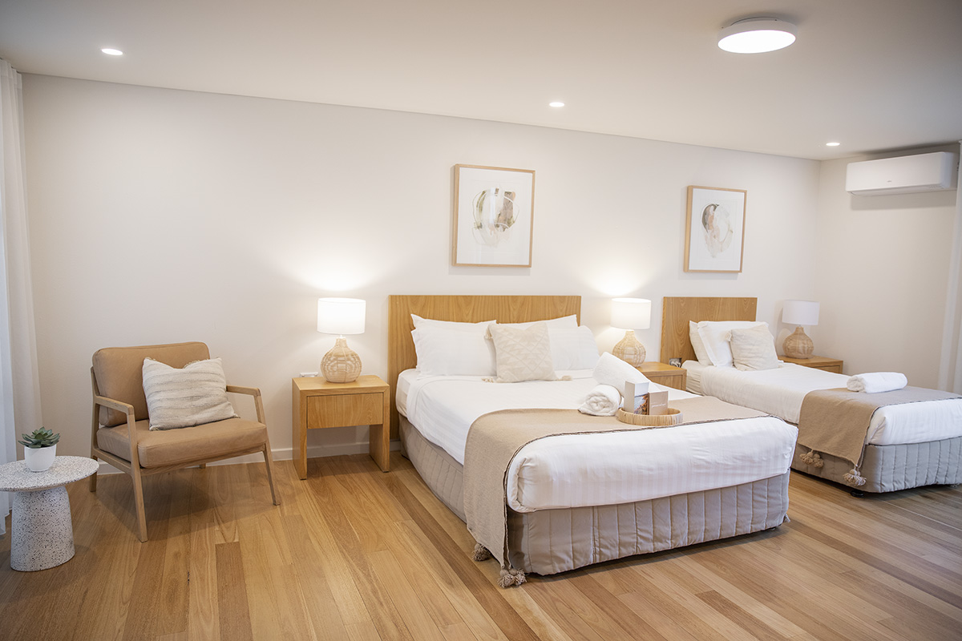
GORR_accommodation_spa_suite

Room Amenities
- In addition, the following further information can assist guests:
Reception staff would go to the room to notify guests.
- Televisions are equipped with closed captioning capability
- There is contrast between the walls, skirtings, floor and furniture
- There is a clear path through the room
- Wardrobe handles are a contrasting colour to the doors and draws
- Housekeeping procedures instruct staff not to reposition furniture that has been moved
- Doors open fully against the adjoining wall
- There is a clear opening at least 850mm wide
- There at least one chair with rigid arms
- Wardrobe and drawer handles are easy to grip
- The bedside lamp switch is easy to reach from the bed
- There is at least 850mm clear space beside the bed
- The bed height is no higher than 680mm from the floor
- There is at least 130mm clearance under the bed
- The business offers a range of non-allergenic bedding
- Non-allergenic cleaning products are used

Bathrooms
The bathrooms have the following facilities/amenities in place
- All heating appliances and hot water pipes are protected or insulated
- All shower, bath and basin taps are clearly differentiated between hot and cold
- The hot water is thermostatically controlled to 41 degrees
- The door is at least 850mm wide
- There is a minimum of 850mm beside the toilet
- There is a minimum of 1400mm of clear space in front of the toilet
- The toilet seat is 460mm above the floor
- A range of non-allergenic toiletries are available
- There is a portable shower head on flexible hose
- A door is fitted to the shower
  - Bathroom Image(s)
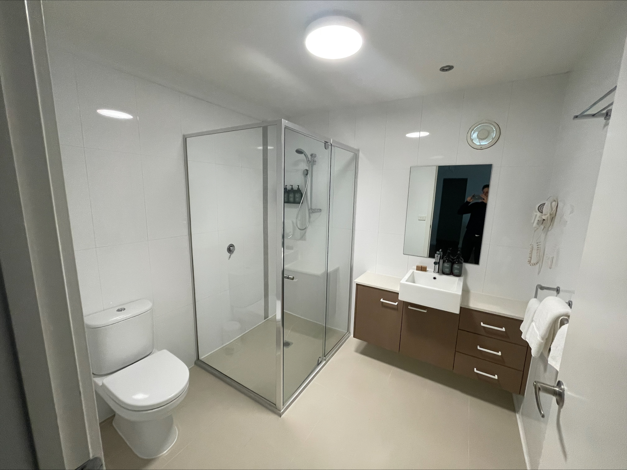
room 5 bathroom

COMMON AREAS

Swimming pools, spas and waterparks
- The following swimming pools, spas and waterparks amenities are available
  - Pool Access Image(s)
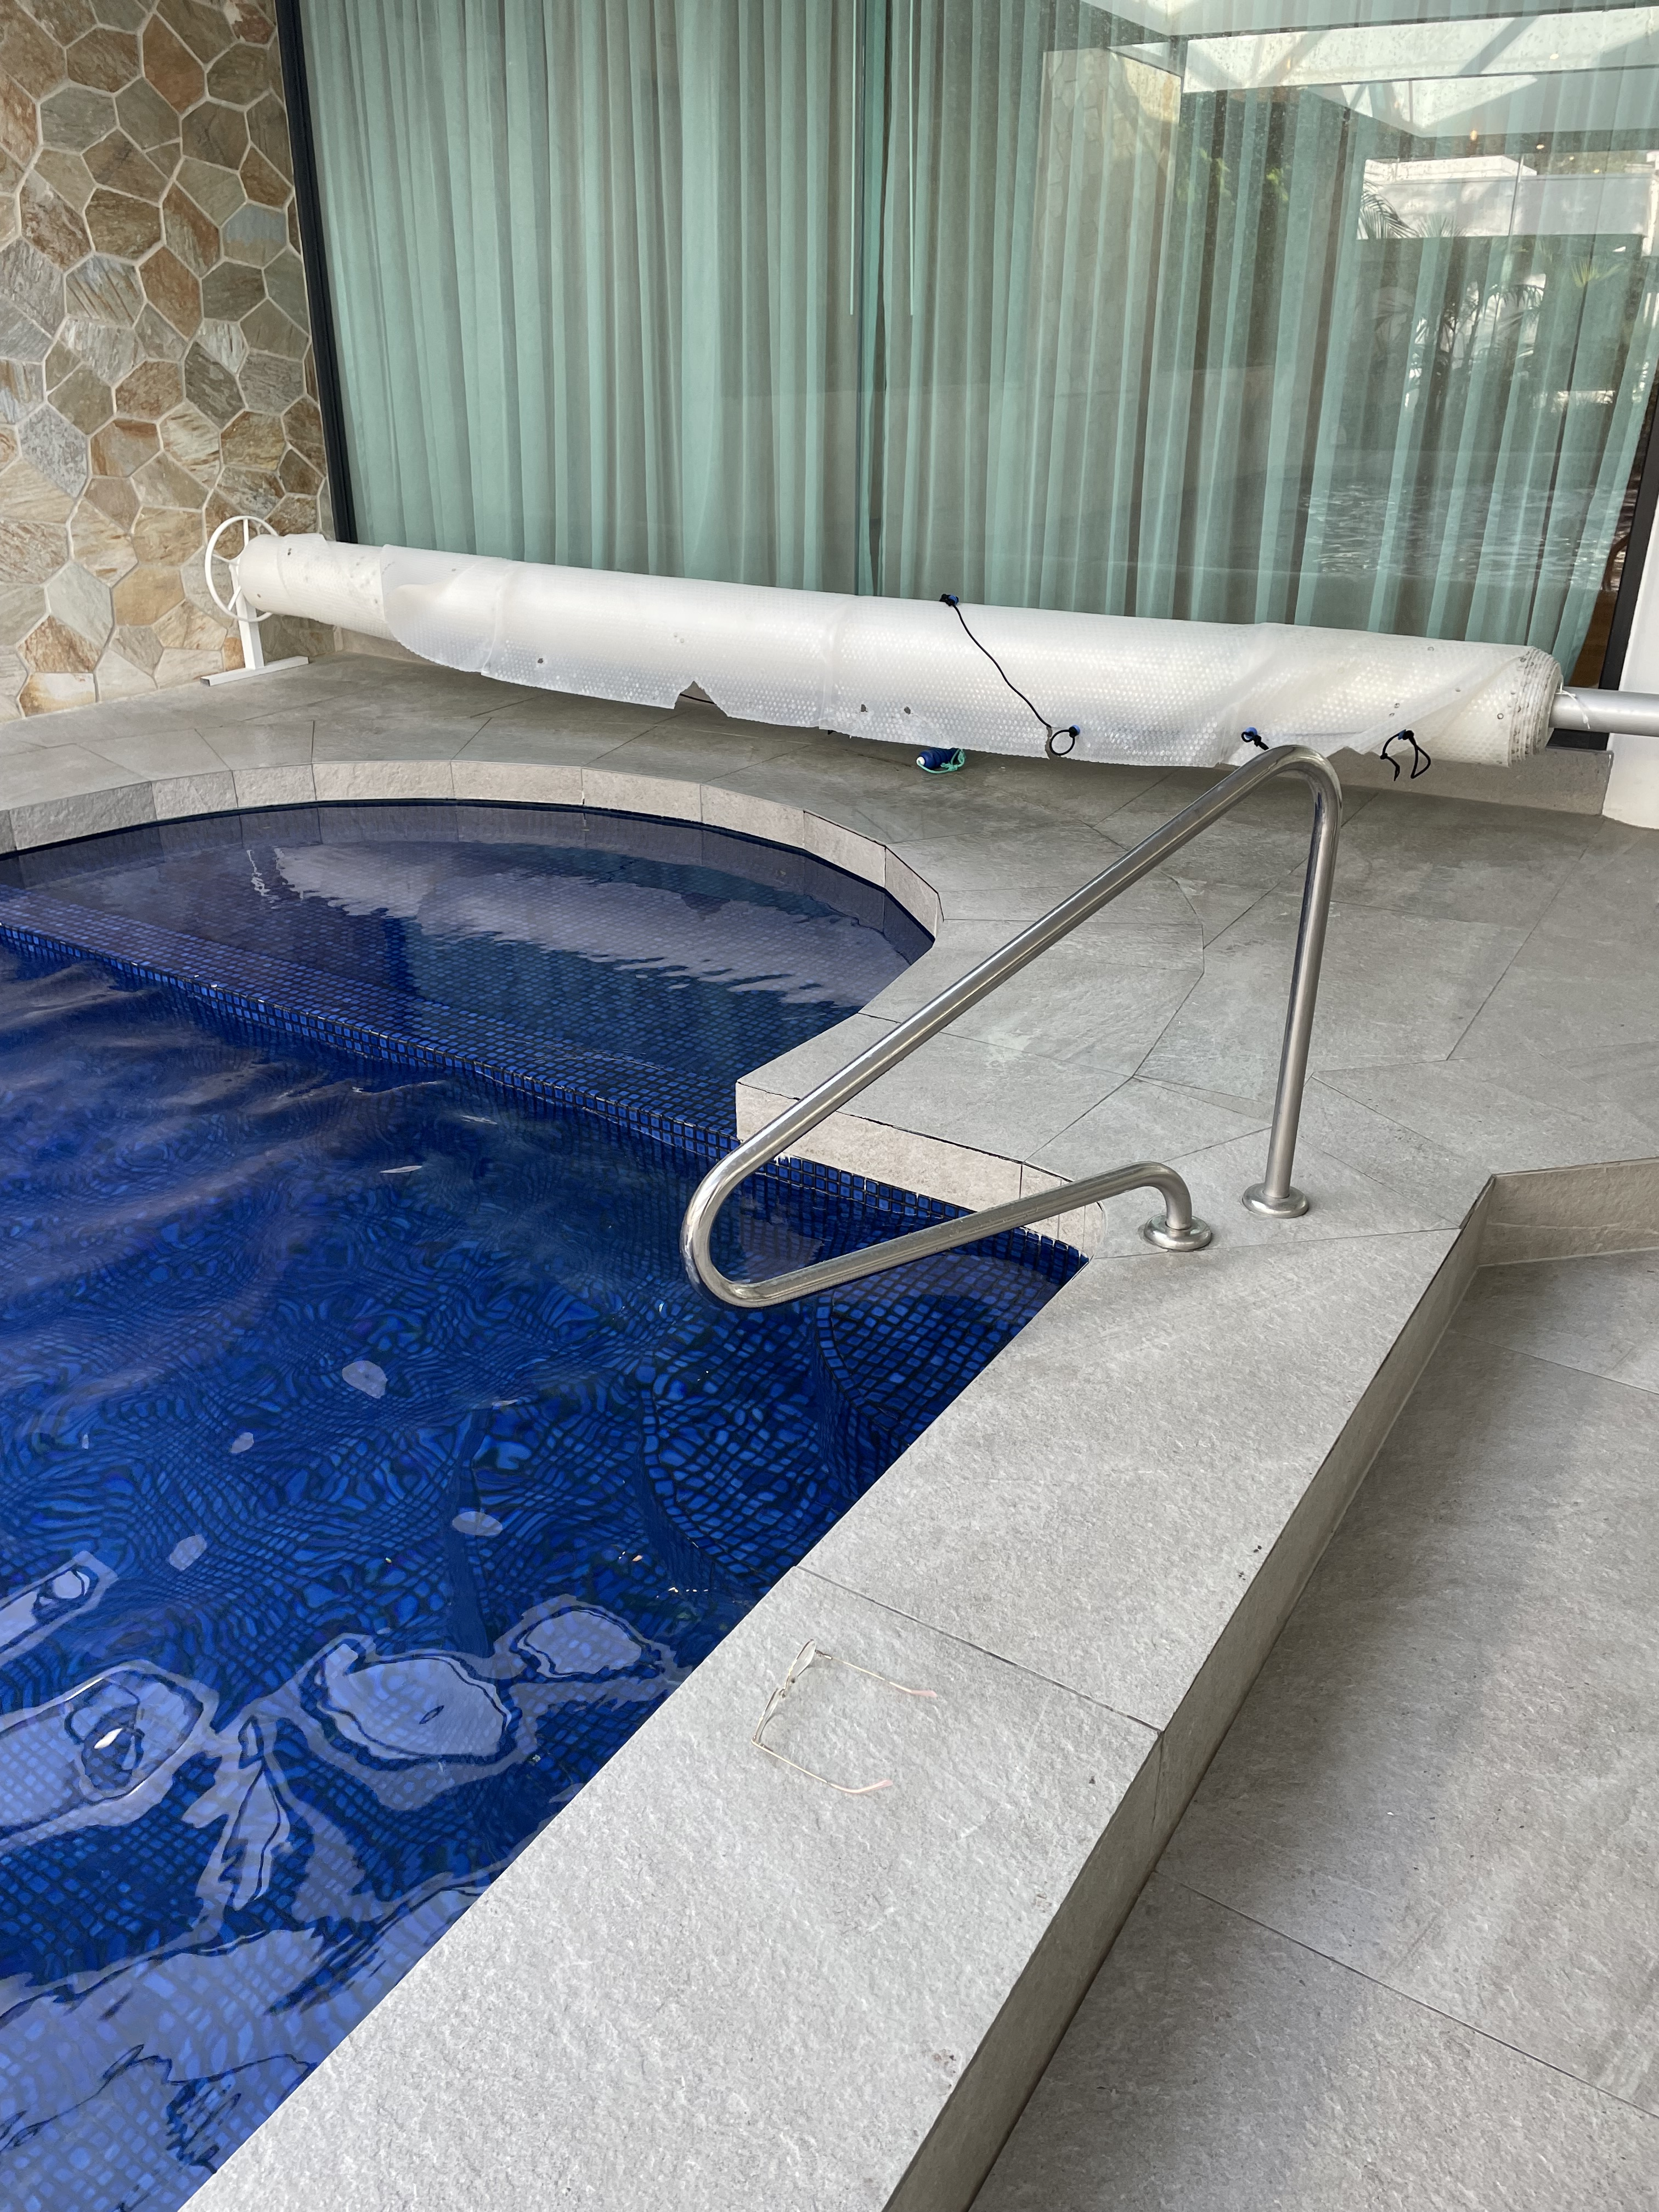
pool hand rail

FOOD AND DRINK

Dining Spaces
The dining spaces have the following facilities/amenities in place
- The entrance has level access
- The doorway is at least 850mm wide
- There is level access through the dining area
- Chairs are moveable to allow for wheelchairs to be seated at the tables
- All glass doors and full height windows have contrast markings
- There are areas of full lighting
- There are large print menus
- There are Plain English menus
- There is an accessible toilet

Our business caters for the following dietary requirements
- Sugar free (diabetic)
- Gluten free (celiac)
- Lactose free (dairy free)
- Low fat and fibre with no gastric content
- Low potassium
- Low sodium
- Nut free
- Additive free
- Organic
- Vegetarian
- Vegan
- Kosher
- Halal
- In addition, the following further information can assist guests:
clearly labelled food storage
different colour chopping boards
Our executive chef regular controls our safe handling food procedures and ensure all our kitchen and restaurant foh team are across these procedures to ensure there is no cross contamination of food products in our kitchen.
- There is a sample menu available online
Sample menu is available here -
https://www.thecoastrestaurant.com.au/dine
  - Food and Beverage Image(s)
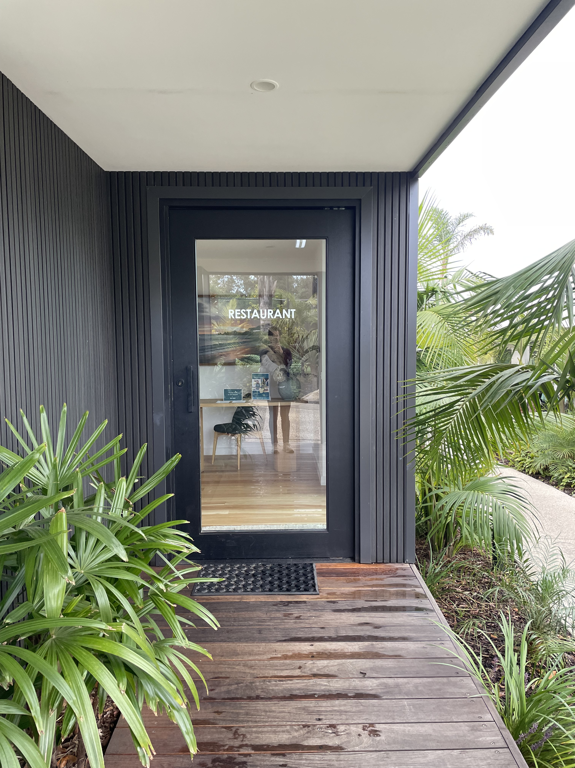
Coast 1
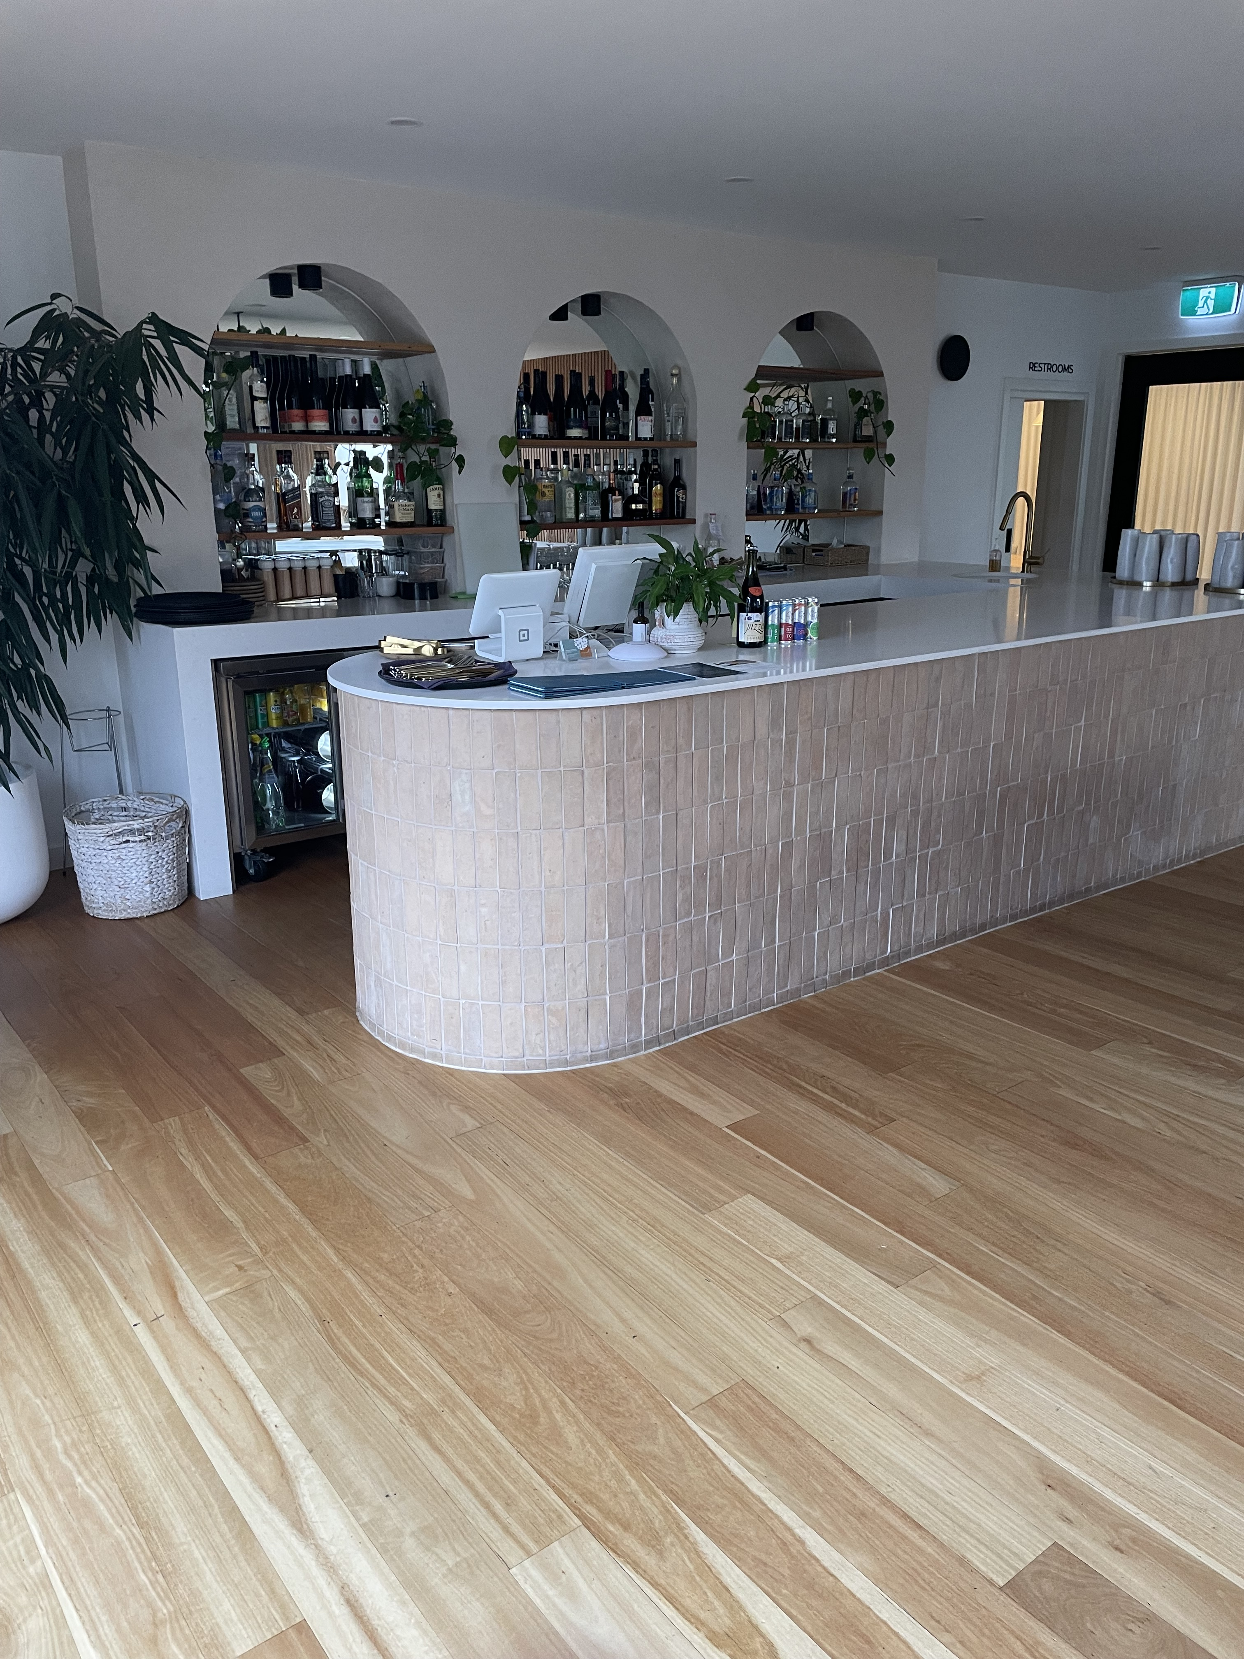
Coast 2
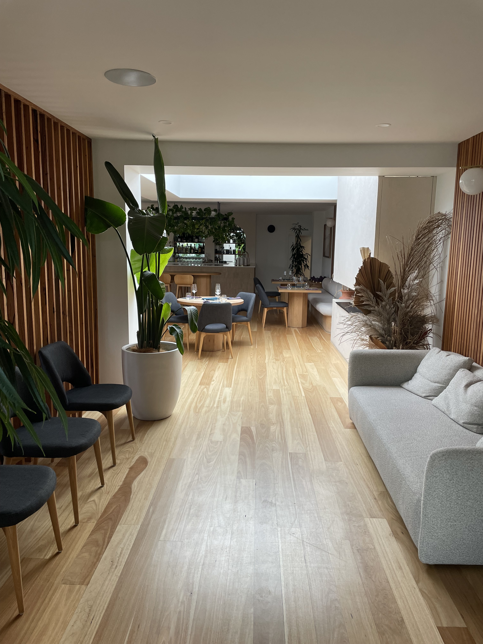
Coast 3

Report Disclaimer
Please note that this business report, provided as a result of the use of the diagnostic assessment, is for information purposes only.
Australian Tourism Industry Council (ATIC) cannot guarantee the accuracy of respondent’s answers, or that they are fully representative of your business. Therefore, ATIC does not warrant or guarantee any particular outcome in respect of your businesses self-assessment.
This report is intended as guidance only for your business and should not be relied on for future marketing considerations. ATIC recommends that you seek your own independent advice as well as the results from the diagnostic.
Links to external web sites are inserted for convenience and do not constitute endorsement of material at those sites, or any associated organisation, product or service.
ATIC does not:
- Assume any legal liability for the accuracy, completeness, or usefulness of any information from this report or any links provided; or
- Accept responsibility for any loss associated directly or indirectly from the use of this report.

