ATIC Accessibility
To support the accessible community in making informed travel decisions for their individual needs

This report prepared for:
Business name: | Kimberley Air Tours
Address: | Lot 309, Dusty Rankin Drive
Town: | Kununurra
Contact for enquiries: | Jaclyn Rawlings
Contact Number: | 0891682653
Contact Email: | info@kimberleyairtours.com.au
Website: | www.kimberleyairtours.com.au
Date: | 2026-08-15 08:33

ATIC Accessibility
The following pages provides travellers with information on the businesses facilities and amenities which aims to support the traveller to make an informed decision on whether the business is suitable for their individual needs.
OVERVIEW 4
Business Overview 4
Bookings 4
Emergency Management 4
Communications 5
Other Information 5
Guide Dog and Service Animals 5
GENERAL 6
Pre-arrival, arrival and reception 6
Cognitive Impairment Support 6
Car Park and Access amenities 6
Entry 6
Internal Spaces 7
Public areas 7
Displays, exhibits, commentary and live performances 7
External Paths 7
Public Toilets/Adult change facilities 8
TOUR OPERATORS 9
Tour/Transport Services 9
Route Planning 9
Guides 9
ADVENTURE ACTIVITIES 12
Report Disclaimer 14

OVERVIEW

Business Overview

The business has the following products/services available
- Tour/Transport
- Adventure

Our business caters for the following disability types:
- Blind or low vision
- Deaf or low hearing
- Limited mobility
- Wheelchairs or mobility scooters
- Food allergies or intolerances
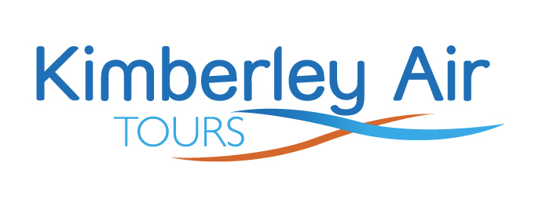

Bookings

The business offers the following methods for bookings and enquiries:
- Phone
- Email
- Webportal
- Our website supports Screen Readers
- Our forms have high contract boxes and submit boxes

Emergency Management

Emergency evacuation procedures are explained prior to boarding the aircraft, and the facility emergency evacuation procedure are displayed near the front entrance.
- Guests with disabilities are noted in the guest log book for emergency and evacuation purposes

Communications
- Our business offers the following alternative communication methods
- Plain English

Not specified
- There is easy to read signage and information (e.g. menus and emergency information)

Other Information
- For bookings made onsite, the ticket booth/counter/box office is accessible for people using a wheelchair

Guide Dog and Service Animals
The business provides the following services for services animals:
We do understand our legal obligations regarding assistance animals; however there are aviation limitations around transporting animals.

GENERAL

Pre-arrival, arrival and reception
The business has the following in place to support guests during pre-arrival, arrival and reception
- Booking information and websites are compatible with screen readers
- There is a reception/public entryway.
- Seating available at reception
- A clipboard to allow check-in/ticket purchase whilst seated
- Lighting in the reception area is even and glare free
- Information and maps are available in written form
- A familiarisation tour
- In addition, the following further information can assist guests:
We have a shaded waiting area with seats available and a cold bottle of water while they wait to be checked in or for their scenic tour to commence.&nbsp;

Cognitive Impairment Support
- Documents are available in plain English for people with cognitive impairment (This may include instructions, guides, menus and general information)

Car Park and Access amenities
The business has the following Car Park and Access amenities
- Level or ramped access from the car park to the entrance

Entry
The business has the following amenities/systems in place for entry
- A path of access to the building is slip resistance and even
- A path of access to the building is clear of obstruction
- Glass doors are fitted with a visual sighting strip
- Door jams/doors are of a contrasting colour to surrounding walls
- Door handles are of a contrasting colour to the door
- Signage is written in a contrasting colour
- Signage is written in a Sans Serif font and use upper and lower case letters
- The entrance sill is less than 13mm
- There a clear space of at least 1500mm x 1500mm in front of all doors.
- The entrance door mats have a thickness less than 13mm and a width of 7500mm or greater

Internal Spaces
- Clear and unobstructed routes through and between buildings
- Interior walls are matte or low sheen
- Floors, walls, counters and furniture are of contrasting colours
- Floor surfaces are hard or short pile carpet
- Seating is available for guests unable to stand for long periods
- All corridors greater than 900mm

Public areas
The public areas have the following amenities in place
- Even lighting
- Seating

Displays, exhibits, commentary and live performances
For displays, exhibits, commentary and live performances the following amenities are in place
- Seating
- Wheelchair accessible spaces/seating
- A written transcript where audio description is provided i.e. display commentary, tour commentary

External Paths
External paths of travel
- Surfaces are concrete, asphalt, smooth paving or hard packed fine gravel (max aggregate size 13mm)
- Pathways are wider than 900mm

No steps around office area

Public Toilets/Adult change facilities
Public Toilets/Adult change facilities have the following amenities are in place
- There is an accessible toilet for public use
- The door is at least 850mm wide
- There is There is no clear space greater than 700mm, the bathroom sink is next to the toilet. mm beside the toilet
- There is 850mm mm of clear space in front of the toilet
- The toilet seat of a contrasting colour to the floor
- The toilet seat is460mm above the floor

TOUR OPERATORS

Tour/Transport Services
The tour/transport services have the following facilities/amenities in place
- Buses/Coaches
- 0 vehicles have wheelchair lifts or ramps
- 0 vehicles have low floors with ramped entry
The maximum wheelchair capacity available in the fleet is:
0
- Commentary is available in written format

Route Planning
- Route Planning
- Walking Tours

Guides

Guides have been trained in the following
- Use of clear/simple English
- There is a audio description of surroundings
  - Image(s)
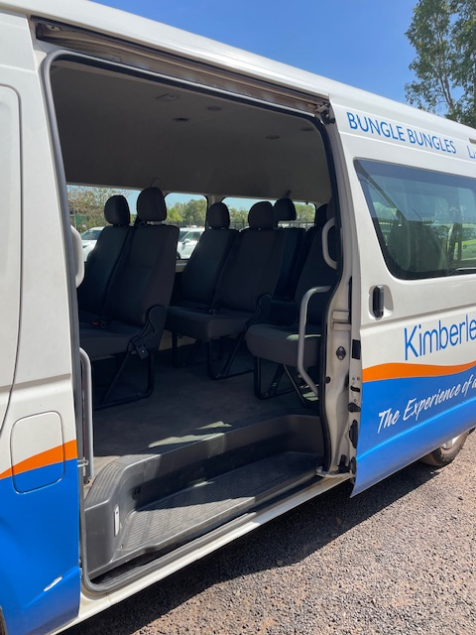
Bus entry
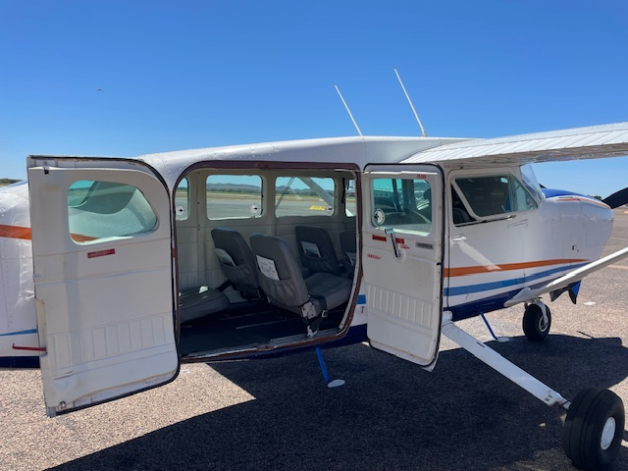
C207 Barn Doors
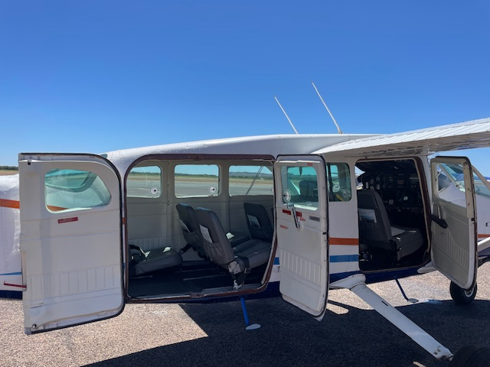
C207 Entry
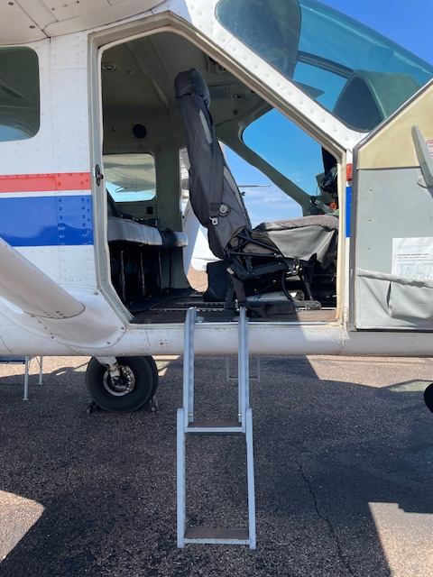
Caravan Front Door entry
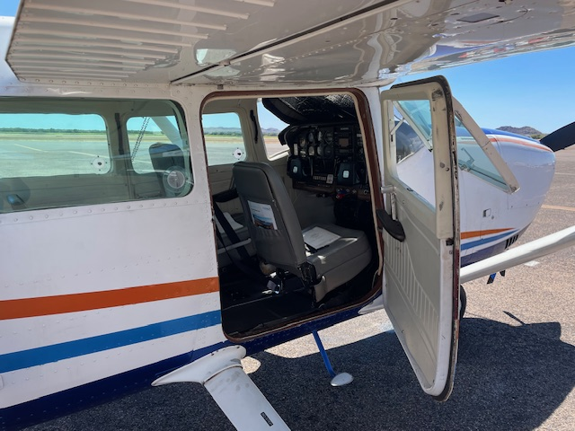
C207 front door
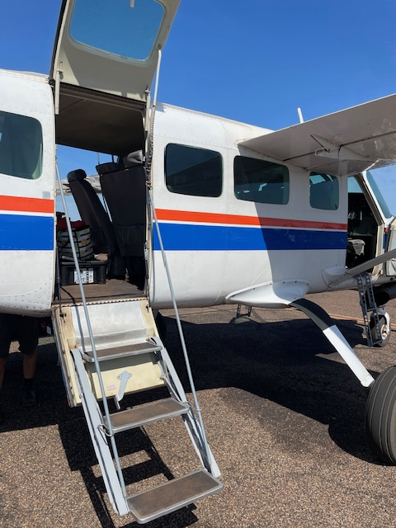
Caravan main acc
- In addition, the following further information can assist guests:
All three Mitchell Falls scenic tour land at the Mitchell River National Park; however this is an unsealed area. This National Park is managed by a government body.&nbsp;

ADVENTURE ACTIVITIES

Report Disclaimer
Please note that this business report, provided as a result of the use of the diagnostic assessment, is for information purposes only.
Australian Tourism Industry Council (ATIC) cannot guarantee the accuracy of respondent’s answers, or that they are fully representative of your business. Therefore, ATIC does not warrant or guarantee any particular outcome in respect of your businesses self-assessment.
This report is intended as guidance only for your business and should not be relied on for future marketing considerations. ATIC recommends that you seek your own independent advice as well as the results from the diagnostic.
Links to external web sites are inserted for convenience and do not constitute endorsement of material at those sites, or any associated organisation, product or service.
ATIC does not:
- Assume any legal liability for the accuracy, completeness, or usefulness of any information from this report or any links provided; or
- Accept responsibility for any loss associated directly or indirectly from the use of this report.

