ATIC Accessibility
To support the accessible community in making informed travel decisions for their individual needs

This report prepared for:
Business name: | Bungle Bungle Guided Tours
Address: | Lot 319 Laine Jones Drive
Town: | Kununurra
Contact for enquiries: | Kym Francesconi
Contact Number: | 0419805279
Contact Email: | bookings@bbgt.com.au
Website: | www.bunglebungleguidedtours.com.au
Date: | 2026-10-20 23:51

ATIC Accessibility
The following pages provides travellers with information on the businesses facilities and amenities which aims to support the traveller to make an informed decision on whether the business is suitable for their individual needs.
OVERVIEW 4
Business Overview 4
Bookings 4
Emergency Management 4
Other Information 5
Guide Dog and Service Animals 5
GENERAL 6
Pre-arrival, arrival and reception 6
Cognitive Impairment Support 6
Displays, exhibits, commentary and live performances 6
External Paths 6
Steps 7
TOUR OPERATORS 8
Tour/Transport Services 8
Route Planning 8
Guides 8
Report Disclaimer 13

OVERVIEW

Business Overview

The business has the following products/services available
- Tour/Transport

Our business caters for the following disability types:
- Deaf or low hearing
- Limited mobility
- Food allergies or intolerances
- Cognitive or people on the Autism Spectrum


Bookings

The business offers the following methods for bookings and enquiries:
- Phone
- Email
- Webportal
- Our forms have high contract boxes and submit boxes
- Staff have undergone disability awareness and training

Emergency Management
- Emergency and evacuation procedures are explained on arrival
- In addition, the following further information can assist guests:
Guests requiring additional assistance are marked on the tour manifest and the guides provided with information.
- In addition, the following further information can assist guests:
All tours are conducted with a minimum of two guides. In the event of an emergency and passengers requiring additional assistance one guide would stay with the person needing assistance and depending on the situation manage it accordingly, for example if an air lift was required HeliSpirit would be alerted.
- Guests with disabilities are noted in the guest log book for emergency and evacuation purposes

Other Information
- The business accepts the companion card

Guide Dog and Service Animals
The business provides the following services for services animals:
Not applicable.

GENERAL

Pre-arrival, arrival and reception
The business has the following in place to support guests during pre-arrival, arrival and reception
- Information and maps are available in written form
- In addition, the following further information can assist guests:
Varying mobility needs can be catered for and the pace of walks is kept to a moderate ability with multiple guides to assist with different paces. The staff at Bungle Bungle Savannah Lodge are on call to collect tired passengers.
- In addition, the following further information can assist guests:
The uneven ground and difficulty of some walking tracks in Purnululu prevent us from accommodating wheelchairs, we welcome those with limited mobility however.

Cognitive Impairment Support
- Documents are available in plain English for people with cognitive impairment (This may include instructions, guides, menus and general information)

Displays, exhibits, commentary and live performances
For displays, exhibits, commentary and live performances the following amenities are in place
- A written transcript where audio description is provided i.e. display commentary, tour commentary

External Paths
External paths of travel
The width of the smallest pathway is:
Very narrow gaps along the designated walking paths in Purnululu National Park.
- There 3 successive steps or less on any path or at any doorway

Steps
Steps
- There are steps.
- In addition, the following further information can assist guests:
There are areas within the National Park that have rough, natural stairs, as well as ladders for climbing. These can be challenging for guests with reduced mobility.
- In addition, the following further information can assist guests:
There are accessible toilet facilities at the main carparks within Purnululu National Park.

TOUR OPERATORS

Tour/Transport Services
The tour/transport services have the following facilities/amenities in place
- Buses/Coaches
- None vehicles have wheelchair lifts or ramps
- None vehicles have low floors with ramped entry
The maximum wheelchair capacity available in the fleet is:
None
- Commentary is available in written format

Route Planning
- Route Planning
- Walking Tours
- Multi-paced to account for slower walkers

Guides

Guides have been trained in the following
- Use of clear/simple English
- Correct pronunciation for lip readers
- There is a audio description of surroundings
  - Image(s)
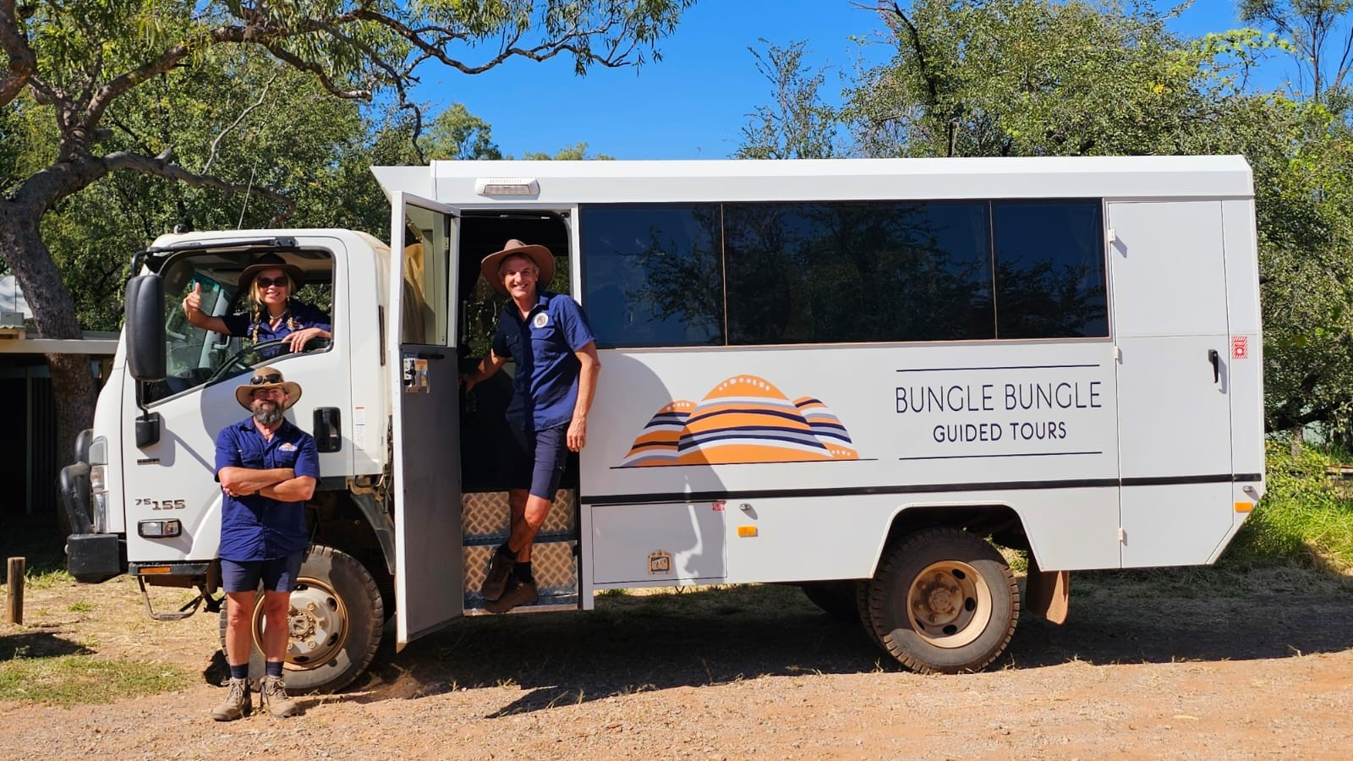
T3
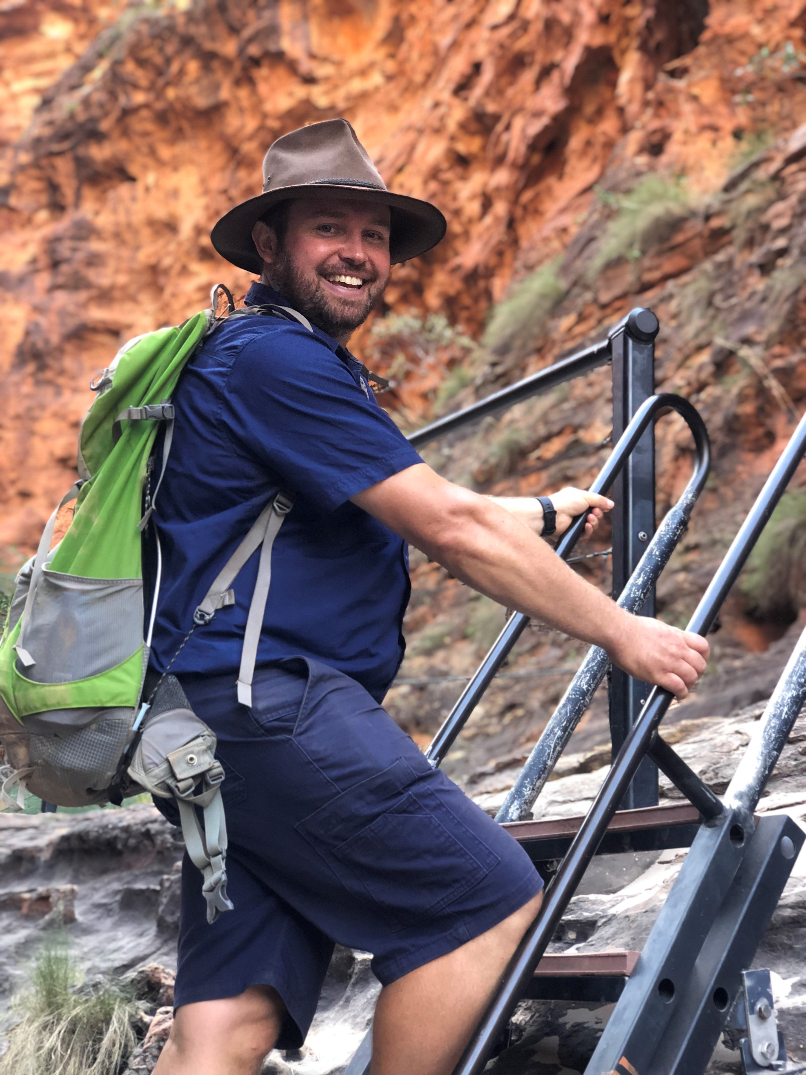
pete 2
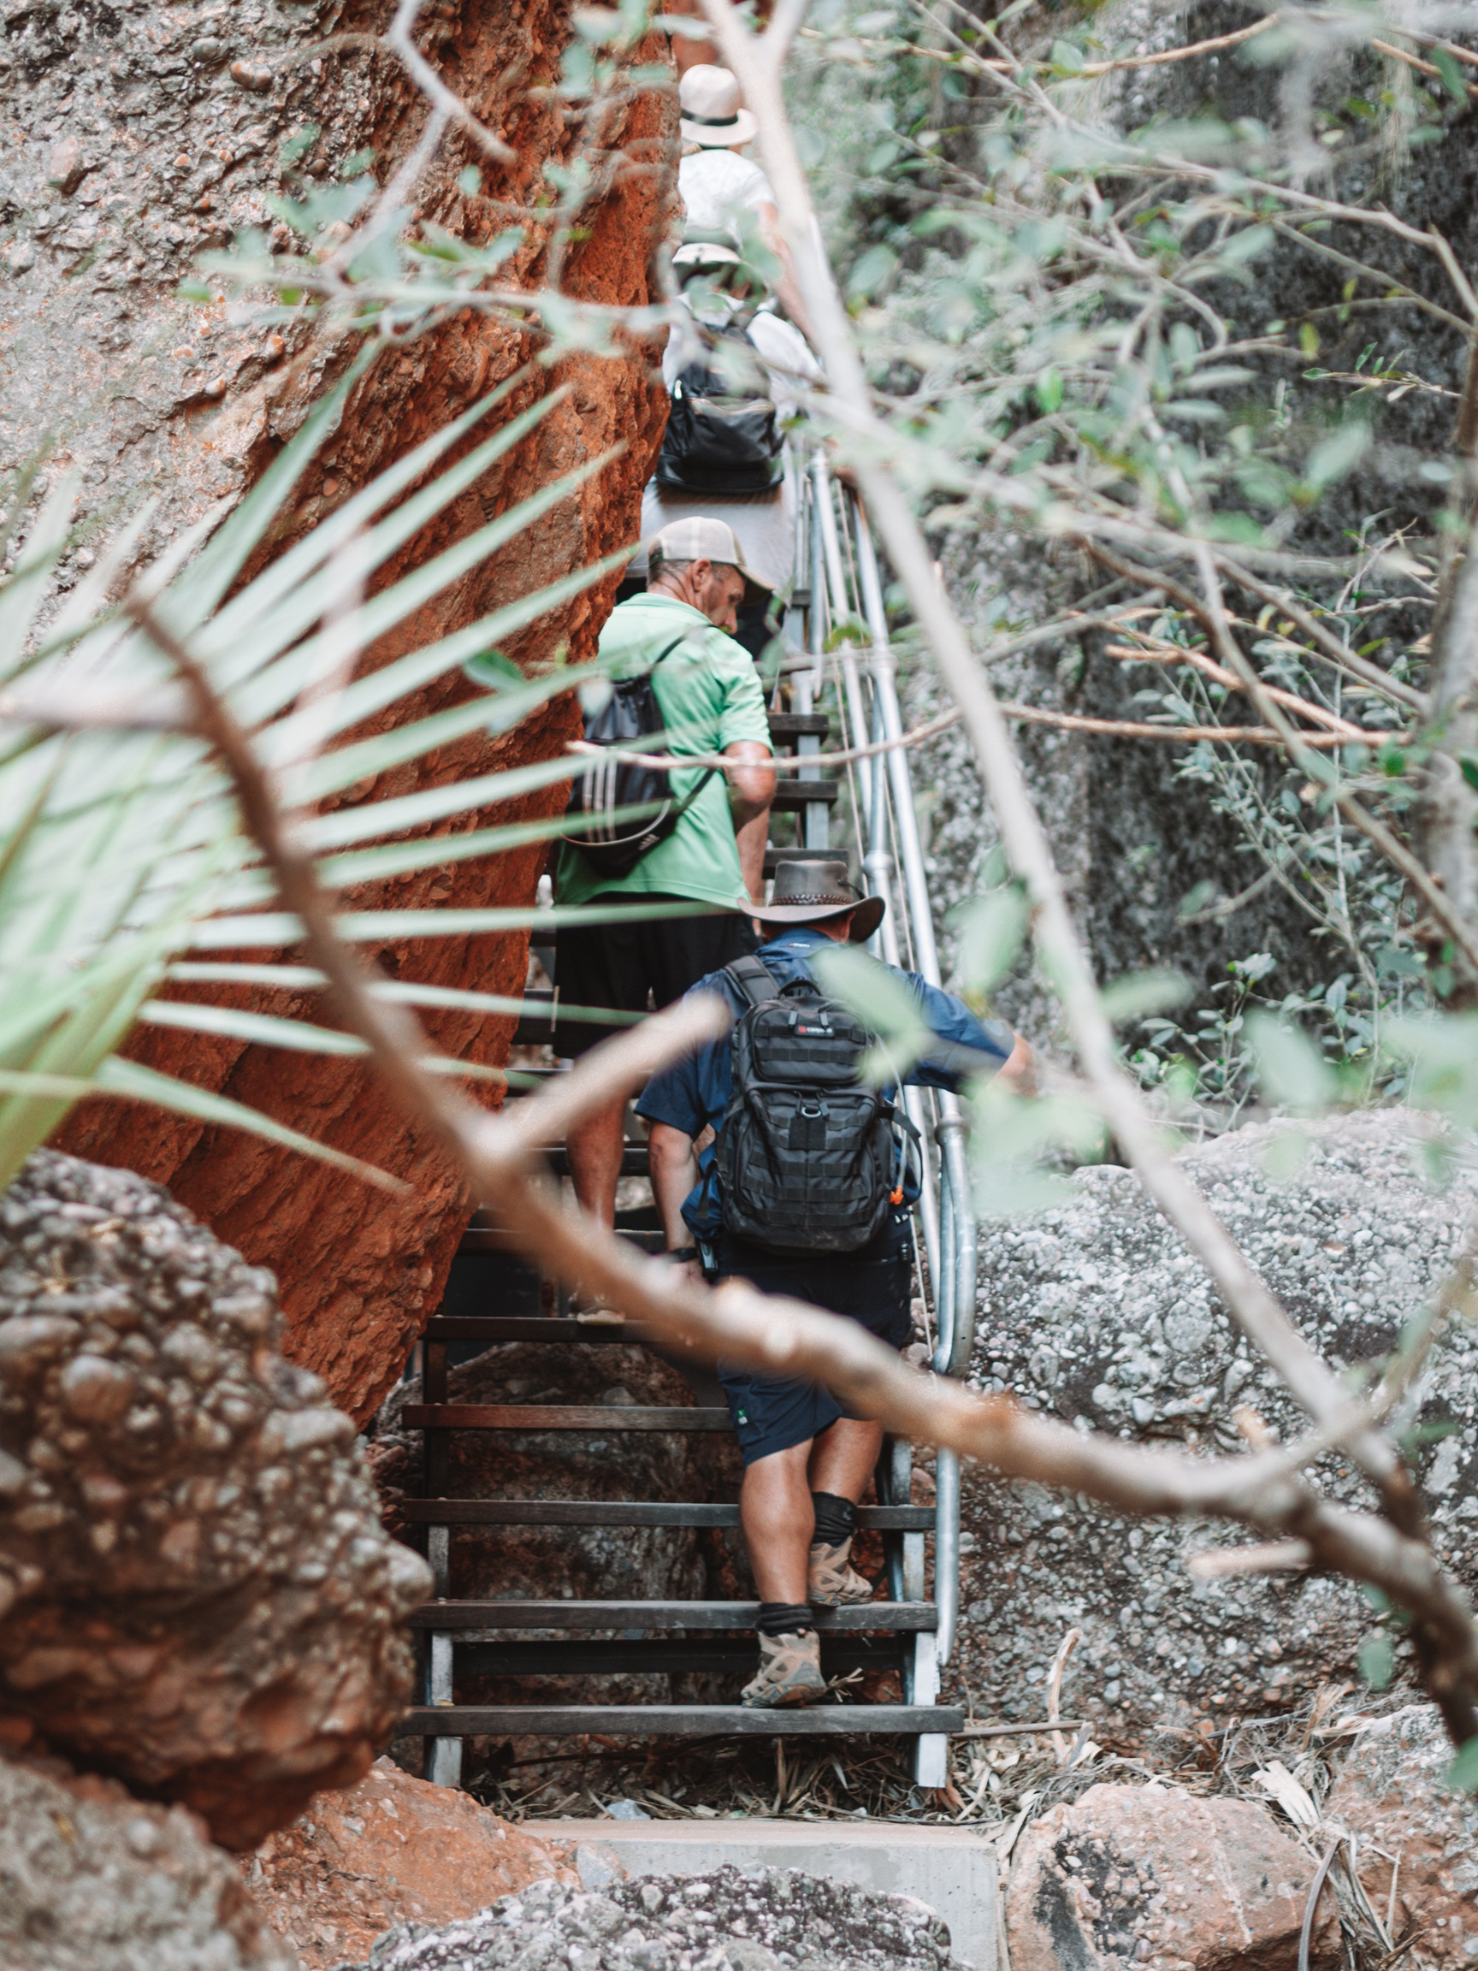
P5260206
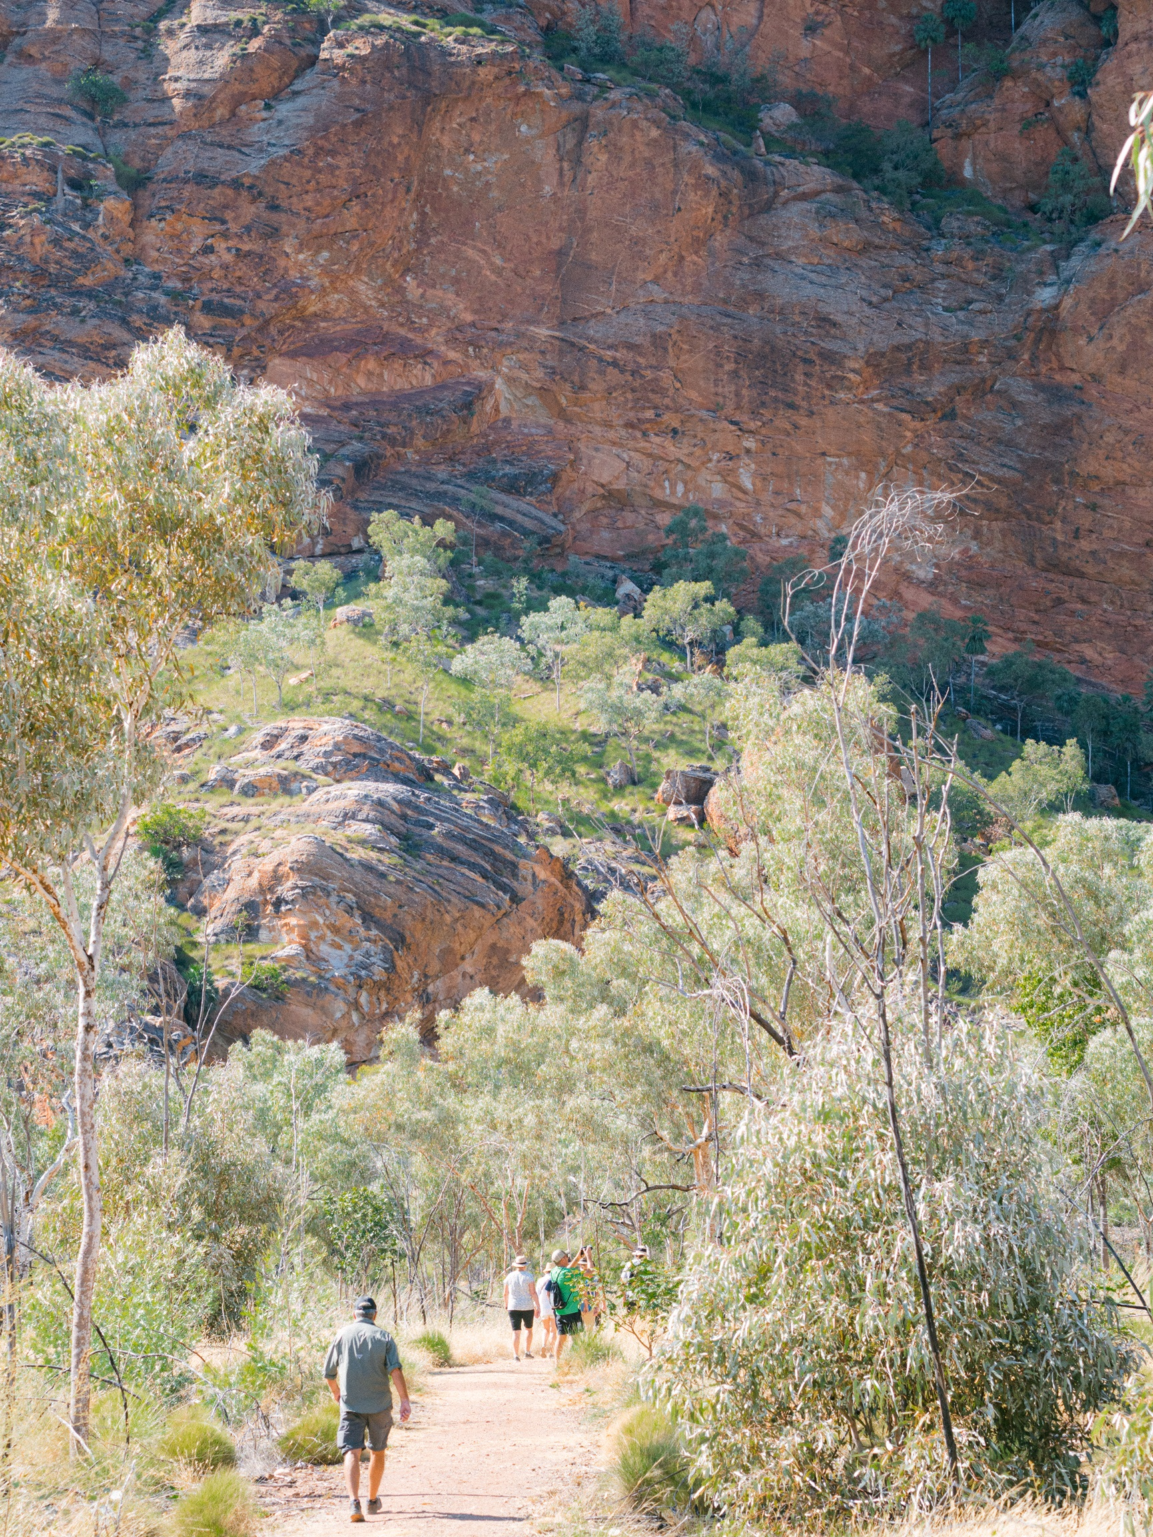
P5260132
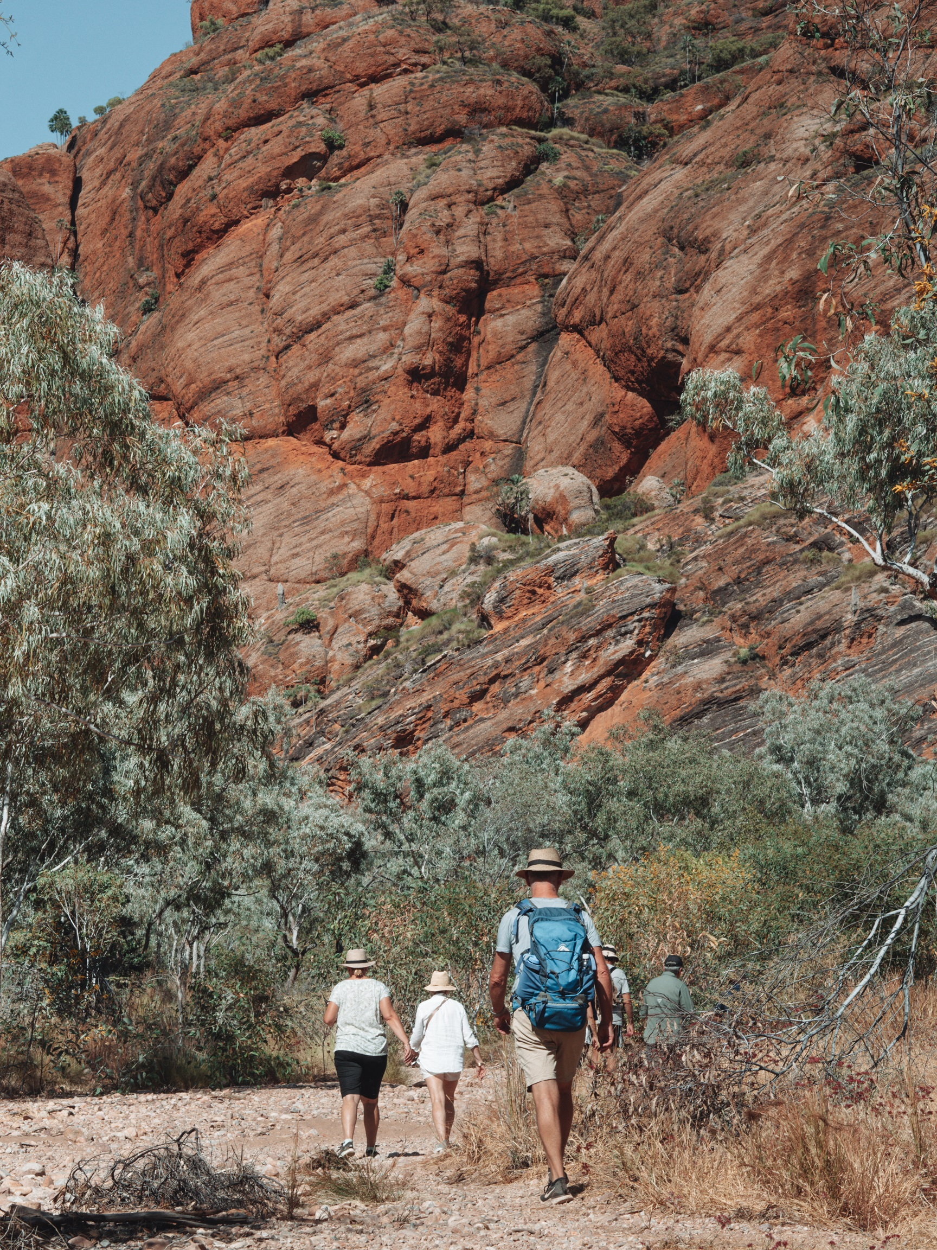
P5260141
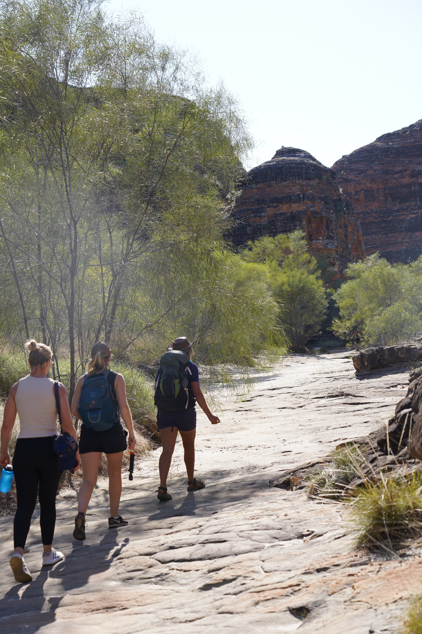
DSC02440
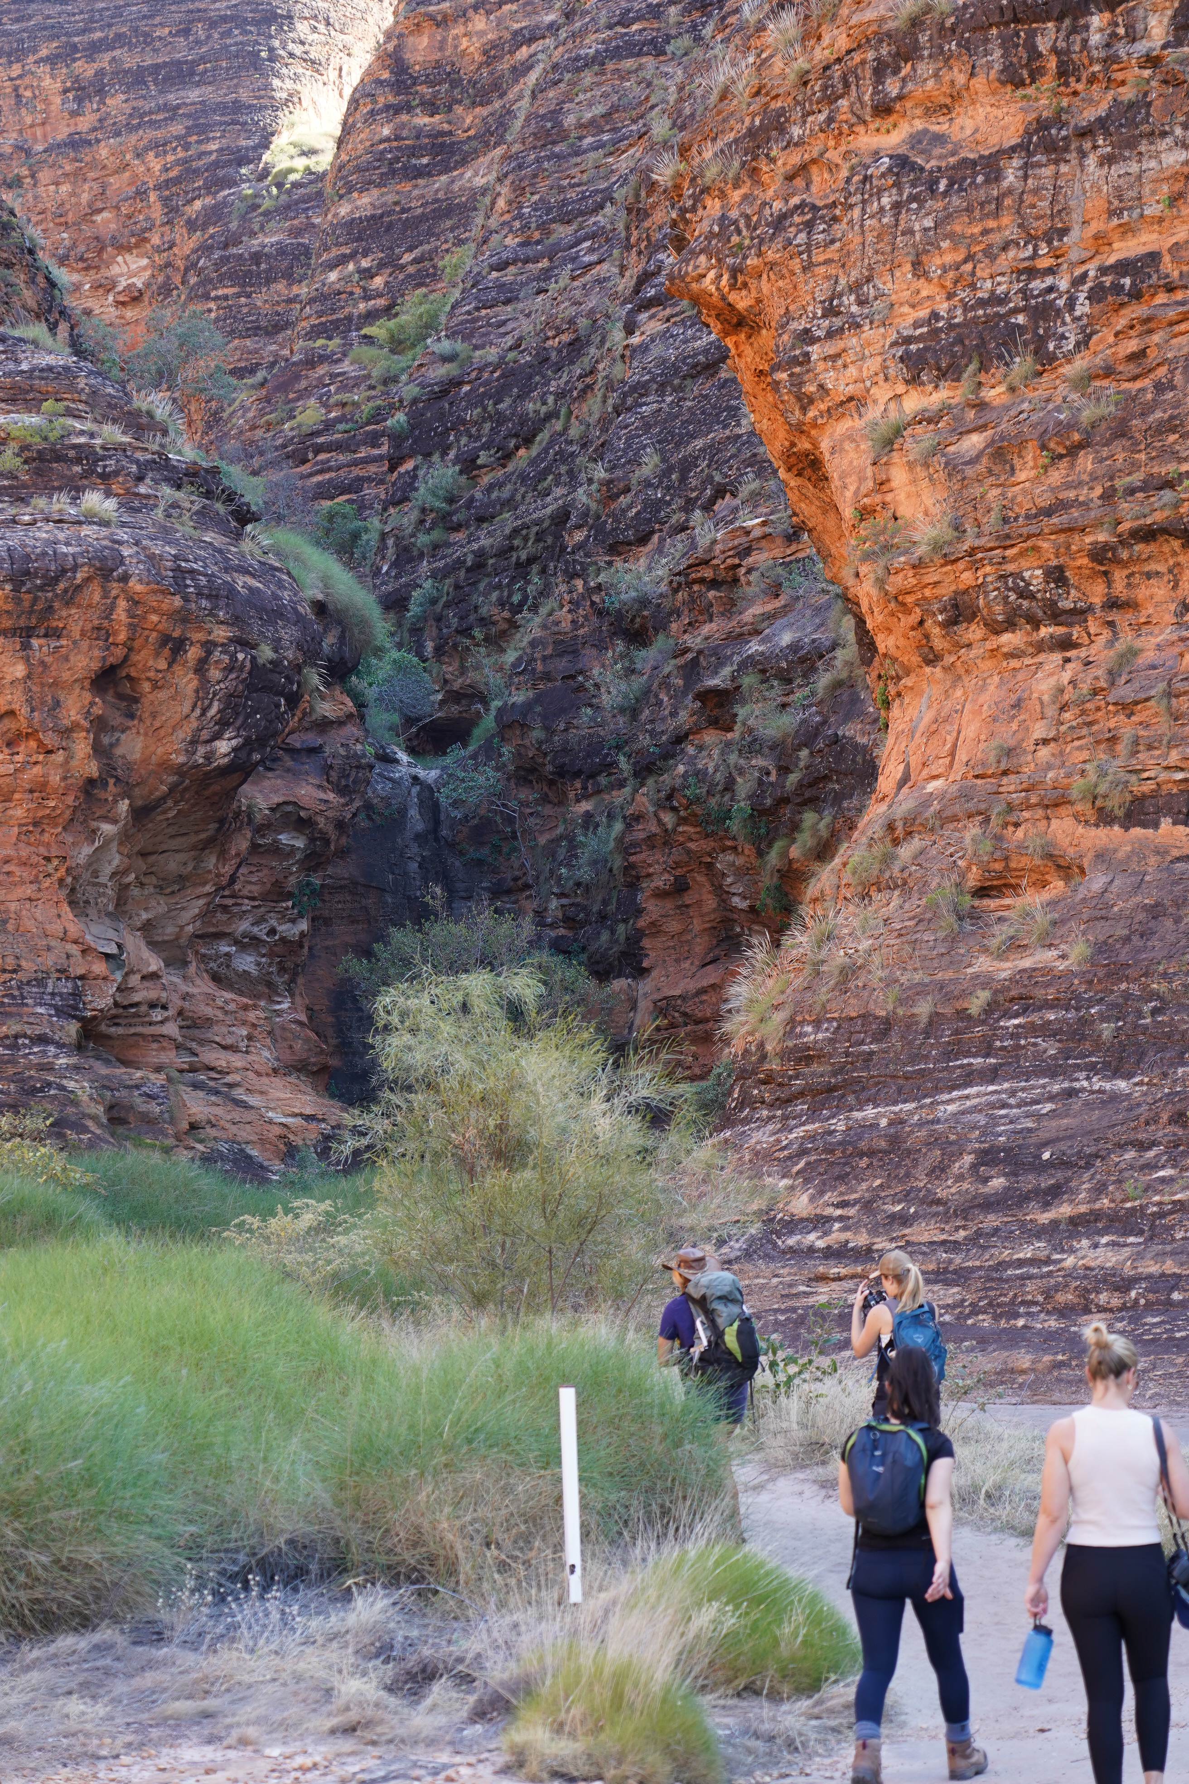
DSC02444
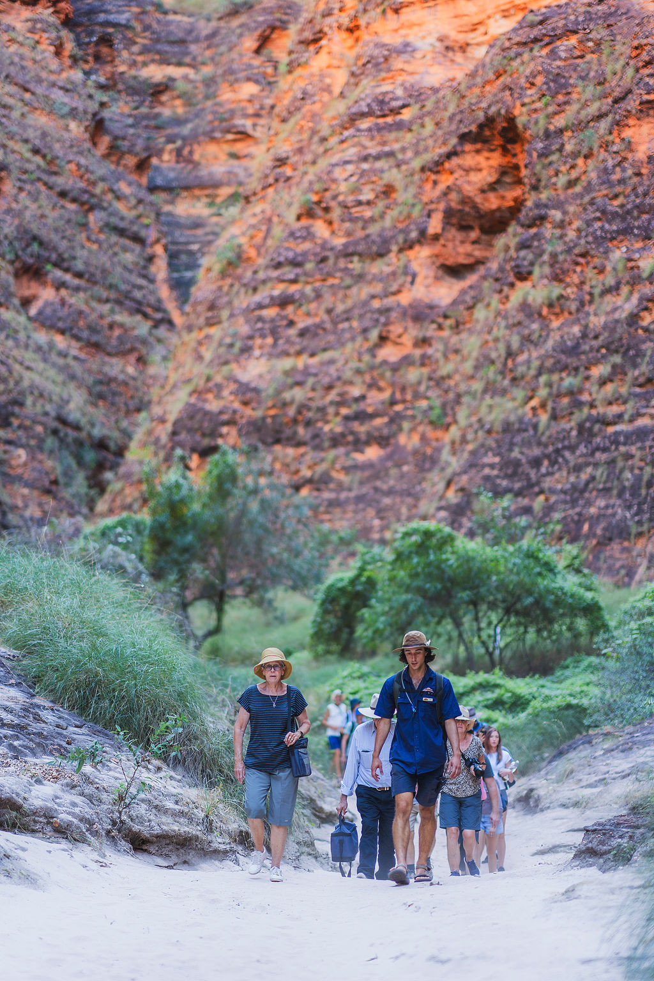
TightA7409003

Report Disclaimer
Please note that this business report, provided as a result of the use of the diagnostic assessment, is for information purposes only.
Australian Tourism Industry Council (ATIC) cannot guarantee the accuracy of respondent’s answers, or that they are fully representative of your business. Therefore, ATIC does not warrant or guarantee any particular outcome in respect of your businesses self-assessment.
This report is intended as guidance only for your business and should not be relied on for future marketing considerations. ATIC recommends that you seek your own independent advice as well as the results from the diagnostic.
Links to external web sites are inserted for convenience and do not constitute endorsement of material at those sites, or any associated organisation, product or service.
ATIC does not:
- Assume any legal liability for the accuracy, completeness, or usefulness of any information from this report or any links provided; or
- Accept responsibility for any loss associated directly or indirectly from the use of this report.

