ATIC Accessibility
To support the accessible community in making informed travel decisions for their individual needs

This report prepared for:
Business name: | Phillip Island Tenpin Bowling & Entertainment Centre
Address: | 91-97 Settlement Rd
Town: | Cowes
Contact for enquiries: | Jeremy Westaway
Contact Number: | 0359523977
Contact Email: | tenpin@pitenpin.com.au
Website: | www.pitenpin.com.au
Date: | 2026-11-08 02:55

ATIC Accessibility
The following pages provides travellers with information on the businesses facilities and amenities which aims to support the traveller to make an informed decision on whether the business is suitable for their individual needs.
OVERVIEW 4
Business Overview 4
Bookings 4
Emergency Management 5
Communications 5
Other Information 5
Guide Dog and Service Animals 5
GENERAL 7
Pre-arrival, arrival and reception 7
Cognitive Impairment Support 8
Car Park and Access amenities 8
Entry 8
Internal Spaces 9
Public areas 9
External Paths 9
Ramps 10
Public Toilets/Adult change facilities 10
ATTRACTIONS 11
COMMON AREAS 12
FOOD AND DRINK 13
Dining Spaces 13
Report Disclaimer 18

OVERVIEW

Business Overview

The business has the following products/services available
- Attraction
- Food and Drink

Our business caters for the following disability types:
- Blind or low vision
- Deaf or low hearing
- Limited mobility
- Wheelchairs or mobility scooters
- Food allergies or intolerances
- Cognitive or people on the Autism Spectrum


Bookings

The business offers the following methods for bookings and enquiries:
- Phone
- Email
- Webportal
- Staff have undergone disability awareness and training

Emergency Management
- The business has an emergency management and evacuation plan for guests with a disability
- Emergency and evacuation procedures are explained on arrival
- Guests with disabilities are noted in the guest log book for emergency and evacuation purposes

Communications
- An accessibility guide is available on the website

https://www.pitenpin.com.au/accessability-1
- Our website meets WCAG 2.0 accessibility standards
- Our business offers the following alternative communication methods
- Plain English
- Braille Displays
- Magnifiers

Not specified
- There is easy to read signage and information (e.g. menus and emergency information)

Other Information
- For bookings made onsite, the ticket booth/counter/box office is accessible for people using a wheelchair
- The business accepts the companion card

Guide Dog and Service Animals
- The business provides a secure area with shade and water for service animals
- The business provides a toilet area for service animals
- Bowls, bedding, etc. are provided for service animals
The business provides the following services for services animals:
Not specified

GENERAL

Pre-arrival, arrival and reception
The business has the following in place to support guests during pre-arrival, arrival and reception
- There is a reception/public entryway.
- Seating available at reception
- A lower counter at reception/ticket office
- A clipboard to allow check-in/ticket purchase whilst seated
- A tablet with text to voice or pen and paper at reception to aid in communication
- Picture Board at reception to aid in communication
- Lighting in the reception area is even and glare free
- Large print information sheets and registration forms
- Information and maps are available in written form
- A familiarisation tour
- In addition, the following further information can assist guests:
At PI Tenpin Bowling &amp; Entertainment Centre, we are committed to providing an inclusive and accessible experience for all visitors, including those who experience fatigue due to disability. To minimise the impact of long wait times, we have implemented the following accommodations:

Priority Support &amp; Flexible Options:Alternative Seating Areas: Comfortable seating is available throughout the venue for rest breaks while waiting or participating.

Queue Bypass Options: Where appropriate, guests with fatigue-related conditions (and their companions) may be offered priority access to reduce standing or waiting times.

Companion Card Recognition: Carers entering the venue with a Companion Card are offered free entry when assisting a guest with a disability, allowing flexible and supported access.

Advance Planning Support:Pre-arrival Coordination: Guests are welcome to contact us in advance to discuss specific needs so we can tailor their visit accordingly (e.g. quieter times, reduced mobility or stamina considerations).

Booking Flexibility for Groups: For schools or organisations with individuals who may experience fatigue, we offer flexible scheduling to help reduce downtime between activities.

Staff Awareness &amp; Training:Our team is trained to recognise fatigue-related needs and respond with empathy and practical adjustments where possible.

We prioritise clear communication and offer help proactively when signs of fatigue are observed.

Cognitive Impairment Support
- Documents are available in plain English for people with cognitive impairment (This may include instructions, guides, menus and general information)
- Quiet periods or early opening times for people on the Autism Spectrum

Car Park and Access amenities
The business has the following Car Park and Access amenities
- Designated disabled parking bays
- Level or ramped access from the car park to the entrance
- The accessible entrance is clearly signed from the parking bay
- In addition, the following further information can assist guests:
The car park is located directly beside the building on a fully concreted surface, with no stairs or uneven ground. From the accessible car park, it’s a maximum of 10 metres to the front entrance. The entrance is at the front left of the building when viewing it from the street, with a wide concrete path leading to the door and no steps.

Entry
The business has the following amenities/systems in place for entry
- A drop off point close to the entrance
- A path of access to the building is slip resistance and even
- A path of access to the building is clear of obstruction
- Self opening entry doors or fitted with a self closer
- Glass doors are fitted with a visual sighting strip
- Door jams/doors are of a contrasting colour to surrounding walls
- Door handles are of a contrasting colour to the door
- Signage is written in a contrasting colour
- The entry door is a minimum of 850mm wide
- The entry door has self opening or a light opening pressure (for manual operations)
- The entrance sill is less than 13mm
- There a clear space of at least 1500mm x 1500mm in front of all doors.

Internal Spaces
- Clear and unobstructed routes through and between buildings
- Interior walls are matte or low sheen
- Floors, walls, counters and furniture are of contrasting colours
- Any protruding or overhanging obstructions are at least 2meters above the floor or are protected
- Tableware/glassware contrast with the table surface or table cloth
- Floor surfaces are hard or short pile carpet
- Seating is available for guests unable to stand for long periods
- Accessible facilities are clearly signed and visible from all areas
- All corridors greater than 900mm

Public areas
The public areas have the following amenities in place
- Even lighting
- Seating

External Paths
External paths of travel
- Surfaces are concrete, asphalt, smooth paving or hard packed fine gravel (max aggregate size 13mm)
- Pathways are wider than 900mm

no steps anywhere

Ramps
Ramps have the following amenities are in place
- There are ramps.
- All fixed ramps are 1:14 or less
- Hand rails are fitted
- Ramps have a raised edge of at least 100mm

Public Toilets/Adult change facilities
Public Toilets/Adult change facilities have the following amenities are in place
- There is an accessible toilet for public use
- The door is at least 850mm wide
- There is a minimum of 850mm beside the toilet
- Handrails are fitted
- The toilet seat is 460mm above the floor
- The toilet seat of a contrasting colour to the floor
- The toilet seat is460mm above the floor
- There is a 'Changing Place' within n/a of our business

ATTRACTIONS

COMMON AREAS

FOOD AND DRINK

Dining Spaces
The dining spaces have the following facilities/amenities in place
- The entrance has level access
- The doorway is at least 850mm wide
- There is level access through the dining area
- Chairs are moveable to allow for wheelchairs to be seated at the tables
- All glass doors and full height windows have contrast markings
- There are areas of full lighting
- There are large print menus
- There are Plain English menus
- There is an accessible toilet

Our business caters for the following dietary requirements
- Sugar free (diabetic)
- Gluten free (celiac)
- Lactose free (dairy free)
- Low fat and fibre with no gastric content
- Low potassium
- Low sodium
- Nut free
- Vegetarian
- Vegan
- Kosher
- Halal
- In addition, the following further information can assist guests:
Procedures to Avoid Cross-Contamination of Food Products at PI Tenpin Bowling &amp; Entertainment Centre

At PI Tenpin Bowling &amp; Entertainment Centre, we take food safety seriously and have strict procedures in place to prevent cross-contamination of food products in our kitchen and food service areas. Our team follows these practices to ensure all guests can dine with confidence:

Separate Preparation Areas: Where possible, foods are prepared in designated areas to keep raw and cooked items apart, and to reduce contact between allergen-containing and allergen-free foods.

Dedicated Equipment: We use colour-coded chopping boards and utensils to help prevent cross-contact between meat, seafood, dairy, gluten-containing, and allergen-free foods.

Frequent Cleaning: All preparation surfaces, utensils, and equipment are cleaned and sanitised between uses and after each task to maintain high hygiene standards.

Hand Washing: Staff are trained to wash their hands thoroughly before handling food, after handling raw ingredients, and after any potential contamination event.

Food Storage: Ingredients are stored in sealed, labelled containers and organised to ensure raw items are kept below ready-to-eat foods to prevent drips or spills.

Staff Training: All food handling staff are regularly trained in food safety, including allergy awareness and the importance of preventing cross-contamination.

Clear Labelling: Allergen information is clearly labelled on menus and packaging, and our team is available to answer questions or accommodate specific dietary needs upon request.

- There is a sample menu available online
Sample menu is available here -
https://www.pitenpin.com.au/licensed-cafe
  - Food and Beverage Image(s)
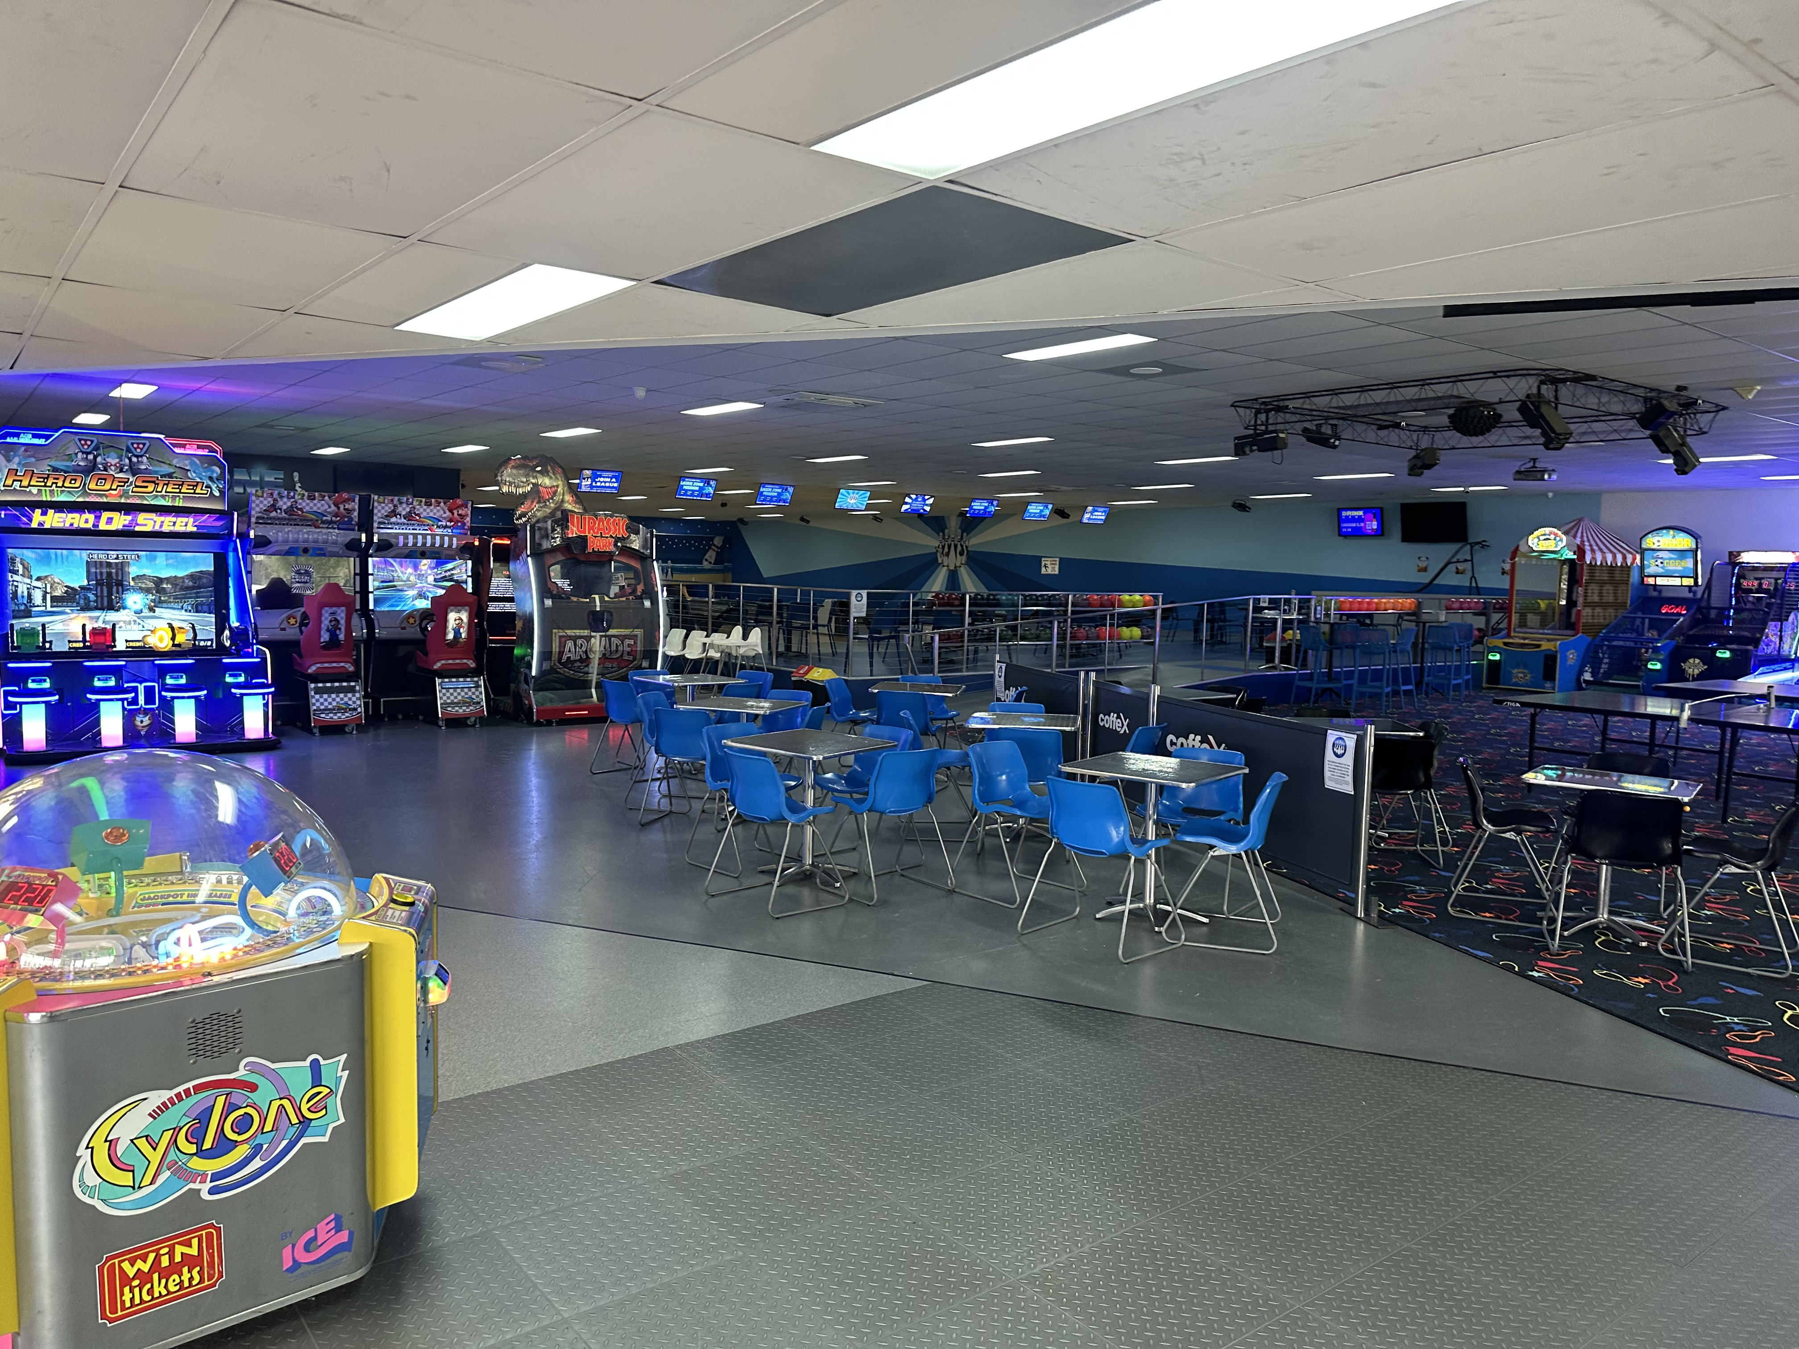
IMG_6611
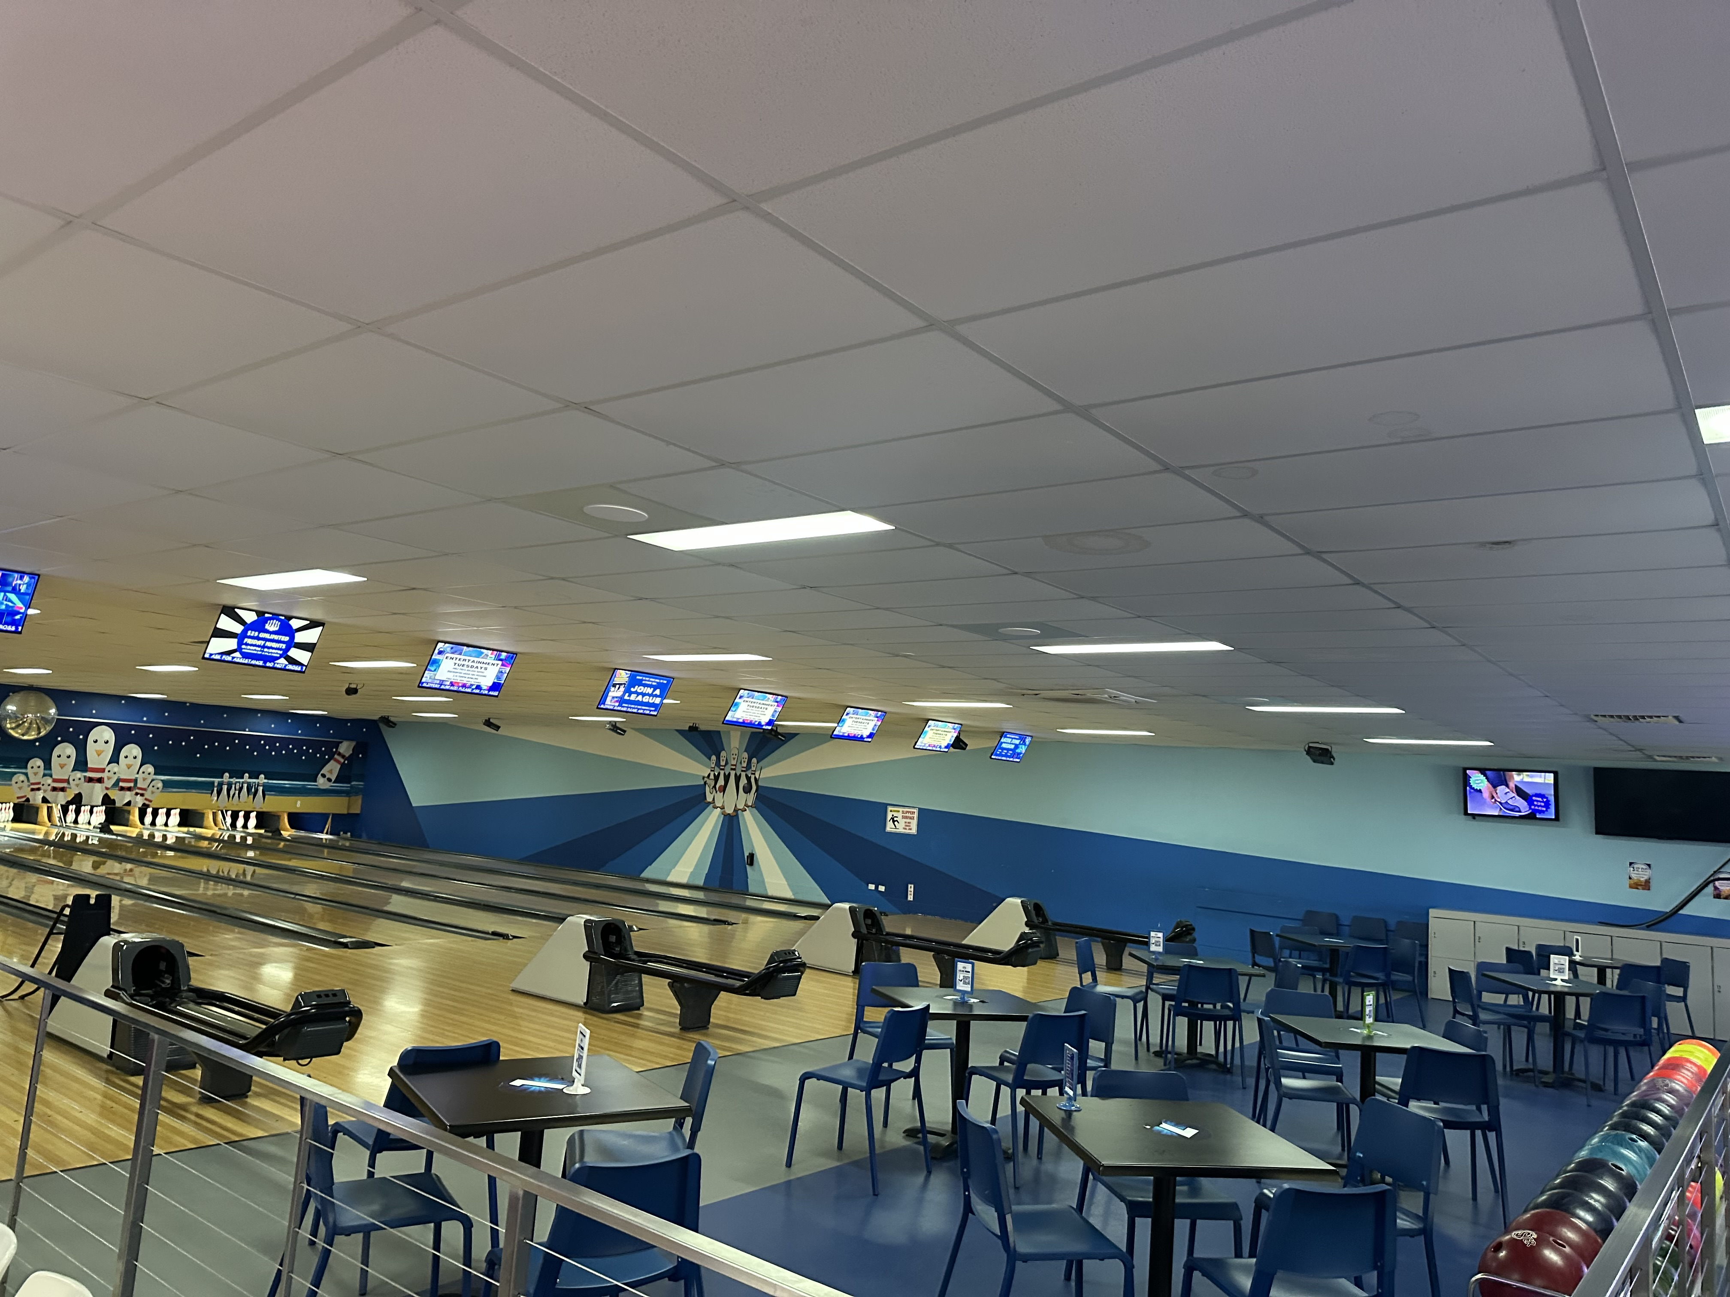
IMG_6614
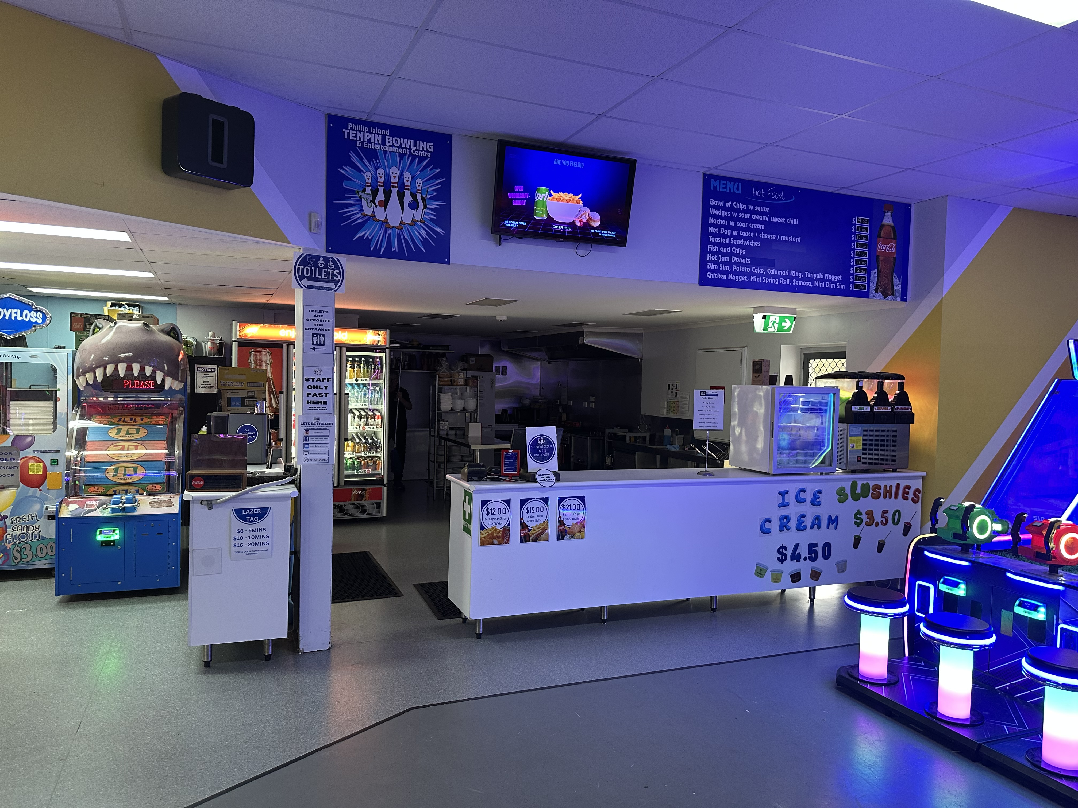
IMG_6612
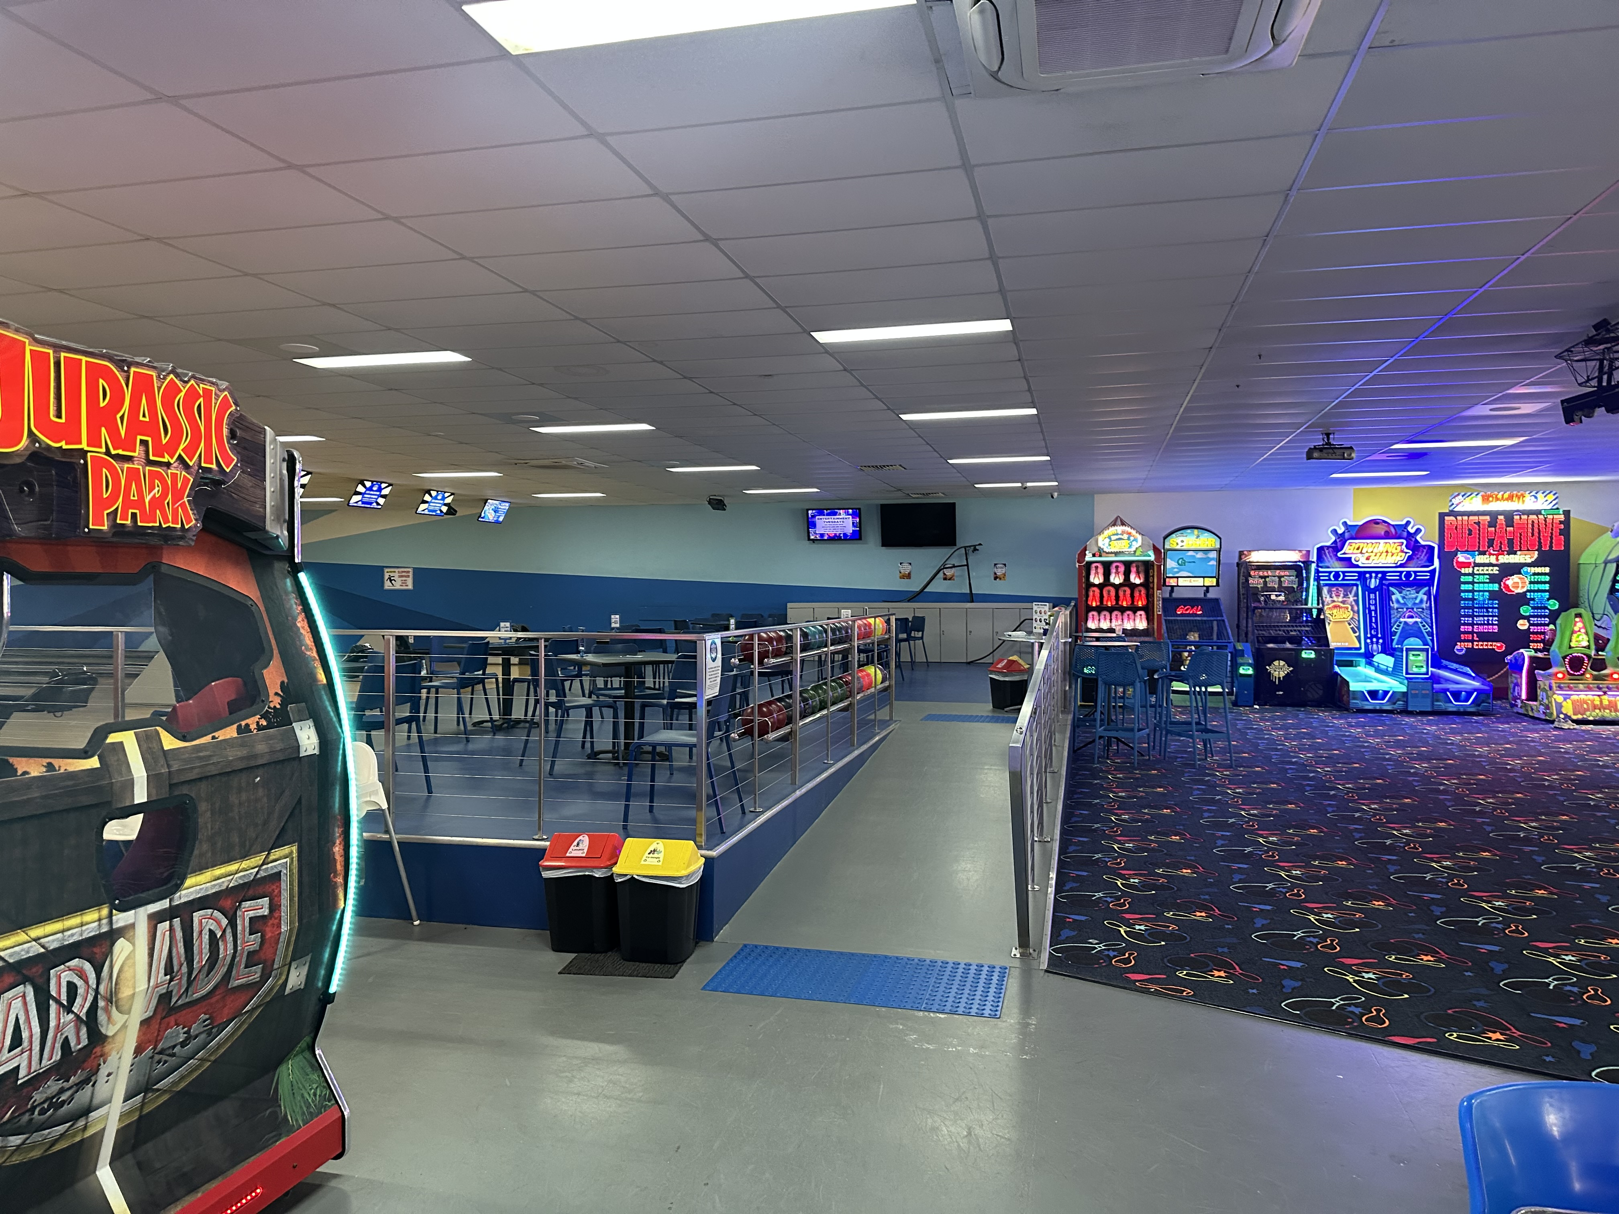
IMG_6613

Report Disclaimer
Please note that this business report, provided as a result of the use of the diagnostic assessment, is for information purposes only.
Australian Tourism Industry Council (ATIC) cannot guarantee the accuracy of respondent’s answers, or that they are fully representative of your business. Therefore, ATIC does not warrant or guarantee any particular outcome in respect of your businesses self-assessment.
This report is intended as guidance only for your business and should not be relied on for future marketing considerations. ATIC recommends that you seek your own independent advice as well as the results from the diagnostic.
Links to external web sites are inserted for convenience and do not constitute endorsement of material at those sites, or any associated organisation, product or service.
ATIC does not:
- Assume any legal liability for the accuracy, completeness, or usefulness of any information from this report or any links provided; or
- Accept responsibility for any loss associated directly or indirectly from the use of this report.

