ATIC Accessibility
To support the accessible community in making informed travel decisions for their individual needs

This report prepared for:
Business name: | Landsdale Bus Charters
Address: | 32 Fellowship Road Gnangara
Town: | Landsdale
Contact for enquiries: | Neville Palmer
Contact Number: | 0401351317
Contact Email: | Info@landsdalebuscharters.com.au
Website: | www.landsdalebuscharters.com.au
Date: | 2026-10-23 19:00

ATIC Accessibility
The following pages provides travellers with information on the businesses facilities and amenities which aims to support the traveller to make an informed decision on whether the business is suitable for their individual needs.
OVERVIEW 3
Business Overview 3
Bookings 3
Emergency Management 3
Guide Dog and Service Animals 4
GENERAL 5
External Paths 5
Steps 5
TOUR OPERATORS 6
Tour/Transport Services 6
Route Planning 6
Guides 6
Report Disclaimer 9

OVERVIEW

Business Overview

The business has the following products/services available
- Tour/Transport

Our business caters for the following disability types:
- Blind or low vision
- Deaf or low hearing
- Limited mobility

Bookings

The business offers the following methods for bookings and enquiries:
- Phone
- Email
- Webportal
- Our forms have high contract boxes and submit boxes

Emergency Management
- There are visual device/s to alert occupants to evacuate.
- Exit signs are clear and easy to see
- Exit access is free and clear at all times
We ensure exit access is free and clear at all times by:
Exit on the coaches and buses is via the front door, we ensure the passageway is kept clear at all times during travel. Some windows have emergency break glass hammers for exit in cases of emergency
- Exit doors are able to be opened by all occupants
- The evacuation point is clearly marked by a sign
- In addition, the following further information can assist guests:
We ask guests to advise us at time of booking if there are people with disabilities and we advise if we can accommodate them
- In addition, the following further information can assist guests:
The bus driver will provide assistance to those who require it

Guide Dog and Service Animals
The business provides the following services for services animals:
Service animals are allowed on board our buses and coaches

GENERAL
- In addition, the following further information can assist guests:
We provide bus and coach transportation, based on the customers itinerary. Pickup and drop off times are adhered to and therefore there are no long wait times to cause stress to the passenger

External Paths
External paths of travel
The width of the smallest pathway is:
not applicable we provide bus transportation and tours, customers do not come to our premises we pick them up from their chosen location
- There 3 successive steps or less on any path or at any doorway

not applicable we provide bus transportation and tours, customers do not come to our premises we pick them up from their chosen location
- In addition, the following further information can assist guests:
not applicable we provide bus transportation and tours, customers do not come to our premises we pick them up from their chosen location

Steps
Steps
- There are steps.
- Top and bottom steps are easily distinguished through colour contrast or the use of TGSIs (Tactile Ground Surface Indicators)
- Handrails fitted to all open sets of steps
- Where steps are present are there three steps or less
- In addition, the following further information can assist guests:
The only steps are those on the coach entrance which have the yellow stip indicator strips and hand rails.

TOUR OPERATORS

Tour/Transport Services
The tour/transport services have the following facilities/amenities in place
- Buses/Coaches
- None vehicles have wheelchair lifts or ramps
- None vehicles have low floors with ramped entry
The maximum wheelchair capacity available in the fleet is:
None

Route Planning
- Route Planning
- The tour route includes stops with accessible toilet facilities
- Lunch stop venues are accessible

Guides
- Use of clear/simple English
- Correct pronunciation for lip readers
  - Image(s)
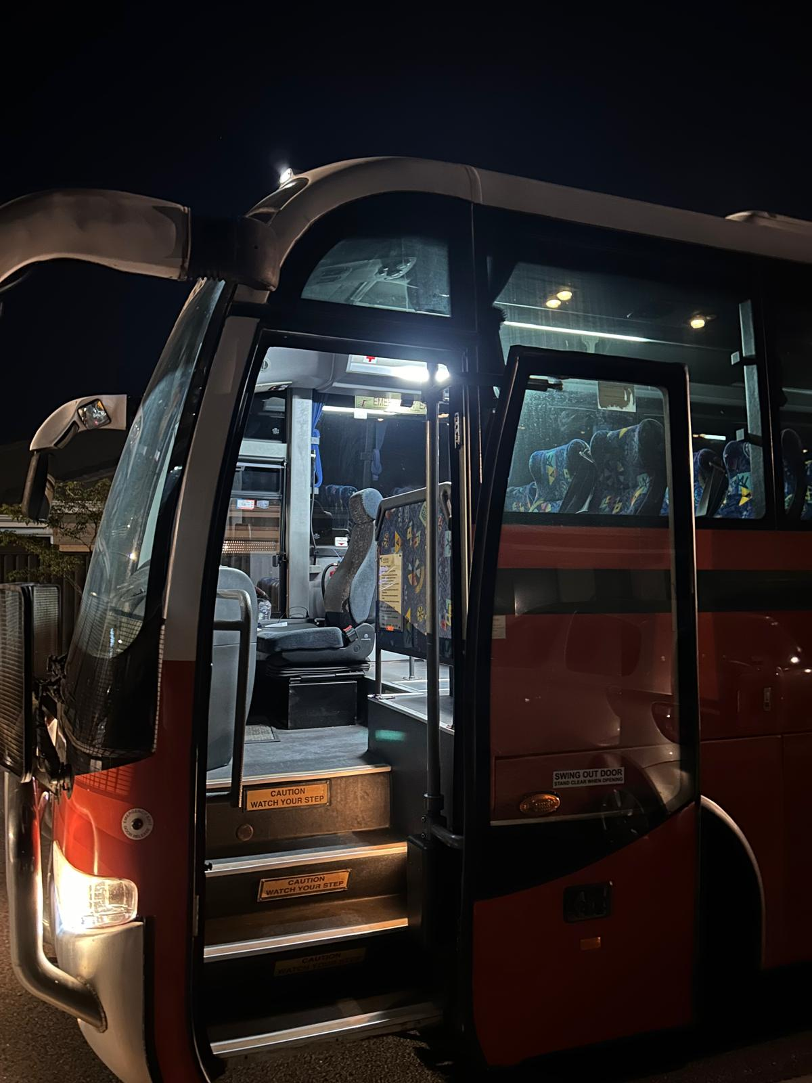
43 seater coach bus enterance
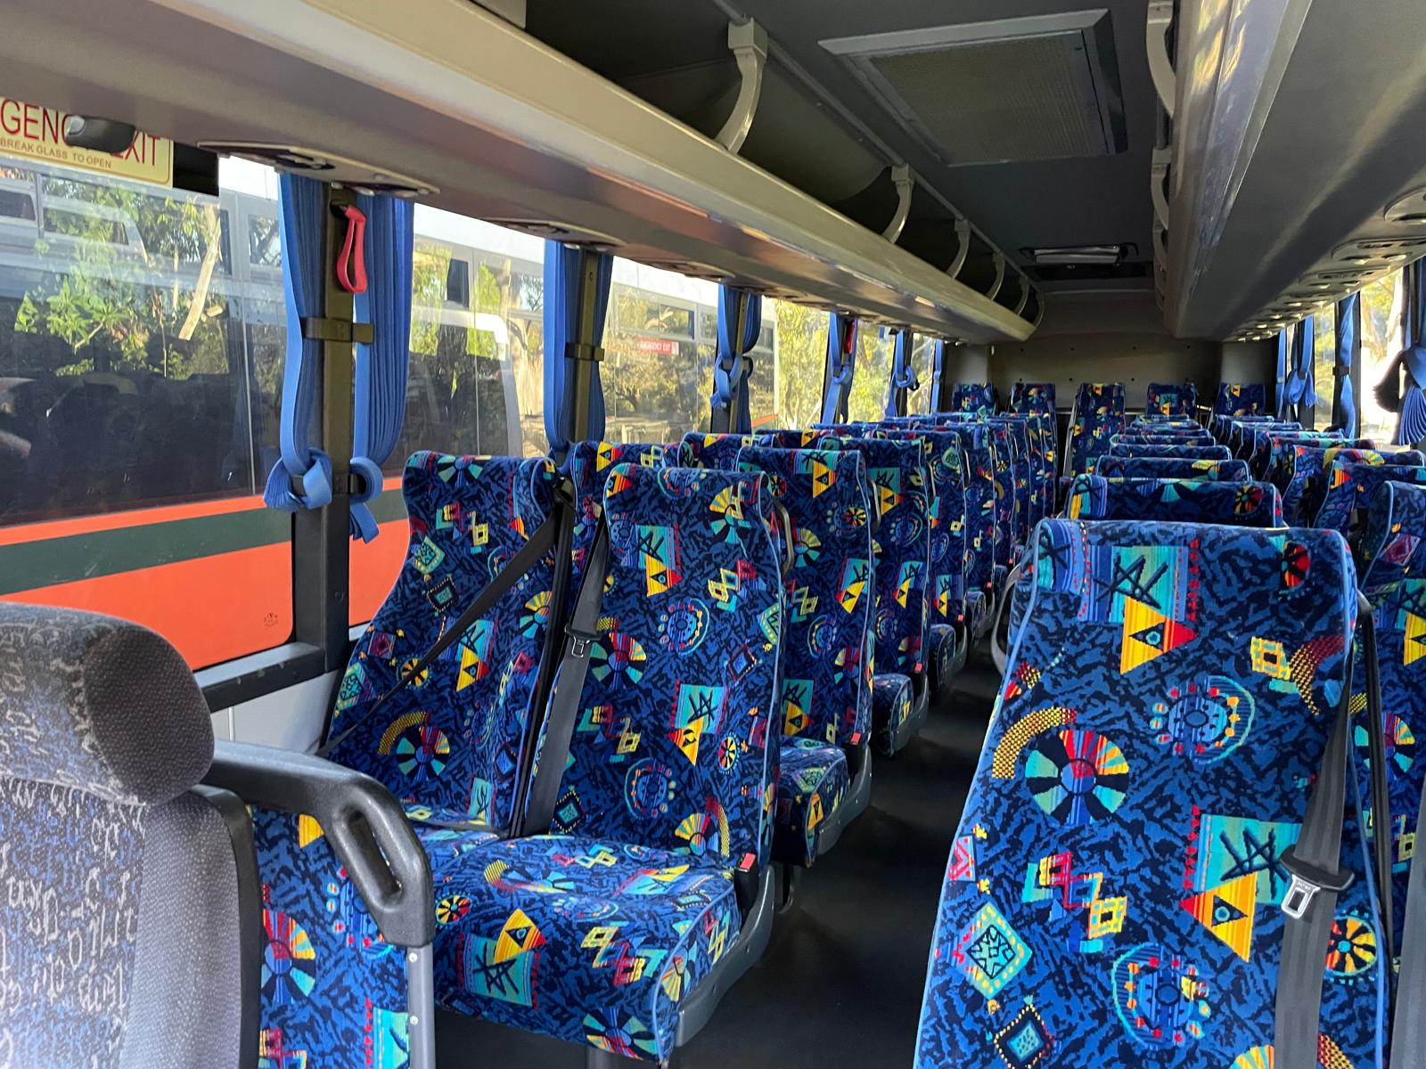
43 seater interior view
- In addition, the following further information can assist guests:
We provide tours and transportation to a number of business in and around Perth and regional WA, We create personalised tours, for example tours of Yanchep National Park and lunch at the Yanchep Inn, Or tours to Araluen National Park
to name a few. Tours are based on where the customer would like to go so are varied and different
- In addition, the following further information can assist guests:
The driver will always ensure that the bus or coach is stopped in a suitable location with level ground to ensure easy access and egress for customers travelling on the bus or coach.

Report Disclaimer
Please note that this business report, provided as a result of the use of the diagnostic assessment, is for information purposes only.
Australian Tourism Industry Council (ATIC) cannot guarantee the accuracy of respondent’s answers, or that they are fully representative of your business. Therefore, ATIC does not warrant or guarantee any particular outcome in respect of your businesses self-assessment.
This report is intended as guidance only for your business and should not be relied on for future marketing considerations. ATIC recommends that you seek your own independent advice as well as the results from the diagnostic.
Links to external web sites are inserted for convenience and do not constitute endorsement of material at those sites, or any associated organisation, product or service.
ATIC does not:
- Assume any legal liability for the accuracy, completeness, or usefulness of any information from this report or any links provided; or
- Accept responsibility for any loss associated directly or indirectly from the use of this report.

