ATIC Accessibility
To support the accessible community in making informed travel decisions for their individual needs

This report prepared for:
Business name: | HeliSpirit
Address: | Lot 320 Laine Jones Drive
Town: | Kununurra
Contact for enquiries: | Kym Francesconi
Contact Number: | 0419805279
Contact Email: | rosie@kimberleyexperiences.com.au
Website: | helispirit.com.au
Date: | 2026-09-23 12:51

ATIC Accessibility
The following pages provides travellers with information on the businesses facilities and amenities which aims to support the traveller to make an informed decision on whether the business is suitable for their individual needs.
OVERVIEW 4
Business Overview 4
Bookings 4
Emergency Management 4
Communications 5
Other Information 6
Guide Dog and Service Animals 6
GENERAL 7
Pre-arrival, arrival and reception 7
Cognitive Impairment Support 7
Car Park and Access amenities 7
Entry 8
Internal Spaces 8
Public areas 8
External Paths 8
TOUR OPERATORS 9
Route Planning 9
Guides 9
ACCOMMODATION 10
Room Amenities 10
Bathrooms 10
COMMON AREAS 12
Swimming pools, spas and waterparks 12
ADVENTURE ACTIVITIES 13
Adventure activities 13
Report Disclaimer 15

OVERVIEW

Business Overview

The business has the following products/services available
- Tour/Transport
- Accommodation
- Adventure

Our business caters for the following disability types:
- Deaf or low hearing
- Limited mobility
- Wheelchairs or mobility scooters
- Food allergies or intolerances
- Cognitive or people on the Autism Spectrum


Bookings

The business offers the following methods for bookings and enquiries:
- Phone
- Email
- Webportal
- Our forms have high contract boxes and submit boxes
- Staff have undergone disability awareness and training

Emergency Management
- Emergency and evacuation procedures are explained on arrival
- There are Audible device/s to alert occupants to evacuate with instructions on how to evacuate.
- Exit signs are clear and easy to see
- Exit access is free and clear at all times
We ensure exit access is free and clear at all times by:
In the aircraft, following CASA regulations, the pilot ensures that the exit is always accessible. Within the office/base environment, staff visually monitor the exits ways to ensure they are clear.
- Exit doors are able to be opened by all occupants
- Exits to the emergency evacuation point does not include stairways
- The evacuation point is clearly marked by a sign
- In addition, the following further information can assist guests:
All guests requiring additional assistance are added to the flight manifest with specific details described.
- In addition, the following further information can assist guests:
All guests requiring assistance must travel with a carer/accompanying passenger. The pilot will lead the rescue and seek help from the accompanying passenger should they be able to assist. If they are unable to assist the pilot will be responsible for providing aid to the guest requiring assistance.
- Guests with disabilities are noted in the guest log book for emergency and evacuation purposes

Communications
- Our business offers the following alternative communication methods
- Plain English

Not specified
- There are Picture boards
  - Picture Boards Image(s)
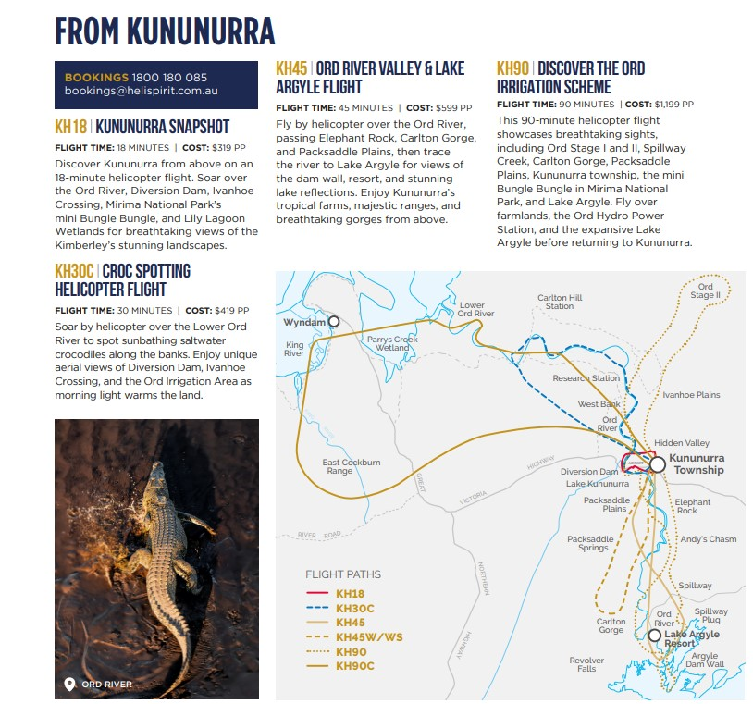
Example of brochure

Other Information
- For bookings made onsite, the ticket booth/counter/box office is accessible for people using a wheelchair

Guide Dog and Service Animals
- The business provides a secure area with shade and water for service animals
- The business provides a toilet area for service animals
The business provides the following services for services animals:
HeliSpirit has a dedicated area for service animals that is shaded and secure, with water bowls provided. Staff are available to monitor the animals.

GENERAL

Pre-arrival, arrival and reception
The business has the following in place to support guests during pre-arrival, arrival and reception
- There is a reception/public entryway.
- Seating available at reception
- A tablet with text to voice or pen and paper at reception to aid in communication
- Lighting in the reception area is even and glare free
- Information and maps are available in written form
- In addition, the following further information can assist guests:
HeliSpirit has seating available in the airconditioned reception and guests are offered cold water whilst they wait.
- In addition, the following further information can assist guests:
There is a sealed path from the parking area to the reception and then a standard size door at entry. Seating is available in reception and there are ablutions available through a standard size door. Access from the office to helicopter is not on a sealed path. However, arrangements can be made to accommodate check in at our sister company, Aviair (neighbouring terminal) for wheelchairs. There is a sealed path from the parking area to the terminal and the terminal to tarmac when accessing via Aviair (note: it would be a slightly longer distance on the tarmac to the helicopters).

Cognitive Impairment Support
- Documents are available in plain English for people with cognitive impairment (This may include instructions, guides, menus and general information)
- A "social script" guide to your premises or attraction describing the sights, sounds and smells to aid parents/carers prepare visitors in advance
- The 'social script' is available in word and other editable formats

Car Park and Access amenities
The business has the following Car Park and Access amenities
- A drop off zone
- Level or ramped access from the car park to the entrance

Entry
The business has the following amenities/systems in place for entry
- A drop off point close to the entrance
- A path of access to the building is slip resistance and even
- A path of access to the building is clear of obstruction
- Glass doors are fitted with a visual sighting strip
- Door jams/doors are of a contrasting colour to surrounding walls
- There a clear space of at least 1500mm x 1500mm in front of all doors.

Internal Spaces
- Interior walls are matte or low sheen
- Floors, walls, counters and furniture are of contrasting colours
- Any protruding or overhanging obstructions are at least 2meters above the floor or are protected
- Floor surfaces are hard or short pile carpet
- Seating is available for guests unable to stand for long periods
The width of the smallest corridor is:
Doorways and corridors are 750mm

Public areas
The public areas have the following amenities in place
- Even lighting
- Seating

External Paths
External paths of travel
- Surfaces are concrete, asphalt, smooth paving or hard packed fine gravel (max aggregate size 13mm)
- Pathways are wider than 900mm
- There is 940cm (note: the toilet is narrow with a 800cm wide door, so not suitable for a wheelchair). mm of clear space in front of the toilet

TOUR OPERATORS

Route Planning
- Route Planning
- Walking Tours
- Multi-paced to account for slower walkers

Guides

Guides have been trained in the following
- Use of clear/simple English
- Correct pronunciation for lip readers
- In addition, the following further information can assist guests:
El Questro - https://elquestro.com.au/
The Hoochery - www.hoochery.com.au
Lake Argyle - www.discoveryholidayparks.com.au/resorts/lake-argyle
Bungle Bungle Guided Tours - www.bunglebungleguidedtours.com.au
- In addition, the following further information can assist guests:
Scenic helicopter tours departing from Kununurra do not have any stops and are accessible for people with limited mobility. The waterfall swimming tours are challenging for people with limited mobility, however this tour is suitable for people with other accessibility needs as long as they are mobile and can step over rocks and potentially climb in and out of waterholes lined with rocks.

ACCOMMODATION

Room Amenities

There are no wardrobes.
- In addition, the following further information can assist guests:
Guests with a hearing impairment are escorted from their room to the muster point by a member of staff.
- There is contrast between the walls, skirtings, floor and furniture
- There is a clear path through the room
- The edges of all furniture and fixtures are rounded
- Housekeeping procedures instruct staff not to reposition furniture that has been moved
- Doors open fully against the adjoining wall
- There is a clear opening at least 850mm wide
- There luggage racks for at least two suitcases
- There at least one chair with rigid arms
- The bedside lamp switch is easy to reach from the bed
- There is at least 850mm clear space beside the bed
- The bed height is no higher than 680mm from the floor
- Blocks are available to put under the bed legs
- The business offers a range of non-allergenic bedding
- Non-allergenic cleaning products are used

Bathrooms
The bathrooms have the following facilities/amenities in place
- All heating appliances and hot water pipes are protected or insulated
- All shower, bath and basin taps are clearly differentiated between hot and cold
- Fixtures and fittings have rounded edges
- The hot water is thermostatically controlled to 41 degrees
- The door is at least 850mm wide
- There is a minimum of 850mm beside the toilet
- Handrails are fitted
- There is a minimum of 1400mm of clear space in front of the toilet
- The toilet seat is a contrasting colour to the floor
- The actual height of the toilet seat is 450mm.
- A range of non-allergenic toiletries are available
  - Bathroom Image(s)
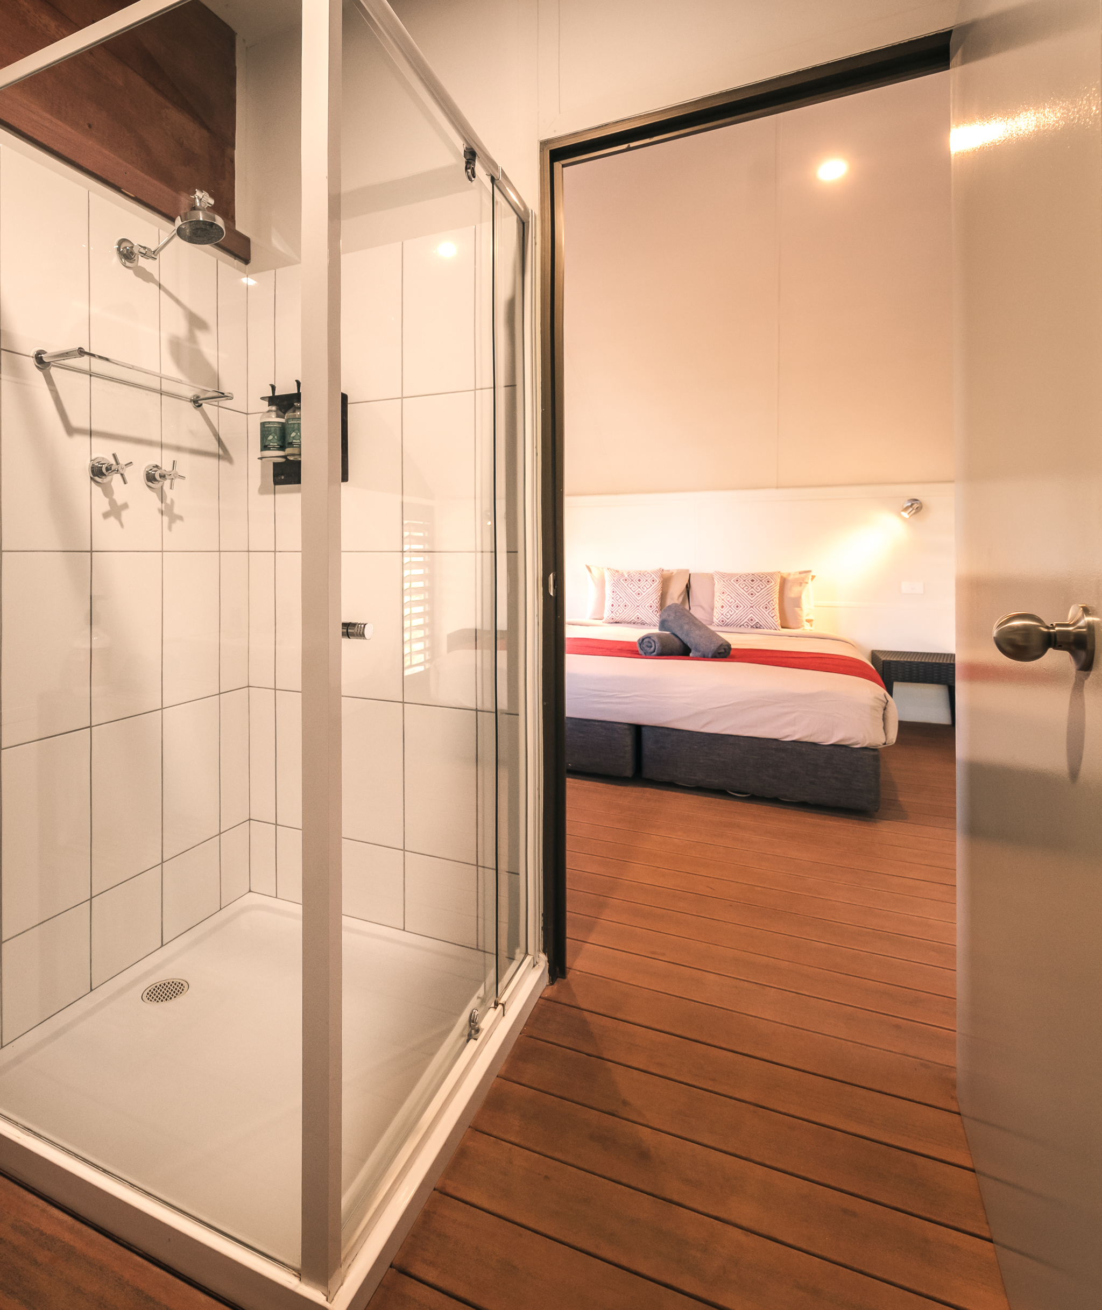
Bathroom shower
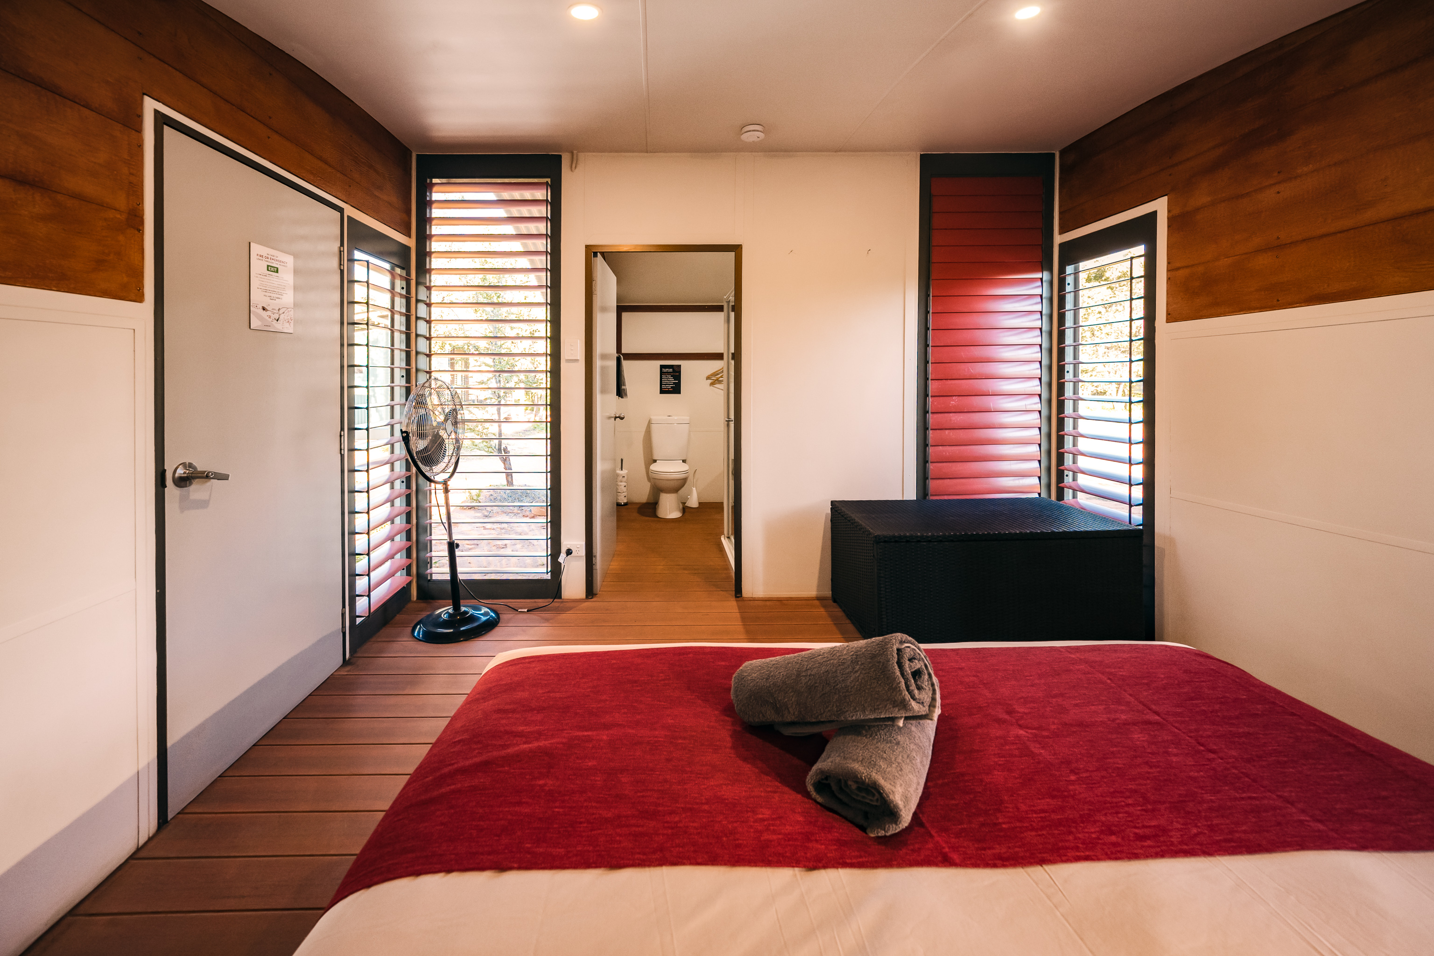
Bedroom and bathroom
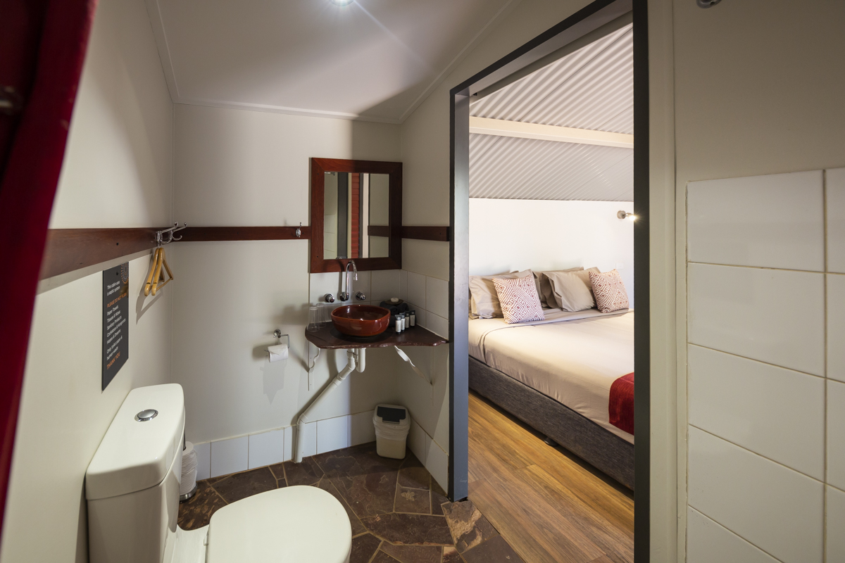
Ensuite

COMMON AREAS

Swimming pools, spas and waterparks
- The following swimming pools, spas and waterparks amenities are available
  - Pool Access Image(s)
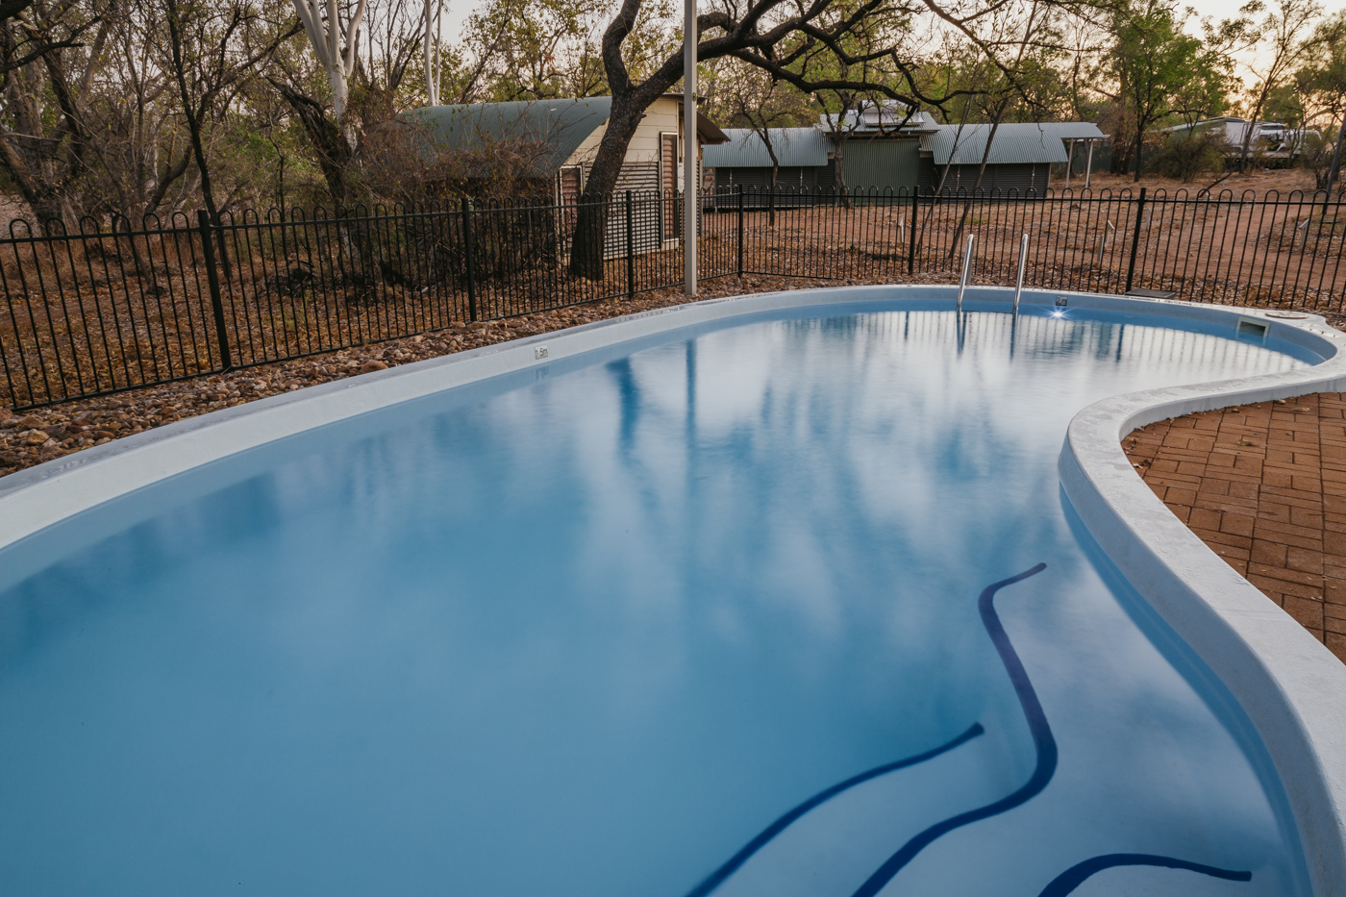
Pool
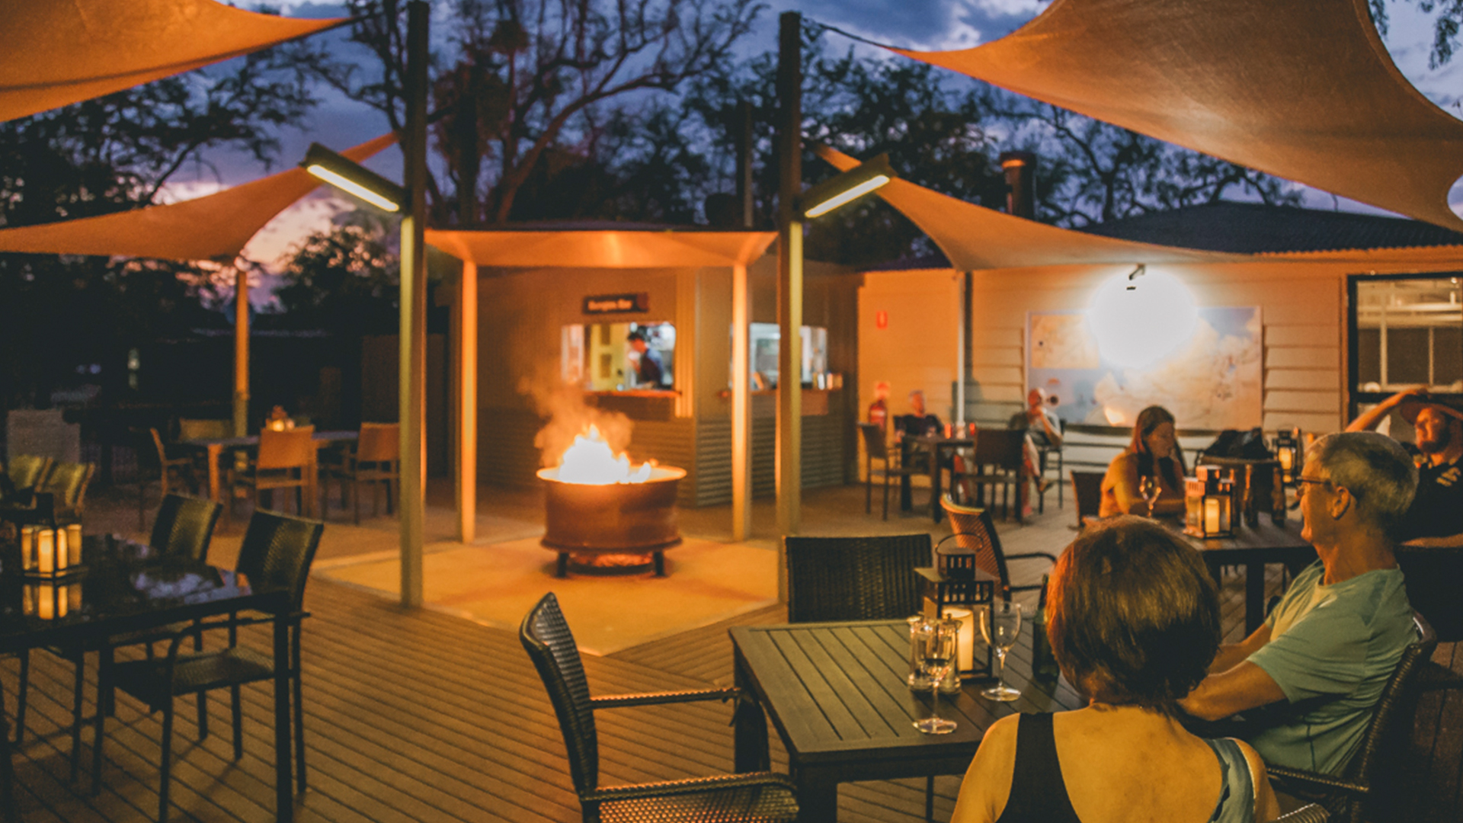
Exterior deck
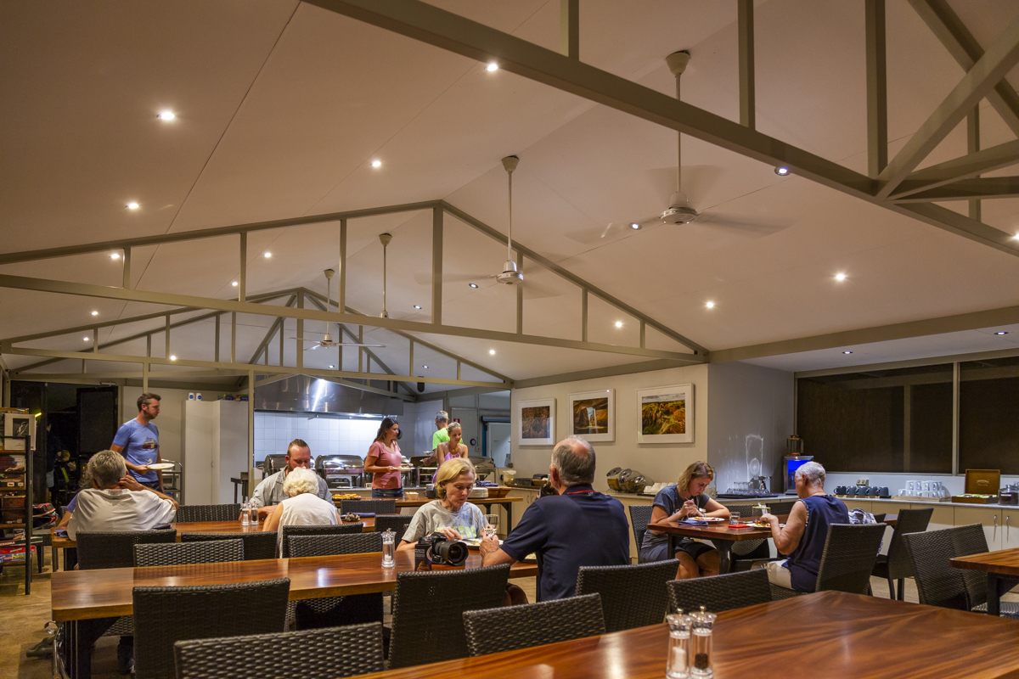
Interior dining room

ADVENTURE ACTIVITIES

Adventure activities
The adventure activities have the following facilities/amenities in place
- Our adventure activities cater for people with a disability
- In addition, the following further information can assist guests:
Our scenic helicopter flights can cater for people with limited mobility.People in wheelchairs can be flown provided they have an accompanying carer to assist.Waterfall tours and tours to third party stops and attractions are challenging for people with limited mobility as it requires navigating to and from the aircraft over grass and/or rough terrain. These tours are suitable for people that do not have limited mobility.All helicopter tours are very visual and focused on the scenery of the area which is suitable for persons with hearing disabilities. However, due to safety reasons, the pilots are unable to speak face-to-face with passengers so lipreading would be difficult.
- In addition, the following further information can assist guests:
All tours are conducted in helicopters.
- In addition, the following further information can assist guests:
Helicopters are used to access remote areas that are undeveloped. These areas have rocks and unstable surfaces which would be challenging for people with limited mobility.Helicopters are not suitable for people who are sensitive to outside stimulation due to their noise. Headsets are provided which do minimise the noise but once the tour has commenced there is no quiet location for people if they are feeling overwhelmed.

Report Disclaimer
Please note that this business report, provided as a result of the use of the diagnostic assessment, is for information purposes only.
Australian Tourism Industry Council (ATIC) cannot guarantee the accuracy of respondent’s answers, or that they are fully representative of your business. Therefore, ATIC does not warrant or guarantee any particular outcome in respect of your businesses self-assessment.
This report is intended as guidance only for your business and should not be relied on for future marketing considerations. ATIC recommends that you seek your own independent advice as well as the results from the diagnostic.
Links to external web sites are inserted for convenience and do not constitute endorsement of material at those sites, or any associated organisation, product or service.
ATIC does not:
- Assume any legal liability for the accuracy, completeness, or usefulness of any information from this report or any links provided; or
- Accept responsibility for any loss associated directly or indirectly from the use of this report.

