ATIC Accessibility
To support the accessible community in making informed travel decisions for their individual needs

This report prepared for:
Business name: | Lazy Lizard Motor Inn
Address: | 121 Davidson
Town: | Port Douglas
Contact for enquiries: | Aidan Mulcahy
Contact Number: | 07 4099 5900
Contact Email: | info@lazylizardinn.com.au
Website: | www.lazylizardinn.com.au
Date: | 2026-10-05 10:42

ATIC Accessibility
The following pages provides travellers with information on the businesses facilities and amenities which aims to support the traveller to make an informed decision on whether the business is suitable for their individual needs.
OVERVIEW 4
Business Overview 4
Bookings 4
Emergency Management 5
Communications 5
Other Information 5
Guide Dog and Service Animals 5
GENERAL 6
Pre-arrival, arrival and reception 6
Cognitive Impairment Support 7
Car Park and Access amenities 7
Entry 7
Internal Spaces 8
Public areas 8
External Paths 8
Steps 8
Ramps 9
ACCOMMODATION 10
Bedrooms 10
Room Amenities 10
Bathrooms 11
COMMON AREAS 12
Swimming pools, spas and waterparks 12
Report Disclaimer 14

OVERVIEW

Business Overview

The business has the following products/services available
- Accommodation

Our business caters for the following disability types:
- Limited mobility
- Wheelchairs or mobility scooters
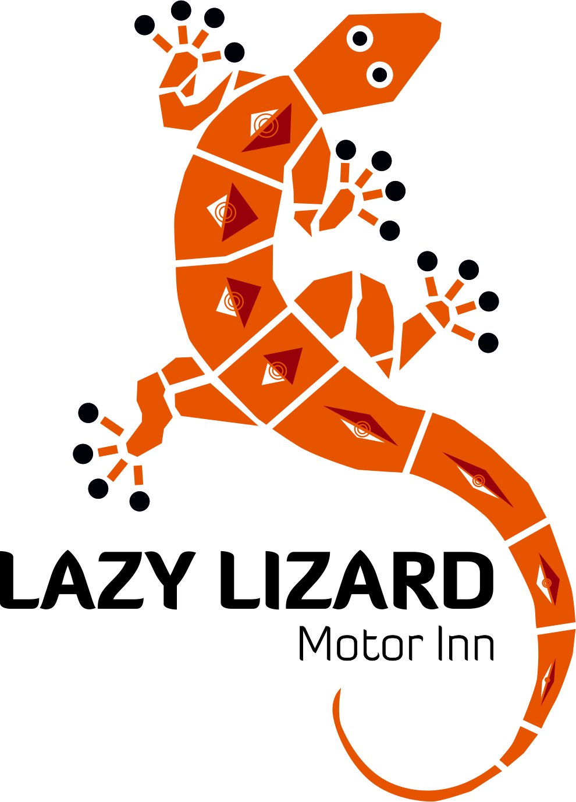

Bookings

The business offers the following methods for bookings and enquiries:
- Phone
- Email
- Webportal
- Staff have undergone disability awareness and training

Emergency Management
- The business has an emergency management and evacuation plan for guests with a disability
- Emergency and evacuation procedures are explained on arrival
- Guests with disabilities are noted in the guest log book for emergency and evacuation purposes

Communications
- An accessibility guide is available on the website

https://www.lazylizardinn.com.au/about-us/accessibility-at-lazy-lizard-motor-inn, https://www.lazylizardinn.com.au/disabled-queen-studio, https://www.lazylizardinn.com.au/fileadmin/user_upload/2026_Accessibility_information.pdf, https://www.lazylizardinn.com.au/fileadmin/user_upload/Planning-Your-Stay-Guide-Lazy-Lizard-Port-Douglas.pdf
- Our business offers the following alternative communication methods
- Plain English
- Magnifiers

Not specified
- There is easy to read signage and information (e.g. menus and emergency information)

Other Information
- For bookings made onsite, the ticket booth/counter/box office is accessible for people using a wheelchair

Guide Dog and Service Animals
- The business provides a secure area with shade and water for service animals
- The business provides a toilet area for service animals
- Bowls, bedding, etc. are provided for service animals
The business provides the following services for services animals:
Bowl and bedding provided

GENERAL

Pre-arrival, arrival and reception
The business has the following in place to support guests during pre-arrival, arrival and reception
- There is a reception/public entryway.
- Seating available at reception
- A lower counter at reception/ticket office
- A clipboard to allow check-in/ticket purchase whilst seated
- A tablet with text to voice or pen and paper at reception to aid in communication
- Picture Board at reception to aid in communication
- Lighting in the reception area is even and glare free
- Large print information sheets and registration forms
- Information and maps are available in written form
- A step free map/guide
- A familiarisation tour
- Advertising material, web sites and social media contain information relating to phone numbers available for non-voice communication e: Text, SMS, email and fax
- A key to any accessible facilities that are locked
- Keys are available for each guest
- Luggage assistance
- In addition, the following further information can assist guests:
As a small owner-operated property, guests do not experience the extended queues commonly associated with larger accommodation providers. Pre-arrival communication provides guests with clear information prior to arrival, reducing the need for lengthy check-in discussions or repeated requests for information.
Ground-floor accommodation and parking directly outside each studio also minimise the distance guests need to travel between their vehicle and their room. Check-in procedures are designed to be straightforward and efficient, allowing guests to settle into their accommodation quickly after travelling.
Where guests advise of accessibility requirements or fatigue-related conditions prior to arrival, Alex & I work directly with them to provide information and support tailored to their individual needs. This may include discussing room suitability, arrival arrangements or other practical considerations to reduce physical exertion and unnecessary waiting.
These measures help ensure guests can access accommodation and support efficiently, comfortably and with minimal disruption to their stay.

Cognitive Impairment Support
- Documents are available in plain English for people with cognitive impairment (This may include instructions, guides, menus and general information)
- A "social script" guide to your premises or attraction describing the sights, sounds and smells to aid parents/carers prepare visitors in advance
- The 'social script' is available in word and other editable formats
- A space for parents and children on the Autism Spectrum

Car Park and Access amenities
The business has the following Car Park and Access amenities
- A drop off zone
- Designated disabled parking bays
- Level or ramped access from the car park to the entrance
- The accessible entrance is clearly signed from the parking bay
- The public transport services available are:

Verbally
- Kerb ramps are in place where a pavement or walkway needs to be crossed

Entry
The business has the following amenities/systems in place for entry
- A drop off point close to the entrance
- A path of access to the building is slip resistance and even
- A path of access to the building is clear of obstruction
- Door handles are of a contrasting colour to the door
- Signage is written in a Sans Serif font and use upper and lower case letters
- The entry door is a minimum of 850mm wide
- The entrance sill is less than 13mm
- There a clear space of at least 1500mm x 1500mm in front of all doors.
- The entrance door mats have a thickness less than 13mm and a width of 7500mm or greater
- In addition, the following further information can assist guests:
The door to reception is always open during business hours

Internal Spaces
- Clear and unobstructed routes through and between buildings
- Interior walls are matte or low sheen
- Floors, walls, counters and furniture are of contrasting colours
- Tableware/glassware contrast with the table surface or table cloth
- Floor surfaces are hard or short pile carpet
- Seating is available for guests unable to stand for long periods
- Accessible facilities are clearly signed and visible from all areas
- All corridors greater than 900mm
- There is a quiet space for parents and children on the Autism Spectrum

Public areas
The public areas have the following amenities in place
- Display units, Televisions, Video displays etc. are open captioned
- Even lighting
- Seating

External Paths
External paths of travel
- Surfaces are concrete, asphalt, smooth paving or hard packed fine gravel (max aggregate size 13mm)
- Pathways are wider than 900mm
- There 3 successive steps or less on any path or at any doorway
- Any paths having steps are clearly identified as non-wheelchair accessible
- Step free routes clearly signed

Steps
Steps
- There are steps.
- Top and bottom steps are easily distinguished through colour contrast or the use of TGSIs (Tactile Ground Surface Indicators)
- Handrails fitted to all open sets of steps
- Handrails extend 300mm beyond the top and bottom step
- Where steps are present are there three steps or less

Ramps
Ramps have the following amenities are in place
- There are ramps.
- All fixed ramps are 1:14 or less
- Temporary ramps are available
- Temporary ramps are in place for the duration of the guests stay

ACCOMMODATION

Bedrooms
The bedrooms have the following facilities/amenities in place
- There are 1 rooms available to guests who use a wheelchair
- Bedroom furniture can be re-arranged on request
  - Layout of room Image(s)
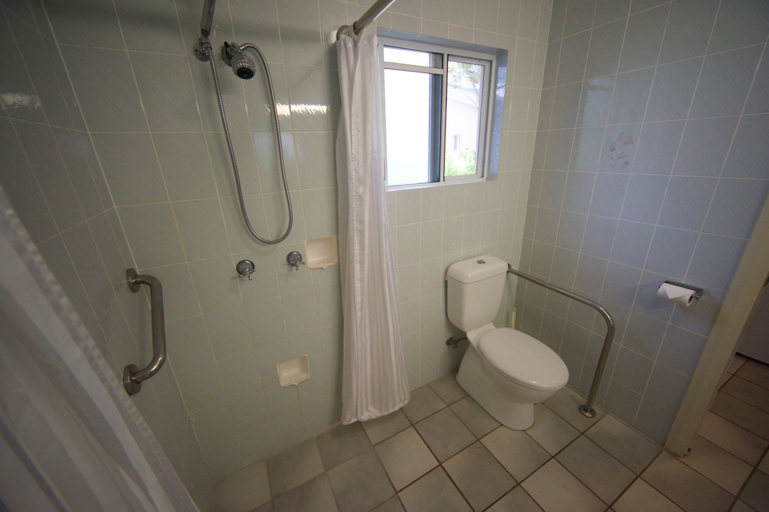
ACCESSIBLE BATHROOM
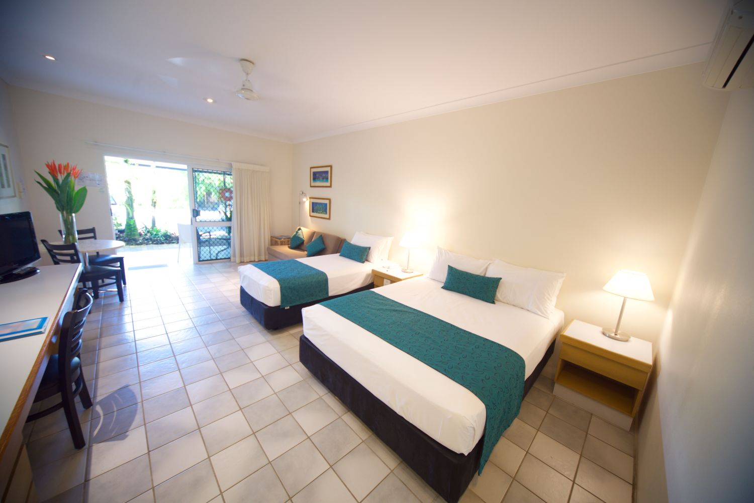
ACCESSIBLE BEDS

Room Amenities
- Televisions are equipped with closed captioning capability
- There is contrast between the walls, skirtings, floor and furniture
- There is a clear path through the room
- The edges of all furniture and fixtures are rounded
- Wardrobe handles are a contrasting colour to the doors and draws
- Housekeeping procedures instruct staff not to reposition furniture that has been moved
- Doors open fully against the adjoining wall
- There is a clear opening at least 850mm wide
- There luggage racks for at least two suitcases
- There at least one chair with rigid arms
- Wardrobe and drawer handles are easy to grip
- The bedside lamp switch is easy to reach from the bed
- There is at least 850mm clear space beside the bed
- The bed height is no higher than 680mm from the floor
- There is at least 130mm clearance under the bed
- Non-allergenic cleaning products are used
- In addition, the following further information can assist guests:
There is a double socket on the patio to recharge electric wheelchairs and mobility scooters

Bathrooms
The bathrooms have the following facilities/amenities in place
- All heating appliances and hot water pipes are protected or insulated
- All shower, bath and basin taps are clearly differentiated between hot and cold
- Fixtures and fittings have rounded edges
- The hot water is thermostatically controlled to 41 degrees
- The door is at least 850mm wide
- There is a minimum of 850mm beside the toilet
- Handrails are fitted
- There is a minimum of 1400mm of clear space in front of the toilet
- The toilet seat is 460mm above the floor
- A range of non-allergenic toiletries are available
- There is a roll-in shower with fold down fixed seat or a shower chair
- There is a portable shower head on flexible hose
  - Bathroom Image(s)
ACCESSIBLE BATHROOM

COMMON AREAS

Swimming pools, spas and waterparks
- The following swimming pools, spas and waterparks amenities are available

Report Disclaimer
Please note that this business report, provided as a result of the use of the diagnostic assessment, is for information purposes only.
Australian Tourism Industry Council (ATIC) cannot guarantee the accuracy of respondent’s answers, or that they are fully representative of your business. Therefore, ATIC does not warrant or guarantee any particular outcome in respect of your businesses self-assessment.
This report is intended as guidance only for your business and should not be relied on for future marketing considerations. ATIC recommends that you seek your own independent advice as well as the results from the diagnostic.
Links to external web sites are inserted for convenience and do not constitute endorsement of material at those sites, or any associated organisation, product or service.
ATIC does not:
- Assume any legal liability for the accuracy, completeness, or usefulness of any information from this report or any links provided; or
- Accept responsibility for any loss associated directly or indirectly from the use of this report.

