ATIC Accessibility
To support the accessible community in making informed travel decisions for their individual needs

This report prepared for:
Business name: | Lardner Park Events
Address: | 155 Burnt Store Road
Town: | Lardner
Contact for enquiries: | Georgina Horstman
Contact Number: | 0356261373
Contact Email: | craig@lardnerpark.com.au
Website: | www.lardnerpark.com.au
Date: | 2026-09-14 17:33

ATIC Accessibility
The following pages provides travellers with information on the businesses facilities and amenities which aims to support the traveller to make an informed decision on whether the business is suitable for their individual needs.
OVERVIEW 4
Business Overview 4
Bookings 4
Emergency Management 5
Communications 5
Other Information 5
Guide Dog and Service Animals 5
GENERAL 6
Pre-arrival, arrival and reception 6
Cognitive Impairment Support 6
Car Park and Access amenities 6
Entry 6
Internal Spaces 7
Public areas 7
Displays, exhibits, commentary and live performances 7
External Paths 8
Ramps 8
Public Toilets/Adult change facilities 8
ATTRACTIONS 9
FOOD AND DRINK 10
Dining Spaces 10
EVENTS 11
Events 11
Report Disclaimer 13

OVERVIEW

Business Overview

The business has the following products/services available
- Food and Drink
- Event

Our business caters for the following disability types:
- Deaf or low hearing
- Limited mobility
- Wheelchairs or mobility scooters
- Food allergies or intolerances
- Cognitive or people on the Autism Spectrum
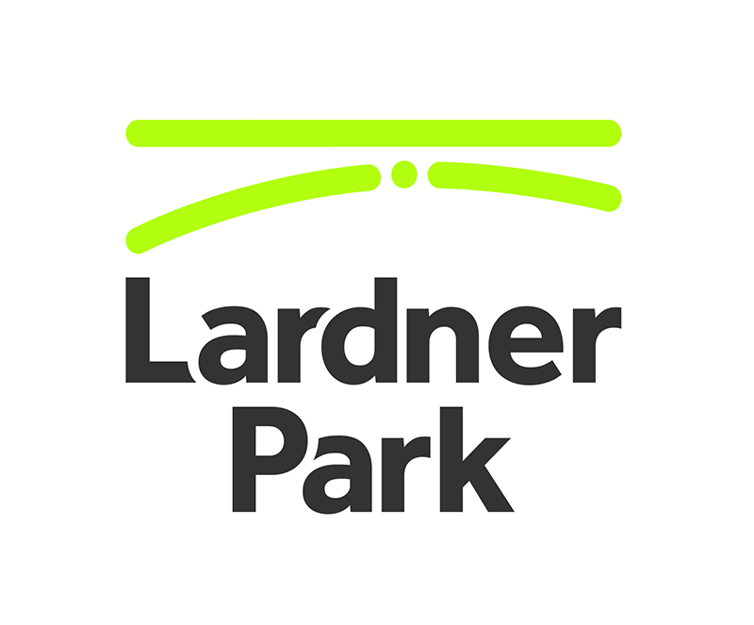

Bookings

The business offers the following methods for bookings and enquiries:
- Phone
- Email
- Webportal
- Our forms have high contract boxes and submit boxes

Emergency Management
- Emergency and evacuation procedures are explained on arrival

Communications
- An accessibility guide is available on the website

https://lardnerpark.com.au/accessibility/
- Our business offers the following alternative communication methods
- Plain English

Not specified
- There is easy to read signage and information (e.g. menus and emergency information)

Other Information
- For bookings made onsite, the ticket booth/counter/box office is accessible for people using a wheelchair
- The business accepts the companion card

Guide Dog and Service Animals
- The business provides a secure area with shade and water for service animals
The business provides the following services for services animals:
we have shade and water on the property for service animals

GENERAL

Pre-arrival, arrival and reception
The business has the following in place to support guests during pre-arrival, arrival and reception
- Booking information and websites are compatible with screen readers
- There is a reception/public entryway.
- Seating available at reception
- A lower counter at reception/ticket office
- A clipboard to allow check-in/ticket purchase whilst seated
- A tablet with text to voice or pen and paper at reception to aid in communication
- Lighting in the reception area is even and glare free
- Information and maps are available in written form
- In addition, the following further information can assist guests:
Not available

Cognitive Impairment Support
- Documents are available in plain English for people with cognitive impairment (This may include instructions, guides, menus and general information)

Car Park and Access amenities
The business has the following Car Park and Access amenities
- A drop off zone
- Designated disabled parking bays
- Level or ramped access from the car park to the entrance

Entry
The business has the following amenities/systems in place for entry
- A drop off point close to the entrance
- A path of access to the building is slip resistance and even
- A path of access to the building is clear of obstruction
- Glass doors are fitted with a visual sighting strip
- Door jams/doors are of a contrasting colour to surrounding walls
- Door handles are of a contrasting colour to the door
- Signage is written in a contrasting colour
- The entry door is a minimum of 850mm wide
- The entry door has self opening or a light opening pressure (for manual operations)
- The entrance sill is less than 13mm
- There a clear space of at least 1500mm x 1500mm in front of all doors.

Internal Spaces
- Clear and unobstructed routes through and between buildings
- Interior walls are matte or low sheen
- Floors, walls, counters and furniture are of contrasting colours
- Any protruding or overhanging obstructions are at least 2meters above the floor or are protected
- Tableware/glassware contrast with the table surface or table cloth
- Floor surfaces are hard or short pile carpet
- Seating is available for guests unable to stand for long periods
- Accessible facilities are clearly signed and visible from all areas
- All corridors greater than 900mm
- There is a quiet space for parents and children on the Autism Spectrum
- In addition, the following further information can assist guests:
Request at reception

Public areas
The public areas have the following amenities in place
- Display units, Televisions, Video displays etc. are open captioned
- Even lighting
- Seating

Displays, exhibits, commentary and live performances
For displays, exhibits, commentary and live performances the following amenities are in place
- Seating
- Wheelchair accessible spaces/seating
- Hearting loops for live shows and presentations
- In addition, the following further information can assist guests:
Hearing loops available on request through AV supplier.

External Paths
External paths of travel
- Surfaces are concrete, asphalt, smooth paving or hard packed fine gravel (max aggregate size 13mm)
- Pathways are wider than 900mm

We don't have paths with steps

We don't have paths with steps

Ramps
Ramps have the following amenities are in place
- There are ramps.
- All fixed ramps are 1:14 or less

Public Toilets/Adult change facilities
Public Toilets/Adult change facilities have the following amenities are in place
- There is an accessible toilet for public use
- The door is at least 850mm wide
- There is a minimum of 850mm beside the toilet
- Handrails are fitted
- The toilet seat is 460mm above the floor
- The toilet seat of a contrasting colour to the floor
- The toilet seat is460mm above the floor

ATTRACTIONS

https://lardnerpark.com.au/

FOOD AND DRINK

Dining Spaces
The dining spaces have the following facilities/amenities in place
- The entrance has level access
- The doorway is at least 850mm wide
- There is level access through the dining area
- Chairs are moveable to allow for wheelchairs to be seated at the tables
- All glass doors and full height windows have contrast markings
- There are areas of full lighting
- There are Plain English menus
- There is an accessible toilet

Our business caters for the following dietary requirements
- Sugar free (diabetic)
- Gluten free (celiac)
- Lactose free (dairy free)
- Low fat and fibre with no gastric content
- Low potassium
- Low sodium
- Nut free
- Additive free
- Organic
- Vegetarian
- Vegan
- Kosher
- Halal
- In addition, the following further information can assist guests:
All care is taken but we cannot guarantee cross-contamination.

EVENTS

Events
Events have the following facilities/amenities in place
- There is step free access throughout the venue
- Reception, registration desks or ticket offices have a lower counter section
- All ancillary areas are step free e.g. breakout rooms, dining areas, outside areas and exhibition spaces
- All stage areas including speaker platforms are accessible
- Accessible toilets are available at the venue
- Audio description is available
- Intra venue transport
- Intra venue transport provides visual indicators of stop off points
- Intra venue transport provides verbal announcements of drop off points
- There is good circulation space with the number of people expected to allow people with a disability to move around freely
- Food and water is available for guide and service animals
- The event is outdoors
- Portable accessible toilets are available
- Seating is at regular intervals
- Side shows, activities etc. are accessible
- Accessible car parking is available
- There are designated drop-off points
- There is an event map available
- The event map shows accessible facilities
- Quiet rooms, marquees or spaces are available

Report Disclaimer
Please note that this business report, provided as a result of the use of the diagnostic assessment, is for information purposes only.
Australian Tourism Industry Council (ATIC) cannot guarantee the accuracy of respondent’s answers, or that they are fully representative of your business. Therefore, ATIC does not warrant or guarantee any particular outcome in respect of your businesses self-assessment.
This report is intended as guidance only for your business and should not be relied on for future marketing considerations. ATIC recommends that you seek your own independent advice as well as the results from the diagnostic.
Links to external web sites are inserted for convenience and do not constitute endorsement of material at those sites, or any associated organisation, product or service.
ATIC does not:
- Assume any legal liability for the accuracy, completeness, or usefulness of any information from this report or any links provided; or
- Accept responsibility for any loss associated directly or indirectly from the use of this report.

