ATIC Accessibility
To support the accessible community in making informed travel decisions for their individual needs

This report prepared for:
Business name: | Scuba Obsession
Address: | 15 Caldervale Ave Ellenbrook
Town: | PERTH
Contact for enquiries: | Chris Jones
Contact Number: | 9296 7165
Contact Email: | info@scubaobsession.com.au
Website: | www.scubaobsession.com.au
Date: | 2026-10-23 07:50

ATIC Accessibility
The following pages provides travellers with information on the businesses facilities and amenities which aims to support the traveller to make an informed decision on whether the business is suitable for their individual needs.
OVERVIEW 4
Business Overview 4
Bookings 4
Emergency Management 5
Communications 5
Other Information 5
Guide Dog and Service Animals 5
GENERAL 7
Pre-arrival, arrival and reception 7
Cognitive Impairment Support 7
Car Park and Access amenities 7
External Paths 7
Public Toilets/Adult change facilities 8
TOUR OPERATORS 9
Tour/Transport Services 9
Guides 9
Report Disclaimer 11

OVERVIEW

Business Overview

The business has the following products/services available
- Tour/Transport

Our business caters for the following disability types:
- Blind or low vision
- Deaf or low hearing
- Limited mobility
- Wheelchairs or mobility scooters
- Food allergies or intolerances
- Cognitive or people on the Autism Spectrum
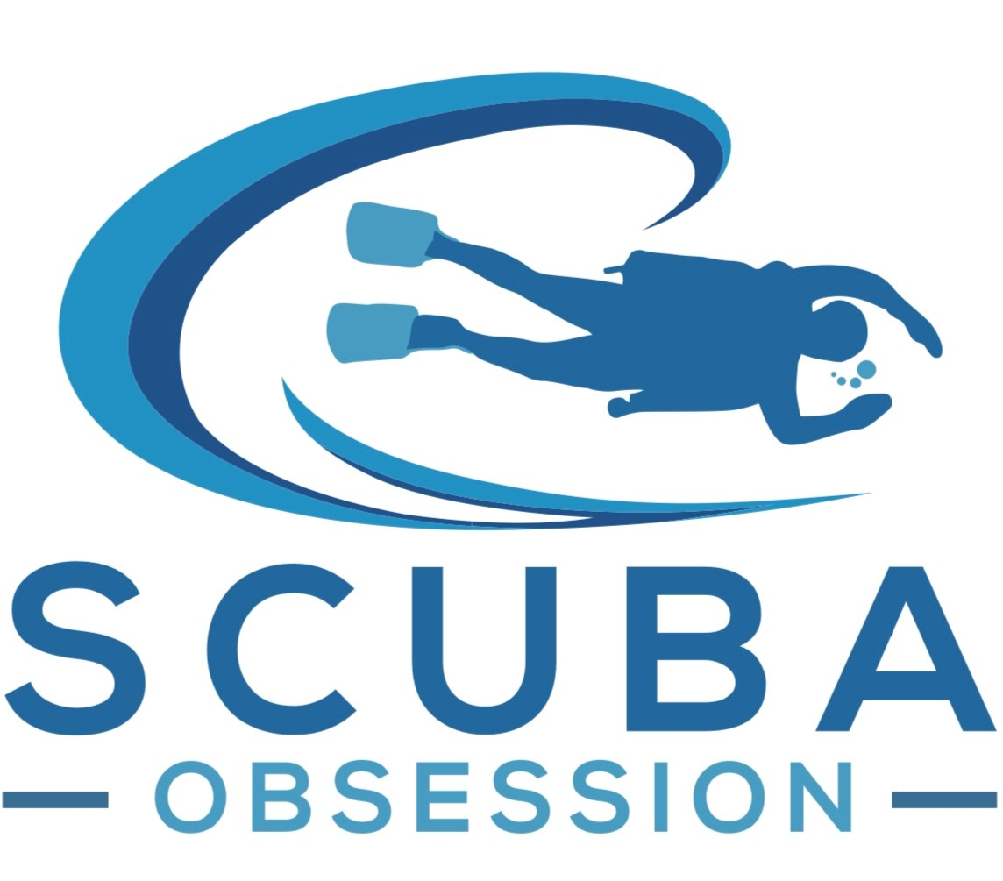

Bookings

The business offers the following methods for bookings and enquiries:
- Phone
- Email
- Webportal
- Our website supports Screen Readers
- Our forms have high contract boxes and submit boxes
- Staff have undergone disability awareness and training

Emergency Management
- The business has an emergency management and evacuation plan for guests with a disability
- Emergency and evacuation procedures are explained on arrival
- Guests with disabilities are noted in the guest log book for emergency and evacuation purposes

Communications
- Our website meets WCAG 2.0 accessibility standards
- Our business offers the following alternative communication methods
- Plain English

Not specified
- There is easy to read signage and information (e.g. menus and emergency information)

Dive site maps for visually impaired students

Other Information
- The business accepts the companion card

Guide Dog and Service Animals
- The business provides a secure area with shade and water for service animals
- The business provides a toilet area for service animals
- Bowls, bedding, etc. are provided for service animals
The business provides the following services for services animals:
Scuba Obsession – Service Animal Support Brief Scuba Obsession proudly provides an inclusive, accessible environment where guests who rely on service animals are welcomed and fully supported. Our team understands the essential role service animals play in independence, safety, and wellbeing, and we ensure their needs are integrated into our operational planning. We provide clear access pathways, safe waiting areas, and staff trained in disability aware interaction, so handlers and their service animals feel comfortable throughout their visit. Service animals may accompany their handler in all public areas, and our crew will assist with boarding procedures, equipment setup, and any additional support required before and after water activities. While service animals cannot enter the water during scuba operations, we ensure they remain safe, supervised, and settled in a designated area until their handler returns. Our approach is built on respect, dignity, and personalised support, ensuring every diver—human and canine—has a smooth, stress free experience.

GENERAL

Pre-arrival, arrival and reception
The business has the following in place to support guests during pre-arrival, arrival and reception
- Booking information and websites are compatible with screen readers
- Information and maps are available in written form
- A step free map/guide
- A familiarisation tour
- In addition, the following further information can assist guests:
N/A

Cognitive Impairment Support
- Documents are available in plain English for people with cognitive impairment (This may include instructions, guides, menus and general information)
- Quiet periods or early opening times for people on the Autism Spectrum
- A space for parents and children on the Autism Spectrum

Car Park and Access amenities
The business has the following Car Park and Access amenities
- A drop off zone
- Designated disabled parking bays
- Level or ramped access from the car park to the entrance
- The accessible entrance is clearly signed from the parking bay
- The public transport services available are:

We have a laminated sheet to show the nearest bus route and train station

External Paths
External paths of travel
- Surfaces are concrete, asphalt, smooth paving or hard packed fine gravel (max aggregate size 13mm)
- Pathways are wider than 900mm

Public Toilets/Adult change facilities
Public Toilets/Adult change facilities have the following amenities are in place
- There is an accessible toilet for public use
- The door is 700mm wide
- There is 300mm mm beside the toilet
- Handrails are fitted
- There is 1000mm mm of clear space in front of the toilet
- The toilet seat of a contrasting colour to the floor
- The height of the toilet seat is: 400mm.
- There is a registered changing places facility

TOUR OPERATORS

Tour/Transport Services
The tour/transport services have the following facilities/amenities in place
- Buses/Coaches
- 0 vehicles have wheelchair lifts or ramps
- 0 vehicles have low floors with ramped entry
The maximum wheelchair capacity available in the fleet is:
0

Guides
- Use of clear/simple English
- Correct pronunciation for lip readers
- Marine

Report Disclaimer
Please note that this business report, provided as a result of the use of the diagnostic assessment, is for information purposes only.
Australian Tourism Industry Council (ATIC) cannot guarantee the accuracy of respondent’s answers, or that they are fully representative of your business. Therefore, ATIC does not warrant or guarantee any particular outcome in respect of your businesses self-assessment.
This report is intended as guidance only for your business and should not be relied on for future marketing considerations. ATIC recommends that you seek your own independent advice as well as the results from the diagnostic.
Links to external web sites are inserted for convenience and do not constitute endorsement of material at those sites, or any associated organisation, product or service.
ATIC does not:
- Assume any legal liability for the accuracy, completeness, or usefulness of any information from this report or any links provided; or
- Accept responsibility for any loss associated directly or indirectly from the use of this report.

