ATIC Accessibility
To support the accessible community in making informed travel decisions for their individual needs

This report prepared for:
Business name: | Bruny Island Coastal Retreats (BrunyIsland.au)
Address: | 12 Cloudy Bay Road
Town: | Lunawanna
Contact for enquiries: | Sergio Pizzica
Contact Number: | 0396635575
Contact Email: | Info@brunyisland.com.au
Website: | Brunyisland.com.au
Date: | 2026-08-24 09:25

ATIC Accessibility
The following pages provides travellers with information on the businesses facilities and amenities which aims to support the traveller to make an informed decision on whether the business is suitable for their individual needs.
OVERVIEW 4
Business Overview 4
Bookings 4
Emergency Management 5
Communications 5
Guide Dog and Service Animals 5
GENERAL 6
Pre-arrival, arrival and reception 6
Cognitive Impairment Support 6
Car Park and Access amenities 6
Internal Spaces 7
External Paths 7
Steps 7
Ramps 8
ACCOMMODATION 9
Bedrooms 9
Room Amenities 9
Bathrooms 10
COMMON AREAS 12
Report Disclaimer 14

OVERVIEW

Business Overview

The business has the following products/services available
- Accommodation

Our business caters for the following disability types:
- Blind or low vision
- Deaf or low hearing
- Limited mobility
- Wheelchairs or mobility scooters
- Food allergies or intolerances
- Cognitive or people on the Autism Spectrum
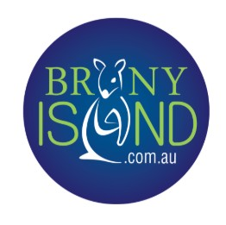

Bookings

The business offers the following methods for bookings and enquiries:
- Phone
- Email
- Webportal
- Our website supports Screen Readers
- Our forms have high contract boxes and submit boxes
- Staff have undergone disability awareness and training

Emergency Management
- The business has an emergency management and evacuation plan for guests with a disability
- Emergency and evacuation procedures are explained on arrival
- Guests with disabilities are noted in the guest log book for emergency and evacuation purposes

Communications
- An accessibility guide is available on the website

https://brunyislandstays.com.au/en/contact-us
- Our website meets WCAG 2.0 accessibility standards
- Our business offers the following alternative communication methods
- Plain English
- Magnifiers

Not specified
- There is easy to read signage and information (e.g. menus and emergency information)

Guest communications are shared in paper, email and in a electronic compendium for multiple channels to share information with them.

Guide Dog and Service Animals
- The business provides a secure area with shade and water for service animals
- The business provides a toilet area for service animals
- Bowls, bedding, etc. are provided for service animals
The business provides the following services for services animals:
None of our accommodation is pet friendly, however, we understand the eligibility for service animals to be part of the travel party. There are clearly accessed areas for service animals, so these don't disturb the wildlife and native fauna of Bruny Island. They are allowed inside the house and coloured towels are left available for them, as well as drinking bowls and a sleeping mat.

GENERAL

Pre-arrival, arrival and reception
The business has the following in place to support guests during pre-arrival, arrival and reception
- Booking information and websites are compatible with screen readers
- Information and maps are available in written form
- A familiarisation tour
- Keys are available for each guest
- In addition, the following further information can assist guests:
All our accommodation is self-contained accommodation, which means guests don't need to wait to gain access to the properties. &nbsp;They go to the houses directly with instructions given in advance by email and SMS.
- In addition, the following further information can assist guests:
Communications shared in advance to guests include but are not limited to: electronic compendium with detailed and graphic instructions on appliance operation; a map of the location and clear directions on how to get into the property; access codes shared the day before to avoid missing information due to lack of reception; an emergency and evacuation plan; timetables of the ferry to Bruny Island; location and name of suitable places for them to buy food, drinks and fresh produce (these prioritise the small independent local businesses in the close proximity to Bruny Island), etc.

Cognitive Impairment Support
- Documents are available in plain English for people with cognitive impairment (This may include instructions, guides, menus and general information)
- A "social script" guide to your premises or attraction describing the sights, sounds and smells to aid parents/carers prepare visitors in advance
- The 'social script' is available in word and other editable formats
- Quiet periods or early opening times for people on the Autism Spectrum
- A space for parents and children on the Autism Spectrum

Car Park and Access amenities
The business has the following Car Park and Access amenities
- A drop off zone
- Designated disabled parking bays
- Level or ramped access from the car park to the entrance
- The accessible entrance is clearly signed from the parking bay
- The public transport services available are:

Our website, as well as communications shared to guests upon reservation, include details of how to get into Bruny Island including the ferry timetables, cost and frequency of travel departing to and from Bruny Island and Kettering.

Internal Spaces
- Tableware/glassware contrast with the table surface or table cloth

External Paths
External paths of travel
- Surfaces are concrete, asphalt, smooth paving or hard packed fine gravel (max aggregate size 13mm)
- Pathways are wider than 900mm

Each property layout differs. The properties with stairs clearly state in the listing their suitability for kids, reduced mobility or others. Properties that are suitable for kids, families with elder travelers or mobility reduced are on a flat path or doorway.
- Any paths having steps are clearly identified as non-wheelchair accessible
- Step free routes clearly signed
- In addition, the following further information can assist guests:
Each property layout differs. &nbsp;The properties with stairs clearly state in the listing their suitability for kids, reduced mobility or others. &nbsp;Properties that are suitable for kids, families with elder travelers or mobility reduced are on a flat path or doorway.

Steps
Steps
- There are steps.
- Top and bottom steps are easily distinguished through colour contrast or the use of TGSIs (Tactile Ground Surface Indicators)
- All steps or staircases have enclosed risers
- The underside of all staircases are enclosed or protected to a height of at least 2 metres
- Handrails fitted to all open sets of steps
- Handrails extend 300mm beyond the top and bottom step
- Where steps are present are there three steps or less

Ramps
Ramps have the following amenities are in place
- There are ramps.
- All fixed ramps are 1:14 or less
- Hand rails are fitted
- Long ramps (more than 10m) are 1:20 or less
- Ramps have a raised edge of at least 100mm

ACCOMMODATION

Bedrooms
The bedrooms have the following facilities/amenities in place
- There are 1 property is suitable for guests who use a wheelchair, and 3 more are suitable for guests with reduced mobility. rooms available to guests who use a wheelchair
- Bedroom furniture can be re-arranged on request
  - Layout of room Image(s)
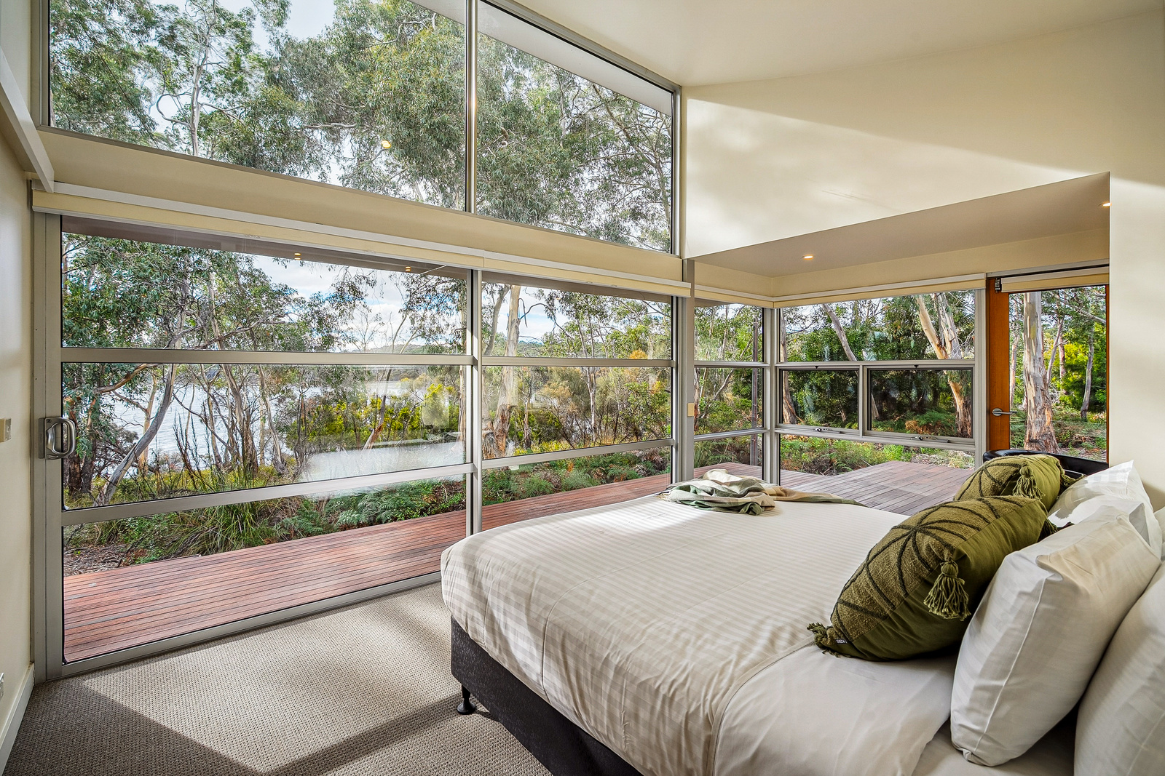
031_Open2view_ID949390-670_Lighthouse_Road

Room Amenities
- Lower hanging rails are in wardrobes
- Televisions are equipped with closed captioning capability
- Vibrating alarm clocks
- Room phones are hearing loop compatible
- Room phones have volume control
- Room phones have a visual ringing indicator
- Room phones are capable of sending and receiving an SMS
- There is contrast between the walls, skirtings, floor and furniture
- There is a clear path through the room
- The edges of all furniture and fixtures are rounded
- Wardrobe handles are a contrasting colour to the doors and draws
- Housekeeping procedures instruct staff not to reposition furniture that has been moved
- Doors open fully against the adjoining wall
- There is a clear opening at least 850mm wide
- There luggage racks for at least two suitcases
- There at least one chair with rigid arms
- Wardrobe and drawer handles are easy to grip
- The bedside lamp switch is easy to reach from the bed
- There is at least 850mm clear space beside the bed
- The bed height is no higher than 680mm from the floor
- There is at least 130mm clearance under the bed
- The business offers a range of non-allergenic bedding
- Non-allergenic cleaning products are used

Bathrooms
The bathrooms have the following facilities/amenities in place
- All heating appliances and hot water pipes are protected or insulated
- All shower, bath and basin taps are clearly differentiated between hot and cold
- Fixtures and fittings have rounded edges
- The hot water is thermostatically controlled to 41 degrees
- The door is at least 850mm wide
- There is a minimum of 850mm beside the toilet
- Handrails are fitted
- There is a minimum of 1400mm of clear space in front of the toilet
- The toilet seat is 460mm above the floor
- A range of non-allergenic toiletries are available
- There is a portable shower head on flexible hose
- A door is fitted to the shower
- A door is fitted to the showers with an outward swing at minimum width of 900 mm
  - Bathroom Image(s)
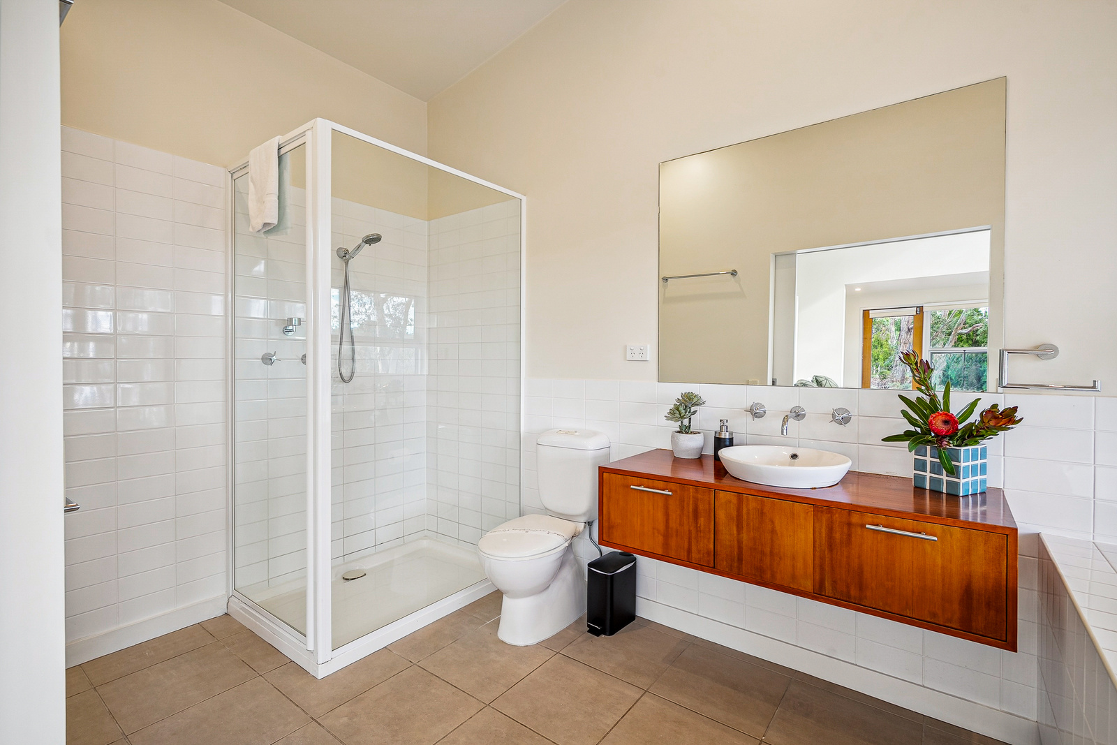
034_Open2view_ID949390-670_Lighthouse_Road
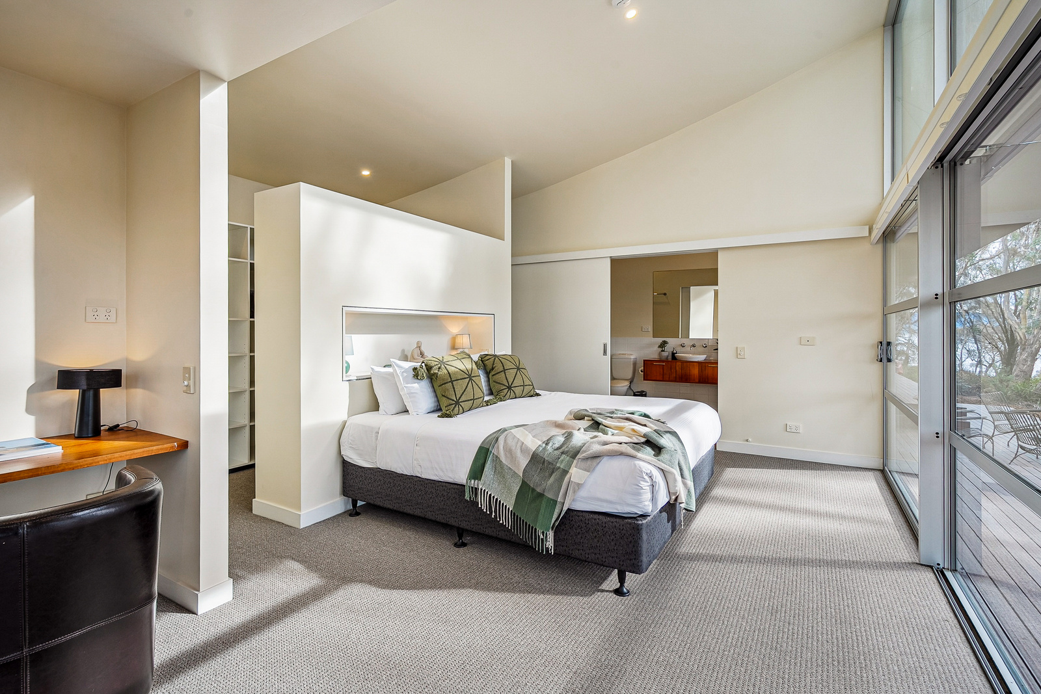
033_Open2view_ID949390-670_Lighthouse_Road

COMMON AREAS

Report Disclaimer
Please note that this business report, provided as a result of the use of the diagnostic assessment, is for information purposes only.
Australian Tourism Industry Council (ATIC) cannot guarantee the accuracy of respondent’s answers, or that they are fully representative of your business. Therefore, ATIC does not warrant or guarantee any particular outcome in respect of your businesses self-assessment.
This report is intended as guidance only for your business and should not be relied on for future marketing considerations. ATIC recommends that you seek your own independent advice as well as the results from the diagnostic.
Links to external web sites are inserted for convenience and do not constitute endorsement of material at those sites, or any associated organisation, product or service.
ATIC does not:
- Assume any legal liability for the accuracy, completeness, or usefulness of any information from this report or any links provided; or
- Accept responsibility for any loss associated directly or indirectly from the use of this report.

