ATIC Accessibility
To support the accessible community in making informed travel decisions for their individual needs

This report prepared for:
Business name: | Yarraman Caravan Park & Cabins
Address: | 12121 D'Aguilar Highway
Town: | Yarraman
Contact for enquiries: | Tania Paul
Contact Number: | 0741638185
Contact Email: | admin@yarramancp.com.au
Website: | www.yarramancp.com.au
Date: | 2026-10-06 14:40

ATIC Accessibility
The following pages provides travellers with information on the businesses facilities and amenities which aims to support the traveller to make an informed decision on whether the business is suitable for their individual needs.
OVERVIEW 4
Business Overview 4
Bookings 4
Emergency Management 5
Communications 5
Other Information 5
Guide Dog and Service Animals 5
GENERAL 6
Pre-arrival, arrival and reception 6
Cognitive Impairment Support 6
Car Park and Access amenities 6
Entry 7
Internal Spaces 7
Public areas 7
External Paths 8
Steps 8
Ramps 8
Public Toilets/Adult change facilities 8
ACCOMMODATION 9
Bedrooms 9
Room Amenities 9
Bathrooms 10
COMMON AREAS 13
Play Spaces 13
Swimming pools, spas and waterparks 13
Parks and gardens 14
Report Disclaimer 17

OVERVIEW

Business Overview

The business has the following products/services available
- Accommodation

Our business caters for the following disability types:
- Blind or low vision
- Deaf or low hearing
- Limited mobility
- Wheelchairs or mobility scooters
- Cognitive or people on the Autism Spectrum
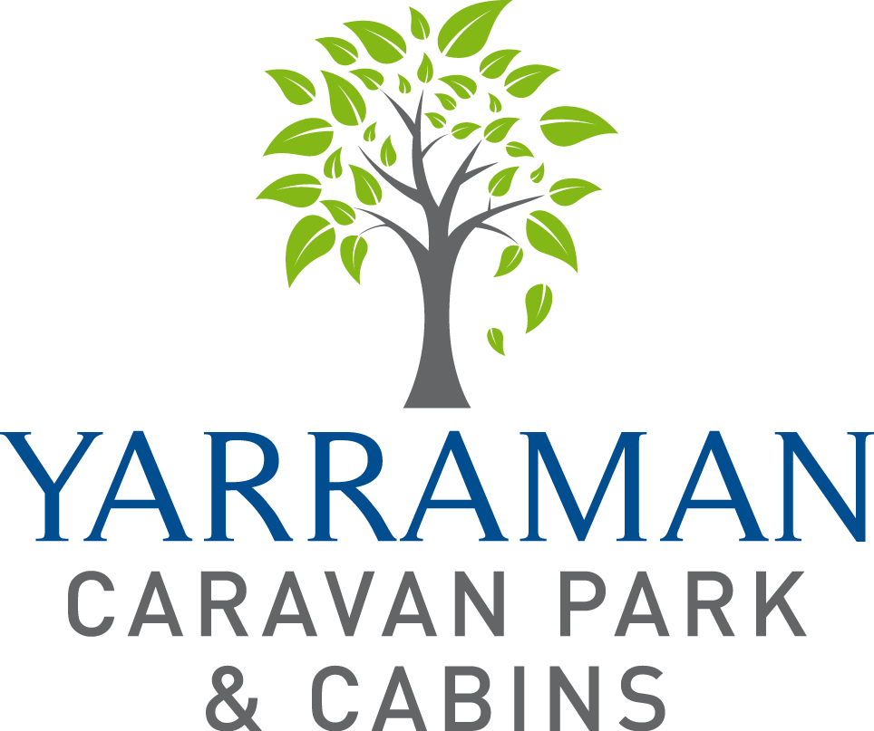

Bookings

The business offers the following methods for bookings and enquiries:
- Phone
- Email
- Webportal
- Our forms have high contract boxes and submit boxes
- Staff have undergone disability awareness and training

Emergency Management
- Exit signs are clear and easy to see
- Exit access is free and clear at all times
We ensure exit access is free and clear at all times by:
Doorways are free and clear at all times and nothing placed near or in doorways
- Exits and access to exists are greater than 900mm
- Exit doors are able to be opened by all occupants
- Exits to the emergency evacuation point does not include stairways
- The evacuation point is clearly marked by a sign
- In addition, the following further information can assist guests:
We prioritize those staying in accessible cabins
- In addition, the following further information can assist guests:
To assist where we can and if necessary call relevant emergency services for assistance

Communications
- An accessibility guide is available on the website

https://yarramancp.com.au/accessibility

Other Information
- For bookings made onsite, the ticket booth/counter/box office is accessible for people using a wheelchair

Guide Dog and Service Animals
The business provides the following services for services animals:
Service animals are welcome in all areas of the park and there is plenty of grassed areas to be walked and toileted

GENERAL

Pre-arrival, arrival and reception
The business has the following in place to support guests during pre-arrival, arrival and reception
- There is a reception/public entryway.
- Seating available at reception
- A clipboard to allow check-in/ticket purchase whilst seated
- A tablet with text to voice or pen and paper at reception to aid in communication
- Lighting in the reception area is even and glare free
- Information and maps are available in written form
- Advertising material, web sites and social media contain information relating to phone numbers available for non-voice communication e: Text, SMS, email and fax
- A key to any accessible facilities that are locked
- Keys are available for each guest
- Luggage assistance
- In addition, the following further information can assist guests:
There are seats available at reception. Also seats available in common areas such as pool area, camp kitchen and outdoor eating area.

Cognitive Impairment Support
- Documents are available in plain English for people with cognitive impairment (This may include instructions, guides, menus and general information)

Car Park and Access amenities
The business has the following Car Park and Access amenities
- A drop off zone
- Level or ramped access from the car park to the entrance
- The accessible entrance is clearly signed from the parking bay
- In addition, the following further information can assist guests:
The park has kerb ramps available and can placed where required as required for use by guests

Entry
The business has the following amenities/systems in place for entry
- A drop off point close to the entrance
- A path of access to the building is slip resistance and even
- A path of access to the building is clear of obstruction
- Glass doors are fitted with a visual sighting strip
- Door jams/doors are of a contrasting colour to surrounding walls
- Door handles are of a contrasting colour to the door
- Signage is written in a contrasting colour
- Signage is written in a Sans Serif font and use upper and lower case letters
- The entry door is a minimum of 850mm wide
- The entry door has self opening or a light opening pressure (for manual operations)
- The entrance sill is less than 13mm
- There a clear space of at least 1500mm x 1500mm in front of all doors.
- The entrance door mats have a thickness less than 13mm and a width of 7500mm or greater

Internal Spaces
- Clear and unobstructed routes through and between buildings
- Interior walls are matte or low sheen
- Floors, walls, counters and furniture are of contrasting colours
- Any protruding or overhanging obstructions are at least 2meters above the floor or are protected
- Floor surfaces are hard or short pile carpet
- Seating is available for guests unable to stand for long periods
- Accessible facilities are clearly signed and visible from all areas
- All corridors greater than 900mm

Public areas
The public areas have the following amenities in place
- Display units, Televisions, Video displays etc. are open captioned
- Even lighting
- Seating

External Paths
External paths of travel
- Surfaces are concrete, asphalt, smooth paving or hard packed fine gravel (max aggregate size 13mm)
- Paths or slopes longer than 15 metres have resting places or seats
- Pathways are wider than 900mm

Steps
Steps
- There are steps.
- Top and bottom steps are easily distinguished through colour contrast or the use of TGSIs (Tactile Ground Surface Indicators)
- Handrails fitted to all open sets of steps
- Handrails extend 300mm beyond the top and bottom step
- In addition, the following further information can assist guests:
Where there are steps there are also alternate ramps for access in public areas

Ramps
Ramps have the following amenities are in place
- There are ramps.
- All fixed ramps are 1:14 or less
- Hand rails are fitted
- Long ramps (more than 10m) are 1:20 or less
- Ramps have a raised edge of at least 100mm

Public Toilets/Adult change facilities
Public Toilets/Adult change facilities have the following amenities are in place
- There is an accessible toilet for public use
- The door is at least 850mm wide
- There is a minimum of 850mm beside the toilet
- Handrails are fitted
- The toilet seat is 460mm above the floor
- The toilet seat of a contrasting colour to the floor
- The toilet seat is460mm above the floor

ACCOMMODATION

Bedrooms
The bedrooms have the following facilities/amenities in place
- There are 2 rooms available to guests who use a wheelchair
- Bedroom furniture can be re-arranged on request
  - Layout of room Image(s)
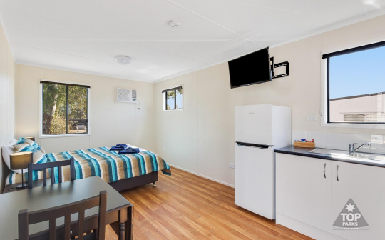
Accessible-cabin-interior (4)

Room Amenities
- In addition, the following further information can assist guests:
In the event of an emergency a staff member will go to each site and cabin and door knock. Text messages are sent out.
- Televisions are equipped with closed captioning capability
- There is contrast between the walls, skirtings, floor and furniture
- There is a clear path through the room
- The edges of all furniture and fixtures are rounded
- Housekeeping procedures instruct staff not to reposition furniture that has been moved
- Doors open fully against the adjoining wall
- There is a clear opening at least 850mm wide
- Wardrobe and drawer handles are easy to grip
- The bedside lamp switch is easy to reach from the bed
- There is at least 850mm clear space beside the bed
- The bed height is no higher than 680mm from the floor
- Non-allergenic cleaning products are used

Bathrooms
The bathrooms have the following facilities/amenities in place
- All heating appliances and hot water pipes are protected or insulated
- All shower, bath and basin taps are clearly differentiated between hot and cold
- Fixtures and fittings have rounded edges
- The hot water is thermostatically controlled to 41 degrees
- The door is at least 850mm wide
- There is a minimum of 850mm beside the toilet
- Handrails are fitted
- There is a minimum of 1400mm of clear space in front of the toilet
- The toilet seat is a contrasting colour to the floor
- The toilet seat is 460mm above the floor
- There is a roll-in shower with fold down fixed seat or a shower chair
- There is a portable shower head on flexible hose
  - Bathroom Image(s)
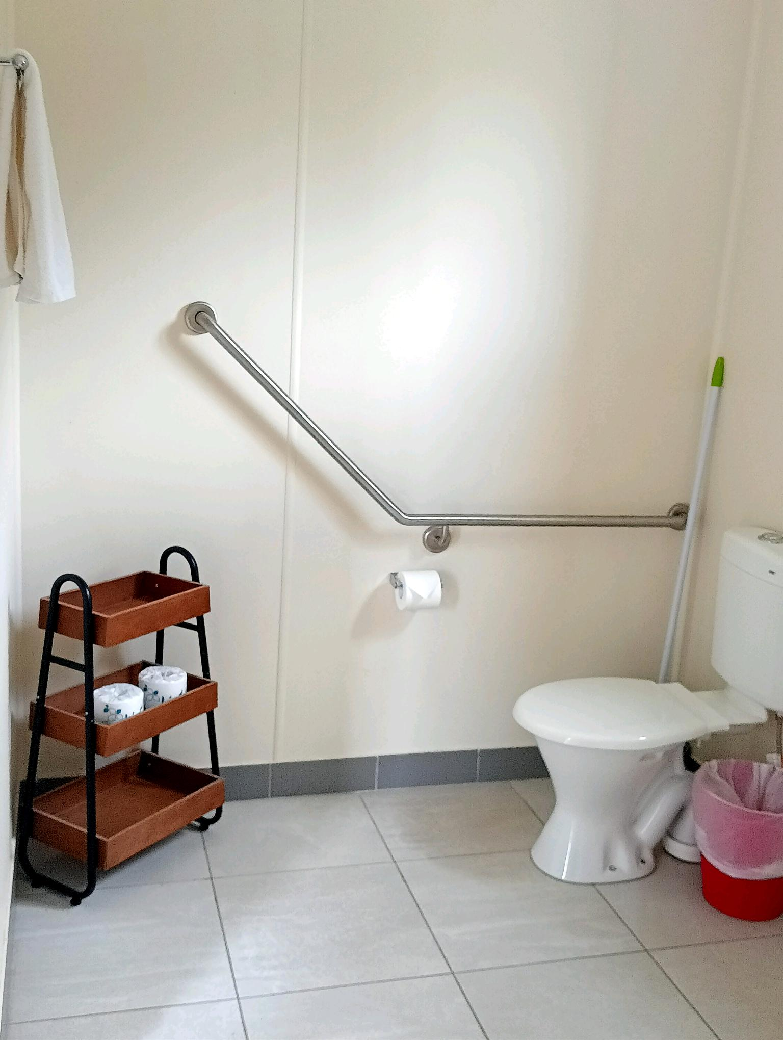
Cabin WCF toilet
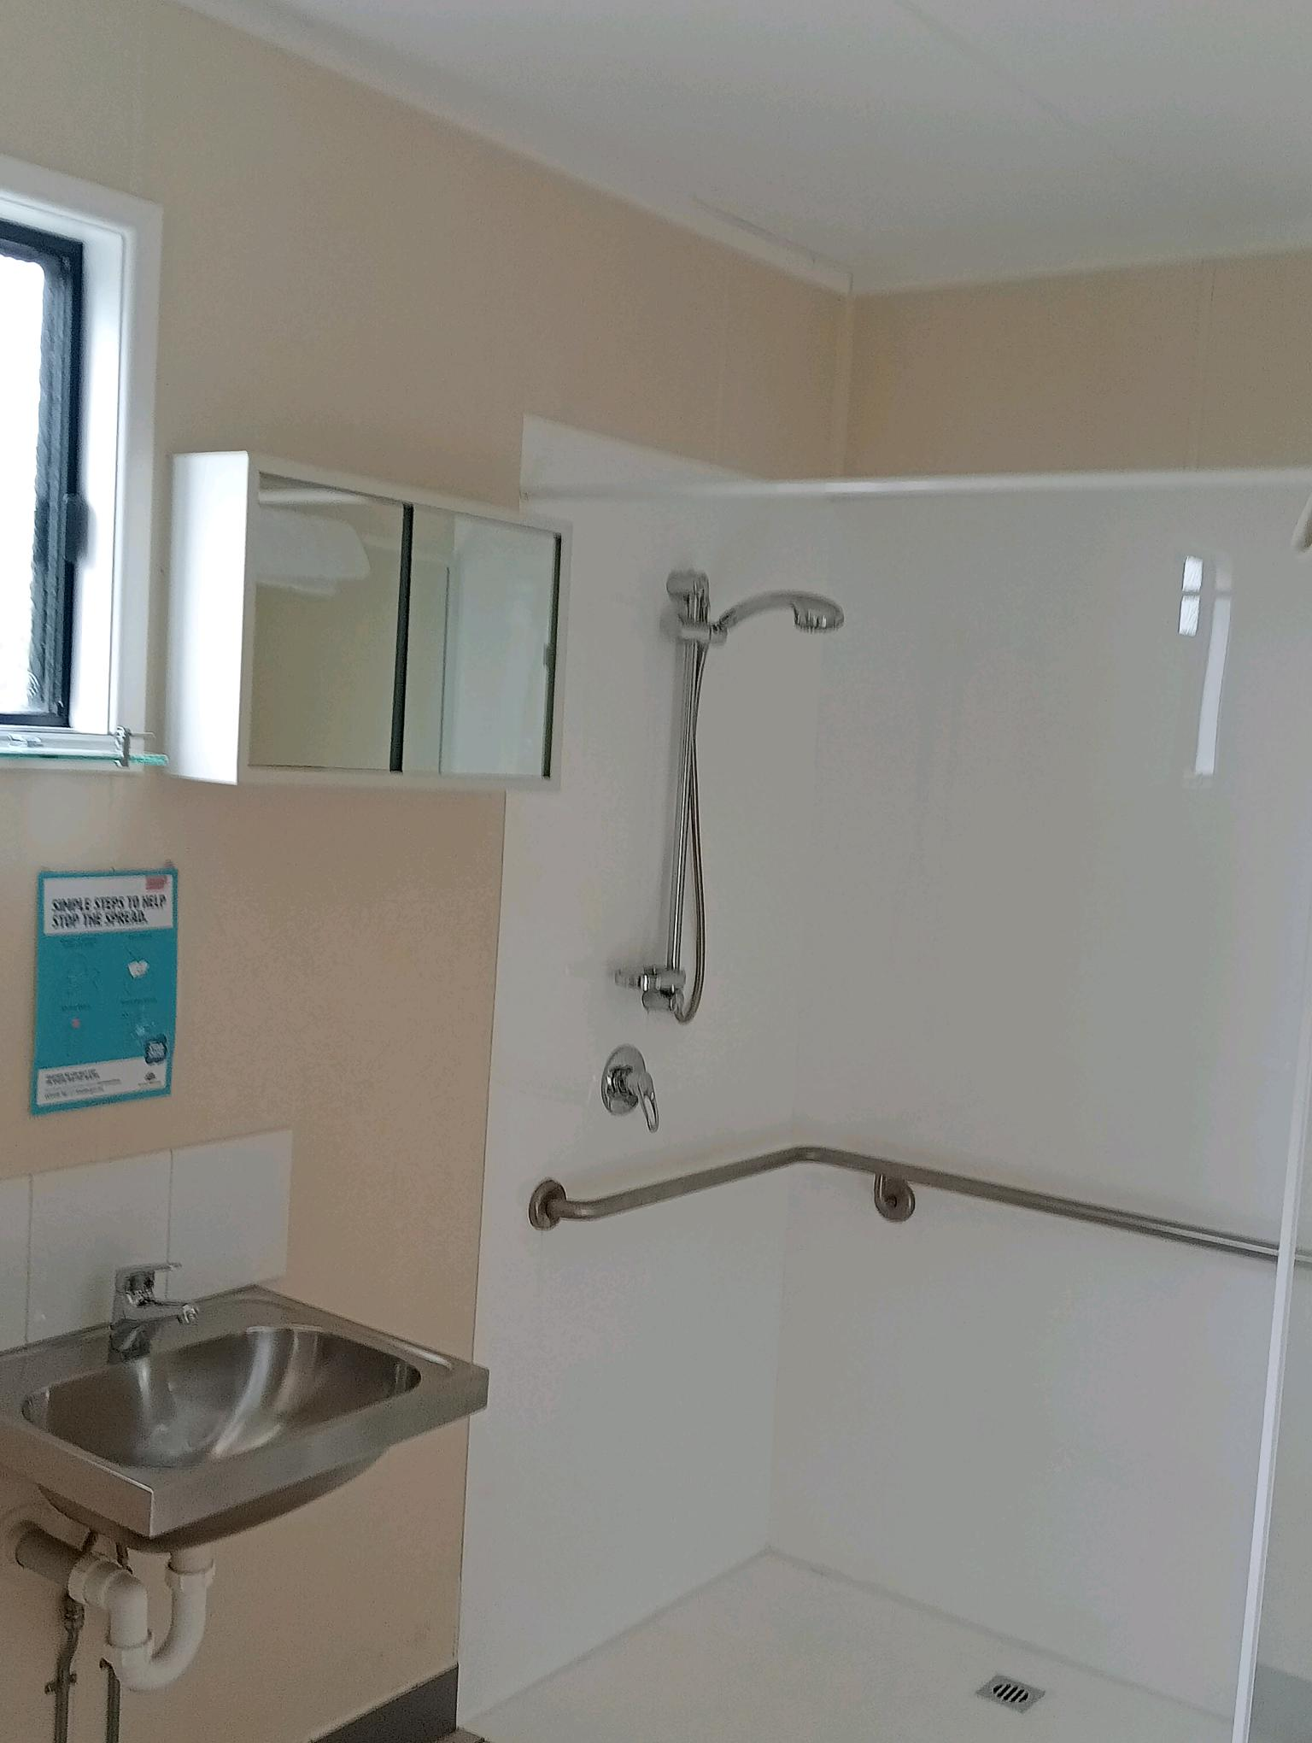
Cabin WCF basin & shower
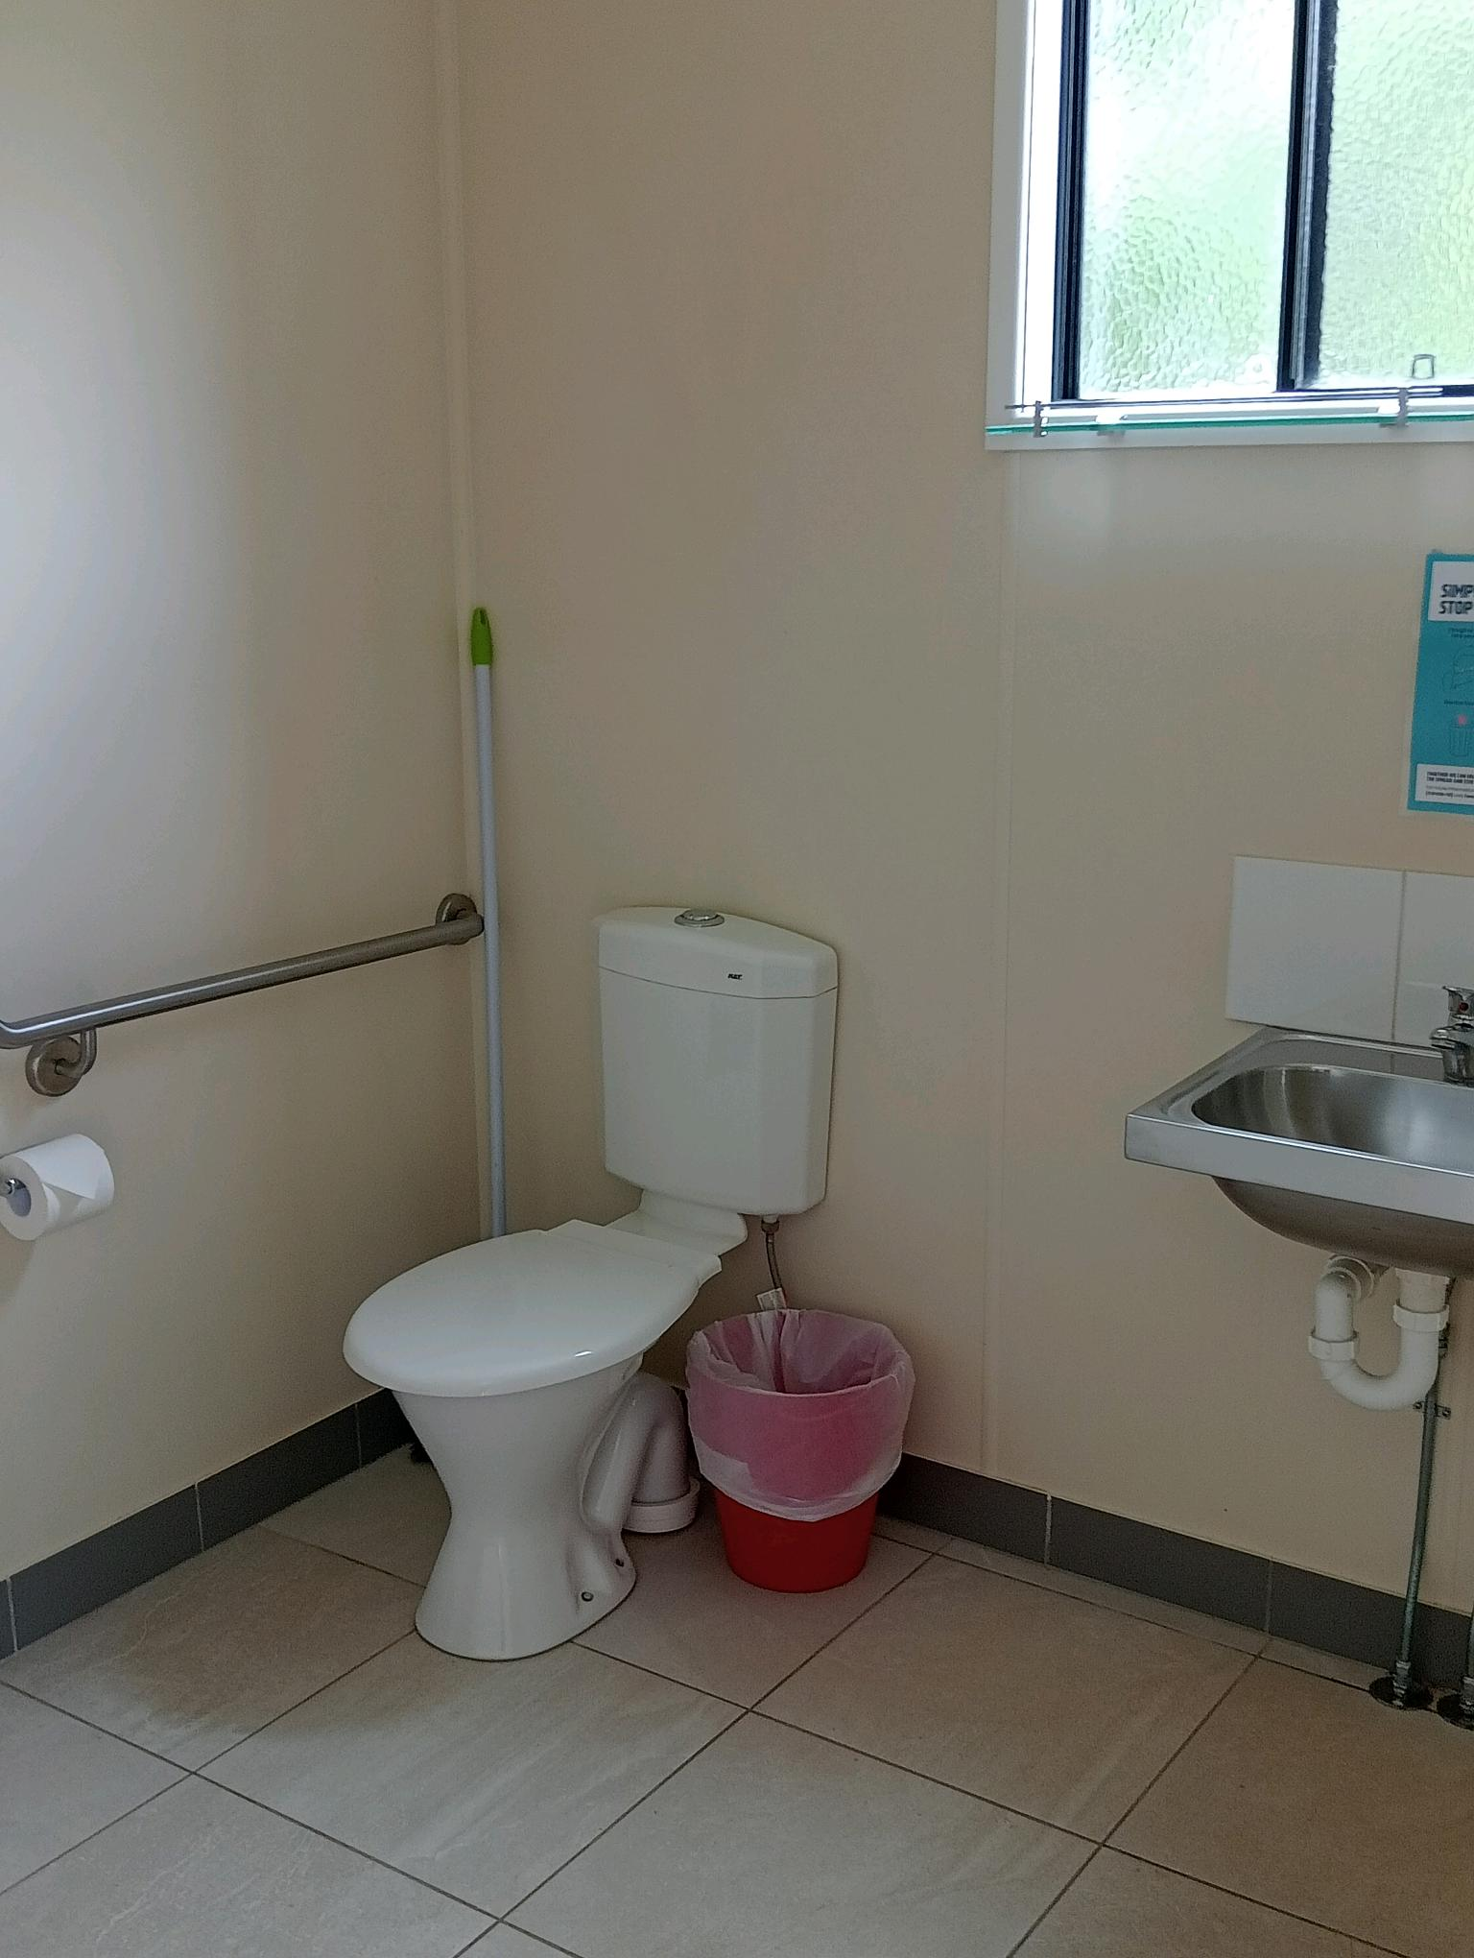
Cabin WCF basin & toilet
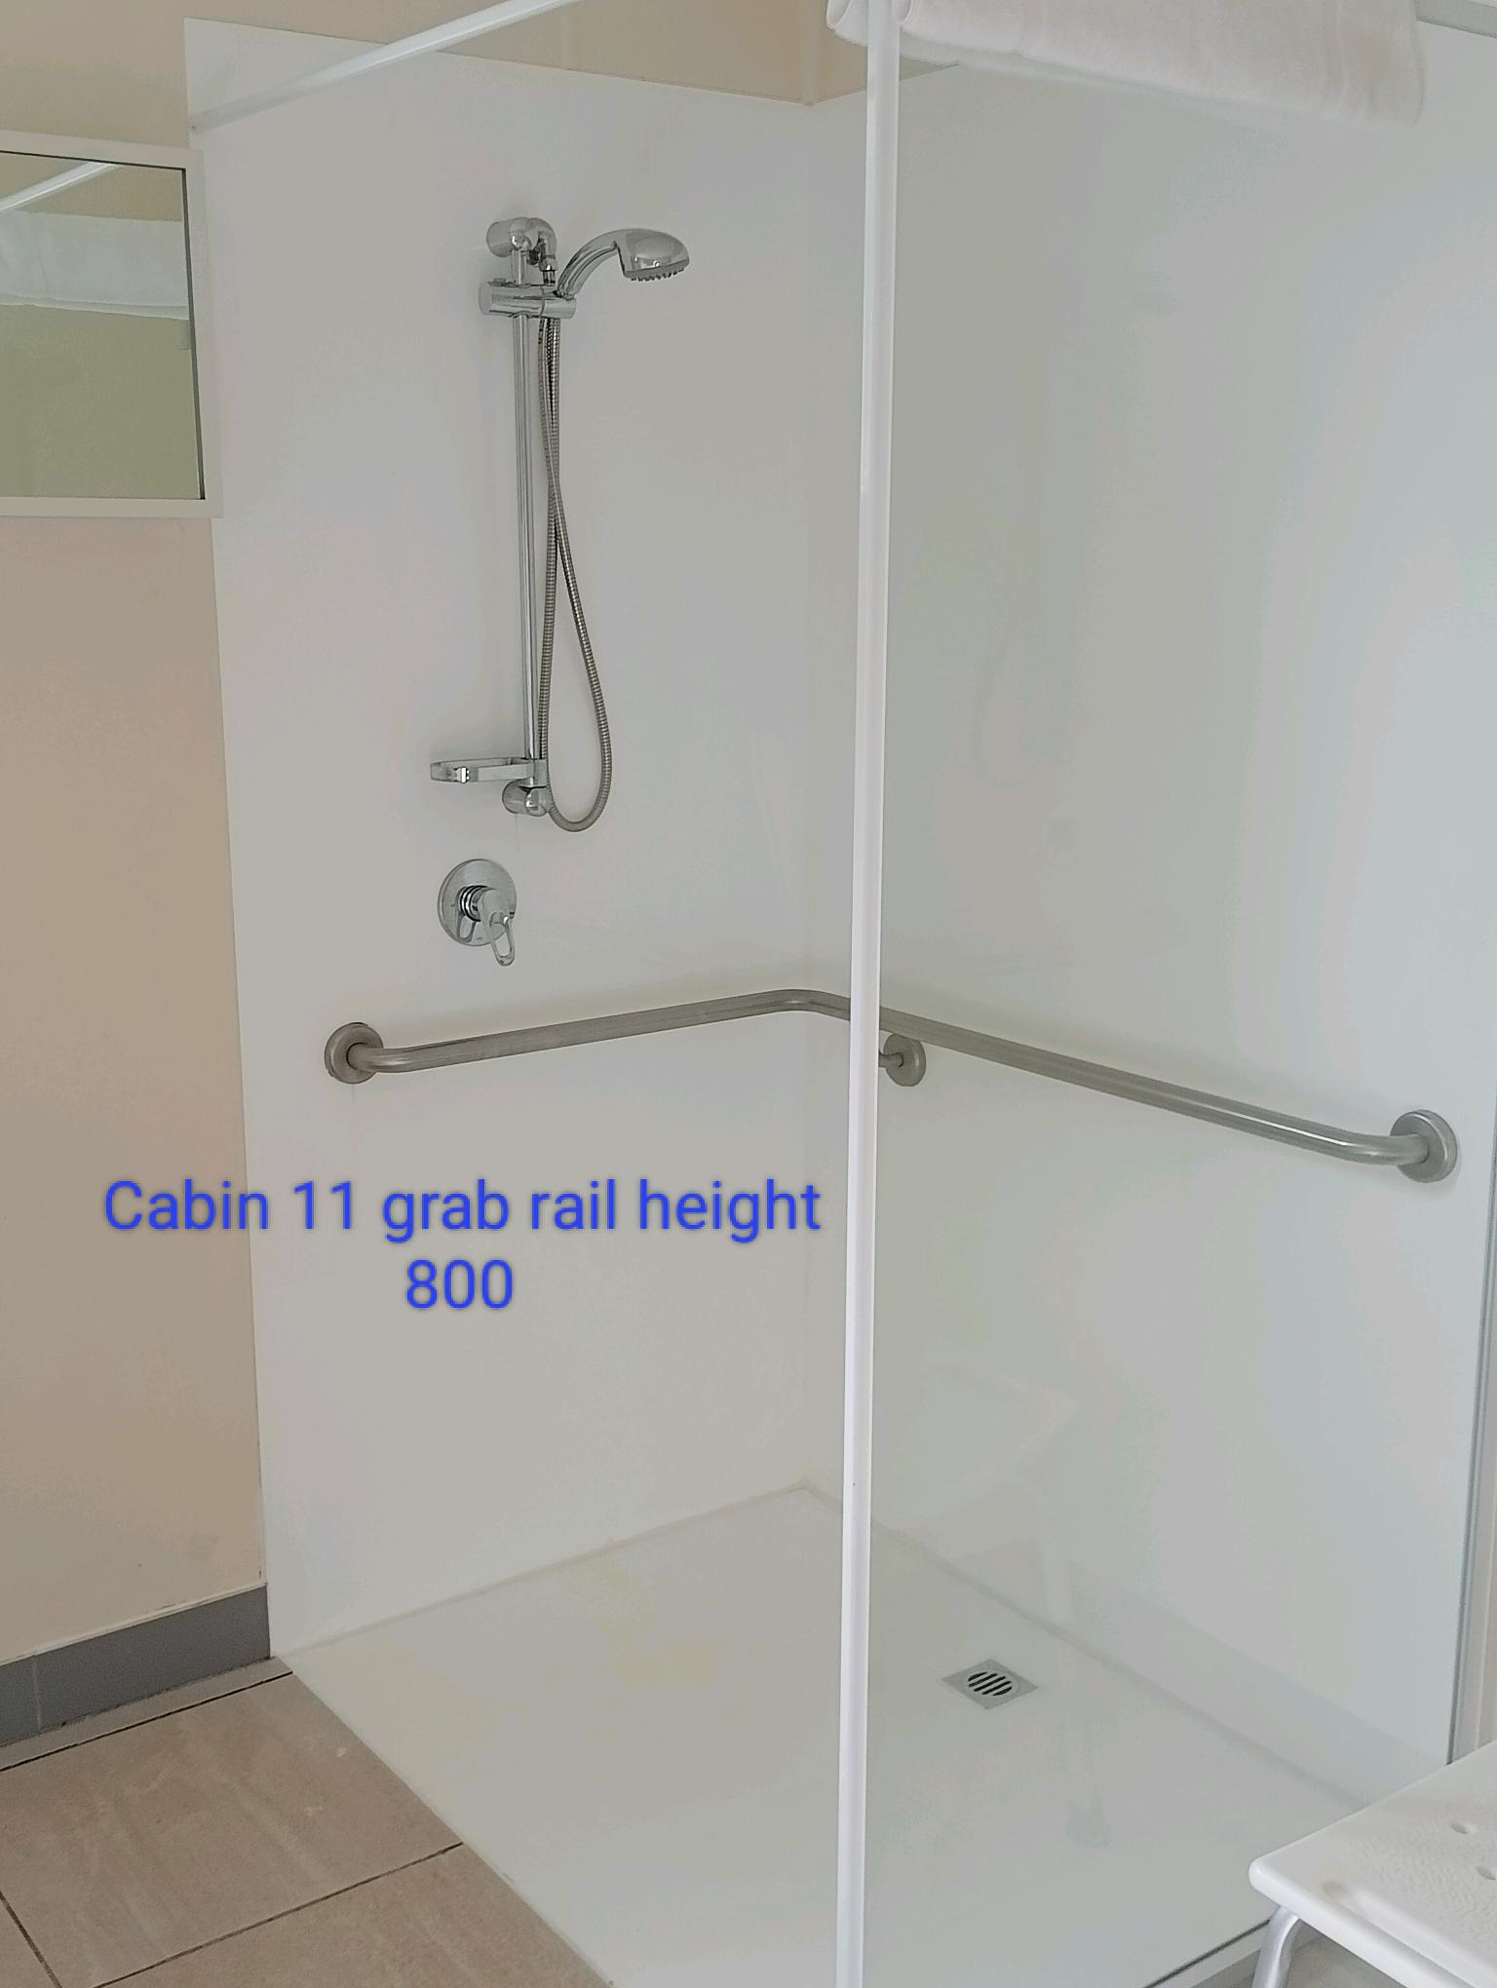
Cabin WCF shower rail & chair

COMMON AREAS

Play Spaces
- Seating is provided in or around the play space
  - Image(s)
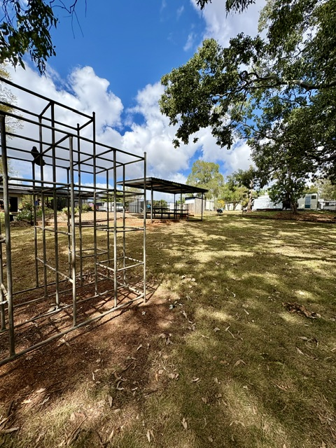
Play area & seating
- In addition, the following further information can assist guests:
Seating near the play area has access via grass area to a concreted area with tables.

Swimming pools, spas and waterparks
- The following swimming pools, spas and waterparks amenities are available
  - Pool Access Image(s)
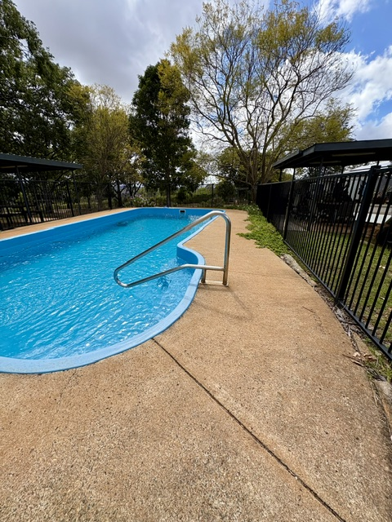
Pool entry
- In addition, the following further information can assist guests:
The swimming pool has handrails and graduated steps at entry

Parks and gardens
- The following parks and gardens amenities are available
- Accessible toilets
- Seats are provided at regular intervals
  - Parks and Gardens Access/Entry Image(s)
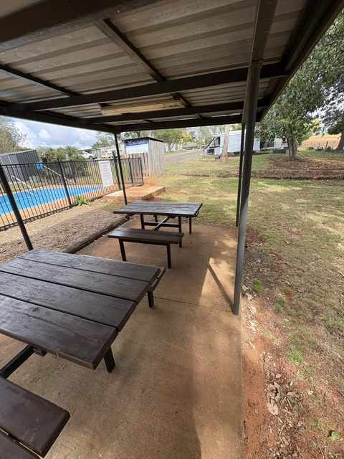
Seating area
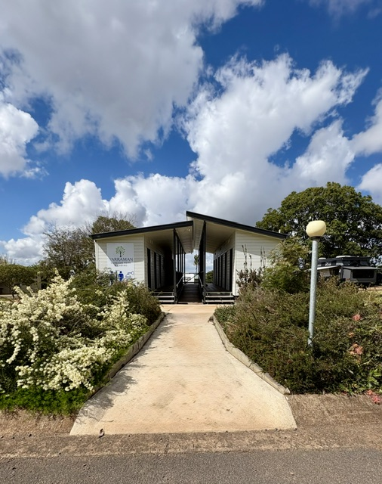
Amenities access and paths
- In addition, the following further information can assist guests:
Picnic area can be accessed via grassed area and free standing chairs can be removed to make space if requried.
- Handrails and stairs are built as per state/territory building code.
- Slip resistance surfaces are used.
- A handrail is available and at 865-965mm in height.
- The handrail is continuously graspable along entire length at least one side.
  - Parks and Gardens Stair entry and exit Image(s)
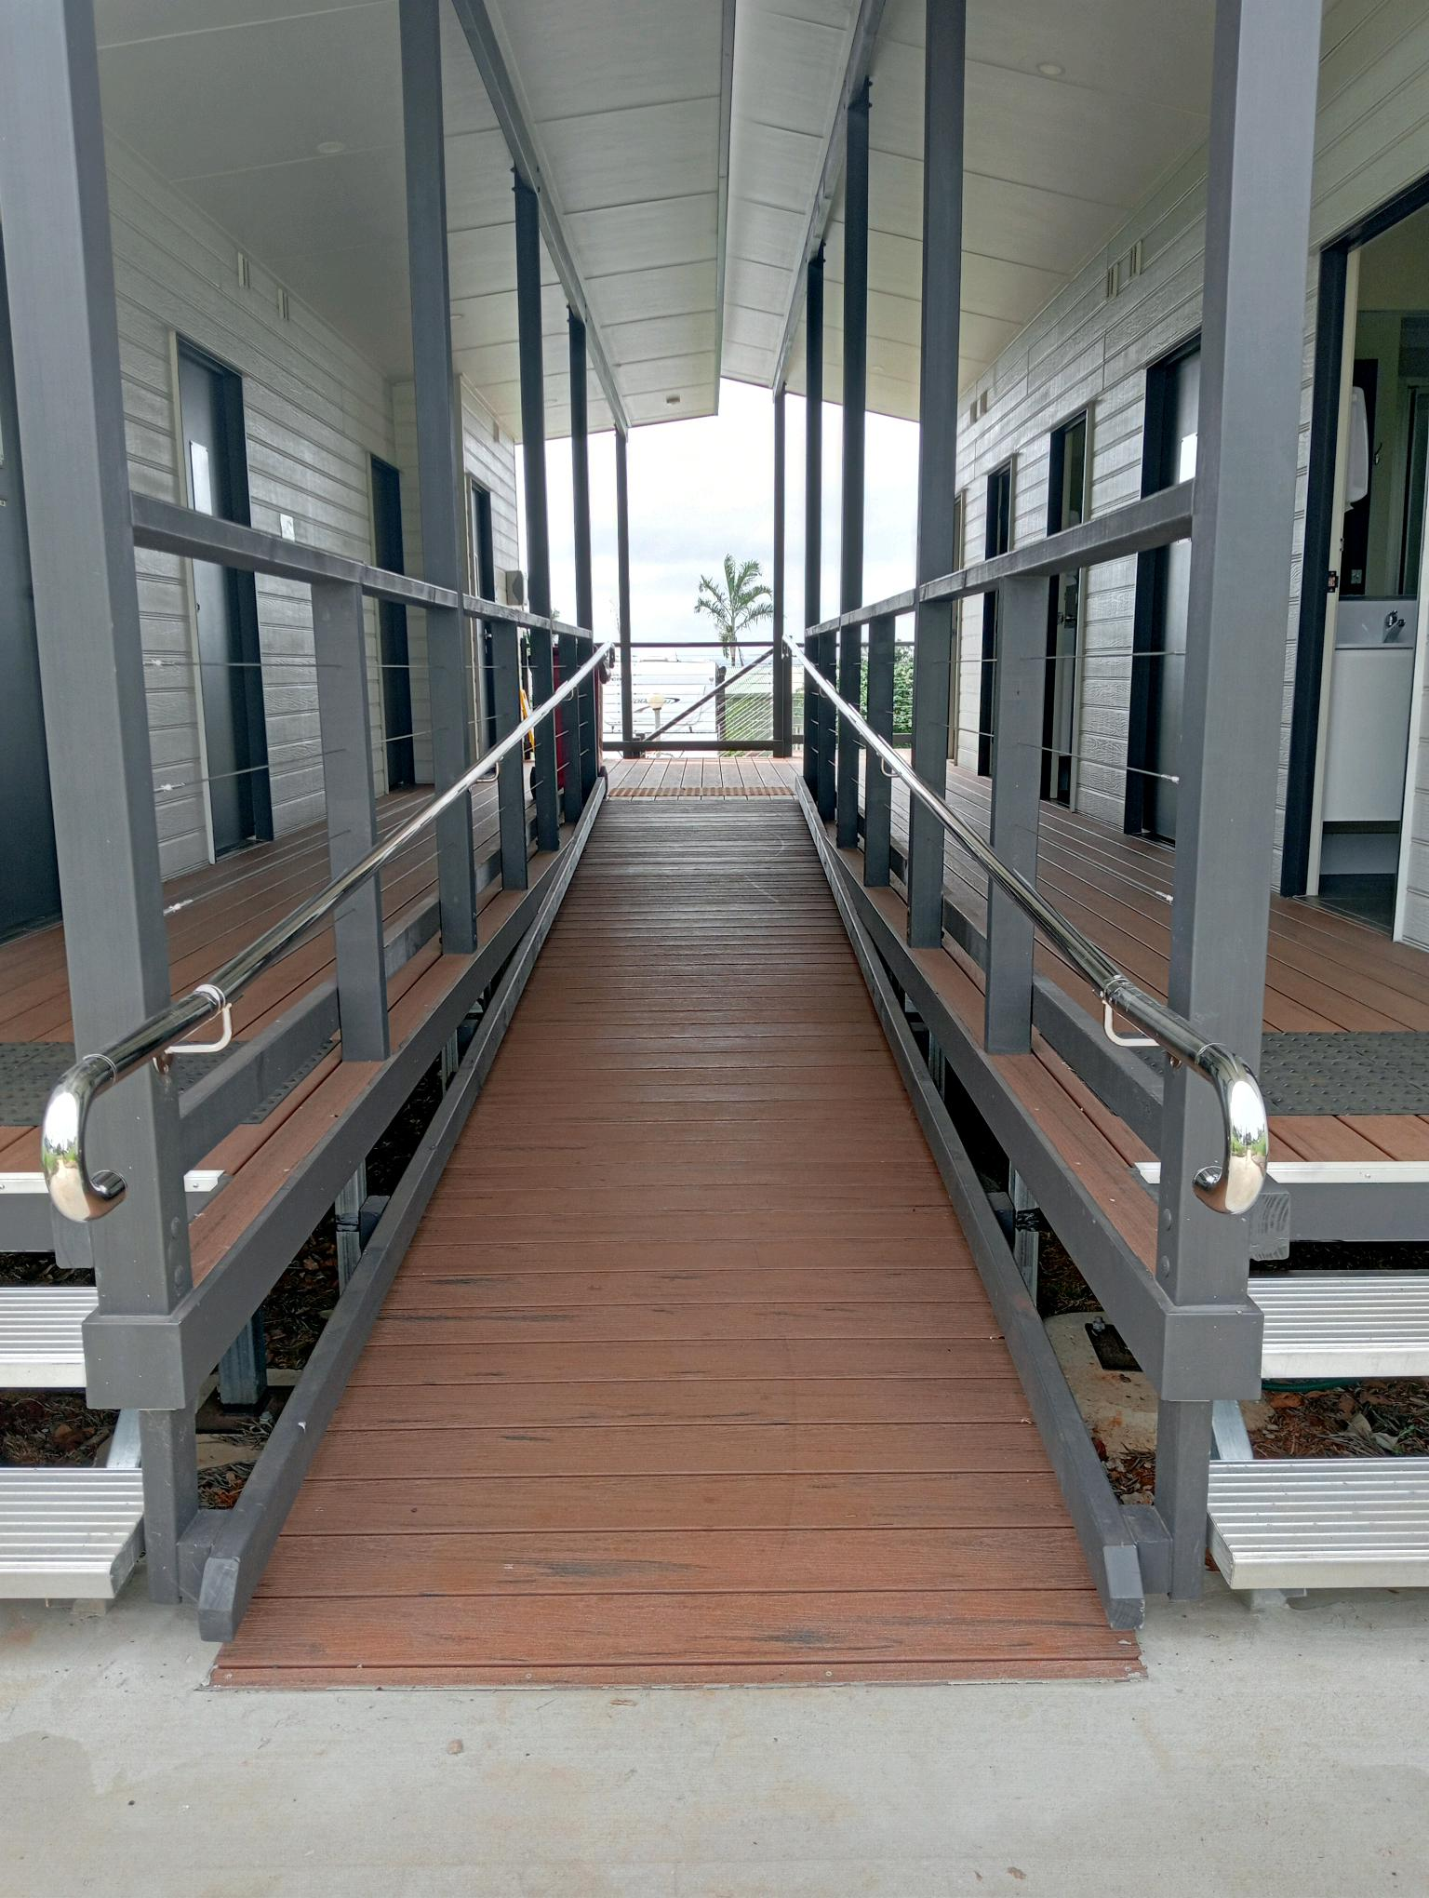
Entry Exit Handrails

Report Disclaimer
Please note that this business report, provided as a result of the use of the diagnostic assessment, is for information purposes only.
Australian Tourism Industry Council (ATIC) cannot guarantee the accuracy of respondent’s answers, or that they are fully representative of your business. Therefore, ATIC does not warrant or guarantee any particular outcome in respect of your businesses self-assessment.
This report is intended as guidance only for your business and should not be relied on for future marketing considerations. ATIC recommends that you seek your own independent advice as well as the results from the diagnostic.
Links to external web sites are inserted for convenience and do not constitute endorsement of material at those sites, or any associated organisation, product or service.
ATIC does not:
- Assume any legal liability for the accuracy, completeness, or usefulness of any information from this report or any links provided; or
- Accept responsibility for any loss associated directly or indirectly from the use of this report.

