ATIC Accessibility
To support the accessible community in making informed travel decisions for their individual needs

This report prepared for:
Business name: | Perth Driver Guide & Tours
Address: | 15-158 Peninsula Rd
Town: | Maylands
Contact for enquiries: | John Pettit
Contact Number: | 0411320377
Contact Email: | perthdriverguide@gmail.com
Website: | perthdriverguide.com
Date: | 2026-10-21 12:51

ATIC Accessibility
The following pages provides travellers with information on the businesses facilities and amenities which aims to support the traveller to make an informed decision on whether the business is suitable for their individual needs.
OVERVIEW 3
Business Overview 3
Bookings 3
Emergency Management 3
Communications 4
Guide Dog and Service Animals 4
GENERAL 5
Car Park and Access amenities 5
TOUR OPERATORS 6
Tour/Transport Services 6
Route Planning 6
Guides 6
Report Disclaimer 9

OVERVIEW

Business Overview

The business has the following products/services available
- Tour/Transport

Our business caters for the following disability types:
- Deaf or low hearing
- Limited mobility
- Wheelchairs or mobility scooters
- Food allergies or intolerances
- Cognitive or people on the Autism Spectrum


Bookings

The business offers the following methods for bookings and enquiries:
- Email
- Webportal

Emergency Management
- Emergency and evacuation procedures are explained on arrival
- Exit signs are clear and easy to see
- Exit access is free and clear at all times
We ensure exit access is free and clear at all times by:
There is nothing blocking the door to exit the vehicle.
- Exits and access to exists are greater than 900mm
- Exit doors are able to be opened by all occupants
- Exits to the emergency evacuation point does not include stairways
- In addition, the following further information can assist guests:
The guide determines if pax needs special care and notified by agent beforehand if special needs are required.
- In addition, the following further information can assist guests:
The guide or assistant will help.

Communications
- Our business offers the following alternative communication methods
- Plain English

Not specified
- There is easy to read signage and information (e.g. menus and emergency information)

Ear Phone Guide

Guide Dog and Service Animals
The business provides the following services for services animals:
No service offered.

GENERAL
- In addition, the following further information can assist guests:
Extra wait times provided for rest if need be.

Car Park and Access amenities
The business has the following Car Park and Access amenities
- Kerb ramps are in place where a pavement or walkway needs to be crossed
- In addition, the following further information can assist guests:
N・A
The width of the smallest pathway is:
N・A

There is no builiding

N・A
- In addition, the following further information can assist guests:
steps on vehicle to enter and disembark.

TOUR OPERATORS

Tour/Transport Services
The tour/transport services have the following facilities/amenities in place
- Buses/Coaches
- 0 vehicles have wheelchair lifts or ramps
- 0 vehicles have low floors with ramped entry
The maximum wheelchair capacity available in the fleet is:
0
- Commentary is available in written format

Route Planning
- Route Planning
- The tour route includes stops with accessible toilet facilities
- In addition, the following further information can assist guests:
Available upon request
- Lunch stop venues are accessible
- Sightseeing and photo opportunity stops are step free
- Walking Tours
- Operated on a step free route
- Multi-paced to account for slower walkers

Guides

Guides have been trained in the following
- Use of clear/simple English
- Correct pronunciation for lip readers
- There is a audio description of surroundings
  - Image(s)
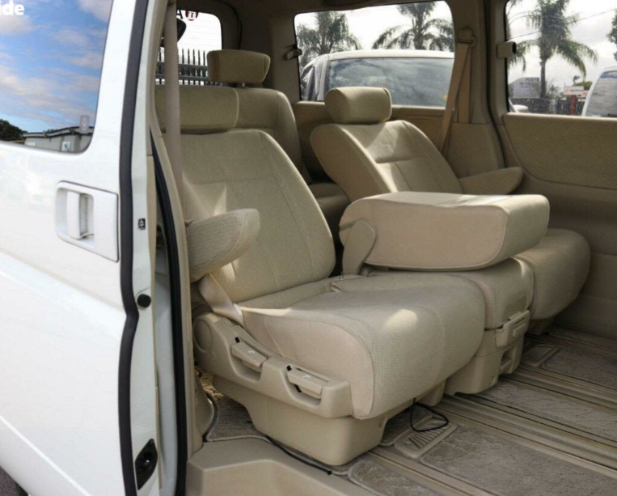
Seats & entrance
- In addition, the following further information can assist guests:
Cervantes Bistro, Margaret River wineries, Wave Rock Cafe etc

Report Disclaimer
Please note that this business report, provided as a result of the use of the diagnostic assessment, is for information purposes only.
Australian Tourism Industry Council (ATIC) cannot guarantee the accuracy of respondent’s answers, or that they are fully representative of your business. Therefore, ATIC does not warrant or guarantee any particular outcome in respect of your businesses self-assessment.
This report is intended as guidance only for your business and should not be relied on for future marketing considerations. ATIC recommends that you seek your own independent advice as well as the results from the diagnostic.
Links to external web sites are inserted for convenience and do not constitute endorsement of material at those sites, or any associated organisation, product or service.
ATIC does not:
- Assume any legal liability for the accuracy, completeness, or usefulness of any information from this report or any links provided; or
- Accept responsibility for any loss associated directly or indirectly from the use of this report.

