ATIC Accessibility
To support the accessible community in making informed travel decisions for their individual needs

This report prepared for:
Business name: | Boat Harbour Jetty B&B
Address: | 25 Wharf Street
Town: | Port Albert
Contact for enquiries: | Sharon Radon
Contact Number: | 0429832535
Contact Email: | BoatHarbourJettyBnB@bigpond.com
Website: | https://PortAlbertBoatHarbourJettyBnB.mydirectstay.com/
Date: | 2026-11-04 02:54

ATIC Accessibility
The following pages provides travellers with information on the businesses facilities and amenities which aims to support the traveller to make an informed decision on whether the business is suitable for their individual needs.
OVERVIEW 4
Business Overview 4
Bookings 4
Emergency Management 4
Communications 5
Other Information 5
Guide Dog and Service Animals 6
GENERAL 7
Pre-arrival, arrival and reception 7
Cognitive Impairment Support 7
Car Park and Access amenities 7
Internal Spaces 8
External Paths 8
Steps 9
Ramps 9
ACCOMMODATION 10
Bedrooms 10
Room Amenities 10
Bathrooms 11
COMMON AREAS 13
FOOD AND DRINK 14
Report Disclaimer 16

OVERVIEW

Business Overview

The business has the following products/services available
- Accommodation

Our business caters for the following disability types:
- Blind or low vision
- Deaf or low hearing
- Limited mobility
- Wheelchairs or mobility scooters
- Food allergies or intolerances
- Cognitive or people on the Autism Spectrum
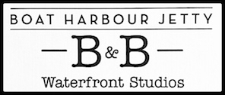

Bookings

The business offers the following methods for bookings and enquiries:
- Phone
- Email
- Webportal
- Our website supports Screen Readers
- Our forms have high contract boxes and submit boxes
- Staff have undergone disability awareness and training

Emergency Management
- Emergency and evacuation procedures are explained on arrival
- Guests with disabilities are noted in the guest log book for emergency and evacuation purposes

Communications
- An accessibility guide is available on the website

https://portalbertboatharbourjettybnb.mydirectstay.com/accessibility.html
- Our website meets WCAG 2.0 accessibility standards
- Our business offers the following alternative communication methods
- Plain English
- Magnifiers

Not specified
- There is easy to read signage and information (e.g. menus and emergency information)
- There are Picture boards
  - Picture Boards Image(s)
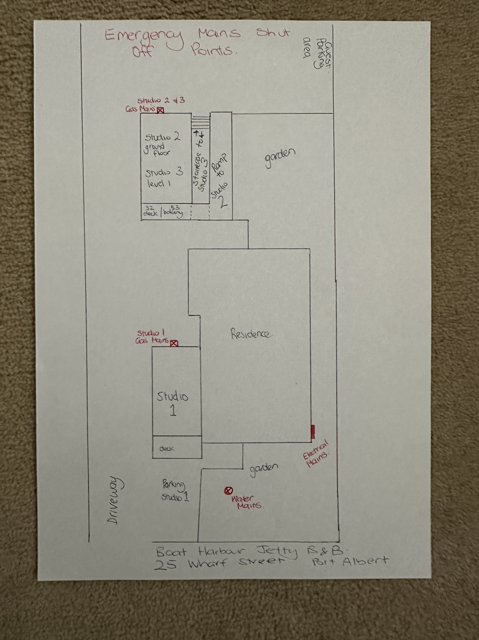
IMG_9878.JPG

introduction cards also as a hosted accommodation we are in first person contact with all guests

Other Information
- For bookings made onsite, the ticket booth/counter/box office is accessible for people using a wheelchair
- The business accepts the companion card

Guide Dog and Service Animals
- The business provides a secure area with shade and water for service animals
- The business provides a toilet area for service animals
- Bowls, bedding, etc. are provided for service animals
The business provides the following services for services animals:
provide secure indoor and outdoor area for service animals, access to fresh water and toilet facilities

GENERAL

Pre-arrival, arrival and reception
The business has the following in place to support guests during pre-arrival, arrival and reception
- Booking information and websites are compatible with screen readers
- Information and maps are available in written form
- A step free map/guide
- A familiarisation tour
- Advertising material, web sites and social media contain information relating to phone numbers available for non-voice communication e: Text, SMS, email and fax
- A key to any accessible facilities that are locked
- Keys are available for each guest
- Luggage assistance
- In addition, the following further information can assist guests:
guests are able to check into their room directly upon arrival
- In addition, the following further information can assist guests:
Guests are contacted day of reservation and provided with clear check in instructions. We ask guests to provide us with an estimated time of arrival so that we can greet guests upon arrival and ensure prompt check in straight to their studio.

Cognitive Impairment Support
- Documents are available in plain English for people with cognitive impairment (This may include instructions, guides, menus and general information)
- A "social script" guide to your premises or attraction describing the sights, sounds and smells to aid parents/carers prepare visitors in advance
- The 'social script' is available in word and other editable formats
- Quiet periods or early opening times for people on the Autism Spectrum
- A space for parents and children on the Autism Spectrum
- Access has alternative procedures and clear written instructions with universal access symbols

Car Park and Access amenities
The business has the following Car Park and Access amenities
- A drop off zone
- Designated disabled parking bays
- Level or ramped access from the car park to the entrance
- The accessible entrance is clearly signed from the parking bay
- The public transport services available are:

closest train station is Traralgon, closest bus stop is Yarram
- Kerb ramps are in place where a pavement or walkway needs to be crossed
- In addition, the following further information can assist guests:
Port Albert does not have public transport.
We greet guests in person as they arrive at the entrance to the car park. Onsite parking is at the rear of the property in clearly marked bays.
We are an adult only accommodation. Each individual studio is well insulated to minimise noise and fitted with dimmers.

Internal Spaces
- Tableware/glassware contrast with the table surface or table cloth

External Paths
External paths of travel
- Surfaces are concrete, asphalt, smooth paving or hard packed fine gravel (max aggregate size 13mm)
- Paths or slopes longer than 15 metres have resting places or seats
- Pathways are wider than 900mm
- There 3 successive steps or less on any path or at any doorway
- Any paths having steps are clearly identified as non-wheelchair accessible
- Step free routes clearly signed
- In addition, the following further information can assist guests:
The property itself is on clear level flat ground (gravel). All pathways are flat gravel. Each studio has it's own private entrance, there are no communal areas. Studio 2 is our only accessible room.

Steps
Steps
- There are steps.
- Top and bottom steps are easily distinguished through colour contrast or the use of TGSIs (Tactile Ground Surface Indicators)
- All steps or staircases have enclosed risers
- The underside of all staircases are enclosed or protected to a height of at least 2 metres
- Handrails fitted to all open sets of steps
- Handrails extend 300mm beyond the top and bottom step
- Where steps are present are there three steps or less
- In addition, the following further information can assist guests:
Each studio has its own private entrance and are fully self contained with no shared facilities. Studio 2 is step free and accessed via a ramp from parking area, alternatively it has 2 steps and handrail at front of deck. Studio 1 has two steps up to entry deck and is fitted with a hand rail. Studio 3 is above Studio 2 and accessed by an external staircase.

Ramps
Ramps have the following amenities are in place
- There are ramps.
- All fixed ramps are 1:14 or less
- Hand rails are fitted
- Long ramps (more than 10m) are 1:20 or less
- Ramps have a raised edge of at least 100mm
- In addition, the following further information can assist guests:
Studio 2 has a ramp
- In addition, the following further information can assist guests:
We are a small private hosted accommodation and do not provide public toilets. There are public toilets including accessible toilets less than 50m away. Studio 2 has been built to AS1428.1 and has accessible features including toilet, hand basin and roll in shower. A shower chair is available for use in the other studios if required.

ACCOMMODATION

Bedrooms
The bedrooms have the following facilities/amenities in place
- There are Property has total of 3 rooms with 1 room available for guests who use a wheelchair (Studio 2 is an accessible room) rooms available to guests who use a wheelchair
  - Layout of room Image(s)
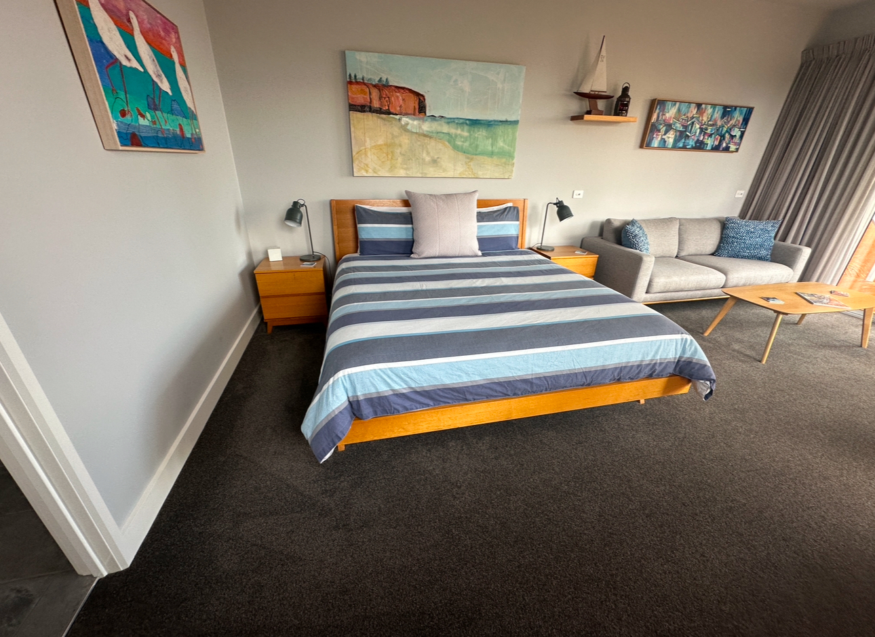
IMG_CDFE7F8F319F-1
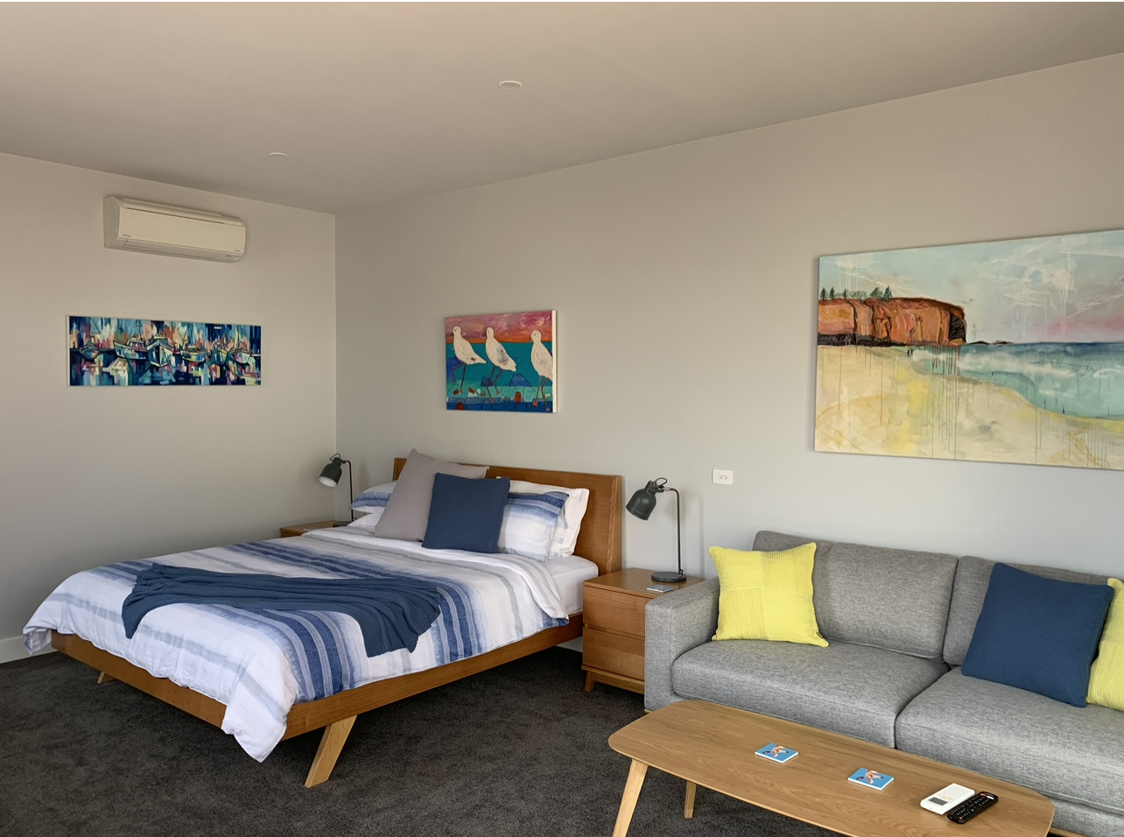
IMG_7548

Room Amenities
- Lower hanging rails are in wardrobes
- Visual alarm is fitted to the room
- Televisions are equipped with closed captioning capability
- Room phones have volume control
- Room phones have a visual ringing indicator
- There is contrast between the walls, skirtings, floor and furniture
- There is a clear path through the room
- The edges of all furniture and fixtures are rounded
- Wardrobe handles are a contrasting colour to the doors and draws
- Housekeeping procedures instruct staff not to reposition furniture that has been moved
- Doors open fully against the adjoining wall
- There is a clear opening at least 850mm wide
- There luggage racks for at least two suitcases
- There at least one chair with rigid arms
- Wardrobe and drawer handles are easy to grip
- The bedside lamp switch is easy to reach from the bed
- There is at least 850mm clear space beside the bed
- The bed height is no higher than 680mm from the floor
- There is at least 130mm clearance under the bed
- The business offers a range of non-allergenic bedding
- Non-allergenic cleaning products are used
- In addition, the following further information can assist guests:
The bedroom furniture cannot be rearranged as the king sized bed has a wood bed frame which does not split apart however there is plenty of clearance each side of the bed due to both the open plan nature of the studios and spacious dimensions (4.5 m width x 8 m length).
There are no phones in the room. However, we live onsite and there is a doorbell for guests to press to get hold of us 24 hours as well as mobile number.

Bathrooms
The bathrooms have the following facilities/amenities in place
- All heating appliances and hot water pipes are protected or insulated
- All shower, bath and basin taps are clearly differentiated between hot and cold
- Fixtures and fittings have rounded edges
- The hot water is thermostatically controlled to 41 degrees
- The door is at least 850mm wide
- There is a minimum of 850mm beside the toilet
- Handrails are fitted
- There is a minimum of 1400mm of clear space in front of the toilet
- The toilet seat is a contrasting colour to the floor
- The toilet seat is 460mm above the floor
- A range of non-allergenic toiletries are available
- There is a roll-in shower with fold down fixed seat or a shower chair
- There is a portable shower head on flexible hose
  - Bathroom Image(s)
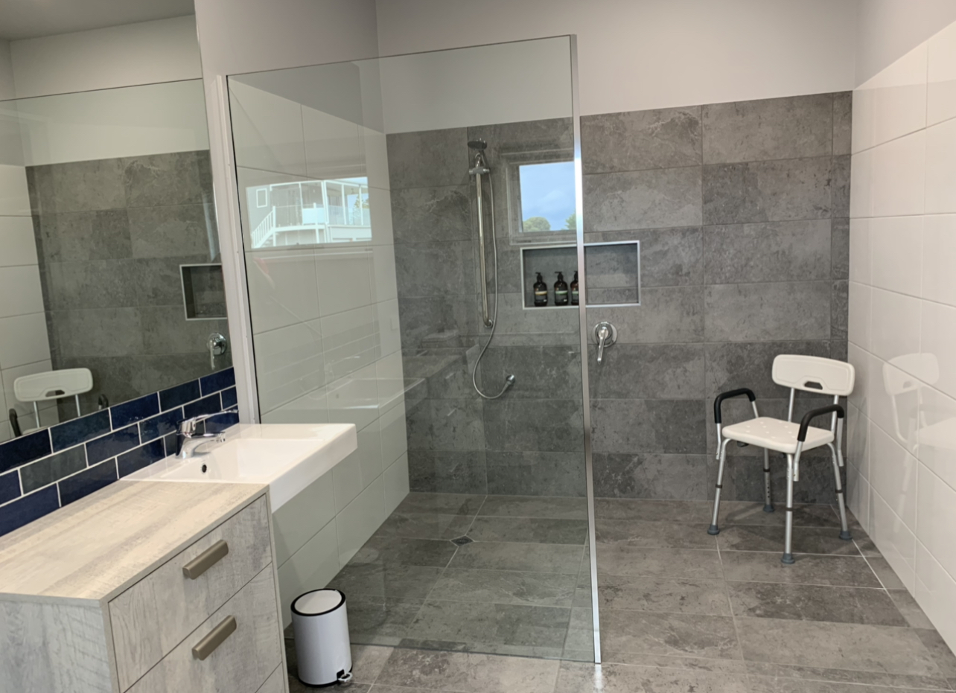
IMG_7081
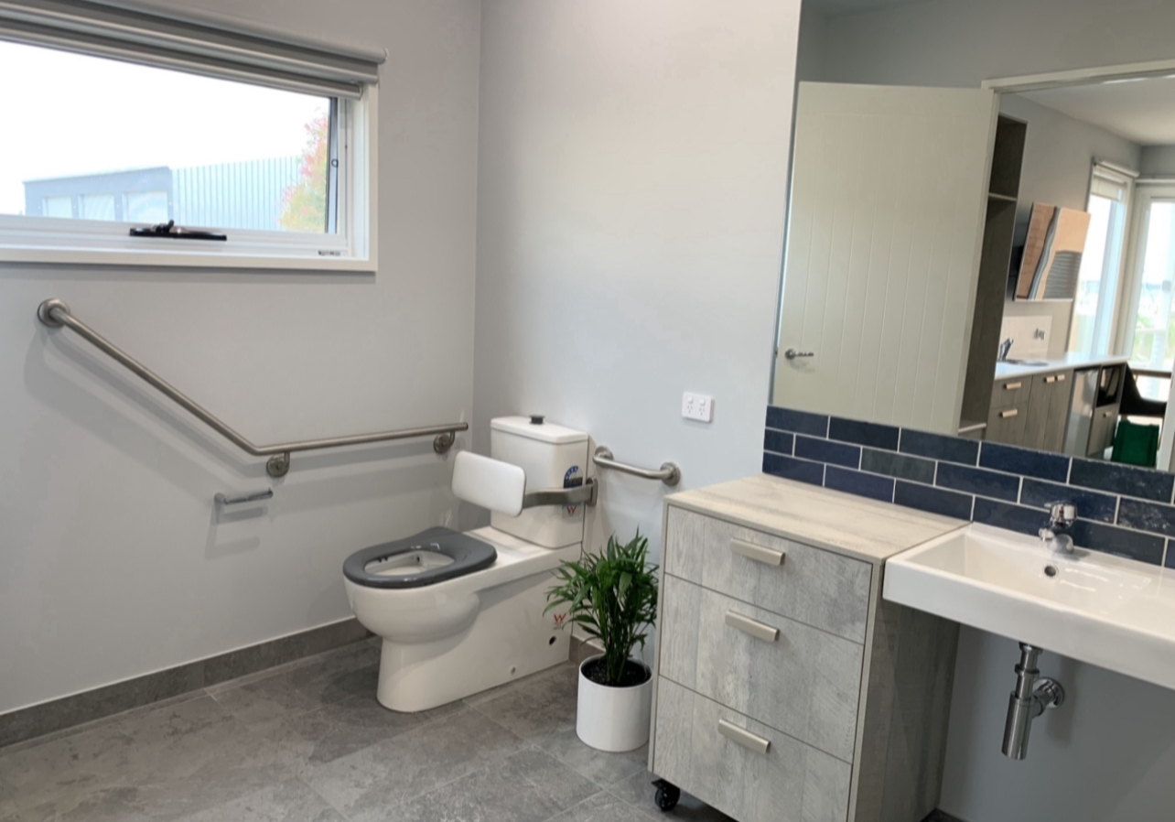
IMG_7496
- In addition, the following further information can assist guests:
We have received wonderful feedback from guests that use wheelchairs complimenting the room layout and facilities of Studio 2 (accessible room). We have both a shower chair available for guest use as well as hand rail in the shower and several addition floor mats suitable for use in the shower for extra grip (tiles are slip resistant)

COMMON AREAS

FOOD AND DRINK
Sample menu is available here -
https://portalbertboatharbourjettybnb.mydirectstay.com/local-dining.html

Report Disclaimer
Please note that this business report, provided as a result of the use of the diagnostic assessment, is for information purposes only.
Australian Tourism Industry Council (ATIC) cannot guarantee the accuracy of respondent’s answers, or that they are fully representative of your business. Therefore, ATIC does not warrant or guarantee any particular outcome in respect of your businesses self-assessment.
This report is intended as guidance only for your business and should not be relied on for future marketing considerations. ATIC recommends that you seek your own independent advice as well as the results from the diagnostic.
Links to external web sites are inserted for convenience and do not constitute endorsement of material at those sites, or any associated organisation, product or service.
ATIC does not:
- Assume any legal liability for the accuracy, completeness, or usefulness of any information from this report or any links provided; or
- Accept responsibility for any loss associated directly or indirectly from the use of this report.

