ATIC Accessibility
To support the accessible community in making informed travel decisions for their individual needs

This report prepared for:
Business name: | Liberty Balloon Flights
Address: | Unit 1
Town: | North Shore
Contact for enquiries: | Nick BRAU
Contact Number: | 0400694299
Contact Email: | info@libertyballoonflights.com.au
Website: | https://libertyballoonflights.com.au
Date: | 2026-09-11 06:02

ATIC Accessibility
The following pages provides travellers with information on the businesses facilities and amenities which aims to support the traveller to make an informed decision on whether the business is suitable for their individual needs.
OVERVIEW 4
Business Overview 4
Bookings 6
Emergency Management 6
Communications 6
Other Information 7
Guide Dog and Service Animals 7
GENERAL 8
Pre-arrival, arrival and reception 8
Car Park and Access amenities 8
Entry 9
Internal Spaces 9
Public areas 9
Displays, exhibits, commentary and live performances 10
External Paths 10
Steps 10
TOUR OPERATORS 12
Tour/Transport Services 12
Guides 12
ATTRACTIONS 13
COMMON AREAS 14
FOOD AND DRINK 15
Dining Spaces 15
ADVENTURE ACTIVITIES 16
Adventure activities 16
EVENTS 17
Events 17
Report Disclaimer 19

OVERVIEW

Business Overview

The business has the following products/services available
- Tour/Transport
- Attraction
- Food and Drink
- Adventure
- Event

Our business caters for the following disability types:
- Blind or low vision
- Deaf or low hearing
- Limited mobility
- Food allergies or intolerances
- Cognitive or people on the Autism Spectrum
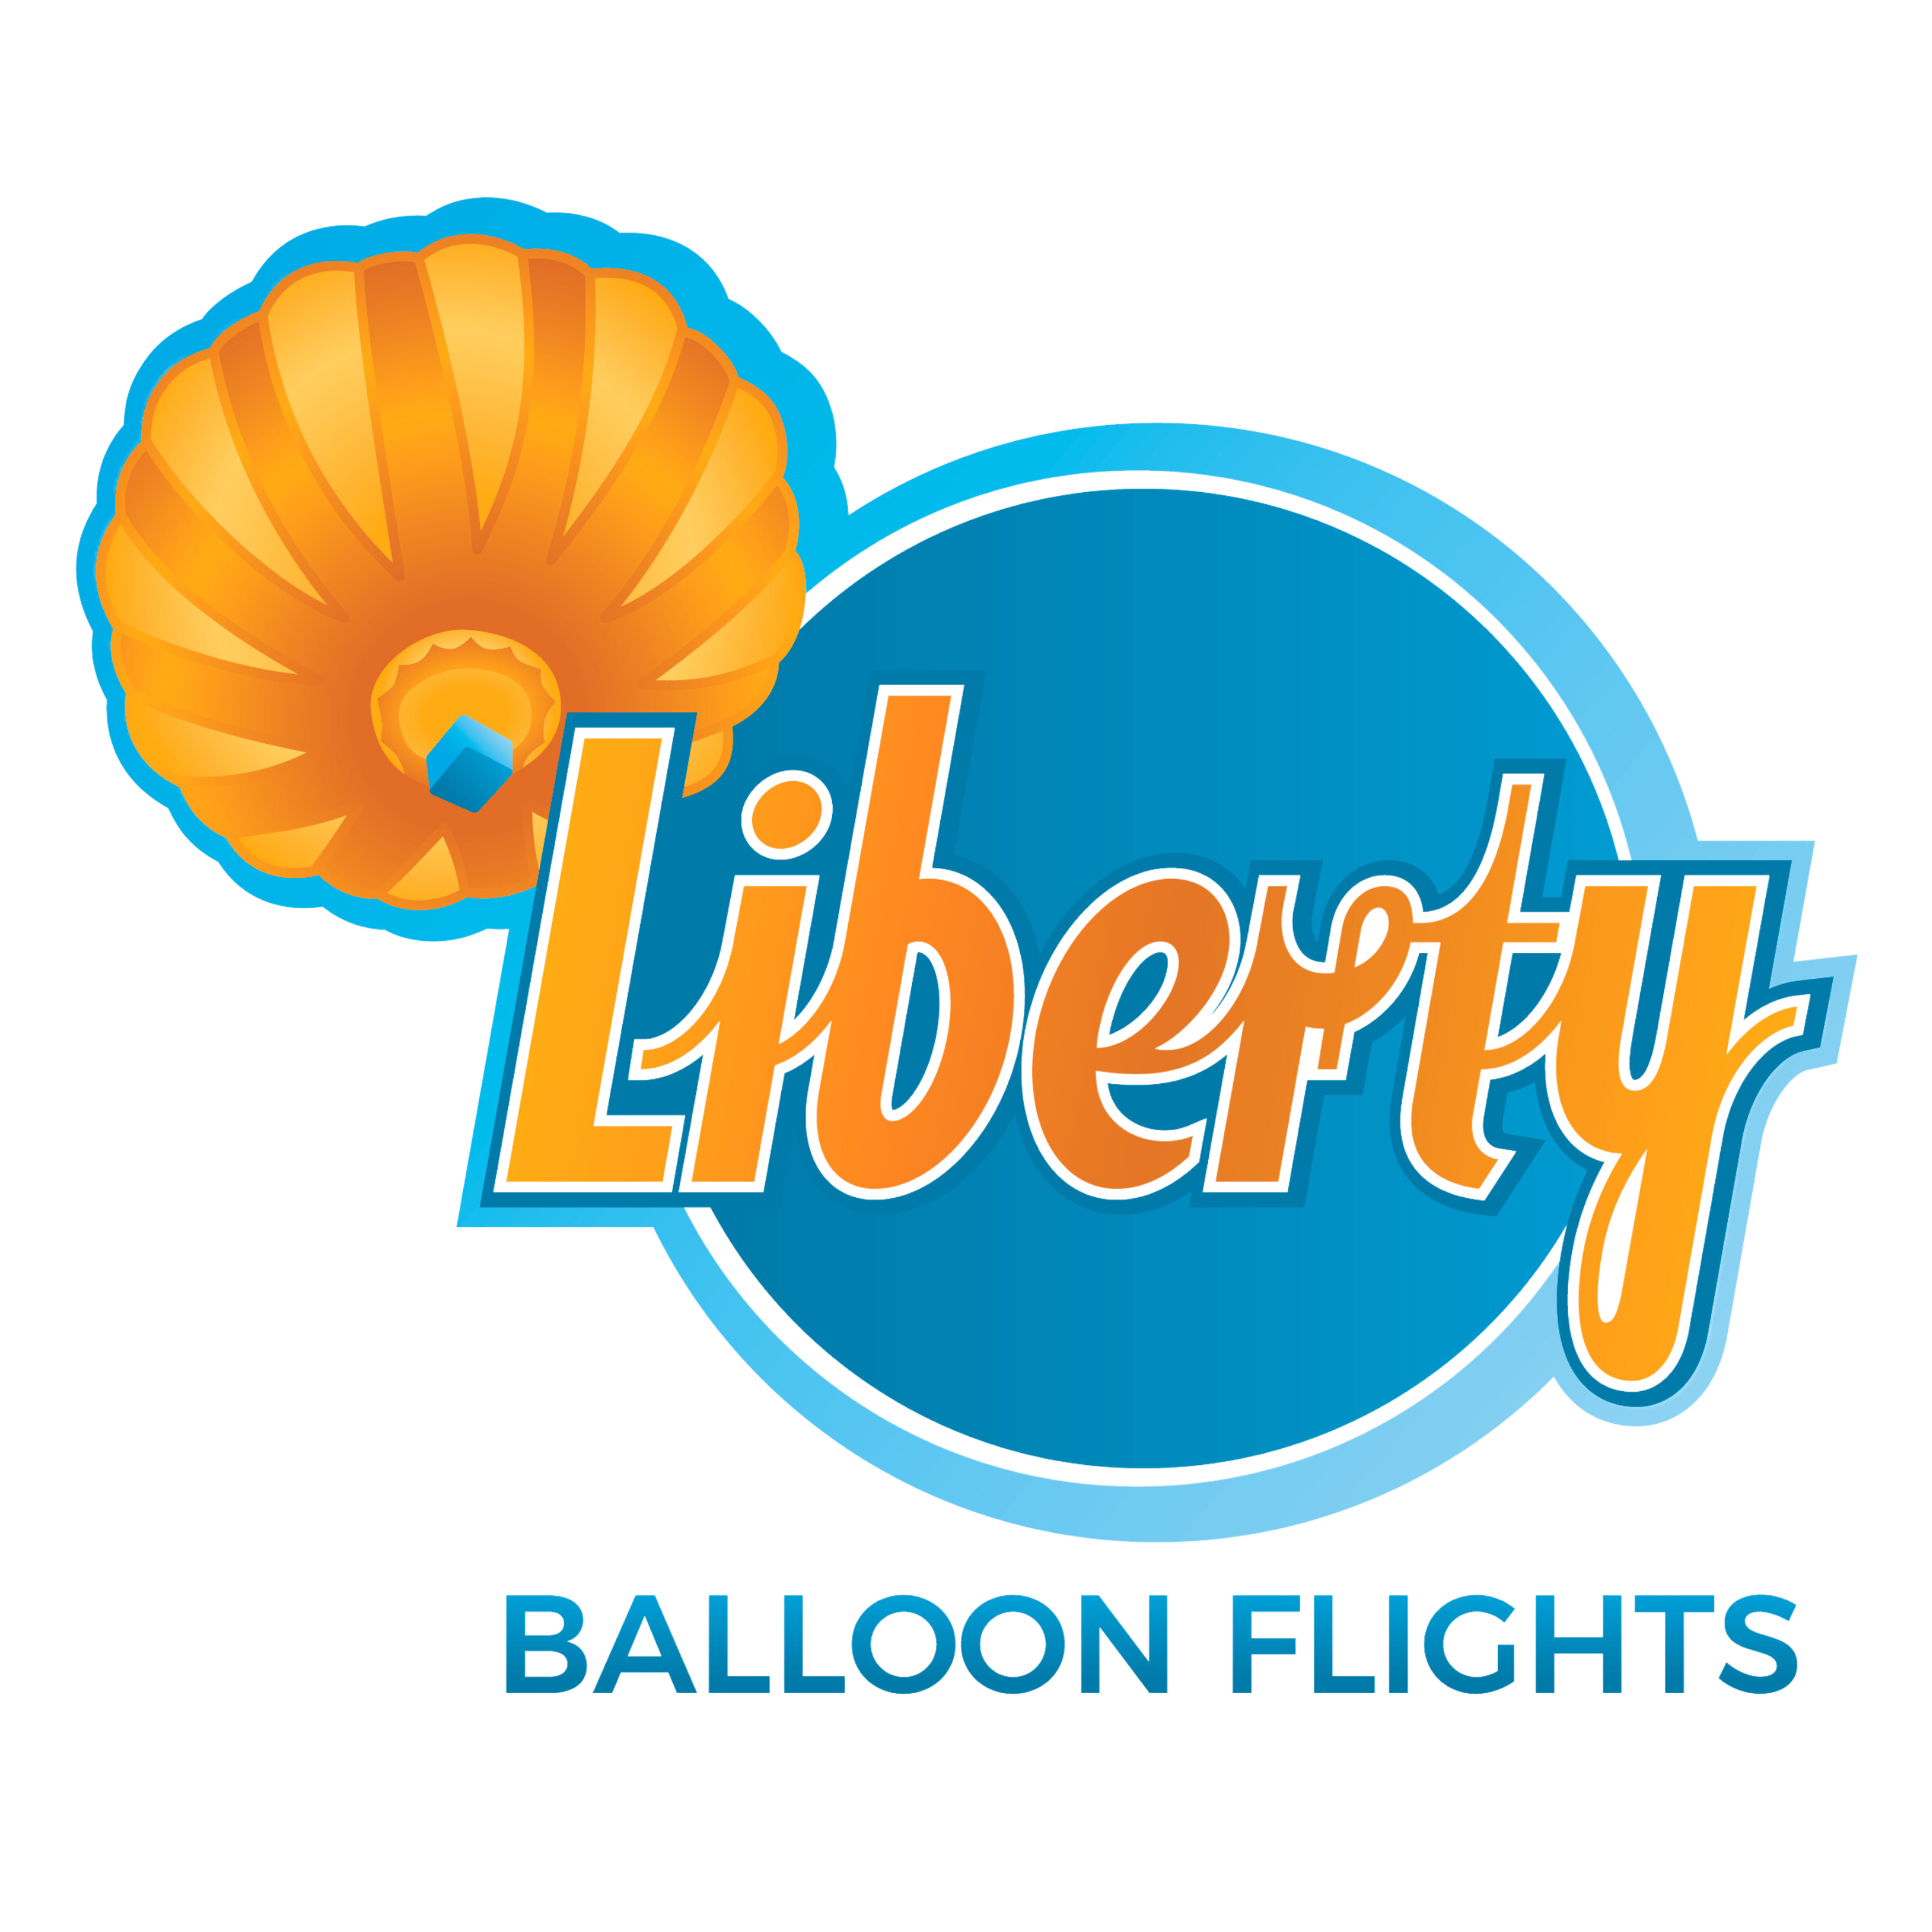

Bookings

The business offers the following methods for bookings and enquiries:
- Phone
- Email
- Webportal
- Our forms have high contract boxes and submit boxes

Emergency Management
- Emergency and evacuation procedures are explained on arrival
- Exit access is free and clear at all times
We ensure exit access is free and clear at all times by:
Doors at meeting places and vehicles and balloon basket entry/exit points are the same. Staff are at entry/exit doors to meet/greet/assist..
- There is an emergency refuge that has an intercommunication system linked and has sufficient fire resistance levels.
- Exits including stairwells, have bright edges used on the steps.
- In addition, the following further information can assist guests:
We speak to the customer on the phone and follow up with email at point of booking and clearly leave relevant notes for all pilots/crew to see.
- In addition, the following further information can assist guests:
Reassure, check and monitor guest, confirm safe landing zone with crew access for support vehicles, assist guest into proper landing position and notify ground crew of expected assistance needs including contacting emergency services if needed, use equipment (steps, extra crew) to disembark guest, provide first aid if needed.
- Guests with disabilities are noted in the guest log book for emergency and evacuation purposes

Communications
- Our business offers the following alternative communication methods
- Plain English

Not specified
- There is easy to read signage and information (e.g. menus and emergency information)

QR codes and greeting boards on easels at check in and to note where breakfast buffet is.

Other Information
- For bookings made onsite, the ticket booth/counter/box office is accessible for people using a wheelchair

Guide Dog and Service Animals
The business provides the following services for services animals:
N/A as outlined above

GENERAL

Pre-arrival, arrival and reception
The business has the following in place to support guests during pre-arrival, arrival and reception
- There is a reception/public entryway.
- Seating available at reception
- A lower counter at reception/ticket office
- A tablet with text to voice or pen and paper at reception to aid in communication
- Lighting in the reception area is even and glare free

All check in is online so customers can magnify and/or use own devices.
- Information and maps are available in written form
- A familiarisation tour
- In addition, the following further information can assist guests:
Seating is available in meeting venues, in vehicles, and support available both on flight (by leaning against soft side of basket or pre requesting a stool) and on landing as/when necessary.
- In addition, the following further information can assist guests:
As a company our staff are empathetic and personable. We communicate with our guests to assess and respond to needs prior, during and following their experiences with us and aim to cater for needs case by case. We are not set up to cater for everyone, however we continue to look at ways to make ballooning safely accessible for as many as possible. We are open to suggestions!

Car Park and Access amenities
The business has the following Car Park and Access amenities
- Designated disabled parking bays
- Level or ramped access from the car park to the entrance
- The accessible entrance is clearly signed from the parking bay
- The public transport services available are:

On website and provided verbally to people when we speak to them on the phone.
- Kerb ramps are in place where a pavement or walkway needs to be crossed
- In addition, the following further information can assist guests:
Due to the nature of ballooning we often work in open spaces with rough/uneven terrain. Once we leave our meeting places an hour and a half before sunrise, there are no toilet facilities until we return for breakfast approximately 3 hours later.

Entry
The business has the following amenities/systems in place for entry
- A drop off point close to the entrance
- A path of access to the building is slip resistance and even
- A path of access to the building is clear of obstruction
- Self opening entry doors or fitted with a self closer
- There a clear space of at least 1500mm x 1500mm in front of all doors.
- In addition, the following further information can assist guests:
All three of our meeting and breakfast locations have facilities that cater for wheelchairs - from their parking bays, access into buildings, ability to move furniture easily to accommodate a wheelchair at a table, through to toilet facilities. They have their own accessibility procedures in place that we work with. It is the transfers and flights themselves where we are currently unable to cater for wheelchair uses. Something we are working on.
- In addition, the following further information can assist guests:
All the venues we use for our morning meeting place and breakfast are on the first floor.

Internal Spaces
- Tableware/glassware contrast with the table surface or table cloth
- Seating is available for guests unable to stand for long periods
- All corridors greater than 900mm
- In addition, the following further information can assist guests:
Please speak to our staff about suitability of hot air ballooning with children in general. It is sensory and the elements of being contained in a basket for a relatively long time and the sound and warmth of the burners above may not suit everyone.

Public areas
The public areas have the following amenities in place
- Seating
- In addition, the following further information can assist guests:
Seating is provided in our meeting and breakfast venues. Due to the outdoor nature of ballooning there is reasonable time outdoors with limited seating options, although we can arrange to have a stool and/or vehicles available to sit in for a while. Participants need to be able to stand (or lean against the basket rim) for up to an hour or more while in the air.

Displays, exhibits, commentary and live performances
For displays, exhibits, commentary and live performances the following amenities are in place
- Seating
- Wheelchair accessible spaces/seating
- In addition, the following further information can assist guests:
At present our breakfast venues can accommodate wheelchairs, however our balloon baskets can not. We are working on changing this into the future.

External Paths
External paths of travel
- Pathways are wider than 900mm

We largely work in open terrain so not one venue. Some have steps, others not.

As above

Steps
Steps
- There are steps.
- All steps or staircases have enclosed risers
- Where steps are present are there three steps or less
- In addition, the following further information can assist guests:
We provide steps to assist passengers into balloons and our crew are trained to help.
- In addition, the following further information can assist guests:
We have toilet facilities (including one for wheelchair access) at our meeting points. We are not able to offer toilet facilities once we leave for launch site/balloon flights and there are no facilities for approx. 3 hours, prior to us returning to breakfast.

TOUR OPERATORS

Tour/Transport Services
The tour/transport services have the following facilities/amenities in place
- Buses/Coaches
- None at present vehicles have wheelchair lifts or ramps
- None at present vehicles have low floors with ramped entry
The maximum wheelchair capacity available in the fleet is:
None at present

Guides
- Use of clear/simple English
- There is a audio description of surroundings
- In addition, the following further information can assist guests:
Dome/Farmer's Home Hotel, Northam, WA - https://www.farmershomehotel.com.au/
Hotel Windsor, Melbourne, VIC - https://www.thehotelwindsor.com.au/
Rydges Geelong, VIC - https://www.rydges.com/accommodation/melbourne-vic/geelong/

ATTRACTIONS

COMMON AREAS

FOOD AND DRINK

Dining Spaces
The dining spaces have the following facilities/amenities in place
- The entrance has level access
- The doorway is at least 850mm wide
- There is level access through the dining area
- Chairs are moveable to allow for wheelchairs to be seated at the tables
- There are areas of full lighting
- There are Plain English menus
- There is an accessible toilet

Our business caters for the following dietary requirements
- Sugar free (diabetic)
- Gluten free (celiac)
- Lactose free (dairy free)
- Low fat and fibre with no gastric content
- Nut free
- Vegetarian
- Vegan
- In addition, the following further information can assist guests:
We work with other companies to provide breakfast, so this varies a little.

ADVENTURE ACTIVITIES

Adventure activities
The adventure activities have the following facilities/amenities in place
- Our adventure activities cater for people with a disability
- In addition, the following further information can assist guests:
Hot air ballooning is more 'soft adventure' and once in the air a very gentle experience. We can cater for people who are vision or hearing impaired and generally situate these people next to our pilot to ensure they benefit through using other senses...listening to stories, descriptions of the experience, feeling the warmth of burners above etc. We cater for older people and children over the age of 6.
We listen to individual needs and best cater if/when it is safe to do so and in the best interest of all involved in the experience.
- In addition, the following further information can assist guests:
We use steps and experienced staff and ensure communication is clear prior, during and following experience.
- In addition, the following further information can assist guests:
Due to the nature of ballooning and the sometimes rough and uneven terrain we launch and land from, the need to climb in and out of the basket and sometimes a bit of a bump on landing hot air ballooning is not for everyone. Some people will also not like being confined in a basket with other people for up to an hour or more in the air. It is best to talk through needs with one of our staff to see what might be possible.

EVENTS

Events
Events have the following facilities/amenities in place
- The event is outdoors
- In addition, the following further information can assist guests:
Our 'events' constitute flying regattas with multiple balloons flying in the air or glowing after inflation on the ground, that might be of interest to the public to watch or follow. If/when we hold larger events we will put many more accessible features in place.

Report Disclaimer
Please note that this business report, provided as a result of the use of the diagnostic assessment, is for information purposes only.
Australian Tourism Industry Council (ATIC) cannot guarantee the accuracy of respondent’s answers, or that they are fully representative of your business. Therefore, ATIC does not warrant or guarantee any particular outcome in respect of your businesses self-assessment.
This report is intended as guidance only for your business and should not be relied on for future marketing considerations. ATIC recommends that you seek your own independent advice as well as the results from the diagnostic.
Links to external web sites are inserted for convenience and do not constitute endorsement of material at those sites, or any associated organisation, product or service.
ATIC does not:
- Assume any legal liability for the accuracy, completeness, or usefulness of any information from this report or any links provided; or
- Accept responsibility for any loss associated directly or indirectly from the use of this report.

