ATIC Accessibility
To support the accessible community in making informed travel decisions for their individual needs

This report prepared for:
Business name: | Nautica Residences Fremantle
Address: | 1 Silas St
Town: | East Fremantle
Contact for enquiries: | Ben Chenery
Contact Number: | 08 9387 0800
Contact Email: | admin@nauticaresidences.com.au
Website: | https://nauticaresidences.com.au/.seashells.com.au
Date: | 2026-06-10 07:11

ATIC Accessibility
The following pages provides travellers with information on the businesses facilities and amenities which aims to support the traveller to make an informed decision on whether the business is suitable for their individual needs.
OVERVIEW 4
Business Overview 4
Bookings 4
Emergency Management 4
Communications 5
Guide Dog and Service Animals 5
GENERAL 6
Pre-arrival, arrival and reception 6
Cognitive Impairment Support 6
Car Park and Access amenities 6
Entry 7
Lifts 7
Internal Spaces 7
Public areas 7
External Paths 8
Steps 8
ACCOMMODATION 9
Bedrooms 9
Room Amenities 9
Bathrooms 10
COMMON AREAS 12
Report Disclaimer 14

OVERVIEW

Business Overview

The business has the following products/services available
- Accommodation

Our business caters for the following disability types:
- Blind or low vision
- Deaf or low hearing
- Limited mobility
- Wheelchairs or mobility scooters
- Food allergies or intolerances
- Cognitive or people on the Autism Spectrum
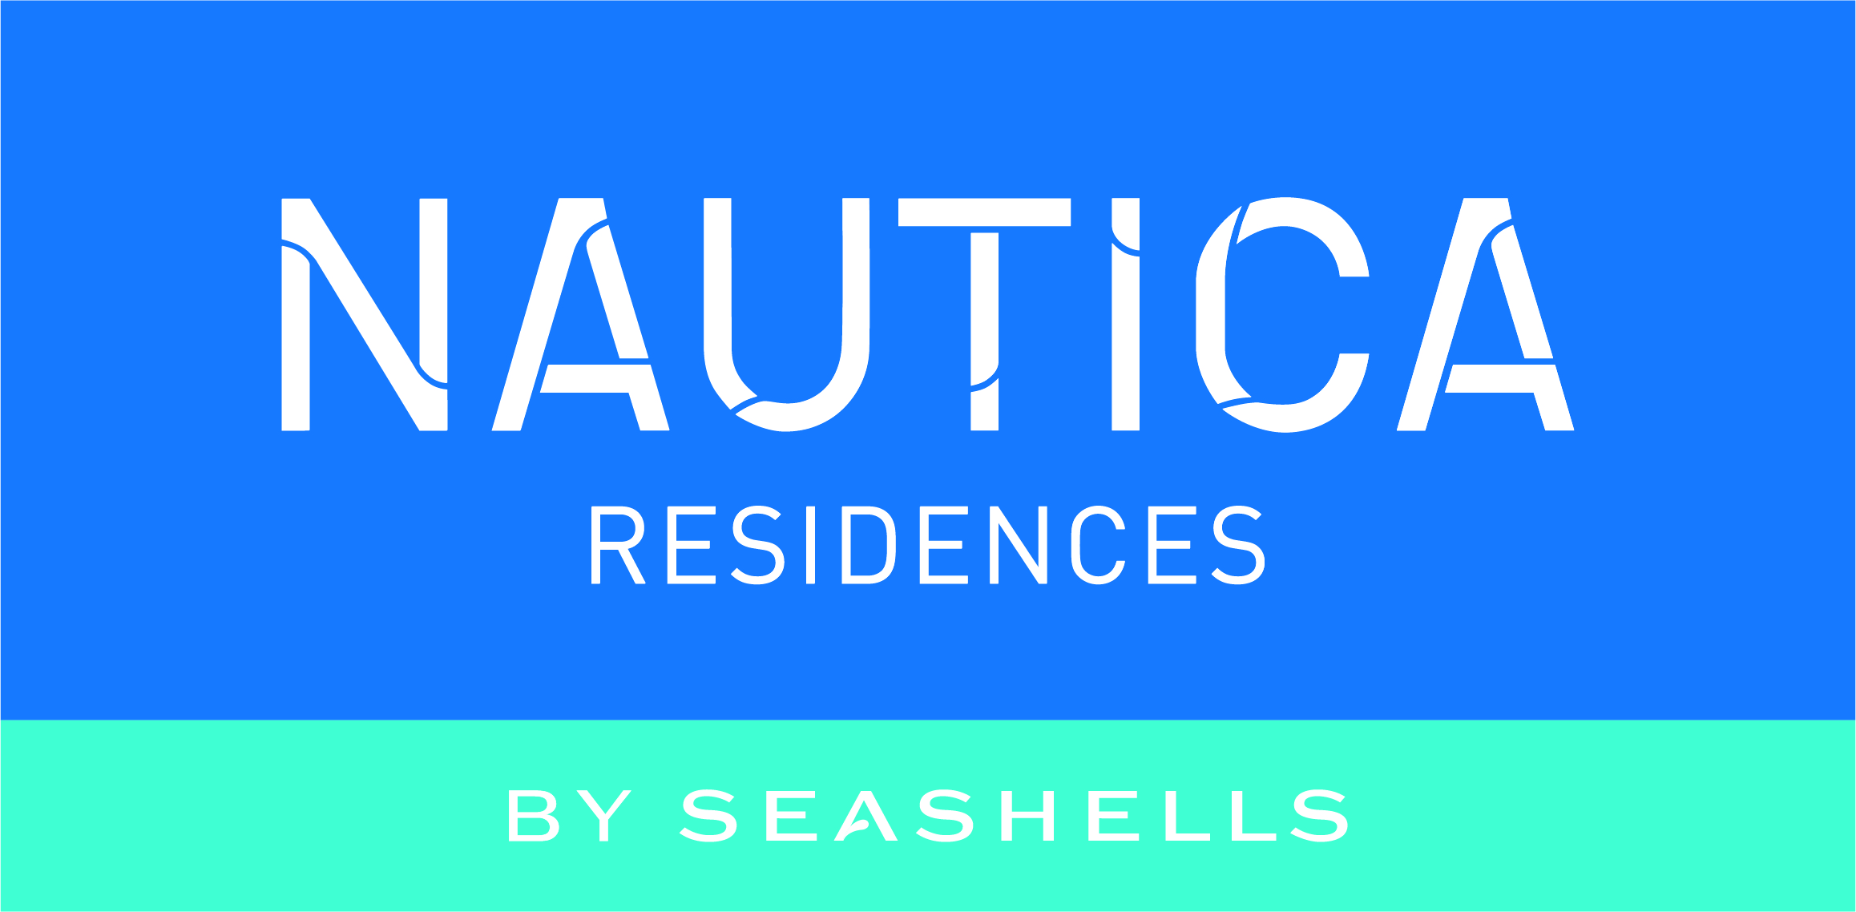

Bookings

The business offers the following methods for bookings and enquiries:
- Phone
- Email
- Webportal
- Our website supports Screen Readers
- Staff have undergone disability awareness and training

Emergency Management
- The business has an emergency management and evacuation plan for guests with a disability
- Guests with disabilities are noted in the guest log book for emergency and evacuation purposes

Communications
- Our business offers the following alternative communication methods
- Plain English

Not specified
- There is easy to read signage and information (e.g. menus and emergency information)

Guide Dog and Service Animals
The business provides the following services for services animals:
Not specified

GENERAL

Pre-arrival, arrival and reception
The business has the following in place to support guests during pre-arrival, arrival and reception
- Booking information and websites are compatible with screen readers
- There is a reception/public entryway.
- Seating available at reception
- A clipboard to allow check-in/ticket purchase whilst seated
- A tablet with text to voice or pen and paper at reception to aid in communication
- Picture Board at reception to aid in communication
- Lighting in the reception area is even and glare free
- Large print information sheets and registration forms
- Information and maps are available in written form
- A familiarisation tour
- Keys are available for each guest
- Luggage assistance
- In addition, the following further information can assist guests:
Being mindful they arrive throughout Reception hours we will attend to their requirements as soon as notified

Cognitive Impairment Support
- Documents are available in plain English for people with cognitive impairment (This may include instructions, guides, menus and general information)

Car Park and Access amenities
The business has the following Car Park and Access amenities
- Designated disabled parking bays
- Level or ramped access from the car park to the entrance
- The accessible entrance is clearly signed from the parking bay
- The public transport services available are:

Local Map provided of Trains & Buses

Entry
The business has the following amenities/systems in place for entry
- A drop off point close to the entrance
- A path of access to the building is slip resistance and even
- A path of access to the building is clear of obstruction
- Self opening entry doors or fitted with a self closer
- Glass doors are fitted with a visual sighting strip
- Door jams/doors are of a contrasting colour to surrounding walls
- Door handles are of a contrasting colour to the door
- Signage is written in a contrasting colour
- The entry door is a minimum of 850mm wide
- The entry door has self opening or a light opening pressure (for manual operations)
- The entrance sill is less than 13mm
- There a clear space of at least 1500mm x 1500mm in front of all doors.
- The entrance door mats have a thickness less than 13mm and a width of 7500mm or greater

Lifts
- Premises has lifts
- Lift location: Carpark. Has visual floor indicator
- Lift location: Accommodation Floors. Has visual floor indicator
- Lift location: Foyer. Has visual floor indicator

Internal Spaces
- Clear and unobstructed routes through and between buildings
- Interior walls are matte or low sheen
- Floors, walls, counters and furniture are of contrasting colours
- Any protruding or overhanging obstructions are at least 2meters above the floor or are protected
- Floor surfaces are hard or short pile carpet
- Seating is available for guests unable to stand for long periods
- Accessible facilities are clearly signed and visible from all areas
- All corridors greater than 900mm

Public areas
The public areas have the following amenities in place
- Even lighting
- Seating

External Paths
External paths of travel
- Surfaces are concrete, asphalt, smooth paving or hard packed fine gravel (max aggregate size 13mm)
- Pathways are wider than 900mm
- There 3 successive steps or less on any path or at any doorway

Steps
Steps
- There are steps.
- All steps or staircases have enclosed risers
- The underside of all staircases are enclosed or protected to a height of at least 2 metres
- Handrails fitted to all open sets of steps
- Handrails extend 300mm beyond the top and bottom step

ACCOMMODATION

Bedrooms
The bedrooms have the following facilities/amenities in place
- There are 1 x 1-bedroom Apartment rooms available to guests who use a wheelchair
  - Layout of room Image(s)
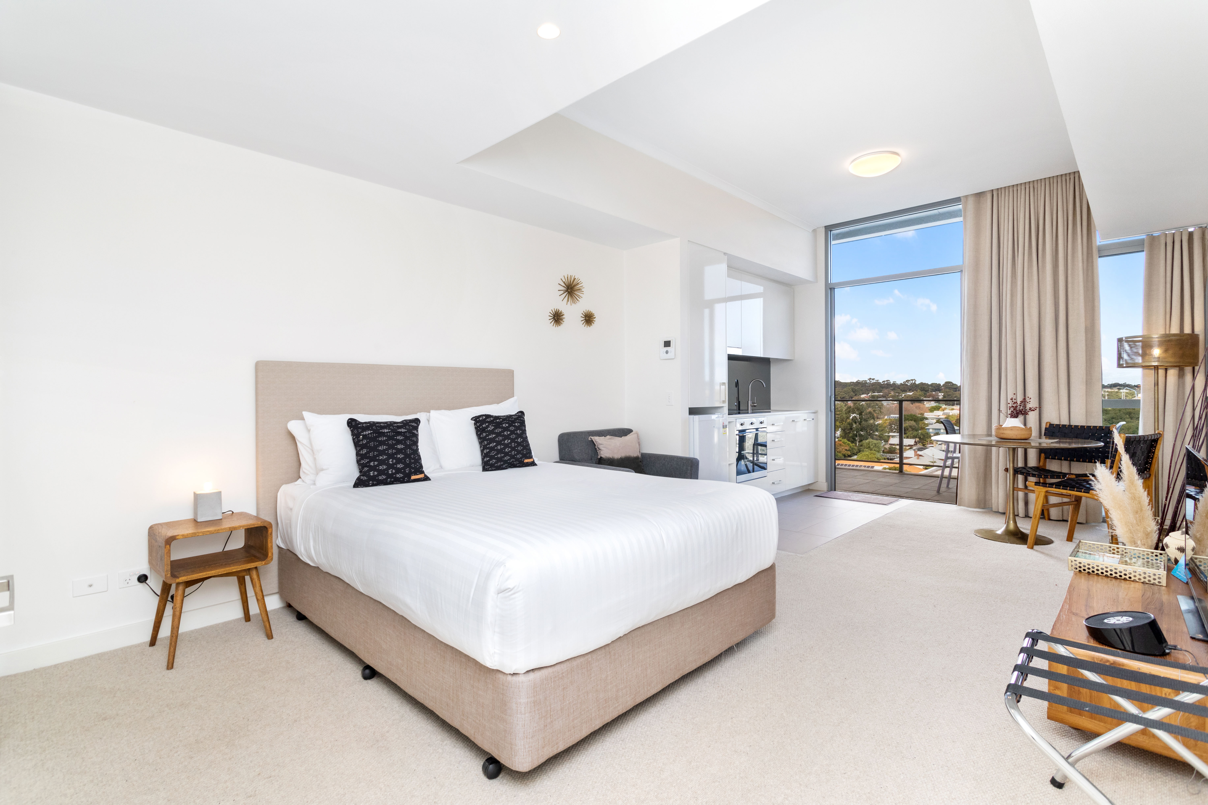
_L4A3441
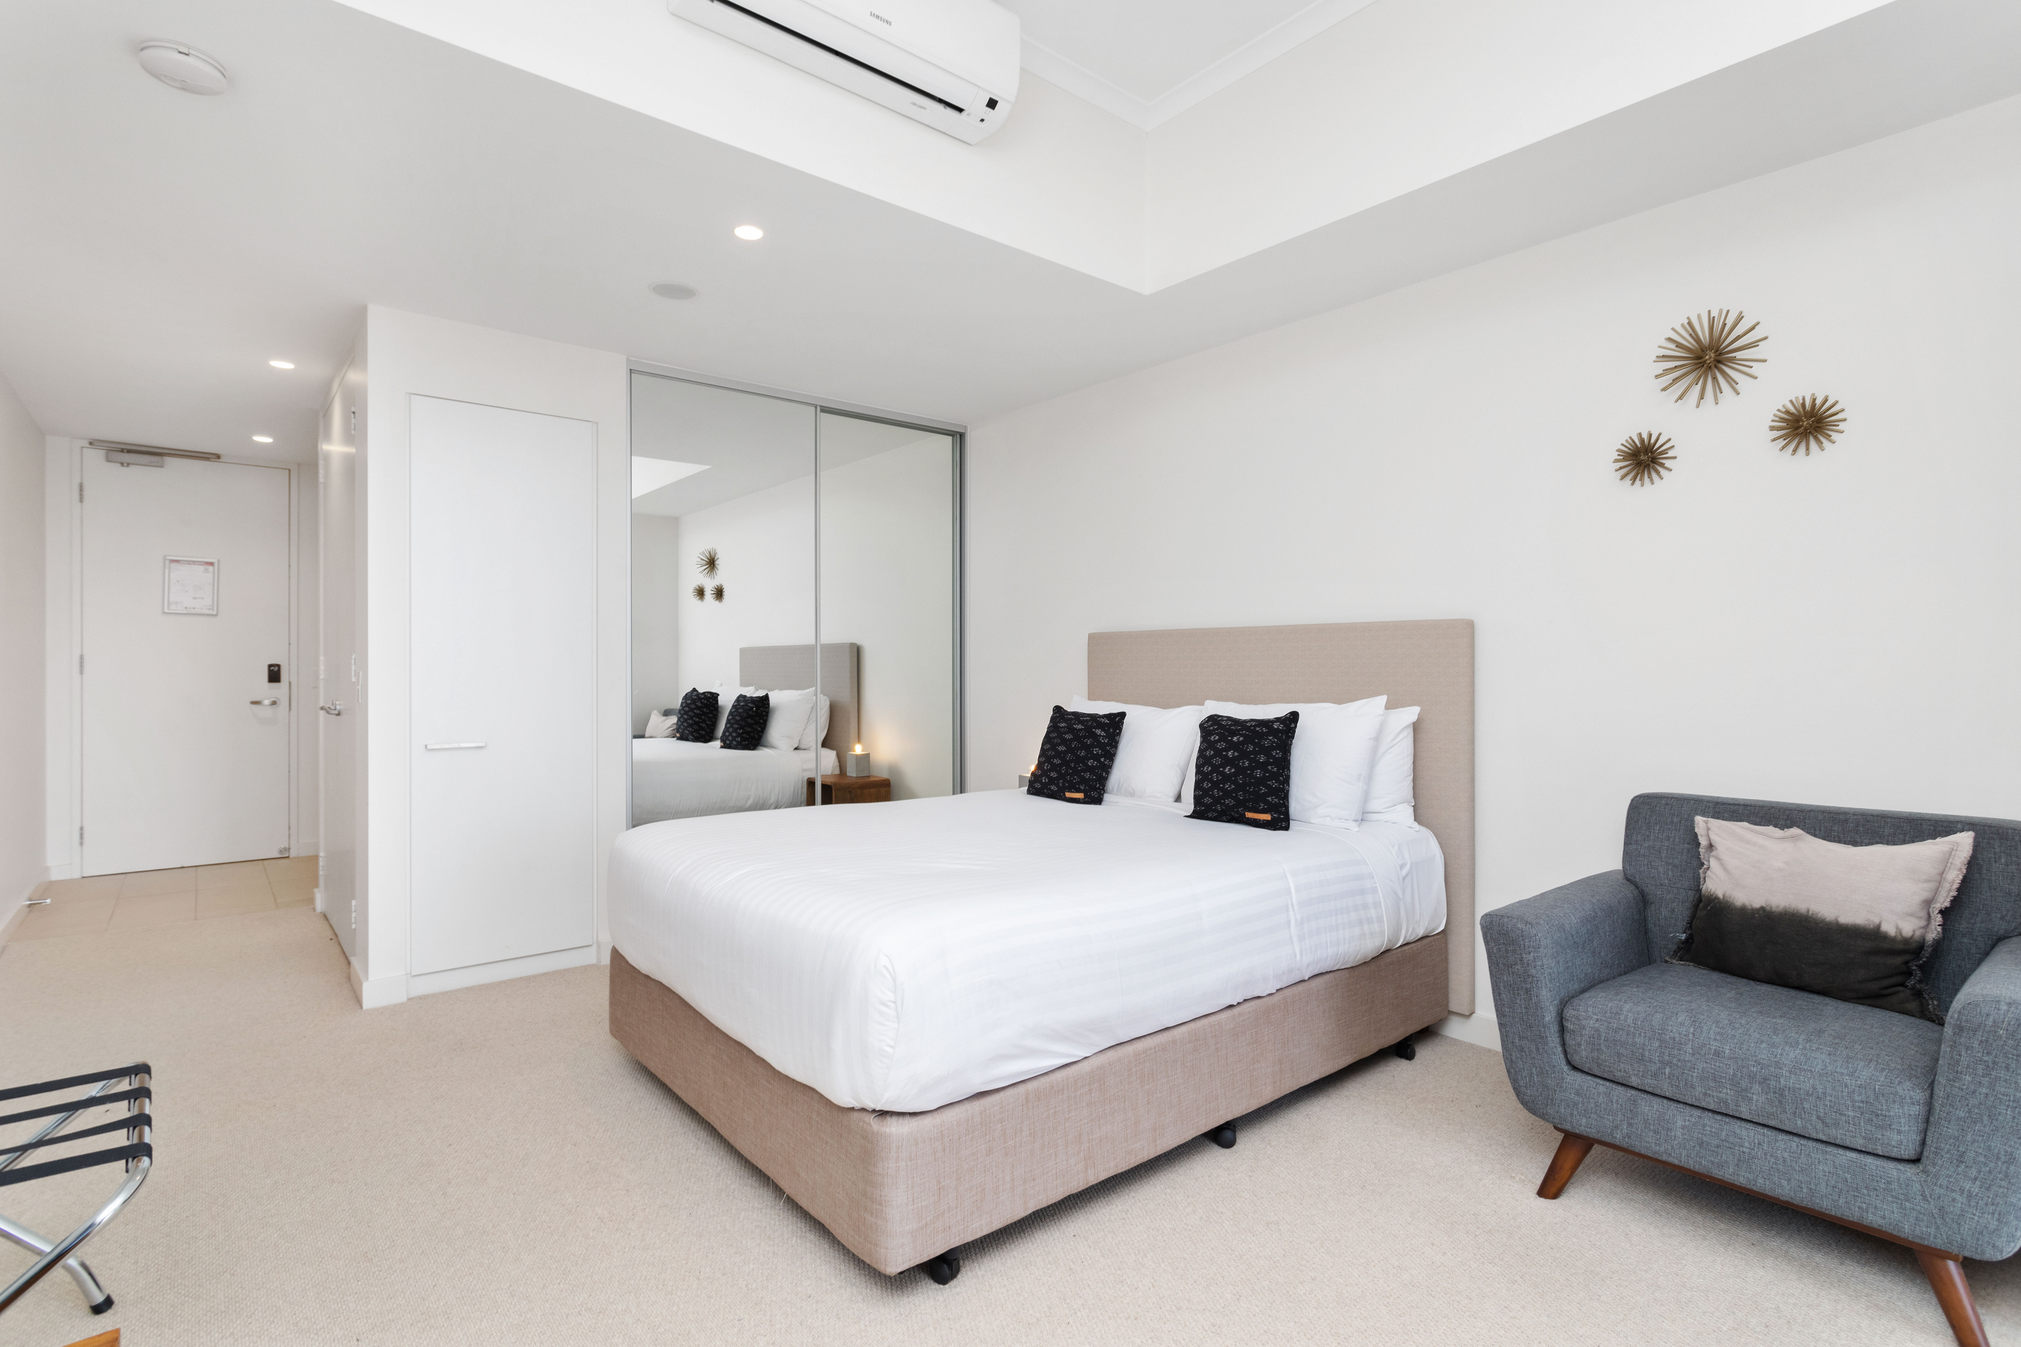
_L4A3463

Room Amenities
- In addition, the following further information can assist guests:
Registration / check in details provided will allow staff member to assist / aid guest on evacuation
- Televisions are equipped with closed captioning capability
- Room phones have volume control
- Room phones have a visual ringing indicator
- There is a clear path through the room
- The edges of all furniture and fixtures are rounded
- Wardrobe handles are a contrasting colour to the doors and draws
- Housekeeping procedures instruct staff not to reposition furniture that has been moved
- Doors open fully against the adjoining wall
- There is a clear opening at least 850mm wide
- There luggage racks for at least two suitcases
- There at least one chair with rigid arms
- Wardrobe and drawer handles are easy to grip
- The bedside lamp switch is easy to reach from the bed
- There is at least 850mm clear space beside the bed
- The bed height is no higher than 680mm from the floor
- There is at least 130mm clearance under the bed

Bathrooms
The bathrooms have the following facilities/amenities in place
- All heating appliances and hot water pipes are protected or insulated
- All shower, bath and basin taps are clearly differentiated between hot and cold
- Fixtures and fittings have rounded edges
- The door is at least 850mm wide
- There is a minimum of 850mm beside the toilet
- Handrails are fitted
- There is a minimum of 1400mm of clear space in front of the toilet
- The toilet seat is a contrasting colour to the floor
- The toilet seat is 460mm above the floor
- There is a roll-in shower with fold down fixed seat or a shower chair
- There is a portable shower head on flexible hose
  - Bathroom Image(s)
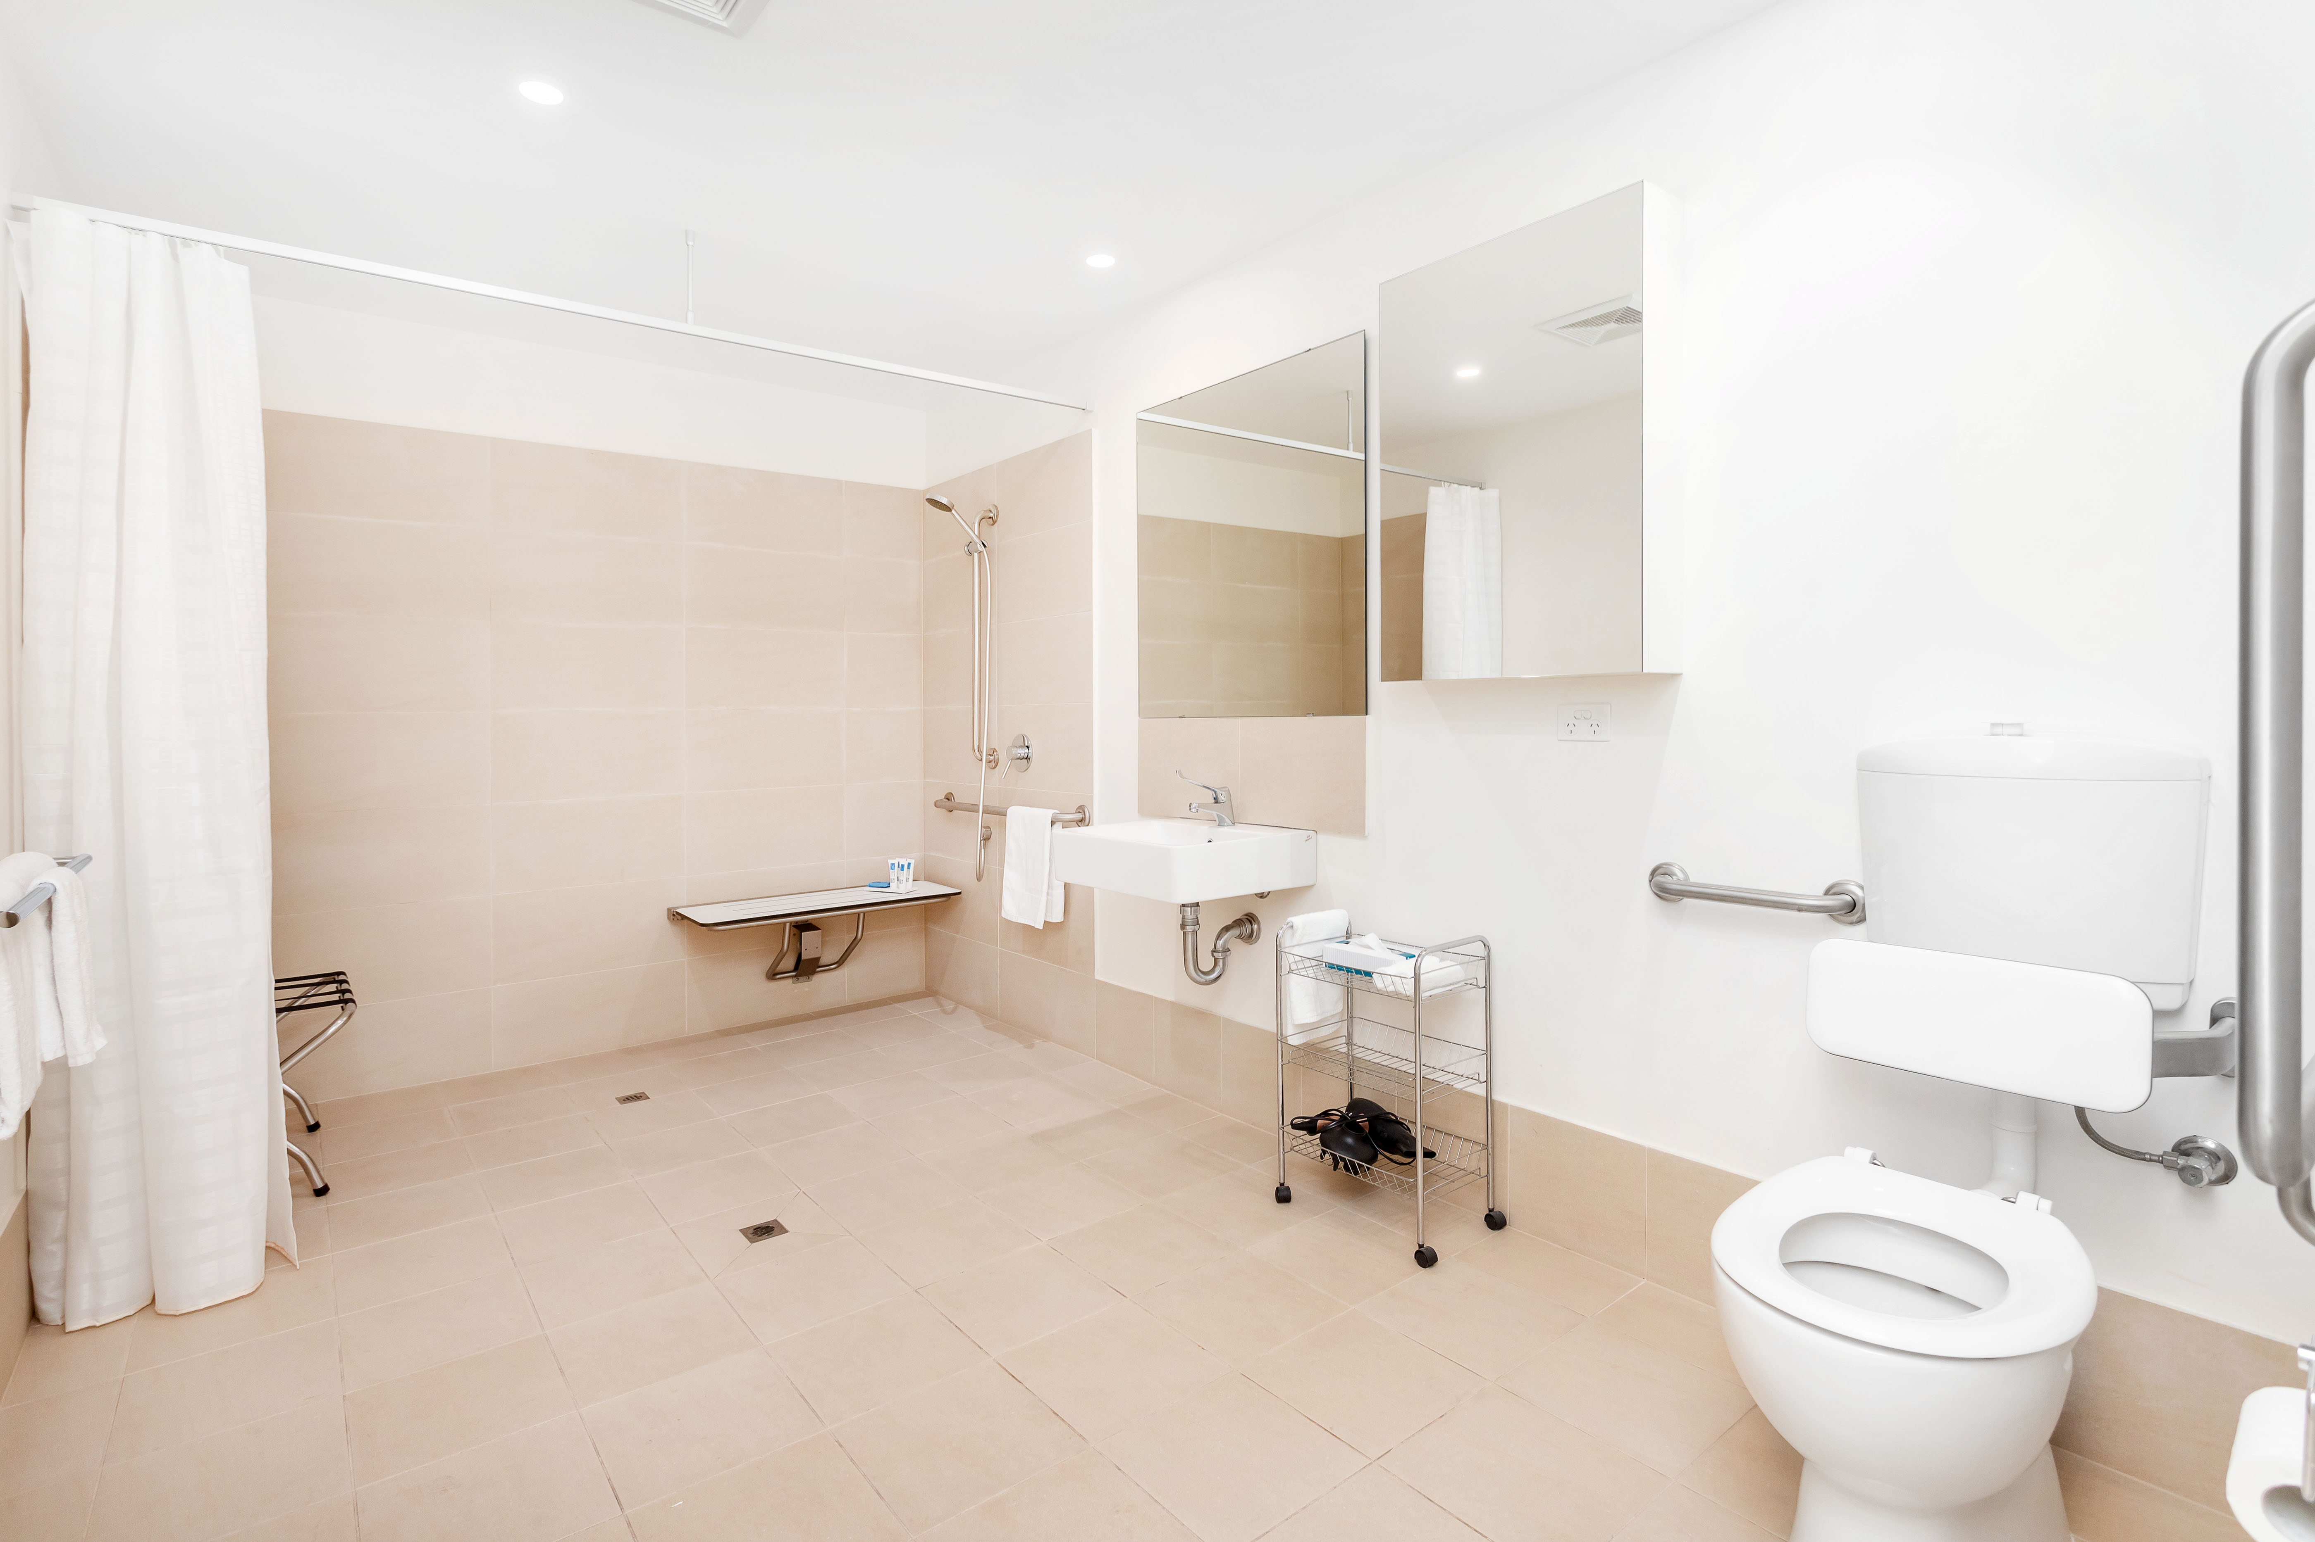
IMG_7295
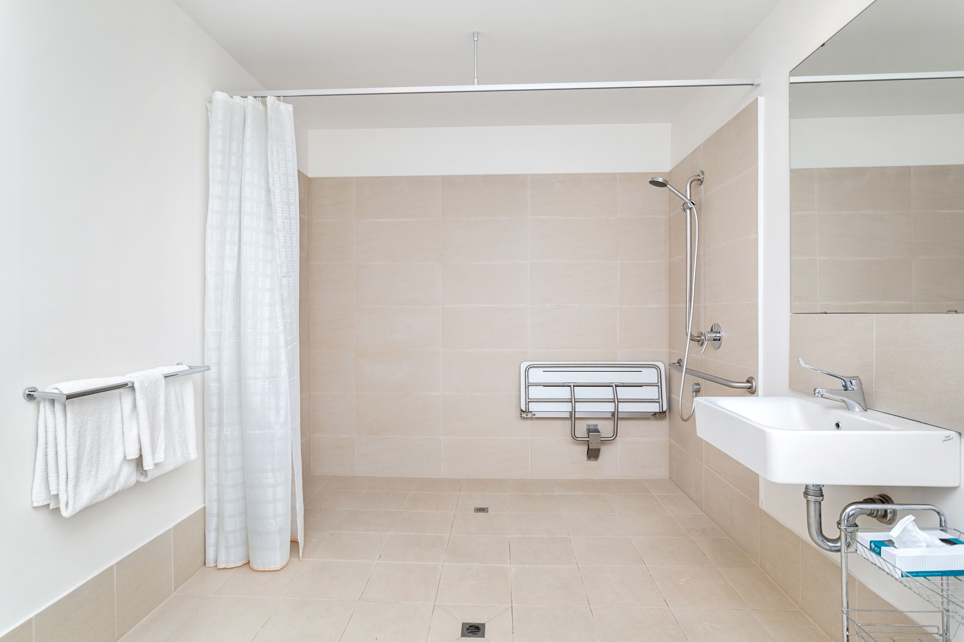
_L4A3435
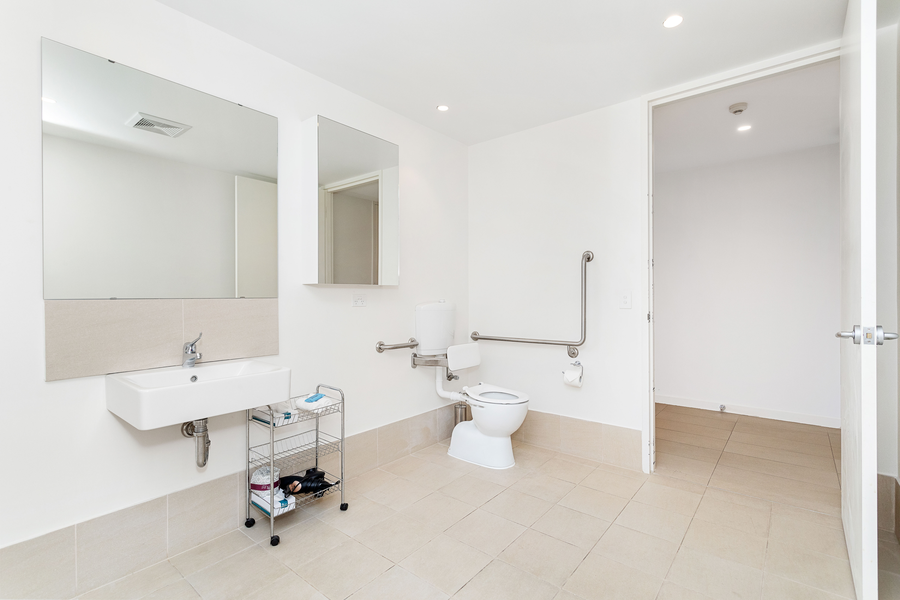
_L4A3437

COMMON AREAS

Report Disclaimer
Please note that this business report, provided as a result of the use of the diagnostic assessment, is for information purposes only.
Australian Tourism Industry Council (ATIC) cannot guarantee the accuracy of respondent’s answers, or that they are fully representative of your business. Therefore, ATIC does not warrant or guarantee any particular outcome in respect of your businesses self-assessment.
This report is intended as guidance only for your business and should not be relied on for future marketing considerations. ATIC recommends that you seek your own independent advice as well as the results from the diagnostic.
Links to external web sites are inserted for convenience and do not constitute endorsement of material at those sites, or any associated organisation, product or service.
ATIC does not:
- Assume any legal liability for the accuracy, completeness, or usefulness of any information from this report or any links provided; or
- Accept responsibility for any loss associated directly or indirectly from the use of this report.

