ATIC Accessibility
To support the accessible community in making informed travel decisions for their individual needs

This report prepared for:
Business name: | Lady M Adventure Cruises
Address: | 1 Arches Way
Town: | Bibra Lake
Contact for enquiries: | Angela Taylor
Contact Number: | 0438855045
Contact Email: | reservations@ladymcruising.com
Website: | www.ladymcruising.com
Date: | 2026-10-23 06:23

ATIC Accessibility
The following pages provides travellers with information on the businesses facilities and amenities which aims to support the traveller to make an informed decision on whether the business is suitable for their individual needs.
OVERVIEW 4
Business Overview 4
Bookings 4
Emergency Management 4
Communications 5
Guide Dog and Service Animals 7
GENERAL 8
Pre-arrival, arrival and reception 8
Internal Spaces 8
Displays, exhibits, commentary and live performances 8
Steps 8
TOUR OPERATORS 10
Tour/Transport Services 10
Route Planning 10
Guides 10
ACCOMMODATION 11
Room Amenities 11
Bathrooms 11
COMMON AREAS 13
Swimming pools, spas and waterparks 13
FOOD AND DRINK 14
ADVENTURE ACTIVITIES 15
Report Disclaimer 17

OVERVIEW

Business Overview

The business has the following products/services available
- Tour/Transport
- Accommodation
- Adventure

Our business caters for the following disability types:
- Deaf or low hearing
- Limited mobility
- Food allergies or intolerances
- Cognitive or people on the Autism Spectrum


Bookings

The business offers the following methods for bookings and enquiries:
- Phone
- Email
- Webportal
- Our forms have high contract boxes and submit boxes

Emergency Management
- Emergency and evacuation procedures are explained on arrival
- There are Audible device/s to alert occupants to evacuate with instructions on how to evacuate.
- Exit access is free and clear at all times
We ensure exit access is free and clear at all times by:
Ensure the area is clear and tidy at all times. Master checks frequently daily
- Exit doors are able to be opened by all occupants
- In addition, the following further information can assist guests:
Guests advise of any medical conditions prior to booking their cruise. They then complete a medical sheet to make the Master aware of any medical issues.
- In addition, the following further information can assist guests:
Each guest is escorted appropriately by crew members to the muster point

Communications
- Our business offers the following alternative communication methods
- Plain English
- Magnifiers

Not specified
- There is easy to read signage and information (e.g. menus and emergency information)
- There are Picture boards
  - Picture Boards Image(s)
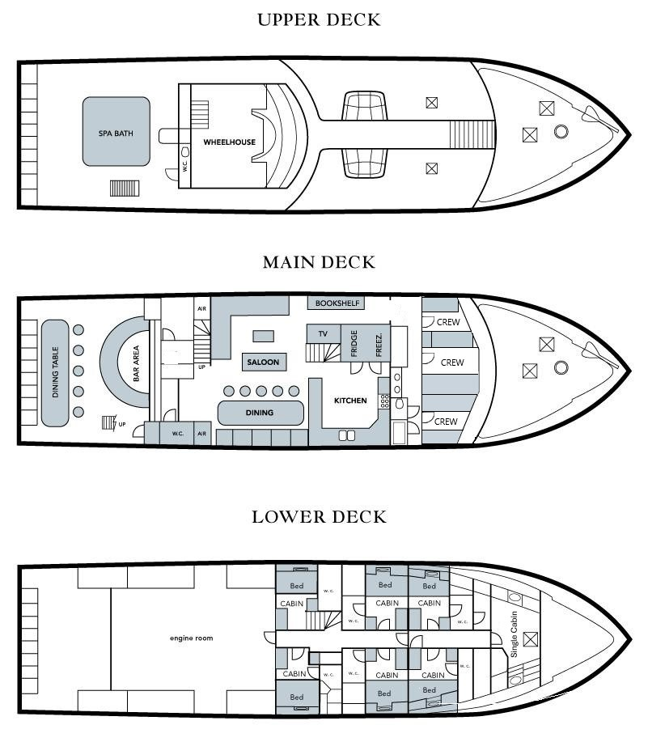
Deck Plan
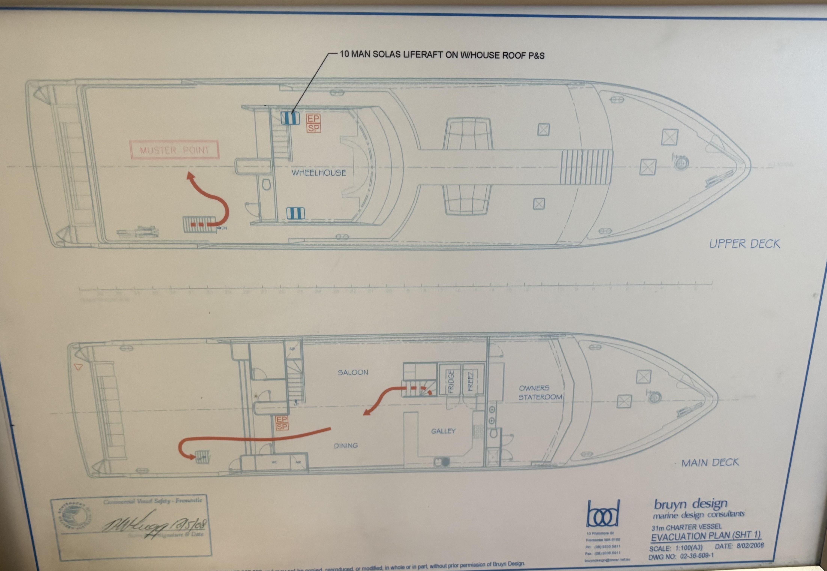
IMG_2859
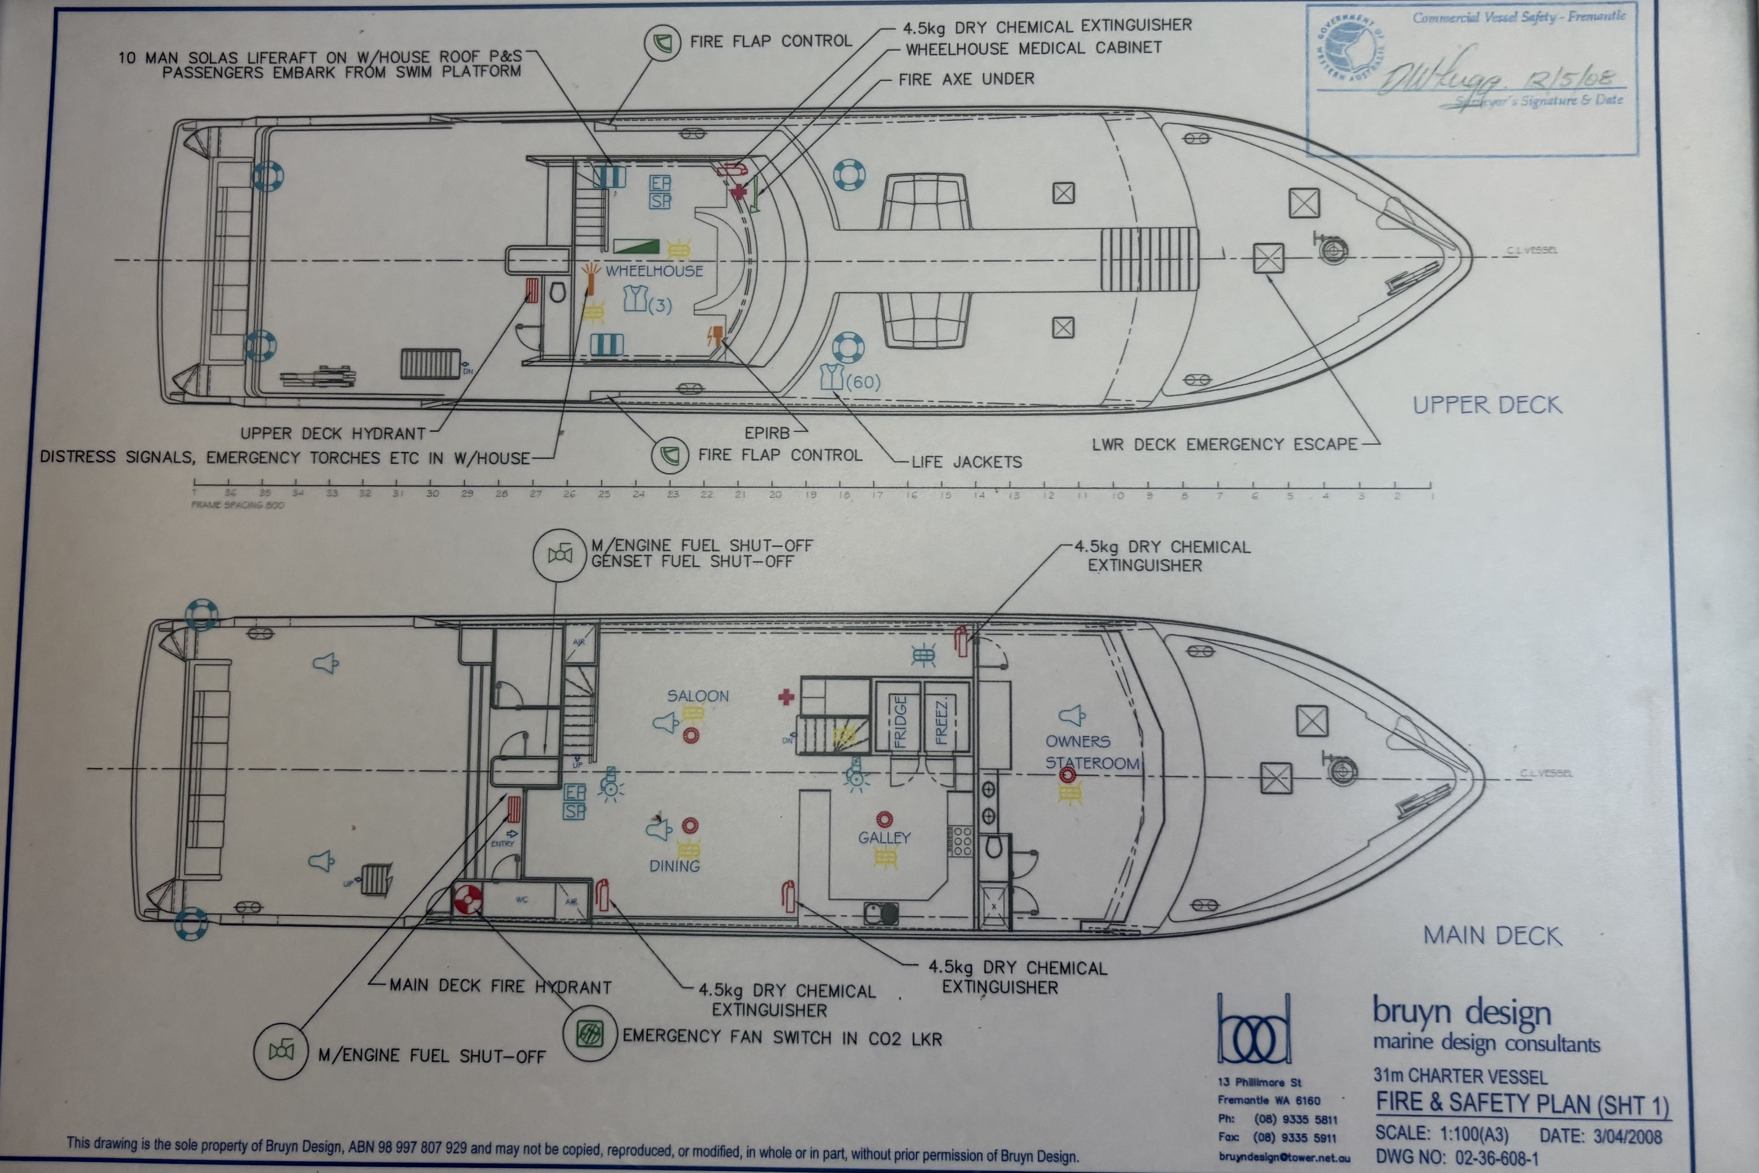
IMG_2857
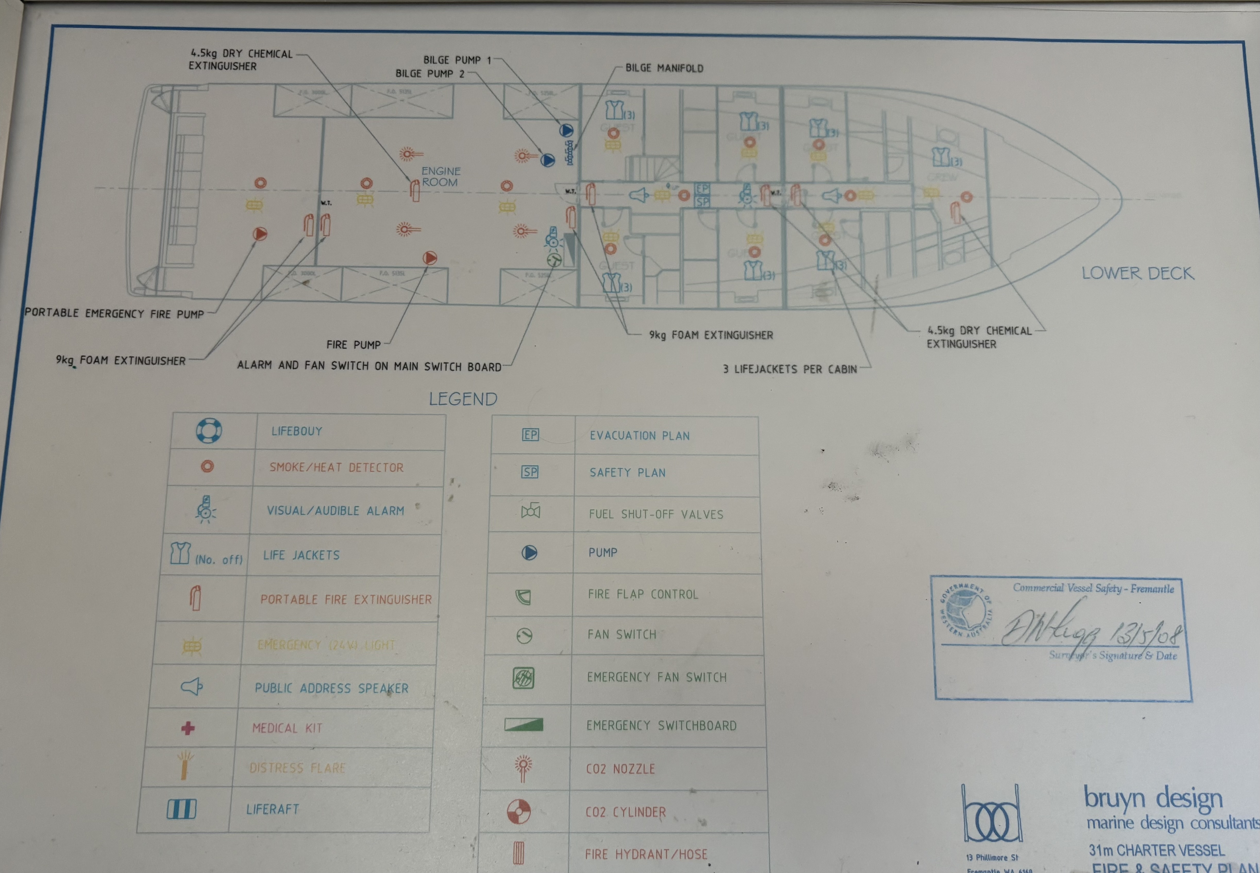
IMG_2856
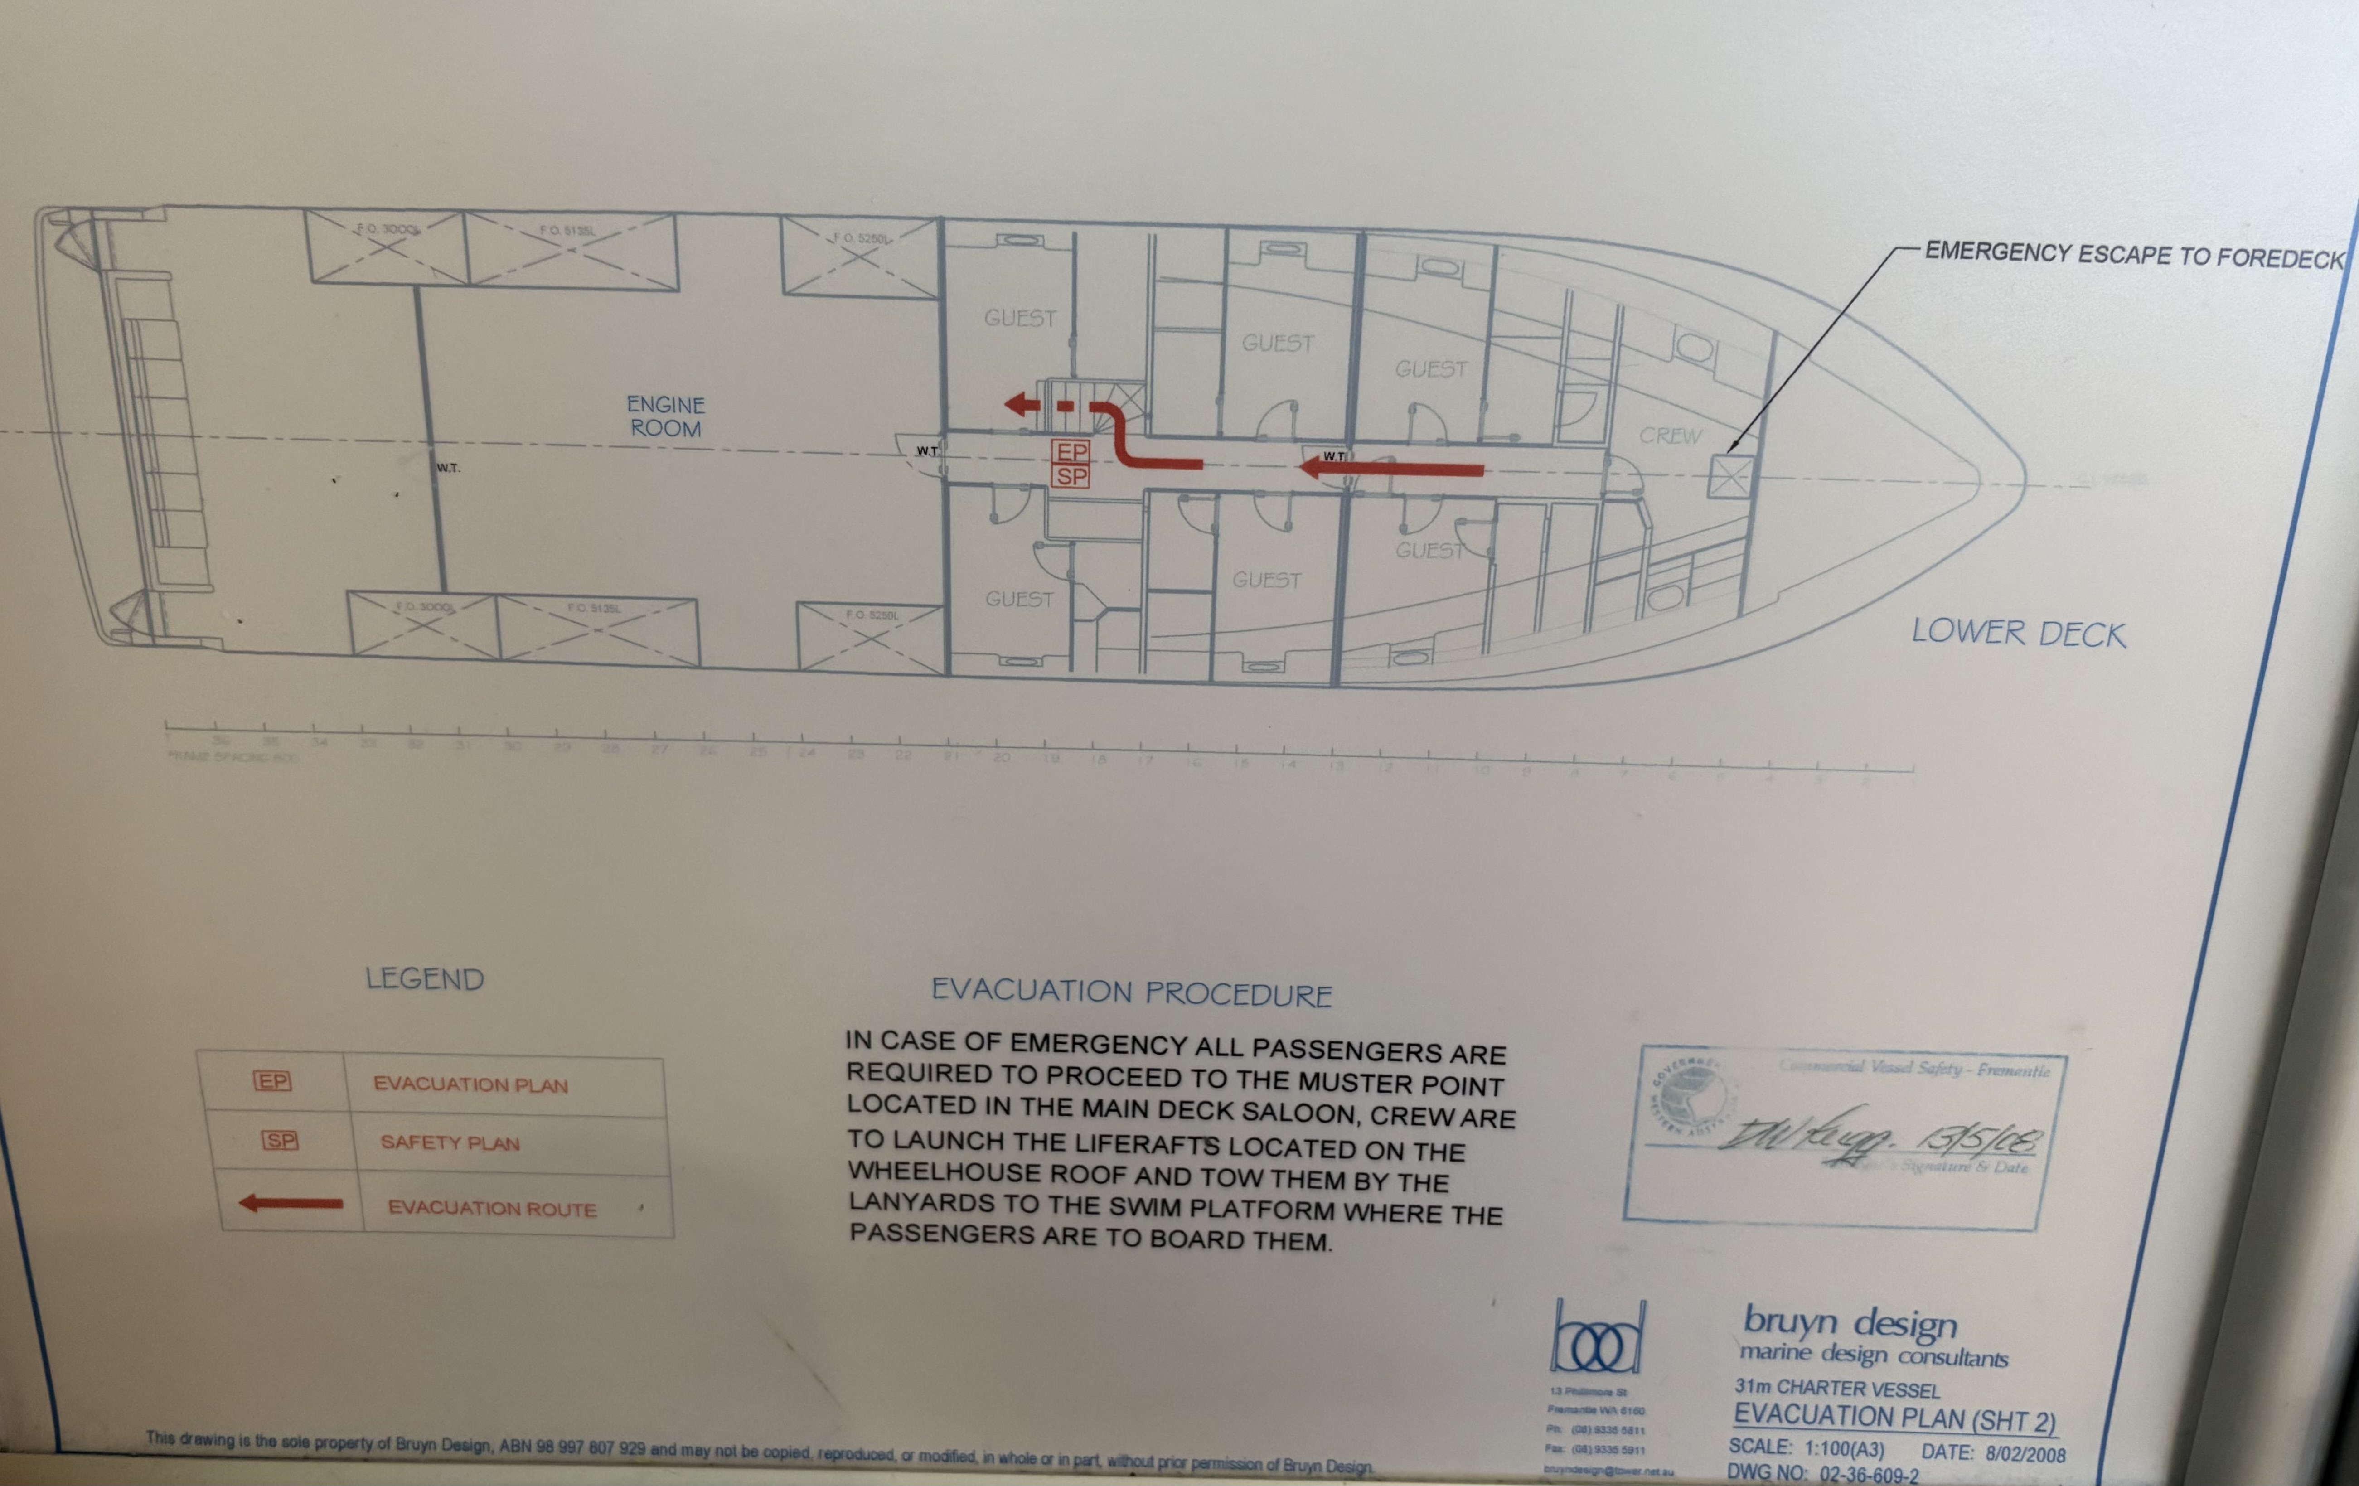
IMG_2858

Guide Dog and Service Animals
The business provides the following services for services animals:
N/A

GENERAL

Pre-arrival, arrival and reception
The business has the following in place to support guests during pre-arrival, arrival and reception
- Information and maps are available in written form
- A familiarisation tour
- Luggage assistance
- In addition, the following further information can assist guests:
All guests have access to their accommodation as soon as they board the vessel.

Internal Spaces
- Tableware/glassware contrast with the table surface or table cloth

Displays, exhibits, commentary and live performances
For displays, exhibits, commentary and live performances the following amenities are in place
- Seating
The width of the smallest pathway is:
Pathways are not applicable to our operation

Pathways are not applicable to our operation

Pathways are not applicable to our operation

Steps
Steps
- There are steps.
- Top and bottom steps are easily distinguished through colour contrast or the use of TGSIs (Tactile Ground Surface Indicators)
- Handrails fitted to all open sets of steps
- Handrails extend 300mm beyond the top and bottom step
- In addition, the following further information can assist guests:
External stairway to the upper deck does not have an enclosed riser. Internal stairways and external stairway to the swim platform have enclosed risers.

TOUR OPERATORS

Tour/Transport Services
The tour/transport services have the following facilities/amenities in place
- Buses/Coaches
- 0 vehicles have wheelchair lifts or ramps
- 0 vehicles have low floors with ramped entry
The maximum wheelchair capacity available in the fleet is:
0

Route Planning
- Route Planning
- Overnight Stops
The total number of wheelchair passengers that can be catered for at overnight stops are:
0
- Walking Tours
- Multi-paced to account for slower walkers

Guides

Guides have been trained in the following
- Use of clear/simple English
- Correct pronunciation for lip readers
- Marine
- In addition, the following further information can assist guests:
Horizontal Falls Seaplane Adventures -Horizontal Falls Seaplane Adventures - Tours, Flights &amp; Cruises

ACCOMMODATION

Room Amenities
- Lower hanging rails are in wardrobes
- In addition, the following further information can assist guests:
In the event of an emergency all guests are escorted out of their cabins to the muster point by a crew member.
- Room phones have volume control
- There is contrast between the walls, skirtings, floor and furniture
- There is a clear path through the room
- The edges of all furniture and fixtures are rounded
- Wardrobe handles are a contrasting colour to the doors and draws
- There is a clear opening at least 850mm wide
- Wardrobe and drawer handles are easy to grip
- The bedside lamp switch is easy to reach from the bed
- Non-allergenic cleaning products are used

Bathrooms
The bathrooms have the following facilities/amenities in place
- All heating appliances and hot water pipes are protected or insulated
- All shower, bath and basin taps are clearly differentiated between hot and cold
- Fixtures and fittings have rounded edges
- The door is at least 850mm wide
- The width beside the toilet is All cabin ensuites are different specifications.
- There is 1.0 mm of clear space in front of the toilet
- The toilet seat is a contrasting colour to the floor
- The toilet seat is 460mm above the floor
  - Bathroom Image(s)
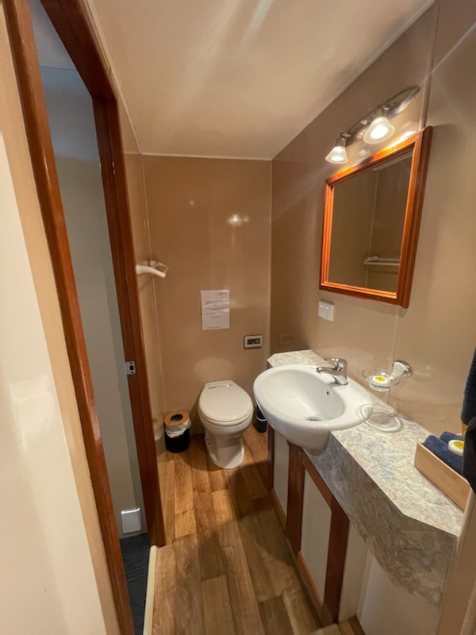
IMG_2141.JPG

COMMON AREAS

Swimming pools, spas and waterparks
- The following swimming pools, spas and waterparks amenities are available

FOOD AND DRINK

ADVENTURE ACTIVITIES

Report Disclaimer
Please note that this business report, provided as a result of the use of the diagnostic assessment, is for information purposes only.
Australian Tourism Industry Council (ATIC) cannot guarantee the accuracy of respondent’s answers, or that they are fully representative of your business. Therefore, ATIC does not warrant or guarantee any particular outcome in respect of your businesses self-assessment.
This report is intended as guidance only for your business and should not be relied on for future marketing considerations. ATIC recommends that you seek your own independent advice as well as the results from the diagnostic.
Links to external web sites are inserted for convenience and do not constitute endorsement of material at those sites, or any associated organisation, product or service.
ATIC does not:
- Assume any legal liability for the accuracy, completeness, or usefulness of any information from this report or any links provided; or
- Accept responsibility for any loss associated directly or indirectly from the use of this report.

