ATIC Accessibility
To support the accessible community in making informed travel decisions for their individual needs

This report prepared for:
Business name: | Cicada Lodge
Address: | Nitmiluk National Park, Gorge Road
Town: | Katherine
Contact for enquiries: | Aron Falletto
Contact Number: | 1300 146 743 / +61 8 8974 3100
Contact Email: | reservations@nitmiluktours.com.au
Website: | https://cicadalodge.com.au/
Date: | 2026-09-10 07:03

ATIC Accessibility
The following pages provides travellers with information on the businesses facilities and amenities which aims to support the traveller to make an informed decision on whether the business is suitable for their individual needs.
OVERVIEW 4
Business Overview 4
Bookings 4
Emergency Management 5
Communications 5
Other Information 5
Guide Dog and Service Animals 5
GENERAL 6
Pre-arrival, arrival and reception 6
Car Park and Access amenities 6
Entry 6
Internal Spaces 7
Public areas 7
External Paths 7
Ramps 8
Public Toilets/Adult change facilities 8
TOUR OPERATORS 9
Route Planning 9
Guides 9
ACCOMMODATION 10
Bedrooms 10
Room Amenities 10
Bathrooms 10
ATTRACTIONS 12
Attractions Basics 12
COMMON AREAS 13
Swimming pools, spas and waterparks 13
FOOD AND DRINK 14
Dining Spaces 14
ADVENTURE ACTIVITIES 15
EVENTS 16
Events 16
Report Disclaimer 18

OVERVIEW

Business Overview

The business has the following products/services available
- Tour/Transport
- Accommodation
- Attraction
- Food and Drink
- Adventure
- Event

Our business caters for the following disability types:
- Blind or low vision
- Limited mobility
- Wheelchairs or mobility scooters
- Food allergies or intolerances
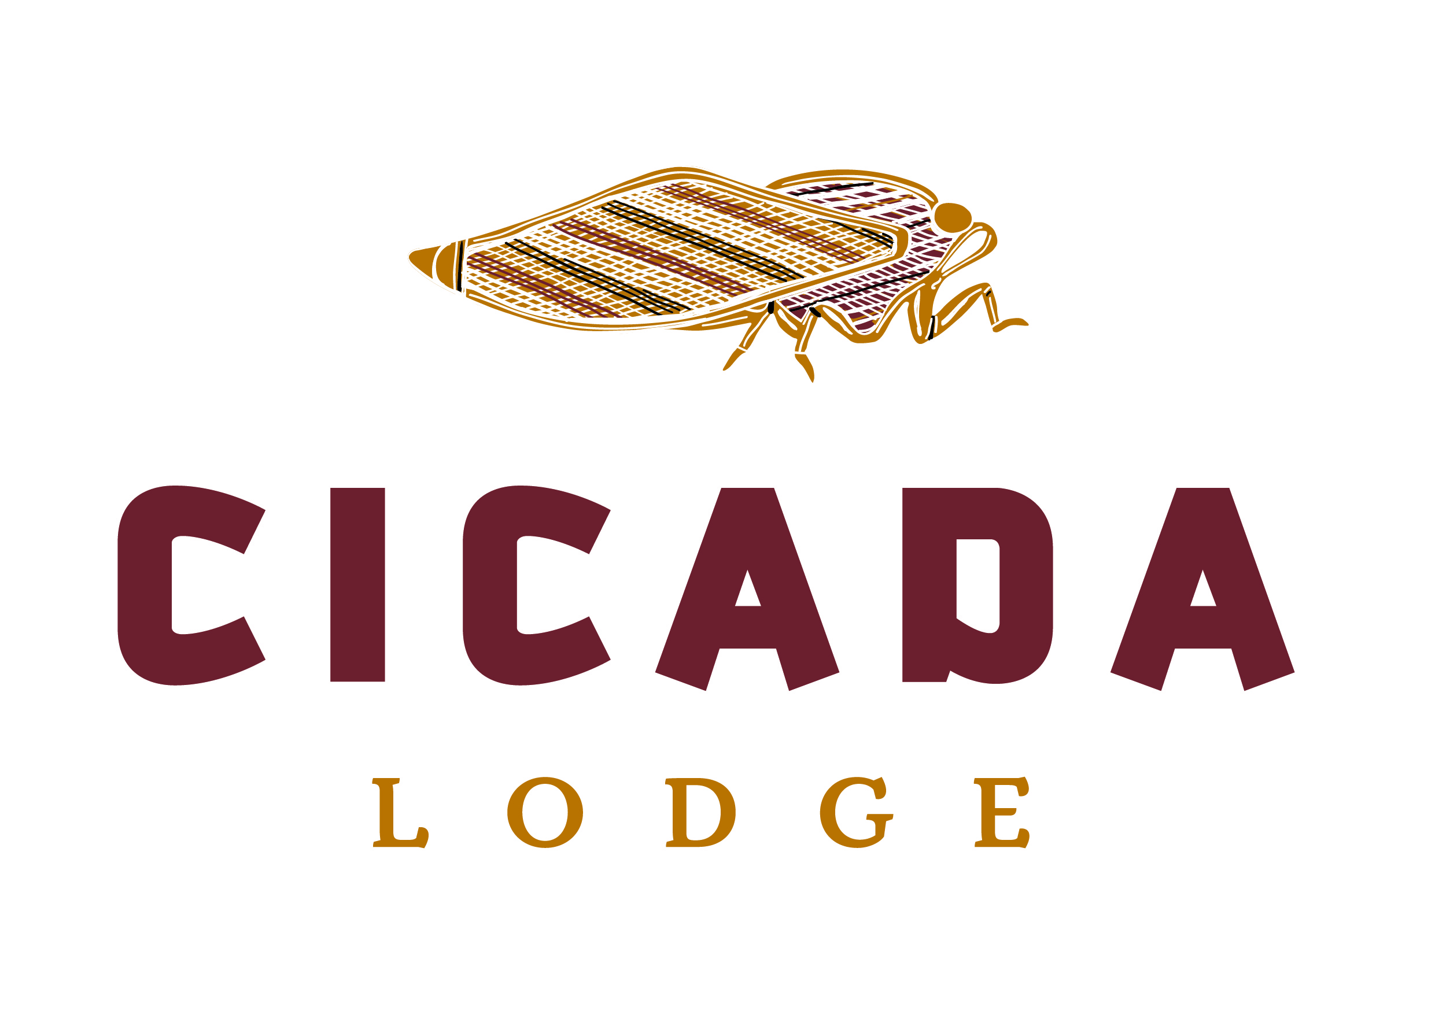

Bookings

The business offers the following methods for bookings and enquiries:
- Phone
- Email
- Webportal
- Staff have undergone disability awareness and training

Emergency Management
- The business has an emergency management and evacuation plan for guests with a disability
- Emergency and evacuation procedures are explained on arrival
- Guests with disabilities are noted in the guest log book for emergency and evacuation purposes

Communications
- An accessibility guide is available on the website

https://accreditation.qualitytourismaustralia.com/report/AccessReportPublicHtml2/83f86da3-2d0b-4f6a-9ff0-56931b489520
- Our website meets WCAG 2.0 accessibility standards

Other Information
- For bookings made onsite, the ticket booth/counter/box office is accessible for people using a wheelchair
- The business accepts the companion card

Guide Dog and Service Animals
The business provides the following services for services animals:
Nitmiluk National don't have permission for other animals, but allow guide dog

GENERAL

Pre-arrival, arrival and reception
The business has the following in place to support guests during pre-arrival, arrival and reception
- Booking information and websites are compatible with screen readers
- There is a reception/public entryway.
- Seating available at reception
- A lower counter at reception/ticket office
- A clipboard to allow check-in/ticket purchase whilst seated
- A tablet with text to voice or pen and paper at reception to aid in communication
- Picture Board at reception to aid in communication
- Large print information sheets and registration forms
- Information and maps are available in written form
- A familiarisation tour
- Keys are available for each guest
- Luggage assistance
- In addition, the following further information can assist guests:
Cicada Lodge

Car Park and Access amenities
The business has the following Car Park and Access amenities
- A drop off zone
- Designated disabled parking bays
- Level or ramped access from the car park to the entrance
- The accessible entrance is clearly signed from the parking bay
- Kerb ramps are in place where a pavement or walkway needs to be crossed

Entry
The business has the following amenities/systems in place for entry
- A drop off point close to the entrance
- A path of access to the building is slip resistance and even
- A path of access to the building is clear of obstruction
- Self opening entry doors or fitted with a self closer
- Glass doors are fitted with a visual sighting strip
- Door jams/doors are of a contrasting colour to surrounding walls
- Door handles are of a contrasting colour to the door
- Signage is written in a contrasting colour
- Signage is written in a Sans Serif font and use upper and lower case letters
- The entry door is a minimum of 850mm wide
- The entry door has self opening or a light opening pressure (for manual operations)
- The entrance sill is less than 13mm
- There a clear space of at least 1500mm x 1500mm in front of all doors.
- The entrance door mats have a thickness less than 13mm and a width of 7500mm or greater

Internal Spaces
- Clear and unobstructed routes through and between buildings
- Interior walls are matte or low sheen
- Floors, walls, counters and furniture are of contrasting colours
- Menus are available in large print or Braille
- Tableware/glassware contrast with the table surface or table cloth
- Floor surfaces are hard or short pile carpet
- Seating is available for guests unable to stand for long periods
- Accessible facilities are clearly signed and visible from all areas
- All corridors greater than 900mm

Public areas
The public areas have the following amenities in place
- Seating

External Paths
External paths of travel
- Surfaces are concrete, asphalt, smooth paving or hard packed fine gravel (max aggregate size 13mm)
- Paths or slopes longer than 15 metres have resting places or seats
- Pathways are wider than 900mm
- There 3 successive steps or less on any path or at any doorway

We have room for people with disability and there’s no step to get in that room, they can easily get there with our accessible ramp.
- Step free routes clearly signed

Ramps
Ramps have the following amenities are in place
- There are ramps.
- All fixed ramps are 1:14 or less
- Hand rails are fitted
- Long ramps (more than 10m) are 1:20 or less
- Ramps have a raised edge of at least 100mm

Public Toilets/Adult change facilities
Public Toilets/Adult change facilities have the following amenities are in place
- There is an accessible toilet for public use
- The door is at least 850mm wide
- There is a minimum of 850mm beside the toilet
- Handrails are fitted
- The toilet seat is 460mm above the floor
- There is N/A mm of clear space in front of the toilet
- The toilet seat of a contrasting colour to the floor
- The toilet seat is460mm above the floor

TOUR OPERATORS

Route Planning
- Route Planning
- The tour route includes stops with accessible toilet facilities
- Lunch stop venues are accessible
- Sightseeing and photo opportunity stops are step free

Guides
- Use of clear/simple English
- Correct pronunciation for lip readers
- There is a audio description of surroundings

ACCOMMODATION

Bedrooms
The bedrooms have the following facilities/amenities in place
- There are 1 rooms available to guests who use a wheelchair
- Bedroom furniture can be re-arranged on request

Room Amenities
- Lower hanging rails are in wardrobes
- Televisions are equipped with closed captioning capability
- Room phones have volume control
- There is contrast between the walls, skirtings, floor and furniture
- There is a clear path through the room
- The edges of all furniture and fixtures are rounded
- Wardrobe handles are a contrasting colour to the doors and draws
- Housekeeping procedures instruct staff not to reposition furniture that has been moved
- Doors open fully against the adjoining wall
- There is a clear opening at least 850mm wide
- There luggage racks for at least two suitcases
- There at least one chair with rigid arms
- Wardrobe and drawer handles are easy to grip
- The bedside lamp switch is easy to reach from the bed
- There is at least 850mm clear space beside the bed
- The bed height is no higher than 680mm from the floor
- There is at least 130mm clearance under the bed

Bathrooms
The bathrooms have the following facilities/amenities in place
- All heating appliances and hot water pipes are protected or insulated
- All shower, bath and basin taps are clearly differentiated between hot and cold
- Fixtures and fittings have rounded edges
- The hot water is thermostatically controlled to 41 degrees
- The door is at least 850mm wide
- There is a minimum of 850mm beside the toilet
- Handrails are fitted
- There is a minimum of 1400mm of clear space in front of the toilet
- The toilet seat is a contrasting colour to the floor
- The toilet seat is 460mm above the floor
- There is a roll-in shower with fold down fixed seat or a shower chair
- There is a portable shower head on flexible hose

ATTRACTIONS

Attractions Basics
- A park map is available here:

https://cicadalodge.com.au/

COMMON AREAS

Swimming pools, spas and waterparks
- The following swimming pools, spas and waterparks amenities are available
- Unisex change facilities with an accessible toilet

FOOD AND DRINK

Dining Spaces
The dining spaces have the following facilities/amenities in place
- The entrance has level access
- The doorway is at least 850mm wide
- There is level access through the dining area
- Chairs are moveable to allow for wheelchairs to be seated at the tables
- All glass doors and full height windows have contrast markings
- There are areas of full lighting
- There are large print menus
- There are Plain English menus
- There is an accessible toilet

Our business caters for the following dietary requirements
- Sugar free (diabetic)
- Gluten free (celiac)
- Lactose free (dairy free)
- Low fat and fibre with no gastric content
- Nut free
- Organic
- Vegetarian
- Vegan
- In addition, the following further information can assist guests:
At Cicada Lodge, the kitchen follows strict procedures to avoid cross-contamination, including:
Using color-coded chopping boards and utensils for different food types.Storing raw and cooked foods separately at appropriate temperatures.Cleaning and sanitizing surfaces and equipment between uses.Implementing rigorous staff training on food safety standards.
- There is a sample menu available online
Sample menu is available here -
Provided on request

ADVENTURE ACTIVITIES

EVENTS

Events
Events have the following facilities/amenities in place
- There is step free access throughout the venue
- Reception, registration desks or ticket offices have a lower counter section
- All ancillary areas are step free e.g. breakout rooms, dining areas, outside areas and exhibition spaces
- Accessible toilets are available at the venue
- There is clear signage throughout the venue including accessible routes and accessible facilities
- All presentations are captioned
- There is good circulation space with the number of people expected to allow people with a disability to move around freely
- Food and water is available for guide and service animals
- Accessible car parking is available
- There are designated drop-off points
- Quiet rooms, marquees or spaces are available
- In addition, the following further information can assist guests:
The lodge does not have a dedicated conference room. If an event is held at the lodge, we will work closely with the organizer to explore accessible solutions on a case-by-case basis.

Report Disclaimer
Please note that this business report, provided as a result of the use of the diagnostic assessment, is for information purposes only.
Australian Tourism Industry Council (ATIC) cannot guarantee the accuracy of respondent’s answers, or that they are fully representative of your business. Therefore, ATIC does not warrant or guarantee any particular outcome in respect of your businesses self-assessment.
This report is intended as guidance only for your business and should not be relied on for future marketing considerations. ATIC recommends that you seek your own independent advice as well as the results from the diagnostic.
Links to external web sites are inserted for convenience and do not constitute endorsement of material at those sites, or any associated organisation, product or service.
ATIC does not:
- Assume any legal liability for the accuracy, completeness, or usefulness of any information from this report or any links provided; or
- Accept responsibility for any loss associated directly or indirectly from the use of this report.

