ATIC Accessibility
To support the accessible community in making informed travel decisions for their individual needs

This report prepared for:
Business name: | Australian Wooden Boat Festival
Address: | Space 229, Salamanca Arts Centre
Town: | Hobart
Contact for enquiries: | Scarlet English
Contact Number: | 03 6223 3375
Contact Email: | office@awbf.org.au
Website: | https://www.awbf.org.au/
Date: | 2026-11-06 21:56

ATIC Accessibility
The following pages provides travellers with information on the businesses facilities and amenities which aims to support the traveller to make an informed decision on whether the business is suitable for their individual needs.
OVERVIEW 4
Business Overview 4
Bookings 4
Communications 5
Other Information 5
Guide Dog and Service Animals 5
GENERAL 6
Pre-arrival, arrival and reception 6
Cognitive Impairment Support 6
Car Park and Access amenities 6
Displays, exhibits, commentary and live performances 6
External Paths 7
Steps 7
Ramps 7
Public Toilets/Adult change facilities 8
EVENTS 9
Events 9
Report Disclaimer 11

OVERVIEW

Business Overview

The business has the following products/services available
- Event

Our business caters for the following disability types:
- Blind or low vision
- Deaf or low hearing
- Limited mobility
- Wheelchairs or mobility scooters
- Food allergies or intolerances
- Cognitive or people on the Autism Spectrum
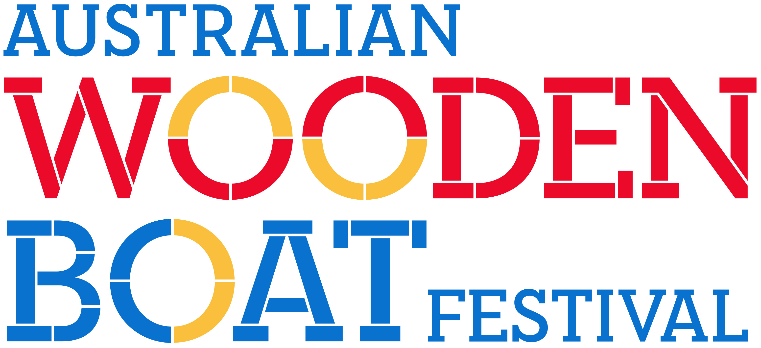

Bookings

The business offers the following methods for bookings and enquiries:
- Phone
- Email
- Webportal
- Our website supports Screen Readers
- Our forms have high contract boxes and submit boxes

Because the festival is large-scale, open-access, and decentralised, there is no single point of arrival or procedure for briefing every attendee — making the question not applicable in a conventional sense.

Communications
- Our business offers the following alternative communication methods
- Plain English

Where possible, the festival provides Auslan interpretation and assisted listening devices at selected events and venues.
- There is easy to read signage and information (e.g. menus and emergency information)

Other Information
- The business accepts the companion card

Guide Dog and Service Animals
The business provides the following services for services animals:
Service animals are welcome at the Australian Wooden Boat Festival. Water bowls are available at all festival information booths, and there are plenty of shaded areas throughout the site to help keep service animals comfortable.

GENERAL

Pre-arrival, arrival and reception
The business has the following in place to support guests during pre-arrival, arrival and reception
- Booking information and websites are compatible with screen readers
- Information and maps are available in written form
- In addition, the following further information can assist guests:
As a large-scale, free, and unticketed event spread across multiple indoor and outdoor locations, the Australian Wooden Boat Festival does not have centralised queues or wait times for general access. However, we recognise that some guests may experience fatigue due to disability. To support this, the festival site includes multiple shaded rest areas, seating throughout the precinct, and accessible facilities. For any events or activities that involve queuing, our staff and volunteers are briefed to offer assistance where possible, including prioritising guests with access needs. We encourage guests to speak with festival staff or visit an information booth if support is required.

Cognitive Impairment Support
- A space for parents and children on the Autism Spectrum

Car Park and Access amenities
The business has the following Car Park and Access amenities
- A drop off zone
- Designated disabled parking bays
- Level or ramped access from the car park to the entrance
- The accessible entrance is clearly signed from the parking bay
- Kerb ramps are in place where a pavement or walkway needs to be crossed

Displays, exhibits, commentary and live performances
For displays, exhibits, commentary and live performances the following amenities are in place
- Seating
- Wheelchair accessible spaces/seating
- Hearting loops for live shows and presentations
- In addition, the following further information can assist guests:
Where possible, assisted listening devices are available at selected venues and events throughout the festival.

External Paths
External paths of travel
- Surfaces are concrete, asphalt, smooth paving or hard packed fine gravel (max aggregate size 13mm)
- Pathways are wider than 900mm

The Australian Wooden Boat Festival takes place across a variety of public spaces and venues, each with different layouts. While many paths and doorways within the festival footprint are step-free or have ramps, some locations may have steps. Where steps are present, there are generally three or fewer successive steps, and alternative accessible routes are provided whenever possible to ensure access for all guests.

Steps
Steps
- There are steps.
- In addition, the following further information can assist guests:
The Australian Wooden Boat Festival is held across many different public and heritage sites. Because of this, not all steps or staircases have modern accessibility features like colour-contrasted edges, enclosed risers, protected undersides, or extended handrails. Also, some locations have more than three steps, reflecting the original design of the site. Due to the nature of the festival footprint and heritage considerations, these features cannot be uniformly updated.

Ramps
Ramps have the following amenities are in place
- There are ramps.
- Temporary ramps are available
- Temporary ramps are in place for the duration of the guests stay
- Ramps have a raised edge of at least 100mm
- In addition, the following further information can assist guests:
The Australian Wooden Boat Festival uses a mix of existing permanent venues and temporary sites. All permanent venues manage their own fixed ramps and accessibility features, including handrails and ramp gradients, according to their own standards. For temporary venues set up by the festival, we provide temporary ramps that remain in place for the duration of the event or the guest’s stay, and these include raised edges where applicable.

Public Toilets/Adult change facilities
Public Toilets/Adult change facilities have the following amenities are in place
- There is an accessible toilet for public use
- The door is at least 850mm wide
- There is a minimum of 850mm beside the toilet
- Handrails are fitted
- The toilet seat is 460mm above the floor
- The toilet seat of a contrasting colour to the floor
- The toilet seat is460mm above the floor
- In addition, the following further information can assist guests:
The Australian Wooden Boat Festival is held across multiple existing public and private venues, each responsible for managing its own accessible toilet facilities. Many of these venues provide accessible toilets that meet local standards, including appropriate door widths, handrails, and clear space requirements. Some venues may also have adult change facilities, but the availability of registered Changing Places facilities, adult change tables, or hoists varies by location and is managed by the individual venue operators.

EVENTS

Events
Events have the following facilities/amenities in place
- Accessible toilets are available at the venue
- There is clear signage throughout the venue including accessible routes and accessible facilities
- Wheelchair designated seating is provided
- We cater for a range of seating and viewing options
- We cater for varying group sizes
- A hearing loop is provided
- Speakers/performers are instructed to use the microphones
- There is good circulation space with the number of people expected to allow people with a disability to move around freely
- The event is outdoors
- Portable accessible toilets are available
- Seating is at regular intervals
- Side shows, activities etc. are accessible
- Accessible car parking is available
- There are designated drop-off points
- There is accessible public transport to the venue
- Accessible public transport is detailed in the event information
- There is an event map available
- The event map shows accessible facilities
- The event includes the use of loud noises, fireworks or strobe lighting
- Quiet rooms, marquees or spaces are available
- In addition, the following further information can assist guests:
The Australian Wooden Boat Festival takes place across many existing venues and outdoor sites, with accessibility features managed by individual venues. While most venues offer step-free access, accessible toilets, and clear signage, some heritage or temporary sites may have limitations. As a free event, there is no central ticket office; ticketed events are booked through external venues, which manage their own accessibility. Assisted listening devices and Auslan interpretation are available at selected events where possible. Water bowls for service animals are provided at information booths, and seating is available throughout the festival site. Accessible parking, drop-off points, and public transport serve the area, and event information includes details on accessible routes, facilities, and sensory warnings, with quiet spaces provided in designated areas.

Report Disclaimer
Please note that this business report, provided as a result of the use of the diagnostic assessment, is for information purposes only.
Australian Tourism Industry Council (ATIC) cannot guarantee the accuracy of respondent’s answers, or that they are fully representative of your business. Therefore, ATIC does not warrant or guarantee any particular outcome in respect of your businesses self-assessment.
This report is intended as guidance only for your business and should not be relied on for future marketing considerations. ATIC recommends that you seek your own independent advice as well as the results from the diagnostic.
Links to external web sites are inserted for convenience and do not constitute endorsement of material at those sites, or any associated organisation, product or service.
ATIC does not:
- Assume any legal liability for the accuracy, completeness, or usefulness of any information from this report or any links provided; or
- Accept responsibility for any loss associated directly or indirectly from the use of this report.

