ATIC Accessibility
To support the accessible community in making informed travel decisions for their individual needs

This report prepared for:
Business name: | Eden Yarra Valley
Address: | 305 Steels Creek Road
Town: | Yarra Glen
Contact for enquiries: | Lisa Chapman
Contact Number: | 0419 368 031
Contact Email: | hello@edenyarravalley.com.au
Website: | edenyarravalley.com.au
Date: | 2026-09-21 04:50

ATIC Accessibility
The following pages provides travellers with information on the businesses facilities and amenities which aims to support the traveller to make an informed decision on whether the business is suitable for their individual needs.
OVERVIEW 4
Business Overview 4
Bookings 4
Emergency Management 4
Communications 5
Other Information 5
Guide Dog and Service Animals 5
GENERAL 6
Pre-arrival, arrival and reception 6
Cognitive Impairment Support 6
Car Park and Access amenities 6
External Paths 6
Steps 6
TOUR OPERATORS 8
ACCOMMODATION 9
Bedrooms 9
Room Amenities 9
Bathrooms 9
COMMON AREAS 11
Play Spaces 11
Swimming pools, spas and waterparks 11
Parks and gardens 11
FOOD AND DRINK 13
Dining Spaces 13
Report Disclaimer 15

OVERVIEW

Business Overview

The business has the following products/services available
- Tour/Transport
- Accommodation
- Food and Drink

Our business caters for the following disability types:
- Limited mobility
- Food allergies or intolerances
- Cognitive or people on the Autism Spectrum


Bookings

The business offers the following methods for bookings and enquiries:
- Phone
- Email
- Webportal
- Staff have undergone disability awareness and training

Emergency Management
- Emergency and evacuation procedures are explained on arrival
- Exit access is free and clear at all times
We ensure exit access is free and clear at all times by:
Door exits are clear at time of guest arrivals. No objects near doors which may be a barrier to exit.
- Exit doors are able to be opened by all occupants
- Exits to the emergency evacuation point does not include stairways
- The evacuation point is clearly marked by a sign
- In addition, the following further information can assist guests:
As the estate is private and self-catering with no staff onsite, hosts are responsible for additional guest assistance. Evacuation and fire safety information is displayed in common areas.
- In addition, the following further information can assist guests:
See above.

Communications
- Our business offers the following alternative communication methods
- Plain English

All pathways, decks and other areas are well lit for safety. Additional handrails for every step for addded safety. Bath aids supplied.
- There is easy to read signage and information (e.g. menus and emergency information)

Other Information
- The business accepts the companion card

Guide Dog and Service Animals
- The business provides a secure area with shade and water for service animals
- The business provides a toilet area for service animals
- Bowls, bedding, etc. are provided for service animals
The business provides the following services for services animals:
Service animals are welcome to stay with guests. Any special requests wouldbe accommodated wherever required.

GENERAL

Pre-arrival, arrival and reception
The business has the following in place to support guests during pre-arrival, arrival and reception
- Information and maps are available in written form
- A familiarisation tour
- Keys are available for each guest
- Luggage assistance
- In addition, the following further information can assist guests:
No waiting applies, no public areas. Set check in times for guests. Early check in is provided when possible, ie people arriving from a flight earlier than standard Eden check in, or with disability needs.

Cognitive Impairment Support
- A space for parents and children on the Autism Spectrum

Car Park and Access amenities
The business has the following Car Park and Access amenities
- A drop off zone

External Paths
External paths of travel
- Pathways are wider than 900mm
- There 3 successive steps or less on any path or at any doorway

Steps
Steps
- There are steps.
- All steps or staircases have enclosed risers
- The underside of all staircases are enclosed or protected to a height of at least 2 metres
- Handrails fitted to all open sets of steps
- Where steps are present are there three steps or less

TOUR OPERATORS
- In addition, the following further information can assist guests:
NA
- In addition, the following further information can assist guests:
NA

ACCOMMODATION

Bedrooms
The bedrooms have the following facilities/amenities in place
- There are 5 rooms available to guests who use a wheelchair
- Bedroom furniture can be re-arranged on request
  - Layout of room Image(s)

Room Amenities
- There is a clear path through the room
- Doors open fully against the adjoining wall
- There is a clear opening at least 850mm wide
- There luggage racks for at least two suitcases
- There at least one chair with rigid arms
- The bedside lamp switch is easy to reach from the bed
- There is at least 850mm clear space beside the bed
- The bed height is no higher than 680mm from the floor
- Non-allergenic cleaning products are used

Bathrooms
The bathrooms have the following facilities/amenities in place
- All heating appliances and hot water pipes are protected or insulated
- All shower, bath and basin taps are clearly differentiated between hot and cold
- Fixtures and fittings have rounded edges
- The hot water is thermostatically controlled to 41 degrees
- The width of the door is 750mm.
- The width beside the toilet is 700mm.
- There is a minimum of 1400mm of clear space in front of the toilet
- The toilet seat is 460mm above the floor
- A range of non-allergenic toiletries are available
- There is a portable shower head on flexible hose
- A door is fitted to the shower
- A door is fitted to the showers with an outward swing at minimum width of 900 mm
  - Bathroom Image(s)
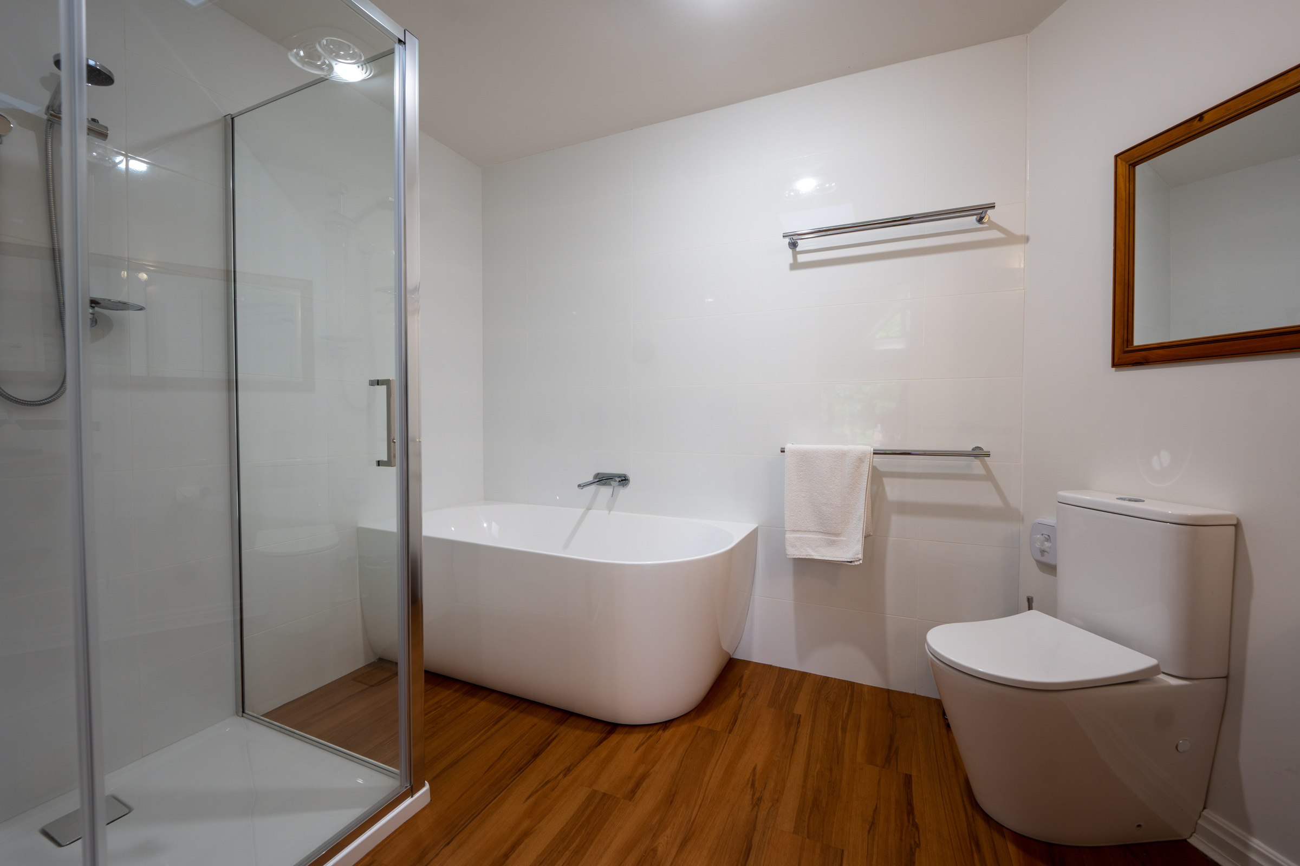
Bedroom 7 spacious bathroom with accesible toilet and separate shower
- In addition, the following further information can assist guests:
Single level large suite, with spacious ensuite with separate shower and accessible toilet.

COMMON AREAS

Play Spaces
- Level access is provided to play spaces
- Ramps provided are at least 25% of elevated sections of the play space
  - Image(s)
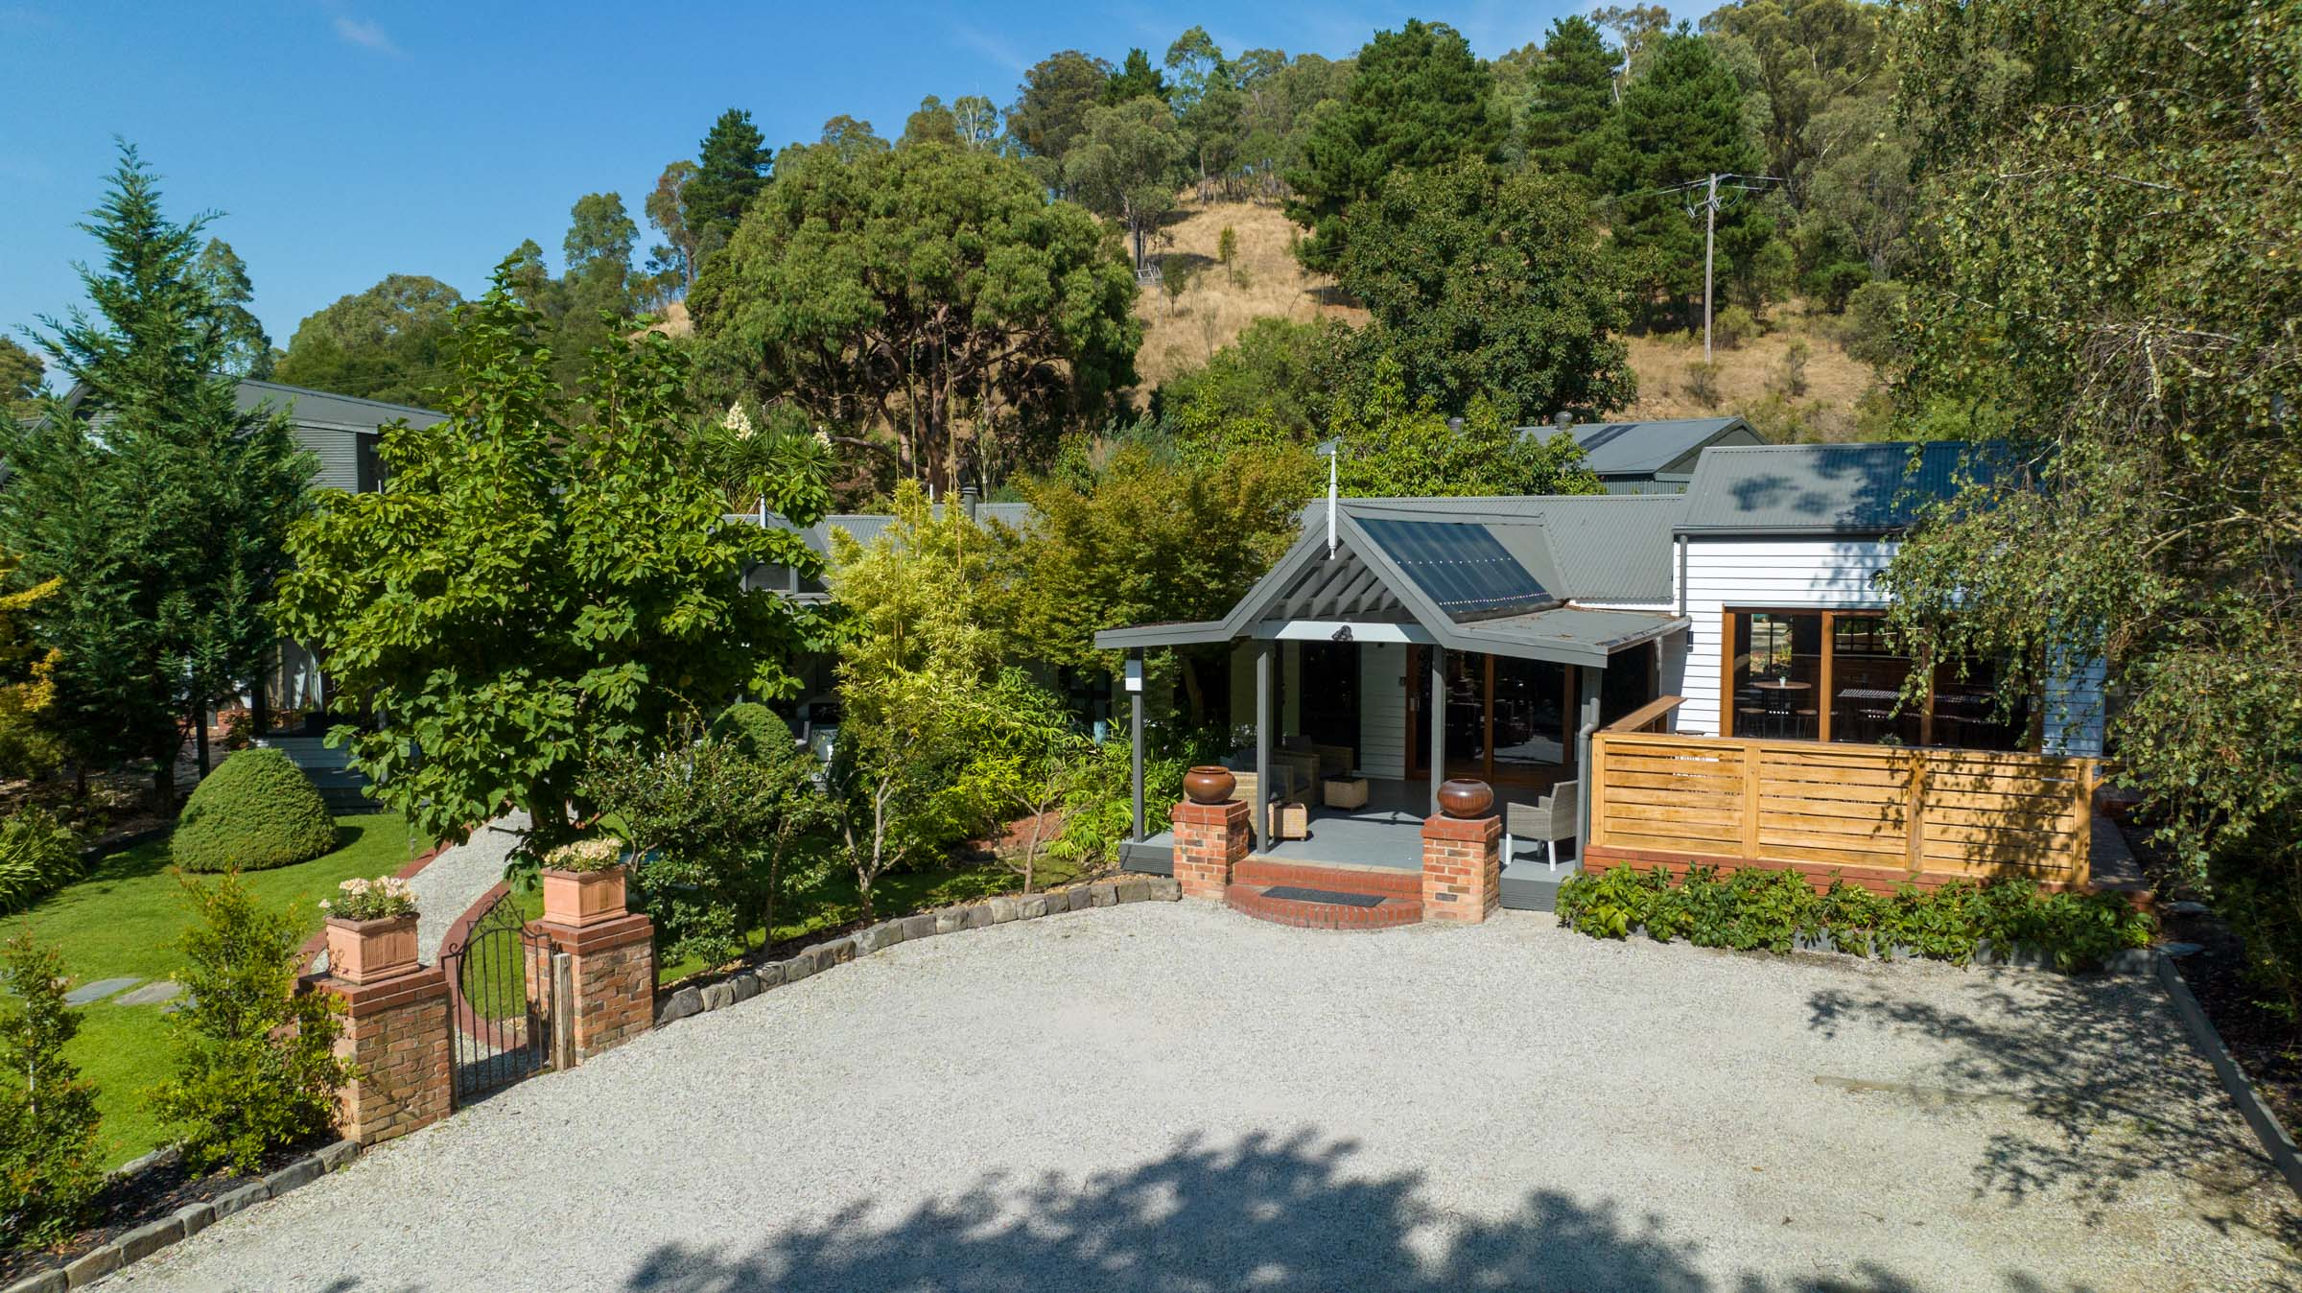
Exterior Main Entry Parking
- In addition, the following further information can assist guests:
Large parking areas.

Swimming pools, spas and waterparks
- The following swimming pools, spas and waterparks amenities are available
- Unisex change facilities with an accessible toilet
- In addition, the following further information can assist guests:
No pool accessibility features

Parks and gardens
- The following parks and gardens amenities are available
- Seats are provided at regular intervals
- Accessible BBQs
  - Parks and Gardens Access/Entry Image(s)
Exterior Main Entry Parking
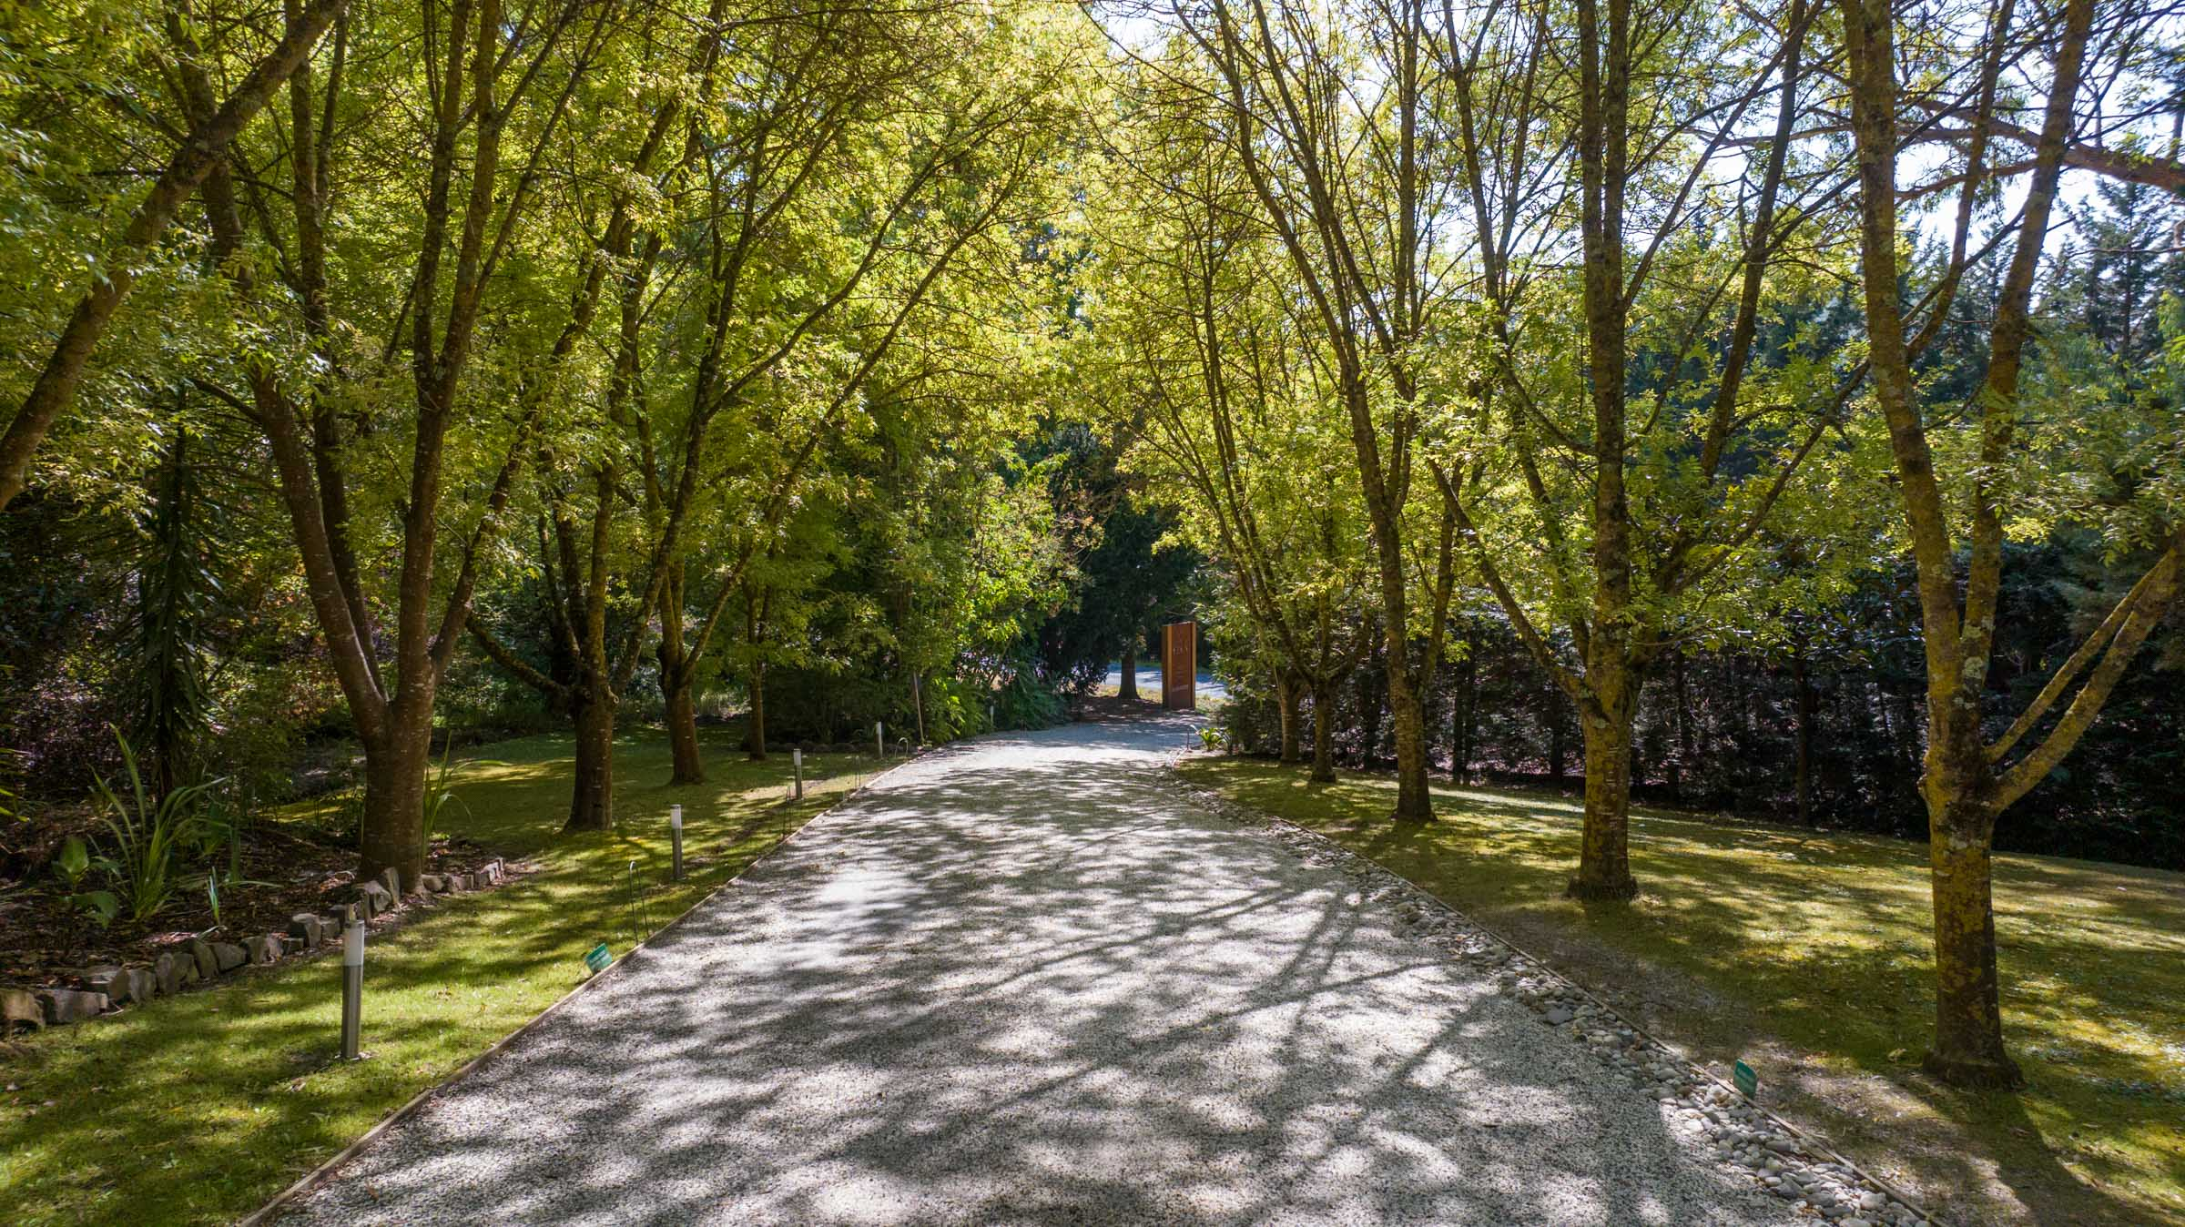
Exterior front drive
- In addition, the following further information can assist guests:
Large parking areas suitable for wheelchairs.
Large bedrooms suites could cater for wheelchair users. 1 step access to rooms.
- Handrails and stairs are built as per state/territory building code.
- Slip resistance surfaces are used.
- A handrail is available and at 865-965mm in height.
  - Parks and Gardens Stair entry and exit Image(s)
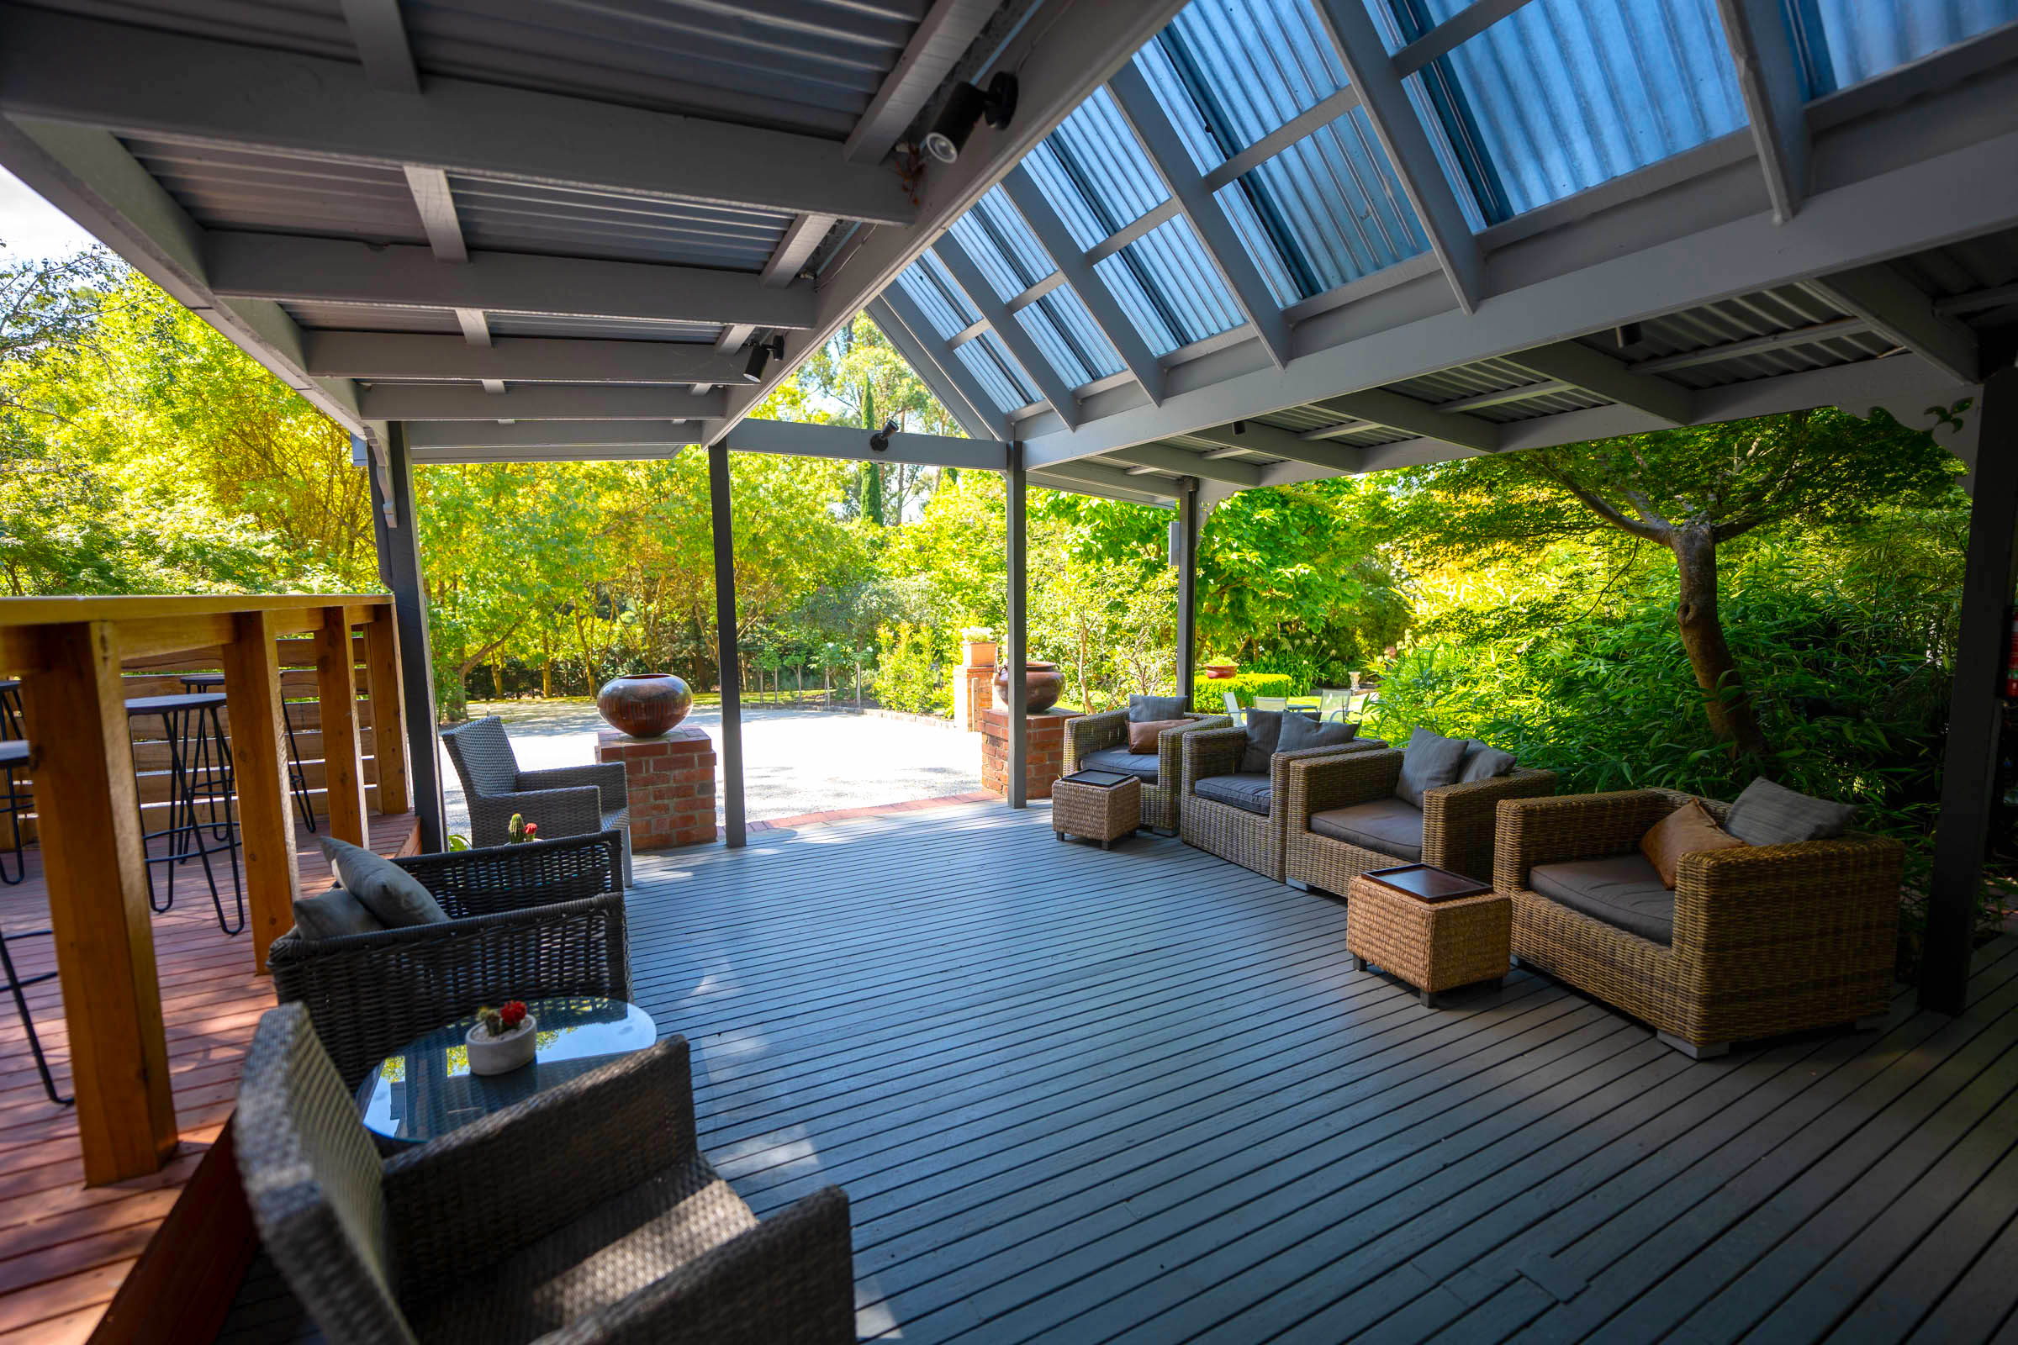
Front entry deck with lounge area

FOOD AND DRINK

Dining Spaces
The dining spaces have the following facilities/amenities in place
- The doorway is at least 850mm wide
- There is level access through the dining area
- Chairs are moveable to allow for wheelchairs to be seated at the tables
- There are areas of full lighting
- There are Plain English menus

Our business caters for the following dietary requirements
- Sugar free (diabetic)
- Gluten free (celiac)
- Lactose free (dairy free)
- Low fat and fibre with no gastric content
- Low potassium
- Low sodium
- Nut free
- Additive free
- Organic
- Vegetarian
- Vegan
- Kosher
- Halal
- In addition, the following further information can assist guests:
Estate is self catering. Unless Professional caterers are providing food, and they can cater to all dietary requirements listed.

Report Disclaimer
Please note that this business report, provided as a result of the use of the diagnostic assessment, is for information purposes only.
Australian Tourism Industry Council (ATIC) cannot guarantee the accuracy of respondent’s answers, or that they are fully representative of your business. Therefore, ATIC does not warrant or guarantee any particular outcome in respect of your businesses self-assessment.
This report is intended as guidance only for your business and should not be relied on for future marketing considerations. ATIC recommends that you seek your own independent advice as well as the results from the diagnostic.
Links to external web sites are inserted for convenience and do not constitute endorsement of material at those sites, or any associated organisation, product or service.
ATIC does not:
- Assume any legal liability for the accuracy, completeness, or usefulness of any information from this report or any links provided; or
- Accept responsibility for any loss associated directly or indirectly from the use of this report.

