ATIC Accessibility
To support the accessible community in making informed travel decisions for their individual needs

This report prepared for:
Business name: | The Billi Resort
Address: | 95-97 Oryx Road
Town: | Cable Beach
Contact for enquiries: | Sharelle Beckworth
Contact Number: | 08 9192 1711
Contact Email: | stay@thebilli.com.au
Website: | www.thebilli.com.au
Date: | 2026-09-14 14:04

ATIC Accessibility
The following pages provides travellers with information on the businesses facilities and amenities which aims to support the traveller to make an informed decision on whether the business is suitable for their individual needs.
OVERVIEW 4
Business Overview 4
Bookings 4
Emergency Management 5
Communications 5
Other Information 5
Guide Dog and Service Animals 5
GENERAL 6
Pre-arrival, arrival and reception 6
Cognitive Impairment Support 6
Car Park and Access amenities 6
External Paths 7
Steps 7
Ramps 7
ACCOMMODATION 8
Room Amenities 8
Bathrooms 8
COMMON AREAS 11
Play Spaces 11
Swimming pools, spas and waterparks 12
Report Disclaimer 17

OVERVIEW

Business Overview

The business has the following products/services available
- Accommodation

Our business caters for the following disability types:
- Blind or low vision
- Deaf or low hearing
- Limited mobility
- Cognitive or people on the Autism Spectrum

Bookings

The business offers the following methods for bookings and enquiries:
- Phone
- Email
- Webportal
- Our forms have high contract boxes and submit boxes
- Staff have undergone disability awareness and training

Emergency Management
- The business has an emergency management and evacuation plan for guests with a disability
- Guests with disabilities are noted in the guest log book for emergency and evacuation purposes

Communications
- An accessibility guide is available on the website

https://thebilli.com.au/accessibility/

Other Information
- For bookings made onsite, the ticket booth/counter/box office is accessible for people using a wheelchair

Guide Dog and Service Animals
The business provides the following services for services animals:
We deeply admire and respect the vital role that guide dogs and other service animals play in the lives of their handlers. However, due to specific reasons, such as resort policies, safety concerns, and our unique environment, we regret that we are unable to accommodate them at our property

GENERAL

Pre-arrival, arrival and reception
The business has the following in place to support guests during pre-arrival, arrival and reception
- There is a reception/public entryway.
- Seating available at reception
- Lighting in the reception area is even and glare free
- Large print information sheets and registration forms
- Information and maps are available in written form
- A familiarisation tour
- Keys are available for each guest
- Luggage assistance
- In addition, the following further information can assist guests:
The Billi reception team will notify each guest via text as soon as their room is ready. This ensures a seamless check-in experience by allowing arrivals to be comfortably staggered throughout the day within the guaranteed check-in period.

Cognitive Impairment Support
- Documents are available in plain English for people with cognitive impairment (This may include instructions, guides, menus and general information)

Car Park and Access amenities
The business has the following Car Park and Access amenities
- A drop off zone
- Level or ramped access from the car park to the entrance
- The accessible entrance is clearly signed from the parking bay
- The public transport services available are:

Transportation options are detailed in our confirmation letters. Additionally, we are happy to provide directions to the nearest bus stop upon request.

External Paths
External paths of travel
- Surfaces are concrete, asphalt, smooth paving or hard packed fine gravel (max aggregate size 13mm)
- Pathways are wider than 900mm
- In addition, the following further information can assist guests:
The Billi has raised timber boardwalks which are continuous and flow around the property leading into each room type.

Steps
Steps
- There are steps.
- All steps or staircases have enclosed risers
- Where steps are present are there three steps or less
- In addition, the following further information can assist guests:
The areas in which have a couple of steps do not need to be accessed at all. Movement around the whole resort is through timber raised boardwalks.

Ramps
Ramps have the following amenities are in place
- There are ramps.
- In addition, the following further information can assist guests:
The resort features sloped timber boardwalks rather than traditional ramps.
- In addition, the following further information can assist guests:
We offer a guest toilet and an outdoor shower/change room for use while waiting to access your room or whilst utilising the pool.

ACCOMMODATION

Room Amenities
- Visual alarm is fitted to the room
- Televisions are equipped with closed captioning capability
- There is contrast between the walls, skirtings, floor and furniture
- The edges of all furniture and fixtures are rounded
- Housekeeping procedures instruct staff not to reposition furniture that has been moved
- Doors open fully against the adjoining wall
- Openings are a minimum of 820mm wide
- There luggage racks for at least two suitcases
- There at least one chair with rigid arms
- The bedside lamp switch is easy to reach from the bed
- There is at least 850mm clear space beside the bed
- Non-allergenic cleaning products are used
- In addition, the following further information can assist guests:
Our wardrobes are open and do not have any doors on them.

Bathrooms
The bathrooms have the following facilities/amenities in place
- All heating appliances and hot water pipes are protected or insulated
- All shower, bath and basin taps are clearly differentiated between hot and cold
- Fixtures and fittings have rounded edges
- The hot water is thermostatically controlled to 41 degrees
- The width of the door is 720mm.
- The width beside the toilet is N/A.
- There is 820mm mm of clear space in front of the toilet
- The toilet seat is a contrasting colour to the floor
- The toilet seat is 460mm above the floor
- A range of non-allergenic toiletries are available
- There is a portable shower head on flexible hose
  - Bathroom Image(s)
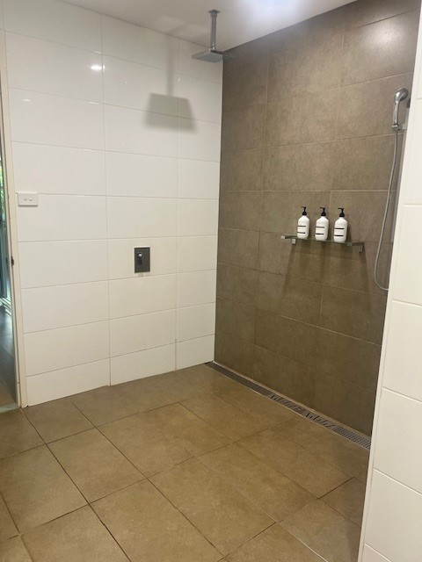
Accessibility Photos Bathroom 1
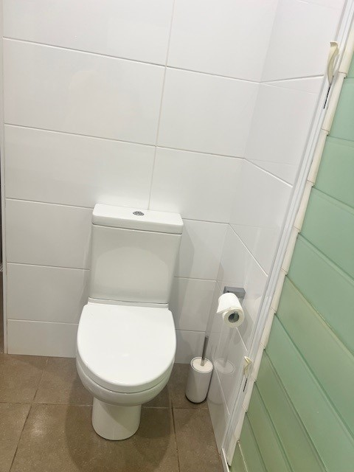
Accessibility Photos Bathroom 2
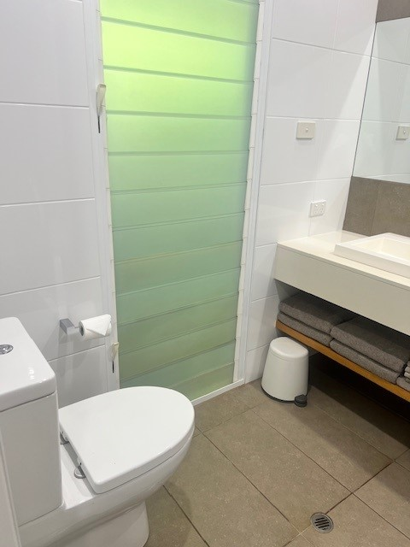
Accessibility Photos Bathroom 3
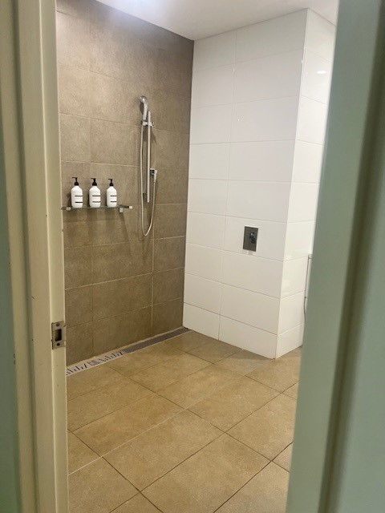
Accessibility Photos Bathroom
- In addition, the following further information can assist guests:
Our Bathroom are of a very open plan style.

COMMON AREAS

Play Spaces
- Level access is provided to play spaces
- The surface of the play space is of a composite or rubberized material
- Seating is provided in or around the play space
  - Image(s)
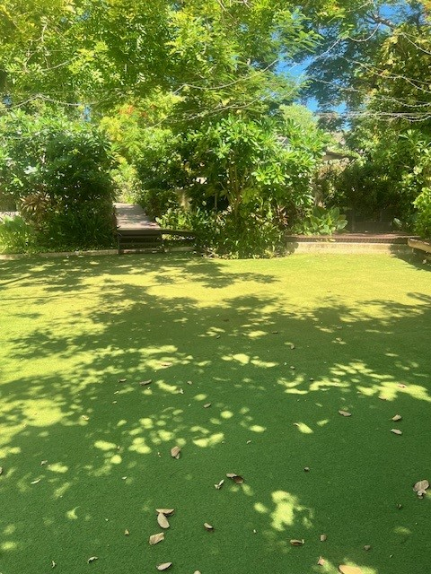
Accessibility Photos Play Area
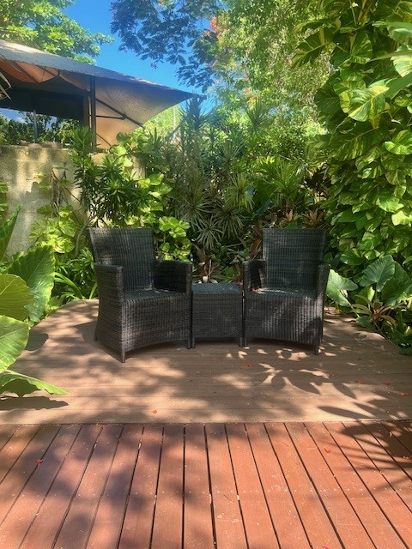
Accessibility Photos Seating 1
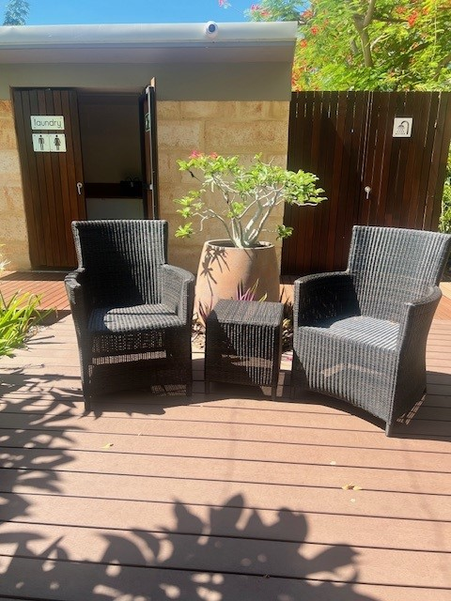
Accessibility Photos Seating

Swimming pools, spas and waterparks
- The following swimming pools, spas and waterparks amenities are available
- Unisex change facilities with an accessible toilet
- The park map includes a step free route
  - Pool Access Image(s)
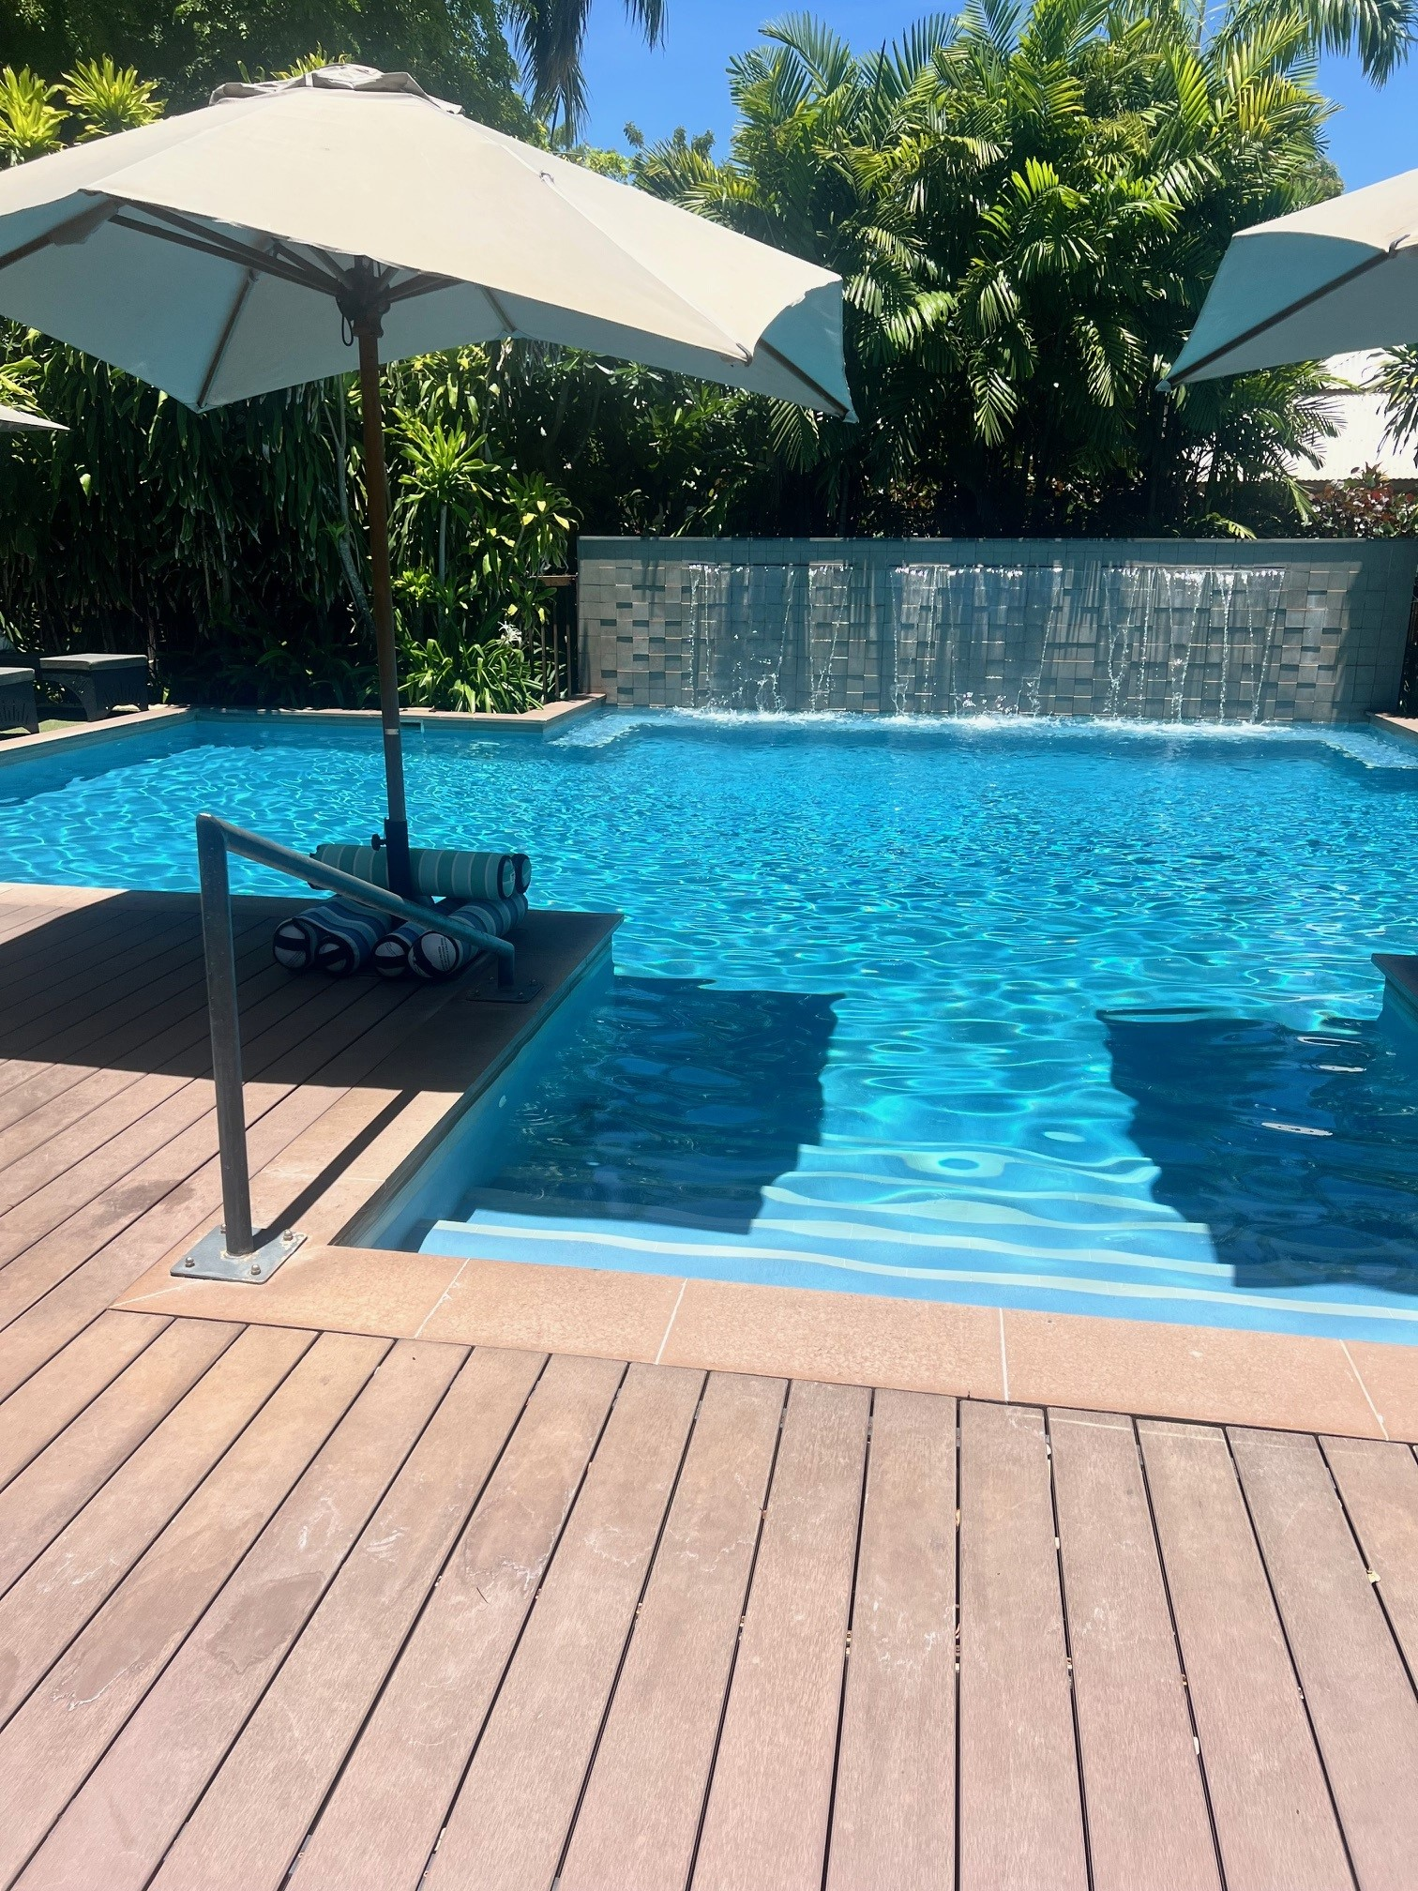
Accessibility Photos Pool Entry
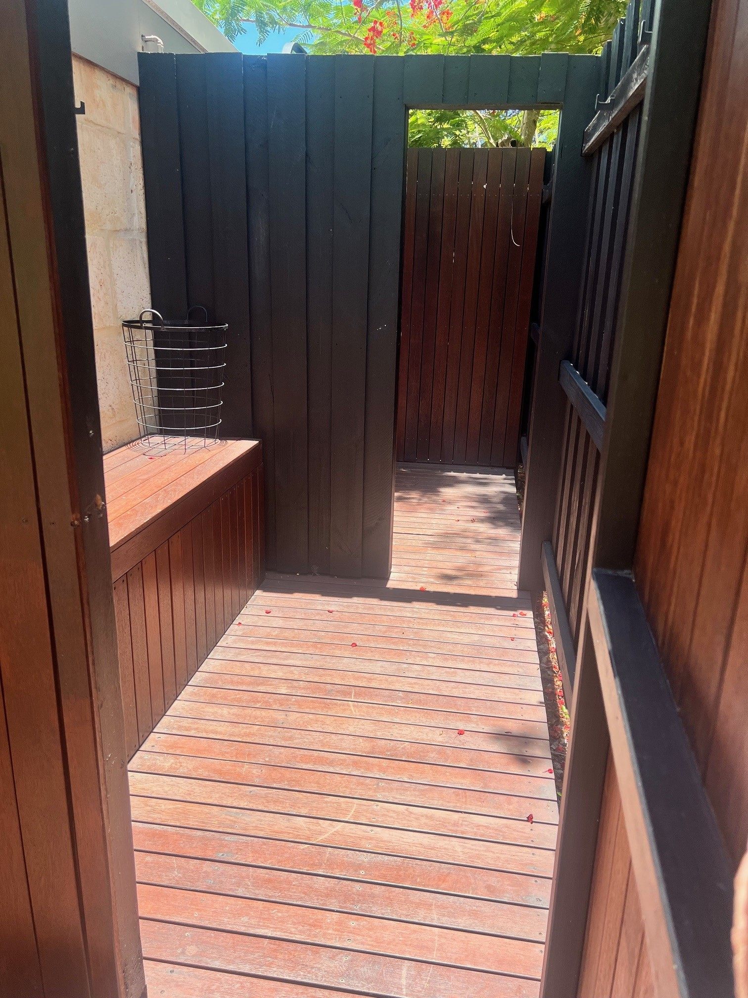
Accessibility Photos Shower & Change Area
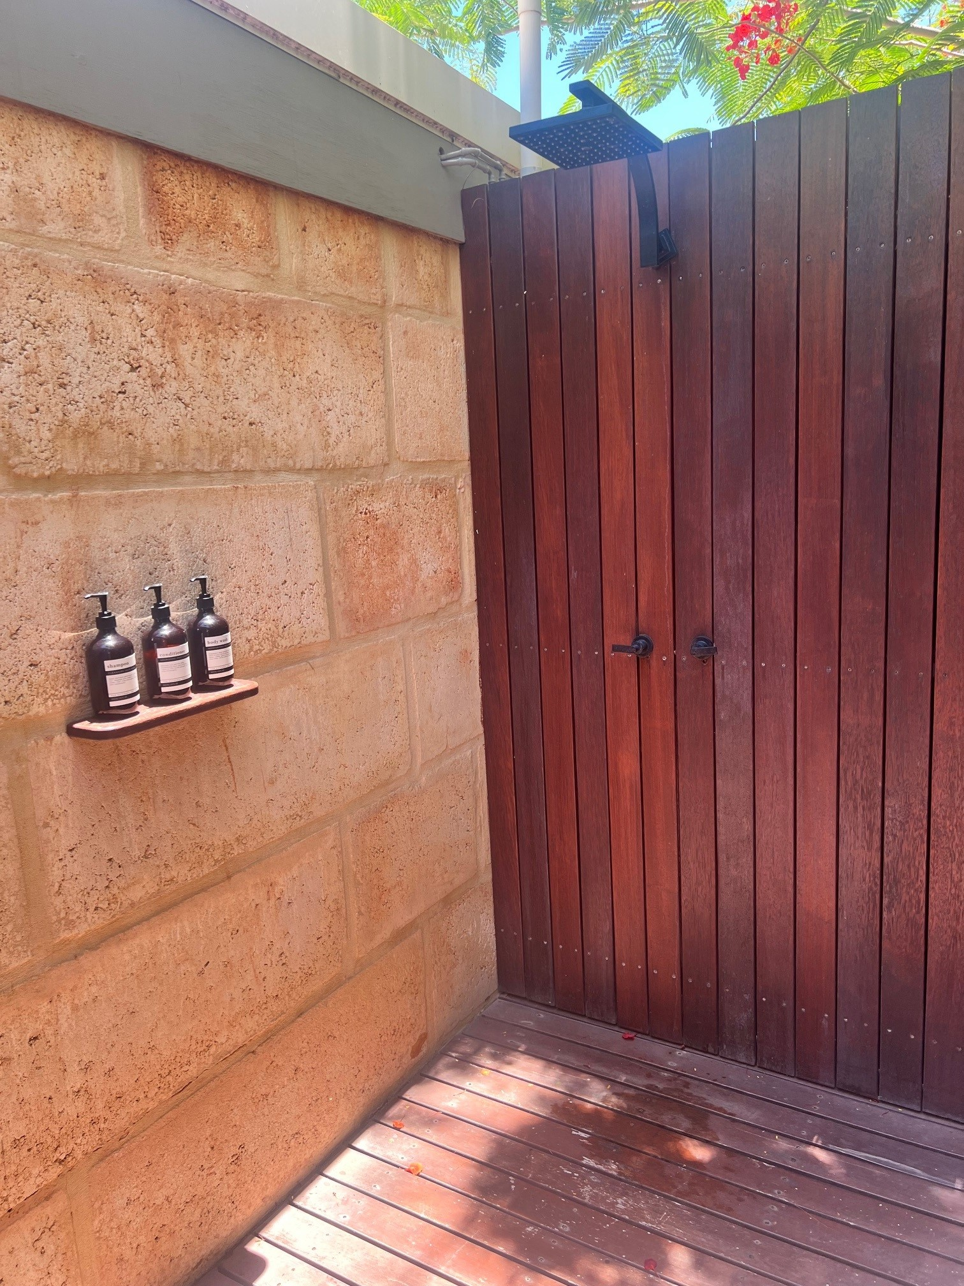
Accessibility Photos Unisex Shower Area
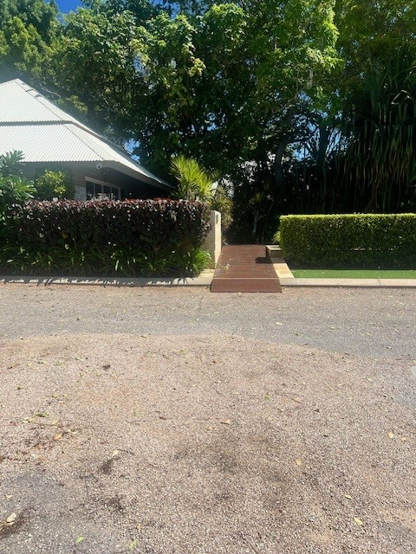
Accessibility Photos Carpark 1
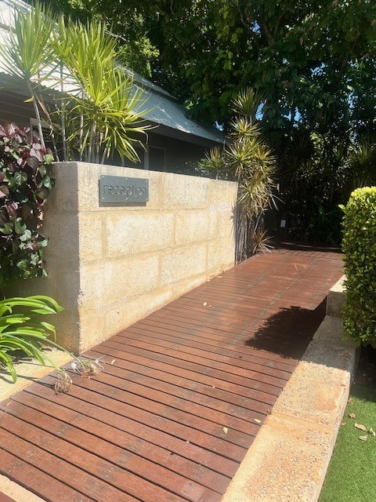
Accessibility Photos Carpark Ramp
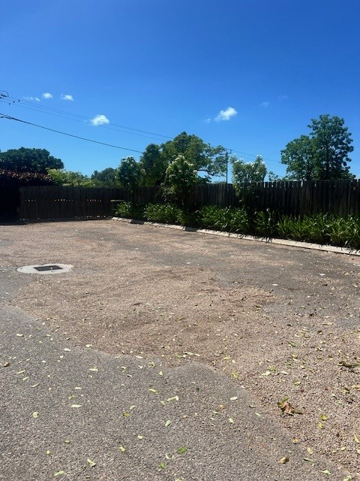
Accessibility Photos Carpark
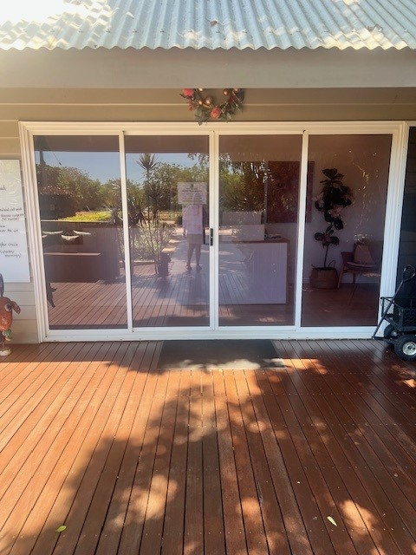
Accessibility Photos Reception
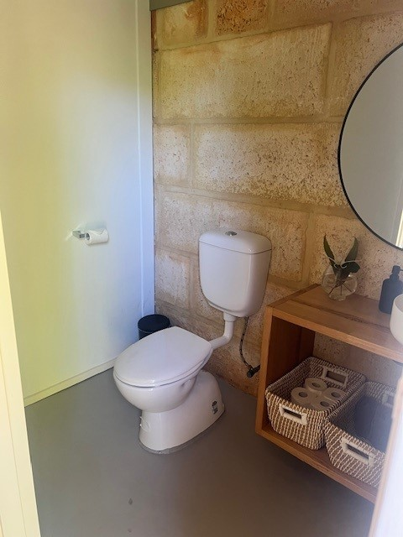
Accessibility Photos Unisex Toilet

Report Disclaimer
Please note that this business report, provided as a result of the use of the diagnostic assessment, is for information purposes only.
Australian Tourism Industry Council (ATIC) cannot guarantee the accuracy of respondent’s answers, or that they are fully representative of your business. Therefore, ATIC does not warrant or guarantee any particular outcome in respect of your businesses self-assessment.
This report is intended as guidance only for your business and should not be relied on for future marketing considerations. ATIC recommends that you seek your own independent advice as well as the results from the diagnostic.
Links to external web sites are inserted for convenience and do not constitute endorsement of material at those sites, or any associated organisation, product or service.
ATIC does not:
- Assume any legal liability for the accuracy, completeness, or usefulness of any information from this report or any links provided; or
- Accept responsibility for any loss associated directly or indirectly from the use of this report.

