ATIC Accessibility
To support the accessible community in making informed travel decisions for their individual needs

This report prepared for:
Business name: | Shine Aviation Services
Address: | Shine Aviation Terminal - 71 Gordon Garratt Drive
Town: | Geraldton
Contact for enquiries: | Alison Gooch
Contact Number: | 08 9923 3600
Contact Email: | reception@shineaviation.com.au
Website: | http://www.shineaviation.com.au
Date: | 2026-09-16 15:00

ATIC Accessibility
The following pages provides travellers with information on the businesses facilities and amenities which aims to support the traveller to make an informed decision on whether the business is suitable for their individual needs.
OVERVIEW 4
Business Overview 4
Bookings 4
Emergency Management 4
Other Information 5
GENERAL 6
Pre-arrival, arrival and reception 6
Car Park and Access amenities 6
Entry 6
Internal Spaces 7
Public areas 7
Displays, exhibits, commentary and live performances 7
External Paths 7
Ramps 7
Public Toilets/Adult change facilities 8
TOUR OPERATORS 9
Route Planning 9
Guides 9
ADVENTURE ACTIVITIES 12
Report Disclaimer 14

OVERVIEW

Business Overview

The business has the following products/services available
- Tour/Transport

Our business caters for the following disability types:
- Limited mobility
- Wheelchairs or mobility scooters
- Food allergies or intolerances

Bookings

The business offers the following methods for bookings and enquiries:
- Phone
- Email
- Webportal

Emergency Management
- Emergency and evacuation procedures are explained on arrival
- There are Audible device/s to alert occupants to evacuate with instructions on how to evacuate.
- Exit signs are clear and easy to see
- Exit access is free and clear at all times
We ensure exit access is free and clear at all times by:
Observation
- Exits and access to exists are greater than 900mm
- Exit doors are able to be opened by all occupants
- The evacuation point is clearly marked by a sign
- In addition, the following further information can assist guests:
Visitor Register
- In addition, the following further information can assist guests:
Man power

Other Information
- For bookings made onsite, the ticket booth/counter/box office is accessible for people using a wheelchair
The business provides the following services for services animals:
Nil

GENERAL

Pre-arrival, arrival and reception
The business has the following in place to support guests during pre-arrival, arrival and reception
- There is a reception/public entryway.
- Seating available at reception
- A clipboard to allow check-in/ticket purchase whilst seated
- A tablet with text to voice or pen and paper at reception to aid in communication
- Lighting in the reception area is even and glare free
- Information and maps are available in written form
- A familiarisation tour
- In addition, the following further information can assist guests:
Nil

Car Park and Access amenities
The business has the following Car Park and Access amenities
- A drop off zone
- Designated disabled parking bays
- Level or ramped access from the car park to the entrance

Entry
The business has the following amenities/systems in place for entry
- A drop off point close to the entrance
- A path of access to the building is slip resistance and even
- A path of access to the building is clear of obstruction
- Glass doors are fitted with a visual sighting strip
- Door jams/doors are of a contrasting colour to surrounding walls
- Door handles are of a contrasting colour to the door
- Signage is written in a contrasting colour
- The entry door is a minimum of 850mm wide
- There a clear space of at least 1500mm x 1500mm in front of all doors.
- The entrance door mats have a thickness less than 13mm and a width of 7500mm or greater

Internal Spaces
- Clear and unobstructed routes through and between buildings
- Interior walls are matte or low sheen
- Floors, walls, counters and furniture are of contrasting colours
- Floor surfaces are hard or short pile carpet
- Seating is available for guests unable to stand for long periods
- All corridors greater than 900mm

Public areas
The public areas have the following amenities in place
- Even lighting
- Seating

Displays, exhibits, commentary and live performances
For displays, exhibits, commentary and live performances the following amenities are in place
- Seating
- Wheelchair accessible spaces/seating

External Paths
External paths of travel
- Surfaces are concrete, asphalt, smooth paving or hard packed fine gravel (max aggregate size 13mm)
- Pathways are wider than 900mm

Ramps
Ramps have the following amenities are in place
- There are ramps.
- All fixed ramps are 1:14 or less
- Long ramps (more than 10m) are 1:20 or less

Public Toilets/Adult change facilities
Public Toilets/Adult change facilities have the following amenities are in place
- There is an accessible toilet for public use
- The door is at least 850mm wide
- There is a minimum of 850mm beside the toilet
- Handrails are fitted
- The toilet seat is 460mm above the floor
- There is 2 metres mm of clear space in front of the toilet
- The toilet seat of a contrasting colour to the floor
- The toilet seat is460mm above the floor
- There is a registered changing places facility
- There is a 'Changing Place' within 2 metres of our business

TOUR OPERATORS

Route Planning
- In addition, the following further information can assist guests:
N/A
- Walking Tours
- Operated on a step free route
- Multi-paced to account for slower walkers

Guides

Guides have been trained in the following
- Use of clear/simple English
- Correct pronunciation for lip readers
- There is a audio description of surroundings
  - Image(s)
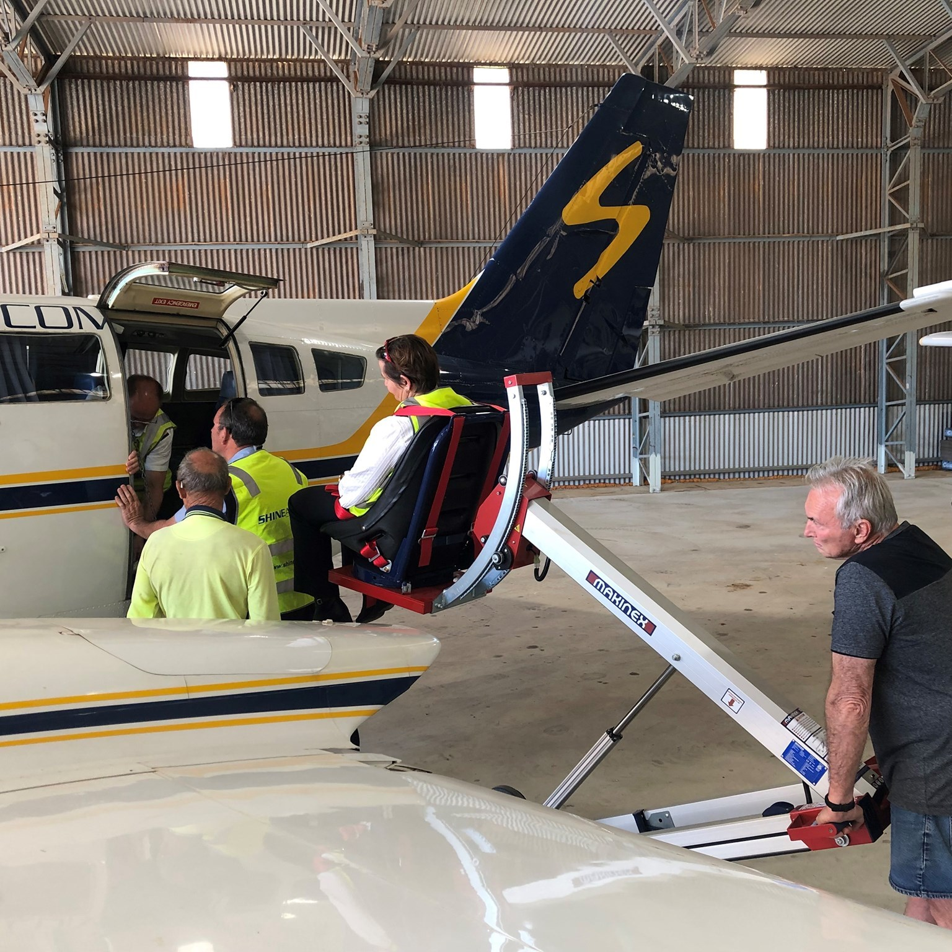
Chair lift

ADVENTURE ACTIVITIES
- In addition, the following further information can assist guests:
Abrolhos Islands tours
- In addition, the following further information can assist guests:
Chair lift, wheel chair, beach chair
- In addition, the following further information can assist guests:
N/A

Report Disclaimer
Please note that this business report, provided as a result of the use of the diagnostic assessment, is for information purposes only.
Australian Tourism Industry Council (ATIC) cannot guarantee the accuracy of respondent’s answers, or that they are fully representative of your business. Therefore, ATIC does not warrant or guarantee any particular outcome in respect of your businesses self-assessment.
This report is intended as guidance only for your business and should not be relied on for future marketing considerations. ATIC recommends that you seek your own independent advice as well as the results from the diagnostic.
Links to external web sites are inserted for convenience and do not constitute endorsement of material at those sites, or any associated organisation, product or service.
ATIC does not:
- Assume any legal liability for the accuracy, completeness, or usefulness of any information from this report or any links provided; or
- Accept responsibility for any loss associated directly or indirectly from the use of this report.

