ATIC Accessibility
To support the accessible community in making informed travel decisions for their individual needs

This report prepared for:
Business name: | Newy Food Adventures
Address: | 171 Old Maitland Road
Town: | Hexham
Contact for enquiries: | Jessica Butler
Contact Number: | 0477701729
Contact Email: | hello@newyfoodadventures.com.au
Website: | NA
Date: | 2026-10-03 09:23

ATIC Accessibility
The following pages provides travellers with information on the businesses facilities and amenities which aims to support the traveller to make an informed decision on whether the business is suitable for their individual needs.
OVERVIEW 3
Business Overview 3
Bookings 5
Emergency Management 5
Guide Dog and Service Animals 5
GENERAL 6
Cognitive Impairment Support 6
External Paths 6
TOUR OPERATORS 7
Route Planning 7
Guides 7
FOOD AND DRINK 8
Dining Spaces 8
Report Disclaimer 10

OVERVIEW

Business Overview

The business has the following products/services available
- Tour/Transport
- Food and Drink

Our business caters for the following disability types:
- Blind or low vision
- Deaf or low hearing
- Limited mobility
- Wheelchairs or mobility scooters
- Food allergies or intolerances
- Cognitive or people on the Autism Spectrum
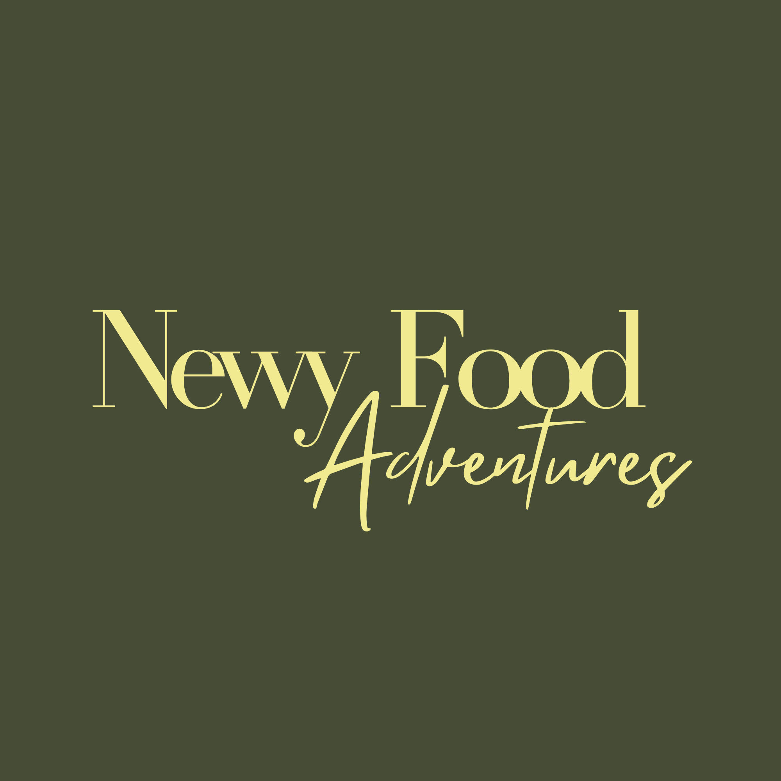

Bookings

The business offers the following methods for bookings and enquiries:
- Phone
- Email
- Webportal
- Our forms have high contract boxes and submit boxes

Emergency Management
- Emergency and evacuation procedures are explained on arrival
- In addition, the following further information can assist guests:
Yes
- In addition, the following further information can assist guests:
If a guest is unable to evacuate independently, our guide stays with them at the nearest safe point (or area of refuge, where the venue has one) while alerting venue staff and, where required, emergency services to their exact location, the guest is never left alone. Where tour support is present, one guide continues assisting the rest of the group while the other remains with the guest requiring assistance.

Guide Dog and Service Animals
The business provides the following services for services animals:
Assistance animals are welcome on every tour, at every stop, with their handler — including venues where food is served, consistent with our obligations under the Disability Discrimination Act 1992. We ensure water is available on request at any stop, and can identify shaded rest points along the route where needed. Routes are already designed to be mostly flat with manageable footing, which also supports guests travelling with an assistance animal. We don't currently offer a dedicated designated rest area at each stop — this is an area we're looking to formalise as part of maturing our broader accessibility planning

GENERAL
- In addition, the following further information can assist guests:
Our tours are already structured in a way that limits fatigue: total walking time is around 45–60 minutes spread across a 4-hour tour, with guests seated at each food stop rather than standing throughout. Story stops (where we pause for context without food or drink) are also brief and don't require standing for extended periods. Where a guest has flagged a fatigue-related need at booking, we can adjust pacing, sit that guest first, or provide extra recovery time between stops

Cognitive Impairment Support
- Documents are available in plain English for people with cognitive impairment (This may include instructions, guides, menus and general information)

External Paths
External paths of travel
- Surfaces are concrete, asphalt, smooth paving or hard packed fine gravel (max aggregate size 13mm)
The width of the smallest pathway is:
Yet to be assessed however we access public paths maintained by Newcastle City Council
- In addition, the following further information can assist guests:
As we operate across a range of independently-owned venues rather than a fixed premises, toilet facilities (including accessible toilets) are provided by each venue rather than by Newy Food Adventures directly. We haven't yet formally confirmed which stops have accessible toilet facilities on-site, and this is something we'd like to check and document as part of our broader venue-by-venue accessibility review.

TOUR OPERATORS

Route Planning
- Walking Tours
- Multi-paced to account for slower walkers
- Hearing aid compatible

Guides

Guides have been trained in the following
- Use of clear/simple English
- Correct pronunciation for lip readers
- In addition, the following further information can assist guests:
Explore Throsby: Wickham &amp; CarringtonVenueRole on tourWebsiteThe Tree of KnowledgeStart point— public landmark, no websiteFlatfish CaféFood stopflatfishcafe.square.siteNewcastle Fish Co-OpStory stop (no food)www.fishcoop.com.au
NYC (Newcastle Cruising Yacht Club / Nautica Dining)Food stopncyc.net.auThe Pav Kitchen (The Pavilion Kitchen)Food stopwww.pavkitchen.comJen Smiths CheesecakeFood stopwww.jensmith.com.auInner City WinemakersFood stopwww.innercitywinemakers.com.auEarp Distilling CoFood stopwww.earpdistillingco.com●ROUTE 2
Explore Throsby: Maryville, Tighes Hill &amp; IslingtonVenueRole on tourWebsiteBaked Uprising (Uprising Bakery)Start / food stopwww.bakeduprising.com.auMaryville TavernFood stopwww.maryvilletavern.comPraise Joe BakeryFood Stopwww.praisejoe.com.auThe Oak, Tighes Hill (Royal Oak Hotel)Food stopNo website Instagram only (@theoak.tigheshill)Islington BarracksFood stopwww. islingtonbarracks.com.au

FOOD AND DRINK

Dining Spaces
The dining spaces have the following facilities/amenities in place
- The entrance has level access
- The smallest doorway is Unknown as we visit private venues wide
- There is an accessible toilet

Our business caters for the following dietary requirements
- Gluten free (celiac)
- Lactose free (dairy free)
- Nut free
- Vegetarian
- Vegan
- In addition, the following further information can assist guests:
As we don't operate our own kitchen, food preparation and cross-contamination control sits with each independent venue, consistent with their own food safety obligations. Our role is to make sure venues have clear, advance notice of every guest's dietary requirement flagged at the time of booking via Rezdy, confirmed directly with each venue in the days before the tour, and checked again with the group at the start of the tour as a second safeguard. This gives each venue the lead time needed to prepare separately or take appropriate precautions (e.g. using clean equipment, separate prep areas) according to their own food safety procedures. We haven't yet formally confirmed each venue's specific cross-contamination protocols (e.g. dedicated gluten-free equipment, allergen-separated prep areas), this is a natural addition to the venue-by-venue accessibility conversations already flagged in the Emergency Evacuation Plan and Venue Directory.

Report Disclaimer
Please note that this business report, provided as a result of the use of the diagnostic assessment, is for information purposes only.
Australian Tourism Industry Council (ATIC) cannot guarantee the accuracy of respondent’s answers, or that they are fully representative of your business. Therefore, ATIC does not warrant or guarantee any particular outcome in respect of your businesses self-assessment.
This report is intended as guidance only for your business and should not be relied on for future marketing considerations. ATIC recommends that you seek your own independent advice as well as the results from the diagnostic.
Links to external web sites are inserted for convenience and do not constitute endorsement of material at those sites, or any associated organisation, product or service.
ATIC does not:
- Assume any legal liability for the accuracy, completeness, or usefulness of any information from this report or any links provided; or
- Accept responsibility for any loss associated directly or indirectly from the use of this report.

