ATIC Accessibility
To support the accessible community in making informed travel decisions for their individual needs

This report prepared for:
Business name: | Benambra Boutique Accommodation Queenscliff
Address: | 15 Hesse Street
Town: | Queensliff
Contact for enquiries: | Belinda Kehoe
Contact Number: | 0448643440
Contact Email: | Belinda@benambraqueenscliff.com
Website: | www.benambraqueenscliff.com
Date: | 2026-09-30 06:14

ATIC Accessibility
The following pages provides travellers with information on the businesses facilities and amenities which aims to support the traveller to make an informed decision on whether the business is suitable for their individual needs.
OVERVIEW 4
Business Overview 4
Bookings 6
Emergency Management 6
Communications 7
Guide Dog and Service Animals 7
GENERAL 9
Pre-arrival, arrival and reception 9
Cognitive Impairment Support 9
External Paths 9
Steps 9
ACCOMMODATION 11
Room Amenities 11
Bathrooms 12
COMMON AREAS 14
FOOD AND DRINK 15
Report Disclaimer 17

OVERVIEW

Business Overview

The business has the following products/services available
- Accommodation

Our business caters for the following disability types:
- Deaf or low hearing
- Limited mobility
- Food allergies or intolerances
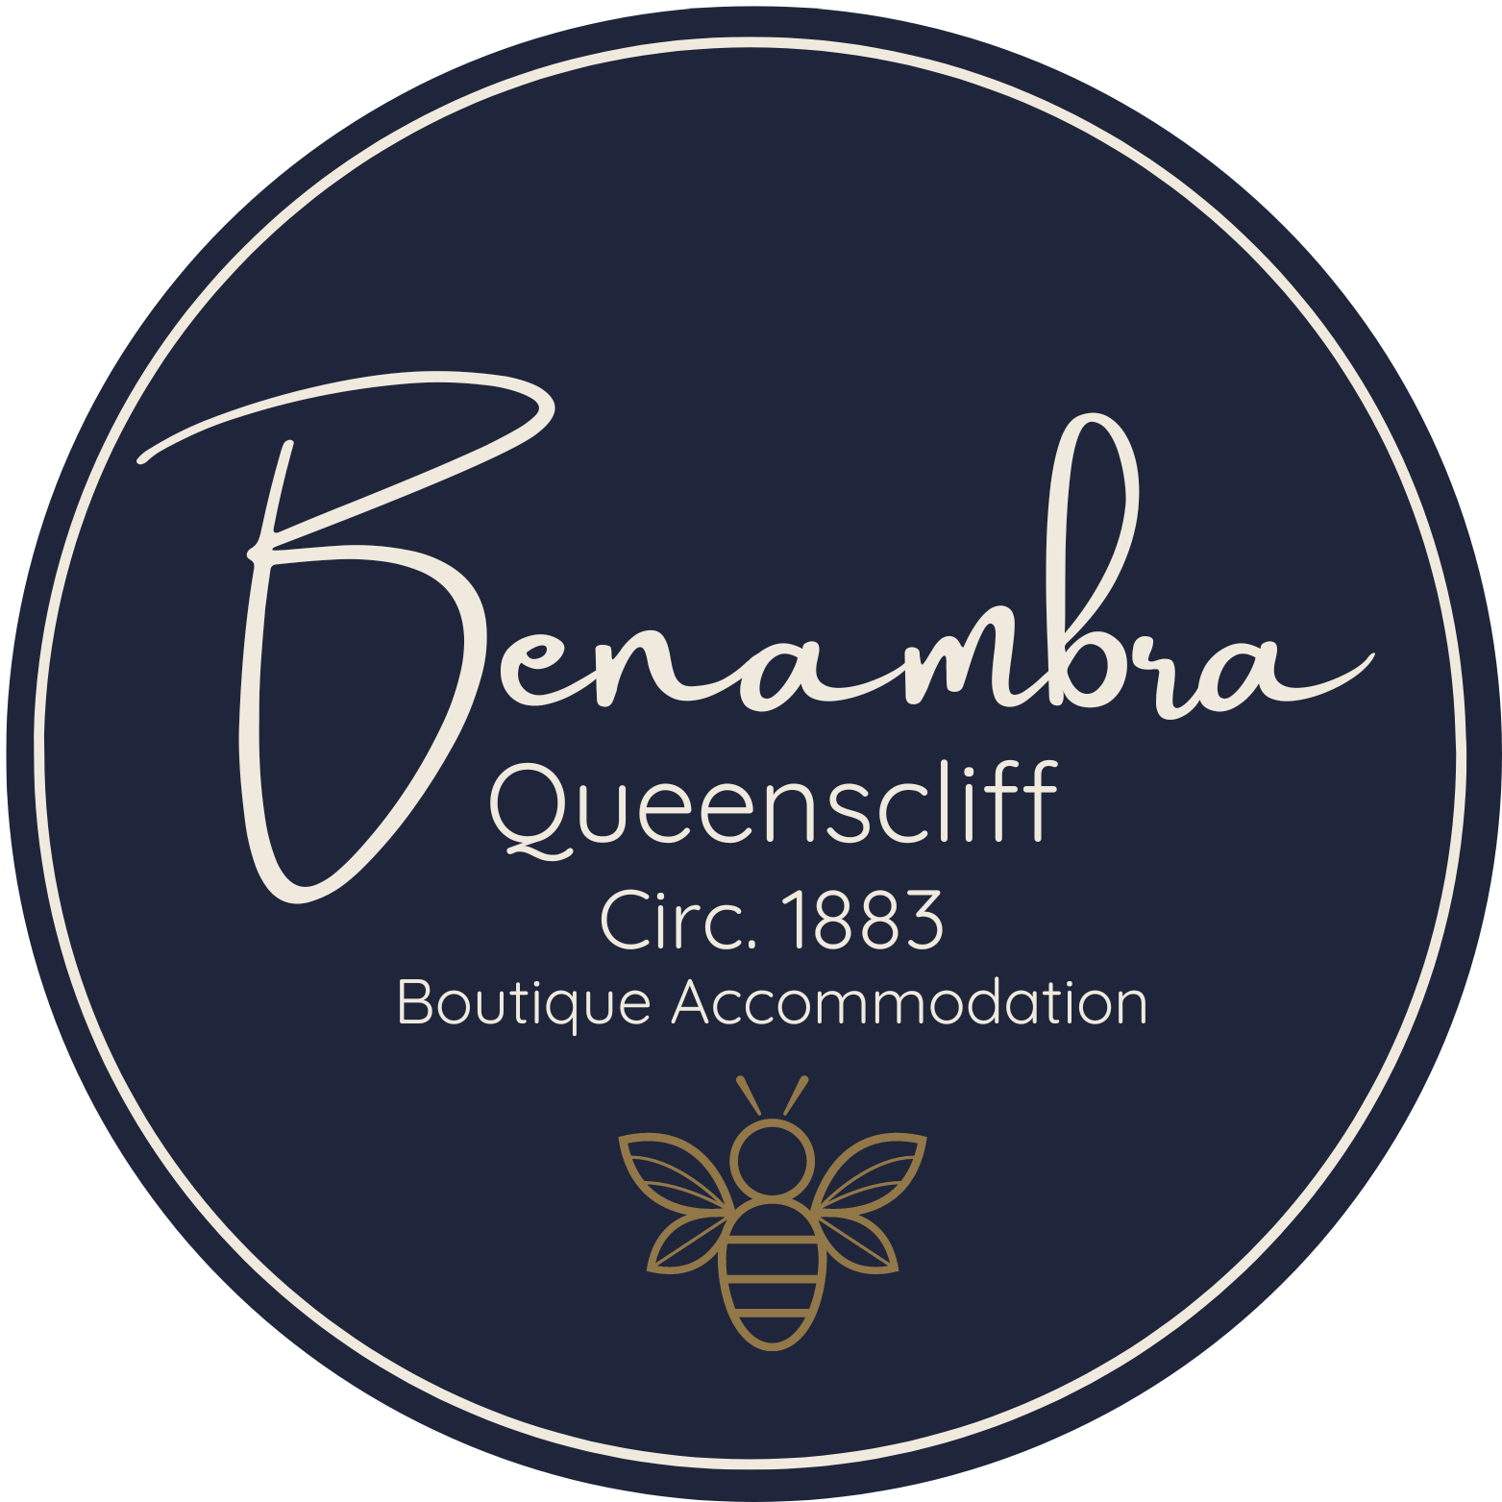

Bookings

The business offers the following methods for bookings and enquiries:
- Phone
- Email
- Webportal
- Our forms have high contract boxes and submit boxes

Emergency Management
- There are Audible device/s to alert occupants to evacuate with instructions on how to evacuate.
- There are visual device/s to alert occupants to evacuate.
- Exit signs are clear and easy to see
- Exit access is free and clear at all times
We ensure exit access is free and clear at all times by:
Hallways and exits are always free and clearly marked
- Exits and access to exists are greater than 900mm
- Exit doors are able to be opened by all occupants
- Exits to the emergency evacuation point does not include stairways
- The evacuation point is clearly marked by a sign
- In addition, the following further information can assist guests:
Identifying Guests Who May Need Additional Assistance in an Emergency At Benambra, all guests complete a digital check-in form via our Guesty App, which includes an optional section to disclose any special needs or mobility concerns. This helps us discreetly identify guests who may require extra support in an emergency. We follow up with all guests via SMS or app messaging and encourage them to let us know if they need assistance. Emergency procedures are clearly displayed in rooms, and as on-site hosts, we're available to respond promptly if needed.
- In addition, the following further information can assist guests:
Call 000 Immediately If a guest requires urgent assistance or is unable to evacuate safely, call 000 without delay. Provide the operator with the property address (Benambra Boutique Accommodation, 15 Hesse Street, Queenscliff VIC) and explain the nature of the emergency, including any mobility or medical concerns. Alert Other On-Site Personnel Notify other household members or staff on-site (if applicable) to ensure everyone is aware of the situation and can assist if needed, while one person remains in contact with emergency services. Assess Safety Before Assisting If safe to do so, locate the guest requiring assistance. Check for hazards (e.g., smoke, fire, structural instability) and never place yourself at risk. Provide Reassurance Stay calm and speak clearly. Reassure the guest that help is on the way and that they are not alone. Assist with Evacuation (if safe) If the guest is mobile but requires help, assist them to the nearest safe exit. Use handrails, walking aids, or wheelchairs if available. If the guest is non-mobile and cannot be moved safely, stay with them (if possible), keep doors closed to limit smoke/fire exposure, and relay their exact location to emergency responders. Meet Emergency Responders Send someone to meet emergency services at the entrance and guide them directly to the guest in need of assistance. Document the Incident After the situation is resolved, document the incident clearly, including time of call, guest name, nature of assistance required, and any actions taken.
- Guests with disabilities are noted in the guest log book for emergency and evacuation purposes

Communications
- Our business offers the following alternative communication methods
- Plain English

Not specified
- There is easy to read signage and information (e.g. menus and emergency information)

Welcome card on arrival

Guide Dog and Service Animals
- The business provides a secure area with shade and water for service animals
- The business provides a toilet area for service animals
The business provides the following services for services animals:
Our services include: 🐾 Service Animal Welcome Certified service animals are welcome in all guest rooms and common areas. There are no additional cleaning fees or restrictions applied to guests with assistance animals. 🦴 Pet Comforts on Request We can provide a pet mat, water bowl, and treats on request to make your service animal feel at home. 🌿 Outdoor Relief Areas Benambra’s garden areas and nearby public green spaces provide suitable spots for service animals to stretch and take breaks. A map of nearby pet-friendly walking routes is available in our digital and in-room guest handbook. 📖 Clear Information Guests travelling with service animals receive specific arrival instructions and information about access, house rules, and nearby veterinary services (if needed) via our digital Guest App and pre-arrival messages. 🛎️ Discreet Assistance We respect the privacy and independence of guests with service animals. However, if additional support or tailored arrangements are required, our team is happy to assist—just let us know in advance or at check-in.

GENERAL

Pre-arrival, arrival and reception
The business has the following in place to support guests during pre-arrival, arrival and reception
- Information and maps are available in written form
- A familiarisation tour
- Luggage assistance
- In addition, the following further information can assist guests:
To support guests with fatigue-related disabilities, we offer flexible check-in options, clear pre-arrival instructions, and fast, low-contact access via our smart lock system to minimise wait times and reduce physical or cognitive strain.

Cognitive Impairment Support
- Documents are available in plain English for people with cognitive impairment (This may include instructions, guides, menus and general information)
- In addition, the following further information can assist guests:
No Carparking available on site

External Paths
External paths of travel
- Surfaces are concrete, asphalt, smooth paving or hard packed fine gravel (max aggregate size 13mm)
- Pathways are wider than 900mm
- There 3 successive steps or less on any path or at any doorway

Steps
Steps
- There are steps.
- All steps or staircases have enclosed risers
- The underside of all staircases are enclosed or protected to a height of at least 2 metres
- Where steps are present are there three steps or less
- In addition, the following further information can assist guests:
There are 2 steps to access the property only. No internal steps

ACCOMMODATION

Room Amenities
- In addition, the following further information can assist guests:
While our rooms are not fitted with visual alarm systems, we have procedures in place to ensure the safe evacuation of guests with hearing impairments:

Guests are encouraged to notify us of any hearing impairment during the booking or check-in process so we can provide personalised support.

In the event of an emergency, we will make direct, in-person contact with the guest to alert them and guide them to safety.

Emergency exit maps are provided in all rooms, and staff are trained to check each room and assist guests with additional needs during evacuation.

Our small scale and on-site hosting ensure rapid response and personal assistance when required.

- Televisions are equipped with closed captioning capability
- There is a clear path through the room
- Doors open fully against the adjoining wall
- There is a clear opening at least 850mm wide
- There luggage racks for at least two suitcases
- Wardrobe and drawer handles are easy to grip
- The bedside lamp switch is easy to reach from the bed
- There is at least 850mm clear space beside the bed
- The business offers a range of non-allergenic bedding
- Non-allergenic cleaning products are used
- In addition, the following further information can assist guests:
nil

Bathrooms
The bathrooms have the following facilities/amenities in place
- All heating appliances and hot water pipes are protected or insulated
- All shower, bath and basin taps are clearly differentiated between hot and cold
- The door is at least 850mm wide
- The width beside the toilet is not greater .
- There is Varies from room to room mm of clear space in front of the toilet
- The toilet seat is 460mm above the floor
- A door is fitted to the shower
  - Bathroom Image(s)
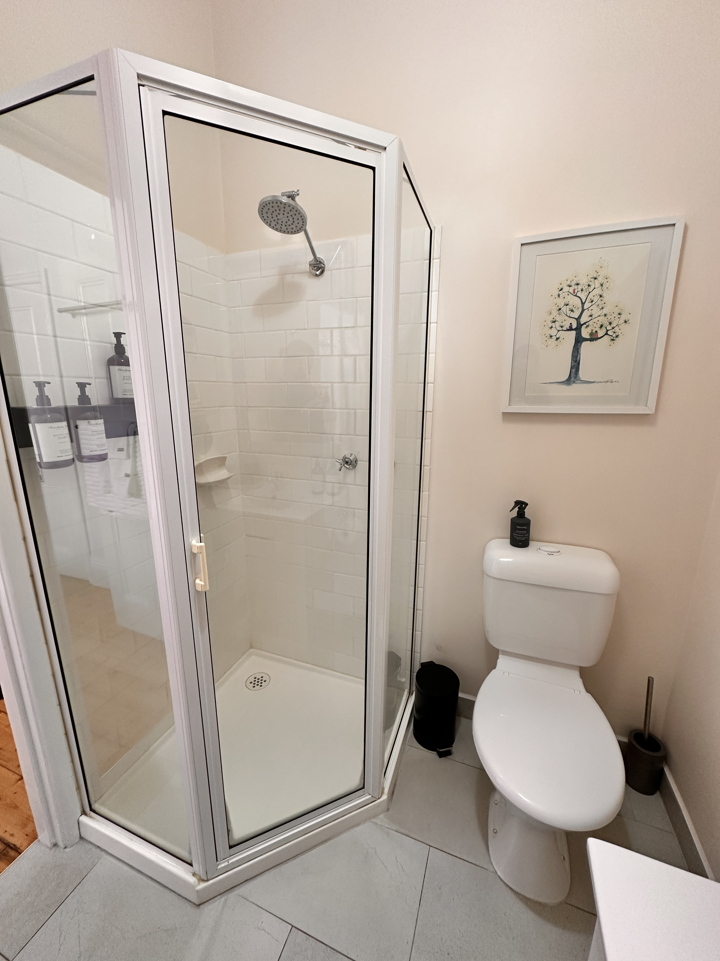
3a.Rosebud.JPG
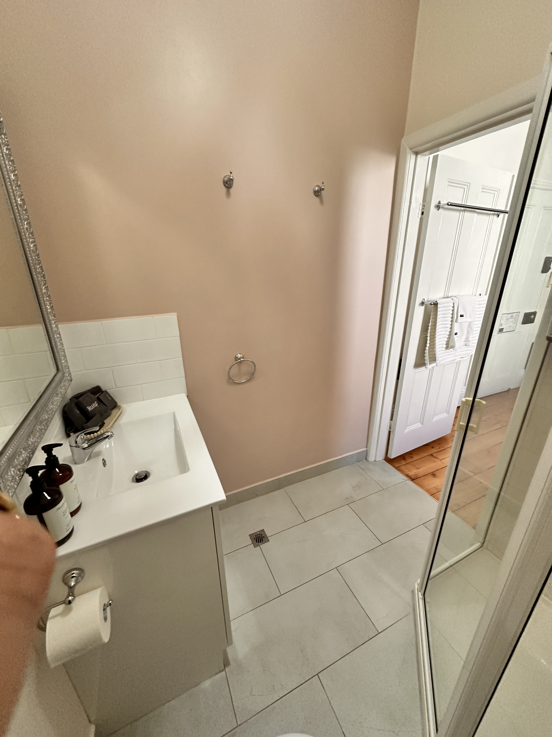
3b.Rosebud.JPG
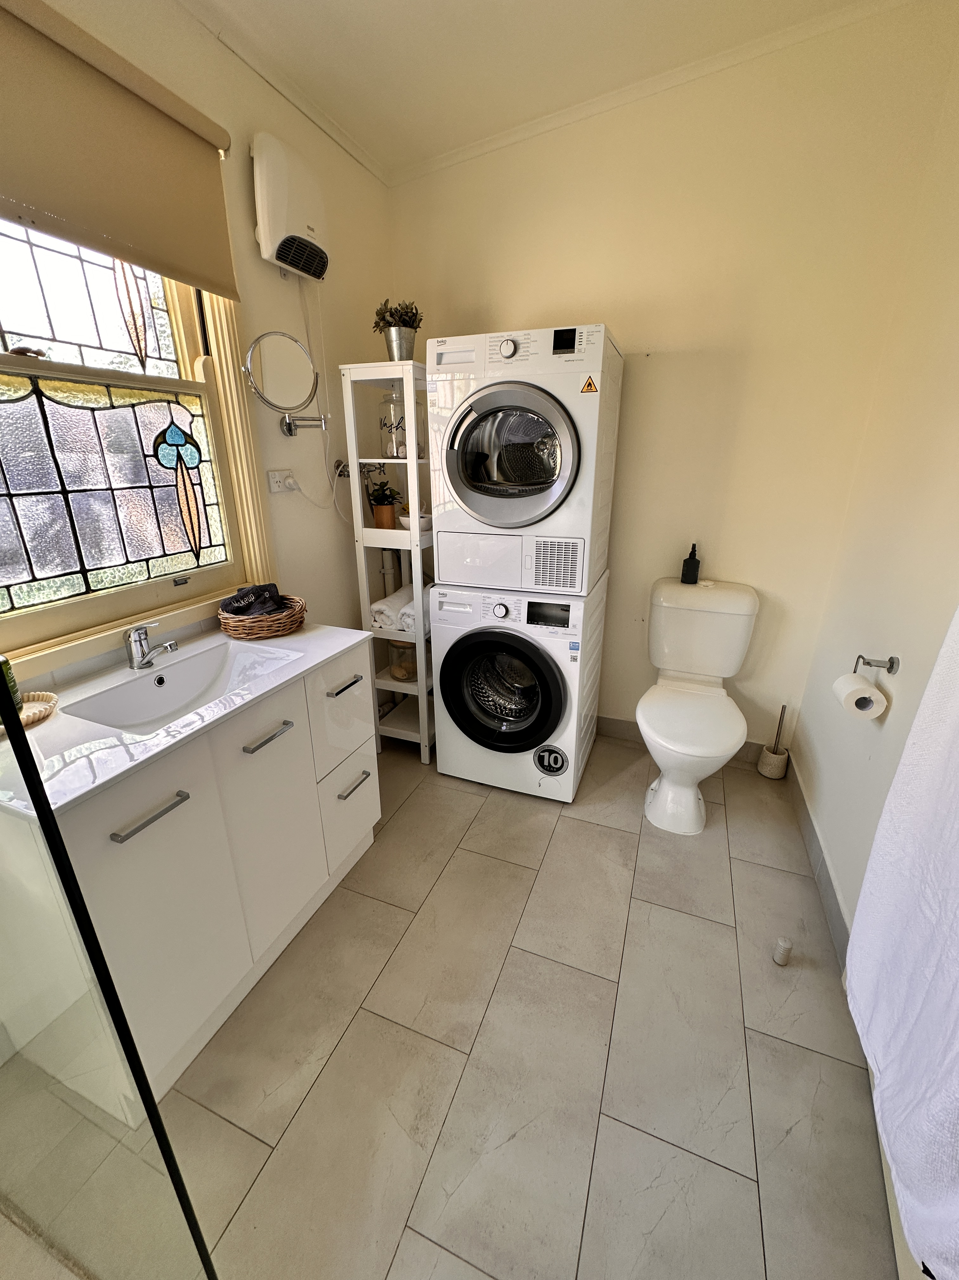
1b.Cottage.JPG
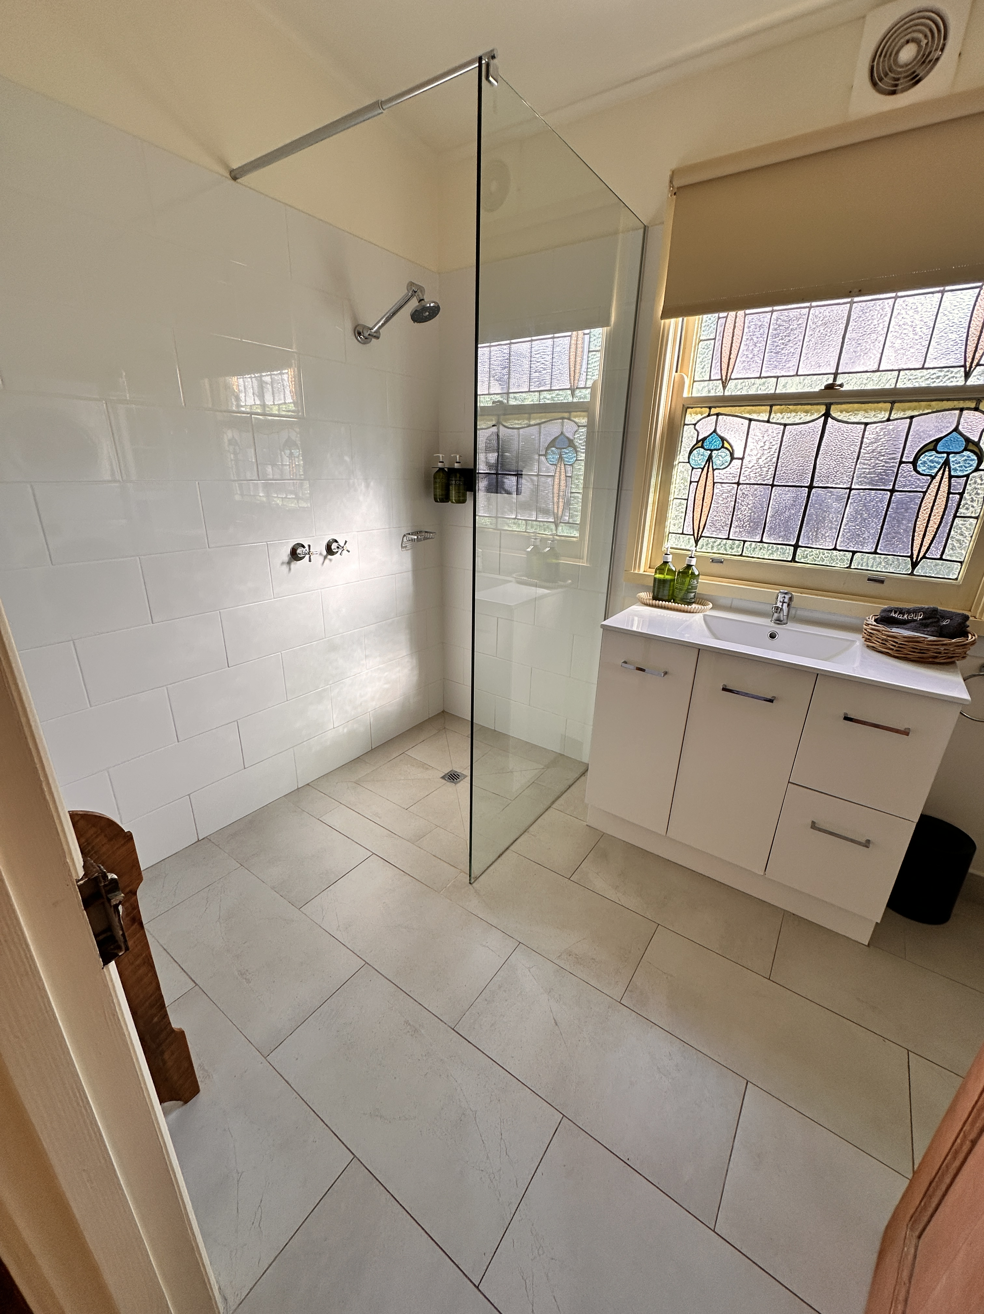
1a. Cottage.JPG
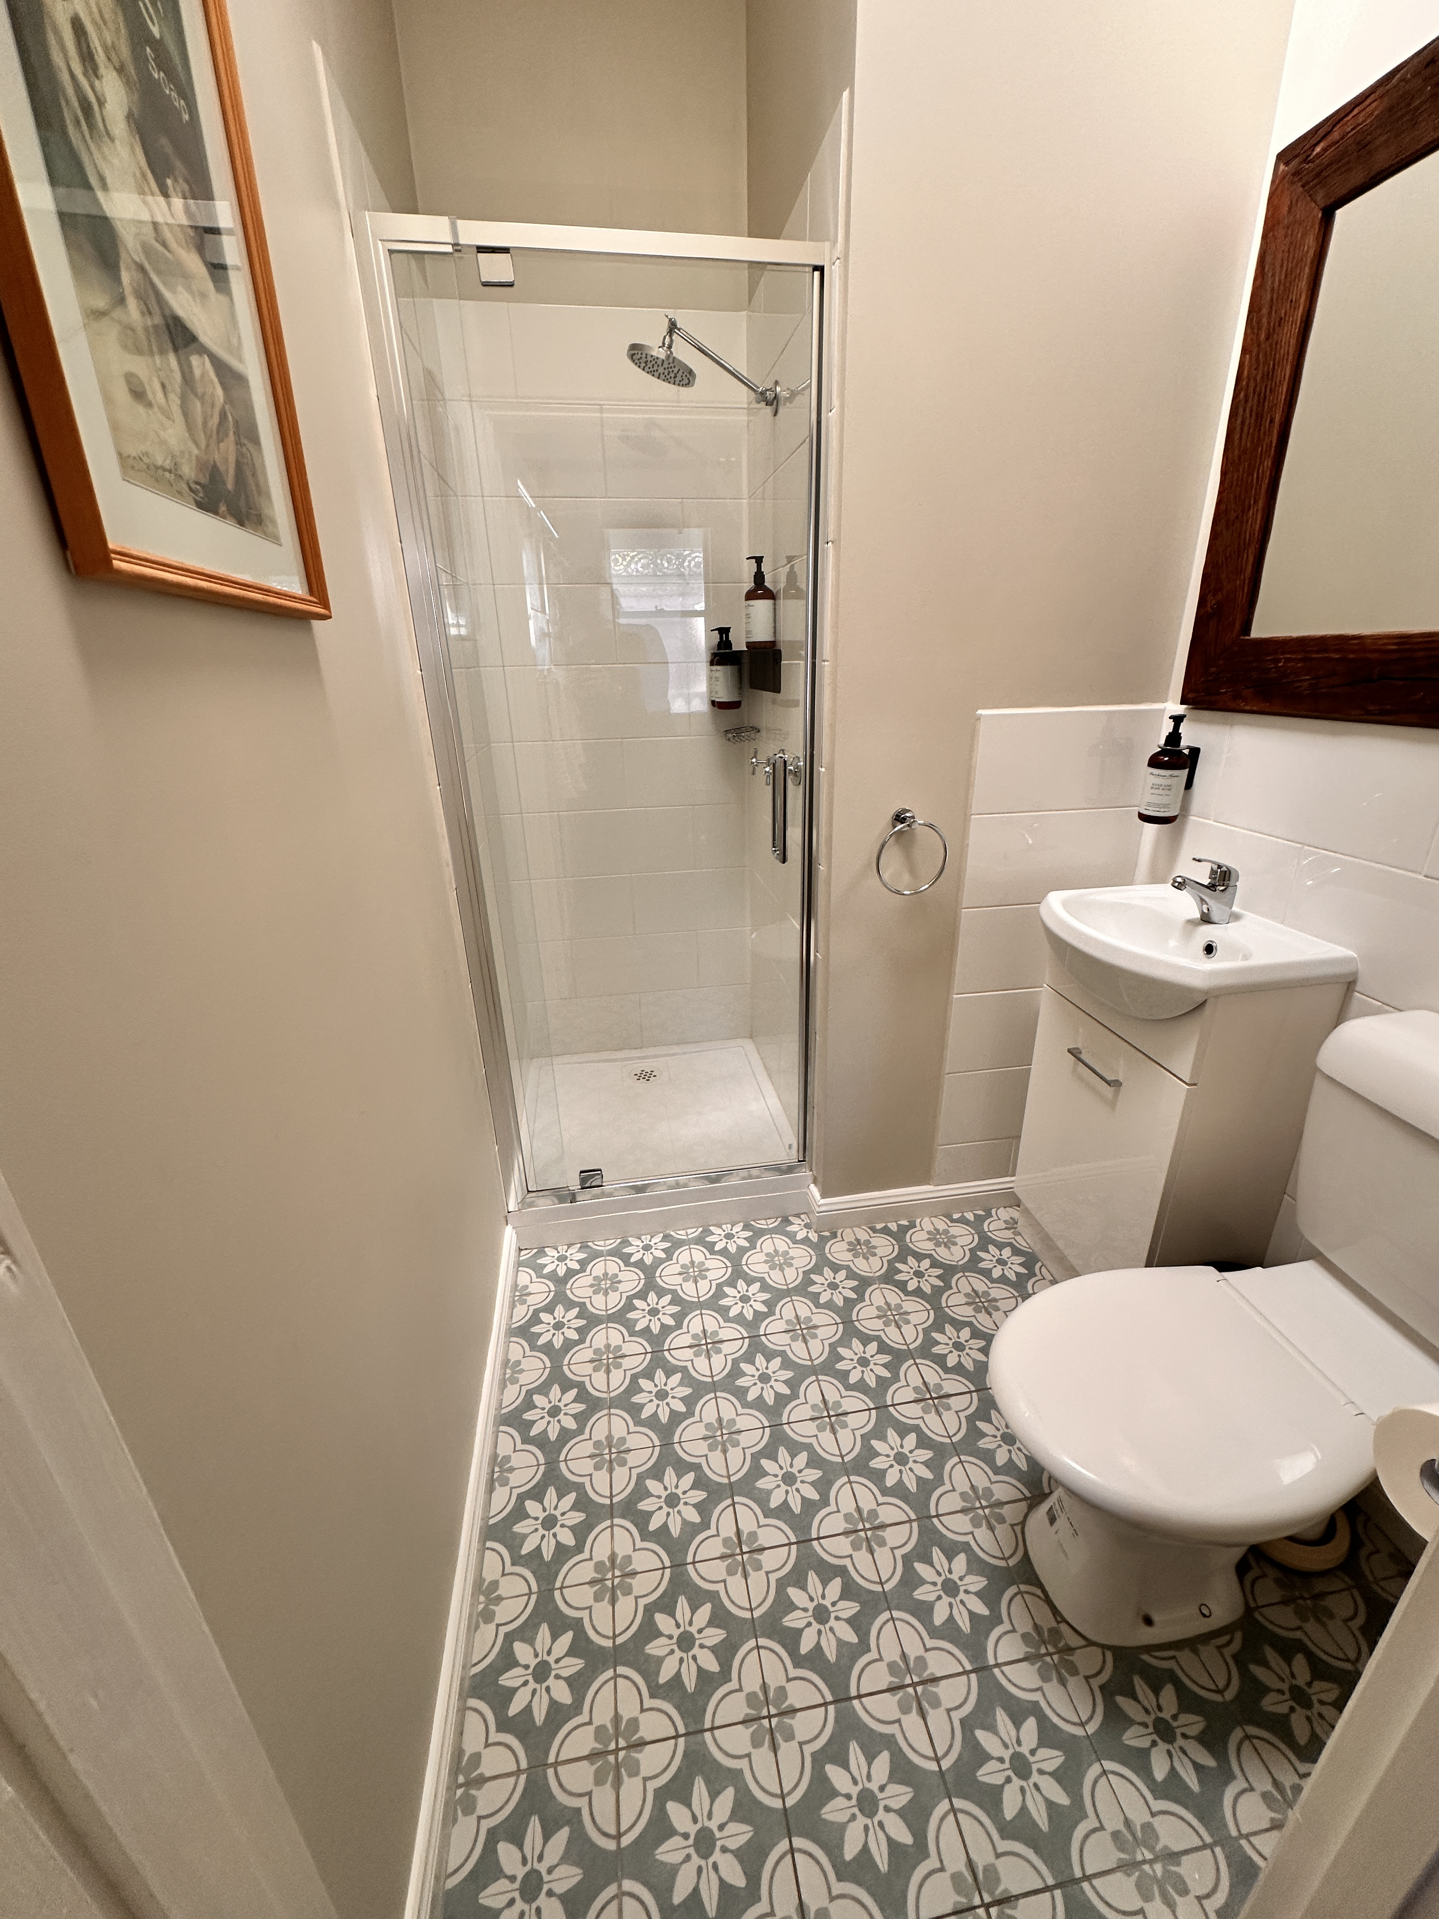
2.Londsale.JPG

COMMON AREAS

FOOD AND DRINK

Report Disclaimer
Please note that this business report, provided as a result of the use of the diagnostic assessment, is for information purposes only.
Australian Tourism Industry Council (ATIC) cannot guarantee the accuracy of respondent’s answers, or that they are fully representative of your business. Therefore, ATIC does not warrant or guarantee any particular outcome in respect of your businesses self-assessment.
This report is intended as guidance only for your business and should not be relied on for future marketing considerations. ATIC recommends that you seek your own independent advice as well as the results from the diagnostic.
Links to external web sites are inserted for convenience and do not constitute endorsement of material at those sites, or any associated organisation, product or service.
ATIC does not:
- Assume any legal liability for the accuracy, completeness, or usefulness of any information from this report or any links provided; or
- Accept responsibility for any loss associated directly or indirectly from the use of this report.

