ATIC Accessibility
To support the accessible community in making informed travel decisions for their individual needs

This report prepared for:
Business name: | Ocean Eco Adventures
Address: | 2 Ross Street Mall
Town: | Exmouth
Contact for enquiries: | James Small
Contact Number: | (08) 9949 1208
Contact Email: | info@oceanecoadventures.com.au
Website: | www.oceanecoadventures.com.au
Date: | 2026-09-13 10:42

ATIC Accessibility
The following pages provides travellers with information on the businesses facilities and amenities which aims to support the traveller to make an informed decision on whether the business is suitable for their individual needs.
OVERVIEW 4
Business Overview 4
Bookings 4
Emergency Management 4
Communications 5
Other Information 5
Guide Dog and Service Animals 5
GENERAL 6
Pre-arrival, arrival and reception 6
Cognitive Impairment Support 6
Car Park and Access amenities 6
Entry 7
Internal Spaces 7
Public areas 8
Displays, exhibits, commentary and live performances 9
Steps 11
TOUR OPERATORS 13
Tour/Transport Services 13
Route Planning 13
Guides 14
Report Disclaimer 19

OVERVIEW

Business Overview

The business has the following products/services available
- Tour/Transport

Our business caters for the following disability types:
- Deaf or low hearing
- Limited mobility
- Wheelchairs or mobility scooters
- Food allergies or intolerances
- Cognitive or people on the Autism Spectrum


Bookings

The business offers the following methods for bookings and enquiries:
- Phone
- Email
- Webportal
- Our forms have high contract boxes and submit boxes

Emergency Management
- Emergency and evacuation procedures are explained on arrival
- There are visual device/s to alert occupants to evacuate.
- Exits and access to exists are greater than 900mm
- In addition, the following further information can assist guests:
all guests on our tours have questions asked about about if they have any health conditions that could affect them on tour during the booking process. we also have a pre arrival waiver form that must be filled out by each guest that tells us if they need any extra assistance.
- In addition, the following further information can assist guests:
All guests that need assistance have been identified by crew members as soon as tour begins. this information is then given to all crewmembers so they are made aware of who needs extra assistance.
- Guests with disabilities are noted in the guest log book for emergency and evacuation purposes

Communications
- Our business offers the following alternative communication methods
- Plain English

Not specified
- There is easy to read signage and information (e.g. menus and emergency information)

Other Information
- For bookings made onsite, the ticket booth/counter/box office is accessible for people using a wheelchair

Guide Dog and Service Animals
The business provides the following services for services animals:
Accredited assistance animals are welcome in line with Australian law. Due to the nature of our offshore marine environment, we assess suitability on a case-by-case basis to ensure the safety of guests, crew, and the animal.

GENERAL

Pre-arrival, arrival and reception
The business has the following in place to support guests during pre-arrival, arrival and reception
- Information and maps are available in written form
- In addition, the following further information can assist guests:
We operate small-group tours with strictly limited passenger numbers (maximum 50 guests for Sunset Whale Watching, 23 for Whale Shark tours, and 12 for our Coral Bay Exclusive experience), which naturally minimises wait times and avoids long queues.

Guests are checked in efficiently, and boarding is managed in a structured and timely manner. Where appropriate, we prioritise boarding for guests with mobility challenges or fatigue-related conditions to reduce time spent waiting.

Our team is always available to provide additional assistance, including offering seating or a quiet place to rest prior to departure if required.

Cognitive Impairment Support
- Documents are available in plain English for people with cognitive impairment (This may include instructions, guides, menus and general information)

Car Park and Access amenities
The business has the following Car Park and Access amenities
- A drop off zone
- Designated disabled parking bays

Entry
The business has the following amenities/systems in place for entry
- A drop off point close to the entrance
- A path of access to the building is clear of obstruction
- Signage is written in a contrasting colour
- In addition, the following further information can assist guests:
As a marine-based tourism operator within the Ningaloo Marine Park, accessibility varies depending on the vessel, departure location, and sea conditions. Boarding environments are influenced by tides and public infrastructure, and may involve steps, ramps, or transfers between vessels.

We are committed to ensuring all guests feel informed, comfortable, and supported, and we encourage anyone with mobility or fatigue-related conditions to contact our team prior to booking so we can recommend the most suitable experience.

Latitude 22 (Whale Shark &amp; Sunset Whale Watching)Whale Shark Tours (Tantabiddi):Boarding is via a tender vessel from the jetty. Depending on tidal conditions, there may be a step of up to 1 metre between the jetty and tender. Crew provide hands-on assistance where safe and appropriate.Sunset Whale Watching (Exmouth Marina):Step-free boarding via a stable ramp from a floating jetty, providing the most accessible option for guests using wheelchairs, walkers, or prams.Onboard:Spacious, open-plan deck with minimal level changes and bathroom access without stairs. The marlin board and deck layout are designed for practical and supported water entry.Additional support:Some guests with limited mobility can be accommodated, including supported in-water experiences with a dedicated guide (case-by-case).Wirraji (Coral Bay Exclusive)Wirraji is a beautifully presented vessel; however, due to its compact design, it is not suitable for guests using wheelchairs or with limited mobility.Access requires navigating steps, narrow passageways, and a downstairs restroom with tight access.Movement onboard may be challenging for guests with balance or fatigue-related conditions.

Internal Spaces
- Floor surfaces are hard or short pile carpet
- Seating is available for guests unable to stand for long periods
- All corridors greater than 900mm
- In addition, the following further information can assist guests:
As a vessel-based experience, our tours do not operate within traditional indoor building environments, and many standard “internal space” accessibility criteria (such as corridors, flooring, and wall finishes) are not applicable. Guests spend the majority of their time on open-air decks rather than enclosed interior spaces.

Onboard layouts vary by vessel. Latitude 22 offers a spacious, open-plan deck with clear movement pathways and ample seating available throughout the tour, allowing guests to rest as needed. Shaded areas are available for comfort, and guests are welcome to move freely between seating areas where conditions allow.

Wirraji is more compact, with narrower walkways and steps, which may be less suitable for guests with limited mobility or those who require additional space to move comfortably.

While we do not have designated quiet rooms, the nature of our small-group tours allows guests to access quieter areas onboard, particularly in shaded or less populated sections of the vessel. Our crew are always happy to assist in creating a more comfortable space for guests who may feel overwhelmed or require time to rest.

We encourage guests with specific accessibility, sensory, or fatigue-related needs to contact our team prior to travel so we can provide personalised advice and ensure the most suitable experience is selected.

Public areas
The public areas have the following amenities in place
- Seating
- In addition, the following further information can assist guests:
As a marine-based tour, we do not utilise fixed public area infrastructure such as televisions, display units, or hearing loop systems. The onboard experience is primarily delivered through direct interaction with our crew in an open-air environment.

Seating is available throughout all tours, allowing guests to rest as needed. On vessels such as Latitude 22, there are spacious seating areas with good natural lighting, which can assist guests who rely on lip reading or visual cues when communicating with crew.

All safety briefings and key tour information are also provided in written format, including English and a range of additional languages, to support guests with hearing impairments or those who prefer written communication.

Our crew provide safety briefings and educational commentary in person and are happy to adjust communication style where possible, including speaking clearly, facing guests, or repeating information on request.

Due to the nature of the experience, we do not have designated quiet indoor public areas; however, guests are welcome to utilise less crowded areas of the vessel where available.

We encourage guests with hearing, sensory, or communication needs to contact our team prior to their tour so we can provide tailored support and ensure the most comfortable experience possible.

Displays, exhibits, commentary and live performances
For displays, exhibits, commentary and live performances the following amenities are in place
- Seating
- In addition, the following further information can assist guests:
All tours include live commentary delivered by our crew, covering safety briefings, wildlife interpretation, and educational information about the surrounding reef and marine life. As each experience is shaped by real-time wildlife encounters and environmental conditions, commentary is not scripted and may vary between tours.

Seating is available on all vessels, allowing guests to comfortably enjoy commentary throughout the experience. On Latitude 22, there is ample space to remain seated while still participating in the tour.

While written transcripts of commentary are not available due to the dynamic nature of the experience, key safety briefings and essential information are provided in written format, including English and a range of additional languages.

We do not utilise hearing loop systems; however, our crew are happy to adapt communication where possible, including speaking clearly, facing guests, and repeating or clarifying information on request.

Accessibility varies by vessel. Latitude 22 offers more space and ease of movement, while Wirraji has a more compact layout and is not suitable for guests requiring wheelchair access.

We encourage guests with hearing, mobility, or communication needs to contact our team prior to travel so we can provide tailored advice and ensure the most suitable experience is selected.

The width of the smallest pathway is:
this is not applicable to us

this is not applicable to us
- In addition, the following further information can assist guests:
As a marine-based tourism operator, our experiences do not operate within fixed land-based pathway systems. Access to our vessels is via public marine infrastructure such as boat ramps, floating jetties, and marina facilities within the Ningaloo Marine Park region. These access points are managed by external authorities and vary in design, surface type, width, gradient, and accessibility features.

For this reason, many external path criteria (such as pathway width, surface composition, resting intervals, and step configurations) are not applicable to our operations.

Boarding routes are determined by vessel location and tidal conditions and may include ramps, stepped access, or transfers between vessels. Where possible, our crew provide assistance to support safe boarding and disembarkation.

Due to the dynamic nature of marine environments, step-free routes and pathway markings are not consistently present or within our control. However, our team actively assists guests during boarding and disembarking and provides pre-trip advice to ensure guests are aware of expected access conditions.

We encourage guests with mobility or fatigue-related concerns to contact us prior to booking so we can recommend the most suitable tour and provide guidance based on current conditions.

Steps
Steps
- There are steps.
- Handrails fitted to all open sets of steps
- In addition, the following further information can assist guests:
As marine vessels, both Latitude 22 and Wirraji include internal and external steps as part of their standard marine design. These steps are necessary for safe movement between deck levels and access to different areas of the vessel.

All steps are fitted with handrails to assist guests when moving between levels. Crew are also available to provide assistance where required during boarding, disembarkation, and movement around the vessel.

Due to the marine environment and vessel design requirements, features such as tactile ground surface indicators, enclosed stair systems, or uniform step configurations are not applicable in this context.

Step edges may vary in appearance depending on lighting, sea conditions, and vessel movement; guests are encouraged to use handrails at all times when moving around the vessel.

Guests with mobility concerns, balance difficulties, or fatigue-related conditions are encouraged to contact our team prior to travel so we can recommend the most suitable vessel and provide appropriate support where possible.

- In addition, the following further information can assist guests:
As marine-based vessels, our onboard facilities are designed within the constraints of vessel safety and space requirements rather than fixed building accessibility standards.

Latitude 22 has a marine toilet located on the main deck level, which is accessed without the need to navigate stairs. While it may support use by some guests with limited mobility, it does not meet formal accessible or “changing places” facility standards.

Wirraji has onboard toilet facilities located on a lower deck level, accessed via a staircase, which may not be suitable for guests with mobility limitations.

Due to vessel design and space constraints, we do not have adult change facilities, ceiling or portable hoists, or registered Changing Places amenities onboard.

We encourage guests with specific accessibility or continence support needs to contact our team prior to booking so we can provide clear advice and help determine whether the vessel layout is suitable for their individual requirements.

TOUR OPERATORS

Tour/Transport Services
The tour/transport services have the following facilities/amenities in place
- Buses/Coaches
- 0 vehicles have wheelchair lifts or ramps
- 0 vehicles have low floors with ramped entry
The maximum wheelchair capacity available in the fleet is:
2
- Commentary is available in written format

Route Planning
- Route Planning
- In addition, the following further information can assist guests:
Our tours operate using a combination of road transport and vessel-based experiences. Due to the nature of our operation, we do not operate wheelchair-accessible buses or coaches. Guests are required to arrange their own transport to the departure location and will meet our team at the designated boarding point.

The tour itinerary includes transitions between transport and vessel access points (such as boat ramps and marinas), where guests will disembark and board vessels as part of the experience.

Vessel Accessibility and CapacityLatitude 22 can accommodate up to two wheelchair users onboard at any one time, subject to vessel layout, sea conditions, and safe boarding requirements. While we can support some guests with limited mobility, we do not have mechanical lifting equipment or formal wheelchair transfer systems onboard.

Due to space and safety considerations, wheelchair users may require assistance from our crew when boarding via ramps, jetties, or tender vessels depending on the tour.

Communication and Onboard InformationWe do not currently provide hearing loops or subtitled audiovisual displays onboard. However, all safety briefings and tour commentary are delivered live by our crew, and key safety information is also available in written format to support guests who prefer or require written communication.

FacilitiesOnboard toilet facilities are available on Latitude 22, however they are not fully wheelchair accessible or classified as “changing places” facilities. Guests requiring specific accessibility support are encouraged to contact our team prior to booking so we can assess suitability and provide tailored advice.

Route and Access ConsiderationsThe tour includes multiple access points between land and vessel, including boat ramps and marina facilities. These environments vary depending on location and tidal conditions and may not always provide step-free or fully accessible infrastructure. Our crew provide assistance where safe and appropriate to support guest boarding and disembarkation

- Sightseeing and photo opportunity stops are step free

Guides
- Use of clear/simple English
- Marine
- Marine craft are wheelchair accessible
- Length (cm) Standard manual wheelchair size (approx. typical everyday wheelchair).
- Width (cm) Standard manual wheelchair width (non-bariatric / non-powered wheelchairs).
- Height (cm) Standard manual wheelchair height (no mobility hoists or powered attachments).
- Weight (kg) Standard manual wheelchair weight only (powered / heavy mobility devices not suitable due to boarding and vessel constraints).
- Accessibility is tide dependent
  - Image(s)
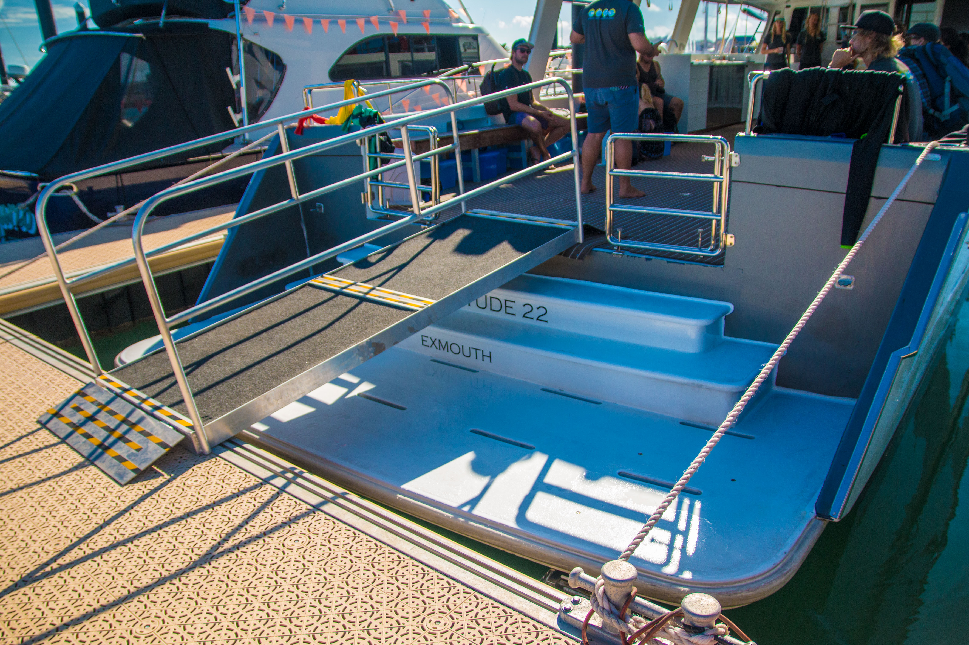
attachment 1 gangway
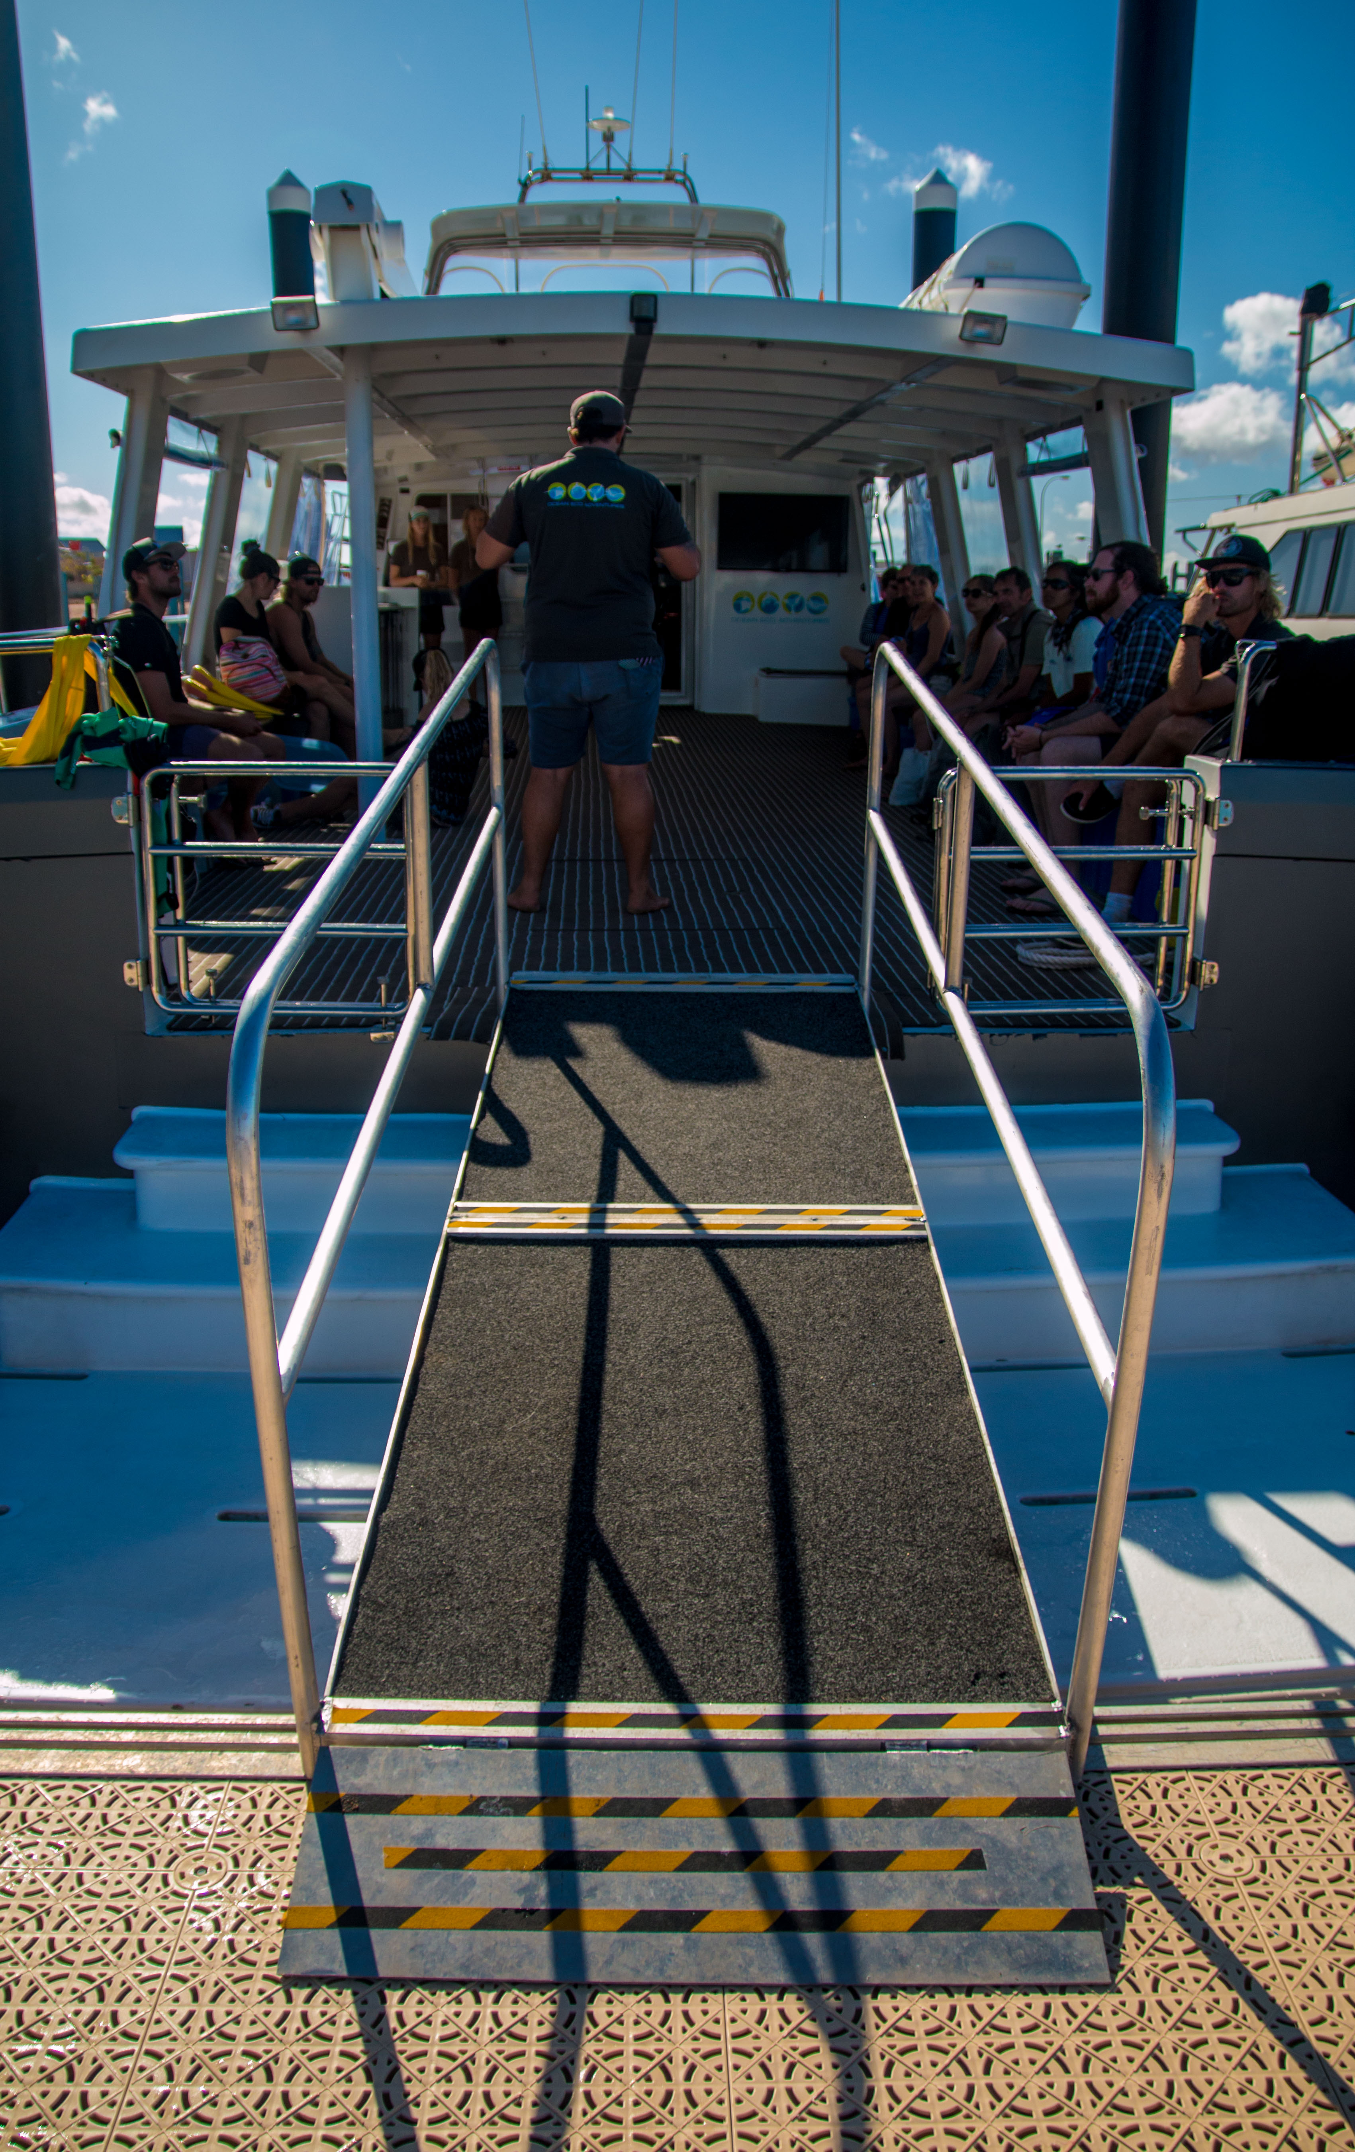
gangway
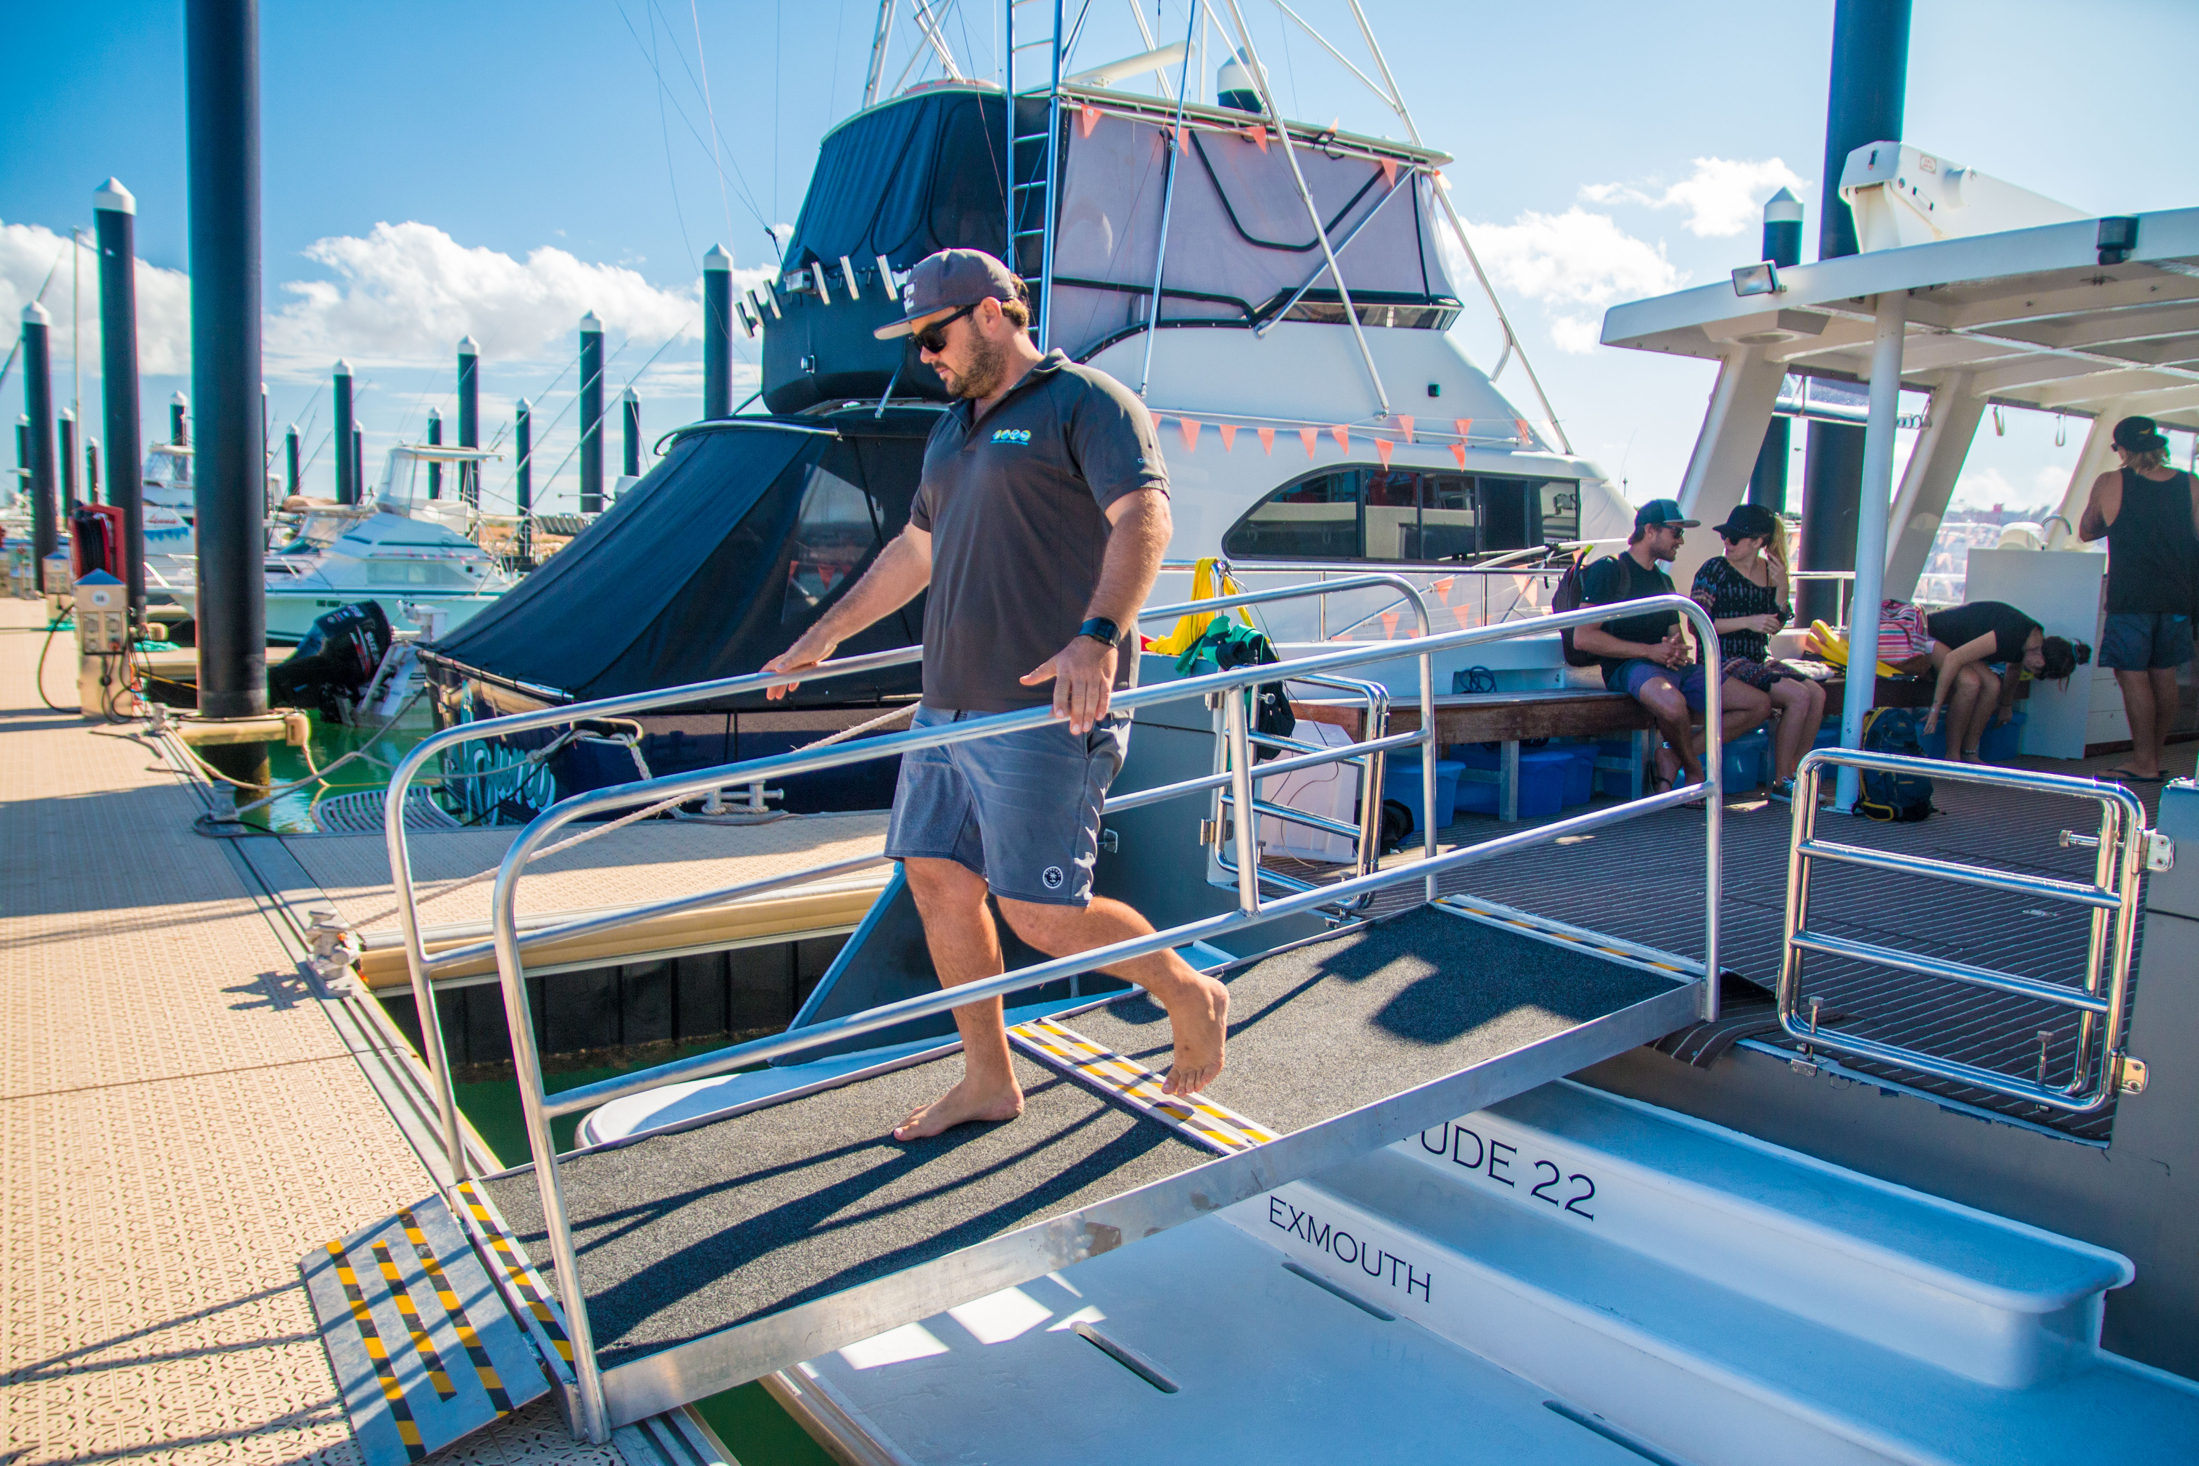
attachment 2 gangway 2
attachment 2 gangway
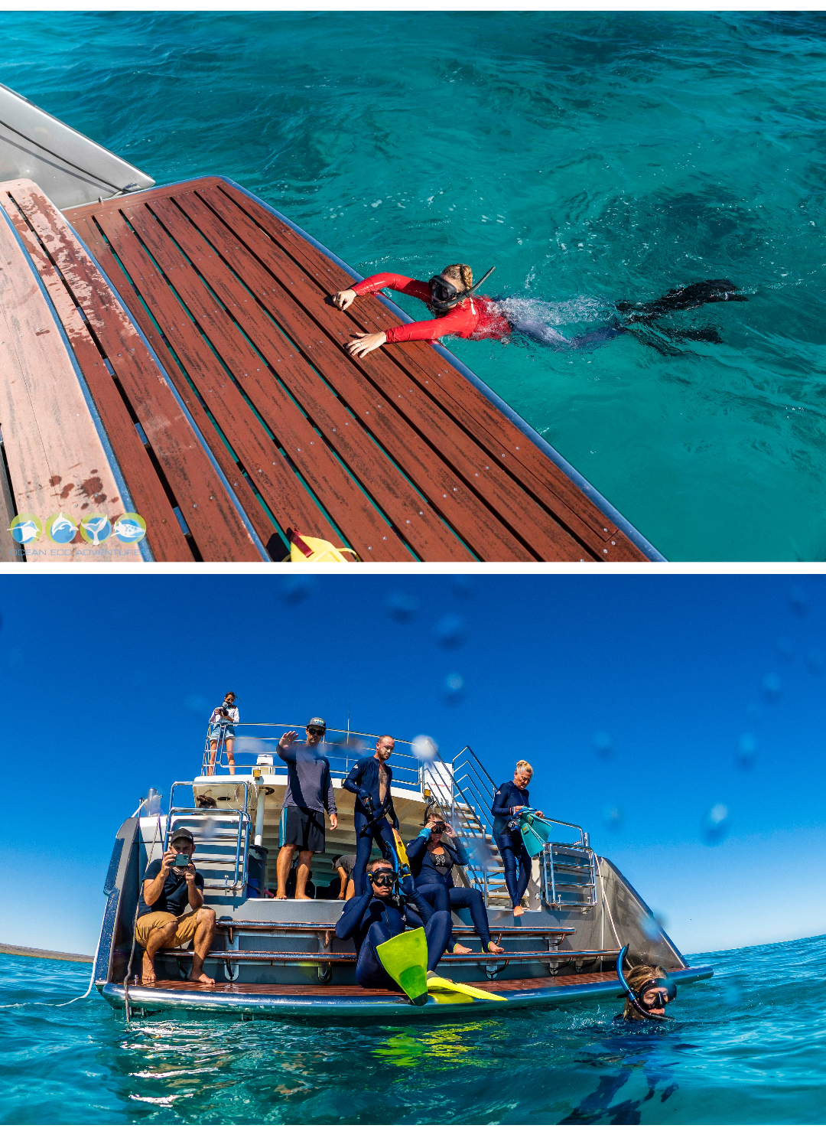
swim platform
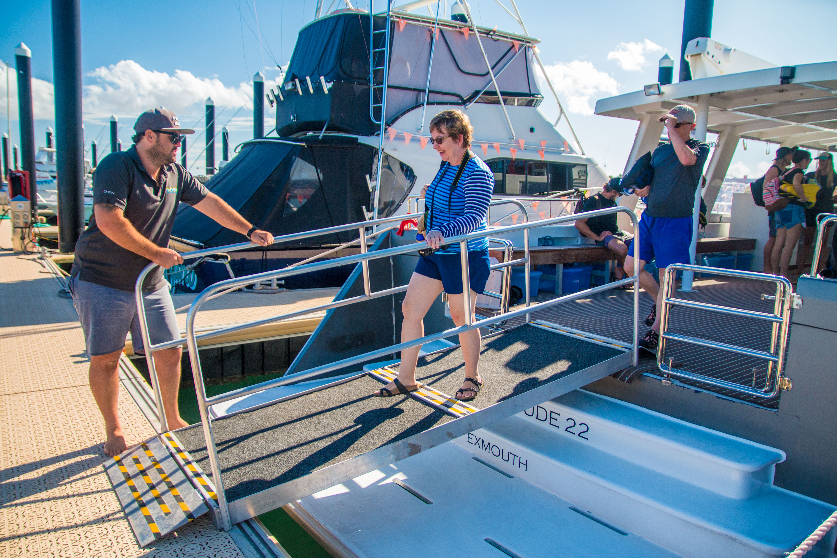
attachment 3 gangway
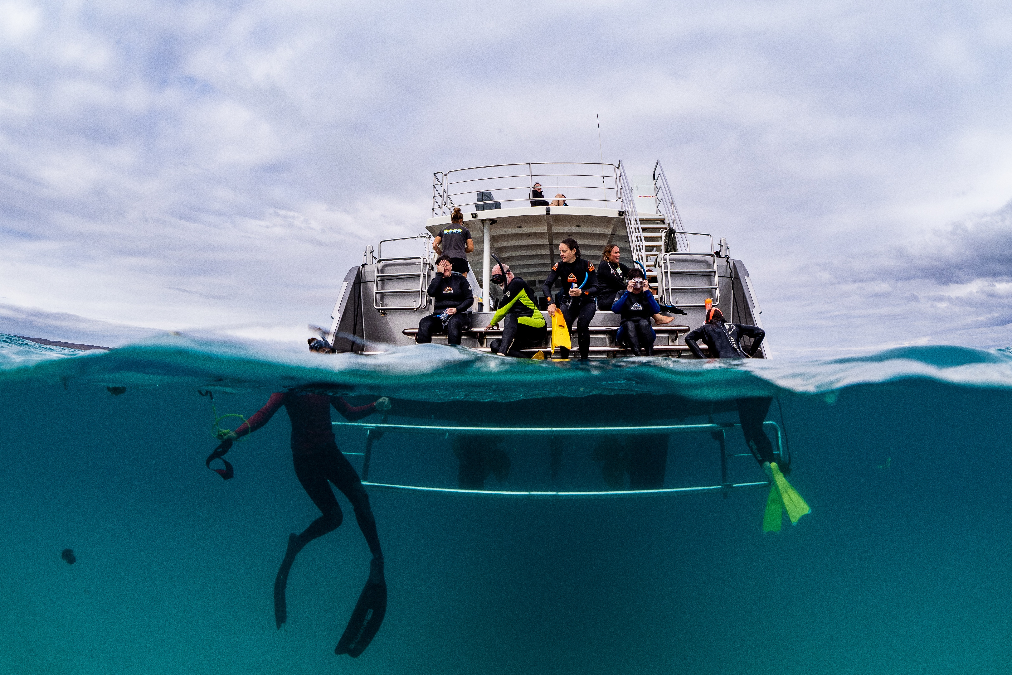
swim platform Latitude 22 low res
- In addition, the following further information can assist guests:
The images provided represent the primary accessible boarding and in-water access features across our fleet, as applicable to different tour departures.

For Latitude 22 sunset whale watching tours, boarding takes place at the Exmouth Marina via a floating jetty and ramped gangway. Images supplied show this gangway system, which provides step-free access between the marina and vessel.

For whale shark tours during season, departures occur from Tantabiddi Boat Ramp within the Ningaloo Marine Park. This location is a public marine facility and does not have a fixed gangway structure; guests board via a tender vessel launched from the ramp. As such, no fixed gangway images are available for this departure point.

Additional images provided show the swim platform on Latitude 22, which is one of the lowest and most accessible in-water entry points used within the local whale shark tour fleet. The platform includes ladder access and is used for snorkelling entry and exit during tours.

These images collectively demonstrate the practical boarding and water access methods used across our operations, noting that access infrastructure varies depending on departure location and vessel type.

Report Disclaimer
Please note that this business report, provided as a result of the use of the diagnostic assessment, is for information purposes only.
Australian Tourism Industry Council (ATIC) cannot guarantee the accuracy of respondent’s answers, or that they are fully representative of your business. Therefore, ATIC does not warrant or guarantee any particular outcome in respect of your businesses self-assessment.
This report is intended as guidance only for your business and should not be relied on for future marketing considerations. ATIC recommends that you seek your own independent advice as well as the results from the diagnostic.
Links to external web sites are inserted for convenience and do not constitute endorsement of material at those sites, or any associated organisation, product or service.
ATIC does not:
- Assume any legal liability for the accuracy, completeness, or usefulness of any information from this report or any links provided; or
- Accept responsibility for any loss associated directly or indirectly from the use of this report.

