ATIC Accessibility
To support the accessible community in making informed travel decisions for their individual needs

This report prepared for:
Business name: | Perfect Nature Cruises
Address: | 9 Leeds Court
Town: | Denham
Contact for enquiries: | Shayne Thomson
Contact Number: | 1800030427
Contact Email: | info@perfectnaturecruises.com.au
Website: | www.perfectnaturecruises.com.au
Date: | 2026-10-08 23:19

ATIC Accessibility
The following pages provides travellers with information on the businesses facilities and amenities which aims to support the traveller to make an informed decision on whether the business is suitable for their individual needs.
OVERVIEW 4
Business Overview 4
Bookings 4
Emergency Management 4
Communications 5
Other Information 5
Guide Dog and Service Animals 5
GENERAL 6
Pre-arrival, arrival and reception 6
Car Park and Access amenities 6
Entry 6
Internal Spaces 7
Public areas 7
External Paths 7
Steps 7
Ramps 8
Public Toilets/Adult change facilities 8
TOUR OPERATORS 9
Tour/Transport Services 9
Route Planning 9
Guides 10
Report Disclaimer 12

OVERVIEW

Business Overview

The business has the following products/services available
- Tour/Transport

Our business caters for the following disability types:
- Blind or low vision
- Deaf or low hearing
- Limited mobility
- Wheelchairs or mobility scooters
- Cognitive or people on the Autism Spectrum
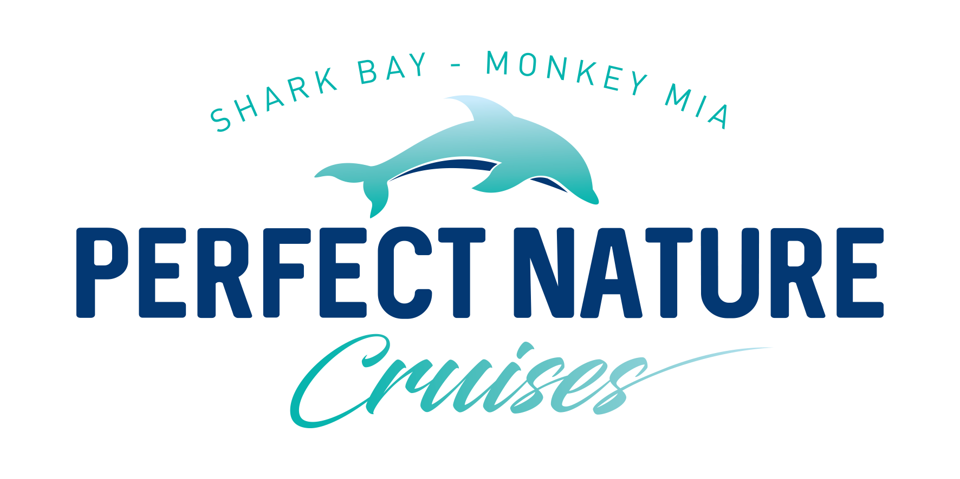

Bookings

The business offers the following methods for bookings and enquiries:
- Phone
- Email
- Webportal
- Our forms have high contract boxes and submit boxes
- Staff have undergone disability awareness and training

Emergency Management
- Emergency and evacuation procedures are explained on arrival
- Exit signs are clear and easy to see
- Exit access is free and clear at all times
We ensure exit access is free and clear at all times by:
On a boat and all passengers are outside already
- Exits and access to exists are greater than 900mm
- Exit doors are able to be opened by all occupants
- Exits to the emergency evacuation point does not include stairways
- The evacuation point is clearly marked by a sign
- In addition, the following further information can assist guests:
We are briefed when the passengers board for the cruise.
- In addition, the following further information can assist guests:
Staff assist lifejacket fitting, then off the boat into the water. Once safely away from the boat the person is assisted into the liferaft.

Communications
- Our website meets WCAG 2.0 accessibility standards

Other Information
- For bookings made onsite, the ticket booth/counter/box office is accessible for people using a wheelchair
- The business accepts the companion card

Guide Dog and Service Animals
- The business provides a secure area with shade and water for service animals
- The business provides a toilet area for service animals
- Bowls, bedding, etc. are provided for service animals
The business provides the following services for services animals:
Water bowls

GENERAL

Pre-arrival, arrival and reception
The business has the following in place to support guests during pre-arrival, arrival and reception
- Booking information and websites are compatible with screen readers
- There is a reception/public entryway.
- Seating available at reception
- A lower counter at reception/ticket office
- A clipboard to allow check-in/ticket purchase whilst seated
- A tablet with text to voice or pen and paper at reception to aid in communication
- Lighting in the reception area is even and glare free

Not necessary for our eco cruises
- A familiarisation tour
- In addition, the following further information can assist guests:
Not necessary for our eco cruises
- In addition, the following further information can assist guests:
Not necessary for our eco cruises

Car Park and Access amenities
The business has the following Car Park and Access amenities
- A drop off zone
- Designated disabled parking bays
- Level or ramped access from the car park to the entrance
- The accessible entrance is clearly signed from the parking bay

Entry
The business has the following amenities/systems in place for entry
- A drop off point close to the entrance
- A path of access to the building is slip resistance and even
- A path of access to the building is clear of obstruction
- Self opening entry doors or fitted with a self closer
- The entry door is a minimum of 850mm wide
- The entrance sill is less than 13mm
- There a clear space of at least 1500mm x 1500mm in front of all doors.
- The entrance door mats have a thickness less than 13mm and a width of 7500mm or greater

Internal Spaces
- Interior walls are matte or low sheen
- Floors, walls, counters and furniture are of contrasting colours
- Any protruding or overhanging obstructions are at least 2meters above the floor or are protected
- Floor surfaces are hard or short pile carpet
- Seating is available for guests unable to stand for long periods
- Accessible facilities are clearly signed and visible from all areas
- All corridors greater than 900mm
- There is a quiet space for parents and children on the Autism Spectrum

Public areas
The public areas have the following amenities in place
- Even lighting
- Seating

External Paths
External paths of travel
- Surfaces are concrete, asphalt, smooth paving or hard packed fine gravel (max aggregate size 13mm)
- Paths or slopes longer than 15 metres have resting places or seats
- Pathways are wider than 900mm
- Step free routes clearly signed

Steps
Steps
- There are steps.
- Top and bottom steps are easily distinguished through colour contrast or the use of TGSIs (Tactile Ground Surface Indicators)
- The underside of all staircases are enclosed or protected to a height of at least 2 metres
- Handrails fitted to all open sets of steps
- Where steps are present are there three steps or less

Ramps
Ramps have the following amenities are in place
- There are ramps.
- Hand rails are fitted

Public Toilets/Adult change facilities
Public Toilets/Adult change facilities have the following amenities are in place
- There is an accessible toilet for public use
- The door is at least 850mm wide
- There is a minimum of 850mm beside the toilet
- Handrails are fitted
- The toilet seat is 460mm above the floor
- The toilet seat of a contrasting colour to the floor
- The toilet seat is460mm above the floor

TOUR OPERATORS

Tour/Transport Services
The tour/transport services have the following facilities/amenities in place
- Buses/Coaches
- We have no vehicles vehicles have wheelchair lifts or ramps
- We have no vehicles vehicles have low floors with ramped entry
The maximum wheelchair capacity available in the fleet is:
10

Route Planning
- There is an accessible toilet on-board for public use
- The door is at least 850mm wide
- There is a minimum of 850mm beside the toilet
- Handrails are fitted
- The toilet seat is 460mm above the floor
- The toilet seat of a contrasting colour to the floor
- The toilet seat is 460mm above the floor
  - Accessible Toilet Image(s)
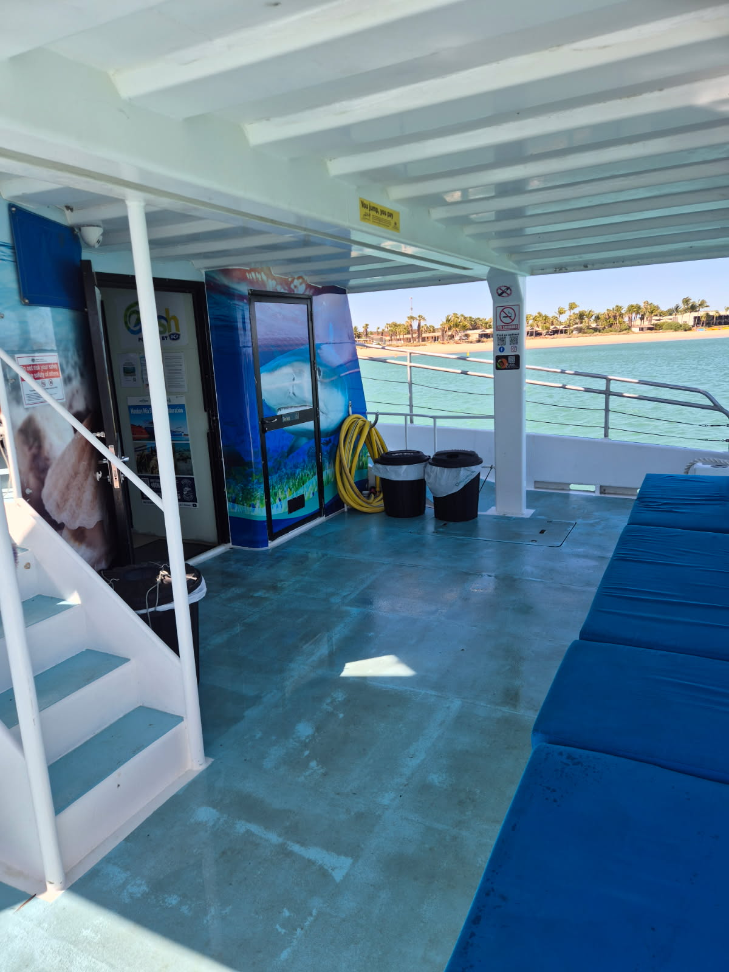
Outside of toilet - back deck of boat
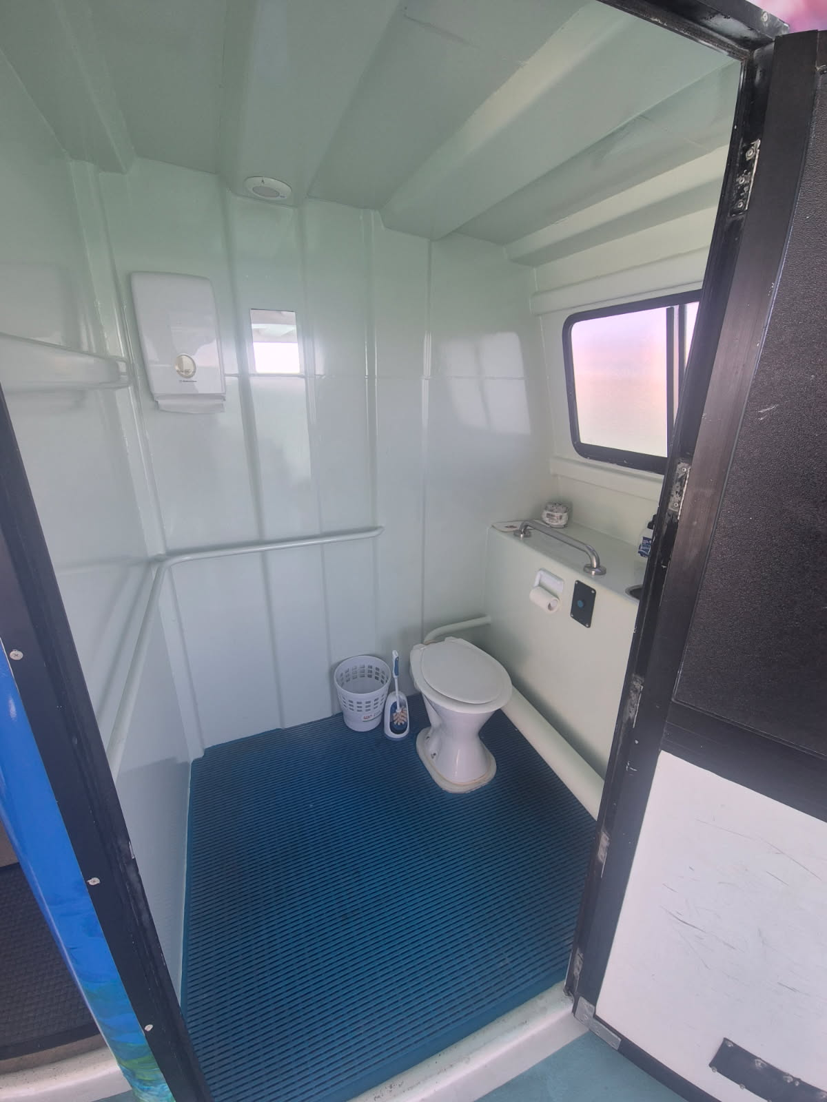
Toilet on board

Guides
- Use of clear/simple English
- Correct pronunciation for lip readers
- There is a audio description of surroundings
- Marine
  - Image(s)
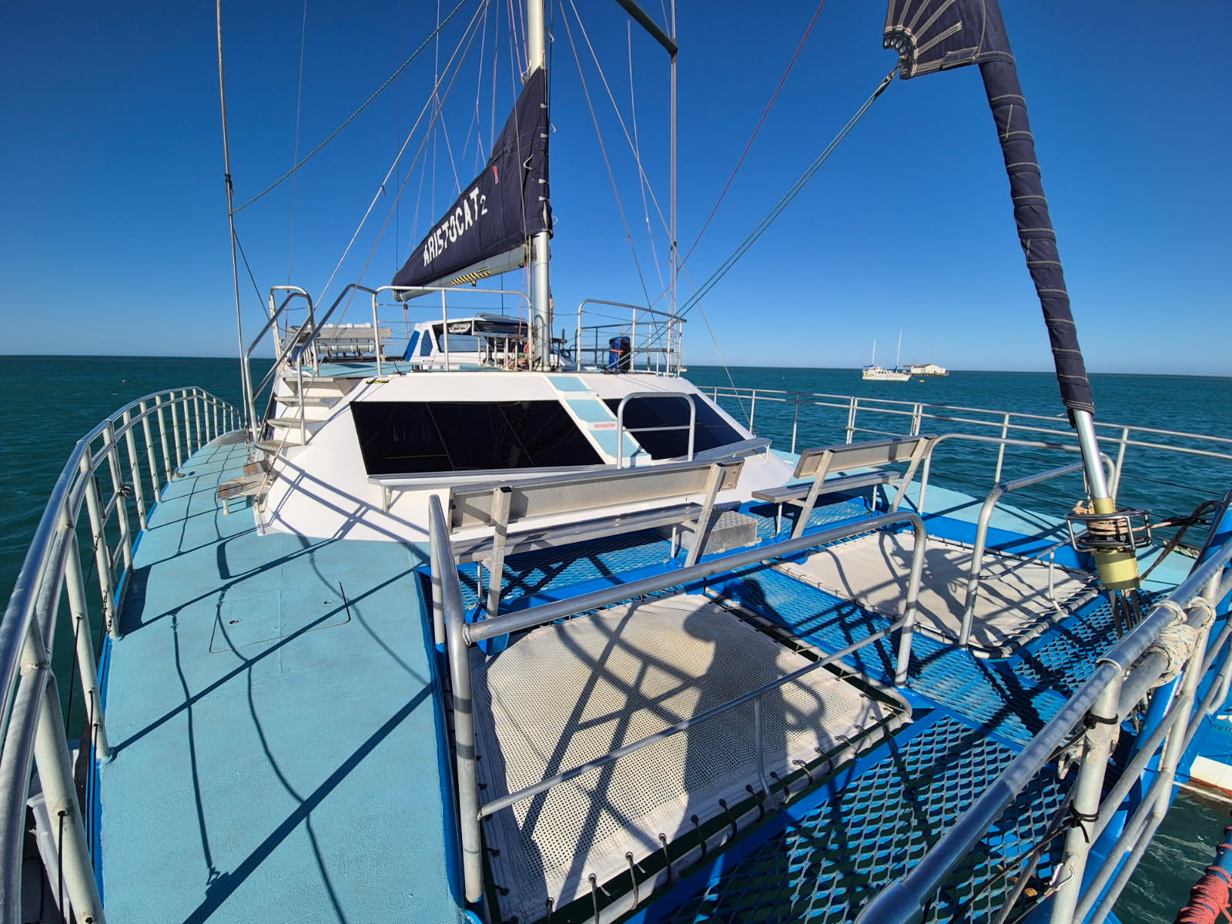
1559248570952879516

Report Disclaimer
Please note that this business report, provided as a result of the use of the diagnostic assessment, is for information purposes only.
Australian Tourism Industry Council (ATIC) cannot guarantee the accuracy of respondent’s answers, or that they are fully representative of your business. Therefore, ATIC does not warrant or guarantee any particular outcome in respect of your businesses self-assessment.
This report is intended as guidance only for your business and should not be relied on for future marketing considerations. ATIC recommends that you seek your own independent advice as well as the results from the diagnostic.
Links to external web sites are inserted for convenience and do not constitute endorsement of material at those sites, or any associated organisation, product or service.
ATIC does not:
- Assume any legal liability for the accuracy, completeness, or usefulness of any information from this report or any links provided; or
- Accept responsibility for any loss associated directly or indirectly from the use of this report.

