ATIC Accessibility
To support the accessible community in making informed travel decisions for their individual needs

This report prepared for:
Business name: | NT Driver Guide - Escorted Touring
Address: | 13/33 Sunset Drive,
Town: | Coconut Grove
Contact for enquiries: | Deb Frosh
Contact Number: | 0459797727
Contact Email: | info@ntdriverguide.com.au
Website: | www.ntdriverguide.com.au
Date: | 2026-10-27 14:40

ATIC Accessibility
The following pages provides travellers with information on the businesses facilities and amenities which aims to support the traveller to make an informed decision on whether the business is suitable for their individual needs.
OVERVIEW 4
Business Overview 4
Bookings 4
Emergency Management 5
Communications 5
Guide Dog and Service Animals 5
GENERAL 6
Pre-arrival, arrival and reception 6
Cognitive Impairment Support 6
Car Park and Access amenities 6
Displays, exhibits, commentary and live performances 7
External Paths 7
TOUR OPERATORS 9
Tour/Transport Services 9
Route Planning 9
Guides 10
ACCOMMODATION 11
Bedrooms 11
Bathrooms 11
ATTRACTIONS 12
Zoos and Wildlife Parks 12
COMMON AREAS 13
Parks and gardens 13
FOOD AND DRINK 14
Dining Spaces 14
ADVENTURE ACTIVITIES 15
Adventure activities 15
Report Disclaimer 17

OVERVIEW

Business Overview

The business has the following products/services available
- Tour/Transport
- Adventure

Our business caters for the following disability types:
- Blind or low vision
- Deaf or low hearing
- Limited mobility
- Wheelchairs or mobility scooters
- Food allergies or intolerances
- Cognitive or people on the Autism Spectrum
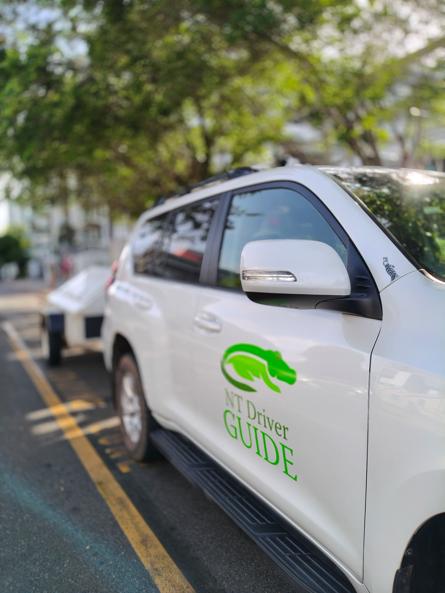

Bookings

The business offers the following methods for bookings and enquiries:
- Phone
- Email
- Webportal
- Our forms have high contract boxes and submit boxes
- Staff have undergone disability awareness and training

Emergency Management
- Emergency and evacuation procedures are explained on arrival
- Guests with disabilities are noted in the guest log book for emergency and evacuation purposes

Communications
- An accessibility guide is available on the website

https://accreditation.qualitytourismaustralia.com/report/AccessReportPublicHtml2/7293afa9-037a-49bb-8be6-93d6d2bbca9f
- Our business offers the following alternative communication methods
- Plain English

Not specified
- There is easy to read signage and information (e.g. menus and emergency information)

Visitor Books and we can use a microphone in the vehicle or blue tooth ear set for those hard of hearing.

Guide Dog and Service Animals
- The business provides a secure area with shade and water for service animals
- The business provides a toilet area for service animals
- Bowls, bedding, etc. are provided for service animals
The business provides the following services for services animals:
If a service animal is required, we advise National Parks and hotel location of the animal and seek confirmation that this is allowed. In accommodation we are required to follow their rules and regulations. In National Parks a service animal must stay on-lead and restrained at all times, and not left alone, or in a car etc. We carry bags for their faeces as required to ensure we clean up after ourselves and a dog bowl for water.

GENERAL

Pre-arrival, arrival and reception
The business has the following in place to support guests during pre-arrival, arrival and reception
- Information and maps are available in written form
- A step free map/guide
- In addition, the following further information can assist guests:
We have priority check ins at each accommodation location. Our guide stays with guests with guests as required, and/or if required we would insist on the guest having a carer with them if necessary - that is, if the impairment for that person required this as per their daily life - we expect that this care continues whilst on tour with us.
- In addition, the following further information can assist guests:
We request on any booking for information in regards to medical requirements considering the remote naure of our tours, fitness and general impairments that the guests/carer/family need to disclose. Our terms and conditions state that it is their responsibility to answer these questions honestly for the health and safety of our guests. We reserve the right to cancel a tour wth no notice and no refund if this information is not disclosed at the time of booking - ie : it becomes apparent on tour that a person has a dissability or impairment that we cannot or do not know how to manage.

Cognitive Impairment Support
- Quiet periods or early opening times for people on the Autism Spectrum
- A space for parents and children on the Autism Spectrum

Car Park and Access amenities
The business has the following Car Park and Access amenities
- A drop off zone
- Designated disabled parking bays
- Level or ramped access from the car park to the entrance
- The accessible entrance is clearly signed from the parking bay
- Kerb ramps are in place where a pavement or walkway needs to be crossed
- In addition, the following further information can assist guests:
Guests are never left alone if they cannot be alone - Most of the questions above are not relevant due to the fact that we have no facilities ourselves, and we manage our guests through assorted locations on tour, guiding them as required to their needs, through walkways, carparks, hotels and nature. We will assist arm in arm and ensure they feel secure at all times, in/out of the vehicle - throughout touring.

Displays, exhibits, commentary and live performances
For displays, exhibits, commentary and live performances the following amenities are in place
- Seating
- Wheelchair accessible spaces/seating
- A written transcript where audio description is provided i.e. display commentary, tour commentary
- In addition, the following further information can assist guests:
We have a microphone system in the car and buses that we use, as well as a blue tooth hearing device that people can use if required. We have a simple printed version of our commentaries which are both used for guests and training if new staff were to join the business.

External Paths
External paths of travel
- Pathways are wider than 900mm

Tours are in nature - we cant control this, however we can chose the best route (walk way) that suits the guests impairment.

There are some pathways specifically designed for wheelchairs - we have used them as required. Pathways that are not designed for wheelchairs are not utilised.
- In addition, the following further information can assist guests:
Whilst we assess the guest ans their abilities on a case by case basis, it would be very unlikey that we would run a tour with one person with any form of physical impairment with no assistance. Guests who are autistic or have some intellectual disability would be assessed prior to ensure that the experience would be right for them - with discussions with their carer's of family members, if they were to tour alone.
- In addition, the following further information can assist guests:
The car has sidesteps, and we have a further step available for between the ground and the car. The extra step is orange. We are assisting with any guest with impairment at all times when entering and exiting the vehicle.
- In addition, the following further information can assist guests:
We dont have our own premises. We will always assist where required, direct carers or partners to appropriate facilities, and assist where required to do so.

TOUR OPERATORS

Tour/Transport Services
The tour/transport services have the following facilities/amenities in place
- Buses/Coaches
- We have access to rent a minibus with a wheel chair access vehicles have wheelchair lifts or ramps
- We have access to low floor buses if required and a fold out ramp. vehicles have low floors with ramped entry
The maximum wheelchair capacity available in the fleet is:
two
- Commentary is available in written format

Route Planning
- Route Planning
- The tour route includes stops with accessible toilet facilities
- In addition, the following further information can assist guests:
Itineraries are custom designed to ensure there is adequate toilet stops and easy access into disabled locations through the day. Itinerary's are carefully design to accommodate any adversity as required on a case by case basis
- Lunch stop venues are accessible
- Sightseeing and photo opportunity stops are step free
- Overnight Stops
- For overnight stays, wheelchair accessible rooms are available
- The accommodation provider used for overnight stops has been independently verified as accessible, please contact us for further information
The total number of wheelchair passengers that can be catered for at overnight stops are:
two per vehicle (hired)
- Walking Tours
- Operated on a step free route
- Multi-paced to account for slower walkers
- Electronic voice augmentation
- Hearing aid compatible

Guides

Guides have been trained in the following
- Use of clear/simple English
- Correct pronunciation for lip readers
- There is a audio description of surroundings
- Marine
- Marine craft are wheelchair accessible
- Length (cm) 125.
- Width (cm) 75.
- Height (cm) 75.
- Weight (kg) 45kg.
- In addition, the following further information can assist guests:
Crocodile Hotel kakadutourism.com
Cooinda Resort kakadutourism.com
Wildlands Wetland Cruises wildlands.com.au
Spectacular Jumping Crocs jumpingcrocodile.com.au
Kakadu Air kakaduair.com.au
Hideaway Litchfield hideawaylitchfield.com.au
Nitmiluk Tours nitmiluktours.com.au
Katherine Outback Experience katherineoutbackexperience.com.au
Museum and Art Gallery of the NT magnt.net.au
Darwin Waterfront darwinwaterfront.gov.nt.au

- In addition, the following further information can assist guests:
We endeavour to assist all guests and go out of our way to ensure that regardless of disability, adversity, injury whether be physical, intellectual or cognitive to ensure the safety and confidence of security for all, with patience and non-judgement.

ACCOMMODATION

Bedrooms
The bedrooms have the following facilities/amenities in place
- There are At accommodation we frequent we always ensure there are appropriate facilities available. Have answered based on what I see/know about accommodation where we stay. rooms available to guests who use a wheelchair
- Bedroom furniture can be re-arranged on request

Bathrooms
The bathrooms have the following facilities/amenities in place
- A door is fitted to the showers with an outward swing at minimum width of 900 mm

ATTRACTIONS

Zoos and Wildlife Parks
- In addition, the following further information can assist guests:
Notification to National Parks is required - Requirements ensure that service animals and kept under control at all times.
- A secure area with shade and water for service dogs is available

COMMON AREAS

Parks and gardens
- Accessible toilets
- Seats are provided at regular intervals
- Direction signage contains distances
- Accessible picnic tables

FOOD AND DRINK

Dining Spaces
The dining spaces have the following facilities/amenities in place
- The smallest doorway is n/a wide
- There is an accessible toilet close by that is open during our business hours

ADVENTURE ACTIVITIES

Adventure activities
The adventure activities have the following facilities/amenities in place
- Our adventure activities cater for people with a disability
- In addition, the following further information can assist guests:
If our activity partners are accredited and able to provide activities for our disabled guests , we will offer this to them. We do not offer these activities our selves.
- In addition, the following further information can assist guests:
n/a
- In addition, the following further information can assist guests:
Subject to the activity type, people could drown, or if they cannot hear or see properly, many adventure activities will be too dangerous. We offer and have conversations to assess if activities are appropriate with a carer assisting etc such as a swim, or visiting animals etc.
- In addition, the following further information can assist guests:
NTDG will assess and discuss your interests, requirements and liabilities and help you decide what is able to be achieved. NTDG reserve the right to cancel or deny certain activities if they exceed the scope of our duty of care.

Report Disclaimer
Please note that this business report, provided as a result of the use of the diagnostic assessment, is for information purposes only.
Australian Tourism Industry Council (ATIC) cannot guarantee the accuracy of respondent’s answers, or that they are fully representative of your business. Therefore, ATIC does not warrant or guarantee any particular outcome in respect of your businesses self-assessment.
This report is intended as guidance only for your business and should not be relied on for future marketing considerations. ATIC recommends that you seek your own independent advice as well as the results from the diagnostic.
Links to external web sites are inserted for convenience and do not constitute endorsement of material at those sites, or any associated organisation, product or service.
ATIC does not:
- Assume any legal liability for the accuracy, completeness, or usefulness of any information from this report or any links provided; or
- Accept responsibility for any loss associated directly or indirectly from the use of this report.

