ATIC Accessibility
To support the accessible community in making informed travel decisions for their individual needs

This report prepared for:
Business name: | Pats Farm
Address: | 3582 Lamington National Park Road
Town: | Canungra
Contact for enquiries: | Nikki Hobbs
Contact Number: | (07) 5502 4911
Contact Email: | reservations@oreillys.com.au
Website: | https://oreillys.beefreecontent.com/EPvc-pats-farm-exclusive-spectacular-off-grid
Date: | 2026-10-10 10:49

ATIC Accessibility
The following pages provides travellers with information on the businesses facilities and amenities which aims to support the traveller to make an informed decision on whether the business is suitable for their individual needs.
OVERVIEW 4
Business Overview 4
Bookings 4
Emergency Management 4
Communications 5
Guide Dog and Service Animals 5
GENERAL 6
Pre-arrival, arrival and reception 6
Cognitive Impairment Support 6
Car Park and Access amenities 6
Internal Spaces 6
External Paths 6
Steps 7
ACCOMMODATION 8
Bedrooms 8
Room Amenities 8
Bathrooms 9
COMMON AREAS 10
Swimming pools, spas and waterparks 10
Report Disclaimer 12

OVERVIEW

Business Overview

The business has the following products/services available
- Accommodation

Our business caters for the following disability types:
- Blind or low vision
- Deaf or low hearing
- Limited mobility
- Wheelchairs or mobility scooters
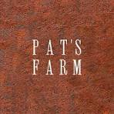

Bookings

The business offers the following methods for bookings and enquiries:
- Phone
- Email
- Webportal
- Our website supports Screen Readers
- Our forms have high contract boxes and submit boxes

Emergency Management
- The business has an emergency management and evacuation plan for guests with a disability
- Guests with disabilities are noted in the guest log book for emergency and evacuation purposes

Communications
- An accessibility guide is available on the website

https://oreillys.com.au/accessible-stays/
- Our website meets WCAG 2.0 accessibility standards
- Our business offers the following alternative communication methods
- Plain English

Not specified
- There is easy to read signage and information (e.g. menus and emergency information)

Guide Dog and Service Animals
- The business provides a secure area with shade and water for service animals
- The business provides a toilet area for service animals
- Bowls, bedding, etc. are provided for service animals
The business provides the following services for services animals:
Not specified

GENERAL

Pre-arrival, arrival and reception
The business has the following in place to support guests during pre-arrival, arrival and reception
- Booking information and websites are compatible with screen readers
- In addition, the following further information can assist guests:
Immediate self check in
Face and number plate recognition upon gate entry and chalet door/s

Cognitive Impairment Support
- Access has alternative procedures and clear written instructions with universal access symbols

Car Park and Access amenities
The business has the following Car Park and Access amenities
- A drop off zone
- Level or ramped access from the car park to the entrance
- The accessible entrance is clearly signed from the parking bay
- Kerb ramps are in place where a pavement or walkway needs to be crossed
- An intercom system is available at the entrance of car park
- Instructions on how to use the system are in Plan English and accompanied by Universal design standard pictures

Internal Spaces
- Tableware/glassware contrast with the table surface or table cloth

External Paths
External paths of travel
The width of the smallest pathway is:
No pathways
- There 3 successive steps or less on any path or at any doorway
- In addition, the following further information can assist guests:
Chalet 1 is fully accessible for wheelchair

Steps
Steps
- There are steps.
- Top and bottom steps are easily distinguished through colour contrast or the use of TGSIs (Tactile Ground Surface Indicators)
- All steps or staircases have enclosed risers
- The underside of all staircases are enclosed or protected to a height of at least 2 metres
- Handrails fitted to all open sets of steps
- Handrails extend 300mm beyond the top and bottom step
- Where steps are present are there three steps or less

ACCOMMODATION

Bedrooms
The bedrooms have the following facilities/amenities in place
- There are 1 of 6 rooms available to guests who use a wheelchair
- Bedroom furniture can be re-arranged on request
  - Layout of room Image(s)
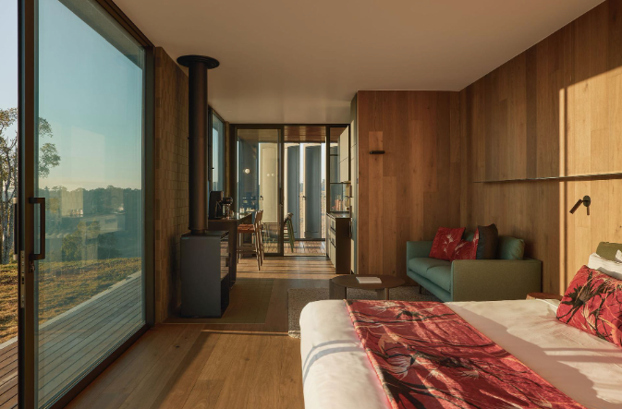
Screen Shot 2026-07-20 at 11.07.37 am

Room Amenities
- Lower hanging rails are in wardrobes
- In addition, the following further information can assist guests:
As instructed
- Room phones are capable of sending and receiving an SMS
- There is contrast between the walls, skirtings, floor and furniture
- There is a clear path through the room
- The edges of all furniture and fixtures are rounded
- Wardrobe handles are a contrasting colour to the doors and draws
- Housekeeping procedures instruct staff not to reposition furniture that has been moved
- Doors open fully against the adjoining wall
- There is a clear opening at least 850mm wide
- There luggage racks for at least two suitcases
- There at least one chair with rigid arms
- Wardrobe and drawer handles are easy to grip
- The bedside lamp switch is easy to reach from the bed
- There is at least 850mm clear space beside the bed
- The bed height is no higher than 680mm from the floor
- There is at least 130mm clearance under the bed
- The business offers a range of non-allergenic bedding
- Non-allergenic cleaning products are used

Bathrooms
The bathrooms have the following facilities/amenities in place
- All heating appliances and hot water pipes are protected or insulated
- All shower, bath and basin taps are clearly differentiated between hot and cold
- Fixtures and fittings have rounded edges
- The hot water is thermostatically controlled to 41 degrees
- The door is at least 850mm wide
- There is a minimum of 850mm beside the toilet
- Handrails are fitted
- There is a minimum of 1400mm of clear space in front of the toilet
- The toilet seat is a contrasting colour to the floor
- The toilet seat is 460mm above the floor
- A range of non-allergenic toiletries are available
- There is a roll-in shower with fold down fixed seat or a shower chair
- There is a portable shower head on flexible hose
  - Bathroom Image(s)
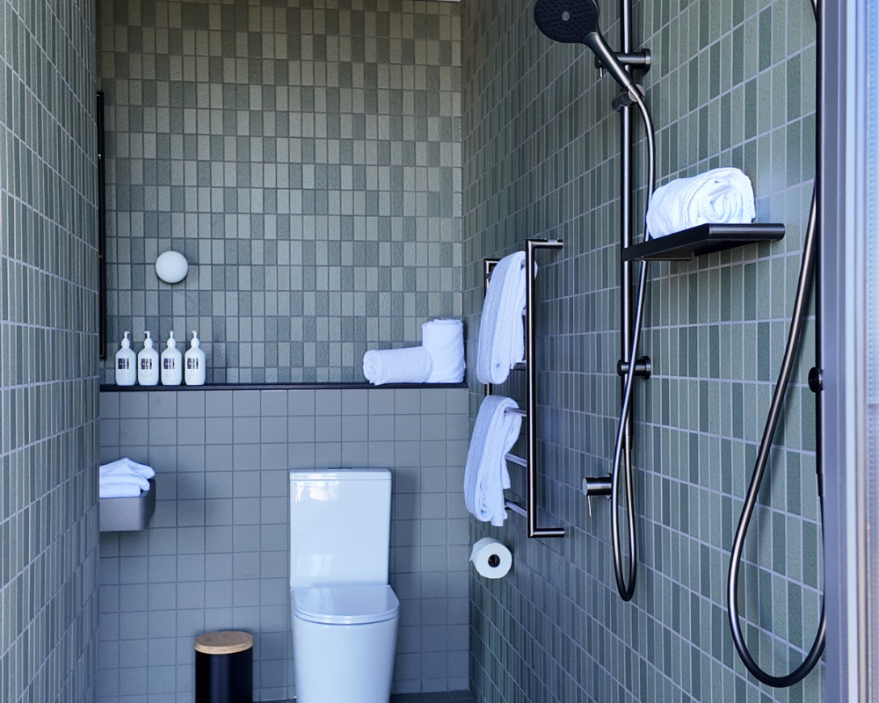
10v

COMMON AREAS

Swimming pools, spas and waterparks
- The following swimming pools, spas and waterparks amenities are available
  - Pool Access Image(s)
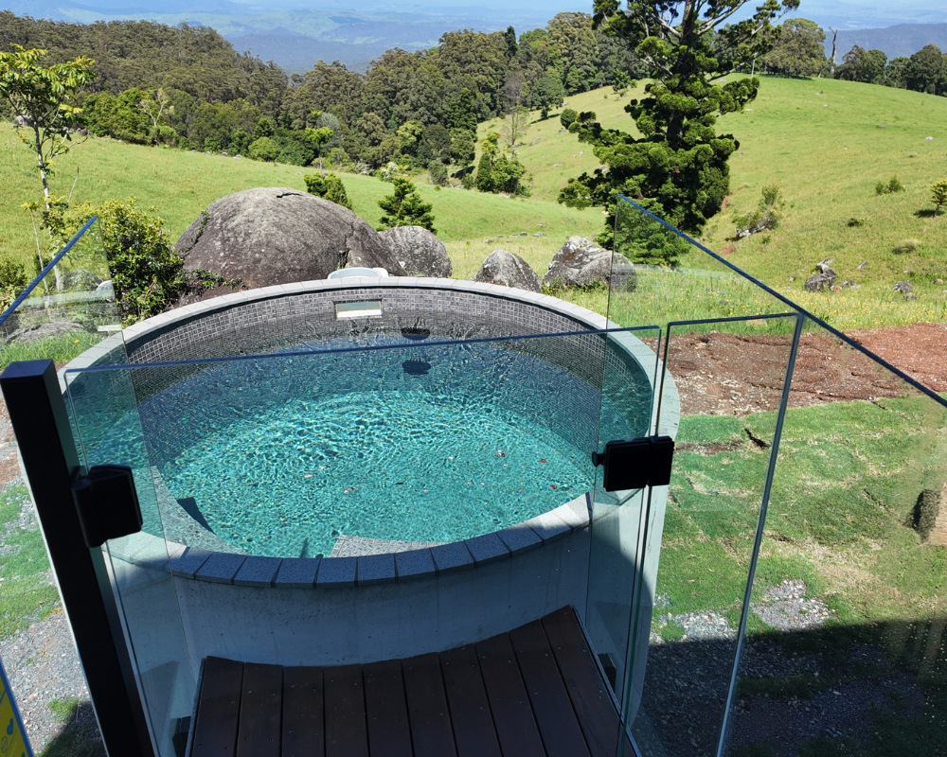
12v

Report Disclaimer
Please note that this business report, provided as a result of the use of the diagnostic assessment, is for information purposes only.
Australian Tourism Industry Council (ATIC) cannot guarantee the accuracy of respondent’s answers, or that they are fully representative of your business. Therefore, ATIC does not warrant or guarantee any particular outcome in respect of your businesses self-assessment.
This report is intended as guidance only for your business and should not be relied on for future marketing considerations. ATIC recommends that you seek your own independent advice as well as the results from the diagnostic.
Links to external web sites are inserted for convenience and do not constitute endorsement of material at those sites, or any associated organisation, product or service.
ATIC does not:
- Assume any legal liability for the accuracy, completeness, or usefulness of any information from this report or any links provided; or
- Accept responsibility for any loss associated directly or indirectly from the use of this report.

