ATIC Accessibility
To support the accessible community in making informed travel decisions for their individual needs

This report prepared for:
Business name: | Quality Hotel Ambassador Perth
Address: | 196 Adelaide Terrace
Town: | East Perth
Contact for enquiries: | Azeem Shah
Contact Number: | 08 9492 7750
Contact Email: | sales@goodearthhotel.com.au
Website: | www.ambassadorhotel.com.au
Date: | 2026-07-28 21:13

ATIC Accessibility
The following pages provides travellers with information on the businesses facilities and amenities which aims to support the traveller to make an informed decision on whether the business is suitable for their individual needs.
OVERVIEW 4
Business Overview 4
Bookings 5
Emergency Management 5
Communications 6
Other Information 6
Guide Dog and Service Animals 6
GENERAL 7
Pre-arrival, arrival and reception 7
Cognitive Impairment Support 7
Car Park and Access amenities 7
Internal Spaces 8
External Paths 8
Public Toilets/Adult change facilities 8
ACCOMMODATION 9
Bedrooms 9
Room Amenities 9
Bathrooms 9
COMMON AREAS 11
FOOD AND DRINK 12
Dining Spaces 12
EVENTS 14
Events 14
Report Disclaimer 16

OVERVIEW

Business Overview

The business has the following products/services available
- Accommodation
- Food and Drink
- Event

Our business caters for the following disability types:
- Blind or low vision
- Deaf or low hearing
- Limited mobility
- Wheelchairs or mobility scooters
- Food allergies or intolerances
- Cognitive or people on the Autism Spectrum
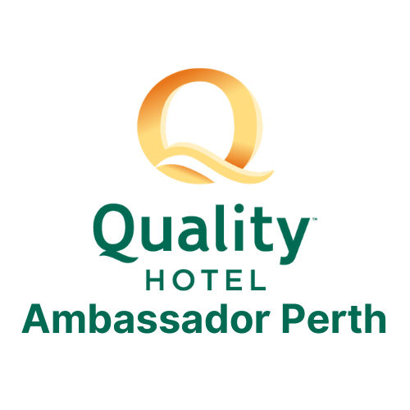

Bookings

The business offers the following methods for bookings and enquiries:
- Phone
- Email
- Webportal
- Our website supports Screen Readers
- Our forms have high contract boxes and submit boxes

Emergency Management
- Exit signs are clear and easy to see
- Exit access is free and clear at all times
We ensure exit access is free and clear at all times by:
No obstacles around the exit access.
- Exits and access to exists are greater than 900mm
- Exit doors are able to be opened by all occupants
- Exits including stairwells, have bright edges used on the steps.
- The evacuation point is clearly marked by a sign
The business identifies guests who need additional assistance should an emergency occur by:
The guests who stay in the accessible rooms, the people who are on wheelchairs or crutches, who is accompanied by a career.
The procedure for assisting guests who need assisted rescue is:
We welcome guests regardless of accessibility issues, as: 1. ramp access, 2. lifts, 3. guide dogs allowed and 4. carers.
- Guests with disabilities are noted in the guest log book for emergency and evacuation purposes

Communications
- Our website meets WCAG 2.0 accessibility standards
- Our business offers the following alternative communication methods
- Plain English

We can read out the information to the guests
- There is easy to read signage and information (e.g. menus and emergency information)

Other Information
- For bookings made onsite, the ticket booth/counter/box office is accessible for people using a wheelchair

Guide Dog and Service Animals
- Bowls, bedding, etc. are provided for service animals
The business provides the following services for services animals:
If we are informed in advance that service animals will be attended, we are happy to provide bowls and bedding.

GENERAL

Pre-arrival, arrival and reception
The business has the following in place to support guests during pre-arrival, arrival and reception
- Booking information and websites are compatible with screen readers
- There is a reception/public entryway.
- A clipboard to allow check-in/ticket purchase whilst seated
- Lighting in the reception area is even and glare free
- Large print information sheets and registration forms
- Information and maps are available in written form
- A step free map/guide
- A familiarisation tour
- Luggage assistance
- In addition, the following further information can assist guests:
We will prioritize their room to be cleaned to reduce the waiting time, which is subject to availability.
- In addition, the following further information can assist guests:
A familiarisation tour is available upon request. As we are a limited service hotel, we expect guests who need assistance all the time to be accompanied by a carer.

Cognitive Impairment Support
- Quiet periods or early opening times for people on the Autism Spectrum
- A space for parents and children on the Autism Spectrum

Car Park and Access amenities
The business has the following Car Park and Access amenities
- A drop off zone
- Designated disabled parking bays
- The public transport services available are:

The GSA will explain the location of the closest bus stop as well as give the direction.
- In addition, the following further information can assist guests:
The hotel parking is outdoor, the entrance and exit of the parking are located beside the hotel with bomb gate. A token is needed to exit the parking which can be retrieved at the reception. Parking fees applied.

Internal Spaces
- Tableware/glassware contrast with the table surface or table cloth

External Paths
External paths of travel
- Surfaces are concrete, asphalt, smooth paving or hard packed fine gravel (max aggregate size 13mm)
- Pathways are wider than 900mm
- Step free routes clearly signed

Public Toilets/Adult change facilities
Public Toilets/Adult change facilities have the following amenities are in place
- There is an accessible toilet for public use
- The door is at least 850mm wide
- There is a minimum of 850mm beside the toilet
- Handrails are fitted
- The toilet seat is 460mm above the floor
- The toilet seat of a contrasting colour to the floor
- The toilet seat is460mm above the floor
- In addition, the following further information can assist guests:
The accessible toilet is on level 1, which can be accessed by lift.

ACCOMMODATION

Bedrooms
The bedrooms have the following facilities/amenities in place
- There are 2 rooms available to guests who use a wheelchair
- Bedroom furniture can be re-arranged on request

Room Amenities
- Lower hanging rails are in wardrobes
- In addition, the following further information can assist guests:
Staff will&nbsp;
- Televisions are equipped with closed captioning capability
- Room phones have volume control
- Room phones have a visual ringing indicator
- There is contrast between the walls, skirtings, floor and furniture
- There is a clear path through the room
- Wardrobe handles are a contrasting colour to the doors and draws
- Housekeeping procedures instruct staff not to reposition furniture that has been moved
- Doors open fully against the adjoining wall
- There is a clear opening at least 850mm wide
- There at least one chair with rigid arms
- Wardrobe and drawer handles are easy to grip
- The bedside lamp switch is easy to reach from the bed
- There is at least 850mm clear space beside the bed
- The bed height is no higher than 680mm from the floor
- There is at least 130mm clearance under the bed
- The business offers a range of non-allergenic bedding
- Non-allergenic cleaning products are used
- In addition, the following further information can assist guests:
NA

Bathrooms
The bathrooms have the following facilities/amenities in place
- All heating appliances and hot water pipes are protected or insulated
- All shower, bath and basin taps are clearly differentiated between hot and cold
- The door is at least 850mm wide
- There is a minimum of 850mm beside the toilet
- Handrails are fitted
- There is a minimum of 1400mm of clear space in front of the toilet
- The toilet seat is a contrasting colour to the floor
- The toilet seat is 460mm above the floor
- A range of non-allergenic toiletries are available
- There is a roll-in shower with fold down fixed seat or a shower chair
- There is a portable shower head on flexible hose
- A door is fitted to the shower
- A door is fitted to the showers with an outward swing at minimum width of 900 mm
- In addition, the following further information can assist guests:
NA

COMMON AREAS

FOOD AND DRINK

Dining Spaces
The dining spaces have the following facilities/amenities in place
- The entrance has level access
- The doorway is at least 850mm wide
- There is level access through the dining area
- Chairs are moveable to allow for wheelchairs to be seated at the tables
- All glass doors and full height windows have contrast markings
- There are areas of full lighting
- There is an accessible toilet

Our business caters for the following dietary requirements
- Sugar free (diabetic)
- Gluten free (celiac)
- Lactose free (dairy free)
- Low fat and fibre with no gastric content
- Low potassium
- Low sodium
- Nut free
- Additive free
- Vegetarian
- Halal
- In addition, the following further information can assist guests:
HACCP Certified, labels, food storage and halal certified
  - Food and Beverage Image(s)
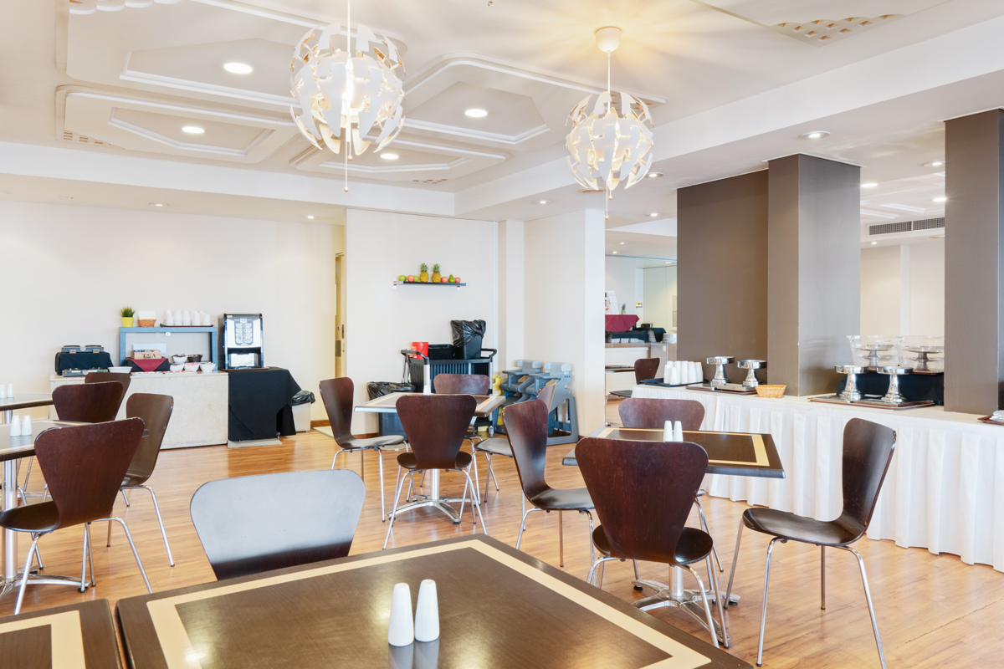
Ambassador Perth-01
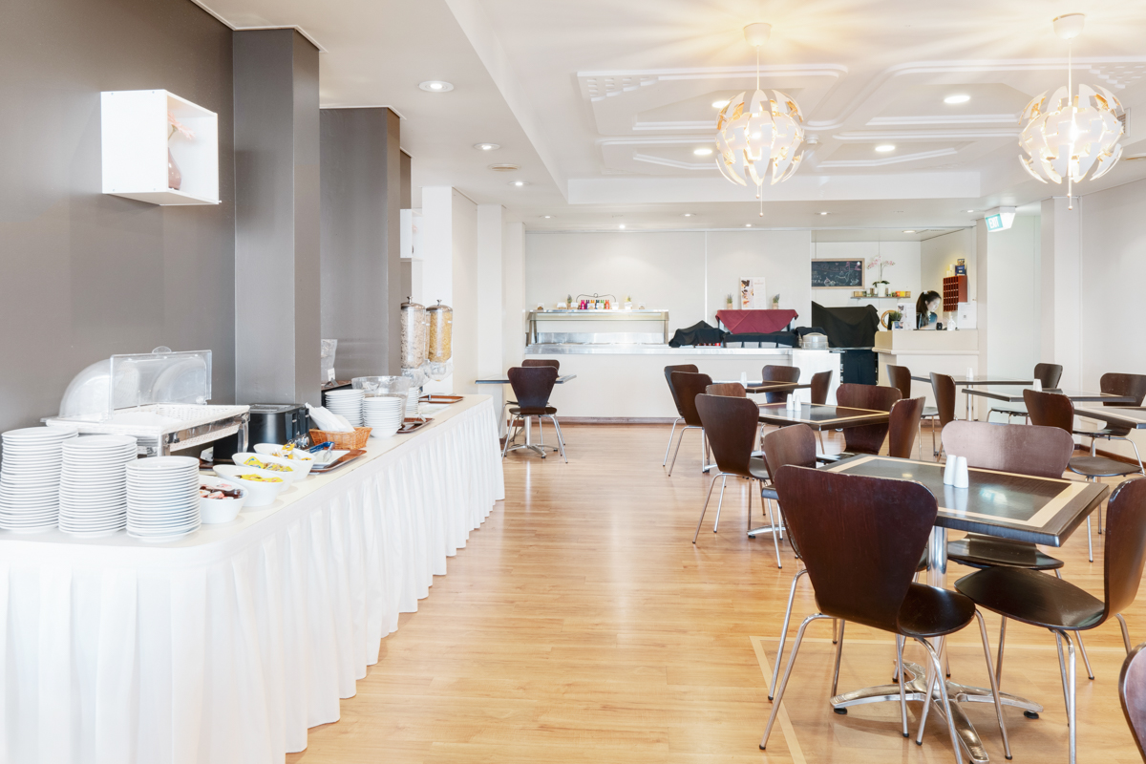
Ambassador Perth-02
- In addition, the following further information can assist guests:
The accessible toilet is located on level 1, which can be accessed via the lift.The restaurant opens for breakfast only, and it is buffet style.

EVENTS

Events
Events have the following facilities/amenities in place
- There is step free access throughout the venue
- All ancillary areas are step free e.g. breakout rooms, dining areas, outside areas and exhibition spaces
- Accessible toilets are available at the venue
- Wheelchair designated seating is provided
- We cater for a range of seating and viewing options
- We cater for varying group sizes
- Food and water is available for guide and service animals
- Accessible car parking is available
- There are designated drop-off points
- There is accessible public transport to the venue
- Accessible public transport is detailed in the event information
- Quiet rooms, marquees or spaces are available
- In addition, the following further information can assist guests:
The hotel has 2 function rooms which are located on level 1 and can be accessed via the lift.We can provide water and food to the guide dogs and service dogs if we are informed in advance.

Report Disclaimer
Please note that this business report, provided as a result of the use of the diagnostic assessment, is for information purposes only.
Australian Tourism Industry Council (ATIC) cannot guarantee the accuracy of respondent’s answers, or that they are fully representative of your business. Therefore, ATIC does not warrant or guarantee any particular outcome in respect of your businesses self-assessment.
This report is intended as guidance only for your business and should not be relied on for future marketing considerations. ATIC recommends that you seek your own independent advice as well as the results from the diagnostic.
Links to external web sites are inserted for convenience and do not constitute endorsement of material at those sites, or any associated organisation, product or service.
ATIC does not:
- Assume any legal liability for the accuracy, completeness, or usefulness of any information from this report or any links provided; or
- Accept responsibility for any loss associated directly or indirectly from the use of this report.

