ATIC Accessibility
To support the accessible community in making informed travel decisions for their individual needs

This report prepared for:
Business name: | Woodhouse Adventure Park
Address: | 37 Spring Gully Road
Town: | PICCADILLY
Contact for enquiries: | Emily Cordell
Contact Number: | 08 8339 3333
Contact Email: | info@woodhouse.org.au
Website: | www.woodhouse.org.au
Date: | 2026-09-30 00:32

ATIC Accessibility
The following pages provides travellers with information on the businesses facilities and amenities which aims to support the traveller to make an informed decision on whether the business is suitable for their individual needs.
OVERVIEW 4
Business Overview 4
Bookings 4
Emergency Management 5
Communications 5
Other Information 6
Guide Dog and Service Animals 6
GENERAL 7
Pre-arrival, arrival and reception 7
Cognitive Impairment Support 7
Car Park and Access amenities 7
Entry 8
Internal Spaces 8
Public areas 9
External Paths 9
Steps 9
Public Toilets/Adult change facilities 10
ACCOMMODATION 11
Bedrooms 11
Room Amenities 11
Bathrooms 12
ATTRACTIONS 14
Attractions Basics 14
COMMON AREAS 15
Parks and gardens 15
ADVENTURE ACTIVITIES 16
Report Disclaimer 18

OVERVIEW

Business Overview

The business has the following products/services available
- Accommodation
- Attraction
- Adventure

Our business caters for the following disability types:
- Blind or low vision
- Deaf or low hearing
- Limited mobility
- Wheelchairs or mobility scooters
- Food allergies or intolerances
- Cognitive or people on the Autism Spectrum


Bookings

The business offers the following methods for bookings and enquiries:
- Phone
- Email
- Webportal
- Staff have undergone disability awareness and training

Emergency Management
- There are Audible device/s to alert occupants to evacuate with instructions on how to evacuate.
- Exit signs are clear and easy to see
- Exit access is free and clear at all times
We ensure exit access is free and clear at all times by:
Having an automatic boom gate installed
- Exits and access to exists are greater than 900mm
- Exits to the emergency evacuation point does not include stairways
- The evacuation point is clearly marked by a sign
- In addition, the following further information can assist guests:
Due to the nature of our site and activities, guests who have a physical or neurological disability that impacts their mobility or ability to evacuate independently are typically accompanied by a support person. This ensures that appropriate assistance is available at all times, including in the event of an emergency. While we do not currently require guests to formally declare accessibility needs, we encourage group organisers and individuals to notify us during the booking process if any members of their group may require additional support. Our staff are trained to provide inclusive, respectful service and will work with support persons as needed to ensure the safety and wellbeing of all guests. As part of our ongoing commitment to accessibility and safety: Support persons are welcomed and encouraged to participate in briefings and evacuation planning where relevant. Our team reviews evacuation procedures with a focus on accessible routes and assistance needs. Staff receive training to recognise when assistance may be required and respond appropriately.
- In addition, the following further information can assist guests:
Woodhouse staff do not typically provide personal care or lifting services but will assist with coordination and response as safely as possible. Of course if the need arose, guest would be transported in company vehicle

Communications
- An accessibility guide is available on the website

www.woodhouse.org.au/accessibility

Other Information
- The business accepts the companion card

Guide Dog and Service Animals
- The business provides a secure area with shade and water for service animals
- The business provides a toilet area for service animals
The business provides the following services for services animals:
We have water access in all main areas and shaded rest areas all over the property. Staff are trained to understand legal rights of assistance animals, know not to pat, feed or distract the animal and are able to identify what constitutes a legitimate assistance animal. Accessible paths are also safe for animal paws and, for guests staying overnight, assistance animal is welcome to stay in accommodation.

GENERAL

Pre-arrival, arrival and reception
The business has the following in place to support guests during pre-arrival, arrival and reception
- There is a reception/public entryway.
- A lower counter at reception/ticket office
- A clipboard to allow check-in/ticket purchase whilst seated
- A tablet with text to voice or pen and paper at reception to aid in communication
- Picture Board at reception to aid in communication
- Lighting in the reception area is even and glare free
- Information and maps are available in written form
- A familiarisation tour
- Luggage assistance
- In addition, the following further information can assist guests:
Priority Access (On Request): While not a formalised "priority pass" system, staff are empowered to offer early access or expedited check-in for guests who have advised of fatigue-related conditions. This can include allowing guests to move ahead in queues during busy times.Seating and Rest Areas:Benches and shaded rest areas are available across the site, particularly near activity zones and accommodation. Staff may direct guests to low-traffic areas for rest if they feel fatigued or overwhelmed.Support Person Inclusion:Guests with fatigue-related disabilities are welcome to attend with a support personwho may assist with carrying items, navigating the site, or managing rest periods.Advance Planning Support:The availability of virtual tours, detailed itineraries for school or group bookings, and open communication with staff allows guests to plan their day around rest breaks and energy levels.

Cognitive Impairment Support
- Quiet periods or early opening times for people on the Autism Spectrum
- A space for parents and children on the Autism Spectrum

Car Park and Access amenities
The business has the following Car Park and Access amenities
- A drop off zone
- Designated disabled parking bays
- Level or ramped access from the car park to the entrance
- Kerb ramps are in place where a pavement or walkway needs to be crossed
- In addition, the following further information can assist guests:
Check out the virtual tour online (copy and paste in your browser) www.camps3d.com.au/aca/woodhouse - or feel free to arrange an in person scoping tour by phoning 08 8339 3333 or emailing info@woodhouse.org.au

Entry
The business has the following amenities/systems in place for entry
- A drop off point close to the entrance
- A path of access to the building is slip resistance and even
- A path of access to the building is clear of obstruction
- Self opening entry doors or fitted with a self closer
- Glass doors are fitted with a visual sighting strip
- Door jams/doors are of a contrasting colour to surrounding walls
- Door handles are of a contrasting colour to the door
- Signage is written in a contrasting colour
- Signage is written in a Sans Serif font and use upper and lower case letters
- The entrance sill is less than 13mm
- There a clear space of at least 1500mm x 1500mm in front of all doors.
- The entrance door mats have a thickness less than 13mm and a width of 7500mm or greater
- In addition, the following further information can assist guests:
Check out the virtual tour online (copy and paste in your browser) www.camps3d.com.au/aca/woodhouse - or feel free to arrange an in person scoping tour by phoning 08 8339 3333 or emailing info@woodhouse.org.au

Internal Spaces
- Clear and unobstructed routes through and between buildings
- Interior walls are matte or low sheen
- Floors, walls, counters and furniture are of contrasting colours
- Any protruding or overhanging obstructions are at least 2meters above the floor or are protected
- Tableware/glassware contrast with the table surface or table cloth
- Floor surfaces are hard or short pile carpet
- Seating is available for guests unable to stand for long periods
- Accessible facilities are clearly signed and visible from all areas
- All corridors greater than 900mm
- There is a quiet space for parents and children on the Autism Spectrum
- In addition, the following further information can assist guests:
Check out the virtual tour online (copy and paste in your browser) www.camps3d.com.au/aca/woodhouse - or feel free to arrange an in person scoping tour by phoning 08 8339 3333 or emailing info@woodhouse.org.au

Public areas
The public areas have the following amenities in place
- Even lighting
- Seating

External Paths
External paths of travel
- Surfaces are concrete, asphalt, smooth paving or hard packed fine gravel (max aggregate size 13mm)
- Pathways are wider than 900mm
- In addition, the following further information can assist guests:
The 54 hectare property connects the activities and accommodation by a bittumanised road loop, which can be driven, ridden or walked (beware of potholes across the 11km road network). The terrain and the gradient of the pathways on Challenge Hill may not be suitable for wheelchairs.

Check out the virtual tour online (copy and paste in your browser) www.camps3d.com.au/aca/woodhouse - or feel free to arrange an in person scoping tour by phoning 08 8339 3333 or emailing info@woodhouse.org.au

Steps
Steps
- There are steps.
- Top and bottom steps are easily distinguished through colour contrast or the use of TGSIs (Tactile Ground Surface Indicators)
- All steps or staircases have enclosed risers
- Handrails fitted to all open sets of steps
- Handrails extend 300mm beyond the top and bottom step
- In addition, the following further information can assist guests:
Rymill Centre and Hooper Bunkhouse can be accessed without using the stairs. The second floor of the Manor is not accessible.

Public Toilets/Adult change facilities
Public Toilets/Adult change facilities have the following amenities are in place
- There is an accessible toilet for public use
- The door is at least 850mm wide
- There is a minimum of 850mm beside the toilet
- Handrails are fitted
- The toilet seat is 460mm above the floor
- The toilet seat of a contrasting colour to the floor
- The toilet seat is460mm above the floor

ACCOMMODATION

Bedrooms
The bedrooms have the following facilities/amenities in place
- There are accessible features in each of the three large group accommodation buildings. HOOPER BUNKHOUSE: 3 bunk rooms are accessible by wheelchair in Hooper Bunkhouse; RYMILL CENTRE: 1 bunk room is accessible and offers accessible ensuite bathroom; OLD WOODHOUSE MANOR: 2 rooms are accessible (queen in one, queen and king single in other). There are accommodation rooms available to guests who use a wheelchair

Room Amenities
- In addition, the following further information can assist guests:
A buddy system is used, pairing the guest with a support person or designated group leader who can provide visual cues and guidance during an evacuation.

Accurate guest lists are maintained for each accommodation area, allowing staff to quickly identify the presence and needs of individuals who may require additional support.

Due to the nature of our group-based accommodation, persons with disabilities (PWD) are never accommodated alone - ensuring that any guest with a hearing impairment has someone nearby to assist with alerts and instructions, particularly in overnight situations.

Staff are trained to communicate using clear visual signals and to check rooms directly where hearing-impaired guests may not respond to audible alarms.

- There is contrast between the walls, skirtings, floor and furniture
- There is a clear path through the room
- Housekeeping procedures instruct staff not to reposition furniture that has been moved
- Openings are a minimum of 800mm wide
- There is at least 850mm clear space beside the bed
- There is at least 130mm clearance under the bed
- The business offers a range of non-allergenic bedding
- Non-allergenic cleaning products are used
- In addition, the following further information can assist guests:
Check out the virtual tour online (copy and paste in your browser) www.camps3d.com.au/aca/woodhouse - or feel free to arrange an in person scoping tour by phoning 08 8339 3333 or emailing info@woodhouse.org.au

Bathrooms
The bathrooms have the following facilities/amenities in place
- All heating appliances and hot water pipes are protected or insulated
- All shower, bath and basin taps are clearly differentiated between hot and cold
- Fixtures and fittings have rounded edges
- The hot water is thermostatically controlled to 41 degrees
- The door is at least 850mm wide
- There is a minimum of 850mm beside the toilet
- Handrails are fitted
- There is a minimum of 1400mm of clear space in front of the toilet
- The toilet seat is a contrasting colour to the floor
- The toilet seat is 460mm above the floor
- There is a roll-in shower with fold down fixed seat or a shower chair
- There is a portable shower head on flexible hose
  - Bathroom Image(s)
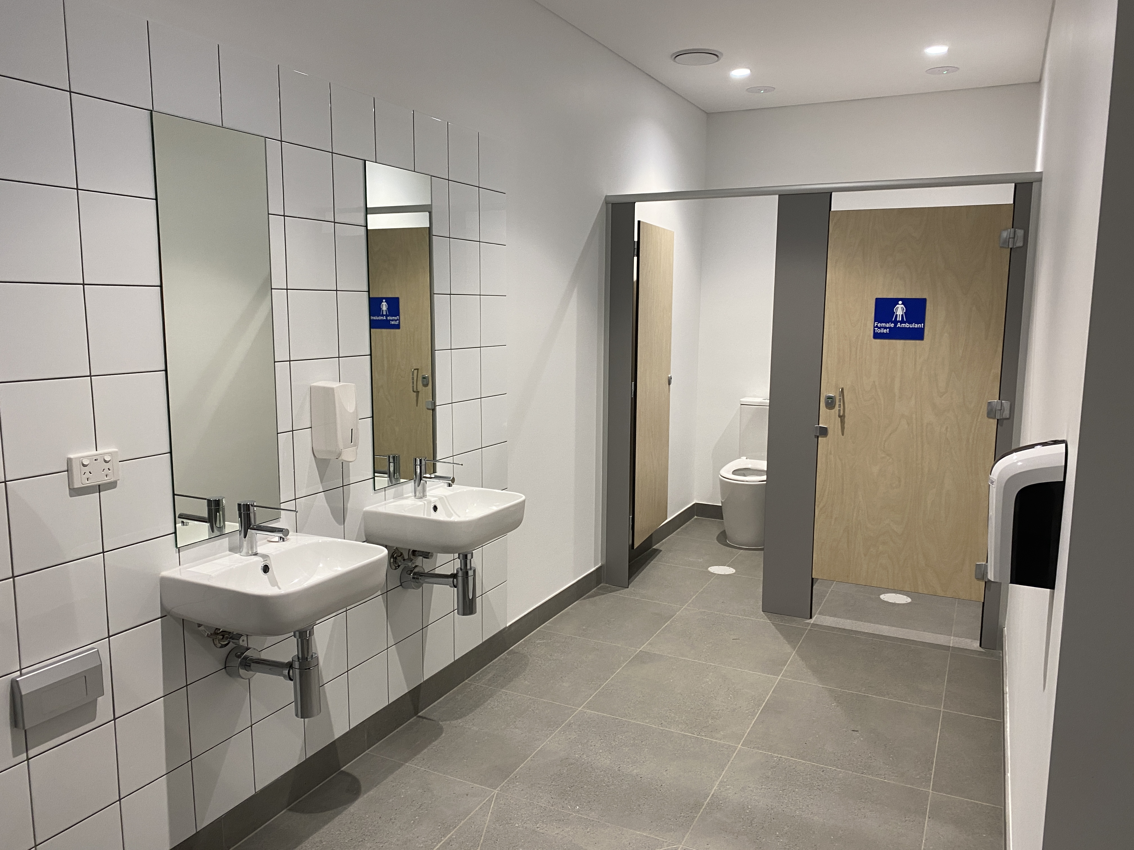
SEEONEE female toilet
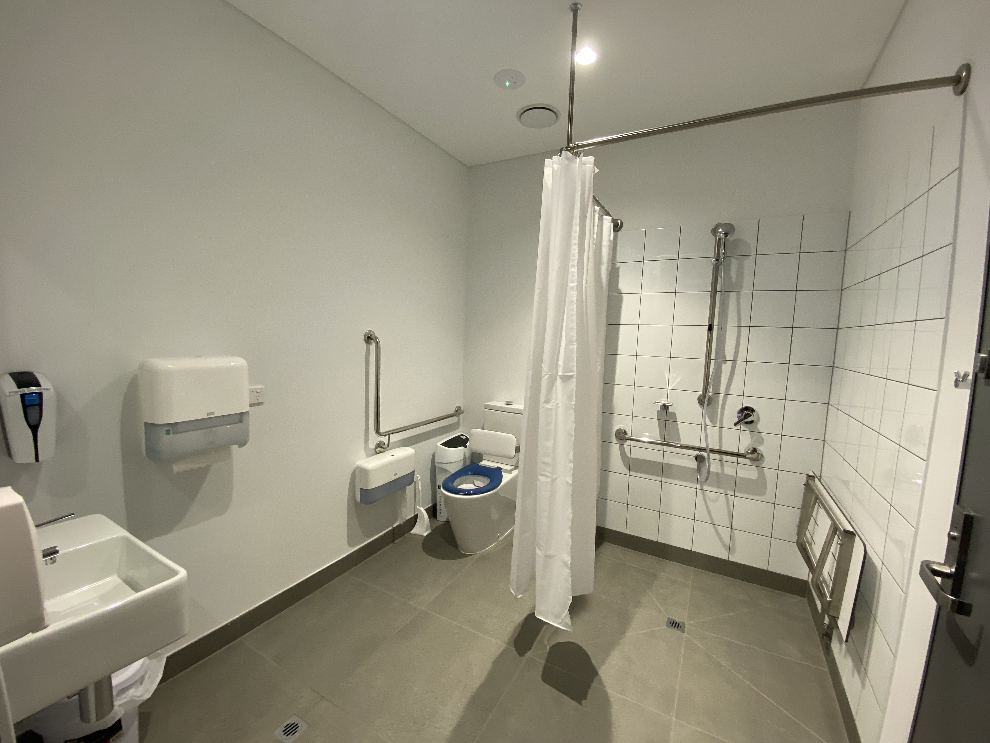
SEEONEE accessible bathroom
- In addition, the following further information can assist guests:
Check out the virtual tour online (copy and paste in your browser) www.camps3d.com.au/aca/woodhouse - or feel free to arrange an in person scoping tour by phoning 08 8339 3333 or emailing info@woodhouse.org.au

ATTRACTIONS

Attractions Basics
- A park map is available here:

https://www.woodhouse.org.au/assets/pdf/Woodhouse-Adventure-Park-Map.pdf
- In addition, the following further information can assist guests:
Tube Slide: Wheelchair-accessible pathway to the top of the slope. Support persons can assist at the slide platform.Disc Golf, Orienteering and Photo Hunts:Self-paced and flexible, with some flat, grassy terrain suitable for mobility devices.The Labyrinth: Accessible through external entry from top and bottom level and may be suitable for some wheelchair users subject to weatherWalking Trails: Vary in gradient and surface. Some areas are suitable for guests using walking aids or accompanied by a support person.Check out the virtual tour online (copy and paste in your browser) www.camps3d.com.au/aca/woodhouse to assess if these activities will be suitable for you

COMMON AREAS

Parks and gardens
- The following parks and gardens amenities are available
- Accessible toilets

https://www.woodhouse.org.au/assets/pdf/Woodhouse-Adventure-Park-Map.pdf
- Accessible picnic tables
- Accessible drinking fountains
- Handrails and stairs are built as per state/territory building code.
- Slip resistance surfaces are used.
- A handrail is available and at 865-965mm in height.
- The handrail is continuously graspable along entire length at least one side.
  - Parks and Gardens Stair entry and exit Image(s)
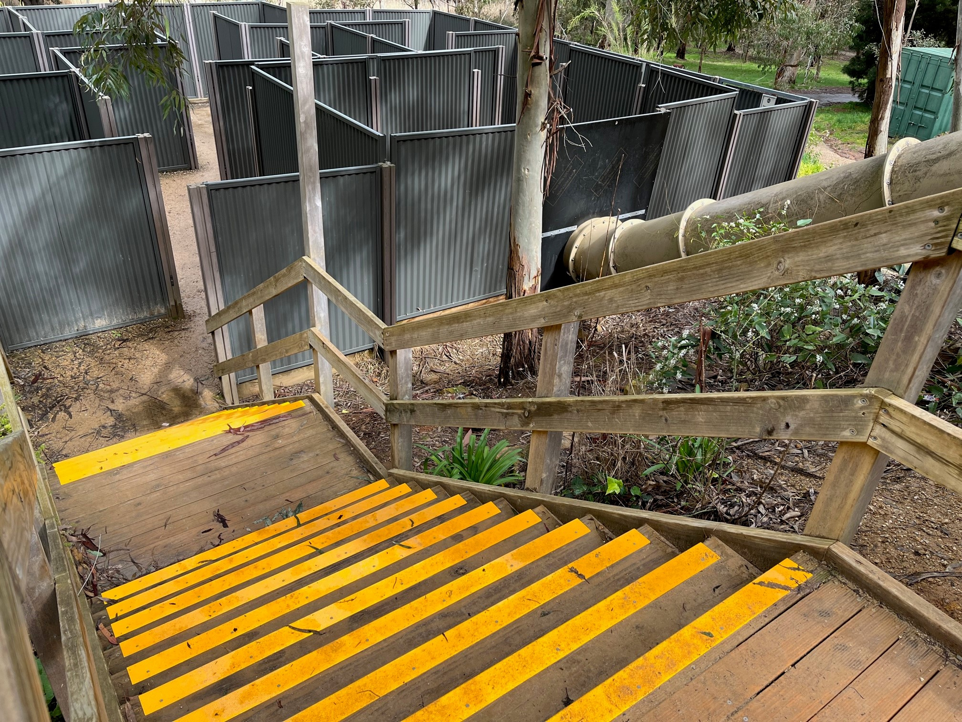
Labyrinth Steps
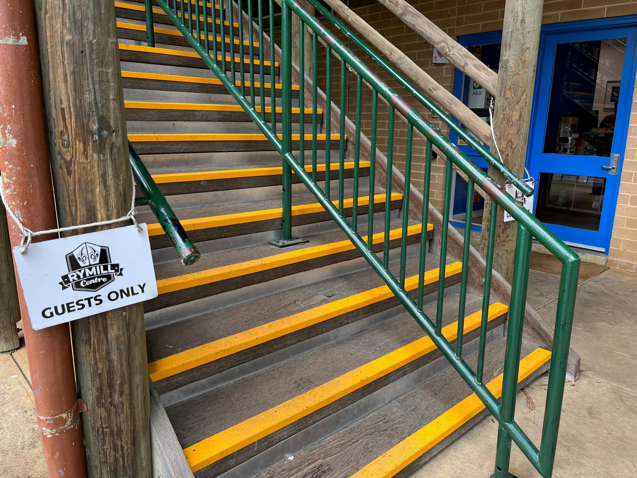
Rymill Steps

ADVENTURE ACTIVITIES
- In addition, the following further information can assist guests:
Many activities are accessible, without modification.

Tube Slide: Wheelchair-accessible pathway to the top of the slope. Support persons can assist at the slide platform.Disc Golf, Orienteering and Photo Hunts:Self-paced and flexible, with some flat, grassy terrain suitable for mobility devices.The Labyrinth: Accessible through external entry from top and bottom level and may be suitable for some wheelchair users subject to weatherWalking Trails: Vary in gradient and surface. Some areas are suitable for guests using walking aids or accompanied by a support person.Check out the virtual tour online (copy and paste in your browser) www.camps3d.com.au/aca/woodhouse to assess if these activities will be suitable for you

Report Disclaimer
Please note that this business report, provided as a result of the use of the diagnostic assessment, is for information purposes only.
Australian Tourism Industry Council (ATIC) cannot guarantee the accuracy of respondent’s answers, or that they are fully representative of your business. Therefore, ATIC does not warrant or guarantee any particular outcome in respect of your businesses self-assessment.
This report is intended as guidance only for your business and should not be relied on for future marketing considerations. ATIC recommends that you seek your own independent advice as well as the results from the diagnostic.
Links to external web sites are inserted for convenience and do not constitute endorsement of material at those sites, or any associated organisation, product or service.
ATIC does not:
- Assume any legal liability for the accuracy, completeness, or usefulness of any information from this report or any links provided; or
- Accept responsibility for any loss associated directly or indirectly from the use of this report.

